Zero-Trust P2P Networks: The Day I Stopped Babysitting My VPN
A photo-driven walkthrough of why identity-based mesh networking beats the classic VPN tunnel for home labs (most of the time).
By Tomas Suarez
It was 6:59 PM, my phone was on its last 17%, and I needed to jump into my home lab to restart a service before the next call. No laptop. No router admin panel. Just an iPhone.
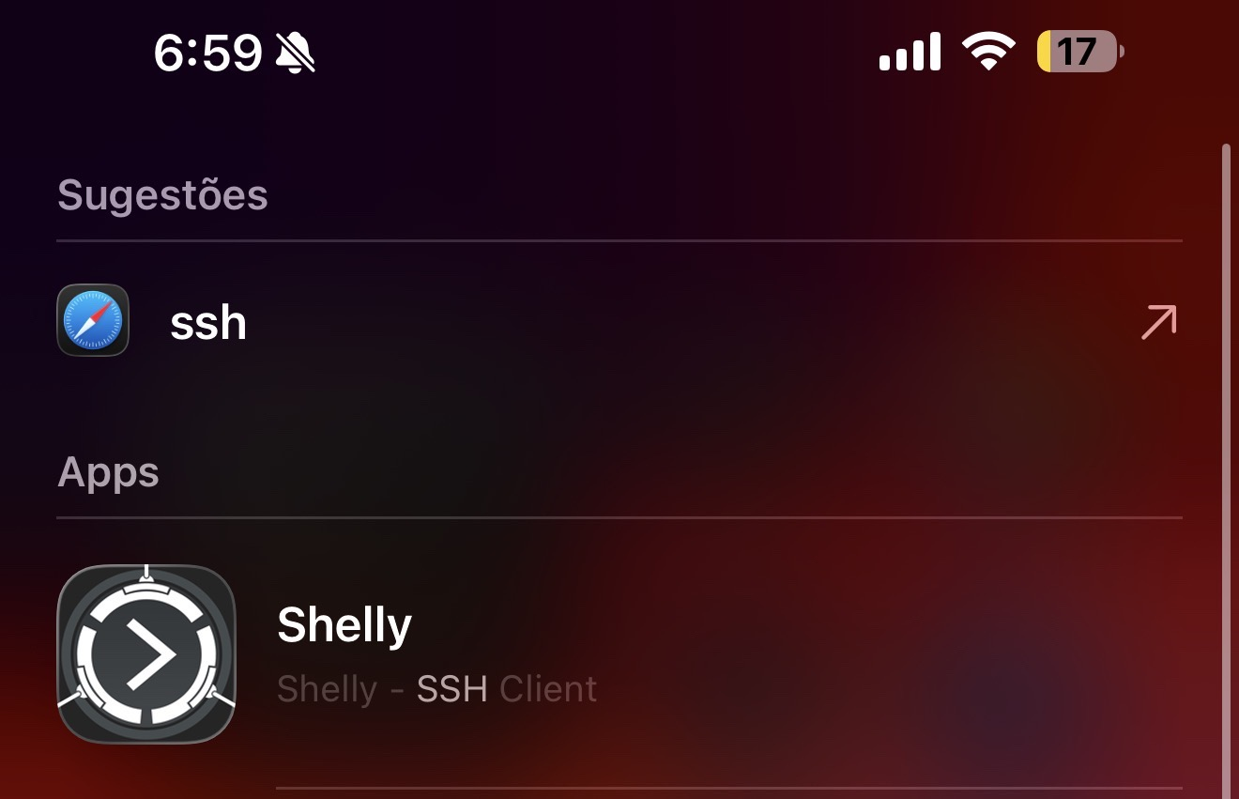
Image 1 — The moment of truth: on iPhone, I search for an SSH client (Shelly) instead of hunting for a “VPN server”.
For years, the ritual looked like this: open a VPN app, wait for a tunnel to come up, hope the VPN endpoint wasn’t down, then SSH through that tunnel to reach anything at home. If that single VPN box or cloud VM sneezed, everything went dark.
Tonight I didn’t want a tunnel. I wanted a direct, authenticated path to exactly one machine. That’s the mental shift behind zero-trust peer-to-peer (P2P) networking.

The classic VPN problem: one choke point, one failure domain
Traditional VPNs are built around a hub-and-spoke model: clients connect to a central VPN gateway (your router, a NAS, or a cloud VM), and that gateway becomes the doorway to your entire network. It’s convenient, but it’s also a single point of failure and a single point of congestion.
When the gateway is down, misconfigured, overloaded, or blocked by a captive network, your remote access disappears. When it’s up, every packet often hairpins through it, even when you’re trying to reach a device that could have been contacted directly.

Zero trust, in plain terms
A zero-trust network flips the assumption. Instead of “you’re on the network, therefore you’re trusted,” it treats every connection as untrusted until proven otherwise. Identity becomes the perimeter.
In a P2P mesh, devices authenticate to each other using strong cryptographic identities. Access policies (ACLs) decide who can talk to what. And when possible, traffic flows directly between peers—not through a central gateway that can bottleneck or fail.
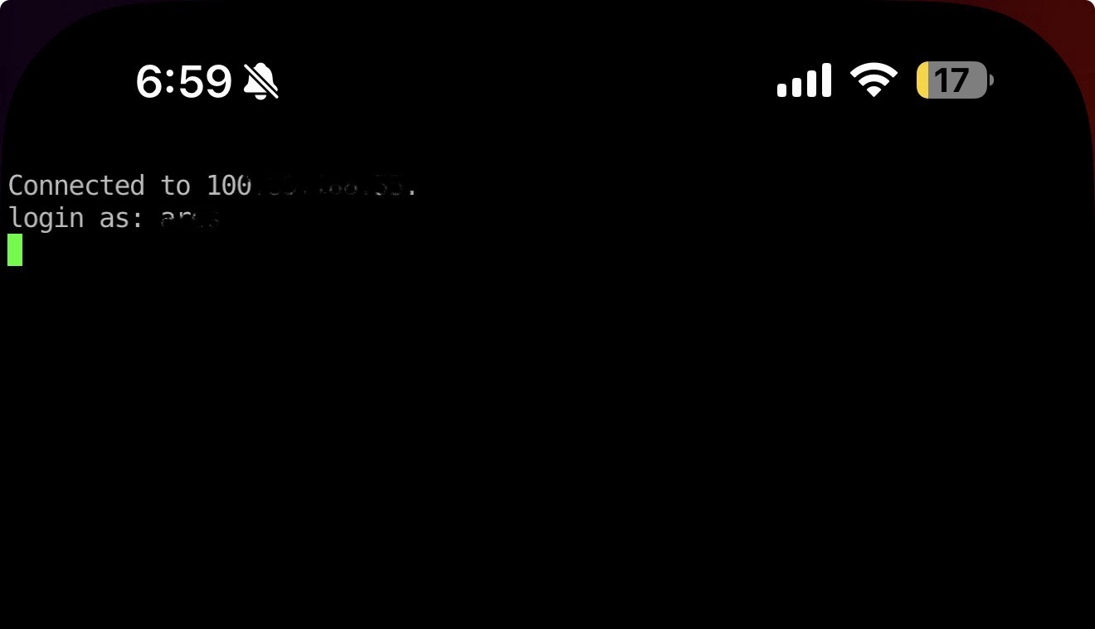
Image 2 — SSH session from iPhone to a 100.x address (Tailscale/WireGuard-style). The traffic is end-to-end encrypted and usually direct peer-to-peer.
Notice what’s missing: a public VPN server IP, port forwarding, and the anxiety of “did my home IP change?” The mesh assigns stable device identities (and often stable internal IPs), so you target the machine—not the network.

Zero trust feels like friction… until you realize what it’s buying you
If you’re used to old-school VPNs, zero trust can look stricter at first: logins, device approval, short-lived keys, re-auth. But that’s the point. Instead of trusting anything that reaches the VPN gateway, you’re explicitly verifying the device and the user.
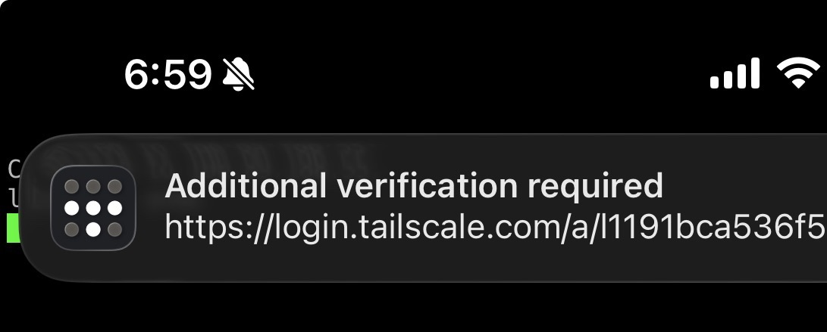
Image 3 — Device/user verification. This is the “trust, but verify” moment that a traditional VPN usually skips.
That extra verification step is an anti-footgun. It reduces the blast radius of a leaked password, a lost phone, or a stale VPN client config. In practice, it’s the difference between “someone got on my network” and “someone got blocked because their device wasn’t approved.”

Yes, iOS calls it “VPN.” No, it doesn’t behave like your old VPN.
On iPhone, mesh networking tools often plug into the OS through the VPN framework, because that’s the system-level hook Apple provides. So you’ll see the familiar VPN indicator—even if the network underneath is a P2P mesh.
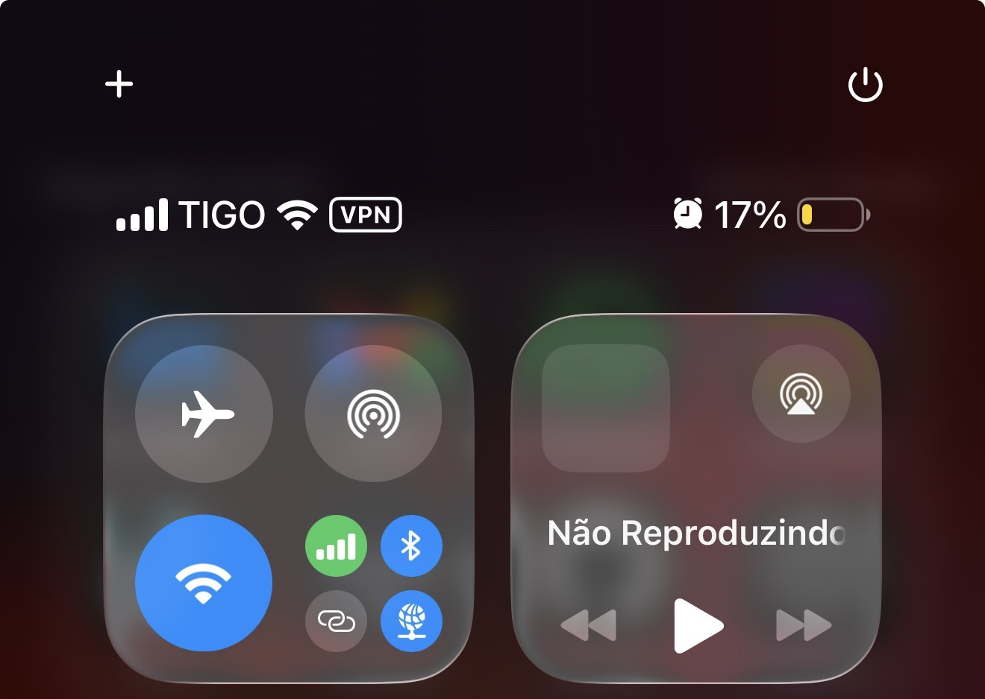
Image 4 — The iOS VPN icon is on. Under the hood, this can be a P2P mesh: direct device-to-device links whenever possible.
The key difference is routing. With a classic VPN, you’re usually backhauling traffic through a gateway. With a mesh, you can keep traffic scoped: only send the flows you need (SSH to a server, HTTPS to a dashboard) and keep the rest of your phone’s internet traffic on the normal path.

The hidden bill: VPN bandwidth up and down can bankrupt you
Even if your VPN is technically “working,” the architecture can quietly drain money.
If your gateway lives in the cloud, every remote session becomes a three-hop story: phone → cloud VPN → home lab. That means you pay for cloud egress, you pay again for the return traffic, and you often burn bandwidth twice because of hairpin routing.
And if you go with a commercial VPN or a managed gateway plan, you’re commonly buying into limits: device caps, “active user” pricing, throughput tiers, or the kind of fine print that pushes you toward a premium plan.
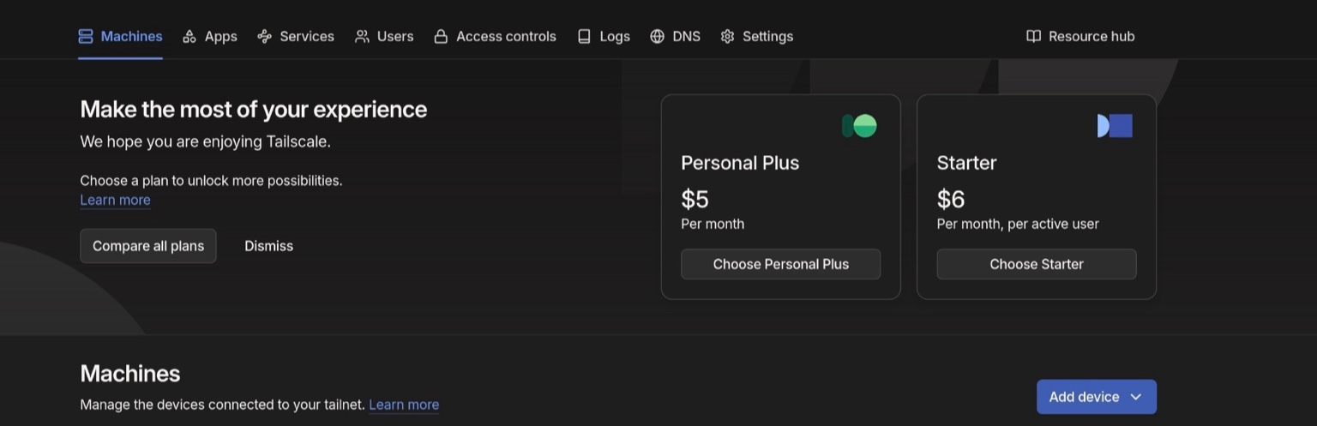
Image 5 — The plan upsell screen is a good reminder: “VPN” solutions often monetize limits (users, devices, throughput, features).
For a home lab, those limits hurt in a very specific way. Labs aren’t one device; they’re a swarm: a NAS, a hypervisor, a couple of Raspberry Pis, maybe an Orange Pi, maybe a router, maybe a backup node. When pricing is per user or per active device, the meter starts running. When bandwidth is capped, even pulling logs or syncing backups becomes a tax.

P2P mesh vs VPN tunnel: a practical comparison (using Tailscale as the example)
Tailscale is a popular way to get a zero-trust mesh without building everything from scratch. It uses WireGuard for encryption and tries hard to connect devices directly (NAT traversal). If a direct path can’t be established, it can relay through a fallback—useful, but still end-to-end encrypted.
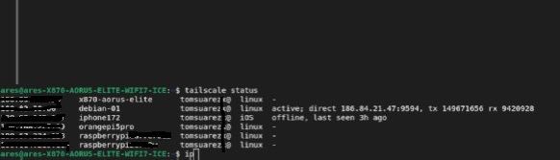
Image 6 — “tailscale status” shows the mesh: many devices, direct links when available, and a clear view of what’s online.
This is where the single-point-of-failure story changes. In a hub VPN, the gateway’s CPU, memory, and uplink are the bottleneck for everyone. In a mesh, each pair of devices is its own path. One chatty connection doesn’t automatically starve the others.
Is there still a control plane? Yes. Most meshes have coordination services for identity, key exchange, and policy distribution. But your data plane is typically peer-to-peer, so you don’t pay (or suffer) for a central gateway pushing all your traffic.

iPhone as a control panel for your lab
Once the mesh is set up, your phone stops being “outside the network.” It becomes just another authenticated node. That means you can check dashboards, hit internal services, or SSH into boxes from anywhere—without exposing ports to the internet.
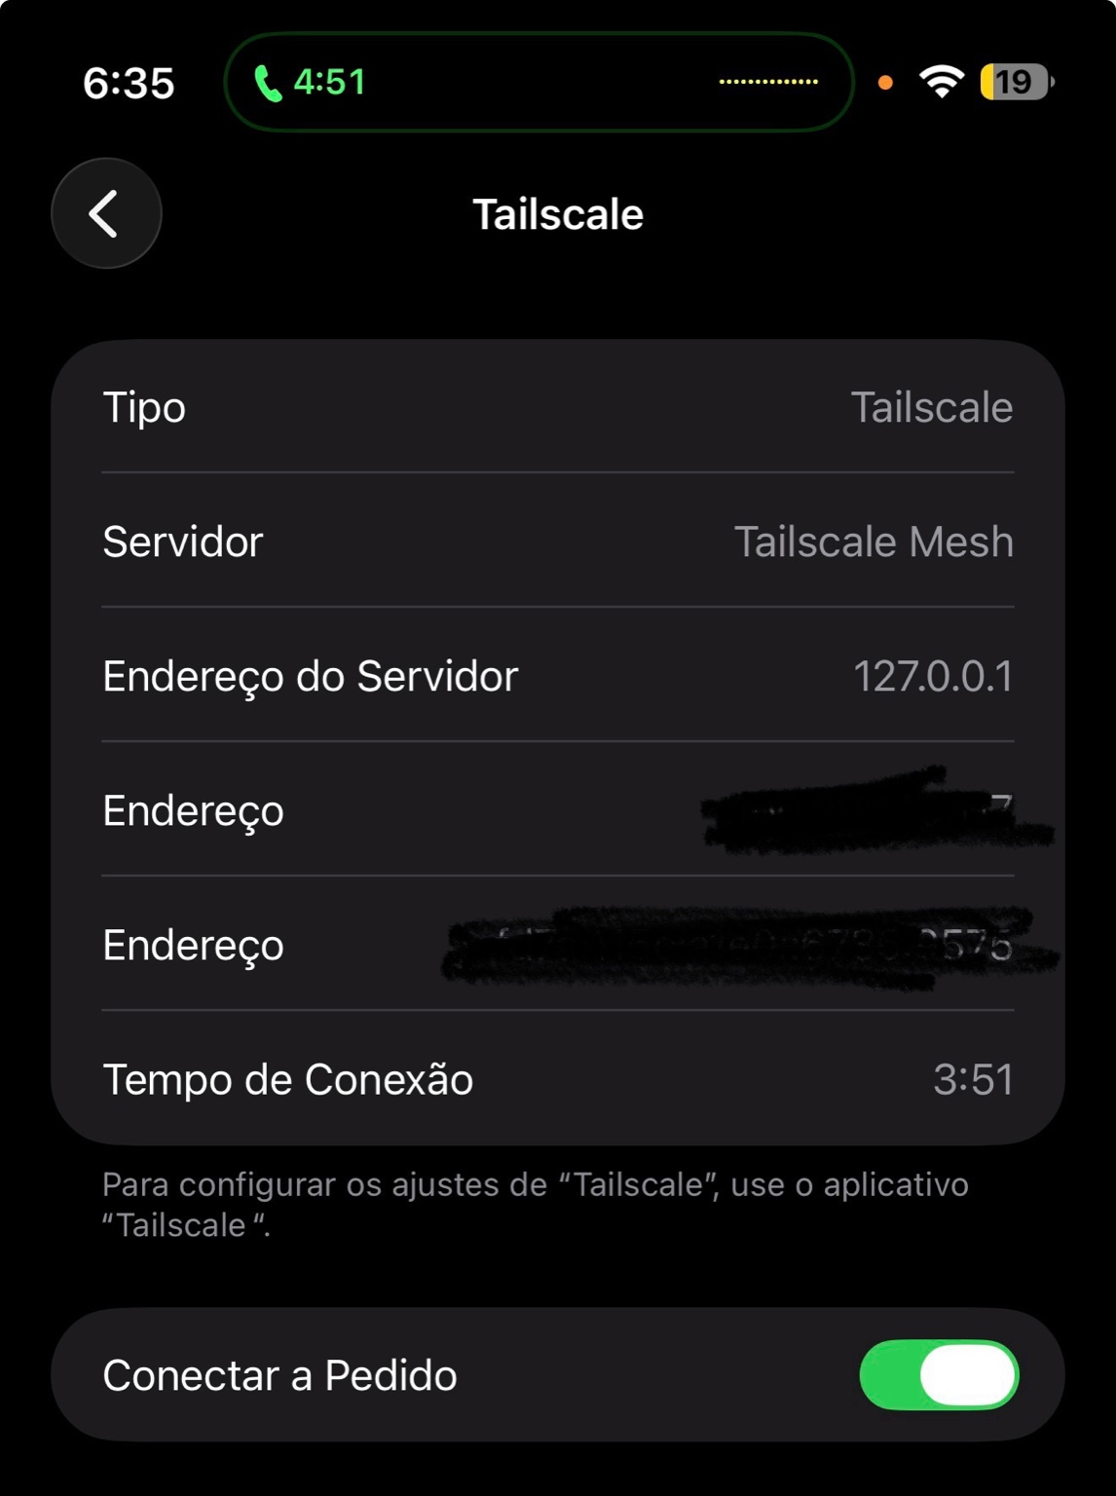
Image 7 — iOS shows a Tailscale VPN profile. It’s the OS-level integration that keeps the mesh always one toggle away.
On iOS you can enable Connect On Demand so the mesh comes up automatically on untrusted Wi-Fi, or keep it manual when you only need it occasionally.
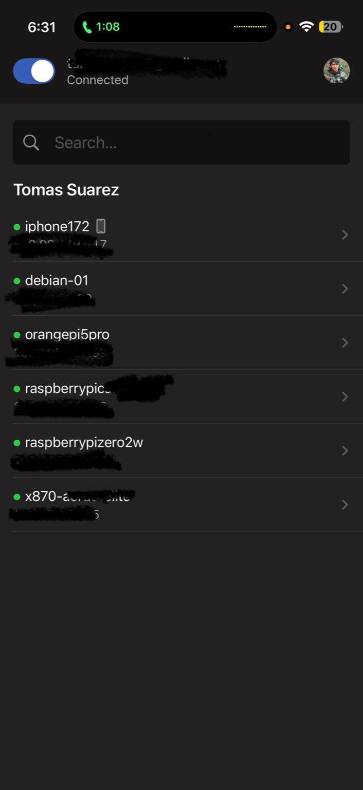
Image 8 — The Tailscale app becomes a directory of your lab: pick a machine, copy its address, and connect.
Pair that with an SSH client like Shelly, and remote maintenance becomes boring—in the best way. Find the host, connect, do the fix, disconnect. No port forwarding. No changing router rules on vacation.

What a zero-trust mesh does NOT replace
A mesh is not the same thing as an “anonymity VPN.” If your goal is to appear in another country for streaming, or to hide your traffic patterns from a public Wi-Fi operator, a consumer VPN with exit servers is built for that.
Same with torrents: a zero-trust mesh encrypts traffic between your devices, but it doesn’t make your BitTorrent traffic anonymous to the public swarm. Peers still see the IP address of the exit point you’re using (your home connection, or whatever server you chose).
Meshes can support exit nodes, but those are still your exits. They’re great for securely reaching home resources and optionally routing through a trusted box you control. They’re not a replacement for a commercial VPN provider’s geographic diversity or anonymity guarantees.

The takeaway
If you’re using a VPN mainly to reach your own devices—home lab, NAS, internal dashboards—a zero-trust P2P mesh usually wins: fewer choke points, less bandwidth waste, and a security model that doesn’t assume trust just because you crossed a tunnel.
And the best part is emotional: the access becomes predictable. When it’s 6:59 PM and you have 17% battery, you don’t want to debug networking. You want to get in, fix the thing, and get back to life.

