Proposed New Intro (Clean, Fun, Professional)
ubernetes has this reputation: complicated, sharp edges, too many YAML files, and way too many moving parts. And honestly? At first glance it does look shady, like a puzzle dumped on the floor with twice the pieces you expected.
But once you start putting the pieces together…
you realize it’s basically LEGO for cloud engineers — except the bricks are pods, identities, file mounts, certificates, and ingress controllers. And it’s weirdly addictive.
My gateway into this world wasn’t because I wanted to “master Kubernetes” or chase certification badges.
It started with something much simpler:
👉 “Run this Drupal container on AKS — securely.”
That one innocent request turned into a full deep dive through: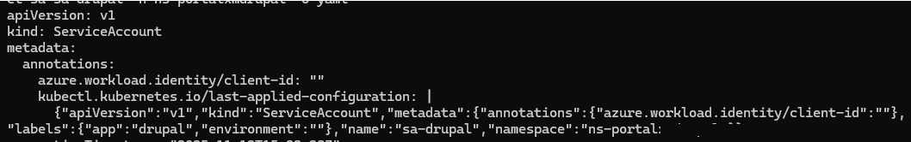
- Azure Files mounts with CSI
- Key Vault integrations
- Workload Identity
- Private endpoints
- TLS certificates
- NGINX ingress routing
- And a parade of kubectl describe rabbit holes
Somewhere along the way, the whole thing clicked — the patterns, the legos, the architecture.
And suddenly I wasn't just deploying Drupal anymore…
I was enjoying building all the pieces around it.
This document is the story and the blueprint.
It’s based on the working implementation here:
🔗 https://github.com/datatomas/aks-secure-storage-and-ingress
Inside the repo, you’ll find everything that turned a “simple Drupal deployment” into a full AKS-powered, production-grade setup:
- Azure Files mounted through Key Vault + Secrets Store CSI
(no more connection strings in YAML)
- Azure Workload Identity
(keyless authentication, no secrets needed)
- A complete NGINX Ingress with TLS, using either:
  - a Key Vault self-signed cert, or
  - an external PFX stripped into .crt + .key
If you’ve ever looked at AKS and thought “this seems complicated,” this guide shows how the pieces actually fit — LEGO-style — into something clean, secure, and surprisingly fun to build.
And if you’re coming from backend or cloud engineering, like me, this is exactly the bridge into understanding the front-end edge of AKS: ingress, certificates, DNS, and identity.

1. A Quick Mental Model: Pods, Services, Ingress and Storage
Before touching YAML, I had to map the AKS pieces in my head:
• Pod: where your container actually runs. In my case, a Drupal image pulled from a private Azure Container Registry (ACR).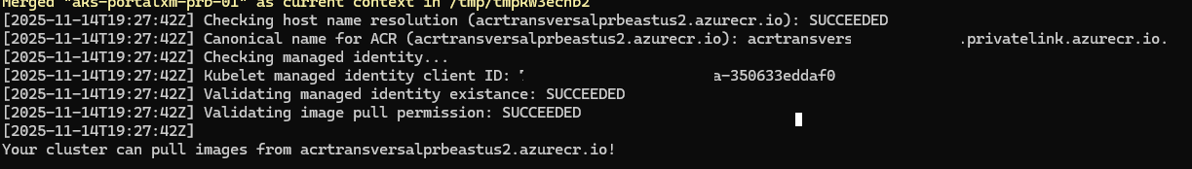
• Service: a stable virtual IP inside the cluster that points to one or more Pods using labels. The Service doesn’t care which node the Pod is on, it just routes traffic to the matching endpoints.
• Ingress: an HTTP/HTTPS entry point into the cluster that routes external traffic to Services. The Ingress object is just config; the real work is done by an Ingress controller (here: NGINX). Kubernetes docs have a great overview: https://kubernetes.io/docs/concepts/services-networking/ingress/
• Storage: in this scenario, an Azure Files share mounted into the Pod using the Azure Files CSI driver (file.csi.azure.com). For AKS details, see: https://learn.microsoft.com/azure/aks/azure-files-volume
• Identity & Secrets: instead of putting storage keys in YAML, we use Azure Workload Identity and the Secrets Store CSI driver to pull secrets from Azure Key Vault at runtime.
Once that picture clicked, the repo structure started to make sense.

2. Repository Layout
Repo: https://github.com/datatomas/aks-secure-storage-and-ingress
The repo is split into two main parts:
• scripts/: helper scripts for identities and certificates
- 01-user-assigned-identity.sh – creates the user-assigned managed identity and gives it the right roles.
- 02-federate-credential.sh – creates the federated credential that links the AKS service account to the managed identity (via the AKS OIDC issuer). This is the Azure Workload Identity piece.
- 03-akv-generate-selfsigned-cert.sh – creates a self-signed certificate in Azure Key Vault, downloads it, converts it to key + cert, and creates a Kubernetes TLS secret.
- 03-local-self-signed.sh – same TLS flow but assuming someone gives you a .PFX file (common in enterprise environments).
• manifests/: all the Kubernetes YAMLs used in the walkthrough:
- service-account.yaml – service account annotated for workload identity and labeled for our app (e.g. app: drupal).
- secret-class-provider.yaml – SecretProviderClass that tells the CSI driver how to pull storage credentials from Key Vault and sync them to a Kubernetes Secret.
- azure-files-pod.yaml – the Pod that mounts the Azure Files share and the Key Vault-backed secret.
- ingress-service.yaml – ClusterIP Service that fronts the Pod.
- ingress-entry-point.yaml – NGINX Ingress with host, path and TLS configuration.
- dns-pod-test.yaml – a tiny debugging pod to test DNS and network connectivity.
- ns-quota.yaml – ResourceQuota / LimitRange so the namespace can’t accidentally burn the whole cluster.

3. Wiring Workload Identity: ServiceAccount ↔ Managed Identity
The first big concept shift for me was Azure Workload Identity. Instead of putting an Azure Storage account key or a Key Vault client secret into Kubernetes, the Pod authenticates using its own Kubernetes service account token. Azure then trusts that token via a federated 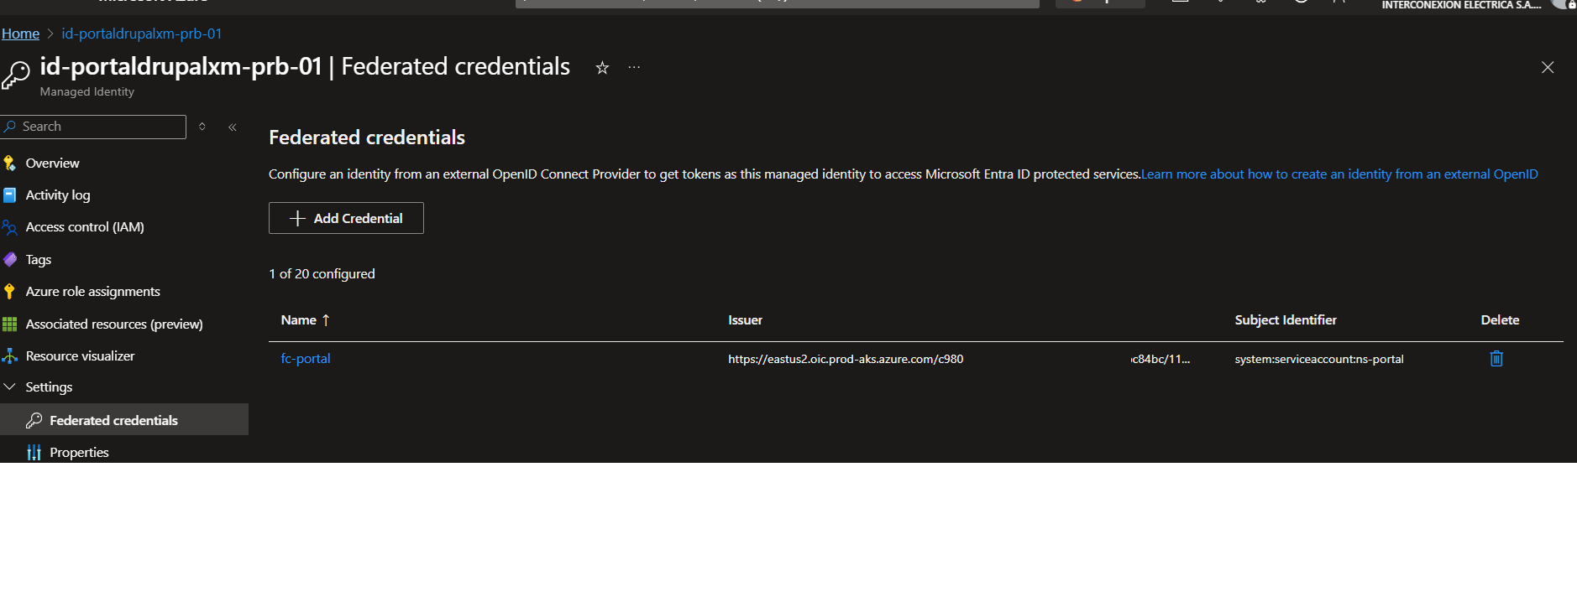 tied to a user-assigned managed identity.
The essential steps (automated by 01 and 02 in scripts/) look like this:
# 1. Create the user-assigned managed identity
az identity create \
--name $IDENTITY_NAME \
--resource-group $RESOURCE_GROUP
# 2. Grant it access to Key Vault and Storage
az role assignment create ...
# 3. Create federated credential (AKS OIDC → identity)
az identity federated-credential create \
--name $FEDERATED_CREDENTIAL_NAME \
--identity-name $IDENTITY_NAME \
--resource-group $RESOURCE_GROUP \
--issuer "https://eastus2.oic.prod-aks.azure.com/<OIDC_ID>" \
--subject "system:serviceaccount:$NAMESPACE:sa-drupal"
On the Kubernetes side, the service-account.yaml file annotates the service account with the managed identity client ID and labels it so that only the right workloads use it.
apiVersion: v1
kind: ServiceAccount
metadata:
name: sa-drupal
namespace: ns-front-app
annotations:
azure.workload.identity/client-id: "<MANAGED_IDENTITY_CLIENT_ID>"
labels:
app: drupal
Once this is in place, any Pod that sets serviceAccountName: sa-drupal will get a projected OIDC token volume. The Azure SDKs and the Secrets Store CSI driver use that token to obtain short-lived access tokens for Key Vault and other resources.

Make sure to check the annotation are there with commands
# Option 1: quick human-readable view
kubectl describe sa sa-drupal -n ns-front-app

# Option 2: full YAML (easy to grep / script)
kubectl get sa sa-drupal -n ns-front-app -n ns-front-app -o yaml
in the output you should see
annotations:
azure.workload.identity/client-id: "<MANAGED_IDENTITY_CLIENT_ID>"
labels:
app: drupal

4. Mounting Azure Files Using Secrets Store CSI and Key Vault
Before diving into the YAML, it helps to understand why we’re using this pattern and the difference between inline volumes and persistent volumes in Kubernetes.

🔍 Inline Volume vs. Persistent Volume — What’s the Difference?
Inline Volume
- Defined directly inside the Pod spec.
- Lives and dies with the Pod — no reuse between Pods.
- Can only reference Secrets in the same namespace.
- Good for simple or temporary workloads.
Persistent Volume (PV)
- A cluster-level storage object that exists independently of any Pod.
- Bound to a PersistentVolumeClaim (PVC).
- Pods can be deleted/recreated without losing data.
- Supports cross-namespace secret references and more advanced configurations.
- Required for applications like Drupal, where the /sites/default/files directory must persist across Pod restarts, upgrades, and rollouts.

Why We Use the CSI Inline + Key Vault Pattern
For this solution we avoided Kubernetes PersistentVolumes for two main reasons:

1. Persistent volumes have operational drawbacks in AKS
AKS best practices discourage using PV/PVC with Azure Disks for app-level storage because:
- They bind pods to specific nodes → no scheduling flexibility
- They complicate upgrades and node rotations
- They require additional IAM roles and storage policies
- They add an extra abstraction layer that is unnecessary when the storage is already external (Azure Storage)
For Drupal, we only need a shared directory (files/), not a block disk.
Azure Files solves this cleanly.

2. Inline CSI keeps the architecture simple and stateless
CSI inline volumes:
- Do not require a PersistentVolume or PVC
- Do not lock the Pod to a specific PV
- Work perfectly with serverless infrastructure (AKS node autoscaling, rolling updates, etc.)
- Are easier to template, deploy, and tear down
Since the storage already lives outside Kubernetes (Azure Files), persistence is in Azure, not in the Pod.

3. Inline CSI + Key Vault avoids storing long-lived secrets
Instead of storing a storage account key in Kubernetes:
- The storage account key sits in Key Vault
- Secrets Store CSI pulls it when the Pod starts
- The driver syncs it into a short-lived K8s Secret
- Azure File CSI mounts the share
This avoids ever placing sensitive credentials inside manifests or Git.
apiVersion: secrets-store.csi.x-k8s.io/v1
kind: SecretProviderClass
metadata:
name: azure-file-secret-provider
namespace: ns-front-app
spec:
provider: azure
parameters:
useVMManagedIdentity: "false"
useAzureWorkloadIdentity: "true"
userAssignedIdentityID: "<MANAGED_IDENTITY_CLIENT_ID>"
keyvaultName: kv-front-app-prb-01
tenantId: "<TENANT_ID>"
objects: |
array:
- |
objectName: storage-account-name
objectType: secret
- |
objectName: storage-account-key
objectType: secret
secretObjects:
- secretName: drupal-storage-key
type: Opaque
data:
- key: azurestorageaccountname
objectName: storage-account-name
- key: azurestorageaccountkey
objectName: storage-account-key
After applying this SecretProviderClass, the Pod manifest (azure-files-pod.yaml) mounts two CSI volumes: one for the Key Vault secrets, and one for Azure Files that consumes the synchronized Kubernetes Secret drupal-storage-key.
apiVersion: v1
kind: Pod
metadata:
name: drup-fs-test
namespace: ns-front-app
labels:
app: drupal
spec:
serviceAccountName: sa-drupal
nodeSelector:
kubernetes.io/os: linux
containers:
- name: drup-fs-test
image: <your-acr>/portal/xmdrupal:496034
volumeMounts:
- name: azure
mountPath: /opt/drupal/web/sites/default/files
- name: kv-secrets
mountPath: /mnt/kv-secrets
readOnly: true
volumes:
- name: kv-secrets
csi:
driver: secrets-store.csi.k8s.io
readOnly: true
volumeAttributes:
secretProviderClass: azure-file-secret-provider
- name: azure
csi:
driver: file.csi.azure.com
readOnly: false
volumeAttributes:
secretName: drupal-storage-key
shareName: portaldrupal-fs
My favorite “it finally works” moment in this section was watching the drup-fs-test Pod events go from “could not get secret(drupal-storage-key)” to the volume mounting successfully once the SecretProviderClass had created the Secret.
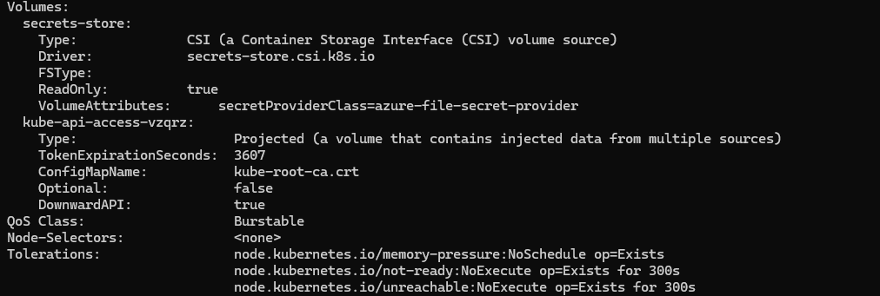
You can verify that the Secrets Store CSI volume and the projected token are wired up with:
# Inspect the pod volumes + events
In the Volumes section you should see:
- A CSI volume with Driver: secrets-store.csi.k8s.io and
secretProviderClass=azure-file-secret-provider
- A kube-api-access-… projected volume (the service account / OIDC token)
At the bottom, in Events, you’ll see the mount go from
could not get secret(drupal-storage-key) to a successful
Successfully mounted volume "secrets-store" once the SecretProviderClass
has finished creating the Secret.
Alternative Option: No Mount at All (Direct SDK Access)
There is a third option:
✨ Don’t mount anything.
Let the container call Azure Storage directly using Workload Identity.
This means:
- no Azure Files
- no CSI volumes
- no secrets
- only OAuth tokens + managed identity
Your teammate mentioned this:
“Desde el AKS se pueden autenticar. Incluso en el BLOB de storage también.”
This is viable, but Drupal specifically expects a local filesystem, so mounting Azure Files is the practical choice.

Exposing the App: Service and NGINX Ingress
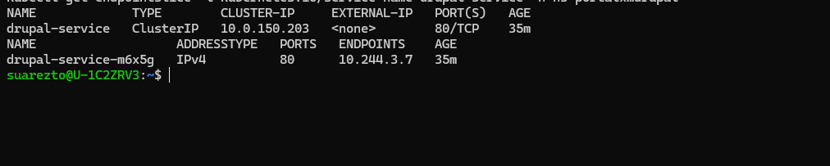
With storage solved, the next step was getting HTTP traffic from the outside world to the Pod. That’s a two-hop story: Service → Ingress.
First we create a ClusterIP Service that selects Pods with app: drupal and forwards traffic on port 80:
apiVersion: v1
kind: Service
metadata:
name: drupal-service
namespace: ns-front-app
spec:
selector:
app: drupal
ports:
- port: 80
targetPort: 80
protocol: TCP
type: ClusterIP
Kubernetes creates an EndpointSlice behind the scenes that lists the Pod IPs backing this Service. You can inspect it with:
kubectl get svc -n ns-front-app
kubectl get endpointslice -l kubernetes.io/service-name=drupal-service -n ns-front-app
Once the Service is healthy, we define an Ingress that uses the NGINX ingressClass and terminates TLS using a secret created from our certificate:
apiVersion: networking.k8s.io/v1
kind: Ingress
metadata:
name: drupal-ingress
namespace: ns-front-app
spec:
ingressClassName: nginx
tls:
- hosts:
- front-app-prb.xm.com.co
secretName: front-app-prb-tls
rules:
- host: front-app-prb.xm.com.co
http:
paths:
- path: /
pathType: Prefix
backend:
service:
name: drupal-service
port:
number: 80
At this point, the ingress-nginx controller picks up the new Ingress, configures the NGINX instance behind the LoadBalancer service, and your DNS CNAME for front-app-prb.xm.com.co can point at the controller’s public IP.

6. Certificates: Self-Signed in Key Vault vs Existing PFX
I ended up with two certificate flows, both captured as scripts in the repo.
Option A – Self-signed certificate created in Azure Key Vault (03-akv-generate-selfsigned-cert.sh):
# 0. Create the certificate in Key Vault
az keyvault certificate create \
--vault-name $KV_NAME \
--name $DOMAIN_NAME \
--policy "$(az keyvault certificate get-default-policy \
| jq '.subject="CN='"$DOMAIN_NAME"'"' )"
# 1. Download as PFX
az keyvault secret download \
--vault-name $KV_NAME \
--name $DOMAIN_NAME \
--file tls.pfx
# 2. Extract key and cert (OpenSSL)
openssl pkcs12 -in tls.pfx -nocerts -nodes -out tls_with_pass.key -legacy
openssl rsa -in tls_with_pass.key -out tls.key
openssl pkcs12 -in tls.pfx -clcerts -nokeys -out tls.crt -legacy
# 3. Create Kubernetes TLS secret
kubectl create secret tls front-app-prb-tls \
--cert=tls.crt \
--key=tls.key \
-n $NAMESPACE
Option B – Someone emails you a PFX (03-local-self-signed.sh): the flow is the same from the OpenSSL step onwards, you just skip the az keyvault certificate create part and start from a local interinfo_xm_com_co.pfx-style file.
In both cases, once the secret exists and the Ingress spec references it under tls.secretName, NGINX will terminate HTTPS with that certificate.

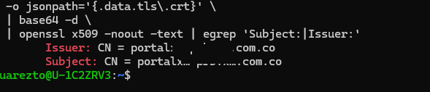

⚠️ Note: What Went Wrong With the Certificate (Issuer vs. Subject Mismatch)
In the screenshot above, the certificate you extracted shows different Issuer and Subject Common Names (CN)—and not just different: they belong to completely different domains.
Example of what you ended up with:
Issuer: CN = portal.…com.co
Subject: CN = portalx.…prod….com.co
This usually happens when:
- the PFX you exported from Key Vault did not contain the certificate you expected,
- or you accidentally mixed a self-signed cert (issuer = subject) with a cert signed by another CA,
- or you used the wrong PFX when testing, so the issuer chain came from a different environment (e.g., PRB vs. PROD).

✔ Why this is a problem
When the Issuer and Subject belong to different unrelated domains, several issues can occur:
- Browser trust errors
Browsers check that the certificate chain makes sense.
If the issuer doesn't match a trusted CA or doesn’t match the expected chain, users may see:
  - “Certificate not trusted”
  - “Unknown issuer”
  - or broken HTTPS padlock.
- TLS termination issues in NGINX
The Ingress controller depends on a valid certificate chain.
A mismatched issuer/subject can cause:
  - warnings in the NGINX logs
  - failure to build the intermediate certificate chain
  - some clients (mobile apps, older browsers, corporate proxies) rejecting the connection
- Key Vault confusion
importing the wrong PFX means:
  - you’re signing traffic with a cert that doesn’t match the DNS name
  - renewals will fail or renew a different certificate entirely
- Potential SNI mismatch
The Subject must match the hostname you are exposing through Ingress.
If it doesn’t, HTTPS termination still works but browsers will show a giant red warning.

✔ Why this happened in your flow
Most likely you did one of these:
- downloaded the wrong PFX from KV (similar certificate name, PRB vs PROD)
- extracted from a local .pfx you thought was the production one but wasn’t
- mixed up the cert and the key from two different PFX files
This is easy to do because the PFX format can contain multiple certs (leaf + intermediate), and Key Vault doesn't enforce strict naming.

✔ How to fix it
- Re-export the correct PFX from Key Vault (verify thumbprint!)
- Re-run the OpenSSL extraction
- Check the Issuer/Subject before creating the Kubernetes secret:

7. Verifying TLS and Debugging Ingress
To make sure the right certificate ended up in the secret, I used this pattern:
kubectl get secret front-app-prb-tls -n ns-front-app \
-o jsonpath='{.data.tls\.crt}' | base64 -d | \
openssl x509 -noout -text | egrep 'Subject:|Issuer:|Not Before|Not After'
Seeing the CN and validity dates match what you expect is strangely satisfying, especially after fighting with base64 blobs and PFX passwords.
For ingress debugging, these commands became muscle memory:
kubectl get ingress -A
kubectl describe ingress drupal-ingress -n ns-front-app
kubectl get svc -n ingress-nginx
kubectl get pods -n ingress-nginx
If you’re allowed to run temporary pods, a curlimages/curl or busybox pod in the same namespace is perfect for testing internal DNS and HTTP routing.

8. Lessons Learned (From a Non-Kubernetes Person)
• Labels are everything. My Service did nothing until the Pod had app: drupal and the selector matched.
• Secrets from Key Vault don’t just appear. The SecretProviderClass has to sync them into a normal Kubernetes Secret if another CSI driver (like Azure Files) needs them.
• Ingress doesn’t talk directly to Pods. It always routes to a Service, which picks Pods via labels.
• Certificates are just data. Whether they start life as a Key Vault self-signed cert or as a random PFX from another team, the end game in Kubernetes is always a tls Secret with a key and a cert.
• Git repos beat screenshots. Capturing all of this in a repo like https://github.com/datatomas/aks-secure-storage-and-ingress means I can forget the exact commands and just re-run the flow next time.
If you’re coming from a data or backend background and suddenly find yourself staring at AKS, I hope this walkthrough makes the path a bit less painful. You don’t need to become a full-time Kubernetes admin to ship a secure app, but you do need a mental model of Pods, Services, Ingress, storage and identity — and a place to keep your YAMLs and scripts. This repo became that place for me.

