MicroPython Wake-on-LAN Button
for an Ubuntu AORUS Desktop
Turn a Raspberry Pi Pico W into a tiny web-powered power button that can wake your Gigabyte AORUS-based Ubuntu PC over the network.

Wake-on-LAN (WoL) is one of those classic PC tricks that feels almost magical: you send a specially crafted “magic packet” to your powered‑off machine and—if everything is configured correctly—the fans spin up and the OS boots like you pressed the power button.
In this guide we’ll build a dedicated WoL helper using a Raspberry Pi Pico W running MicroPython. The Pico W connects to your Wi‑Fi, listens for a simple HTTP request, and then sends a WoL magic packet (optionally with a SecureOn password) to wake an Ubuntu desktop with a Gigabyte AORUS motherboard.
Along the way we’ll:
• Flash MicroPython onto the Pico W.
• Talk to the board with Thonny.
• Configure WoL correctly on Ubuntu with NetworkManager (including a WoL password).
• Write a tiny MicroPython web service that exposes `/` and `/wake?token=…` endpoints.
By the end you’ll have a URL you can hit from your browser or phone to wake your PC—no more crawling under the desk to mash the power button.

Hardware and software used
- Ubuntu desktop PC with a Gigabyte AORUS motherboard and an Ethernet port that supports Wake-on-LAN.
- Raspberry Pi Pico W (RP2040 + Wi‑Fi).
- USB cable for connecting the Pico W to the Ubuntu machine.
- MicroPython firmware for the Pico W (e.g. `RPI_PICO_W-20250911-v1.26.1.uf2`).
- Thonny IDE, used as a friendly MicroPython editor and REPL.
- A working Wi‑Fi network that both the Pico W and the Ubuntu box can reach.

1. Flashing MicroPython onto the Pico W
The first step is to get MicroPython running on the Pico W. Raspberry Pi boards make this pleasantly simple thanks to their UF2 bootloader.
1. Disconnect the Pico W from USB.
2. Hold the BOOTSEL button on the board.
3. While keeping BOOTSEL pressed, plug the USB cable into your Ubuntu PC.
4. Release BOOTSEL once the board appears as a USB mass‑storage device named `RPI-RP2`.
On Ubuntu you can confirm that the board has appeared as a storage device with `lsblk`:
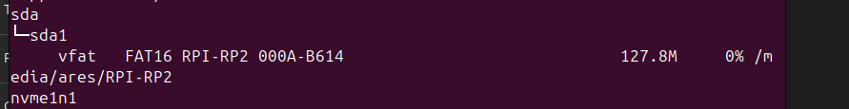
Figure 1 – `lsblk` showing the Pico W mounted as the `RPI-RP2` mass‑storage device.
You should also see the device in `lsusb` with an ID that corresponds to the bootloader (RP2 Boot):
Figure 2 – Pico W in BOOTSEL (UF2) mode, showing up as “Raspberry Pi RP2 Boot”.
Now copy the MicroPython UF2 file to the mounted `RPI-RP2` volume. You can do this from the command line:
cp "/path/to/RPI_PICO_W-20250911-v1.26.1.uf2" /media/youruser/RPI-RP2
As soon as the file is copied, the Pico W reboots itself. The `RPI-RP2` mount disappears, and the board restarts running MicroPython instead of the UF2 bootloader.
Back in `lsusb` and `dmesg`, you’ll now see the board reported as a generic “Board in FS mode” manufactured by MicroPython:

Figure 3 – After flashing MicroPython, the Pico W enumerates as a MicroPython USB device.

2. Talking to MicroPython with Thonny
MicroPython exposes a REPL (interactive Python prompt) over a USB serial device. On Linux this typically shows up as `/dev/ttyACM0` or `/dev/ttyUSB0`.
You can find the exact device name by grepping `dmesg` for TTY devices after plugging the Pico W back in normally (without BOOTSEL held):
dmesg | grep -i tty
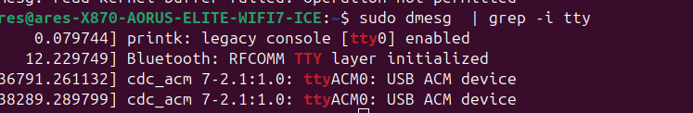
Figure 4 – `dmesg` showing the Pico W attached as `/dev/ttyACM0`.
If you haven’t already, install Thonny from Ubuntu’s repositories:
sudo apt install -y thonny
Launch Thonny, choose the interpreter “MicroPython (Raspberry Pi Pico)” and point it at the serial port you found (for example `/dev/ttyACM0`). Once connected, you’ll see a Python prompt in the Shell pane and can run MicroPython code interactively.
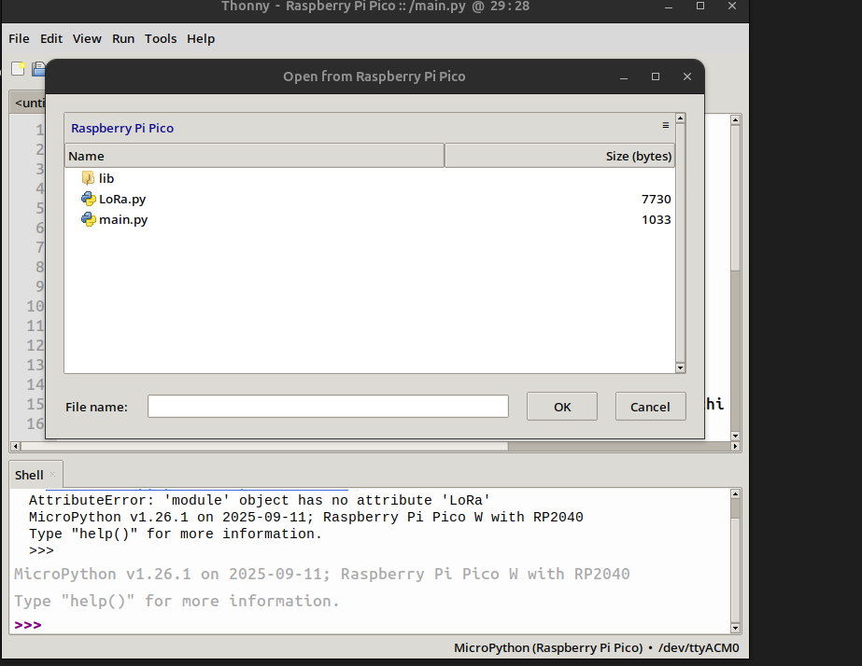
Figure 5 – Thonny connected to the Pico W, showing files on the board and the MicroPython REPL.
To avoid running Thonny as root, make sure your user is in the `dialout` group so it can access serial devices:
sudo usermod -aG dialout $USER
Log out and back in so the new group membership is applied.

3. Enabling Wake-on-LAN on the Ubuntu AORUS box
Before the Pico W can wake your machine, the PC itself has to be willing to listen for WoL magic packets. That means enabling WoL both in firmware (BIOS/UEFI) and in the operating system.
On Gigabyte AORUS boards, look for options like “Wake on LAN”, “Power On By PCI-E”, and “ErP”. Typically you’ll want WoL/PCI-E wake enabled and ErP disabled so the NIC stays partially powered when the system is off.
Once firmware is configured, boot into Ubuntu and inspect the Ethernet interface with `ethtool`. Replace `enp7s0` with the actual interface name from `ip link`:
sudo ethtool enp7s0 | grep Wake-on
You should see something like `Supports Wake-on: pumbg` followed by a line indicating the current setting, for example `Wake-on: d` (disabled) or `Wake-on: g` (magic packet).
At first it’s tempting to enable WoL with a one‑shot command or a small systemd service that runs `ethtool -s enp7s0 wol g` at boot. But on systems managed by NetworkManager, the network stack may reconfigure the interface after your service runs and silently flip WoL back to disabled.
The more reliable solution is to let NetworkManager own the setting.
Check the NetworkManager connection profile for your wired interface:
nmcli connection show "netplan-enp7s0" | grep -i wake
Initially this often shows `802-3-ethernet.wake-on-lan: --`, which means “use the default” (usually not what we want). Set it explicitly to `magic`:
sudo nmcli connection modify "netplan-enp7s0" 802-3-ethernet.wake-on-lan magic
Then restart NetworkManager so the new policy is applied:
sudo systemctl restart NetworkManager
After the restart, confirm that the connection profile advertises WoL on magic packets:
nmcli connection show "netplan-enp7s0" | grep -i wake
You should now see `802-3-ethernet.wake-on-lan: magic`. A fresh `ethtool` listing should show `Wake-on: g`, and the setting will persist across reboots because NetworkManager re‑applies it each time the interface comes up.

3.1 Adding a SecureOn WoL password
Some NICs support a six‑byte WoL password (often called a SecureOn password). The machine will only wake if the magic packet contains both the correct MAC address and this password.
NetworkManager exposes this through the `802-3-ethernet.wake-on-lan-password` property. The password must be exactly six bytes, written as six hexadecimal pairs separated by colons (similar to a MAC address). For example:
sudo nmcli connection modify "netplan-enp7s0" 802-3-ethernet.wake-on-lan-password 11:22:33:44:55:66
Restart NetworkManager again:
sudo systemctl restart NetworkManager
And verify the configuration one more time:
nmcli connection show "netplan-enp7s0" | grep -i wake
With that, the Ubuntu AORUS box is ready: it expects WoL magic packets plus a SecureOn password of `11:22:33:44:55:66`.

4. Writing the MicroPython Pico W WoL service
Now for the fun part: turning the Pico W into a tiny web server that wakes the PC on demand.
The idea is simple:
• The Pico W connects to your Wi‑Fi.
• It calculates the network broadcast address from its own IP.
• It exposes a minimal HTTP server on port 80.
• When you hit `/wake?token=YOUR_SECRET`, it sends a WoL magic packet (plus the SecureOn password) to the broadcast address on UDP port 9.
Below is a complete `main.py` you can copy to the Pico W using Thonny.
import network
import socket
import time
import binascii
# --- configuration ---
WIFI_SSID = "YOUR_WIFI_SSID"
WIFI_PASSWORD = "YOUR_WIFI_PASSWORD"
# MAC address of the PC you want to wake
TARGET_MAC = "AA:BB:CC:DD:EE:FF"
# Shared secret for the HTTP endpoint
SECRET_TOKEN = "NaranjaMora2025!"
# Optional SecureOn password (must match your nmcli setting)
SECUREON_PASSWORD = "11:22:33:44:55:66"
# will be set after Wi-Fi connects
BROADCAST_IP = None
def get_broadcast_ip(wlan):
ip, netmask, _, _ = wlan.ifconfig()
ip_parts = [int(x) for x in ip.split(".")]
mask_parts = [int(x) for x in netmask.split(".")]
bcast_parts = [(ip_parts[i] | (255 - mask_parts[i])) for i in range(4)]
return ".".join(str(x) for x in bcast_parts)
def wake_on_lan(mac, bcast_ip, secureon_password=None):
# Normalize MAC: remove : or -
mac = mac.replace(":", "").replace("-", "")
mac_bytes = binascii.unhexlify(mac)
# base WoL magic packet: 6 x 0xFF followed by MAC repeated 16 times
magic_packet = b"\xff" * 6 + mac_bytes * 16
# Optionally append a 6-byte SecureOn password
if secureon_password:
pwd = secureon_password.replace(":", "").replace("-", "")
if len(pwd) != 12:
print("Invalid SecureOn password length (need 6 bytes / 12 hex chars)")
else:
pwd_bytes = binascii.unhexlify(pwd)
magic_packet += pwd_bytes
print("Magic packet length:", len(magic_packet))
sock = socket.socket(socket.AF_INET, socket.SOCK_DGRAM)
sock.setsockopt(socket.SOL_SOCKET, socket.SO_BROADCAST, 1)
try:
sent = sock.sendto(magic_packet, (bcast_ip, 9))
print("Bytes actually sent:", sent)
except Exception as e:
print("Send failed:", e)
finally:
sock.close()
print("WOL sent to", mac, "via", bcast_ip)
def connect_wifi():
wlan = network.WLAN(network.STA_IF)
wlan.active(True)
wlan.connect(WIFI_SSID, WIFI_PASSWORD)
print("Connecting to WiFi...")
while not wlan.isconnected():
time.sleep(1)
print("Waiting...")
print("Connected:", wlan.ifconfig())
return wlan
def handle_client(client):
global BROADCAST_IP
req = client.recv(1024)
request_line = req.split(b"\r\n", 1)[0]
print("Request:", request_line)
if b"GET /wake" in request_line:
if f"token={SECRET_TOKEN}".encode() in request_line:
try:
wake_on_lan(TARGET_MAC, BROADCAST_IP, SECUREON_PASSWORD)
body = "OK: WOL sent\n"
status = "200 OK"
except Exception as e:
body = "ERROR: %s\n" % repr(e)
status = "500 Internal Server Error"
else:
body = "Forbidden\n"
status = "403 Forbidden"
else:
body = "Pico W WOL service\n"
status = "200 OK"
response = (
"HTTP/1.1 " + status + "\r\n"
"Content-Type: text/plain\r\n"
"Content-Length: " + str(len(body)) + "\r\n"
"\r\n" +
body
)
client.send(response.encode())
client.close()
def start_server():
addr = socket.getaddrinfo("0.0.0.0", 80)[0][-1]
s = socket.socket()
s.bind(addr)
s.listen(1)
print("HTTP server on port 80")
while True:
client, addr = s.accept()
print("Client:", addr)
handle_client(client)
# ---- main ----
wlan = connect_wifi()
BROADCAST_IP = get_broadcast_ip(wlan)
print("Broadcast IP:", BROADCAST_IP)
print("Pico IP:", wlan.ifconfig()[0])
start_server()
Make sure to replace the Wi‑Fi credentials, the target MAC address, and (optionally) the secret token and SecureOn password with values that make sense for your network.

5. Testing the setup
With the Pico W running `main.py` and connected to Wi‑Fi, grab its IP address from the serial output in Thonny. The script prints both the Pico’s IP and the broadcast address it will use.
Open a browser on any device on the same network and visit the Pico’s root URL:
http://PICO_IP/
You should see a simple `Pico W WOL service` response. That confirms the HTTP server is alive.
To actually wake the PC, hit the `/wake` endpoint with the correct token:
http://PICO_IP/wake?token=NaranjaMora2025!
If everything is configured correctly, your AORUS Ubuntu box should spring to life as soon as the magic packet hits the network. If it doesn’t, double‑check the following:
- BIOS/UEFI WoL and PCI‑E wake are enabled, and ErP is disabled.
- The NIC supports WoL and `sudo ethtool enp7s0 | grep Wake-on` shows `Wake-on: g`.
- NetworkManager has `wake-on-lan: magic` and (if used) the correct SecureOn password.
- The MAC address and SecureOn password in `main.py` match the Ubuntu machine’s configuration.
- Your firewall (if any) isn’t blocking UDP broadcast packets on port 9.

6. Optional: waking your PC from anywhere with Tailscale
Everything above works perfectly inside your home network: as long as you can reach the Pico W’s IP, you can wake the Ubuntu box. If you’d like to trigger WoL when you’re away from home, one elegant option is to layer Tailscale on top.
Tailscale creates a secure mesh VPN between your devices. You can install the Tailscale client on the same Ubuntu machine that hosts the Pico W’s USB connection and use it to proxy HTTP traffic to the Pico, or simply expose a small HTTPS endpoint that forwards `/wake` requests internally.
The important idea is this: the Pico W remains a dumb, local WoL appliance, and tools like Tailscale handle the secure, encrypted access from outside your LAN. That way you never have to open random ports on your router just to wake your desktop.

7. Wrapping up
With just a Raspberry Pi Pico W, MicroPython, and a handful of network commands, you’ve built a tiny always‑on web‑controlled power button for your Gigabyte AORUS Ubuntu desktop.
The Pico W quietly sits on your desk (or behind your monitor), sipping milliwatts, waiting for an HTTP request. Your PC stays fully powered down until you actually need it, and a single tap from your browser or phone brings it back to life via Wake‑on‑LAN. It’s a neat blend of classic PC management tech and modern microcontroller tinkering—and a great excuse to explore both MicroPython and Linux networking in one weekend project.

