- The most dangerous trend predicted by climate change is probably the increase in world temperature. Reducing water levels in dry areas and melting polar ice caps and glaciers, temperature change is expected to lead to sea level rise and flooding. Although establishing a global trend requires data from many locations, data from one place can support—or fail to support—the trend. Long-term data sets are particularly important as they provide the opportunity to average out the annual fluctuations. One such data set comes from the Nenana Ice Classic, a contest held every year in Alaska. Participants bet on when the ice in the Nenana River will melt. In early March, a tripod is built on the ice and tied by a cable to a clock on a tower on the bank. When the ice breaks, the tripod falls over and the cable stops the clock; the person who guesses the date closest to the time the clock stops wins the jackpot ($300,000 in 2016). Since its start in 1917 by bored railroad engineers waiting for the winter to end, a hundred years of data have been collected. They are listed in the file NenanaIceClassic.xlsx.
- Make a scatter plot of the data. Fit a line and paste the scatter plot with the line in your solution. (Think about which variable you want to choose as $y$ and which as $x$. Label $x$ and $y$ axes appropriately.)
- What does the slope of the line tell you about the Nenana River? Give units in your answer.
- Run a bivariate linear regression on this data. (See posted instructions on how to do this in Excel.) Paste the table in your solution.
- Does the data provide evidence that the date on which the ice melts is getting significantly earlier? To answer this question, set up the hypothesis test and show all the steps in your reasoning. State clearly which values in the table you are using to draw conclusions.
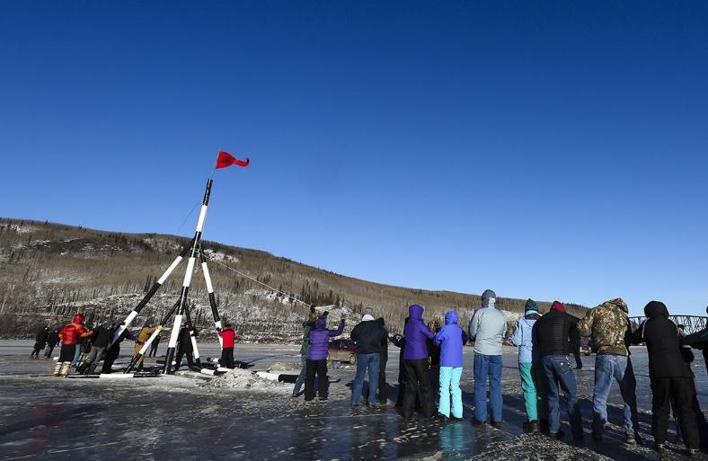
Rasing the tripod on the Nenana River, March 6, 2016
___________________________________________

Solution
- Each year has a number—the melt date in days since April 19. The year is the explanatory variable and the days since April 19 is the response variable.

- The line has equation
$Days=-0.077∙Year+166.652.$

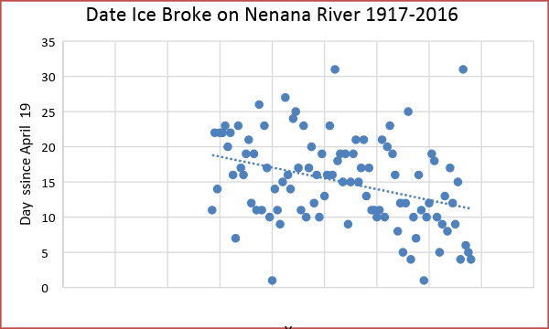

- The slope tells us that, on average, the ice breaks 0.077 days earlier each year.

- The table is as follows:
 | Coefficients | Standard Error | t Stat | P-value | Lower 95% | Upper 95%
Intercept | 166.652 | 40.498 | 4.115 | 8.1E-05 | 86.285 | 247.020
Year | -0.077 | 0.021 | -3.745 | 0.00031 | -0.118 | -0.036

- Null hypothesis is $H_{0}:Slope =0.$

Alternate hypothesis is $H_{a}:Slope ≠0.$

Test statistic is $t=-3.745.$

p-value is $p=0.00031.$

Since the $p$-value is small, we have evidence that the line does have a significant downward slope—in other words, that the melting date is moving earlier.

http://www.nenanaakiceclassic.com/
http://www.newsminer.com/news/local_news/tripod-raising-starts-the-clock-for-th-nenana-ice-classic/article_7a4d198e-e43d-11e5-8ce4-e781317b8ca3.html

