**Visual Journey in the World of Pokémon**

|  |  |
| --- | --- |
| Saurabh Loya  u1472299  [saurabh.loya@utah.edu](mailto:saurabh.loya@utah.edu) | Anushk Vijayvargiya  u1472411  [anushk.vijayvargiya@utah.edu](mailto:anushk.vijayvargiya@utah.edu) |

**Project Repository:** [Visual-Journey-in-the-World-of-Pokémon](https://github.com/dataviscourse2024/group-project-visual-journey-in-the-world-of-pokemon)

* **Background and Motivation**

The Pokémon world has captivated audiences globally for decades, featuring complex interactions between species, their attributes, and combat strategies. Our motivation for choosing this project is deeply connected with a childhood fascination with Pokémon. This Project will allow us to blend my interests by exploring Pokémon data deep within, analyzing things like power, health, and types. By providing an intuitive way to explore Pokémon stats, battle outcomes, and type effectiveness, this visualization tool will appeal to both data enthusiasts and gaming fans.

* **Related Work**

The idea for this project was inspired by various Pokémon databases and fan-made applications that offer basic data on Pokémon types and stats, such as **Pokémon Showdown, Pokemondb, pokedex** and **Bulbapedia**. Additionally, data visualizations like radar charts from Pokémon analysis sites and type-effectiveness charts have helped shape our design ideas. Additionally, we reviewed past projects from this course to understand how others have implemented visualizations. Our approach differs by aiming for an interactive, user-friendly interface that visually communicates relationships within the data.

* **Questions**

The primary questions we aim to answer with our visualization are:

1. **Can Pokémon stats be visualized in a way that is easily understandable, even for those without prior interest or knowledge?**
2. **Which Pokémon types are effective against which other types?**
3. **Which Pokémon types are the strongest in battles?**
4. **What are the evolutionary trends across different Pokémon generations?**

* **Data**

We will be utilizing three datasets sourced from Kaggle for our analysis and visualization.

1. [**The Complete Pokemon Dataset (kaggle.com)**](https://www.kaggle.com/datasets/rounakbanik/pokemon)This dataset contains the names, Poke Dex number, their generation, abilities physical stats like height and weight, their typing, their defence multiplier against each type etc.
2. [**Pokemon Images Dataset (kaggle.com)**](https://www.kaggle.com/datasets/kvpratama/pokemon-images-dataset) This dataset contains images of all Pokémon, useful for adding visuals to the project.
3. [**Pokemon Dataset with Team Combat (kaggle.com)**](https://www.kaggle.com/datasets/tuannguyenvananh/pokemon-dataset-with-team-combat)This dataset contains Battle data with IDs of two combatants and the winner which is useful for analyzing battle outcomes.

* **Exploratory Data Analysis**

In our data analysis process, we began with data preprocessing to map Pokémon to their images, verifying the existence of those images. We combined Pokémon stats from complete pokemon dataset with combat dataset to obtain stats for Pokémon involved in battles. We assessed the total number of records in our dataset, identified how many Pokémon images were missing, and counted the available combat results.

We discovered that while specific battle records are available, randomly selecting two Pokémon does not always yield a clear winner. We hope to integrate a language model to predict the winner based on stats, time permitting. If that’s not feasible, we will summarize the stats and make a decision on the winner, acknowledging that this approach may not be entirely accurate. Nonetheless, our primary goal is to provide effective visualizations.

For the analysis, we started with basic visualizations like histograms to examine the distribution of Pokémon stats such as HP, Attack, and Speed. We didn’t spend much time coding for data analysis since we had a Jupyter notebook provided with the dataset, where previous work had already covered the necessary analyses for our project. The preliminary insights confirmed that certain Pokémon types and generations have higher stat averages, which led us to focus more on type effectiveness and evolutionary trends. We also examined Pokémon stats in a scatterplot to see which combinations of stats (e.g., Defense vs. Speed) result in higher success rates.

* **Visualization Design**

To effectively display our data, we explored three alternative prototype designs for our visualization and then merged the best elements into a final design. In our design, we present a list of Pokémon in a table format, which offers an intuitive and familiar way of browsing. Pokémon stats are visualized in a histogram within the table. When a Pokémon is selected, a detailed breakdown of its stats (e.g., defense, attack), types, height, weight, and other key attributes is displayed using radar charts and box plots, focusing on special defense, special attack, defense, attack, and speed. The next section will showcase battle comparisons, followed by a type effectiveness matrix to visualize Pokémon type interactions.

Below is an overview of the three prototypes and our final design, along with the reasoning behind our choices of visual encodings.

**Prototype 1: Pokéball-Inspired Interface**

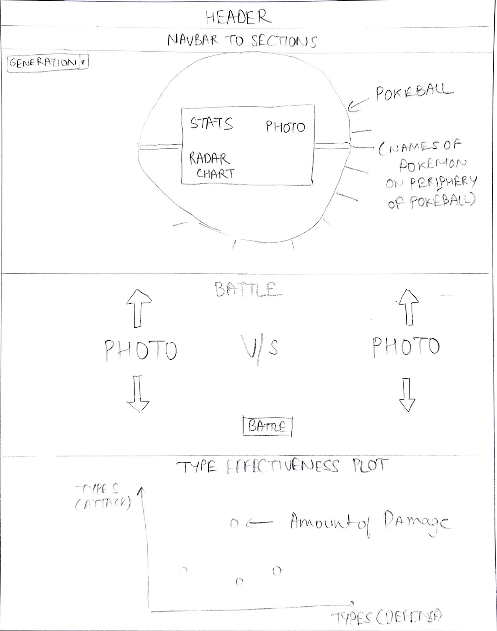

In our first prototype, we envisioned a Pokéball-themed layout where users are presented with a list of Pokémon from selected generations. Upon clicking a Pokémon’s name, an information card appears, displaying the Pokémon’s stats, photo, and a radar chart to visualize its key attributes like attack, defense, and speed. The next section of the webpage features a battle simulator. Users can cycle through Pokémon from the selected generation, view their stats, and simulate battles based on these statistics. The final section of this design incorporates a type effectiveness chart presented as a scatter plot. This visualization allows users to compare the damage output of different Pokémon types against each other and assess their overall effectiveness in battle. This design emphasizes simplicity and intuitive interaction.

**Prototype 2: Split View Layout with Filters**

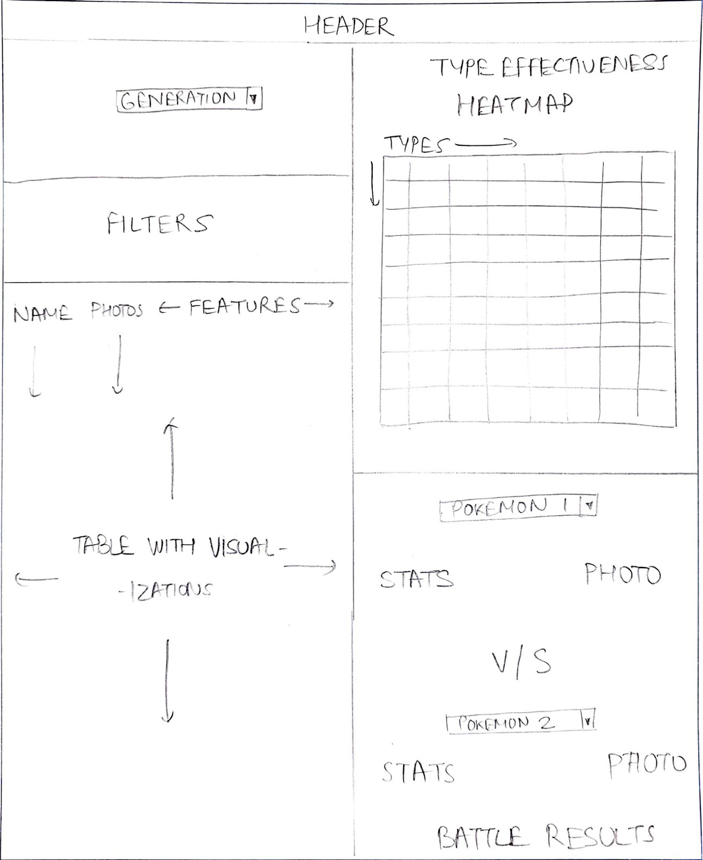

In our second prototype design, the webpage is split into two vertical halves. The left side displays a list of Pokémon, which users can filter by features like type, generation, or legendary status. The right side is divided into two parts: The upper section features a **type effectiveness heatmap**, allowing users to compare the relative strengths of Pokémon types in battle. The lower section includes a **battle simulator**, where users can select Pokémon from dropdown menus to simulate battles, with outcomes based on their stats. This design emphasizes user control over data filtering and comparisons.

**Prototype 3: Checkbox Feature Selection with Arc Diagram**

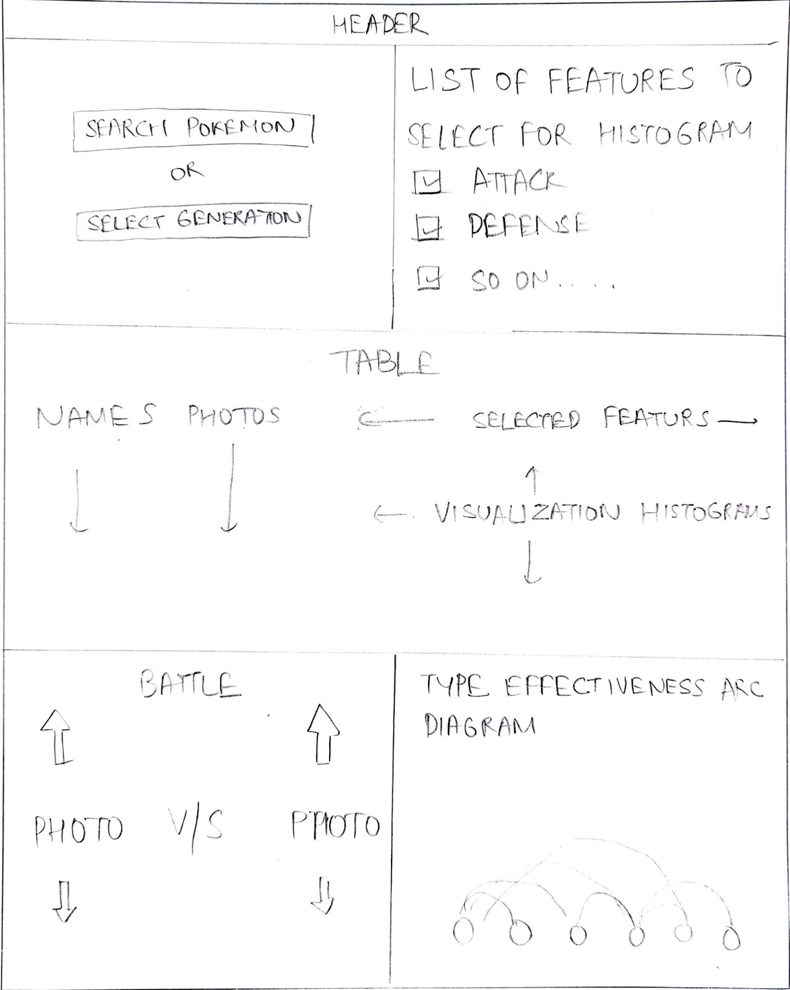

In the third prototype, users select features using checkboxes to filter a list of Pokémon and visualize selected attributes. The bottom section of the page is divided into: **Battle Simulator (left)**: Users can simulate battles between Pokémon based on their stats. **Type Effectiveness Arc Diagram (right)**: This diagram visually compares the damage output between Pokémon types, allowing users to assess which types are more effective in battle. This design emphasizes detailed comparisons and interactive features for exploring relationships between Pokémon types.

**Final Design: Interactive Pokémon Dashboard**

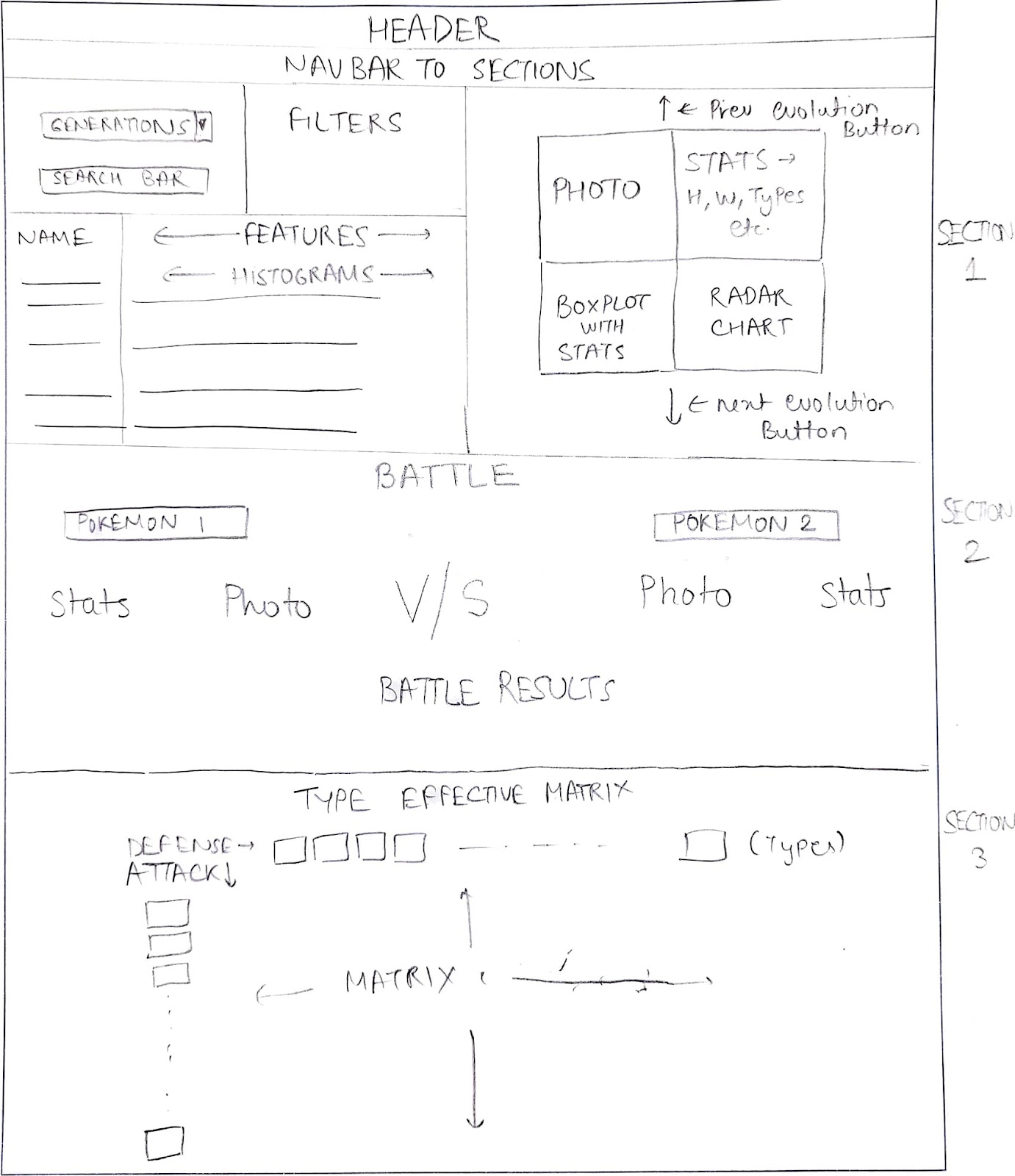

Our final design incorporates the strengths of all three prototypes, resulting in a comprehensive and interactive dashboard that balances usability with depth of information.

* **Design Evolution**

We considered many visualizations for our project but we settled on the following and we will explain why –

* **Table Data with numerical stats**: Using a table layout to list Pokémon is a natural and organized way to display large datasets. It allows for sorting, filtering, and easy lookup of specific Pokémon and their features, making it accessible for users to view at a glance
* **Radar Chart**: Ideal for comparing multiple attributes of a Pokémon (attack, defense, speed etc.) in a single view. It also creates an intuitive “shape” for each Pokémon. A major advantage of using radar chart is how it allows quick identification of balanced vs specialized Pokémon
* **Box Plot**: Provides a clear statistical summary showing where a Pokémon stands relative to the population, highlighting medians, quartiles, and outliers for key stats, making it easy to identify exceptional Pokémon
* **Battle Comparison**: A side-by-side display allows for easy comparison of two Pokémon's stats and predicted battle outcomes.

Visual Encodings –

Our visualization system employs careful consideration of visual encoding principles to enhance data comprehension and user experience. The **colour** scheme plays a vital role in differentiating various Pokémon statistics in the box plot, where each stat is assigned a distinct colour. This colour differentiation allows users to quickly identify and track specific stats across different representations. In the radar chart, we opted for a consistent blue theme with semi-transparent fills, creating a professional and clean aesthetic while maintaining readability.

We designed our visualizations to reflect the essence of the data in a way that feels natural and intuitive. The radar chart, with its circular **shape**, captures the well-rounded nature of Pokémon stats, giving each one a unique "profile" that highlights its strengths and weaknesses at a glance. For the box plot, we used simple rectangular boundaries to clearly show statistical ranges, making it easy to see how different stats stack up across the world of Pokémon.

Gestalt Principles –

We applied the principle of **proximity** by carefully grouping related elements together throughout the interface. Statistics and their corresponding values are positioned near each other. The principle of **enclosure** is effectively utilized in both our major visualizations. In the box plot, we created clear visual groupings of related statistics, helping users understand the relationships between different statistical measures.

* **Implementation**

So far, we have implemented:

1. **Section 1**: This section features a table with Pokémon stats. When a user selects a Pokémon from the table, the radar chart, photo, boxplot and infocard on the right update accordingly.

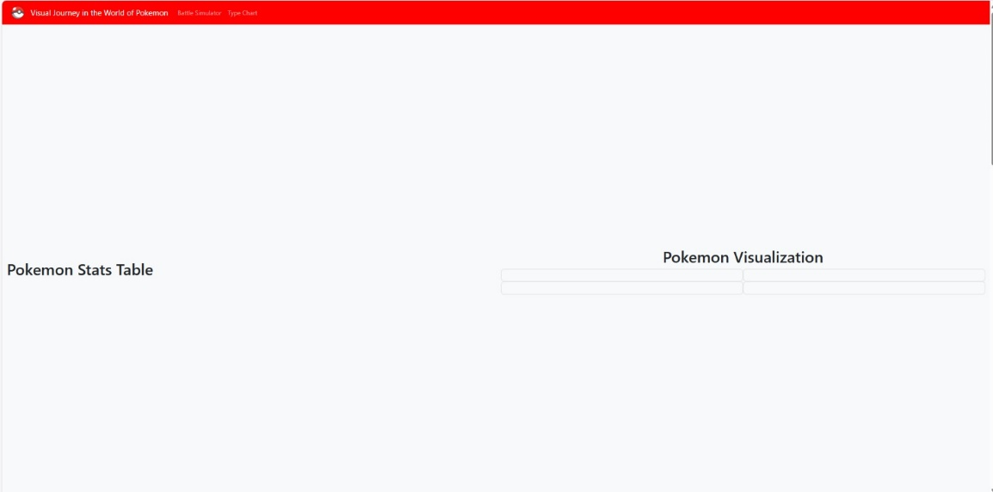

This was our initial layout for section 1 where left side will house the tabular data while right side will have our Pokémon info card with different visualizations

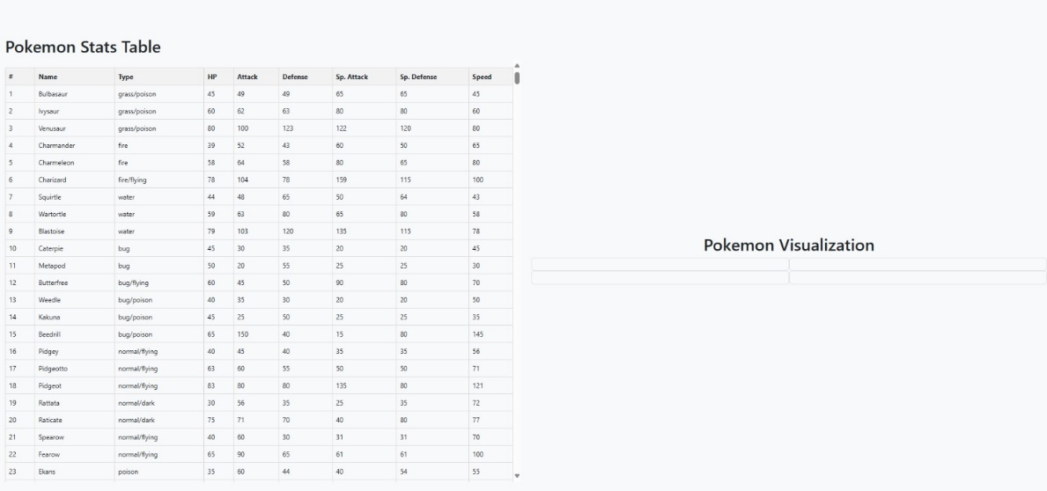

We created a JavaScript function to fetch data from our csv datasets and load it into tabular format

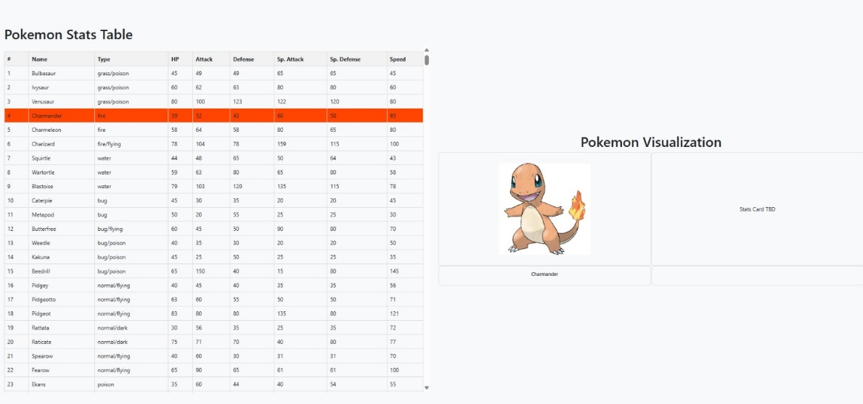

After adding the table, we added the hover effect so it’s easier for users to see the selected Pokémon. We then fetched the image data mapped to selected Pokémon

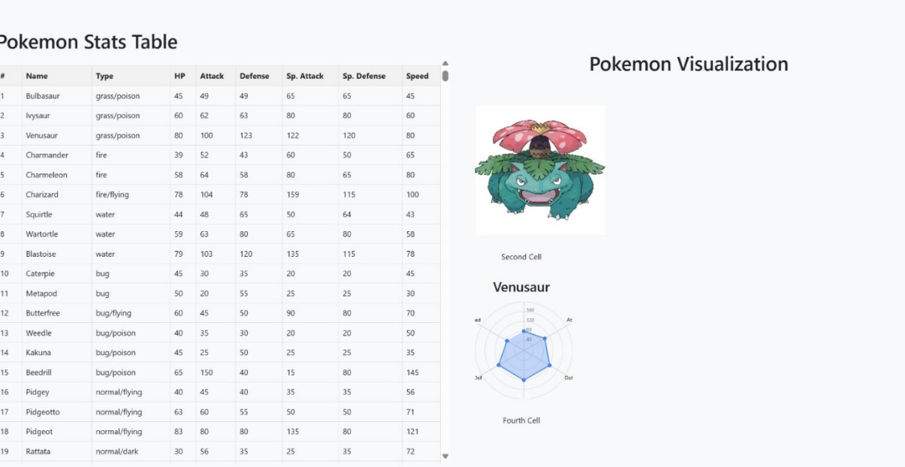

After adding images, we started to work on Radar Chart. There are some issues with aligning the labels properly but we would work on it later

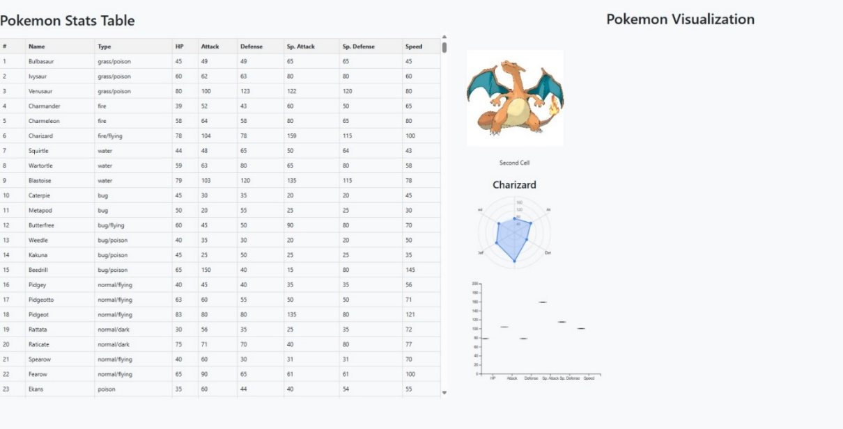

After Radar Chart, our main focus was on creating a Box Plot. This is the first attempt of creating Box Plot

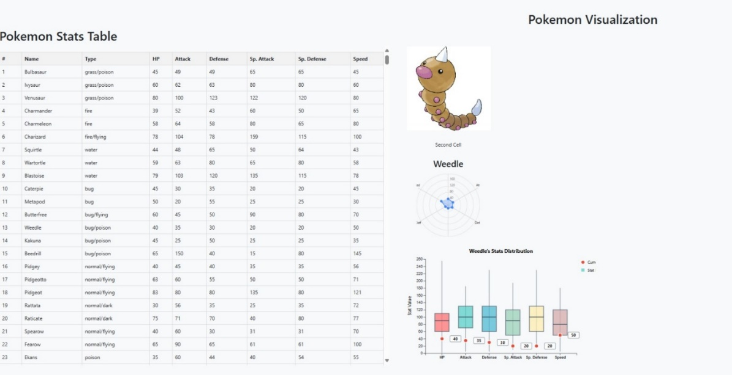

After multiple trials and errors, we were able to render a correct Box Plot

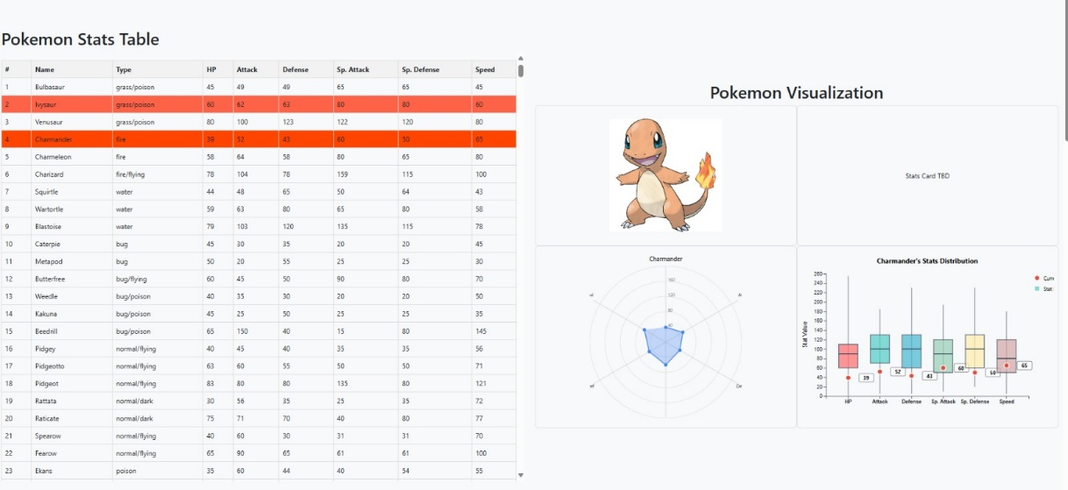

After getting the basic visualizations done, we worked on fixing the info card grid by fixing the CSS and related HTML code

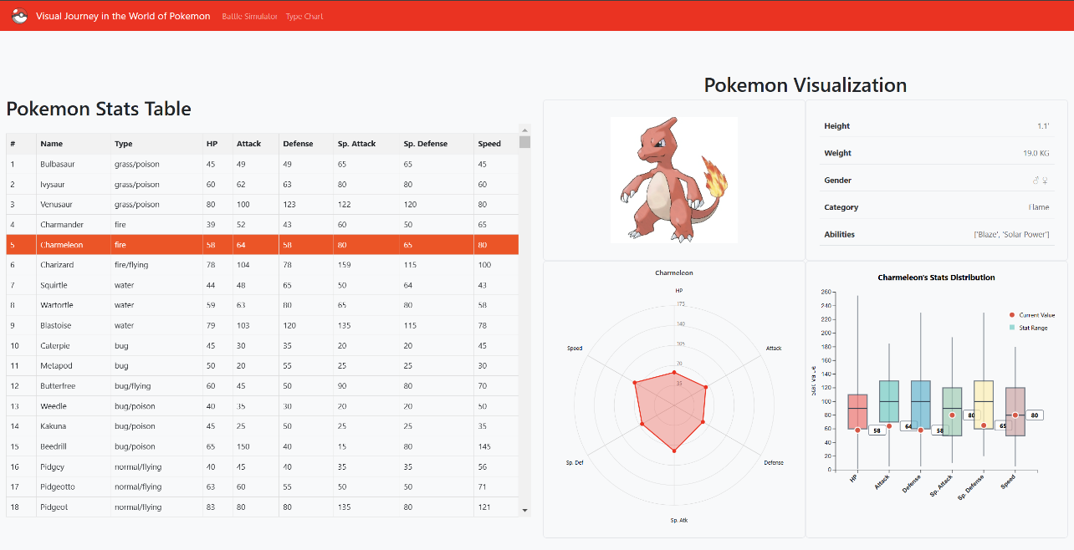

Next, we improved the alignment of the Radar Chart and Boxplots, added animations, and included an info card for each Pokémon

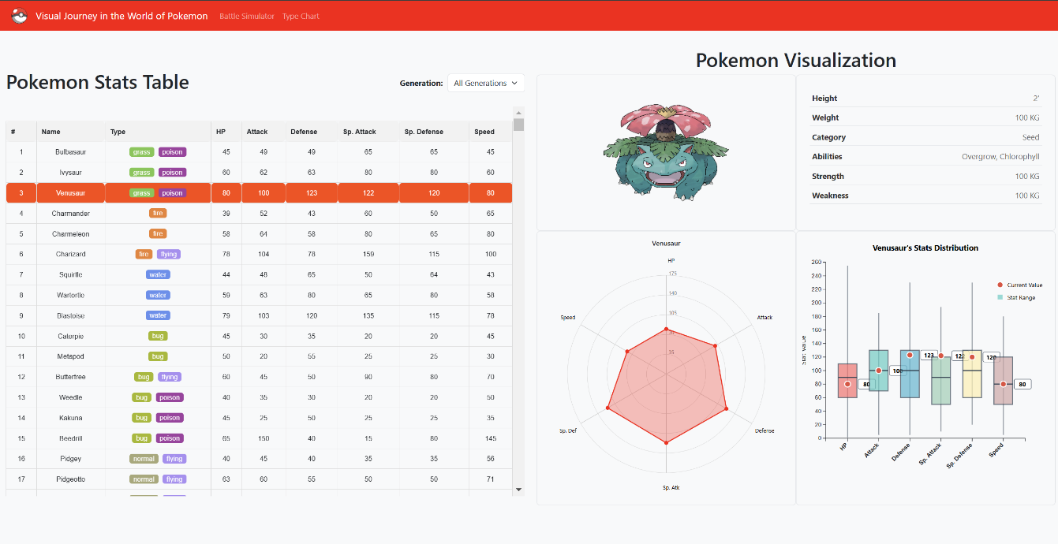

Following that, we updated the visuals to PNG images and added type icons for easier type identification and added generation dropdown

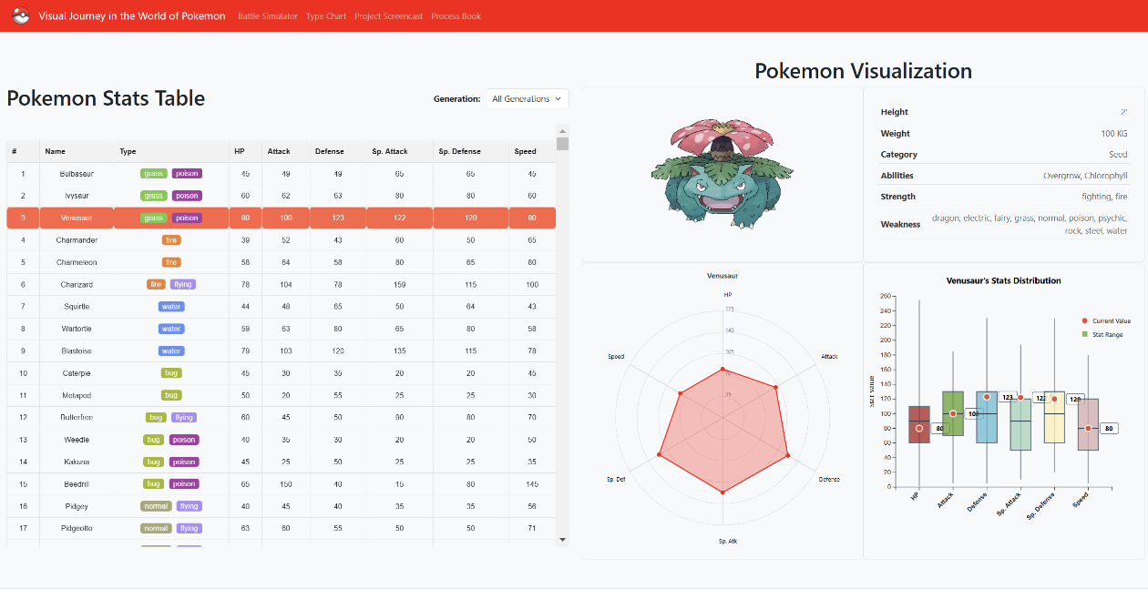

To complete Section 1, we added strengths and weaknesses to the info card and resolved alignment issues in tables and cards and added links to project screenshot video and process book

1. **Section 2 (Battle Arena)**: Users can select two Pokémon, and their stats, photos, and results of battle simulations are displayed side by side.

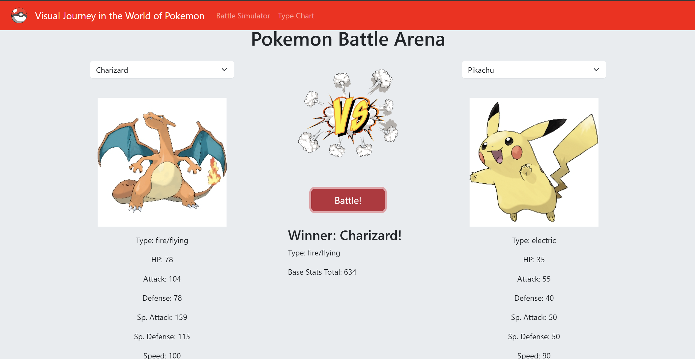

After working on section 1, we worked on section 2 to show the results of Pokémon battle

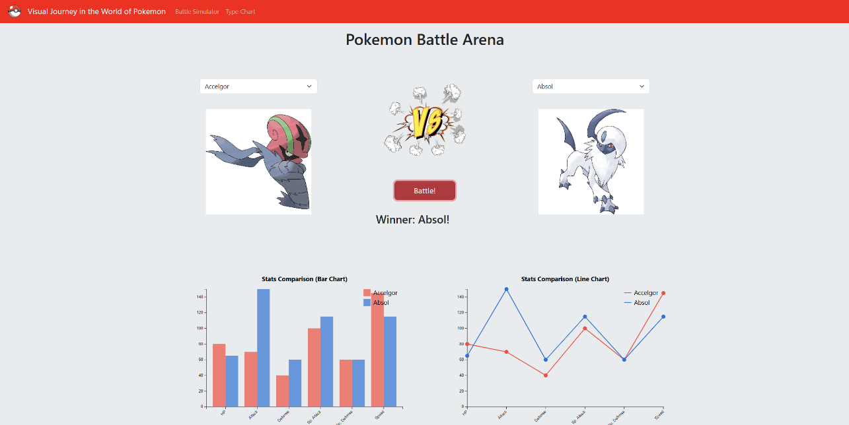

We updated the representation of textual stats to a combination of a histogram and a line chart for better intuitiveness and easier comparison of battle stats between both Pokémon

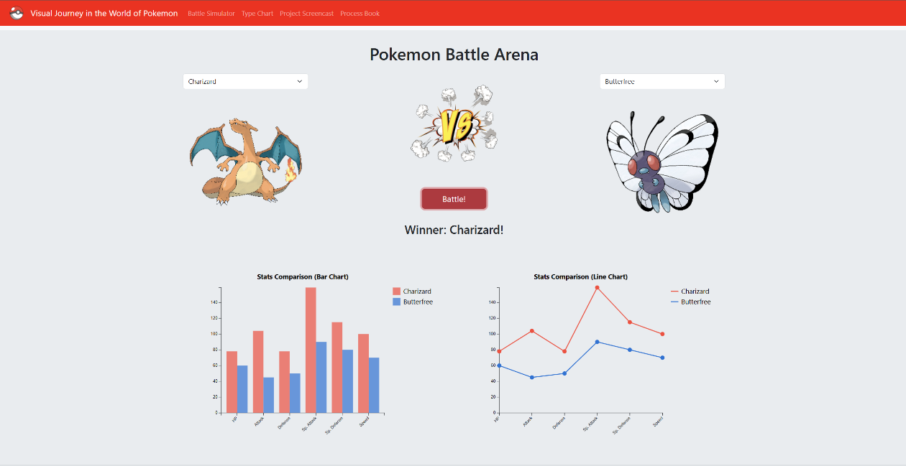

To complete Section 2, we corrected the legends for both charts and resolved minor alignment bugs

1. **Section 3 (Type-Effectiveness Matrix)**: The Type-Effectiveness Matrix provides a clear visual representation of Pokémon type interactions. Through color-coded cells and intuitive mapping, users can quickly identify advantageous and disadvantageous type matchups in battle scenarios.

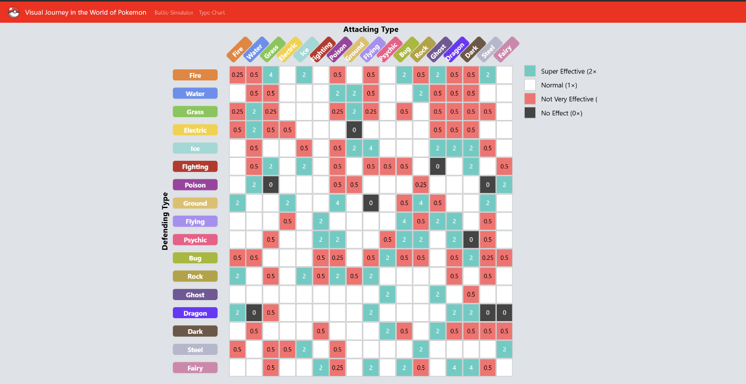

Next, we added a Type-Effectiveness Matrix to visually showcase which Pokémon types have an advantage in battle

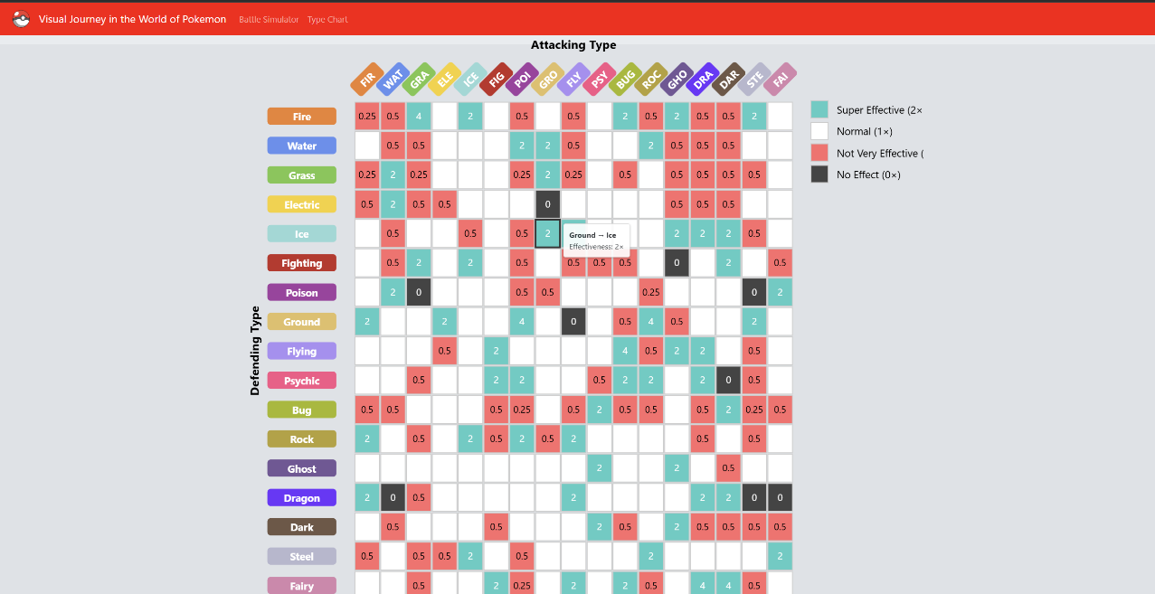

We enhanced the Type-Effectiveness Matrix with interactivity, allowing users to highlight individual cells and rows for specific type combinations and truncated x-axis labels for better clarity

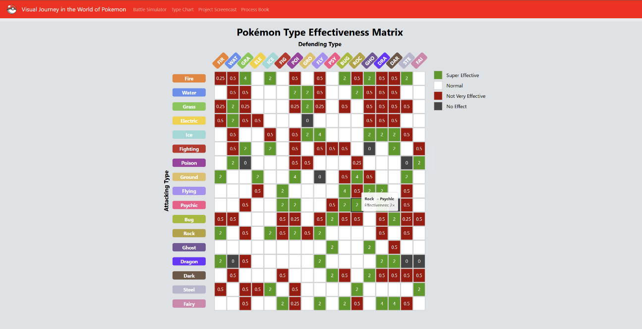

To complete Section 3, we fixed some alignment issues and updated cell colours for better clarity

* **Evaluation**

Using our visualizations, we learned a lot about the Pokémon data, especially about battle strengths, type advantages, and how stats are spread out. For example, the Type-Effectiveness Matrix showed which types are stronger in battles, and the Radar Chart and Boxplots made it easy to compare each Pokémon’s strengths and weaknesses.

We answered our main questions by using these visualizations to explain complex data in a simple way. For example, the histograms and line charts showed clear patterns, like how stats are distributed across different generations and types.

The visualizations worked well overall, but there’s still space to improve. We could make them more interactive by adding tooltips to show extra details, fix any small alignment issues, and add better ways to predict battle results. These changes would make the visualizations easier and more fun to use.