### 

### 

**Artificial Computation and Intelligence**

**Assignment 1 | Group 13**

[Problem Statement 1]

### 

### 

### 

### 

### **BITS IDs & Individual contribution percentages:**

| **S.NO** | **NAME** | **BITS ID** | **CONTRIBUTION %** |
| --- | --- | --- | --- |
| **1** | **SHRISHTI SINGH** | **2024da04293** | **100 %** |
| **2** | **MAYANK NAROTTAM SAHU** | **2024da04332** | **100 %** |
| **3** | **ADITYA RAJ GUPTA** | **2024DA04349** | **100 %** |
| **4** | **ATINDRANATH GHOSH** | **2024da04350** | **100 %** |

### **Part:1) PEAS Description**

* **Performance Measure (P)**:  
  + Maximize total value of selected items in the bag(i.e 8 for given problem).
  + Ensure total weight does not exceed 20 kg.
  + Prioritize high-value-to-weight ratio combinations.
* **Environment (E)**:  
  + Discrete, deterministic, static.
  + A finite list of items with known weight and value.
  + A 20 kg backpack constraint.
* **Actuators (A)**:  
  + Selection mechanism that picks or skips items.
  + Permutation of item selection order to simulate different packing strategies.
* **Sensors (S)**:  
  + Detects current weight and value of selected items.
  + Evaluate constraints and update pheromone trails and heuristic visibility.

### **Part:2) Ant Colony Optimization (ACO) Implementation**

To solve the 0/1 Knapsack problem, we apply the **Ant Colony Optimization (ACO)** algorithm. The approach models item selection based on **pheromone levels** (experience from past ants) and **heuristic desirability** (value-to-weight ratio). Each ant attempts to build a valid solution within the weight constraint (20 kg).

Given DataSet:

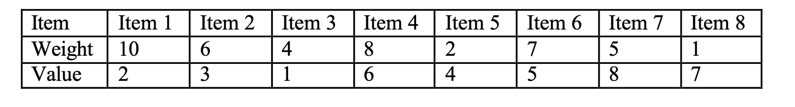

#### **Ant Colony Optimization Algorithm Design Summary:**

* **Items** are defined as (weight, value) pairs.

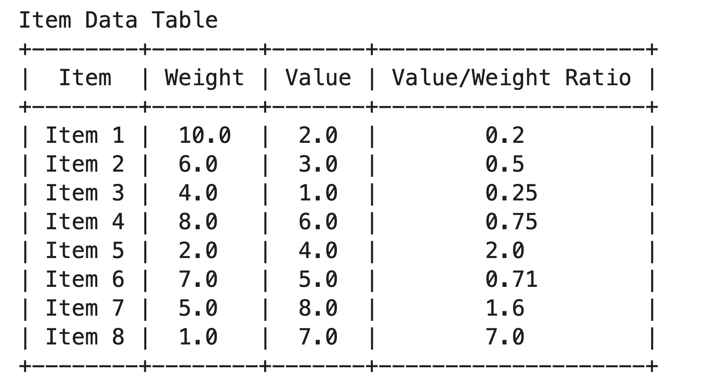

* **Heuristic** = value / weight for each item.



* At every iteration, each ant constructs a solution using:
  + **Pheromone influence** (τ) raised to the power of α

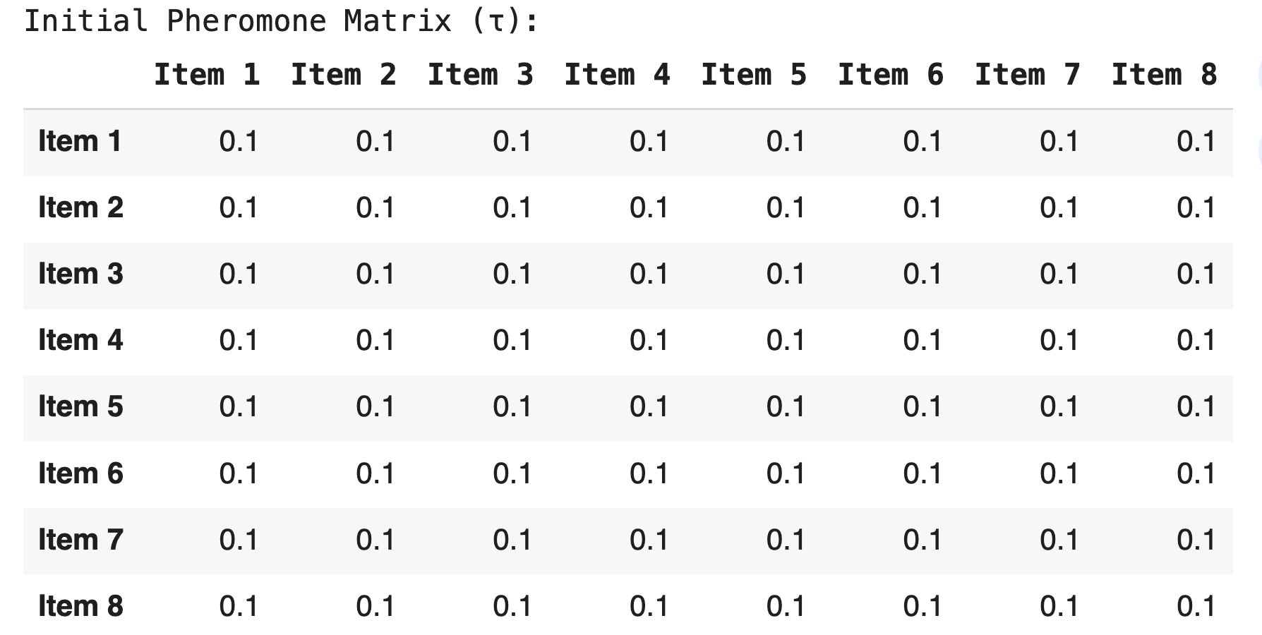

* + **Heuristic influence** (η) raised to the power of β

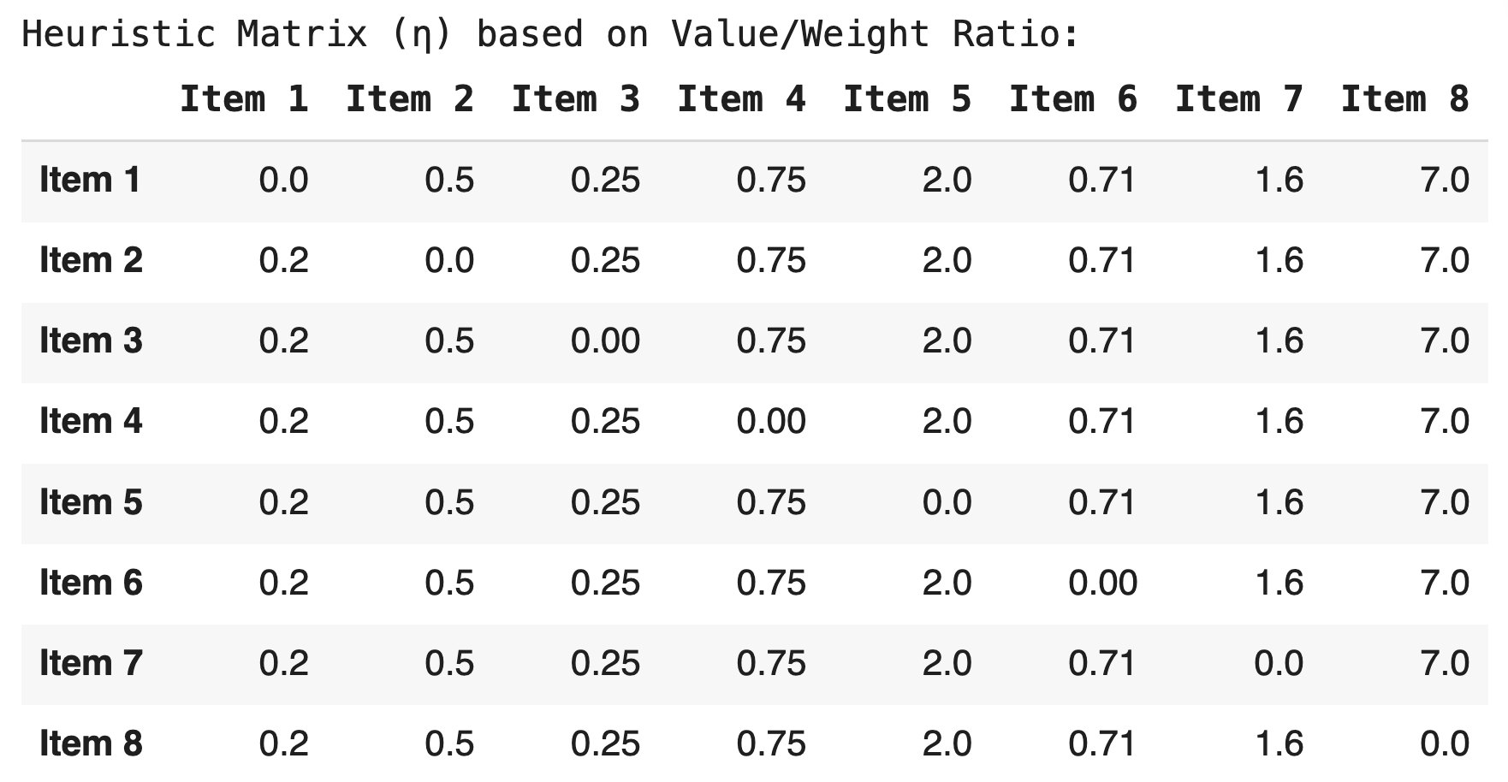

* Only items that keep total weight ≤ 20 kg are considered.

**\*\*Since our given data set does not have any item with weight more than 20, hence entire data will be considered.**



#### **Scenario 1**

**Given Parameters:**

* Number of Ants: **3**
* Alpha (pheromone influence): **0.5**
* Beta (heuristic influence): **3**
* Iterations: **10**

**Output:**

1. **Final Selected Items and Corresponding Value**

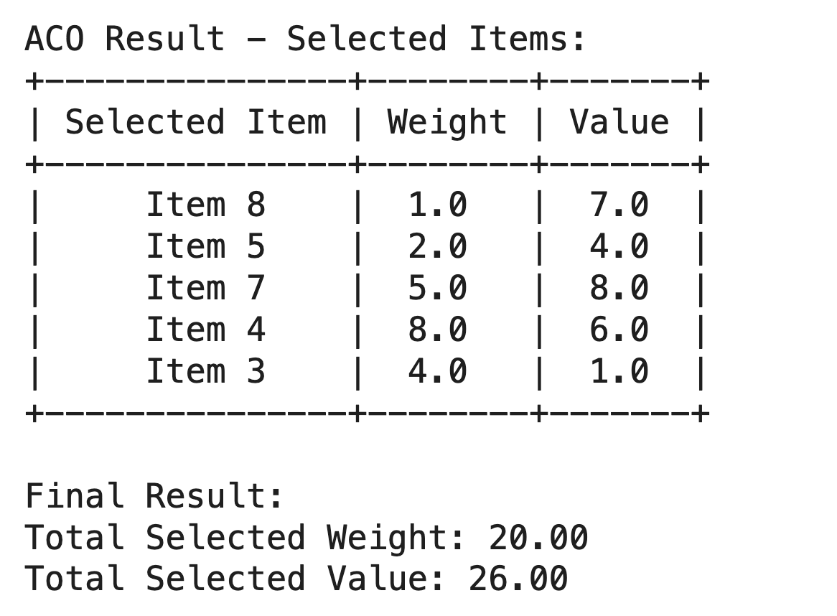

1. **Final Pheromones Value**

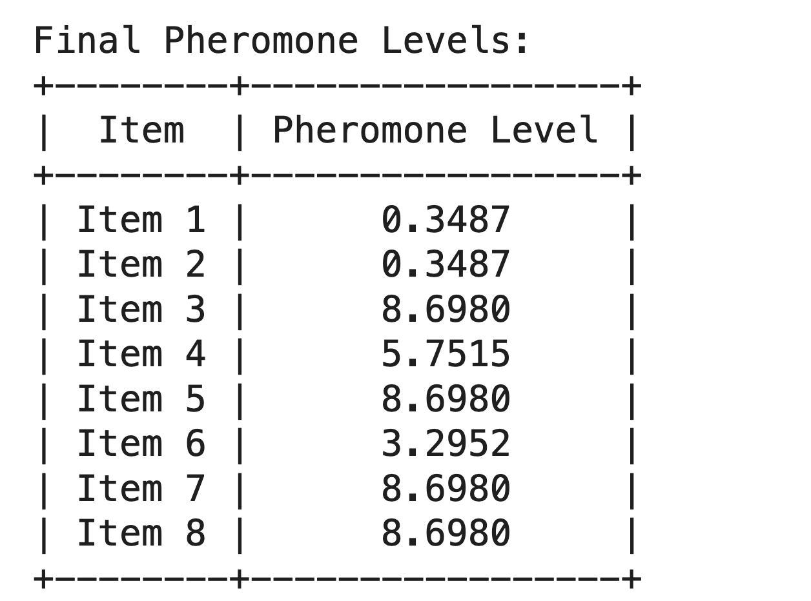

#### **Scenario 2**

**Given Parameters:**

* Number of Ants: **5**
* Alpha (pheromone influence): **0.5**
* Beta (heuristic influence): **7**
* Iterations: **10**

**Output:**

1. **Final Selected Items and Corresponding Value**: **Final**

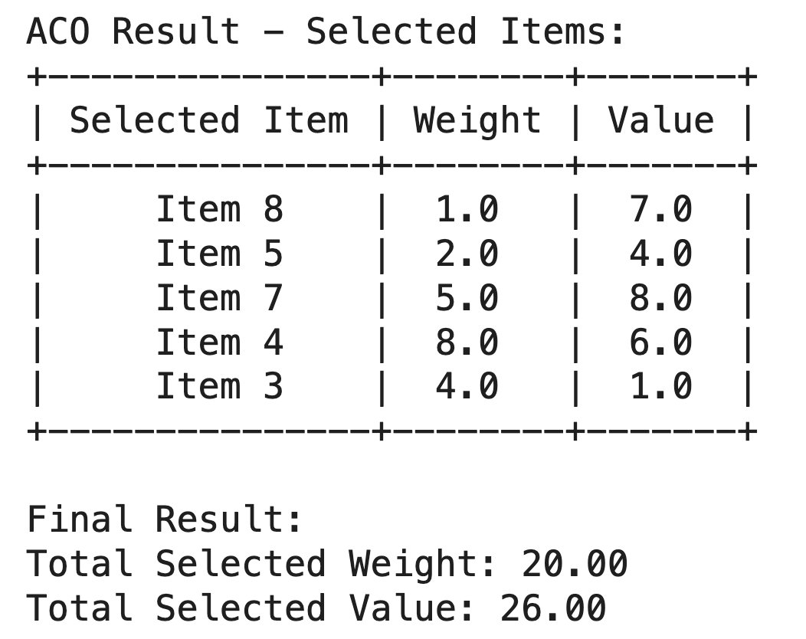

1. **Final Pheromones:**

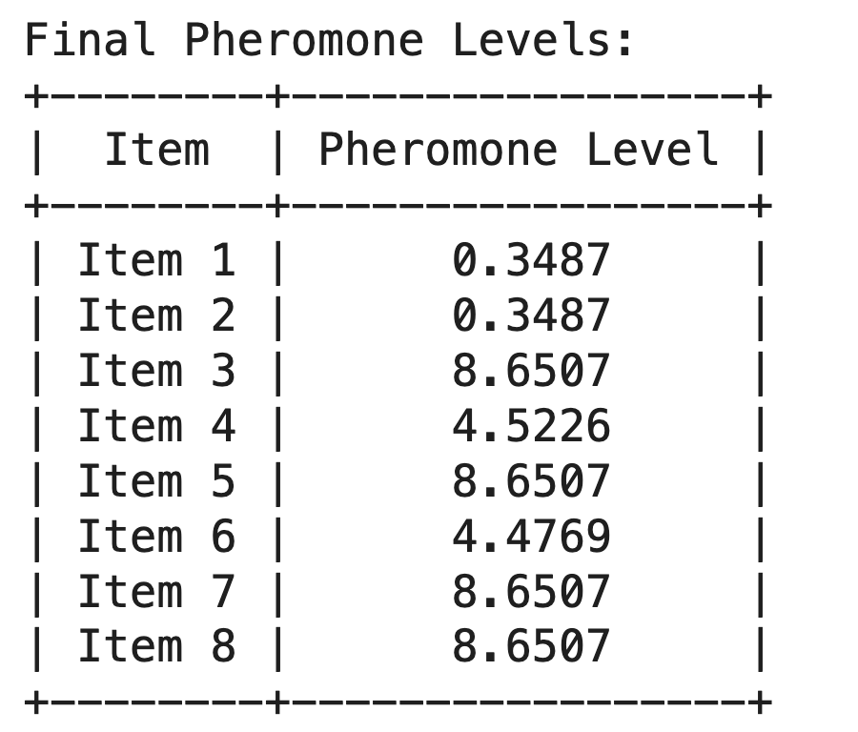

#### **OBSERVATIONS**

**Given Parameters**:

The Ant Colony Optimization (ACO) algorithm was executed in two independent scenarios to solve the 0/1 knapsack problem. The objective was to maximize the total value of items packed into a knapsack with a strict 20kg weight capacity. The following analysis details the outcomes and offers an interpretation of the algorithm's performance.

| **Parameter** | **Scenario 1** | **Scenario 2** |
| --- | --- | --- |
| Ants | 3 | 5 |
| α (pheromone) | 0.5 | 0.5 |
| β (heuristic) | 3 | 7 |
| Iterations | 10 | 10 |

**Final Result Summary:**

| **Metric** | **Scenario 1** | **Scenario 2** |
| --- | --- | --- |
| Selected Items | 8,5,7,4,3 | 8,5,7,4,3 |
| Total Weight | 1+2+5+8+4 = 20 | 1+2+5+8+4 = 20 |
| Total Value | 7+4+8+6+1 = 26 | 7+4+8+6+1 = 26 |
| Pheromone Patterns | Stronger on items 3, 4, 5, 7, 8 | Stronger on 3, 4, 5, 7, 8, but diluted |

**Interpretation & Comparison:**

In both Scenario 1 and Scenario 2, the algorithm converged on the exact same combination of items: **Items 8, 7, 5, 4, and 3**. This resulted in a total value of **26.0** and a total weight of **20.0 kg**. The convergence to an identical optimal solution across independent runs demonstrates the algorithm's **robustness and reliability**, suggesting the result is likely the global optimum.

#### **Solution Efficiency**

A key outcome in both scenarios was the perfect utilization of the knapsack's capacity. The final weight of 20.0 kg meant that **100% of the capacity was used**, leaving no wasted space. This indicates that the algorithm found a highly efficient packing solution.

#### **Core Item Pheromones**

Across both runs, a "core" set of items—**Items 3, 5, 7, and 8**—consistently showed high and stable pheromone levels. This demonstrates that the algorithm was able to quickly and consistently identify the most valuable components of the optimal solution, indicating a strong and rapid convergence.

#### **Contested Item Pheromones**

The primary difference between the scenarios was observed in the pheromone levels of the remaining items.

* In **Scenario 1**, the choice was clear: Item 4 had a much higher pheromone level (5.75) than Item 6 (3.29).
* In **Scenario 2**, the choice was more contested: Item 4's level (4.52) was only slightly higher than Item 6's (4.47).

This reveals that the two runs explored different search paths. Scenario 2 involved a stronger "competition" from Item 6, indicating a more varied exploration of the solution space before the algorithm ultimately settled on the optimal choice (Item 4).

#### **Algorithm Behavior**

The difference in pheromone trails highlights the inherent **stochastic nature of ACO**. Scenario 1 showed a more direct, deterministic-like convergence on the best choice. In contrast, Scenario 2 involved a more stochastic exploration of "good" versus "best" choices. This proves that while the path may differ between runs, the algorithm's guiding mechanism successfully ensures convergence to a high-quality result.

#### **Overall Outcome**

Both scenarios were **successful**. Scenario 1 found the optimal solution with clear and decisive pheromone reinforcement. Scenario 2 validated this same optimal solution while also demonstrating the algorithm's ability to navigate a more complex and competitive search path.

In summary, the results from both scenarios conclusively demonstrate the effectiveness of the Ant Colony Optimization algorithm for this problem. The convergence on an identical, highly efficient solution underscores the robustness of the approach. Furthermore, the subtle variations in the final pheromone trails provide valuable insight into the stochastic yet powerful nature of the metaheuristic search, confirming its suitability for complex optimization tasks.