NIGERIAN HEALTHCARE DATA ANALYTICS PROJECT
Data Cleaning, SQL Analysis, and Interactive Dashboard Development
Prepared by: Data Analyst | Public Health
Tools: MySQL Workbench, SQL, Microsoft Excel, and Power BI
Dataset: Synthetic Healthcare Dataset

- DATABASE CREATION
Objective
To create a dedicated MySQL database for storing, cleaning, and analyzing healthcare records.
CREATE DATABASE nigerian_healthcare_db;
Explanation
The CREATE DATABASE statement creates a new database named nigerian_healthcare_db. This database will serve as the foundation for the healthcare analytics project.

Database Selection
USE nigerian_healthcare_db;
The USE statement selects the database so that subsequent SQL commands run within it.

Data Import and Validation
The raw healthcare dataset was imported from a CSV file into Microsoft SQL Server using SQL Server Management Studio (SSMS).
The imported data was stored in the dbo.hospital_records_raw table within the HealthcareDB database.
To validate the import, the SQL COUNT(*) function was used to determine the total number of records stored in the table.
SQL Query
USE HealthcareDB;
GO

SELECT COUNT(*) AS Total_Records
FROM dbo.hospital_records_raw;
Result: 5,000 records successfully imported.
Validation: The record count confirmed that the expected 5,000 records were present in the destination table.
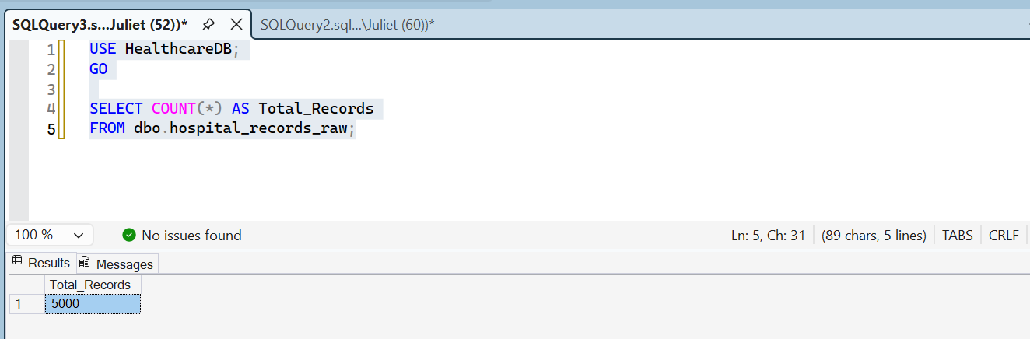

Initial Data Quality Assessment
An initial assessment was performed on the 5,000-record healthcare dataset using SQL Server Management Studio.
The assessment identified missing values in several important fields, including patient names, ages, genders, diagnoses, and treatment costs.
Column | Missing Values
Patient_Name | 133
Age | 1,220
Gender | 809
Diagnosis | 404
Treatment_Cost_NGN | 1,293
No missing values were detected in the Visit_ID and Patient_ID columns during this assessment.
These findings indicate that data cleaning and validation are necessary before conducting further analysis. The missing values will be investigated and handled according to the nature of each field and the analytical requirements.
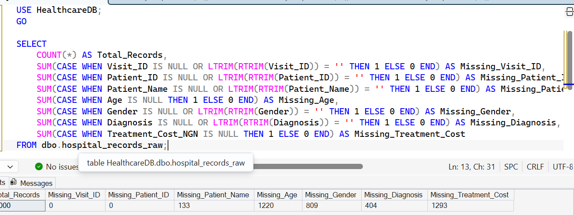

Duplicate Visit ID Assessment
A duplicate identification query was performed on the healthcare dataset using SQL Server Management Studio.
The query identified 12 visit IDs that appeared more than once in the raw dataset. Each of the identified visit IDs appeared twice.
This finding indicates potential duplicate records that require further investigation. Before removing any records, the associated rows must be compared to determine whether they are exact duplicates or represent different information associated with the same visit ID.
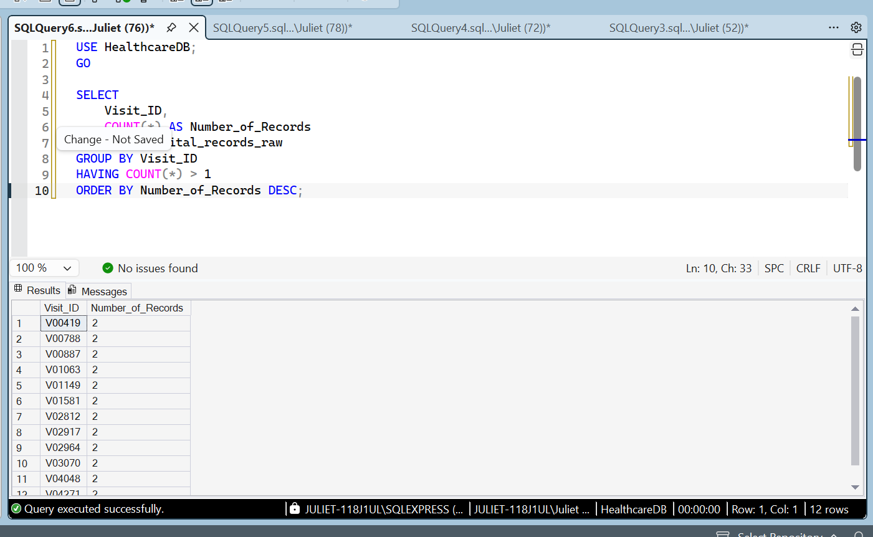
Duplicate Records and Data Quality Findings
A duplicate identification query was performed on the 5,000-record healthcare dataset using SQL Server Management Studio.
The query identified 12 Visit_ID values that appeared more than once, producing 24 rows associated with those repeated identifiers.
Further inspection revealed potential data quality issues, including missing discharge dates, missing patient types, invalid age values, and inconsistent diagnosis labels.
These findings indicate that the dataset requires additional validation and cleaning before it can be used for reliable analysis.
Duplicate records will be verified across all columns before removal to avoid accidentally deleting legitimate healthcare records.

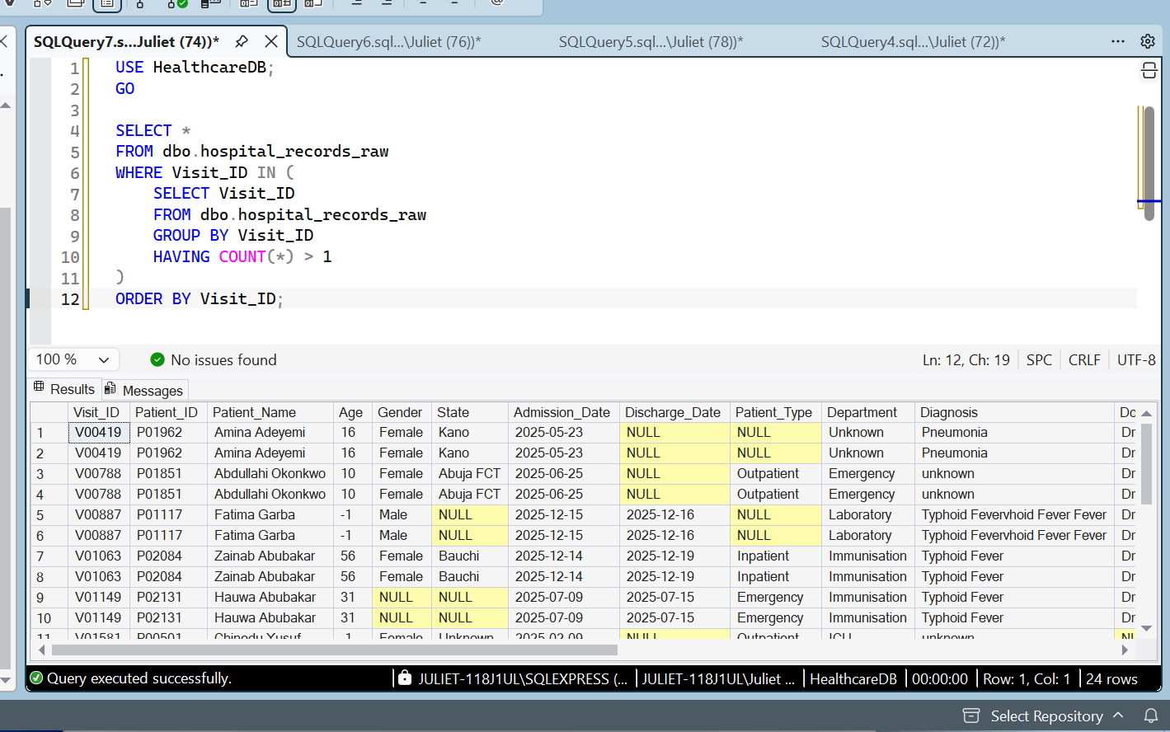

Age Data Quality Assessment
A SQL query was used to identify age values outside the initial validation range of 0 to 120 years.
The query returned 1,263 records with ages below zero or above 120. The visible results included multiple records with an age of -1.
These values require further investigation because invalid ages can affect patient demographic summaries and age-group analysis.
A separate count of negative ages, ages above 120, and missing ages will be used to document the issue accurately before cleaning begins.

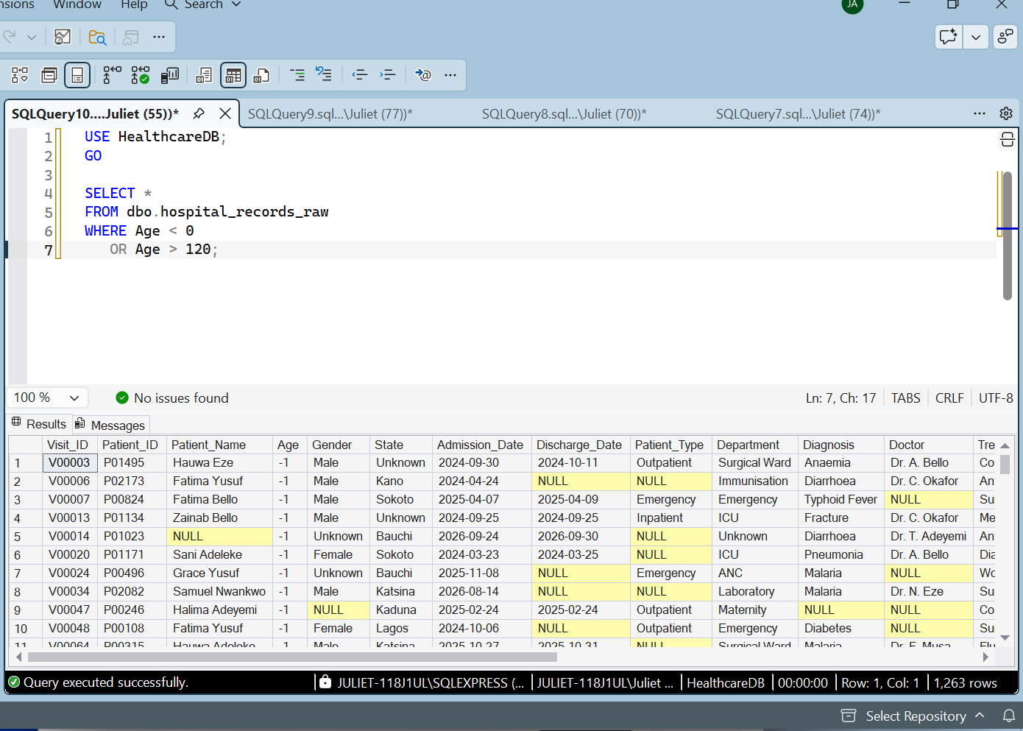

Diagnosis Data Quality Assessment
A SQL query was used to examine the distribution of diagnosis values in the raw healthcare dataset.
The assessment identified 404 records with missing diagnoses, 386 records labelled "unknown", and 400 records containing the inconsistent diagnosis label "Typhoid Fevervhoid Fever Fever".
These findings indicate that the diagnosis field requires cleaning and standardization. Missing and unknown diagnoses will be handled separately from confirmed diagnosis values. Inconsistent labels will be investigated before correction to avoid introducing inaccurate medical information.
The original raw dataset will be preserved to maintain data traceability throughout the cleaning process.
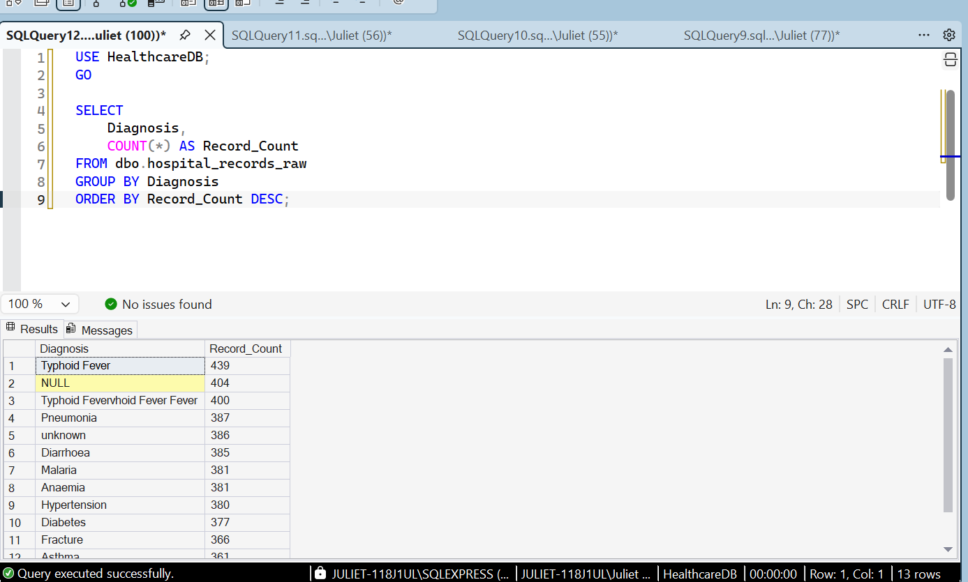

Gender Data Quality Assessment
A SQL query was used to examine the distribution of gender values in the raw healthcare dataset.
The assessment identified 1,706 records labelled Male, 1,657 labelled Female, 828 labelled Unknown, and 809 records with missing gender values.
The findings indicate that 1,637 records have either an Unknown or missing gender value. These records require appropriate handling during data cleaning. Unknown and missing values will be preserved as distinct categories unless further information justifies a change.
No assumptions will be made about patients' gender when the information is unavailable.

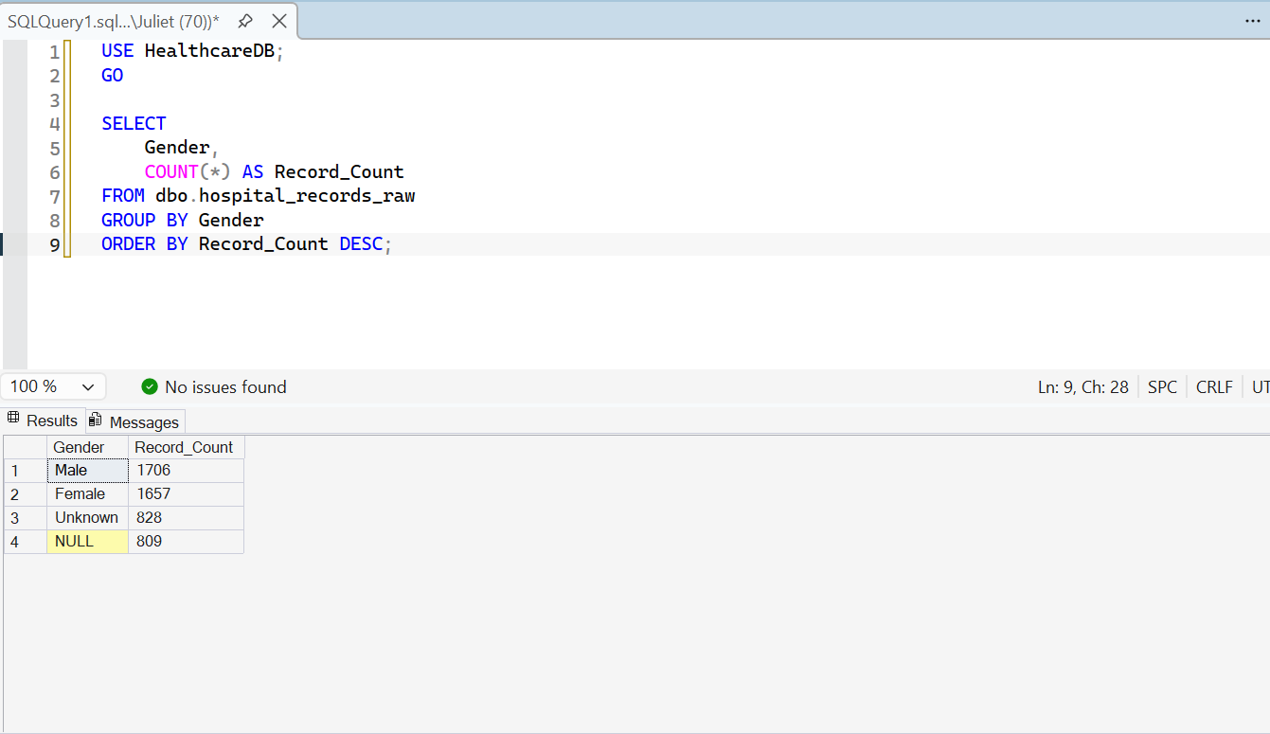

Geographical Data Quality Assessment
A SQL query was used to examine the distribution of patient records by state in the raw healthcare dataset.
The assessment identified 423 records with missing state values and 379 records labelled "Unknown", giving a total of 802 records without specified geographical information.
These findings indicate that the State field requires attention during data cleaning. Missing and unknown values will be preserved as distinct categories unless reliable information is available to correct them.
This assessment uses a synthetic healthcare dataset created for portfolio development and does not represent official Nigerian healthcare statistics.

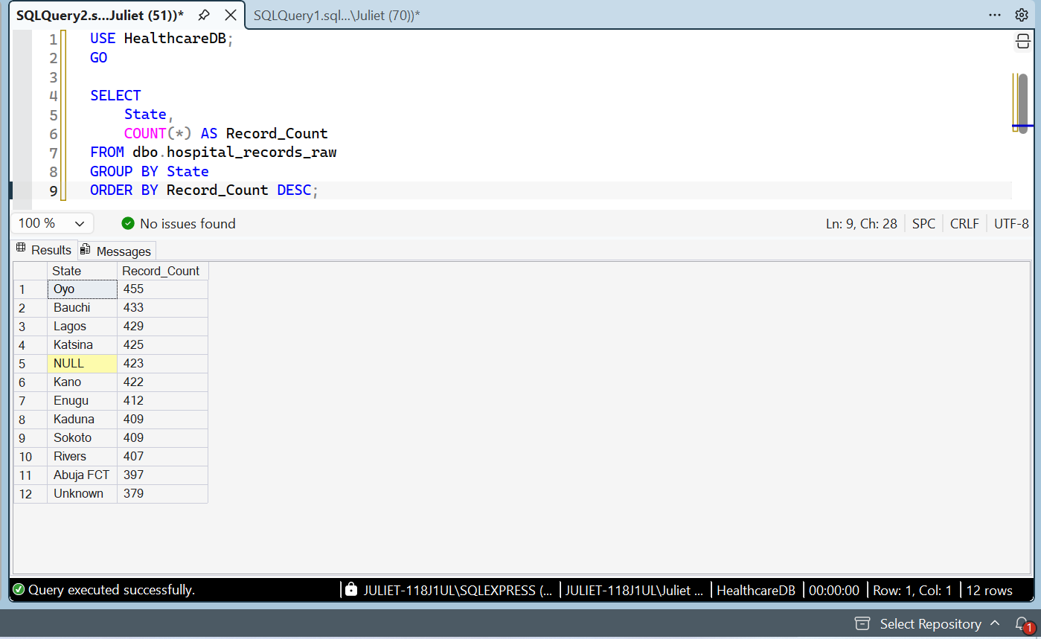

Discharge Date Data Quality Assessment
A SQL query was used to assess the completeness of the Discharge_Date field in the raw healthcare dataset.
The dataset contains 5,000 records, of which 1,338 have missing discharge dates, representing 26.76% of all records.
These missing values may affect calculations of length of stay and analyses involving patient discharge dates. The affected records will be investigated before cleaning. Missing dates will not be filled with assumed values without reliable supporting information.
The original raw dataset will be preserved to maintain data integrity throughout the cleaning process.

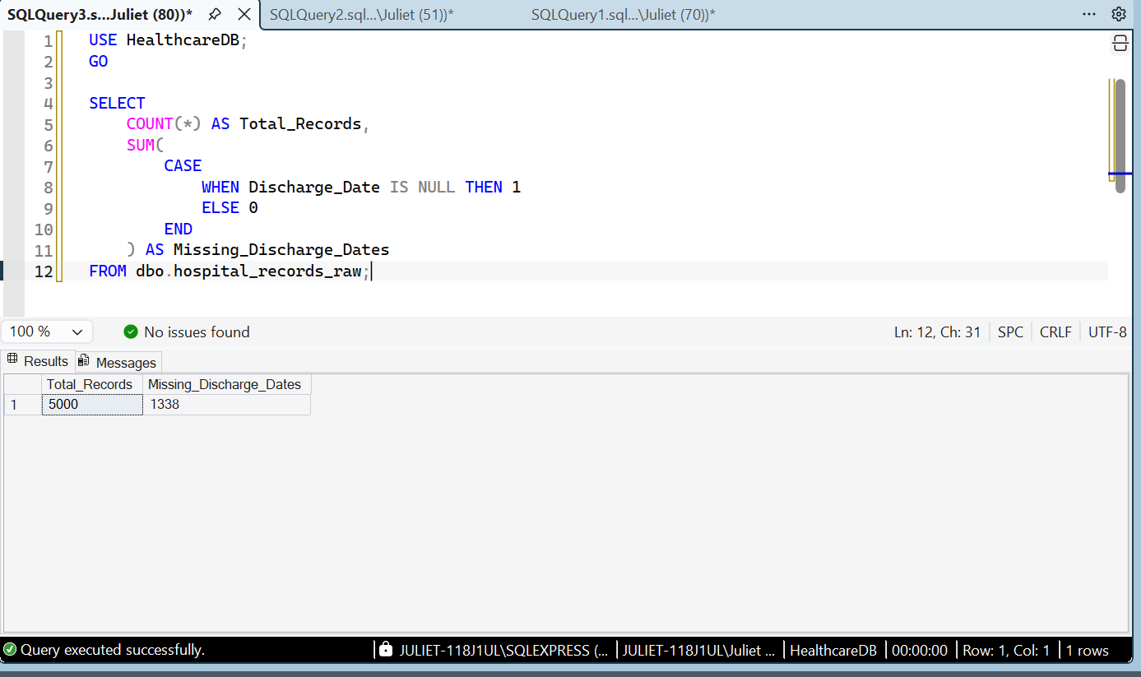

Diagnosis Label Standardization
The diagnosis field was standardized using SQL Server Management Studio.
First, 400 records containing the inconsistent label "Typhoid Fevervhoid Fever Fever" were standardized to "Typhoid Fever". Subsequently, 386 records labelled "unknown" were standardized to "Unknown".
These changes improved consistency in the diagnosis field while preserving missing diagnosis values for separate handling. All updates were applied to the cleaned table, leaving the original raw dataset unchanged.

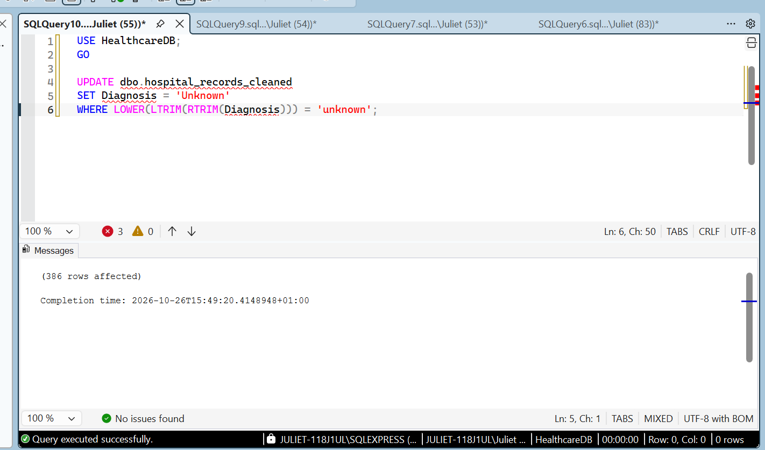

Gender Data Cleaning
The gender field was standardized using SQL Server Management Studio (SSMS). A total of 828 records containing the label "unknown" were updated to "Unknown" to ensure consistent capitalization.
Missing gender values (NULL) were preserved separately rather than being assigned an assumed gender.
This cleaning step improved consistency in the gender field and prepared it for subsequent analysis and visualization.
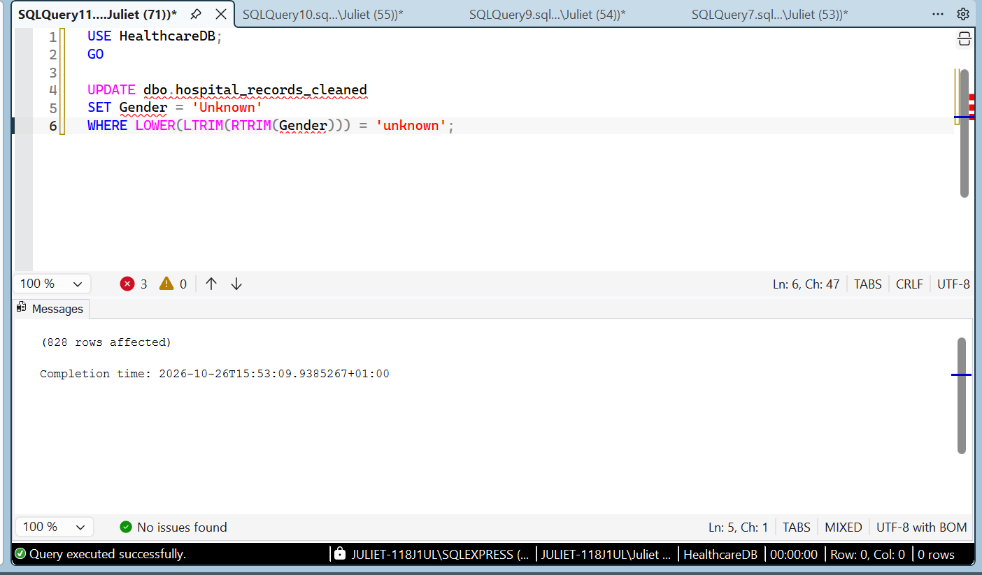

State Data Cleaning
The State field was standardized using SQL Server Management Studio (SSMS). A total of 379 records containing the label "unknown" were updated to "Unknown" to ensure consistent capitalization.
Missing state values (NULL) were preserved separately because no reliable information was available to determine the correct state.
This step improved consistency in the geographical field and prepared it for further analysis.
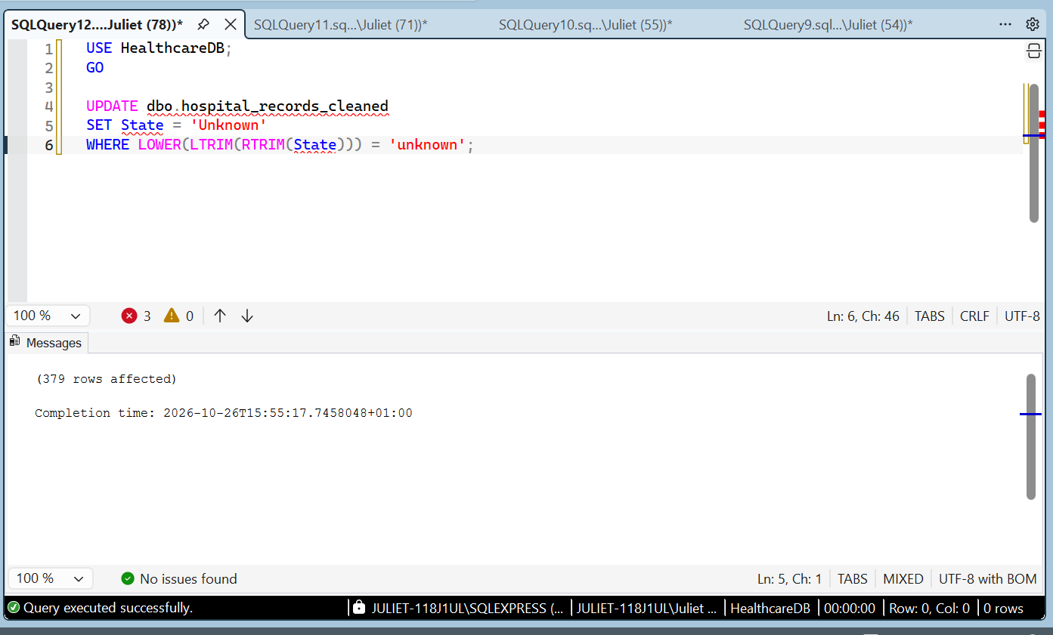

Duplicate Visit ID Assessment
A SQL query using GROUP BY and HAVING COUNT(*) > 1 was used to identify repeated visit identifiers in the cleaned healthcare dataset.
The assessment identified 12 Visit_ID values that each appeared twice.
Repeated identifiers do not automatically indicate exact duplicate records. Further inspection is required to determine whether the records contain identical information or differ in other fields.
No records were deleted during this assessment.

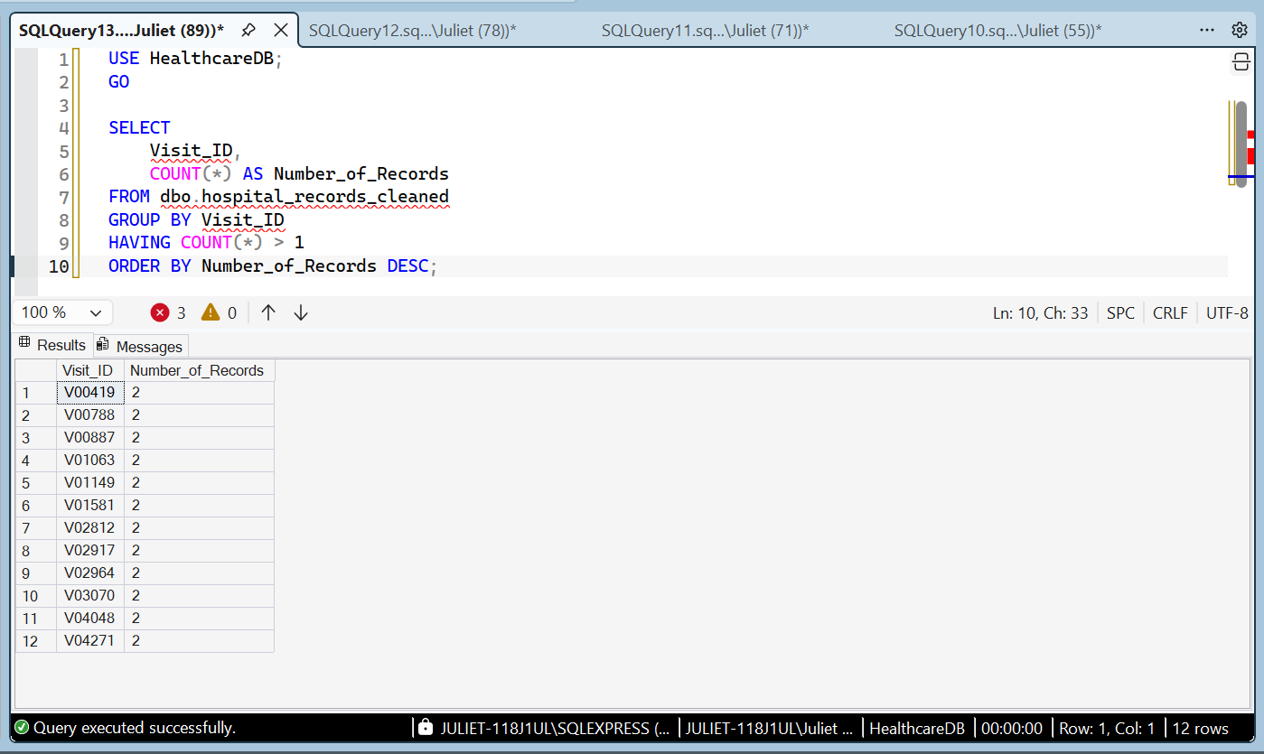

Treatment Cost Data Cleaning
An SQL validation query identified 1,211 records containing negative treatment costs. These values were treated as invalid and replaced with NULL in the cleaned dataset because a valid replacement amount could not be established from the available information.
The original raw table was preserved. A verification query was used to confirm that no negative treatment costs remained in the cleaned table.

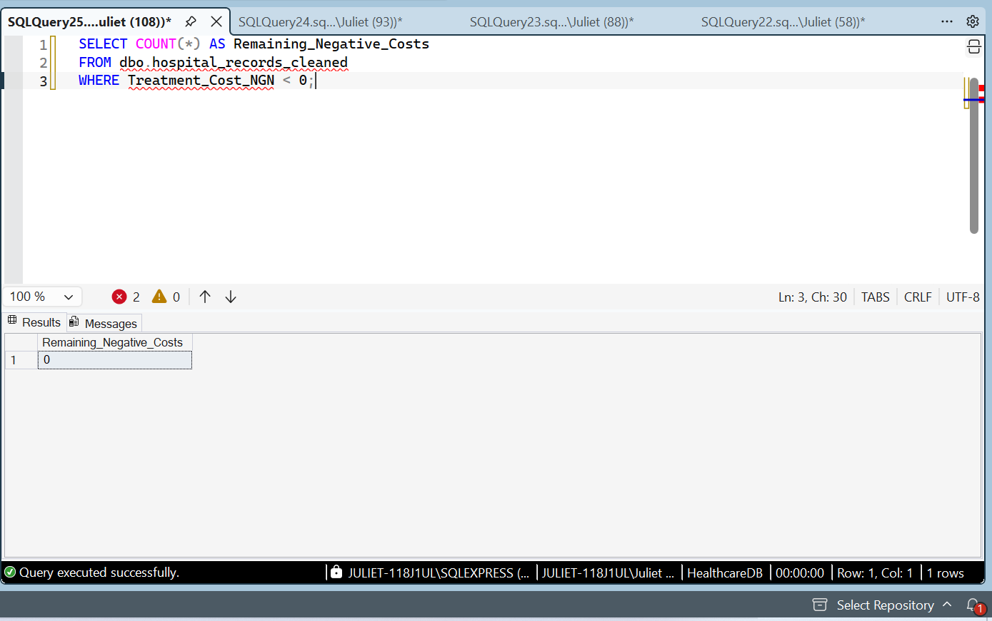

Gender Data Cleaning
The gender column was examined for missing values and inconsistent entries. Missing or blank gender values were replaced with “Unknown” to maintain data integrity without making assumptions about patients' gender.
After cleaning, the dataset contained 1,706 Male records, 1,657 Female records, and 1,637 Unknown records, giving a total of 5,000 records.
The results were verified using an SQL query that grouped the records by gender and counted the number of records in each category.

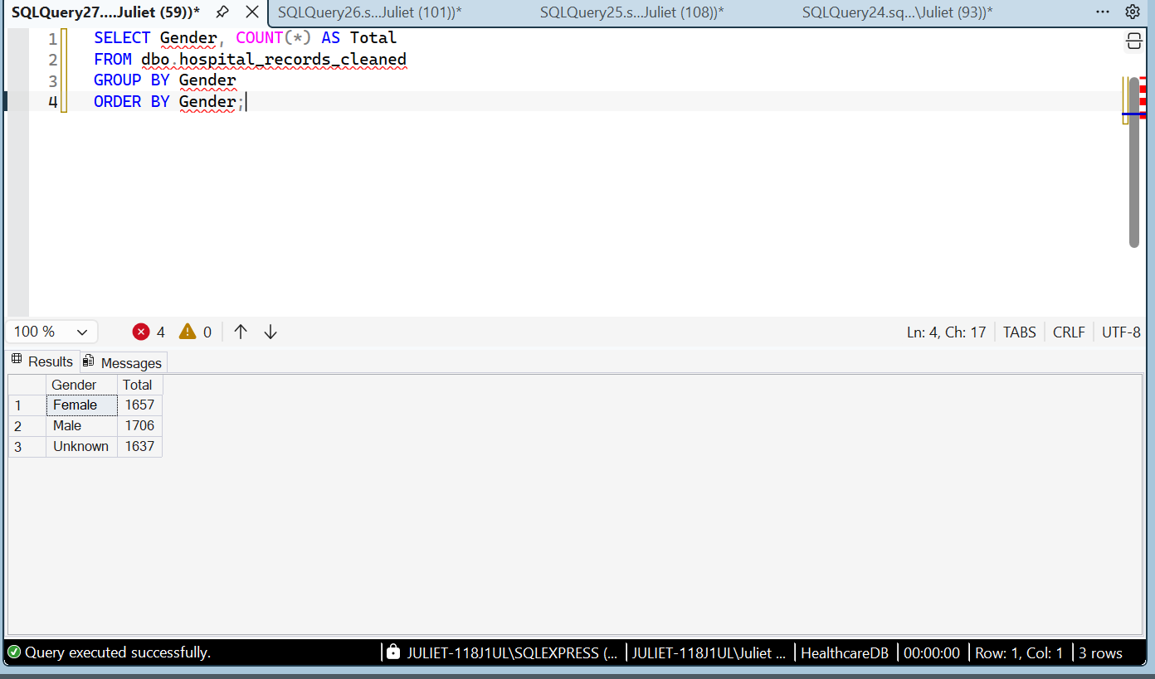

Payment Method Data Cleaning
The payment method column was assessed for missing and inconsistent values. The initial assessment identified 692 records with missing payment methods and 734 records labelled “unknown” in lowercase.
Missing values and inconsistent “unknown” entries were standardized to “Unknown” in the cleaned dataset. This preserved the records without making assumptions about the payment method used.
The results were verified using an SQL query that grouped records by payment method and counted the number of records in each category.

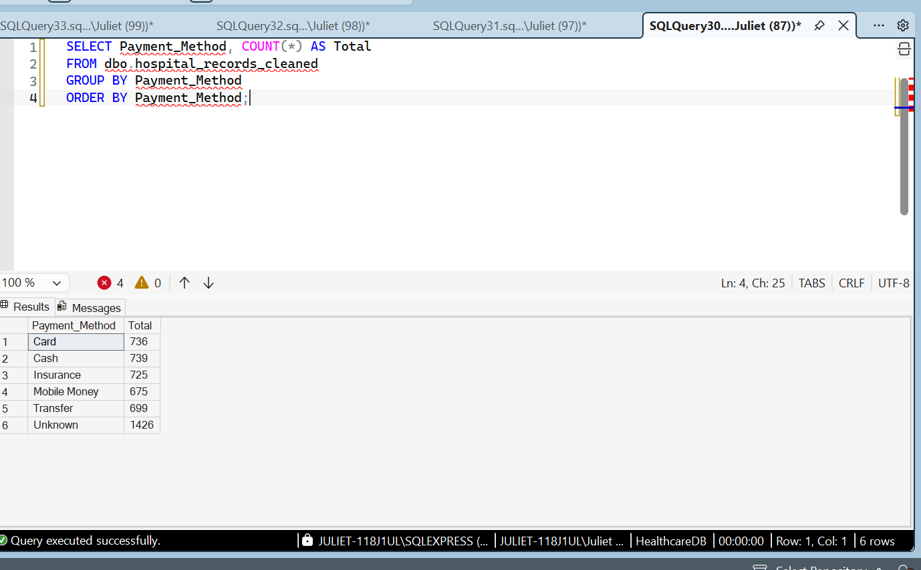

Patient Outcome Data Cleaning
The patient outcome column initially contained 867 missing values and 814 records labelled “Unknown.”
SQL was used to replace missing outcomes with “Unknown,” preserving the records without making assumptions about patients' outcomes.
After cleaning, the dataset contained 816 admitted records, 885 records marked as died, 800 discharged records, 818 referred records, and 1,681 records with unknown outcomes. The total remained 5,000 records.
The results were verified using an SQL query that grouped the records by outcome and counted each category.

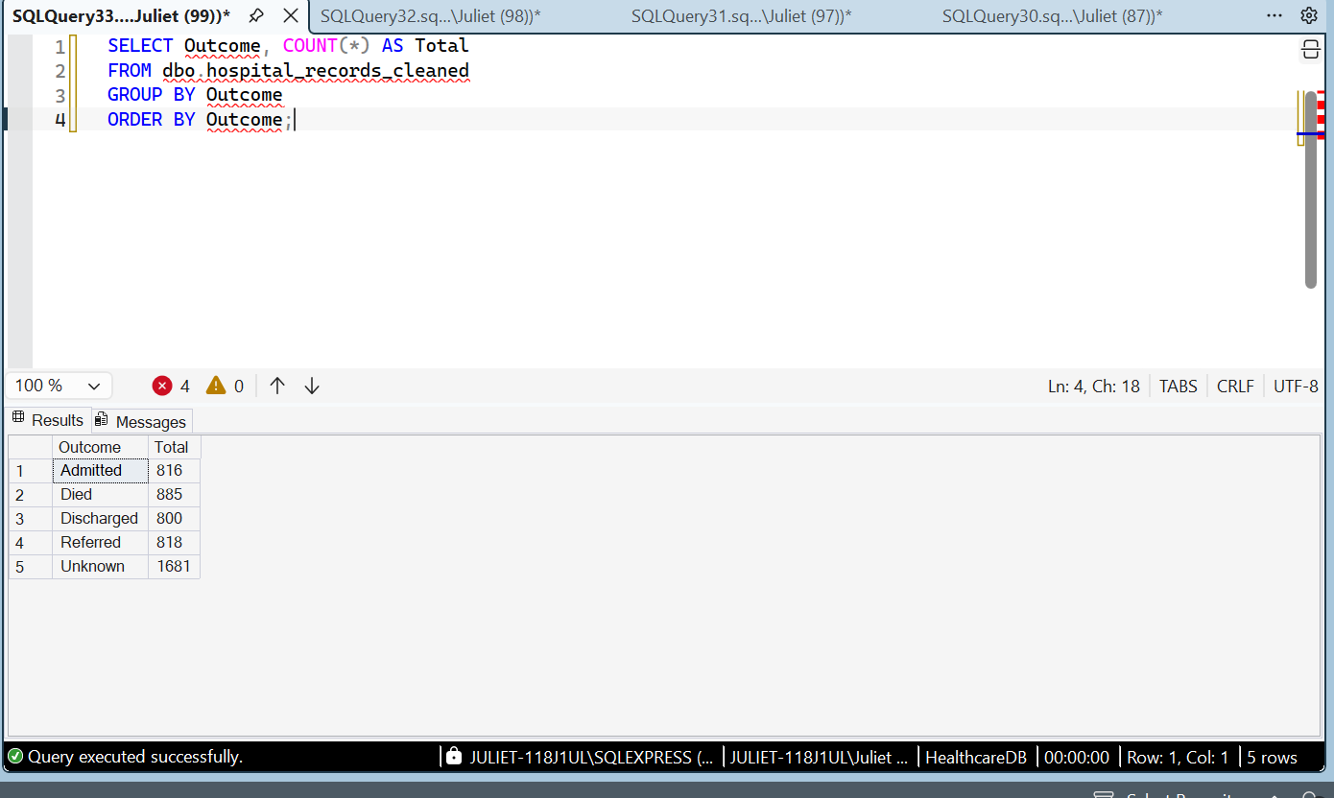

Insurance Data Cleaning
The insurance column was examined for missing values. The initial assessment identified 987 records with missing insurance information.
SQL was used to replace missing values with “Unknown” in the cleaned dataset. This preserved the records without assuming whether the patients had insurance coverage.
The results were verified using an SQL query that grouped records by insurance category and counted the records in each category.

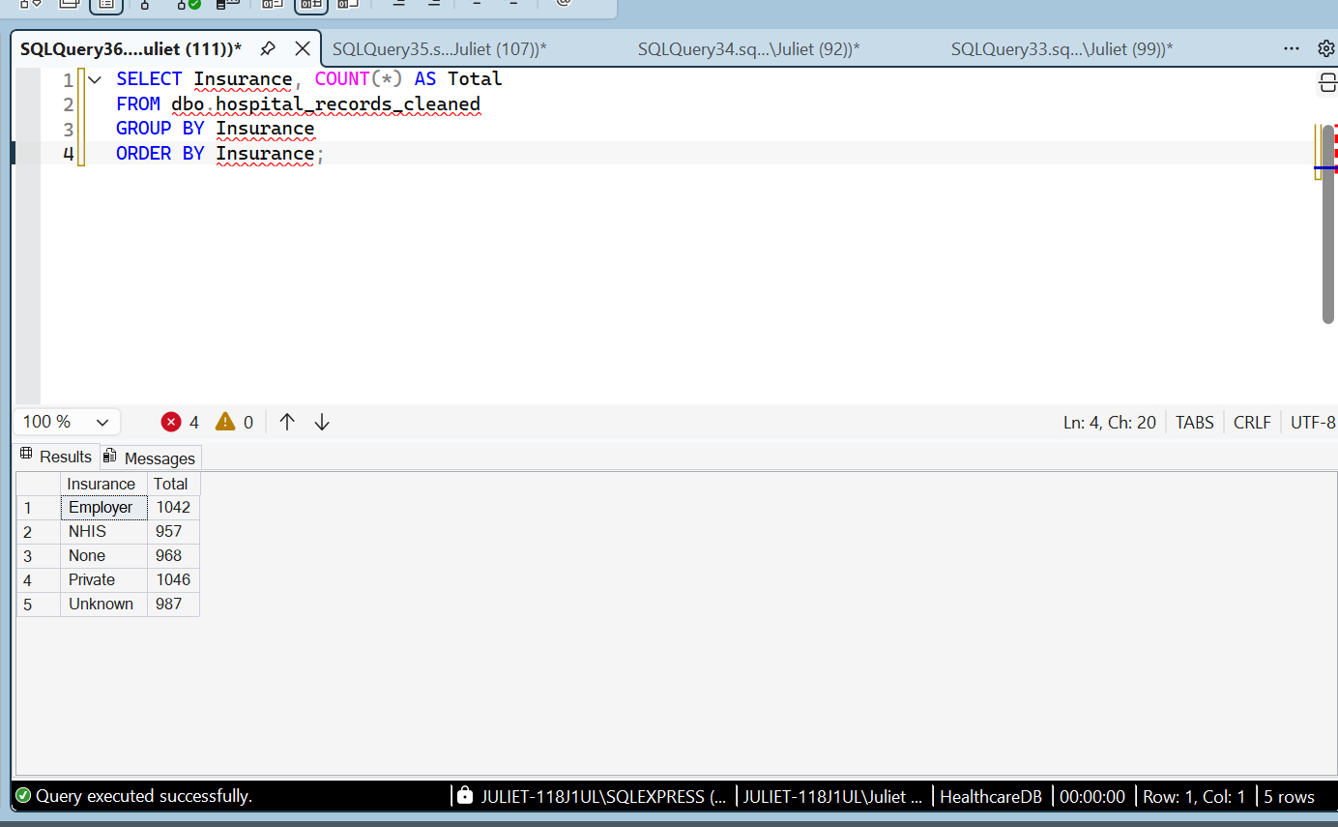

Readmission Data Cleaning
The readmission column was examined for missing values. The initial assessment identified 855 records with missing readmission information and 778 records already labelled “Unknown.”
SQL was used to replace missing values with “Unknown” in the cleaned dataset. This preserved the records without making assumptions about whether patients had been readmitted.
The results were verified using an SQL query that grouped records by readmission status and counted the records in each category.
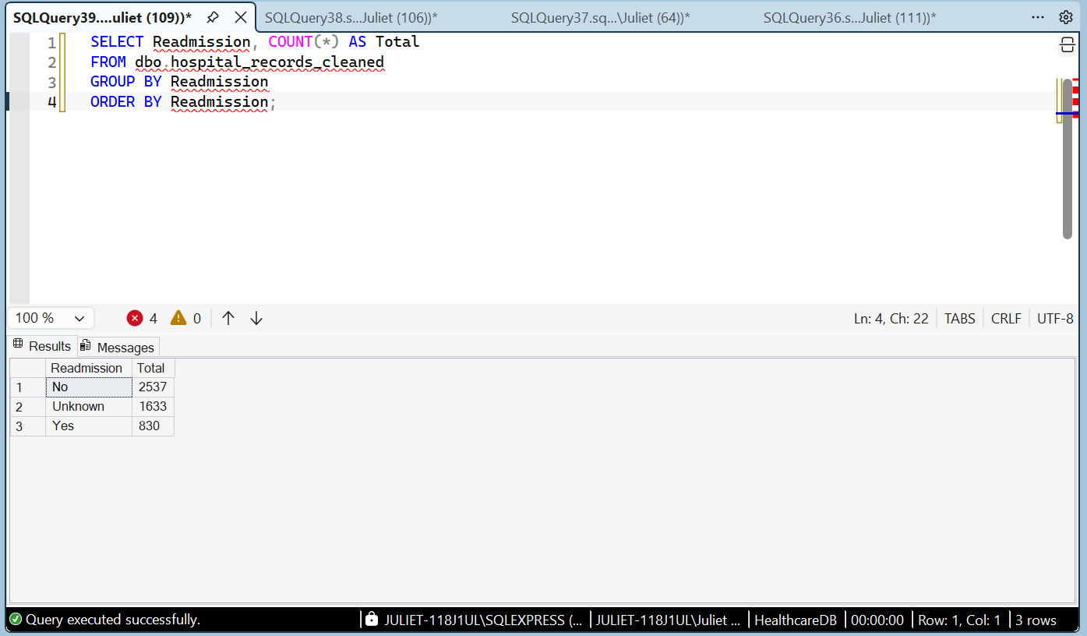

Satisfaction Score Data Quality Assessment
The satisfaction score column was assessed for missing values and score-range validity. The initial assessment identified 1,010 missing scores. The recorded values ranged from 0 to 6.
Missing scores were retained as NULL because no reliable information was available to determine the patients' actual satisfaction ratings. Scores of 0 and 6 were not altered because the intended scoring scale had not been independently confirmed.
An SQL validation query was used to identify values outside the observed range.

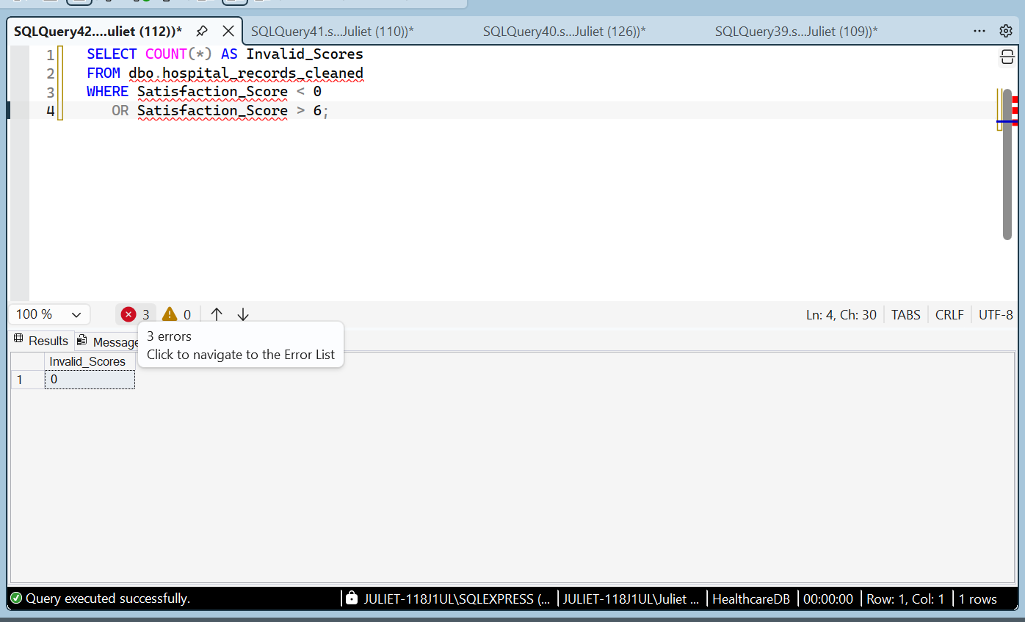

Age Data Cleaning and Validation
The age column was assessed for missing and invalid values. The cleaned dataset contains 5,000 records, of which 2,517 have recorded ages and 2,483 have missing ages.
Values below 0 or above 120 were treated as invalid and replaced with NULL because reliable replacement ages could not be established. The observed age range after cleaning was 0 to 90 years.
A validation query was used to check for any remaining ages below 0 or above 120.

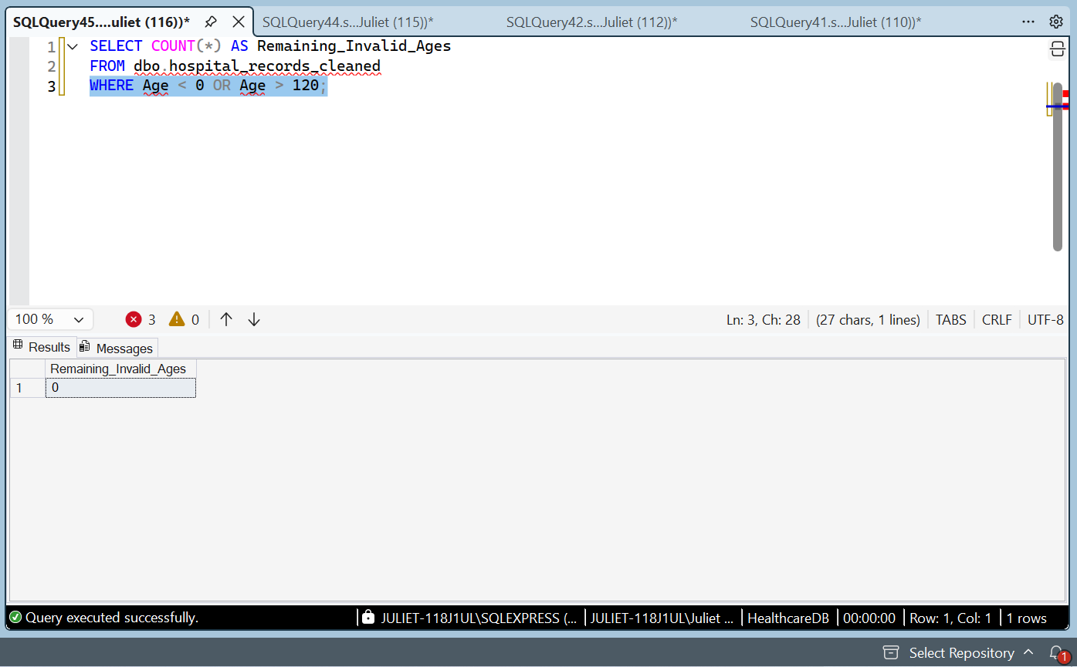

Treatment Cost Data Cleaning and Validation
The treatment cost column was assessed for missing and invalid values. The dataset contained 5,000 records, of which 2,496 had recorded treatment costs and 2,504 had missing costs.
Negative treatment costs were identified and replaced with NULL because valid replacement amounts could not be established from the available information. The observed treatment costs ranged from approximately ₦5,105.90 to ₦349,902.88.
Missing costs were retained as NULL rather than replaced with invented amounts. An SQL validation query was used to check whether any negative treatment costs remained.
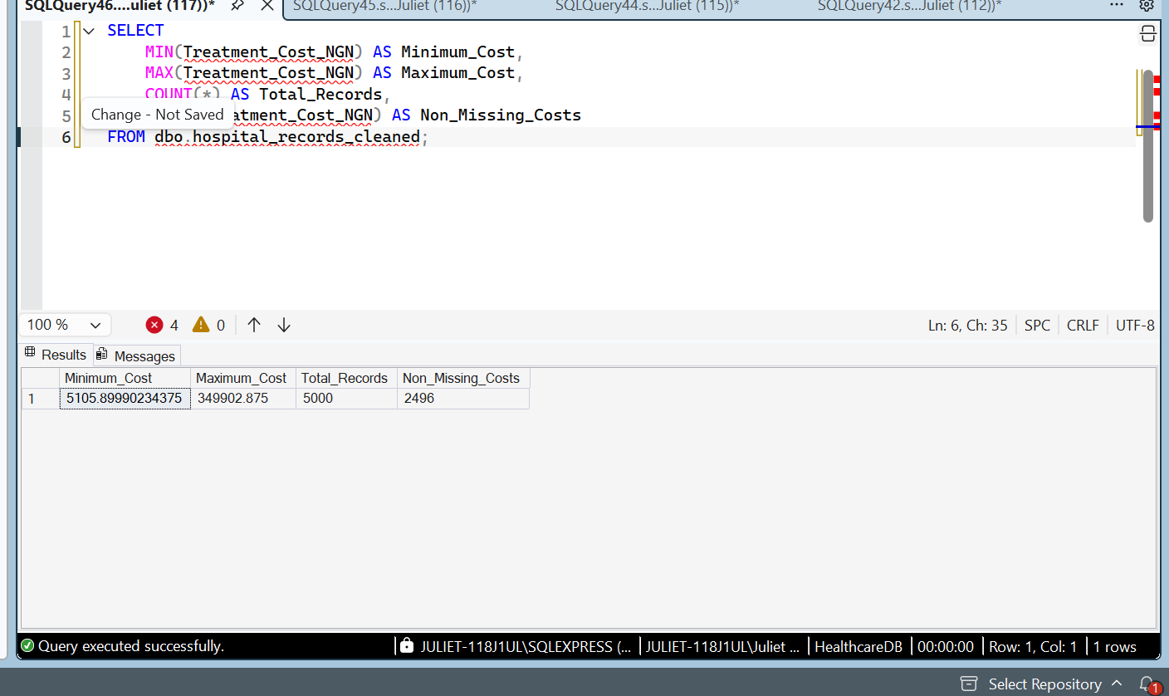

Length of Stay Data Cleaning
The length of stay column was examined for missing and invalid values. The initial assessment identified 1,264 records containing negative lengths of stay.
These invalid values were replaced with NULL because the correct duration could not be established from the available information. Existing missing values were preserved, and the original raw table remained unchanged.
An SQL validation query was used to confirm that no negative lengths of stay remained in the cleaned dataset.
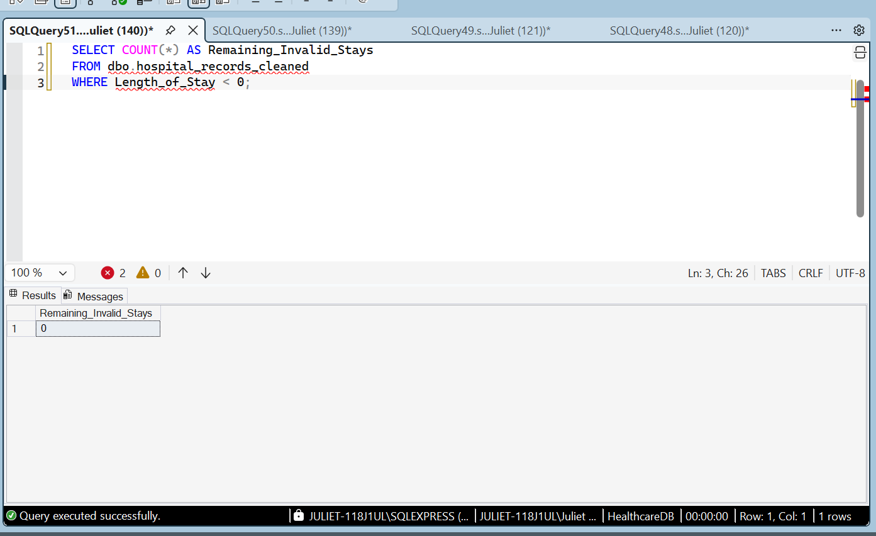

Admission and Discharge Date Validation
The admission and discharge dates were checked for chronological consistency. The validation query identified no records where the discharge date was earlier than the admission date.
The final verification returned zero invalid date records. This indicates that all records with both dates present satisfy this chronological condition. Records with missing dates were not assessed by this check.
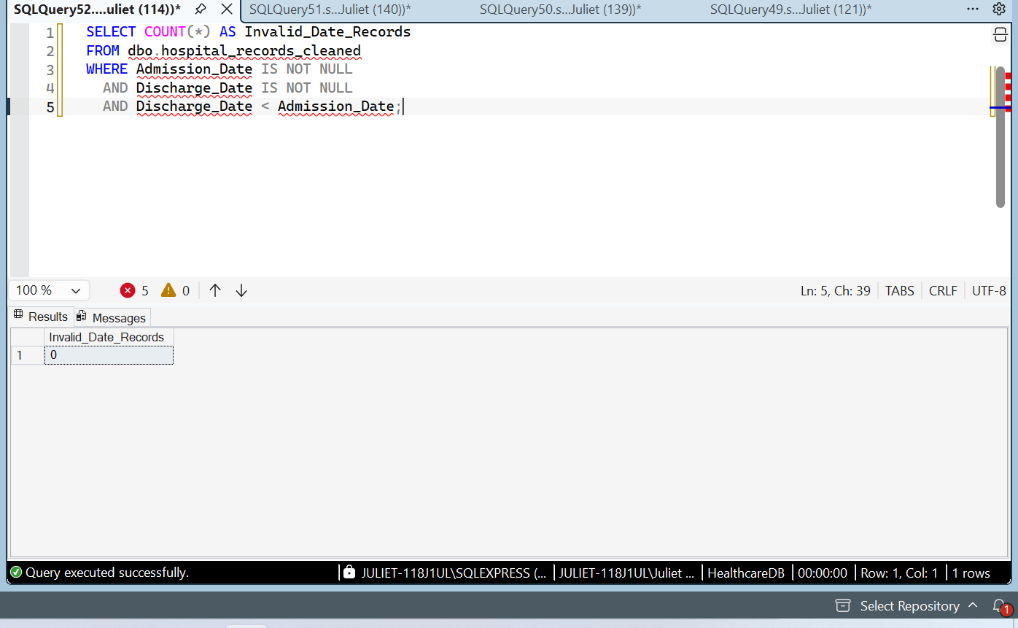

Patient Name Data Cleaning
The patient name column was checked for missing and blank values. The assessment identified 133 records without patient names.
SQL was used to replace these missing values with “Unknown” in the cleaned dataset. This preserved all records without inventing patient names. The original raw table remained unchanged.
A verification query was used to confirm that no missing or blank patient names remained in the cleaned table.
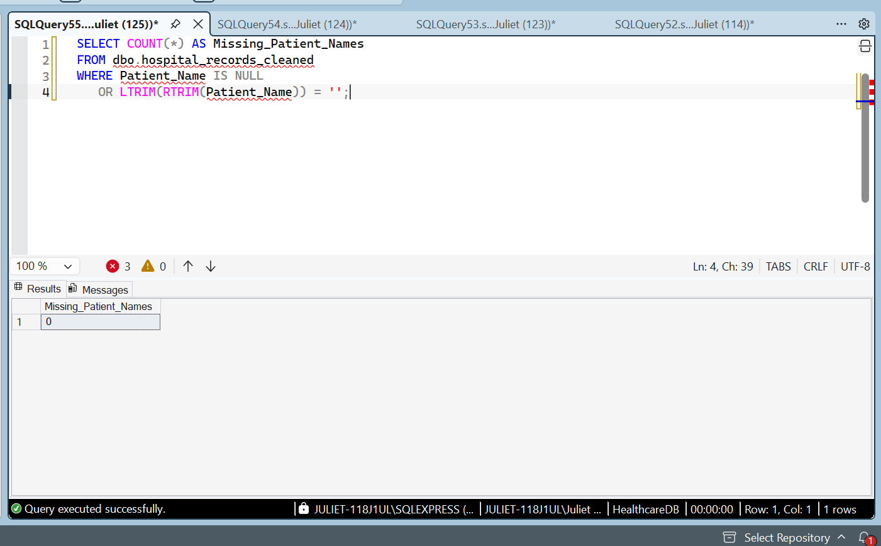

Patient ID Repeat Visit Assessment
The Patient ID column was examined to identify patients associated with multiple records. The SQL query returned 1,442 rows representing Patient IDs that appeared more than once.
Repeated Patient IDs were not automatically classified as errors because a patient may have multiple hospital visits. No records were deleted during this assessment. Further analysis of Visit IDs and visit details would be needed to distinguish legitimate repeat visits from duplicate records.
Duplicate Visit Record Assessment
The cleaned dataset was assessed for repeated Visit IDs. The initial query identified 12 Visit IDs appearing twice, representing 24 records.
A further SQL query grouped records by all 20 columns to determine whether the repeated visits were exact duplicates. The query returned 12 groups, each representing two records with matching values across the listed columns.
These records were identified as potential exact duplicates. The original raw table was preserved, and the findings were documented before deciding whether to remove duplicate rows from the cleaned table.
Duplicate Record Removal
The dataset was checked for duplicate Visit IDs. The assessment identified 12 Visit IDs that each appeared twice. A further comparison of all 20 columns confirmed that the corresponding records matched across the listed fields.
Using SQL Server's ROW_NUMBER() function, one copy of each exact duplicate was retained and the extra copy was removed from the cleaned table. A total of 12 duplicate rows were deleted, reducing the record count from 5,000 to 4,988.
The original raw table was preserved to maintain an unmodified copy of the imported dataset.
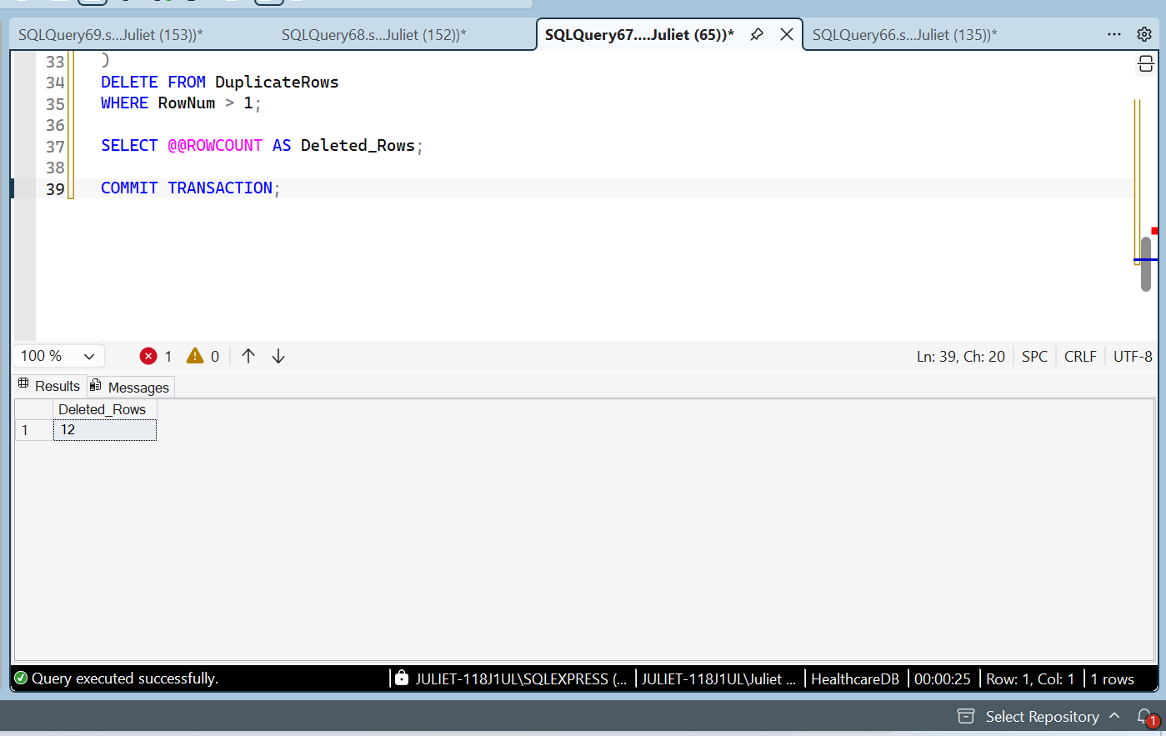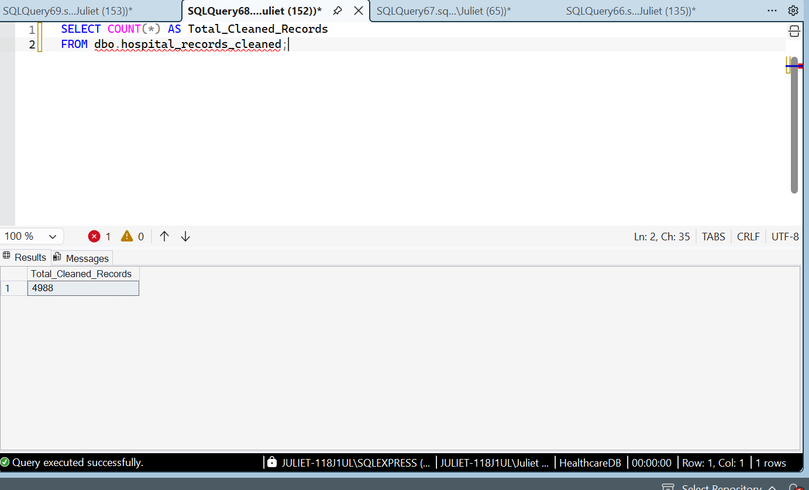

Department Data Cleaning
The department column was assessed for missing values. The initial assessment identified 395 records with missing department information and 443 records already labelled “Unknown.”
SQL was used to standardize missing department values to “Unknown” in the cleaned dataset. This preserved all records without assuming which department handled each patient.
The update was verified using an SQL query that grouped records by department and counted the records in each category. The original raw table remained unchanged.
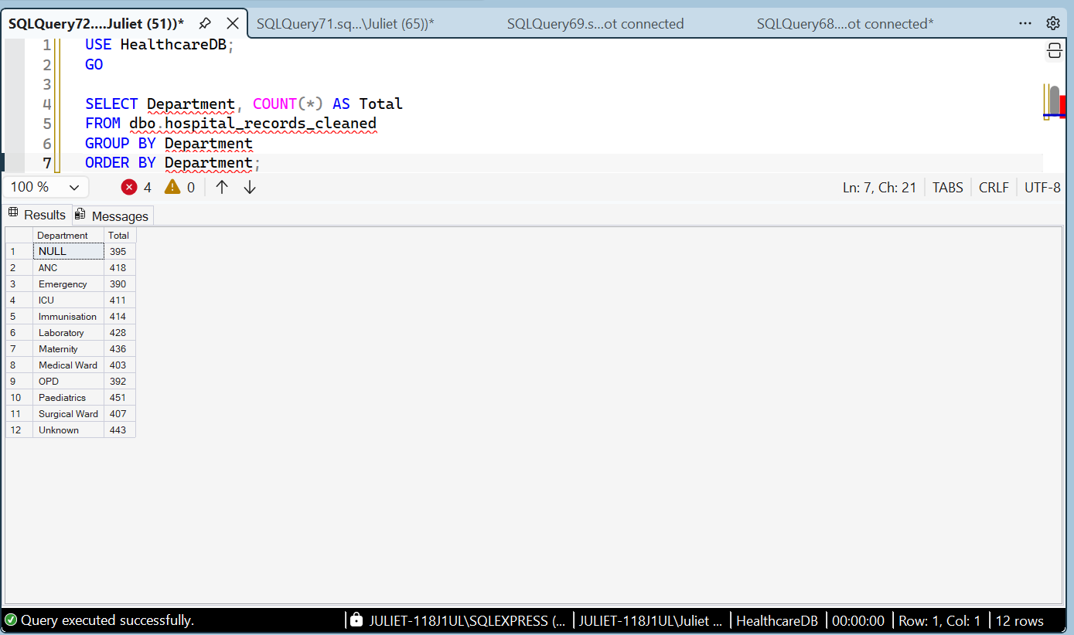

Patient Type Data Cleaning and Validation
The Patient_Type column was examined for missing values. The initial assessment identified 1,264 records with missing patient type information.
SQL was used to replace these missing values with “Unknown” in the cleaned dataset. This approach preserved all records without making assumptions about the patients' classifications.
The results were verified using a SQL query that grouped records by patient type and counted each category. The final dataset contained 4,988 records, including 1,264 records classified as “Unknown.” The original raw table remained unchanged.
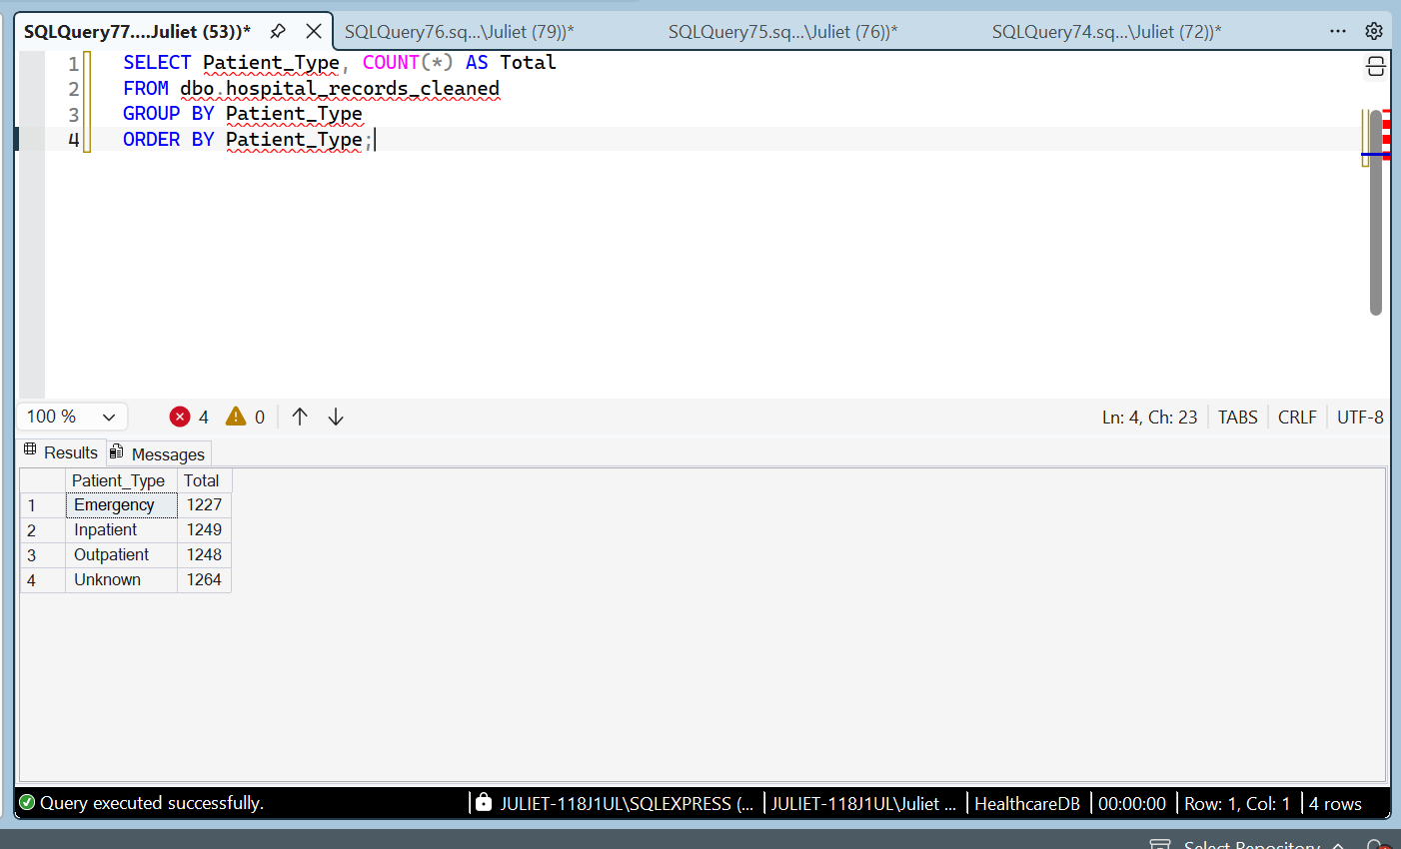

Treatment Data Cleaning and Validation
The Treatment column was examined for missing values. The initial assessment identified 538 records with missing treatment information.
SQL was used to replace the missing values with “Unknown” in the cleaned dataset. This prevented unsupported assumptions about the treatments provided to patients.
The results were verified using a SQL query that grouped records by treatment and counted each category. The final dataset contained 4,988 records, with 538 records classified as “Unknown.” The original raw table remained unchanged.
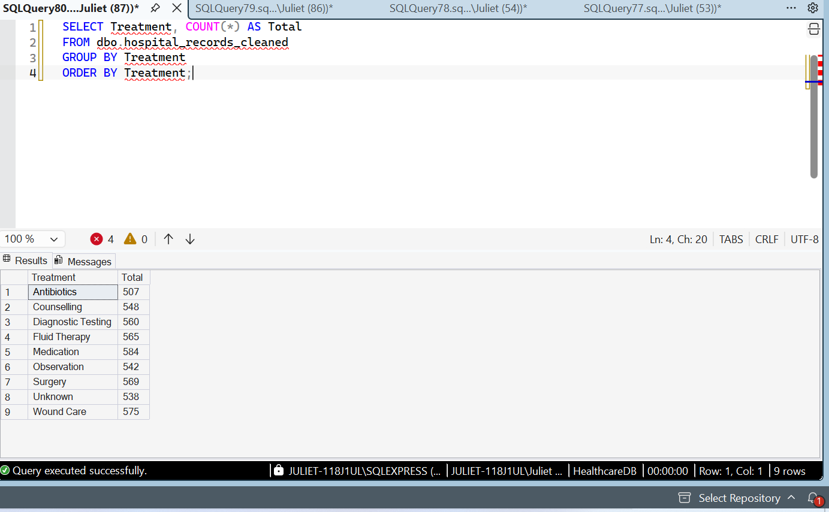

Doctor Data Cleaning and Validation
The Doctor column was examined for missing values. The initial assessment identified 556 records with missing doctor information.
SQL was used to replace the missing values with “Unknown” in the cleaned dataset. This prevented assumptions about which doctors attended to the patients.
The results were verified using a SQL query that grouped records by doctor and counted each category. The final dataset contained 4,988 records, including 556 records classified as “Unknown.” The original raw table remained unchanged.
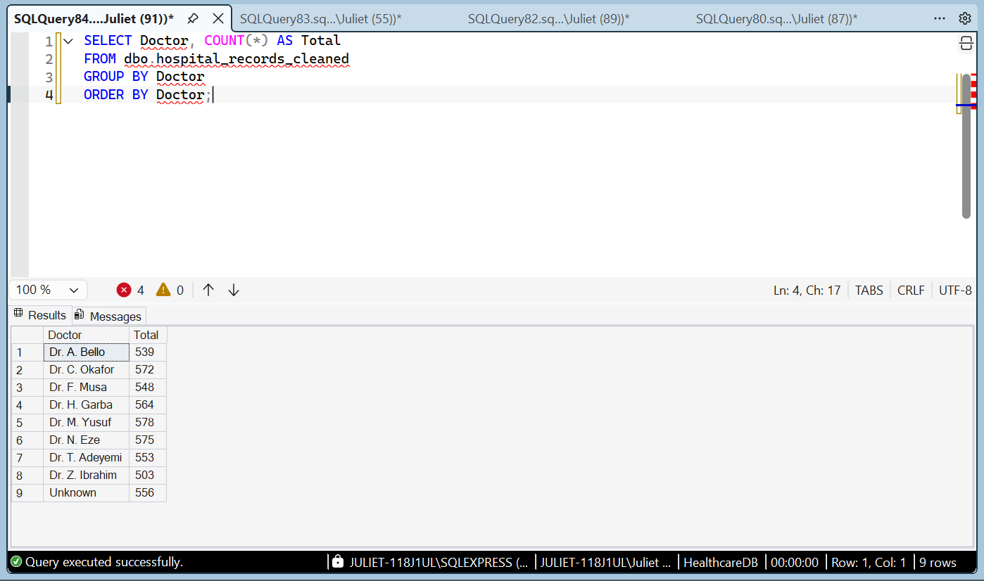

Outcome Data Cleaning and Validation
The Outcome column was examined for missing values. The initial category assessment showed five outcome categories: Admitted, Died, Discharged, Referred, and Unknown.
An SQL validation query checked for both NULL and blank values. The query returned zero records, confirming that no missing or blank outcome values remained in the cleaned dataset.
The original raw table was preserved, and the cleaned dataset retained 4,988 records.
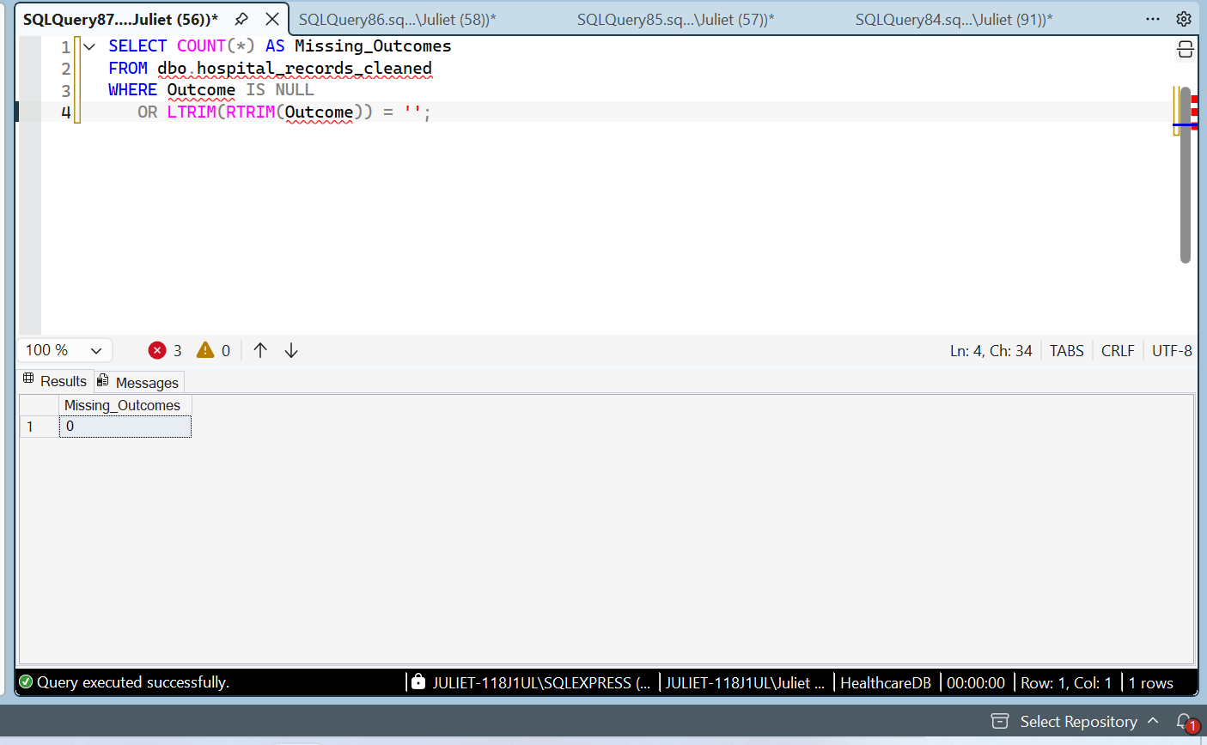

Overall Healthcare KPI Analysis
SQL aggregate functions were used to calculate the overall performance indicators for the cleaned healthcare dataset.
The analysis covered 4,988 records and identified 1,970 distinct patient IDs. The average recorded patient age was 45.31 years, while the average recorded length of stay was 5.54 days.
The total recorded treatment cost was ₦32,780,623.56, with an average recorded treatment cost of ₦131,753.87 per record with a non-missing cost.
These results provide an overview of patient records, demographics, hospital stay duration, and treatment costs. They also establish a foundation for further analysis of diagnoses, departments, patient outcomes, and financial patterns.
The findings describe the synthetic dataset used in this portfolio project and are not official Nigerian healthcare statistics.
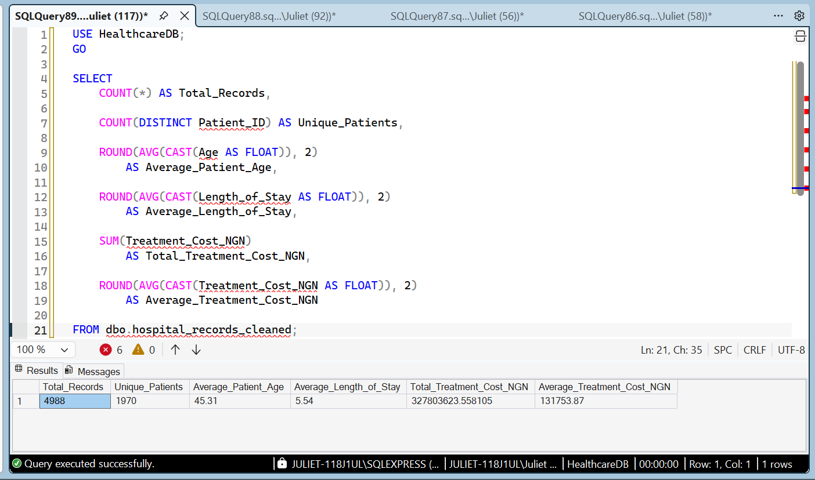

Disease Frequency Analysis Using SQL
The disease frequency analysis was conducted using SQL aggregation functions to determine the number of records and distinct patients associated with each diagnosis. Missing and unknown diagnosis categories were excluded from the analysis.
Typhoid Fever was the most frequently recorded diagnosis, with 836 records involving 709 distinct patients. Pneumonia followed with 386 records, while diarrhoea had 384 records. Anaemia accounted for 381 records, and hypertension and malaria each had 380 records.
The findings demonstrate how SQL can be used to rank diagnoses, measure the number of associated records, and distinguish between total records and distinct patients.
These results are based on a synthetic healthcare dataset created for portfolio development and should not be interpreted as official disease prevalence statistics.
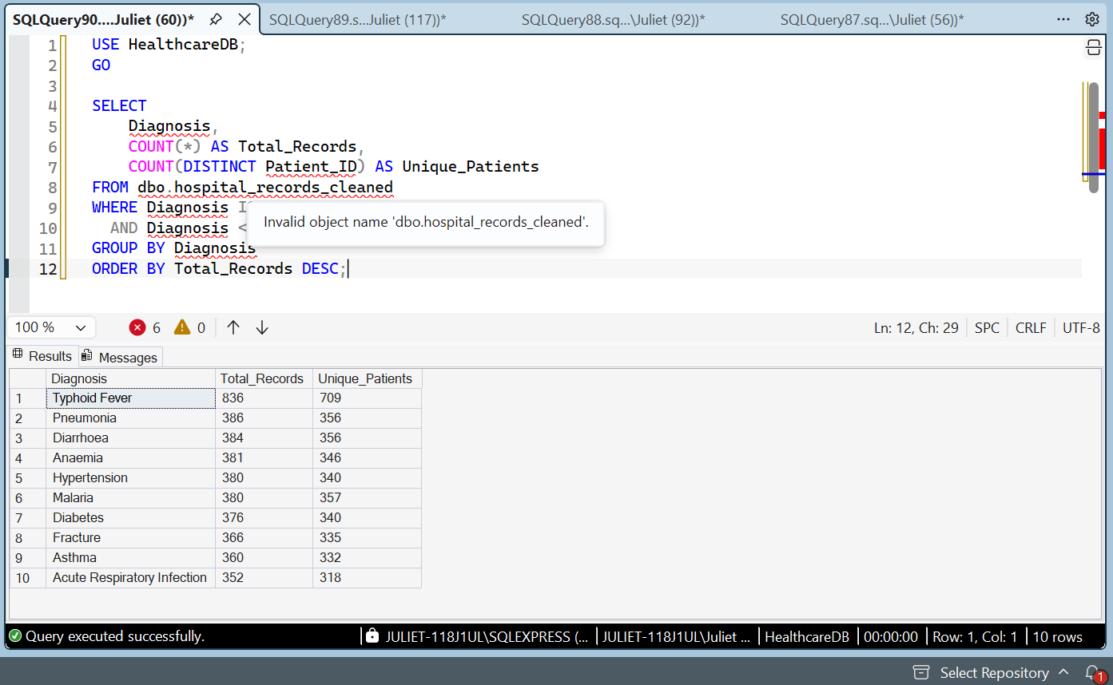

Treatment Cost Analysis by Diagnosis Using SQL
SQL aggregate functions were used to calculate the number of records with available treatment costs, average treatment cost, and total treatment cost for each diagnosis.
Fracture recorded the highest average treatment cost, at approximately ₦141,913 per record. Acute Respiratory Infection ranked second, at approximately ₦134,194, followed by Anaemia at approximately ₦133,123.
Typhoid Fever recorded the highest total treatment cost, at approximately ₦56.27 million, based on 432 records with available costs. This demonstrates that the diagnosis with the highest average treatment cost is not necessarily the diagnosis with the highest total expenditure.
The analysis illustrates how SQL can support healthcare cost comparisons and financial reporting. The findings are based on a synthetic dataset and should not be interpreted as actual hospital expenditure figures.
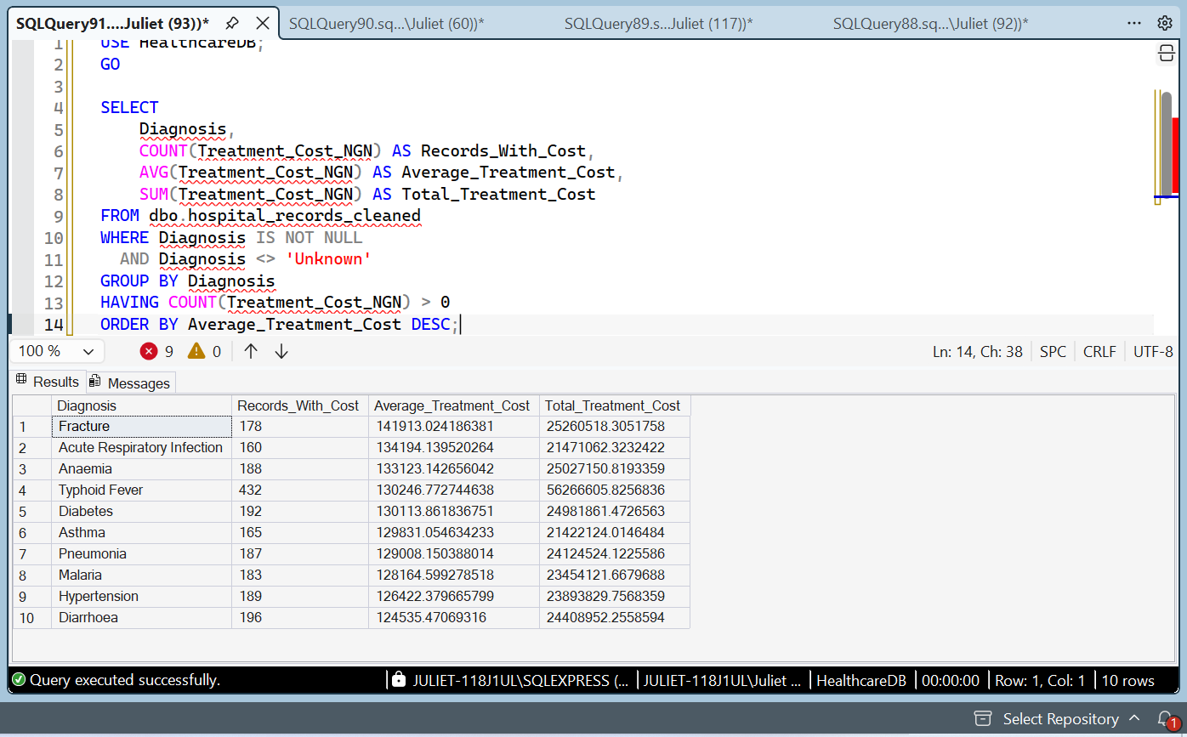

Patient Outcome Analysis by Diagnosis Using SQL
SQL aggregate functions were used to examine the distribution of patient outcomes across different diagnoses. The analysis grouped records by diagnosis and outcome and counted the number of records in each group.
In the displayed results, Acute Respiratory Infection had 75 discharged records, while Anaemia had 71 admitted records. Asthma had 75 records classified as Died. Diabetes, Diarrhoea, and Fracture had 72, 71, and 71 discharged records, respectively.
This analysis demonstrates how SQL can be used to compare recorded patient outcomes across diagnoses. Because the dataset is synthetic, these findings are illustrative and should not be interpreted as actual clinical statistics.
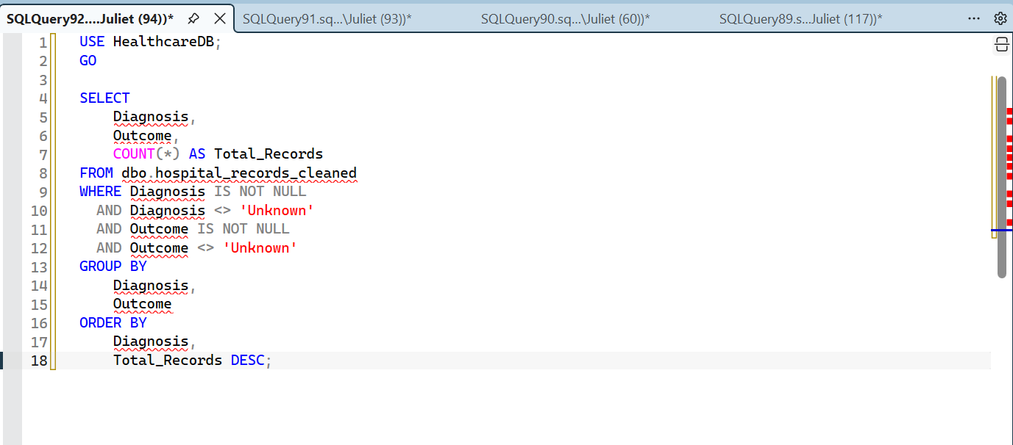
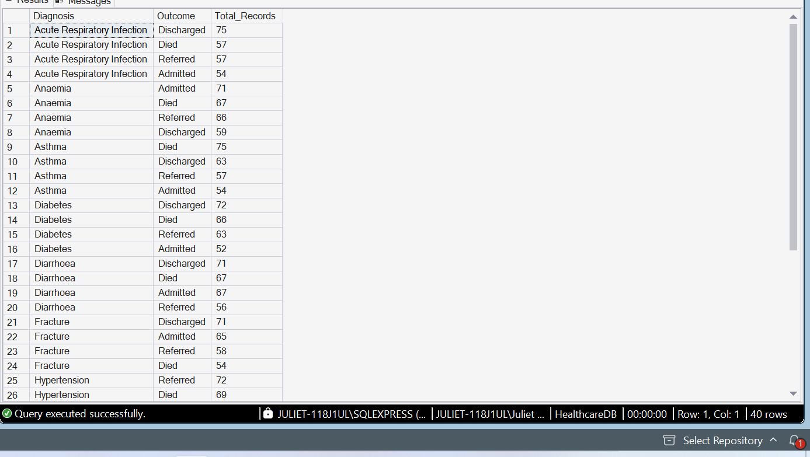

Patient Demographic Analysis by Gender Using SQL
SQL aggregate functions were used to compare the number of male and female records and calculate the average, minimum, and maximum ages for each group.
The analysis identified 1,701 male records and 1,652 female records. Male records were therefore higher by 49. The average age was approximately 45.75 years for males and 45.96 years for females, indicating a small difference between the groups.
Both groups had a minimum recorded age of zero and a maximum age of 90. An age of zero may represent an infant and should not automatically be classified as an error.
This analysis demonstrates how SQL can be used to summarize demographic information and compare groups in a healthcare dataset. The dataset is synthetic, so the results are intended for analytical practice.
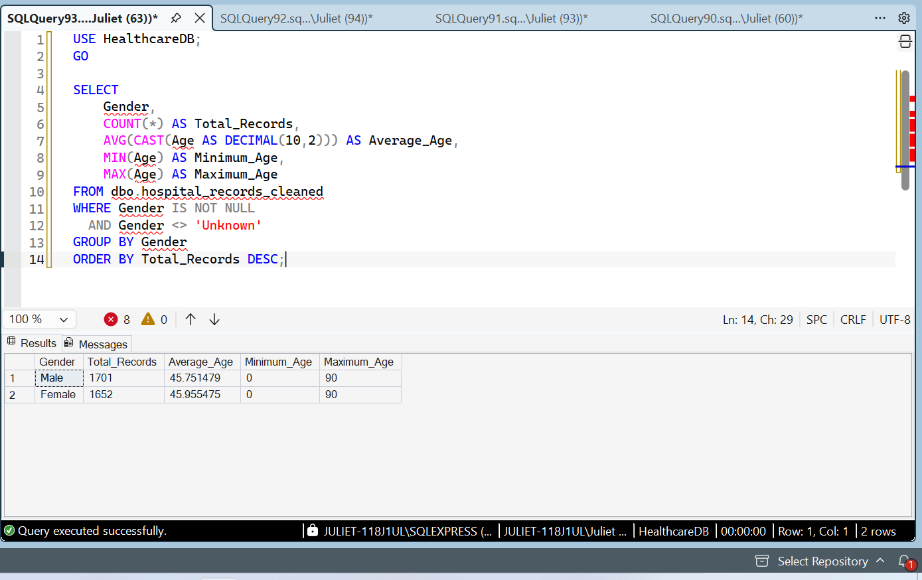

Patient Volume Analysis by State Using SQL
SQL aggregate functions were used to calculate total healthcare records and unique patients by state.
Oyo recorded the highest number of records, with 455 records and 409 unique patients. Bauchi ranked second with 431 records, while Lagos ranked third with 429 records. Abuja FCT had the lowest number of records among the ten states displayed, with 395 records and 364 unique patients.
The difference between total records and unique patients indicates that some patients have multiple records. This analysis demonstrates how SQL can be used to compare record volumes and patient distribution across geographic areas.
The dataset is synthetic; therefore, these findings are for portfolio and analytical practice rather than a representation of actual healthcare utilization in Nigeria.
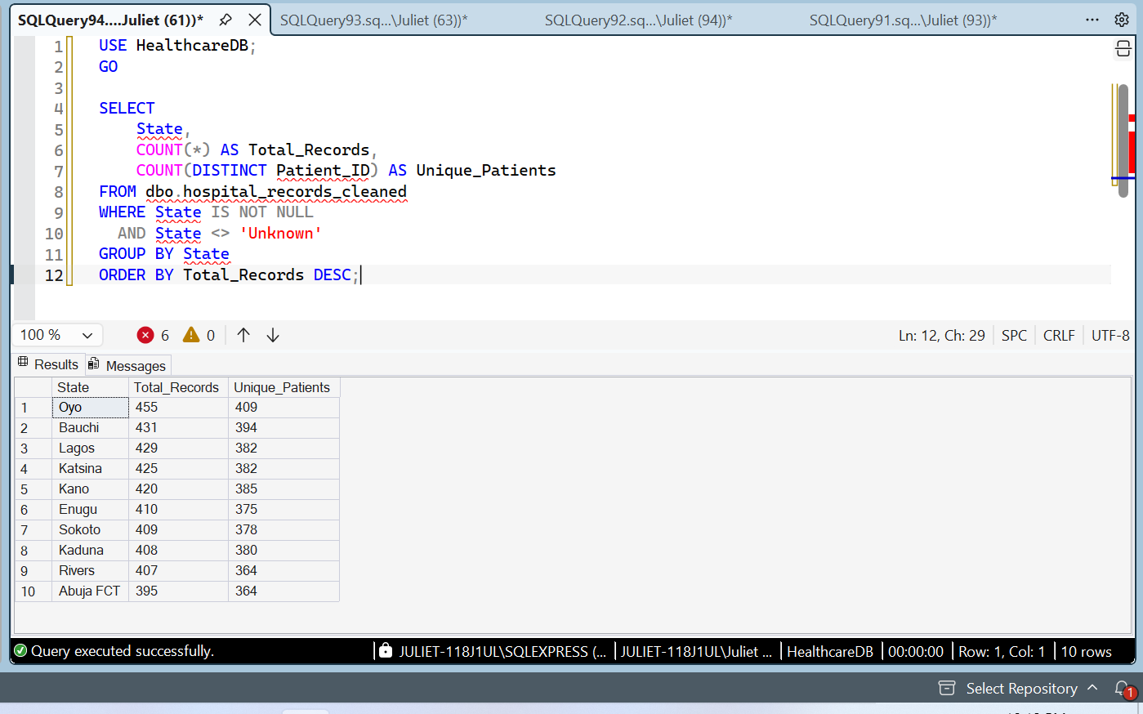

Length of Stay Analysis by Department Using SQL
SQL aggregate functions were used to calculate the number of records, average length of stay, and maximum length of stay for each department.
The Medical Ward recorded the highest average length of stay at approximately 6.11 days, followed by the Laboratory at 6.07 days and ANC at 5.79 days. Maternity had the lowest average among the displayed departments, at approximately 5.21 days.
All ten departments had a maximum recorded length of stay of 14 days. These findings demonstrate how SQL can be used to compare average stays across departments and identify differences in recorded service patterns.
The results are based on a synthetic dataset. In addition, the length-of-stay figures for departments such as Laboratory and OPD should be interpreted cautiously because their operational workflows may differ from those of inpatient wards.
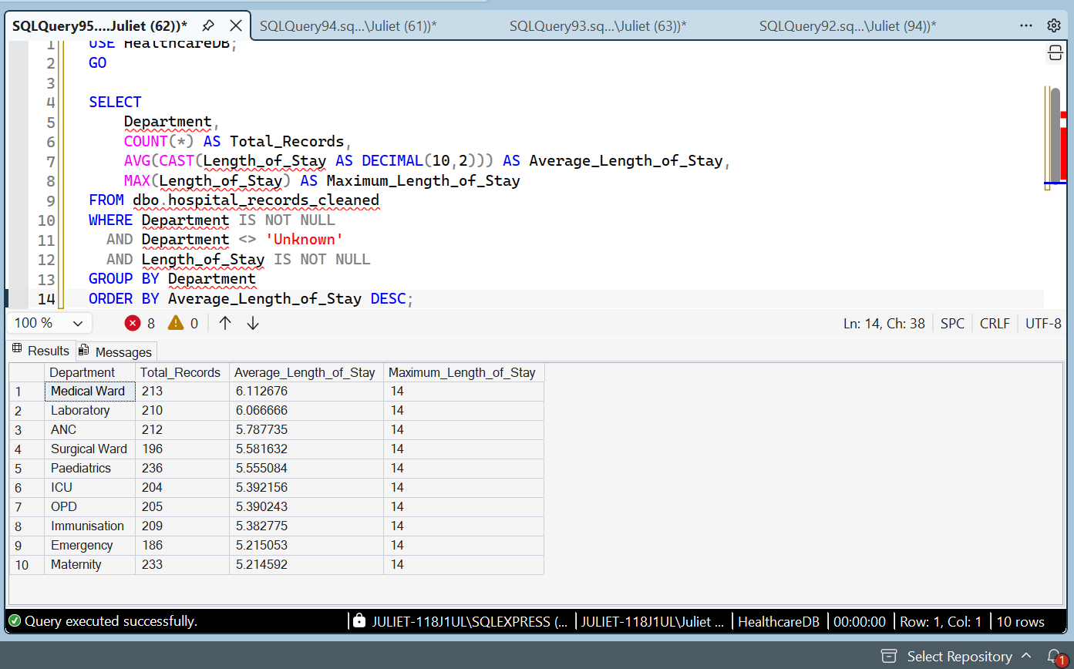

Monthly Patient Admission Trend Analysis Using SQL
SQL date functions and aggregate functions were used to examine monthly healthcare record volumes from 2024 to 2026. The analysis grouped records by admission year and month and calculated both total records and unique patients.
April 2024 recorded 166 records, the highest monthly count visible in the reviewed results. August 2025 recorded 122 records, the lowest monthly count visible. The results also showed differences between total records and unique patients, indicating that some patients had multiple records within a month.
This analysis demonstrates how SQL can be used to organize time-based healthcare data and identify variations in monthly record volumes. Because the dataset is synthetic, the findings are illustrative rather than actual hospital admission statistics.
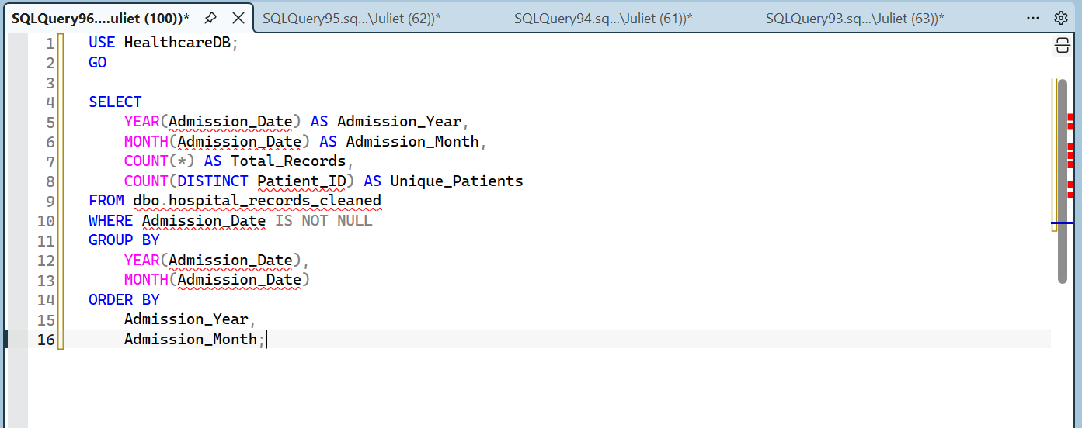
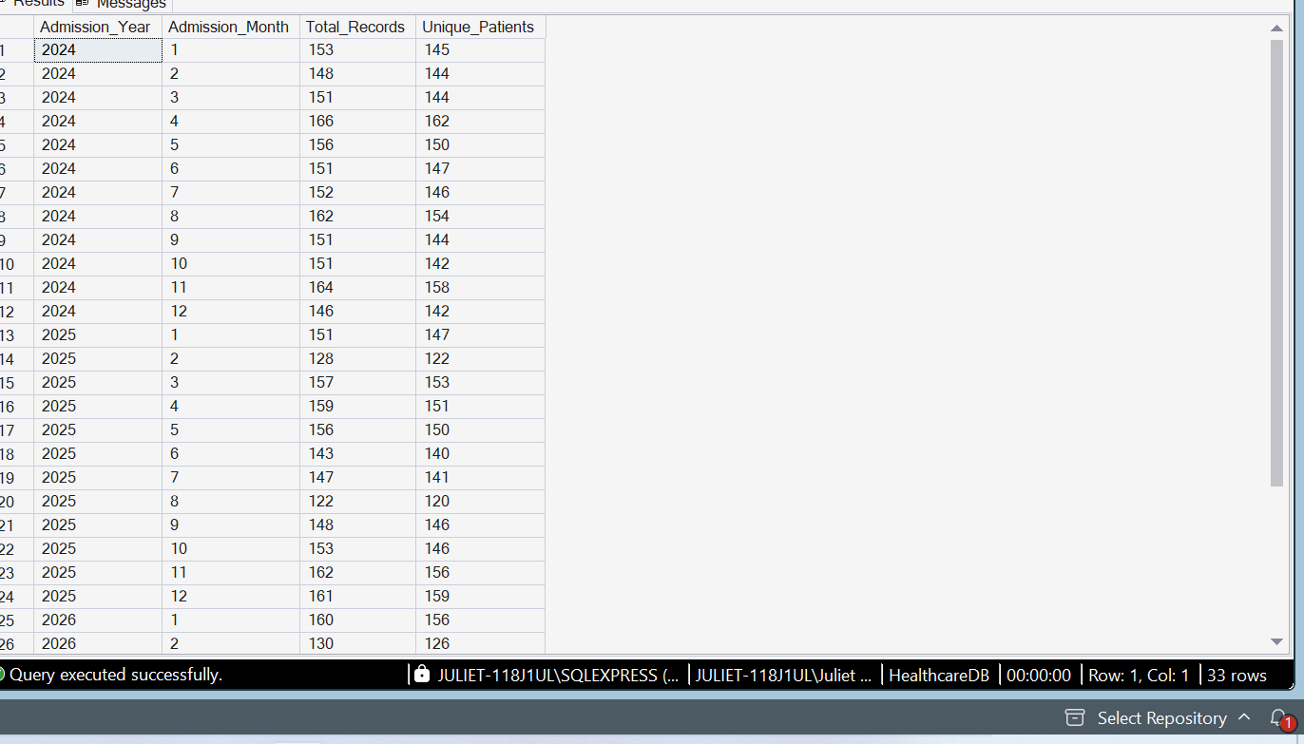

Payment Method and Treatment Cost Analysis Using SQL
SQL aggregate functions were used to compare healthcare treatment costs across five payment methods: Cash, Card, Insurance, Transfer, and Mobile Money.
The analysis showed that Cash had the highest total recorded treatment cost, approximately ₦50.22 million. Transfer had the highest average treatment cost, approximately ₦136,834.74 per record with an available cost. Mobile Money had the lowest total recorded treatment cost, approximately ₦43.69 million.
The analysis also identified missing treatment-cost values across all payment methods. Therefore, comparisons were based on the available cost records, and the totals should be interpreted with this limitation in mind.
This analysis demonstrates how SQL can support healthcare financial reporting by comparing payment methods, summarizing treatment costs, and identifying gaps in financial data. The dataset is synthetic and does not represent actual hospital financial records.
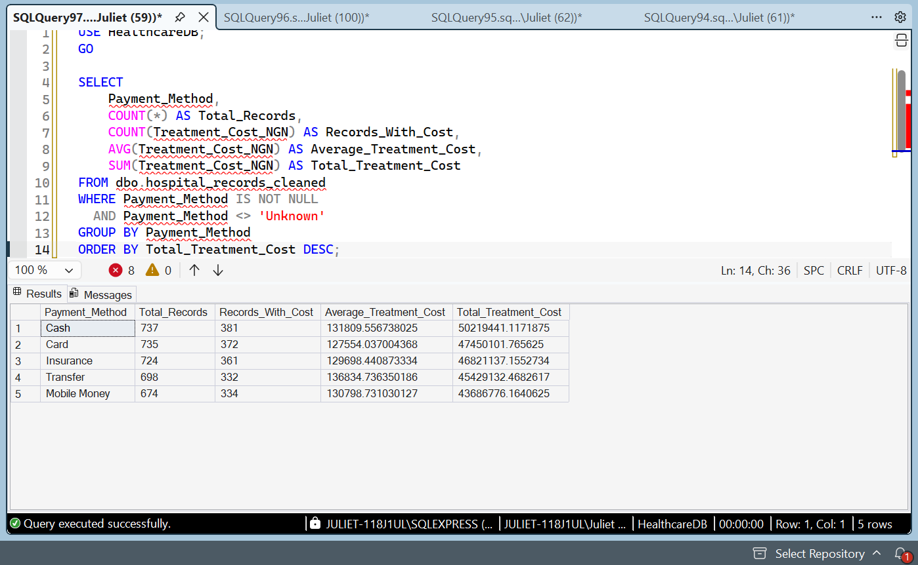

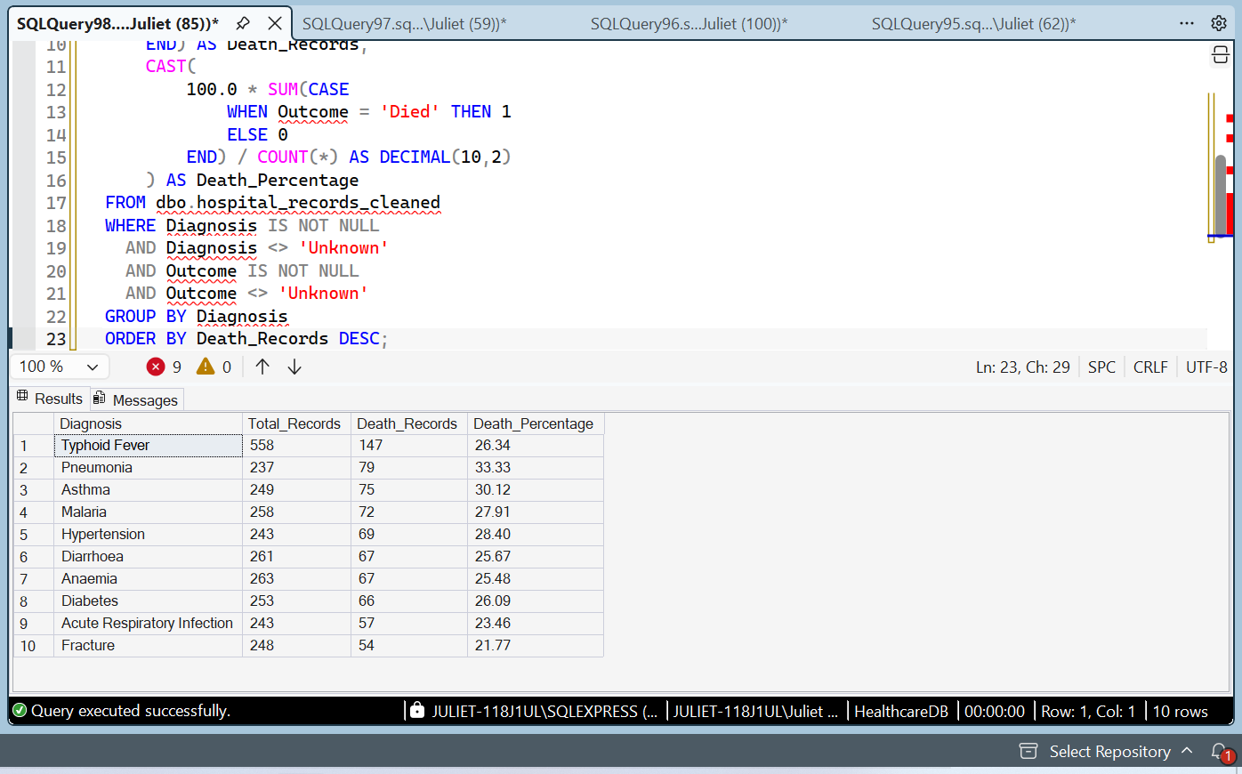

Patient Outcome Analysis by Diagnosis Using SQL
SQL aggregate functions and conditional logic were used to examine recorded patient outcomes across diagnoses. The analysis calculated the total number of records, the number of records with a recorded outcome of death, and the percentage of records with that outcome for each diagnosis.
The results showed that Typhoid Fever had the highest recorded death count, with 147 records. Pneumonia had the highest death percentage among the diagnoses displayed, at 33.33%. Fracture had the lowest percentage among the displayed diagnoses, at 21.77%.
The findings demonstrate how SQL can be used to summarize patient outcomes and compare recorded counts and percentages across diagnostic categories. Because the dataset is synthetic, these results are for analytical practice and should not be interpreted as real-world clinical evidence.

Repeat Visit Analysis Using SQL
A repeat visit analysis was conducted using SQL Common Table Expressions (CTEs), grouping, conditional aggregation, and percentage calculations.
The analysis identified 1,970 unique patients, of whom 1,441 had multiple records. This represents 73.15% of the unique patients in the dataset.
The findings demonstrate how SQL can identify patients with multiple records and quantify the proportion of patients with repeat visits. However, multiple records do not necessarily indicate formal readmission. Further analysis of the Readmission field and admission dates would be required to distinguish confirmed readmissions from other repeat visits.
The analysis was performed using a synthetic healthcare dataset and should not be interpreted as evidence of actual hospital readmission rates.
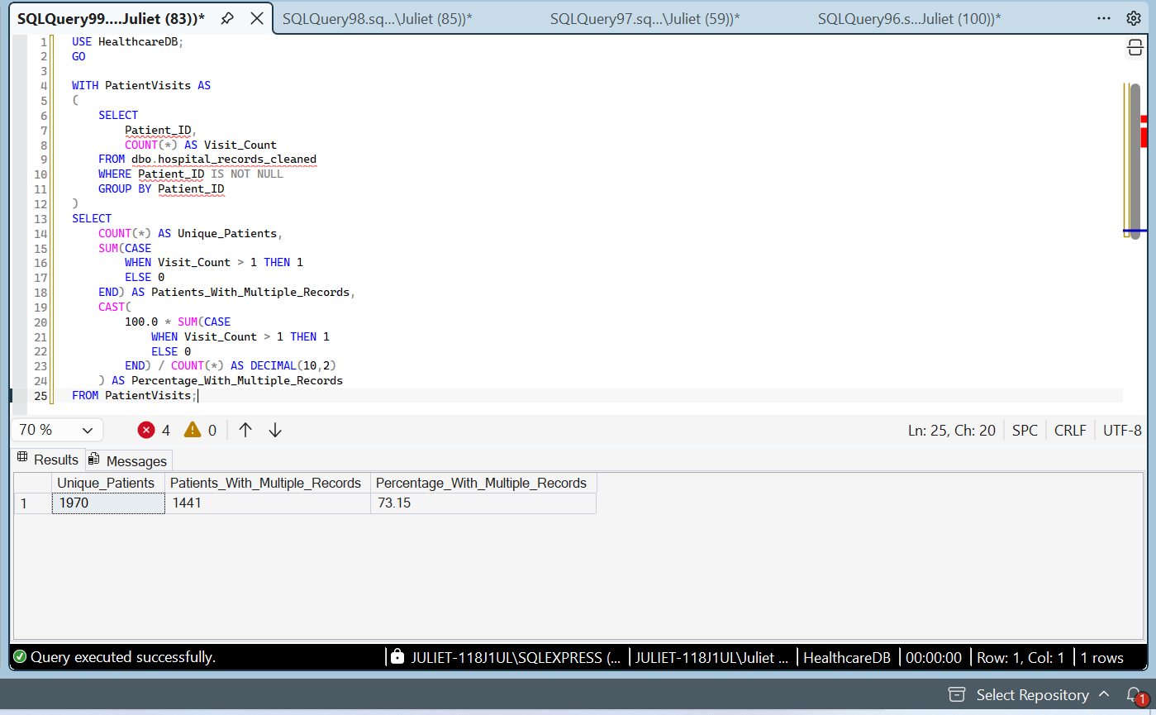

Readmission Status Analysis Using SQL
SQL grouping and aggregate functions were used to examine readmission status in the cleaned healthcare dataset.
The analysis identified 2,531 records classified as No, 827 classified as Yes, and 1,630 classified as Unknown. The records classified as Yes represented approximately 16.59% of all 4,988 records. Among records with a known readmission status, approximately 24.63% were classified as Yes.
The analysis also identified a substantial proportion of records with unknown readmission status. This limitation should be considered when interpreting the results. The figures describe the synthetic dataset and do not represent actual hospital readmission statistics.
