📚 ENGLISH CODING · 영어코딩

🧊 M003 Week 3 — English Worksheet (Beginner)
Topic: Pixel Art on the Wall (x, y) · Course: 3D Coordinates · Level: Beginner · Time: about 30 minutes
This week you copy a picture made of blocks onto your wall. Every block sits at a spot named by two numbers — (x, y). x is how far across, y is how far up. You read the picture and place each block at its (x, y).
First, build your canvas. Run this to make a blank 15 × 15 wall, then put a red block at your feet as your home spot:
🧩 Blocks
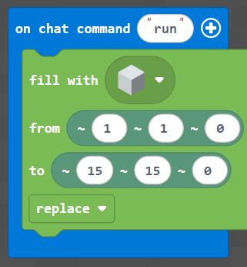
🐍 Python
def on_run():
blocks.fill(WHITE_CONCRETE,
pos(1, 1, 0),
pos(15, 15, 0),
FillOperation.REPLACE)
player.on_chat("run", on_run)
🔴 Stand on the red block every time you run. If you move, the picture moves too and the blocks land in the wrong place. Same spot every time = a clean picture.

1 · Predict 🔮
Read the steps. Before you imagine it happening, circle or write your answer.
place red block at (6, 1)
place red block at (7, 1)
place red block at (8, 1)
Do these blocks make a line going across? Circle one: across · up
Which number stays the same — x or y?
place green block at (8, 13)
place green block at (8, 14)
These share x = 8 and y grows. Do they go across or up? Circle one: across · up

2 · Find the Difference 🐛
Each pair shows the correct line first, then a broken one. Circle what's different and write one short sentence about the bug.
Pair A — A line should grow across at the bottom: (5, 1), (6, 1), (7, 1).
# correct
place red block at (5, 1)
place red block at (6, 1)
place red block at (7, 1)
# broken
place red block at (5, 1)
place red block at (5, 1)
place red block at (5, 1)
What is wrong? Where do all three blocks land?
Pair B — The stem should grow up at x = 8.
# correct
place brown block at (8, 13)
place brown block at (8, 14)
# broken
place brown block at (13, 8)
place brown block at (14, 8)
What is wrong? Which two numbers got swapped?

3 · Fill the Gap ✏️
To move across a row, the first number (x) has to grow. Fill in the missing numbers so this line goes across the bottom.
place yellow block at (6, 1)
place yellow block at (__, 1)
place yellow block at (__, 1)
Word bank for the blanks: 7 · 8
Write the two missing numbers:

4 · Tell Me What You Built 📸
Stand on your home spot (the red block).
Warm up first. Copy this small green cross onto your wall. Read each green square's (x, y) and place a green block there.
🟩 Green cross
 | 1 | 2 | 3 | 4 | 5
5
4
3
2
1

Now pick one big picture — the 🍍 pineapple or the 🍎 apple from the main worksheet grid — and copy it the same way. Read each colored square and place that color at its (x, y).
When you finish, send a photo of your picture, then explain what you did. Use these sentence starters — write 2 or 3 sentences.
I built the …
The lowest block in my picture is at (x = …, y = …).
One tricky moment was when …

5 · Record Your Walkthrough 🎥
Take a video on your phone (or a parent's phone) while you show your picture on the wall. Talk like you are teaching a friend. Try to use these words: x, y, across, up, home spot.
- Show your home spot (the red block) and say why you stand on it.
- Show your finished picture.
- Point at one block and read its coordinate: "this one is at x …, y …".
Write what you will say in your video. You can read from it while filming.

Submit ✅
Send this worksheet + your walkthrough video to teacher on KakaoTalk.

