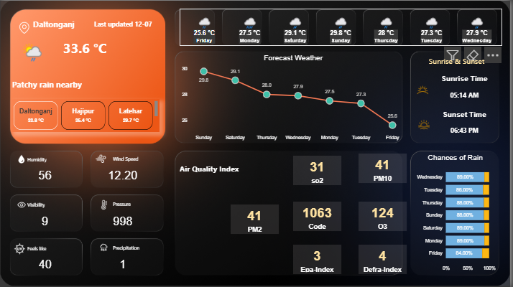  Weather API Dashboard Project Documentation  Power_BI_Dashboard_Preparation | Abstract  Developed a Power BI dashboard using WeatherAPI to visualize forecasts for selected Indian cities. Integrated API data, built DAX measures, and created KPIs. Guided by a YouTube tutorial, the project highlights real-time weather analytics.  Prabhat Pathak
Table of Contents
Table of Contents 2
1. Project Overview 3
2. Tools and Technologies Used 3
3. API Source and Access 3
4. Data Extraction Process 3
5. Data Preparation and Reference Dataset Creation 3
6. Power BI Data Modeling 4
7. DAX Measures and KPIs 4
8. Date Conversion using DAX 4
9. Dashboard Design and Visualizations 4
10. Conclusion 4
11. Project Guidance Source 5

1. Project Overview
This project involves the creation of a Power BI dashboard to visualize weather forecasts using data retrieved from the WeatherAPI (https://www.weatherapi.com/api-explorer.aspx#forecast). The dashboard provides insightful KPIs, visualizations, and day-wise weather patterns for selected locations.

2. Tools and Technologies Used
- Power BI
- DAX (Data Analysis Expressions)
- WeatherAPI
- Microsoft Excel (for initial data prep)
- Python (optional, for API retrieval)

3. API Source and Access
The weather data is retrieved from WeatherAPI using the Forecast API endpoint.
API Key used: 37a227ee51****a29b3624562512** (masked for security purposes)
Base URL: https://api.weatherapi.com/v1/forecast.json
Example API Call:
https://api.weatherapi.com/v1/forecast.json?key=YOUR_API_KEY&q=Ranchi&days=3

4. Data Extraction Process
The data was retrieved using the above API calls for each of the following locations:
- Hajipur
- Daltonganj
- Latehar
- Satbarwa
- Ranchi
The JSON responses were parsed and exported to CSV/Excel format before importing into Power BI.

5. Data Preparation and Reference Dataset Creation
A master table was created with the list of all locations. This served as a reference dataset to map and filter the weather data per location in Power BI. Each record was enriched with metadata like State, Region, and Coordinates.

6. Power BI Data Modeling
The imported datasets were structured into fact and dimension tables. Relationships were established between the master table (locations) and the weather forecast tables. The model was cleaned for unnecessary columns and optimized for performance.

7. DAX Measures and KPIs
Custom DAX measures were created to compute metrics such as:
- Avg_Temperature = AVERAGE(Weather[temperature])
- Total_Rainfall = SUM(Weather[rain_mm])
- Max_Humidity = MAX(Weather[humidity])
KPIs included:
- Temperature Status: Good / Moderate / High
- Rainfall Alerts

8. Date Conversion using DAX
To convert date fields into day names for easier visualization and trend analysis, the following DAX was used:
Day_Name = FORMAT(Weather[forecast_date], "dddd")

9. Dashboard Design and Visualizations
The dashboard included the following elements:
- Slicer for Locations
- Line chart for Temperature over Days
- Column chart for Rainfall comparison
- Card KPIs for Max Temperature, Humidity
- Matrix visual for daily breakdown

10. Conclusion
This project provided a practical implementation of API integration, data modeling, DAX usage, and visualization in Power BI. The Weather Dashboard offers a comprehensive and interactive view of weather patterns in selected locations, which can be extended to any global location supported by the API.

11. Project Guidance Source
This Power BI Weather Dashboard project was developed with guidance from the YouTube channel The Developer. The tutorial video titled “How to Create a Weather Forecast Dashboard in Power BI | Weather API Integration” provided step-by-step instructions for integrating WeatherAPI with Power BI.
🔗 Watch the tutorial here
The video was instrumental in helping understand:
- API integration in Power BI
- Creating and transforming JSON queries
- Designing interactive and user-friendly dashboards
- DAX usage for time-series and metric calculation
Proper credits are extended to the creator for their valuable content that helped shape this project.

