Horizon Financial Group – Loan Default Risk Analysis
Objective: Identify key drivers of loan defaults and recommend underwriting thresholds to reduce default rates.

Executive Summary
Analysis of more than 600 personal loans indicates that credit score and debt-to-income (DTI) ratio are strong predictors of default risk. Borrowers with low credit scores and high DTI ratios exhibit substantially higher default rates. Certain loan purposes, such as Wedding and Home Improvement loans, also show elevated risk.

Methodology
1. Loaded borrower and loan application datasets.
2. Checked data quality, null values, and data types.
3. Joined datasets using borrower_id.
4. Created risk buckets for credit score and DTI.
5. Calculated default rates by segment.
6. Compared loan purposes and default behavior.
7. Developed underwriting recommendations.

Credit Score Analysis
Credit Score Bucket | Total Loans | Defaults | Default Rate
520-599 | 116 | 57 | 49.14%
600-649 | 93 | 27 | 29.03%
650-699 | 75 | 21 | 28.00%
700-749 | 86 | 14 | 16.28%
750+ | 231 | 27 | 11.69%
Finding: The 520–599 credit score bucket has the highest default rate (49.14%), while borrowers with scores above 750 have the lowest default rate (11.69%).

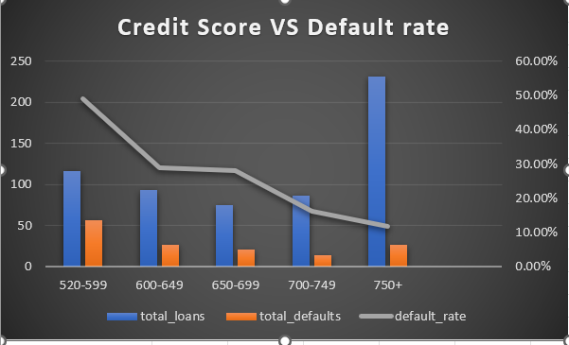

DTI Analysis
DTI Bucket | Total Loans | Defaults | Default Rate
90-100% | 12 | 5 | 41.67%
70-89.99% | 62 | 23 | 37.10%
100%+ | 22 | 8 | 36.36%
50-69.99% | 175 | 57 | 32.57%
30-49.99% | 204 | 35 | 17.16%
0-29.99% | 126 | 18 | 14.29%
Finding: Default rates increase significantly once DTI exceeds 50%. Borrowers with DTI above 70% show default rates above 37%.

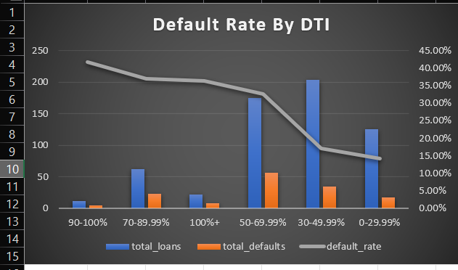

Loan Purpose Analysis
Loan Purpose | Total Loans | Defaults | Default Rate
Wedding | 56 | 18 | 32.14%
Home Improvement | 70 | 20 | 28.57%
Auto Loan | 59 | 16 | 27.12%
Business Loan | 58 | 14 | 24.14%
Education | 53 | 12 | 22.64%
Finding: Wedding loans have the highest observed default rate, followed by Home Improvement and Auto Loans.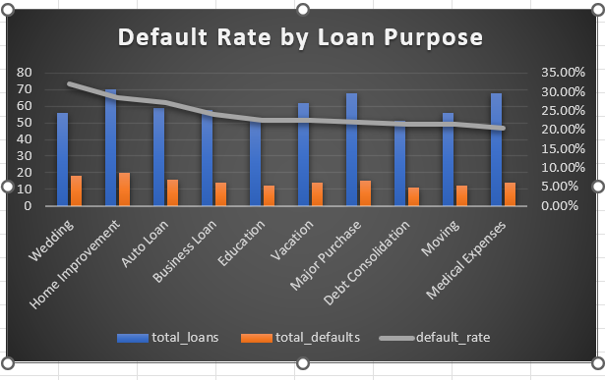

Key Risk Factors
- Low Credit Score (<600)
- High DTI Ratio (>50%)
- Higher-risk loan purposes (Wedding, Home Improvement, Auto Loan)

Recommendations
1. Set a minimum credit score threshold of 650 for standard approvals.
2. Require additional review for DTI above 50%; consider declining applications above 70%.
3. Apply stricter underwriting criteria for high-risk loan purposes.
4. Incorporate credit score and DTI as primary inputs in the risk model.
5. Monitor default trends quarterly and recalibrate approval thresholds.

