**DWIT COLLEGE**

**DEERWALK INSTITUTE OF TECHNOLOGY**

**Tribhuvan University**

**Institute of Science and Technology**



**BACKEND DEVELOPER OF BIDHEE CONSTRUCTION CRM**

**INTERNSHIP WORK REPORT**

**Submitted to**

**Department of Computer Science and Information Technology**

**DWIT College**

***In partial fulfillment of the requirements for the Bachelor’s Degree in Computer Science and Information Technology***

Submitted by

Milan Budhathoki

5-2-1175-45-2015

December, 2019

**DWIT College**

**DEERWALK INSTITUTE OF TECHNOLOGY**

**Tribhuvan University**

**MENTOR’S RECOMMENDATION**

I hereby recommend that this internship report prepared under my supervision by Sabin Pathak entitled “**Back End Developer of Bidhee Construction CRM**” be processed for evaluation as fulfilling in partial requirements for the degree of Bachelor of Science in Computer Science and Information Technology.

______________________

Mr. Om Prakash Jagri

Software Engineer

Bidhee Pvt. Ltd.

(Internship Mentor)

**DWIT College**

**DEERWALK INSTITUTE OF TECHNOLOGY**

**Tribhuvan University**

**SUPERVISOR’S RECOMMENDATION**

I hereby recommend that this internship report prepared under my supervision by Sabin Pathak entitled “**Back End Developer of Bidhee Construction CRM**” is accepted as fulfilling in partial requirements for the degree of Bachelor of Science in Computer Science and Information Technology.

______________________

Mr. Ritu Raj Lamsal

HoD, Department of Electronics

DWIT College

(Internship Report Supervisor)

**DWIT College**

**DEERWALK INSTITUTE OF TECHNOLOGY**

**Tribhuvan University**

**LETTER OF APPROVAL**

This is to certify that this internship report prepared by Sabin Pathak entitled “**Back End Developer of Bidhee Construction CRM**” in partial fulfillment of the requirements for the degree of Bachelor of Science in Computer Science and Information Technology has been well studied. In our opinion, it is satisfactory in the scope and quality as a project for the required degree.

______________________ _____________________

Mr. Ritu Raj Lamsal Mr. Hitesh Karki

HoD, Department of Electronics DWIT College

DWIT College (Chief Academic Officer)

(Internship Report Supervisor)

_____________________ ________________________

Mr. Om Prakash Jagri Mr. Bikash Balami

Software Engineer Assistant Professor, CDCSIT

Bidhee Pvt. Ltd, Kathmandu IOST, Tribhuvan University

(Internship Mentor) (External Examiner)

# ACKNOWLEDGMENT

I would like to thank my supervisor Mr. Ritu Raj Lamsal, HoD, Department of Electronics, DWIT College for his continuous support, expert advice and encouragement help in completing this internship report, its organization and its content. I would also like to thank DWIT college committee for their continued support and encouragement.

I would also like to express my special gratitude to Bidhee Pvt. Ltd. for providing me an internship opportunity. I would like to express my special thanks to Mr. Om Prakash Jagri (Software Engineer), Mr. Rajendra Moktan (Software Engineer) and Mr. Prakash Gharti (Software Engineer) for their guidance to tackle various problems during my internship period.

Finally, I would like to express my sincere thanks to the entire Care Manager team for their valuable guidance and support, my parents and family members, who have always supported me and to all my seniors, juniors and friends who directly or indirectly helped me.

Milan Budhathoki

TU Exam Roll no: 7454/072

# ABSTRACT

Bidhee Construction CRM provides you powerful, easy to use, dynamic and secure cloud based system for planning, managing, prioritizing, reporting and delivering construction projects.

This report provides insights on the internship work carried out as a back end developer for major modules of Bidhee Construction CRM. It is the responsibility of a back-end developer to fix the bugs present in the back-end site of the existing applications, add new features based on the specifications provided and work on the support for the features added.

This report puts emphasis on the main technical tasks carried out during the internship period. To add new incentive programs based on the specifications provided and it also highlights technical workflow of the task done during the internship period.

**Keywords**: *Software Development, Functional Requirement, Non-functional Requirement, Agile Development, Composer, Laravel.*

# LIST OF FIGURES

Figure 1: Organization Hierarchy of Bidhee Pvt. Ltd. 2

Figure 2: HR use case diagram 11

Figure 3: Store Keeper use case diagram. 11

Figure 4: Project Manager use case diagram 12

Figure 5: Tender Bid Manager use case diagram 12

Figure 6: Admin use case diagram 13

Figure 7: Architectural design of Laravel Application 15

Figure 8: Model-View-Controller Architecture [1] 16

Figure 9: Agile development methodology 18

# ABBREVIATIONS

|  |  |
| --- | --- |
| CEO | Chief Executive Officer |
| CFO | Chief Financial Officer |
| CM | Care Manager |
| CTO | Chief Technology Officer |
| IDE | Integrated Development Environment |
| JDK | Java Development Kit |
| MVC | Model-View-Controller |
| PM | Project Manager |
| QA | Quality Assurance |
| QC | Quality Control |
| QM | Quality Manager |
| SQL | Structured Query Language |
|  |  |
|  |  |
|  |  |
|  |  |

|  |  |
| --- | --- |
|  |  |
|  |  |

# TABLE OF CONTENTS

ACKNOWLEDGMENT v

ABSTRACT vi

LIST OF FIGURES vii

ABBREVIATIONS viii

TABLE OF CONTENTS ix

CHAPTER 1: INTRODUCTION 1

1.1 Introduction 1

1.1.1 Organizational Overview 2

1.1.2 Organizational Structure 2

1.2 Problem Statement 4

1.3 Objectives 4

1.4 Responsibilities Assigned 4

1.5 Motivation 5

1.6 Limitations 5

1.7 Internship Constraints and Prerequisites 5

1.8 Core Internship Tasks 6

1.9 Report Organization 6

CHAPTER 2: LITERATURE REVIEW 8

2.1 Laravel 8

2.2 Composer 8

2.3 mySQL 8

CHAPTER 3: ANALYSIS 10

3.1 Requirement Collection 10

3.2 System Requirements 10

3.2.1 Functional Requirements 10

3.2.2 Non-Functional Requirements 11

3.2.3 Use Case Diagram 11

3.3 Feasibility Study 14

CHAPTER 4: DESIGN 15

4.1 Architectural Design 15

4.2 Software Architecture Used 15

CHAPTER 5: IMPLEMENTATION 17

5.1. Development Technical Tools 17

5.1.1. PHP storm as IDE 17

5.1.2. MySQL Workbench for MySQL operations 17

5.1.3. Slack as a communication medium 17

5.2 Development Methodology 18

5.3. Workflow of project 19

CHAPTER 6: TESTING 20

6.1. Testing 20

6.2. Deployment 20

CHAPTER 7: CONCLUSION 21

7.1 Conclusion 21

7.2 Lessons Learnt 22

REFERENCES 24

# CHAPTER 1: INTRODUCTION

## Introduction

The internship was carried out working as a developer for “Bidhee Construction CRM” which is a web application of Bidhee Pvt. Ltd. “Bidhee Construction CRM” is a web application and provides powerful, easy to use, dynamic and secure cloud-based system for planning, managing, prioritizing, reporting and delivering construction projects as well as providing equipment by the vendors. Some of the modules of Bidhee Construction CRM are Employee Information System, Human Resource Management, Payroll, Equipment Management, Project Management, Vendor Management, Warehouse Management, BOQ Management, Tracking Management, Procurement etc. The major features available in Bidhee Construction CRM are the Customizable User Dashboards, Employee Profile, Organization Management, Attendance Management, Leave Management, Shift Management, Document Management, Holiday Management, Payroll Generation, Tender Bid Management, Employee Assignment, Vehicle Management, Equipment Management etc. Besides the major features, it also provides some additional advanced features such as Real Time Notification, Customized Reporting etc. There are many benefits of using Bidhee Construction CRM in the construction industry. From project planning to project completion, Bidhee Construction CRM offers numerous advantages. Bidhee Construction CRM could control expenses and budgetary allocations. This ERP helps in planning of Raw Materials, Effective Use of Labor, Architectural Designing and Scheduling. It also avoids unnecessary delay and issues with contractors in the duration of the project. Bidhee Construction CRM software for construction can be used to determine accurate estimation for raw materials, designs, labor, equipment, vehicles, and project duration. It also helps the contractors to find out the profit/ loss in each project. It also makes information access and sharing easier.

### Organizational Overview

Bidhee Pvt. Ltd. was established in 2014 with the purpose of transforming ideas into digital platform by fulfilling custom need of clients. Today it is among the leading companies in Nepal for developing and deploying innovative products and services in the field of Mobile & Web technology. The core focus is to digitalize customer needs, develop software for fulfillment of client’s goal/milestone achievement and create an innovative product to improve/enhance organization’s ability in terms of day to day performance and decision making. The core products are ERP for different business sectors, construction management system (especially focus on digitalizing construction business), Supply chain management, Inventory management, HR and payroll management, Sales CRM, project management system and customized software solution. Bidhee has been able to serve array of leading organizations Nationally and Internationally. Bidhee has been able to work with impressive giant names like: Ministry of Energy, US Embassy, US Education Foundation (USEF), Con-tech Pvt. Ltd., Agni Group, ICIMOD, Varosa Services, Nagarik Republica Daily, Kathmandu World School, Buddha Travels, AP1 television and many other clients from around the world.

### Organizational Structure

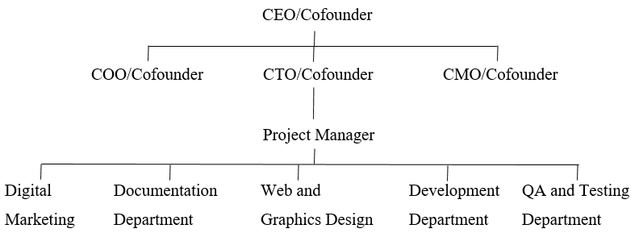

Figure 1: Organization Hierarchy of Bidhee Pvt. Ltd.

Figure 1 represents the overall organization hierarchy of Bidhee Pvt. Ltd. The chain of command splits into CEO, CTO, CMO, COO respectively.

**Board of directors:**

Bidhee Pvt. Ltd, Board of directors consists of,

* **Chief Executive Officer (CEO):** The CEO works closely with the Zen Lab overall team for overall management.
* **Chief Technology Officer (CTO):** CTO is responsible for the technology vision and the development effort for delivering high quality and cost-effective services and solutions.
* **Chief Marketing Officer (CMO):** The CMO leads the business development, client relations and strategy planning and execution for Bidhee Pvt. Ltd.
* **Chief Operating Officer (COO):** The COO organizes and manages the overall operation of the organization. COO is responsible for handling all the regular activities being conducted in Bidhee Pvt. Ltd.
* **Director:** Directors are involved in management of the Bidhee Pvt. Ltd.

**Senior Management**

Along with CEO and Directors Bidhee Pvt. Ltd, Senior Management consists of,

* **Project Manager:** Project Manager is responsible for managing the overall activities of the project from the very start until the project is completed. Project manager is responsible for system analysis and design, overlooks the development process, testing process, documentation process, integration process, deployment process and finally follows up with the users or customers for support and maintenance.

## Problem Statement

Requirements evolve and managing requirements evolution is necessary to meet the business needs of a customer and this applies for product based Software Company like Bidhee as well. In order to sustain in the market, evolution is the necessity. The continuous evolution of software system needs continuous application upgrade. To make the software system more robust, error free and capable to handle user’s demand, developers must work on it through bug fixes, maintenance, code refactors, and feature additions. Since a software solution is never cent percentage error free, the issues that are seen in the software products needs to be resolved.

Bidhee Construction CRM is responsible for maintaining all of the relationship details of its clients and the related information regarding those clients. It is also required to keep the details about the employee of the organization. Bidhee Construction CRM helps in managing the all of the aspects of an organization related to its customers, employee, contractors, vendors, payroll, etc.

## Objectives

* To learn about the workflow of a software company.
* To work in a team to solve problem and develop interpersonal skills.
* To implement features/support refactors according to the specifications provided.

## Responsibilities Assigned

* To research about existing methods and techniques to solve a problem.
* To complete the assigned task by the mentor.
* To find and fix bugs during software development.
* To make changes to the application whenever necessary.

## Motivation

I was keenly interested in the field of technology and only when I joined Bsc.CSIT I came to know that technology can only exist because of the advancement in the field of computer science and programming. I knew more about the advanced programming language and its importance in the field of technology.

All of the programming languages where new and I kept on learning new languages. It was exciting and it gave me the feel of achievement. That’s when I knew I wanted to be a developer who develops new advance products.

## Limitations

* This report does not cover all aspects of all modules of the products, Bidhee Construction CRM. It only focuses the technical details of major feature implemented during the internship period.
* Since every employee or interns who worked in Bidhee have to sign for company policy, they have to adopt some restrictions while sharing information. So, information regarding clients, bug details and core software details on which internship work was carried out sharing in this internship report might not be complete.
* Because of company policy, the backend structure of the products cannot be included in this report. The database structure and the architectural design of the products cannot be disclosed.

## Internship Constraints and Prerequisites

Most of the products of Bidhee are targeted for Non-Governmental Organizations, Government of Nepal and clients within Nepal. It is mandatory for developer and all other employees that all the works they perform should be performed inside the company’s perimeter. Any developer is not allowed to take the project code outside the work environment.

## Core Internship Tasks

As an intern of back end developer of Bidhee, one has to fix as many bugs in the software as possible. It is the responsibility of back-end developers to add new features as per the specifications provided, to provide support for the feature and to solve the exceptions that arises in the software project. Out of all these tasks, this report mainly focused on finding and fixing the bug as well as adding new features.

#### Finding and fixing bugs

Bugs are the essential part of any software development to improve the efficiency and productivity. Bugs can be encountered depending on the scenario of the application. Though Quality Assurance teams are responsible for finding bugs and reporting to the developers but certain level of testing is done by developers to find and fix the bug during development process.

#### Adding new feature

A client requirement for the software/product can vary throughout the software development process and it is the responsibility of a project manager to acquire the details of new feature from client. The acquired details is passed on to the developers who implement those ideas to the software/product.

## Report Organization

This project report is organized as follows:

* Chapter 2 describes the use of various software development methods and languages for software development.
* Chapter 3 introduces requirements collection procedures, system requirements and feasibility analysis.
* Chapter 4 describes about the architecture of the projects, workflow of the internship.
* Chapter 5 describes about how the system is implemented along with the tools used.
* Chapter 6 describes the testing procedure used in the internship and an example of unit test.
* Chapter 7 concludes the report. Conclusion and recommendation for this project are provided.

# CHAPTER 2: LITERATURE REVIEW

## 2.1 Laravel

The Laravel is a free, open-source PHP web framework, created by Taylor Otwell and was created for the development of web-based applications That follows the MVC architectural pattern and hugely based on Symfony. Laravel provides the features of modular packaging system with a dedicated dependency manager, accessing relational databases, utilities that aid in application deployment and maintenance.

## 2.2 Composer

Composer is an application-level package manager for the PHP that provides a standard format for managing the dependencies of PHP and libraries it requires. It was developed by Nils Adermann and Jordi Boggiano, with proper updates till date. They began development in April 2011 and first released it on March 1, 2012 Composer is strongly inspired by Node.js's "npm" and Ruby's "bundler".

Composer is based on command line interface and installs dependencies for the desired application. It also provides features to install PHP applications that are available from the repository containing the available packages.

## 2.3 mySQL

MySQL is an Oracle-backed open source relational database management system ([RDBMS](https://searchdatamanagement.techtarget.com/definition/RDBMS-relational-database-management-system)) based on Structured Query Language ([SQL](https://searchsqlserver.techtarget.com/definition/SQL)). MySQL runs on virtually all platforms, including [Linux](https://searchdatacenter.techtarget.com/definition/Linux-operating-system), [UNIX](https://searchdatacenter.techtarget.com/definition/Unix) and [Windows](https://searchwindowsserver.techtarget.com/definition/Windows). Although it can be used in a wide range of applications, MySQL is most often associated with web applications and online publishing. Originally conceived by the Swedish company MySQL AB, MySQL was acquired by Sun Microsystems in 2008 and then by Oracle when it bought Sun in 2010. Developers can use MySQL under the GNU General Public License ([GPL](https://searchdatacenter.techtarget.com/definition/GNU-General-Public-License-GNU-GPL-or-simply-GPL)), but enterprises must obtain a commercial license from Oracle.

# CHAPTER 3: ANALYSIS

## 3.1 Requirement Collection

Requirement collection was conducted by the Project Manager and the client as a result of periodic meetup. Designer was assigned to make a wireframe in according to the requirement collected and sent to feedback to the client. Requirement collection process was carried out till the client approves the wireframe.

## 3.2 System Requirements

The functional and non-functional requirements of the Bidhee Construction CRM are listed below:

### 3.2.1 Functional Requirements

In overview, the functional requirements are:

* The system allows the admin and users to log in to the system.
* The system allows PM who is responsible for the management of projects, material/equipment acquisition, employee management and vendor management.
* The system allows HR who is responsible for the employment management of the current employees at the organization, leave management of the employees, and assigning the department for the employees.
* The system allows Storekeeper who manages the acquired material/equipment.
* The system allows Tender bid officer who manages the project bids and manages the financial result of the organization.

### 3.2.2 Non-Functional Requirements

The non-functional requirements are:

* The system should be easy to use and navigate through.
* The system should be available 24 hours a day.
* The system should provide specific details to the specific users.
* The system should notify the admin about the changes in the system.
* The system should be responsive at all time.

### 3.2.3 Use Case Diagram

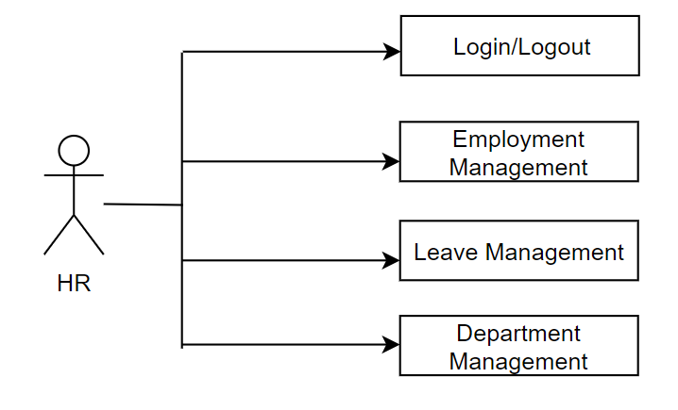

Figure 2: HR use case diagram

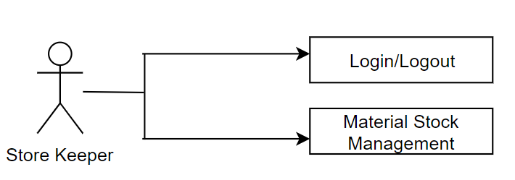

Figure 3: Store Keeper use case diagram.

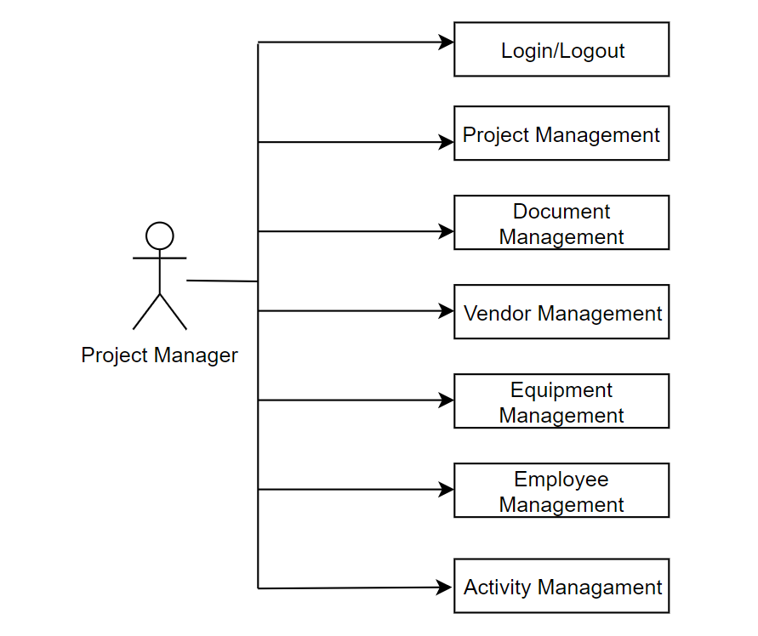

Figure 4: Project Manager use case diagram

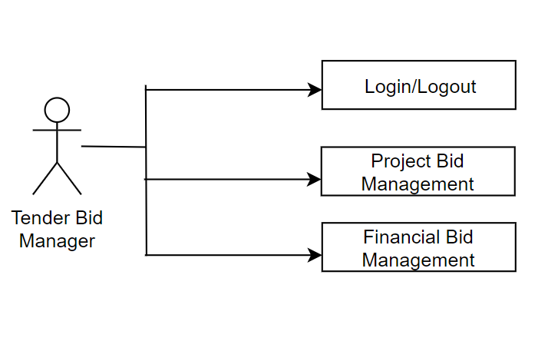

Figure 5: Tender Bid Manager use case diagram

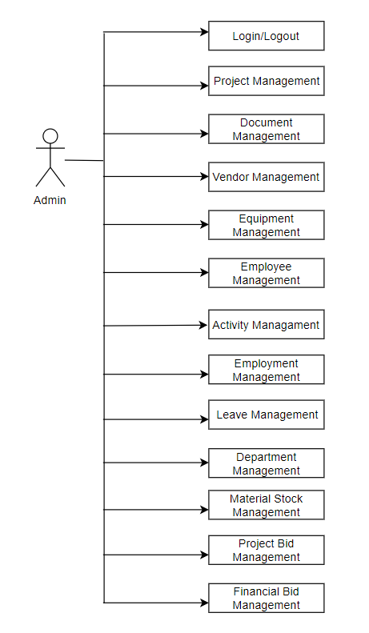

Figure 6: Admin use case diagram

## 3.3 Feasibility Study

Once the requirements get gathered by the requirement collection team, PM along with the other concerned authority will carry out the feasibility analysis of the collected requirements. They will verify whether the completion of the requirements collected is feasible or not along with the gathered resources based on different feasibility analysis parameters. The study of various parameters of feasibility are as follows:

* **Technical Feasibility:** Laravel provides a complete framework to develop the system with all the required modules and plugins available to the public. mySQL is a RDMS with proper linking to the application program. The developer can design the database schema as required by the system.
* **Operational Feasibility:** Laravel is an opensource framework with multiple features and plugins readily available to use. The framework is timely updated with newer version along with added features and security. mySQL is easily the most efficient and simple to use RDMS with very low latency and simple integration features.
* **Schedule Feasibility:** Since the system was to be built within three months, Choosing Laravel and SQLite reduced the time of development. The built-in support for the plugins and modules resulted in rapid development of the system.
* **Economic Feasibility:** Laravel is a light weight framework hence it can be used in relatively low powered machines with very low consumption of power and resources. SQLite is not a client–server database engine hence it is embedded in the application making load times faster and proper optimization of resources

# CHAPTER 4: DESIGN

## 4.1 Architectural Design

Bidhee Construction CRM is a proprietary software, and the architectural design of these software cannot be disclosed. Only, basic architectural design of application is shown in figure below:

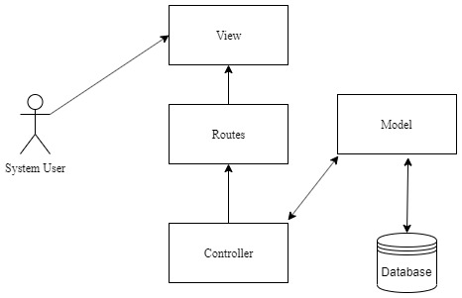

Figure 7: Architectural design of Laravel Application

## 4.2 Software Architecture Used

Both the application follows the Model-View-Controller (MVC) design pattern. The MVC pattern is a software architectural pattern that is used for the separation of Model from View components which makes it possible to implement several user interfaces that reuse the common core business logic [1].

The pattern not only defines the roles objects play in the application, but also defines the way objects communicate with each other [2]

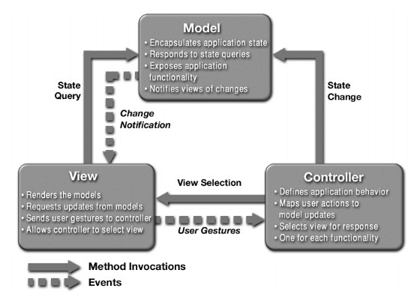

Figure 8: Model-View-Controller Architecture [1]

**Model**: The model manages the behavior and data of the application domain, responds to requests for information about its state (usually from the view) and responds to instructions to change state (usually from the controller).

**View**: The view manages the display of information.

**Controller**: The controller interprets the mouse and keyboard inputs from the user, informing the model and/or the view to change as appropriate.

# CHAPTER 5: IMPLEMENTATION

## 5.1. Development Technical Tools

Following technical tools were used during internship:

### 5.1.1. PHP storm as IDE

PhpStorm is a commercial, cross-platform IDE for PHP, developed by the Czech Republic-based company JetBrains. PhpStorm provides an editor for PHP, HTML and JavaScript with on-the-fly code analysis, error prevention and automated refactoring’s for PHP and JavaScript code.

### 5.1.2. MySQL Workbench for MySQL operations

MySQL Workbench for mySQL (DB4S) is a high quality, visual, open source tool to create, design, and edit database files compatible with mySQL.

### 5.1.3. Slack as a communication medium

Software development process is carried with certain people working together to complete the software. So, during the development process communication between the team members is a must and Bidhee Pvt. Ltd uses Slack as a medium of communication.

## 5.2 Development Methodology

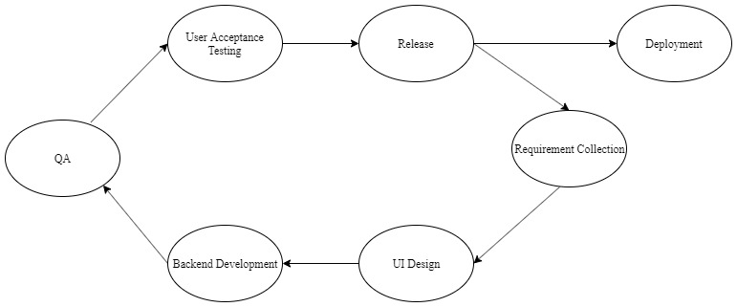

Figure 9: Agile development methodology

Bidhee uses agile methodology for software development. So, it works on sprint basis. Each sprint is around a month long and will go for release after every sprint. The sprint is planned based on the feature requirement documents provided. The tasks covering in the sprint is figured out and the deadline for the sprint is estimated.

In the development phase, Laravel release (version 5.8) was used to develop the website. JavaScript was used for DOM behavior manipulation to make the website more dynamic and efficient. And finally, the CSS framework Bootstrap was used to bind everything together and enhance the overall look and feel of the website. The main advantage of developing the system in Laravel was that the plugins and modules made it very efficient to quickly develop the features of the system according to the client’s preferences.

## 5.3. Workflow of project

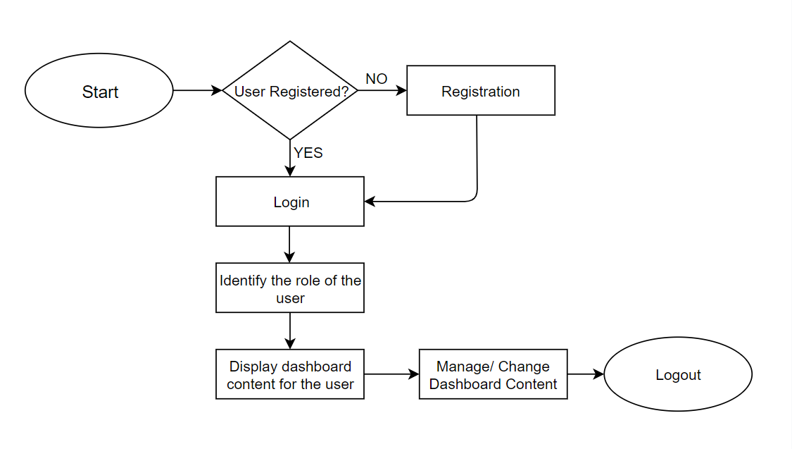

Figure 10: Workflow of project

# CHAPTER 6: TESTING

## 6.1. Testing

The Quality Analysis and the User Acceptance Testing falls under this category. The QA engineers perform series of testing to ensure proper functioning of the system. After the feature successfully passes the QA testing, it is put through user acceptance testing. This ensures that the feature is functioning exactly as it was defined by the client.

## 6.2. Deployment

Once the feature is properly functioning, it will enter the staging area for deployment. The “master” branch in GitLab was used as a staging branch from where the feature was deployed into the client’s server.

# CHAPTER 7: CONCLUSION

## 7.1 Conclusion

Within the course of my internship in Bidhee Pvt. Ltd. I was able to experience an environment where there was mutual understanding between the team members, building up of strategies to solve the problems.

I am thankful to my mentor who helped me to understand the flow of Laravel platform when I was just a beginner. I am thankful to my seniors who helped me to understand the work environment and carried me along with the team members. I was able to understand how to carry a team along, solve the arising problems, meet the deadline of the project.

It helped to enhance problem solving skills and critical thinking. Most of all, it provided an opportunity to work in a team and helped me learn working in a team environment and collaborative working strategies. Besides, this the internship period proved to be a great platform to learn and improve communication skills with regular information exchange with mentor and the clients.

All in all, it was a great internship experience as it helped to understand how a software company handles project. It expanded the extent of knowledge on solving problems and approaching projects with the consideration of time and effort.

## 

## 7.2 Lessons Learnt

The internship in one of the growing IT companies of Nepal, Bidhee Pvt. Ltd., has helped me a lot to be familiar with new technology, to work under pressure, to work in a team environment and many more. And, working with multiple features and bugs simultaneously in a single sprint and handling immediate and urgent bugs have assisted in enhancing professionalism to meet deadlines enhances my capacity to work under pressure.

Moreover, the technical tasks that were undertaken during the internship period have helped the me in improving software development and debugging skills. It has helped in gaining knowledge about various technical tools and frameworks used in software development and the process that should be followed for proper development completion.

Furthermore, the internship has facilitated me in understanding how IT company in Nepal operates. Also, working as an intern in one of the growing IT companies of Nepal, has boosted the confidence and has polished my professionalism as well as soft skills in the IT sector.

# REFERENCES

[1]. Design Patterns: Model View Controller (MVC) Pattern - 2018. (2019). Retrieved from https://www.bogotobogo.com/DesignPatterns/mvc_model_view_controller_pattern.ph p

[2]. Model-View-Controller. (2019). Retrieved from https://developer.apple.com/library/content/documentation/General/Conceptual/DevPedia-CocoaCore/MVC.html