e) The least square error is **74.113**, **ϴ0 = -0.064516** and **ϴ1 = 0.049948(**In additional: **Minimal cost function J = 0.686232)**;

f) 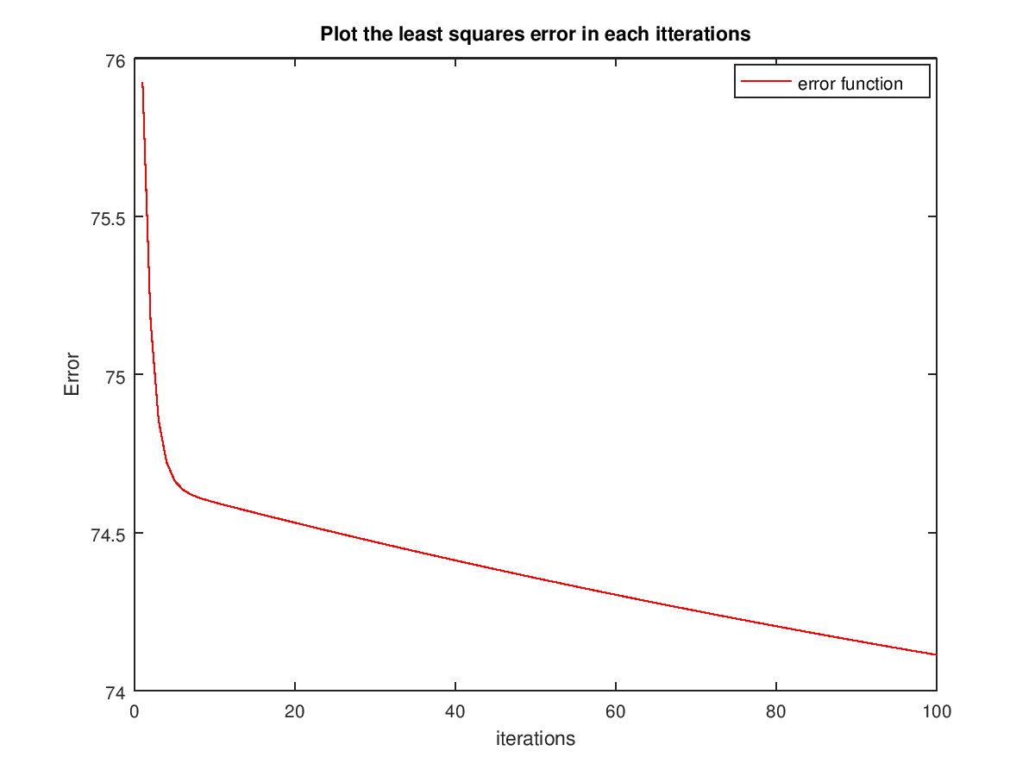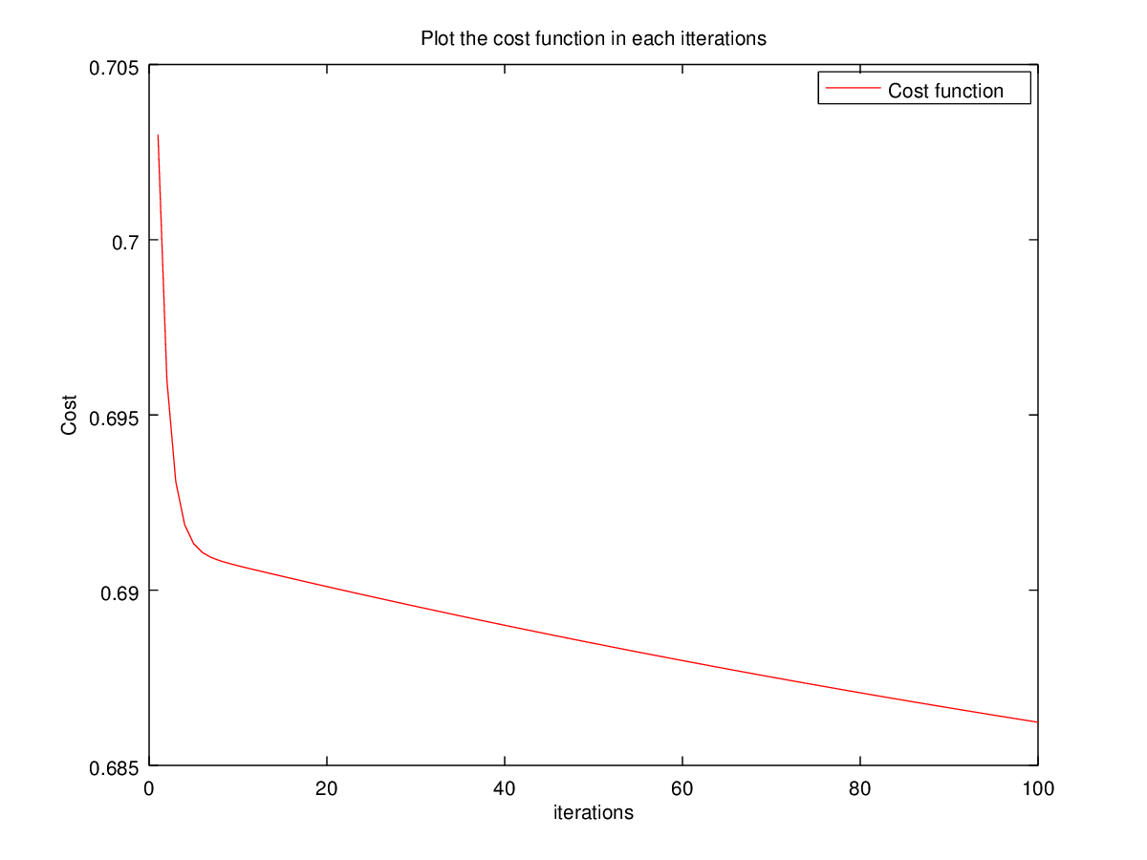

g) 