Initial data:

Number of iterations = 10000, α=.00001, **θ**0=0.1, **θ**1=0.1, θ2=0.1 .

a)

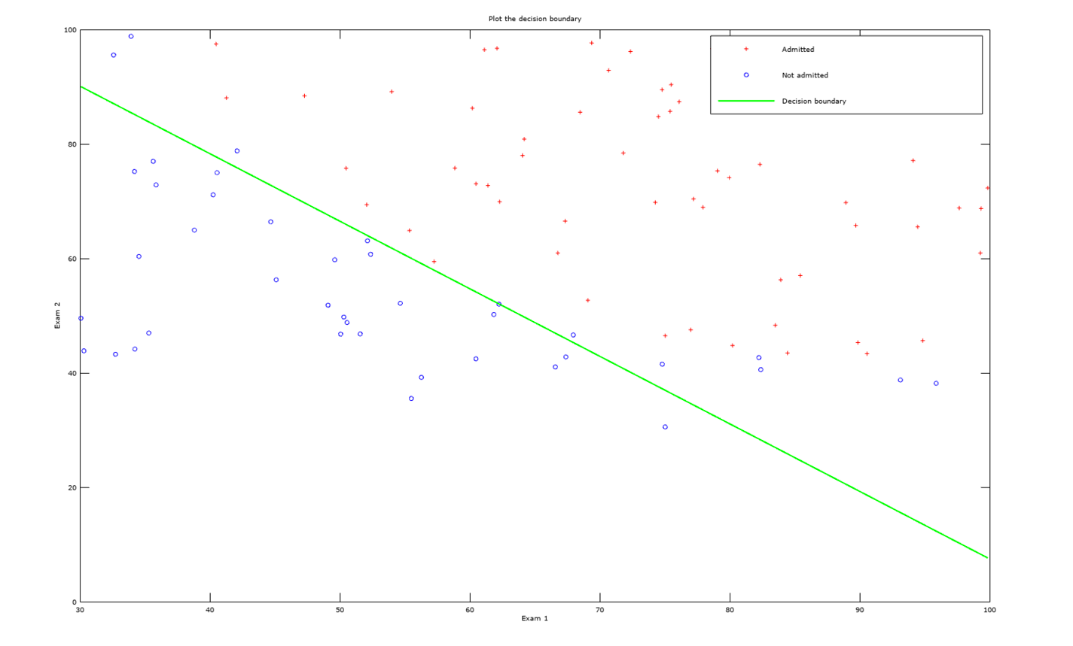

b) **Minimal cost function is 38.902367**

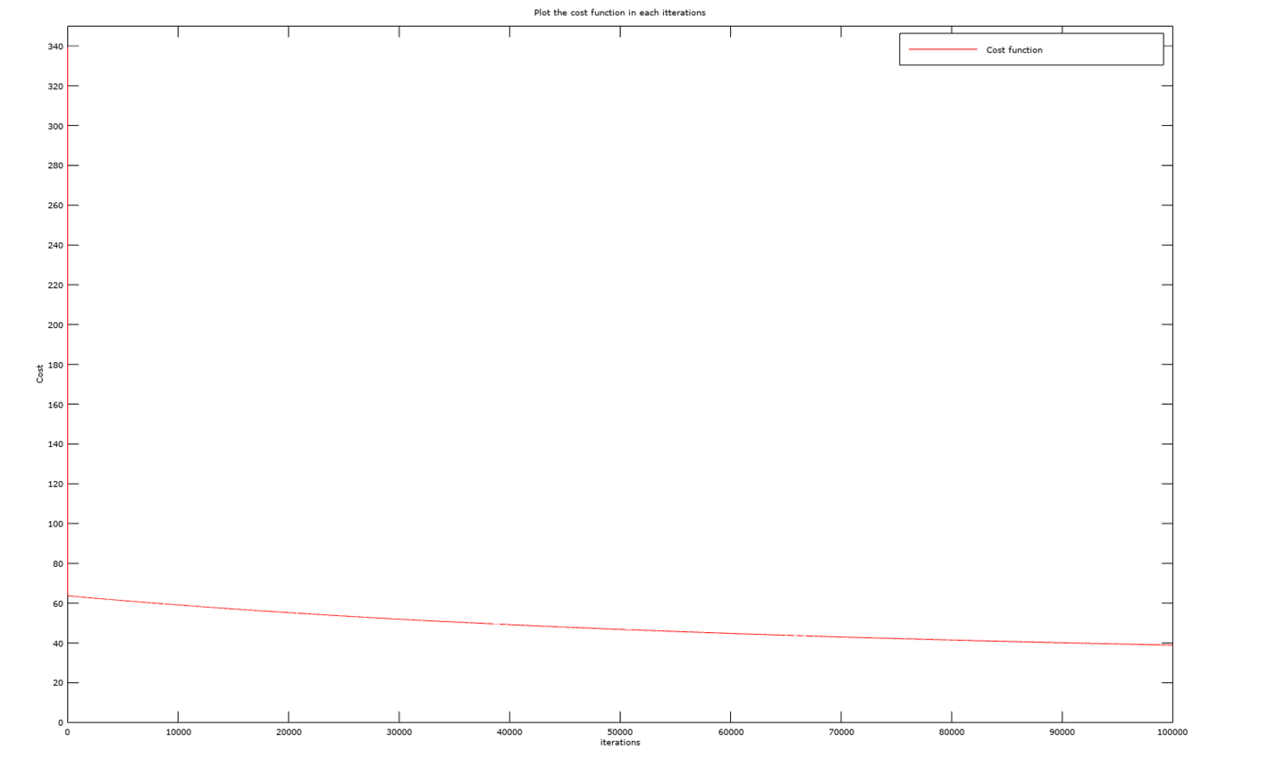

c) **θ1 is 0.044800 θ2 is 0.037951**

d) According to our model a candidate with scores exam1 = 100 and exam2 = 50 has probability **83,375%**

