Number of iterations for one random initialization of centroids = 100;

Number of random of initialization of centroids = 50

Min error = 1518860.611400

Incorrect classification = 404

Accuracy = 0.596

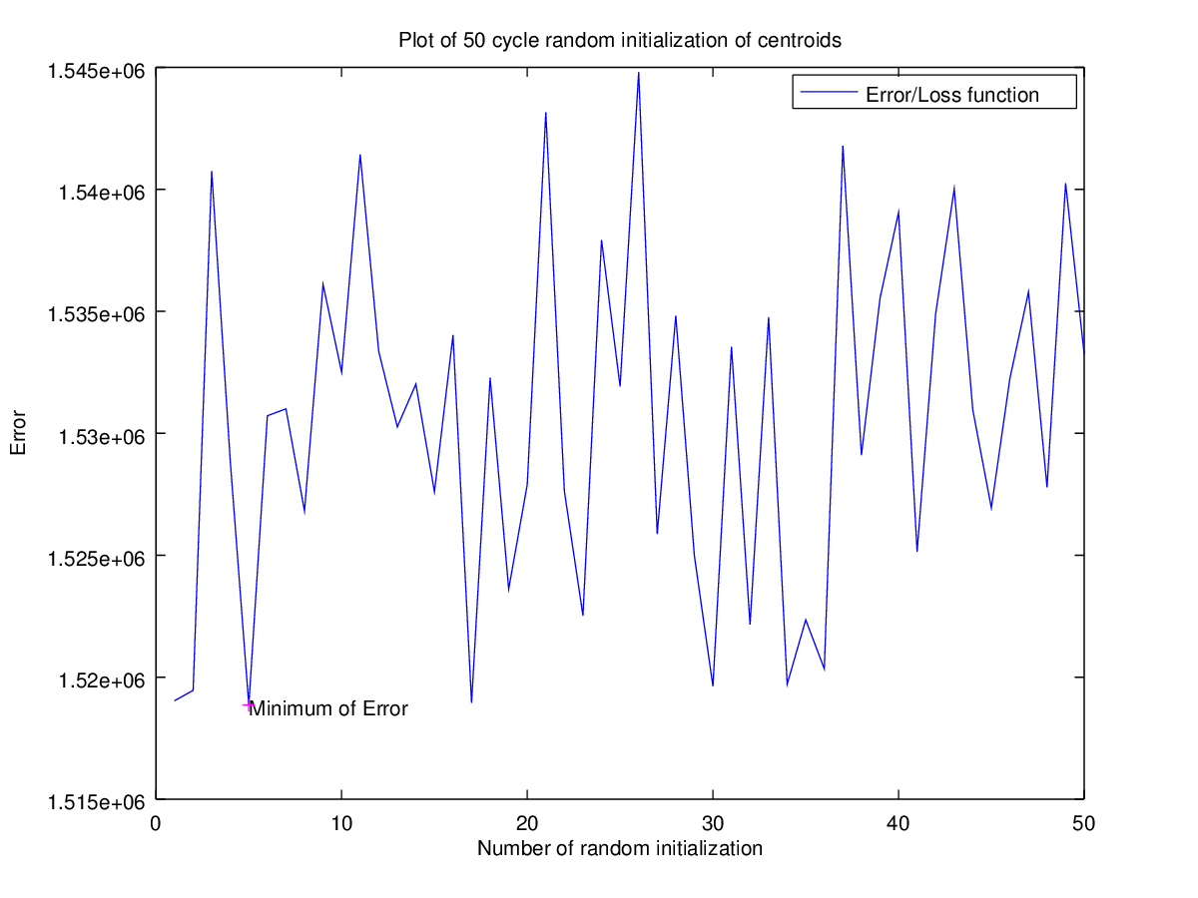

Histogram of digits in MNIST set.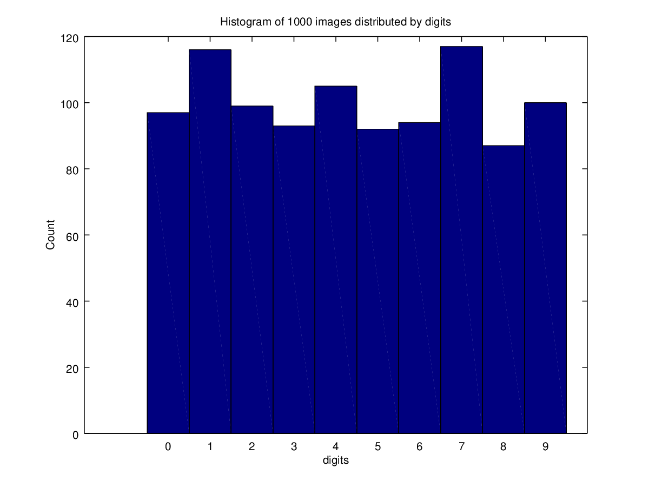

And histogram of our classification.

