In order to move along, below is an explanation of interleaving:

----------------------------------------------------------------------

Bursty Errors and Coding:

----------------------------------------------------------------------

Suppose that error bursts last up to 5msec in a radio environment.

At 10kbps, this means that errors come in burst of up to 50 errors.

Coding is good at correcting isolated, occasional errors. For instance

the BCH (40,28) code can correct 5 errors in 40bits. This implies that

to correct 50 errors, codewords would have to be 100's of bits longs.

The longer the codeword, the harder to decode.

Consider the following:

Cij is the jth bit of the ith codeword.

Normally a channel might send codewords in order:

C11, C12, C13, ..., C1n, C21, C22, C23, ...

xxxxxxxxxxxxxxxxxxxxxxxxxxxxxxxxxx

This means that bursts of errors (shown by x's) would fall on whole

codewords at a time in which case no short codeword coding scheme would

help.

----------------------------------------------------------------------

Interleaving:

----------------------------------------------------------------------

Overall the error rate on the bursty channel can be low, e.g. 10^-3 or lower.

The errors that do occur are simply grouped in bursts.

This suggests the following scheme. Group m codewords at a time and

send the first bit of each codeword than the second and so on:

C11, C21, C31, ..., Cm1, C12, C22, C32, ...

xxxxxxxxxxxxxxxxxxxxxxxxxxxxxxxxxx

Now a burst of errors would fall across many codewords with each

codeword responsible for a few errors. This would allow short, easy to

decode, codewords to be used.

----------------------------------------------------------------------

Interleaver Matrix:

----------------------------------------------------------------------

A simple way to think about interleaving is to group the m codewords in

a matrix with one codeword per row:

C11, C12, ..., C1n | Codeword 1

C21, C22, ..., C2n | Codeword 2

. | .

. | .

. | .

Cm1, Cm2, ..., Cmn | Codeword m

In this setup codeword bits are written in row by row and then read out

column by column.

At the receiver, the bits are read in column by column and read out row

by row to recreate the original stream.

In between, the bursts of errors are distributed down columns spreading

over several codewords.

----------------------------------------------------------------------

Interleaving Impact:

----------------------------------------------------------------------

The impact of interleaving is to make the errors appear to the coding

as more random and distributed. Thus, the coding can do its job.

Interleaving does not change the data rate or throughput.

Interleaving requires almost no computing power, only storage for the

matrix.

For streaming data, interleaving does add a delay of (mn bits)/(channel

bit rate). This can be significant in real-time applications. For store

and forward data networks, this is just an alternative way of storing

the data and so it does not have any impact.

----------------------------------------------------------------------

Macro Interleaving:

----------------------------------------------------------------------

The same concepts can be applied at a larger level, where the Cij are

not bits, but blocks of data. For instance in GSM one packet of data is

divided into 8 sub-packets and then packets are interleaved in an 8x8

matrix.

This gives even greater diversity (in GSM especially since different

packets can be sent on different frequencies). This allows for recovery

of whole packets if they fall within a fade since errors will fall

across 8 of the original packets and then the Micro interleaving will

spread these errors evenly within each packet.

This adds even greater delays.

----------------------------------------------------------------------

Summary:

----------------------------------------------------------------------

Interleaving "spreads the pain" of errors uniformly across codewords.

It cost nothing in throughput and complexity but does add delays to

streaming data.

**Interleaving - Speech Transmission in GSM**

Interleaving is a process of dispersing the bits of a data burst over multiple bursts in a systematic way. Benefit of this technique: when a data-burst is lost (due to burst error in the radio interface) it does not mean a 100% loss of a single burst rather a partial loss of many bursts

**First level of interleaving**

The channel coder provides 456 bits for every 20 ms of speech which are interleaved in eight blocks of 57 bits shown below.

[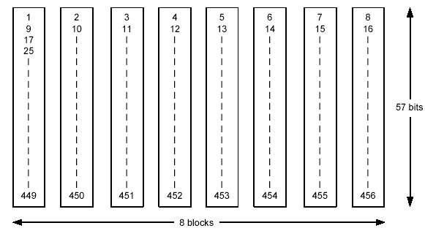](http://4.bp.blogspot.com/-HBuplEUmmzw/VJJ27KUxZrI/AAAAAAAAPGM/F2NpoP39aY0/s1600/1.png)

In a normal burst, there is space for two of these speech blocks (Figure). Thus, if one burst transmission is lost, there is a 25% BER for the entire 20 ms of speech (2/8= 25%).

[http://3.bp.blogspot.com/-M-ri_l875Bg/VJJ27VGwvWI/AAAAAAAAPGQ/73PwZrTU91o/s1600/2.png](http://3.bp.blogspot.com/-M-ri_l875Bg/VJJ27VGwvWI/AAAAAAAAPGQ/73PwZrTU91o/s1600/2.png)

**Second level of interleaving**

If only one level of interleaving is used, a loss of this burst results in a total loss of 25%. This is too much for the channel decoder to correct. A second level of interleaving can be introduced to further reduce the possible BER to 12.5%.

Instead of sending two blocks of 57 bits from the same 20 ms of speech within one burst, a block from one 20 ms and a block from next sample of 20 ms are sent together. A delay is introduced in the system when the MS must wait for the next 20 ms of speech. However, the system can now afford to lose a whole burst, out of eight, as the loss is only 12.5% of the total bits from each 20ms speech frame. 12.5% is the maximum loss level that channel decoder can correct.

[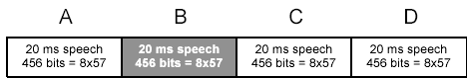](http://1.bp.blogspot.com/-2PPo_oVXyZ0/VJJ27e9wdZI/AAAAAAAAPGY/-n9w8NvXY0c/s1600/3.png)

**Speech Frame**

[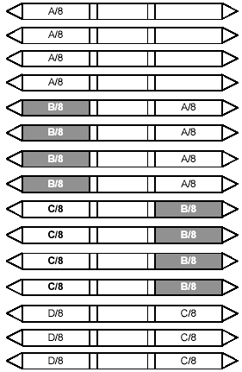](http://2.bp.blogspot.com/-jPKTpHnh2VM/VJJ28hjtRNI/AAAAAAAAPGg/SpKYMgOcsY0/s1600/4.png)

The bits must then be sent over the air using a carrier frequency. GSM uses the GMSK modulation technique. The bits are modulated onto a carrier frequency and transmitted.

--

**A. Speech coding:**

* GSM speech coder is RELP (Residually Excited Predictive Coder), which is enhanced by including a Long Term Predictor (LTP).
* The coder provides 260 bits for 20ms blocks of speech, which yields a bit rate of 13kbps.
* GSM system operates in Discontinuous Transmission mode (DTX) by incorporating a Voice Activity Detector (VAD) in speech coder. This mode provides a longer battery life and reduces instantaneous radio interference since GSM transmitter is not active during silent periods.
* A Comfort Noise Subsystem (CNS) is used at receiver which adds background acoustic noise to compensate for the annoying switched muting which occurs due to DTX.

**B. Channel coding:**

* The outputs of the speech coder are ordered into for error protection, based upon their significance in contributing groups to speech quality.
* Out of 260 bits in a frame, the most important 50 bits called type Ia bits, have 3 parity check (CRC) bits added to them to detect non-correctable errors at the receiver.
* The next 132 bits with first 53 are appended by 4 trailing zero bits, thus providing a data block of 189 bits. This block is then encoded for error protection using a rate ½ convolution encoder with constant length K=5, thus providing a sequence of 378 bits.
* The least important 78 bits do not have error protection and concatenated to existing sequence to form a block of 456 bits in 20ms frame, data rate of speech signal becomes 22.8kbps.

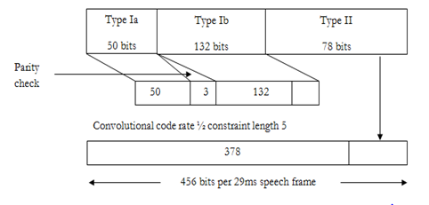

**C. Interleaving:**

* To minimize the effect of sudden fades on the received data, the total of 456 encoded bits within each 20ms speech frame or control message frame are broken into eight 57 bits sub blocks and they are numbered even odd according to block number. These eight consecutive blocks are spread over eight consecutive TCH time slot.
* If a burst is lost due to interference or fading, channel coding ensures that enough bits will still be received correctly to allow the error correction to work.
* Each TCH time slot carries two 57 bits blocks of data from two different 20ms speech blocks. Time slot of first 4 frames contains even data blocks of present speech frame and odd data block of previous speech frame. Time slot of next 4 frames contains odd blocks of present speech frame and even data block of next speech frame.

**D. Burst formatting:**

Burst formatting adds binary data to the data block to help synchronization and equalization of the received signal.

**E. Ciphering:**

* Ciphering modifies the contents of the eight interleaved blocks by encryption techniques known only to the particular mobile station and base transceiver station.
* The A3 ciphering algorithm is used to authenticate each mobile by verifying the user password within the SIM with the cryptographic key at the MSC.
* The A5 ciphering algorithm is used for encryption. It provides scrambling for 114 coded bits sent in each TS.
* The A8 is used for ciphering key.

**F. Modulation:**

* The modulation scheme used by GSM system is 0.3GMSK where 0.3 describes 3db bandwidth of the Gaussian pulse shaping filter.
* The channel data rate of GSM is 270.833 kbps which is four times the RF frequency shift. This minimizes bandwidth of the modulation spectrum and hence improves channel capacity.
* MSK modulated signal is then passed through Gaussian filter to smooth the rapid frequency transitions which would otherwise spread energy in adjacent channels.

**G. Demodulation:**

* The portion of the transmitted forward channel signal which is of interest to a particular user is determined by the assigned TS and ARFCN. The appropriate TS is demodulated with aid of synchronization data provided by the burst formatting.
* After demodulation the binary information is deciphered, de-interleaved, channel decoded and speech decoded.

The Definition of [**Interleaving**](http://teletopix.org/tag/interleaving/) is simply encode [**logical channel**](http://teletopix.org/tag/logical-channel/) for error protection and security.lets understand how interleaving works in gsm.

Having encoded, or error protected the logical channel, the next step is to build its bit stream into bursts that can then be transmitted within the TDMA frame structure. It is at this stage that the process of interleaving is carried out. Interleaving spreads the content of one traffic block across several TDMA timeslots.

The following interleaving depths are used:

Speech – 8 blocks

Control – 4 blocks

Data – 22 blocks

This process is an important one, for it safeguards the data in the harsh [**air interface**](http://teletopix.org/tag/air-interface/) radio environment. Because of [**interference**](http://teletopix.org/tag/interference/), noise, or physical interruption of the radio path, bursts may be destroyed or corrupted as they travel between MS and BTS, a figure of 10–20% is quite normal.

The purpose of interleaving is to ensure that only some of the data from each traffic block is contained within each burst. By this means, when a burst is not correctly received, the loss does not affect overall [**transmission**](http://teletopix.org/tag/transmission/) quality because the error correction techniques are able to interpolate for the missing data. If the system worked by simply having one traffic block per burst, then it would be unable to do this and transmission quality would suffer.

It is interleaving that is largely responsible for the robustness of the GSM air interface, enabling it to withstand significant noise and interference and maintain the quality of service presented to the subscriber.

**[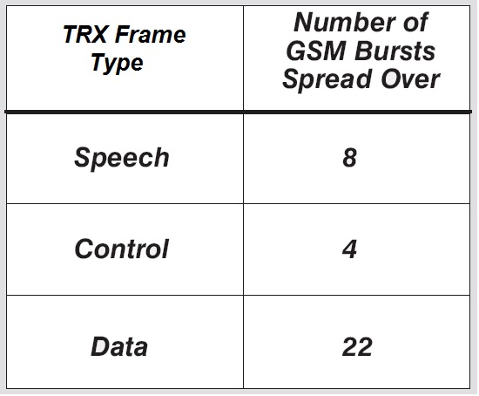](http://www.teletopix.org/wp-content/uploads/2013/02/interleaving-depth-gsm.jpg)**

There are two types of [**Interleaving in GSM**](http://teletopix.org/tag/interleaving-in-gsm/) **Diagonal Interleaving** and **Rectangular Interleaving**. From Which Diagonal Interleaving used in [**Speech interleaving**](http://teletopix.org/tag/speech-interleaving/) and Data interleaving and Rectangular Interleaving used for Control Interleaving.