Corporate Sales and Product Department |  | Treasury Division

SOLIDNESS & CONFIDENCE
ECONOMIC AND FINANCIAL REPORT |  |  |  | Week 42: 12.10 - 16.10.2026
Interbank money market:  The interbank interest rate market in the week 42 traded within a stable range, with the ON–2W tenors fluctuating between 3.1% and 5.0%. The State Bank of Vietnam (SBV) shifted to a net-injection position this week with over VND 13.3 trillion injected, lifting the outstanding OMO balance to VND 110 trillion. Short-term USD/VND swap points under 1 month fluctuated within a wide band of -0.5% to 1.8%, while 3–6 month swap rates remained steady between 2.0% and 2.9%.  Forecast: ON-2W interest rates are highly likely to  fluctuate to around 3.0%-5.5%. | Interbank interest rate |  | Breaking news:  - In September, total electronics export turnover reached USD 28.73 billion. Of which, computers and electronic components accounted for USD 22.56 billion (+112.7% YoY), while mobile phones reached USD 6.17 billion.  - UOB revised up its forecast for Vietnam's 2026 GDP growth to 9.2% (from the previous 8.5%), while raising its full-year average inflation forecast to 4.7%.  - Industrial production maintained double-digit growth in Q3/2026, lifting the nine-month Index of Industrial Production (IIP) by 12.3% year-on-year, marking the highest growth rate for the same period since 2019.
Foreign exchange market (USD-VND):  USD-VND exchange rate traded flat compared to the opening level earlier in the week, maintaining a stable trend and edging down toward 25,870. The rate briefly spiked to a peak of 25,980 for a short duration before correcting lower in tandem with the movement of the US dollar in international markets. The SBV reported that green credit outstanding in the first half of this year increased by nearly 10% compared to end-2025, reaching VND 856 trillion, equivalent to approximately 4.2% of the economy's total outstanding credit.  Forecast: Exchange rate is projected to fluctuate  within the region of 25,800 – 25,950. | USD-VND exchange rate in the interbank |  | Basis indicators:
   | 05.10-09.10 | 28.09-02.10 | Forecast
  Prime rate | 9% | 9% | 9%
  Discount rate | 3.00% | 3.00% | 3.00%
  Refinance rate | 4.50% | 4.50% | 4.50%
  Overnight rate | 5.00% | 5.00% | 5.00%
  OMO IR | 4.5% | 4.5% | 4.5%
  Central rate | 25,637 | 25,629 | 25,620
Bond market:  The bond market traded sideways across most tenors. Government bond yields on the secondary market ended at 3Y 3.85%; 5Y 4.38%; 7Y 4.46%; 10Y 4.55%; 15Y 4.72%. State Treasury successfully auctioned VND 11,452/18,000 billion offered. The winning yield for the 3Y tenor settled at 3.55%, while the 5Y tenor awarded VND 6.839/7.0 trillion offered at 4.27%, and the 10-year tenor awarded VND 4.413 trillion at 4.43%, both remaining unchanged from their prior auctions.  Forecast: Bond yield would fluctuate around 4.55 – 4.6% (10-year government bond). | Yield curve in the interbank market |  | Credit and deposit growth rate
  Sofr USD 1 month | Sofr USD 3 months | Sofr USD 6 months
  3.97183 | 4.11624 | 4.29534
  0.04718 | 0.07375 | 0.09394
  ECB interest rate | Fed interest rate | BOJ interest rate
  2.50% | 3.75%-4.00% | 1.25%
  +25bps | +25bps | +25bps
  BCOM Index | USD Index | Gold
  143.7 | 101.79 | 4,184.57
  0.64% | -0.50% | -0.12%
* Changes in above table are changes compared to the beginning of the week

International forex market  USD Dollar retreated from an 18-month peak this week as investors looked past strong US inflation. Data showed that US consumer prices rose sharply in September as gasoline costs surged. Besides, US producer prices rose by the most in 4.5 years in September as goods and services costs increased, adding to evidence that inflation pressures are spreading beyond energy. Traders are pricing in a 72% chance of the Fed standing pat later this month, up from 53% a month earlier, CME's FedWatch tool showed. As a results, EUR was lifted from 17-month low.  Forecast: EUR-USD could trade around 1.1291, USD-JPY could trade around the 157.65 area. | EUR-USD exchange rate Sources: Reuters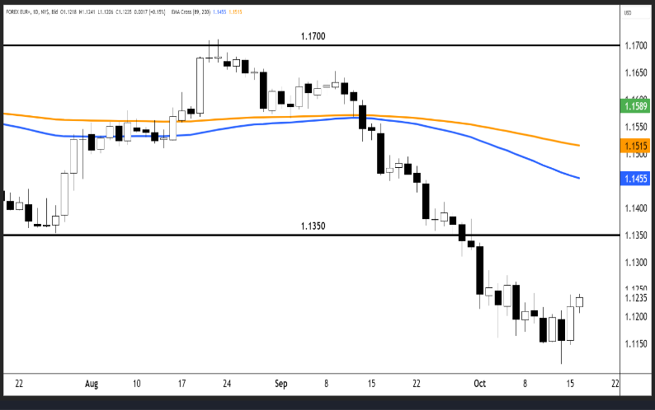 |  |  | USD-JPY exchange rate Sources: Reuters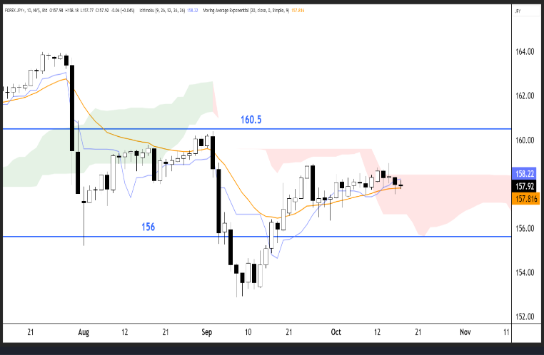
International coffee market  Arabica coffee futures price settled down 1.1%, at 294.8 Usc/lbs​​​​, having hit a one-week high on Wednesday. Uganda's coffee exports fell 13.7% in August as a prolonged drought reduced the harvest in some areas. ICE certified stocks fell for the last three days to reach only 238,976 bags, although people in the market expect coffee to arrive for grading soon. Also, Robusta coffee fell 3.1% to $3,375/ton. The harvest in top grower Vietnam is getting underway and industry participants expect output will be roughly steady versus last year.  Forecasts: Arabica might trade around 280.45 USc/lbs, and Robusta is traded near $3,350/ton. | Coffee Arabica price Sources: Reuters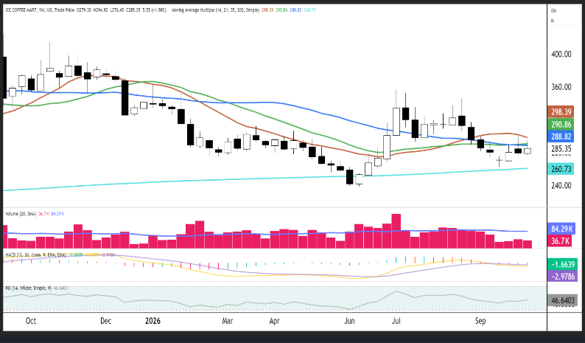 |  |  | Coffee Robusta price Sources: Reuters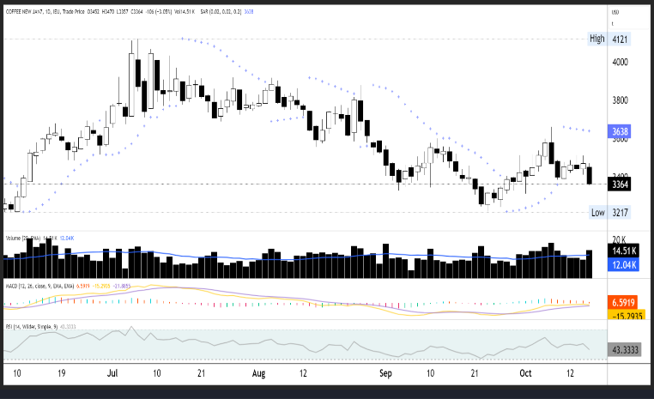
International energy market  Oil prices edged lower on Friday to $105.42/Bbl, driven by persistent Middle East supply concerns and a sharp draw in US crude inventories. Intensified attacks by Iran and regional tensions have disrupted shipments through the vital Strait of Hormuz, reducing tanker flows to roughly 68% of baseline levels. Although the International Energy Agency agreed to release over 20 million barrels of emergency diesel and the US is considering targeted sanctions relief on tankers to curb freight costs, markets continue to price in significant geopolitical risk premiums until tensions ease.  Forecast: Brent Crude Oil might trade around 102.8  USD/Bbl, Gasoline around the 3.11 (USD/Gal) area. | Brent price Sources: Reuters 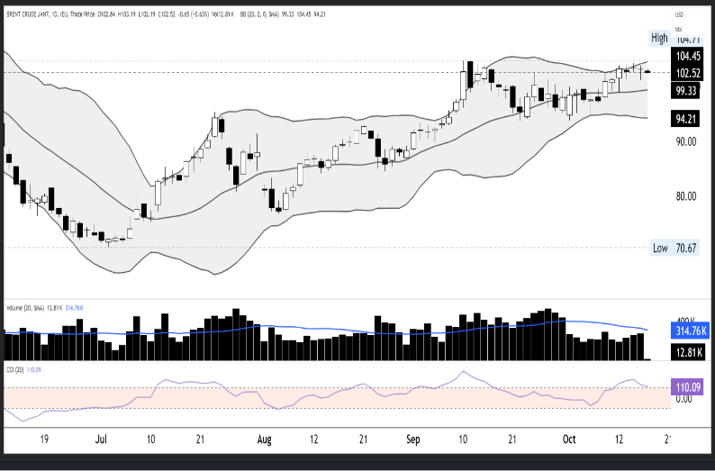 |  |  | Gasoline price Sources: Reuters 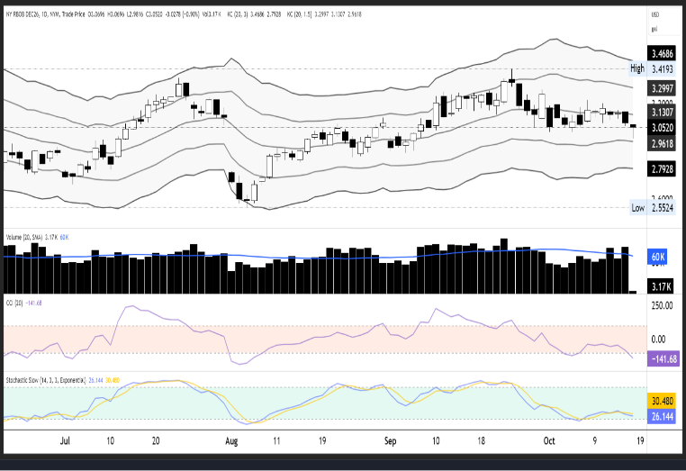
Economic calendar (Week 43: 19.10.2026 – 23.10.2026)
Date | Event |  | Country/Area |  | Forecast |  | Previous
19.10.2026 |  | Vietnam Customes announced trade data | Vietnam
 |  | GDP Growth Rate YoY | China | 4.4% |  | 4.3%
 |  | Industrial Production YoY | China | 0.0 |  | 5.20%
 |  | Retail Sales YoY | China | 1.00% |  | 0.40%
 |  | Inflation Rate YoY | Canada | 3.2% |  | 3.0%
20.10.2026 |  | Unemployment Rate | United Kingdom | 4.9% |  | 4.9%
 |  | Building Permits Prel | United States | 1.39M |  | 1.403M
 |  | Housing Starts | United States | 1.3M |  | 1.275M
21.10.2026 |  | Balance of Trade | Japan | ¥ -250B |  | ¥-1105.6B
 |  | Inflation Rate YoY | United Kingdom | 3.4% |  | 3.1%
22.10.2026 |  | Initial Jobless Claims | United States | 200.0K |  | 199K
23.10.2026 |  | Inflation Rate YoY | Japan | 2.0% |  | 1.9%
 |  | Retail Sales MoM | United Kingdom | 0.1% |  | 0.5%
Disclaimer

This document has been prepared and is being distributed by the Research Desk of Corporate Sales and Product Department - Treasury Division - MB Bank and is intended solely for the members and clients of MB Banks and is not for publication to other people, whether through the press or by other means.

This document is published solely for informational purposes, and it should not be regarded as an offer to sell or as a solicitation of an offer to buy any financial instruments mentioned in it and/or to participate in any trading strategy. Any statement of facts here in contained are derived from sources believed dependable, but are not guaranteed as to accuracy, nor do they purport to be complete. No responsibility is assumed with respect to any such statement, nor with respect to any expression of opinion contained herein. Facts and views in this report have not been reviewed by, and may not reflect information known to, professionals in other MB Bank business areas. Accordingly, readers should, before acting on the advice, consider the appropriateness of the advice, having regard to their objectives, financial situation, and needs. The MB Bank will not be liable for any consequential, incidental, or special damages including but not limited to any lost profits or trading losses arising out of or relating to the use of or inability to use the data and information provided. Additional information on recommended instruments/products is available on request.

Re-transmission or duplication of any part of this publication by any means electronic, mechanical, photocopying, recording, or otherwise, is prohibited without the prior written permission of Research Desk of MB Bank.
Contacts:

- Hoa Hung Cuong – Senior Financial Analyst T : 024 6266 1088 (Ext: 2532) Email: Cuonghh@mbbank.com.vn
- Nguyen Huu Dat – Financial Analyst T : 024 6266 1088 (Ext: 2533) Email: Datnh1@mbbank.com.vn

