|  |
| --- |
|  |
| **RTL_EXERCISE_1 BOUND FLASHER** |
|  |
| |  |  | | --- | --- | | Author | Đỗ Nguyễn Đạt | | Date | 2021/06/26 | | Version | 1.2 | |
|  |
|  |

|  |
| --- |
|  |

Contents

1. Interface 2

2. Functional implementation. 3

3. Internal implementation. 5

3.1. Overall. 5

3.2. State Machine 6

4. History 7

# 1. Interface

|  |
| --- |
| LED  **bound_flasher**  clk  16  flick  rst_n |
| Figure 1: the figure of Bound Flasher System |

|  |  |  |  |
| --- | --- | --- | --- |
| Signal | Width | In/Out | Description |
| clk | 1 | In | Generated posedge or negedge clock when it change from low to high or reverse. |
| rst_n | 1 | In | Turned off 16 LEDs when it is activated LOW. |
| flick | 1 | In | Control LED’s state. |
| LED | 16 | Out | Display led’s state (ON or OFF). |

Table 1: Description of signals in Bound Flasher

# 2. Functional implementation.

* Implement a 16-bits LEDs system
* System’s Operation base on three input signal
  + Reset
  + Clock
  + Flick
* The system specification
* Clock signal is provided for system inspire of function status. The function operate state’s transition at positive edge of the clock signal.
* Reset signal:
* LOW-ACTIVE Reset = 0: System is restarted to Initial State.
* HIGH-ACTIVE Reset = 1: System is started with initial state.
* Flick signal: special input for controlling state transfer.
* At the initial state, all lamps are OFF. If flick signal is ACTIVE, the flasher start operating:
* The lamps are turned ON gradually from LEDs [0] to LEDs [5].
* The LEDSs are turned OFF gradually from LEDs [5] to LEDs [0].
* The LEDSs are turned ON gradually from LEDs [0] to LEDs [10].
* The LEDSs are turned OFF gradually from LEDs [10] to LEDs [5].
* The LEDSs are turned ON gradually from LEDs [5] to LEDs [15].
* Finally, the LEDs s are turned OFF gradually from LEDSs [15] to LEDSs [0], return to initial state.
* Additional condition: At each kickback point (LEDs [5] and LEDs [10]), if flick signal is ACTIVE, the LEDs will turn off gradually again to the LED[0] of the previous state and then continue operation as above. For simple, kickback point is considered only when the LEDs s are turned OFF gradually, except the first state.
* Some insulations:
* When flick = 0 at kickback points

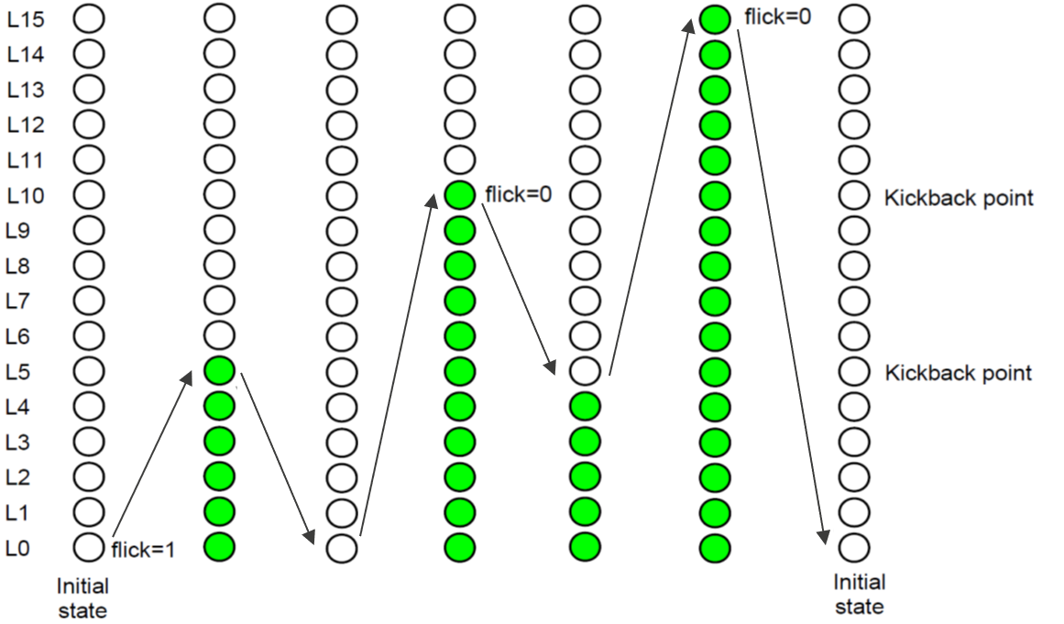

* When flick = 1 at kickback points (lamp[10])

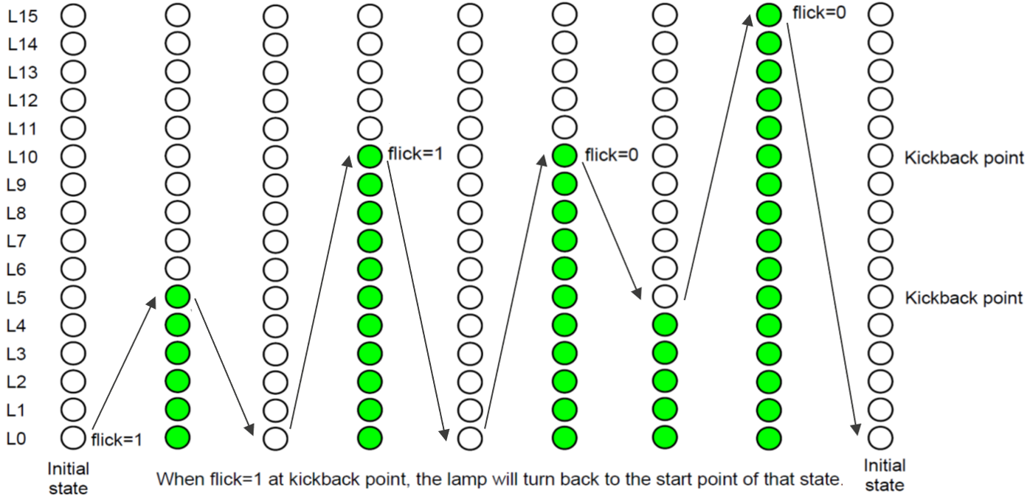

# 3. Internal implementation.

## 3.1. Overall.

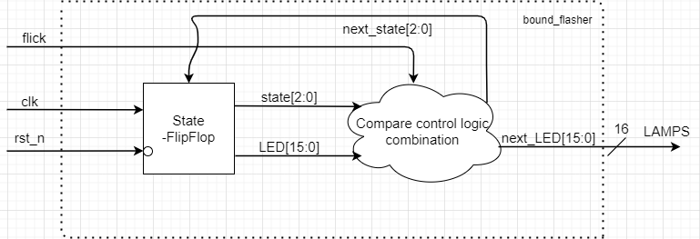

Figure 3.1: Block diagram of Bound Flasher

|  |  |  |  |  |  |  |
| --- | --- | --- | --- | --- | --- | --- |
| |  |  | | --- | --- | | **Block** | **Meaning** | | State-FlipFlop | Control state and the status of the LEDs, triggered by reset or clock | | Compare control logic combination | Compare condition of flick and boundary LEDs to update the next state and status of the LEDs. | |

­­

Table 3.1: Block diagram of Bound Flasher Description

## 3.2. State Machine

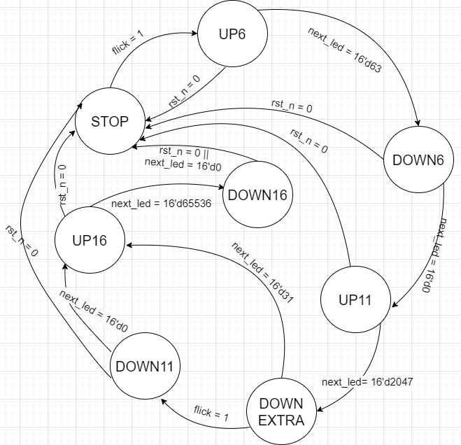

Figure 3.2: State Machine of Bound Flasher

|  |  |
| --- | --- |
| Variable name | Meaning |
| rst_n | If reset = 0(LOW), the system will be reset and return to initial state. |
| flick | The control signal to start the system and return to previous state. |
| next_led | The next status of led. For example, next_led = 16’d63, it’s mean we consider the array leds from 0 to 5. |

Table 3.2: variable name of State machine

|  |  |
| --- | --- |
| State Machine | Meaning |
| STOP | At the beginning, all leds are OFF. If flick = 1, system change to next state. |
| UP6 | LEDs are turned on gradually from LED[0] to LED[5]. |
| DOWN6 | LEDs are turned off gradually from LED[5] to LED[0]. |
| UP11 | LEDs are turned on gradually from LED[0] to LED[10]. If flick = 1 at LED[5], LEDs turn off gradually to LED[0]. |
| DOWN11 | LEDs are turned off gradually from LED[10] to LED[0]. |
| DOWNEXTRA | LEDs are turned off gradually from LED[10] to LED[5]. If flick = 1 at LED[4], LEDs turn off gradually to LED[0]. |
| UP16 | LEDs are turned on gradually from LED[0] to LED[15]. If flick = 1 at LED[5] or LED[10], LEDs turn off gradually to LED[0]. |
| DOWN16 | LEDs are turned off gradually from LED[15] to LED[0] and return to initial state. |

Table 3.3: state name of State machine

# 4. History

|  |  |  |  |
| --- | --- | --- | --- |
| Date | Author | Modified part | Description |
| 2021/06/18 | Dat | All | New creation |
| 2021/06/26 | Dat | Design spec | Fix almost contents |
|  |  |  |  |
|  |  |  |  |