City Traffic Simulator

A realistic view of traffic density.

Team Members:

Reid Stagemeyer

Zoe Fu

Dat Nguyen

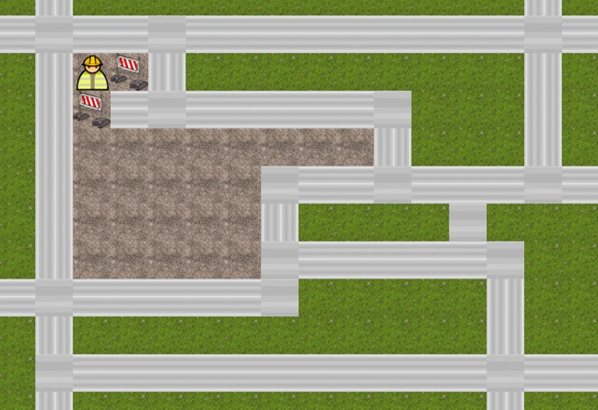

# 1. Introduction

## 1.1 Purpose

This is application will allows the user, Mayor Mann, manage mayor city traffic. It simulates the flow of traffic within a preloaded city map. Relevant goals and desired features of the application are explained below:

* Structure and organize the entire traffic flow for the city.
* Facilitate fast, unbiased, and accurate interactions at each intersection.
* Provide a flexible, automated, and interactive interface between the user and the program by showing live statistics of the traffic flow.

## 1.2 Scope

This project will allow Mayor man to investigate the impact of changing traffic component placement (stop lights, stop signs, etc.) at intersections to determine their optimal combinations/locations.

## 1.3 Core of the system

Application will be able to:

* Allow users to dynamically create the city map or load map from csv files.
* Allow users to adjust the start/stop locations and number of cars.
* Allow user to adjust the location and combinations of traffic components (traffic lights, stop signs).
* Allow users to run multiple traffic simulations.
* Provide a GUI that allows user to drag and drop traffic components.
* Provide a terminal window to show live traffic flow statistics.
* Display a full report of the traffic flow at the completion of a simulation run.

## 1.4 Objectives and Success Criteria

Our application will closely simulate actual city traffic for the Mayor. This will give him the most realistic and accurate look of the traffic flows to find the optimal placement of traffic components. The optimal placement of components is defined as getting the most cars to their destination the fastest. The system should allow multiple simulations to be run with various combinations/placements to be analyzed. A simulation is finished once every car on the map reaches their destination, however the user can terminate the current simulation at any time. Many constraints will be included, first, all moving traffic components (i.e cars) will be moving at the same speed and making consistent turning decisions at each intersection. The simulation will be running in a one-time thread.

## 1.5 Definitions, Acronyms, and Abbreviations

OOP: Programming language model organized around objects rather than “actions” and data rather than logics

UML: Diagram based on the UML (Unified Modeling language) with the purpose of visually representing a system along with its main actors, role.

Intersection: An area shared by two or more roads.

Tile: a smallest countable unit on the City Boost simulation map.

GUI: Graphical User Interface.

Time thread: the smallest sequence of programmed instruction that can be managed independently by a scheduler.

Turn: Action that each car agents will take at the intersection

## 1.6 References

<https://searchmicroservices.techtarget.com/definition/object-oriented-programming-OOP>

<https://tallyfy.com/uml-diagram/>

# 2. Current System

N/A

# 3. Proposed System

## 3.1 Overview

The proposed system must allow Mayor Mann to efficiently determine the optimal placement of traffic components (traffic lights, stop signs) throughout the city. This will be done by creating an application that lets Mayor man company run multiple simulations using various locations and combinations of those traffic components. He will also be able to change the number of cars and their start/end points. Various statistics and reports will be output to allow the user to determine what combination is most desirable.

## 3.2 Functional Requirements

F1. Run multiple simulations

F2. Let user change the location of traffic components

F3. Let user change the combination of traffic components

F4. Analyze traffic performance

F5. Allow user to change number of cars

F6. Allow user to change start/end locations for each car

F7. Allow user to change the layout of the map

## 3.3 Nonfunctional Requirements

N1 Usability:

* Our program will provide statistical data of running time along with customer’s traffic combination decisions and speed of cars.
* User can run this program by some desktop applications, like Java applet.
* User will be able to see a 2D digital graph represented car moving.

N2 Reliability:

* The program will be able to recognize that when User enter starting points or destinations out of the map. It will give the warning and stop the program until getting correct input.
* The User will have control that the cars only move along the road and they cannot move out of map.
* The Program will make sure that user will only be able to set the stop sign or traffic light in intersections, and make sure every intersection gets one and only one stop sign or traffic lights. When an intersection doesn’t get assigned with any traffic sign, the program will be able to automatically set a traffic light here. If an intersection gets 2 assigned traffic signs, the program will random select one sign here.

N3 Performance:

* Program must be able to work for multiple cars moving together.
* When the map changes, the program will also be able to work by implementing the new roads.

N4 Supportability:

* The program should be able to run on any platform supporting Java.
* Project will be able to work in some web application with a 2D visualization.

N5 Implementation:

* Project will be coding in Java and shared in GitHub.
* The 2D graph will be done using the third-party library pixiJS.

## 3.4 System Models

### Use Case Model

1. Users can input # of cars, position of cars
2. Users set combinations of traffic lights and stop signs (optional: system set combinations randomly)
3. Start the simulation, users decide to press stop and change traffic combination
4. Track progress and show statistic of traffic.
5. System shows final report of the traffic flow
6. System allow user to restart the simulation and reset all traffic components simulation.

### Structural Model

TBD

### Behavioral Model

TBD

### User Interface: Navigational Paths and Screen Mockups

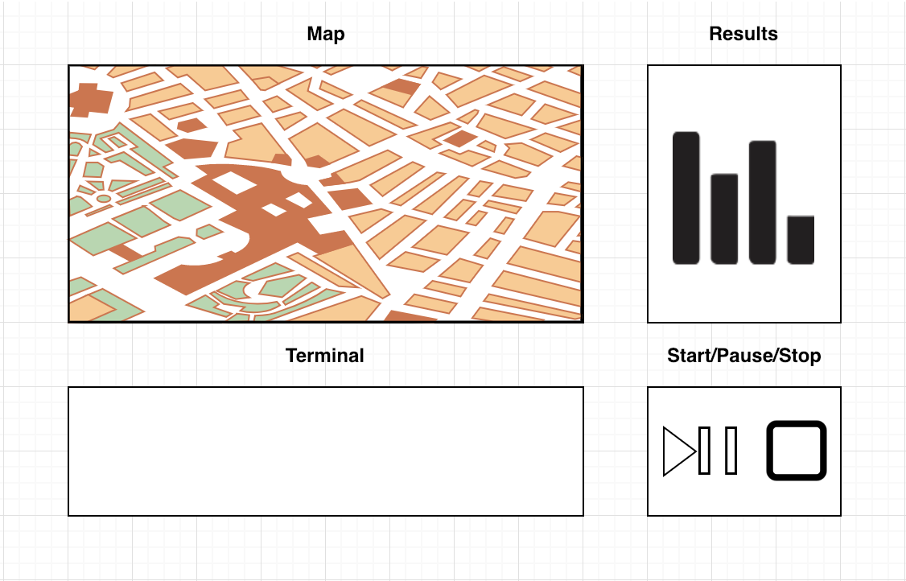

# Glossary

TBD