Test 3

Note:
- Using ADO.NET
- Database: DBScript2.sql

Develope GUI looks like bellow: (2 point)
At design:

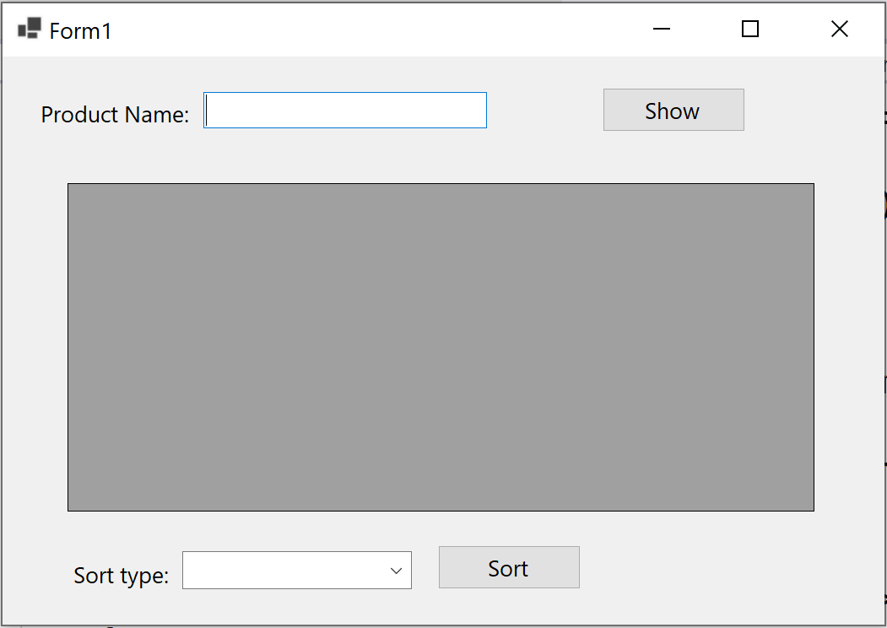
At running after pressing the "Show" button, the GUI looks like: (4 point)
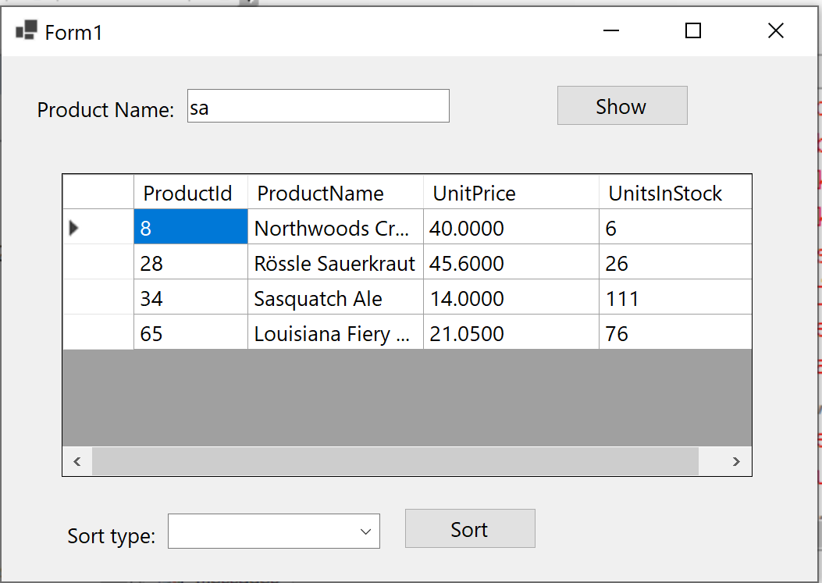

If an user presses a "Sort" button, the result is: (3 point)
