Test 6

Note:
- Using ADO.NET
- Database: DBScript2.sql

Develope GUI looks like bellow (2 point):
At design:

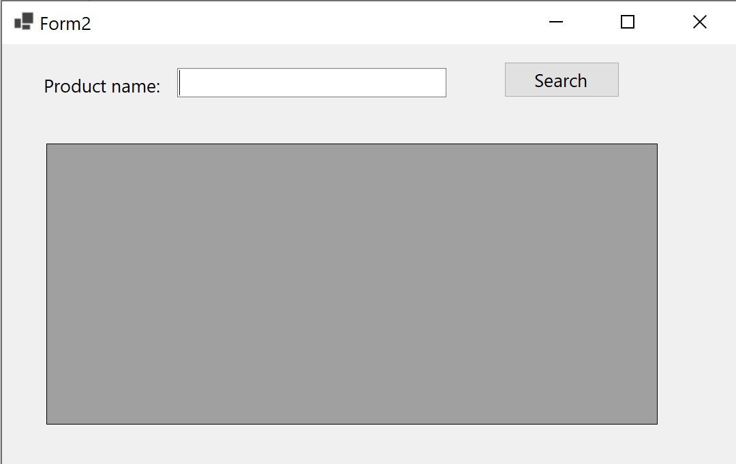
At running after pressing the "Show" button, the GUI looks like: (7 point)
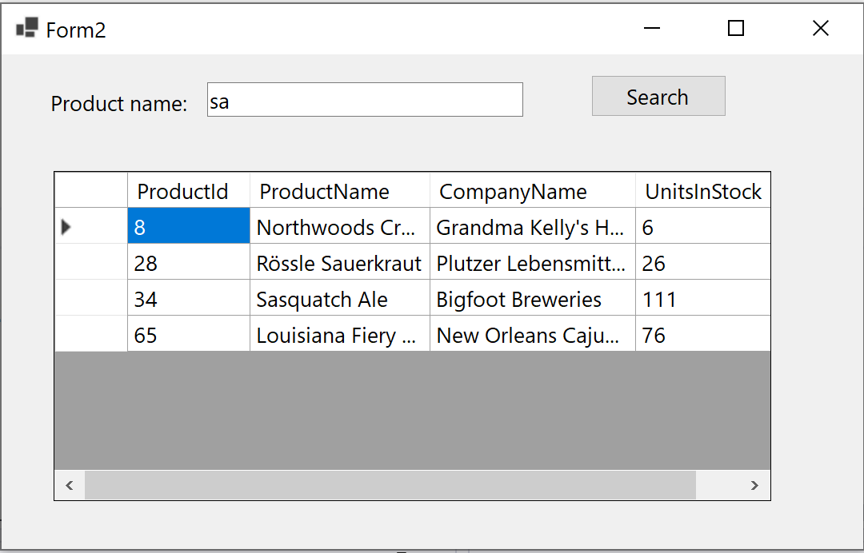

If the result not like above (2 point)

