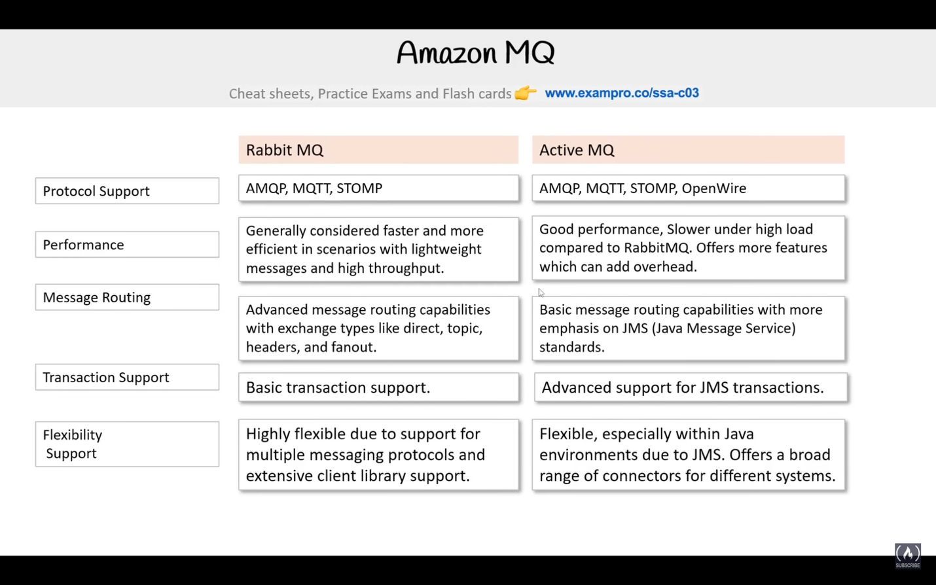

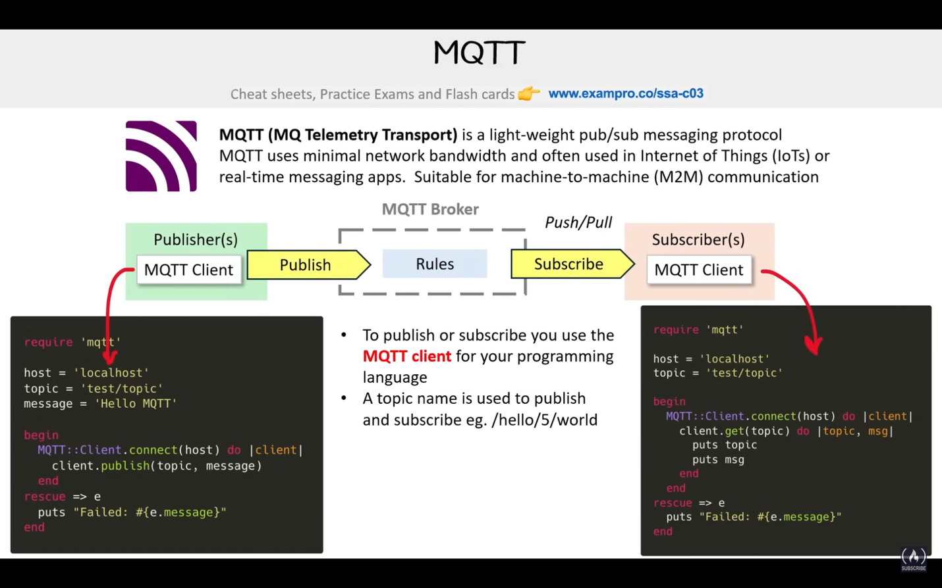

<- Last Watched

The rest is follow along