Blog Text

Hannes Pieper

4/21/2021

# to include still:  
  
total_words <- read.csv(file = "./data/data_for_graphs/total_words.csv")  
talking_speed <- read.csv(file = "./data/data_for_graphs/talking_speed.csv")

# Critical Graphs: Shenanigans with Critical Role Season 1 subtitles

With the end of season two approaching, it is time to look back on the humble beginnings of the show. What is Critical Role you ask? To use their words: it’s a bunch of nerdy ass voice actors, who sit around and play Dungeons and Dragons. Thousands around the world tune in to watch them live and millions view their shenanigans later on YouTube. The fact that nothing is scripted makes this show so thrilling to watch. Nobody writes out an episode beforehand. Whatever happens is up to the players and the dice to decide. Everything is possible and only happens in the imagination of the players and the viewers. That’s what makes it so intriguing to watch. It also makes it interesting for some nerdy ass data analyses. Be aware: spoilers ahead.

The first question for every data analysis to answer is what data to use. Luckily, the community provided subtitles for every episode of the first season. These can be used to construct the data. For example, a typical episode might start with the game master Matthew Mercer saying: “Hello everybody and good evening. Welcome to Critical Role […]”. In the subtitles this may look as follows:

00:00:00,500 –> 00:00:04,043 MATT: Hello, everyone and good evening. Welcome to Critical Role, a show where a bunch of us

##   
## 1 function (x, format, digits = getOption("digits"), row.names = NA,   
## 2 col.names = NA, align, caption = NULL, label = NULL, format.args = list(),   
## 3 escape = TRUE, table.attr = "", booktabs = FALSE, longtable = FALSE,   
## 4 valign = "t", position = "", centering = TRUE, vline = getOption("knitr.table.vline",   
## 5 if (booktabs) "" else "|"), toprule = getOption("knitr.table.toprule",   
## 6 if (booktabs) "\\\\toprule" else "\\\\hline"), bottomrule = getOption("knitr.table.bottomrule",

, where the numbers indicate the time a subtitle is shown on the screen. Doing some data manipulation we can turn this into a nicer format. Unfortunately, not every volunteer followed the same naming convention. For example, when the game master is acting as a character in game, this could be written in the subtitles as the character’s name or as ‘Matt’. The same applies for the players, who may be referred to by their name or their character’s name. Additionally, as is inevitable when transcribing long spoken text (an average episode is 4 hours long), people make mistakes. Which brings us to the first interesting question to ask: which actor got misspelled the most?

Out of the cast, Marisha got misspelled the most was . These include, for example, ‘Marishaia’ or ‘Marishaaaa’. However, she was not alone in her fate. For example, Travis Willingham, playing a character named Grog, often got misspelled as ‘Tavis’ or as ‘Gorg’. Yet, taking everything together, the amount of misspells for all the subtitles is astonishingly low. Over 114 episodes and a run time of roughly 475 hours the total amount of misspells is only 150.

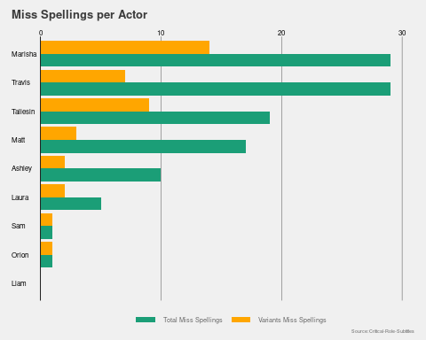

Still, not everybody has the same chance of being misspelled. The direct comparison may be unfair for two reasons: first, not every actor was present for all episodes. Second, not every actor spoke for the same amount of time. While Matt, as the game master, must be present for every episode and has to describe everything that happens in game, other actors can give short answers or sit out an episode. So let’s look at both attendance and the amount of dialog in turn.

Examining the attendance by the players some differences become clear. Out of the eight players, five didn’t miss more than 5 out of total 115 episodes. Meanwhile, Ashley was only present for less than half of the episodes. Similarly, Orion did only participate in every fifth episode. The main reason for the absence of the latter is the fact that he left the show after only a quarter of the episodes. Hence, it seems reasonable that he got misspelled less compared to many of the other cast members. We can also see that about one in five episodes had guests joining the show.

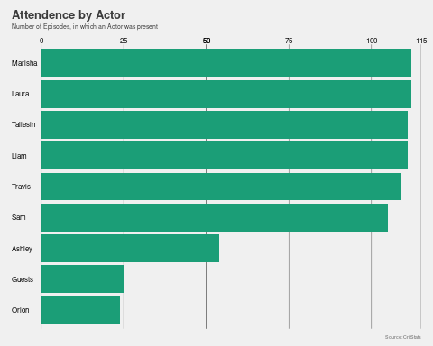

Now let’s look at the amount of time the actors speak. Unsurprisingly, Matt speaks the most of the group. After all, a game master has to describe how everything looks and feels. He has to act out non player characters and their reaction to the actions of the players. Lastly, he has to describe how the actions of the players are playing out in the imaginary world. In total, he speaks three quarters of the time and uses fifty percent of all words spoken. Like in the misspellings, Marisha tops the list in terms of time speaking compared to the other players. However, Laura uses the most words. Given that she also uses significantly less time compared to other cast members, it indicates that she speaks at a quicker pace compared to the other cast members. Interestingly, both Ashley and Orion only speak roughly the same as all guests of the show combined.

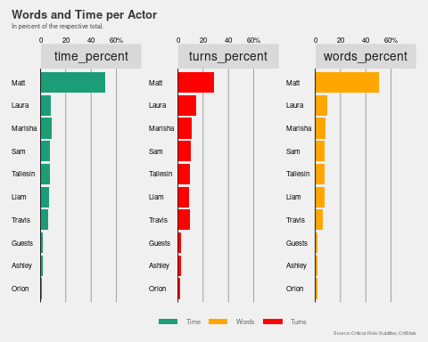

There is, however, a catch to these numbers, as not everything that is said is shown in the subtitles. Sometimes many people speak at the same time. If that happens only the important parts are written in the subtitles. This affects the calculated time the actors speak, as it is measured by the time subtitles are shown on the screen. For example, a long description from Matt may span over 30 seconds. If one of the players were to comment on the scenery at the same time it may be omitted from the subtitles. In total the subtitles contain roughly 3.4 million words spoken over 13 hours of play.

Despite these obvious shortcomings, we can still look at the most used words per actors to see if players have some unique words that they use often. To do so we can calculate the log-odds ratio for the words used by the players. A high log-odds ratio tells us that, a given spoken text contains a specific word, it is more likely to be said by a certain cast member. For example, the graphs below show that if a text contains the word ‘inspire’ it is likely to be said by Sam, who plays the bard Scanlan. As inspire is a class ability of bards, it is not surprising that it indicates Sam speaking. Similar relationships between class abilities and what the player said can be found for almost all players. Moreover, it is unsurprising to find Matt use ‘you’ more often compared to the rest of the cast as he is describing their actions. Still, more sophisticated statistical tests are needed to examine the relationship properly. I will do so in a later blog post.

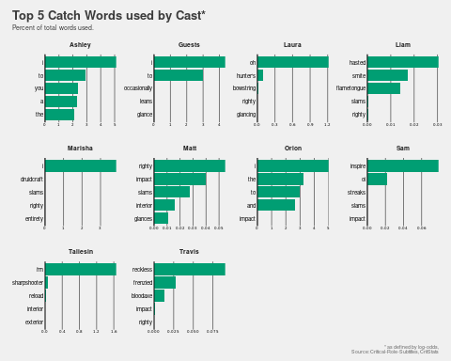

So far, differences in the words used between the cast members became obvious. We can use this to examine, which cast member used the most elaborate vocabulary. Using the Coleman–Liau index, we can get a score which can be translated to a grade equivalent (a the index is normally intended for written text, but its nice interpretability makes it a convenient choice to use). As expected, Matt uses the most elaborate vocabulary.

Additionally, one might argue that the vocabulary correlates with the intelligence of the character played. Yet, this does not seem to be the case. For example, Grog (played by Travis) , while being the dumbest member of Vox Machina (as the characters call themselves), seems to use more expressive vocabulary than Pike (played by Ashley). This may, however, be an artifact of the fact that Ashley is less present and Pike as a character is rather shy. Hence, the low grade level. In total there does not seem to be a strong correlation between intelligence score and the grade level of the text (the correlation is 0.12). Please note, in the interest of keeping this spoiler-light I intentionally do not differentiate between different characters played by the same actor.

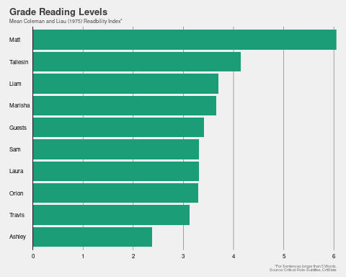

As Pike and Grog are best buddies, lets see if they are speak the most to each other in game. Indeed, Ashley interacts with Travis the second most out of all the players. However, given that Ashley is only present in some of the episodes the other member of Vox Machina interact more with rest of the group. In total, Laura also has the most interactions with everybody. As Ashley sits next to Travis and Laura, it shows that people sitting next to each other are more likely to interact with each other. We can also be see this by the amount of interactions between Marisha and Taliesin. Likewise, in-game relationships between characters become clear to some extent. Liam interacts most with his in-game sister played by Laura and his love interest played by Marisha. Similarly, Taliesin interacts most with his in game love interest played by Laura.

Like the analyses before, there are some caveats to the results though. Interactions as shown in the graph are measured by counting when actors speak after each other. Thus, the number could be influenced by, among other things, Laura giving short comments throughout the show. Indeed, on average a segment from her only contains 9 words, while average for all players is 10. As a side note, given the role of Matt as a DM, everybody interacts with him the most. Therefore, Matt is not shown in the graph.

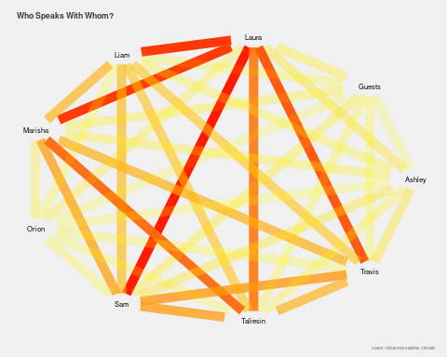

Yet, sometimes actors may the same thing simultaneously. For example, when a party member is close to dying in a fight they may have the same reaction. In the subtitles this may be shown by as follows: “Ashley and Laura: no no no no!”. So let’s examine who says the same things.

Similarly to the interactions earlier, we can see that Laura has the most shared spoken text with her cast members, indicating that she indeed has the most short comments from the group. Out of the cast she Marisha often share the same thought. Likewise, Marisha and Taliesin often have the same ideas. The same applies to Ashley, Laura and Travis or Sam and Taliesin respectively, though to a lesser extend. Interestingly, Matt never says the same thing together with a guest.

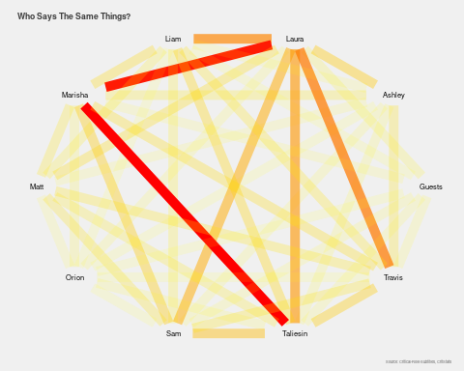

The subtitles can also be used to examine, which character, arc or episode is the most happy or sad. To do so, dictionaries can be used, which assign words or sentences a happy or a sad sentiment, where higher values indicate happier dialogue. These values can then be used to examine which characters are the most happy and sad. As we have seen earlier, different actors speak more or less often. Thus, to make it comparable, let’s look at the mean sentiment of sentences spoken per actor. As this will give us some hints towards the personal journey of characters, be wary of spoilers (and mimics) from now on.

Looking at the sentiment across the actors some differences become clear. To begin with, Liam and Travis seem to be playing the saddest characters. For Liam this seems rather unsurprising given how he plays his character. He also stated that Dungeons and Dragons serves as an outlet for him. For Travis this may be because Grog often gets told he cannot do a lot of stuff or because he plays the character with the lowest intelligence.

In contrast, the guests seem to be happier than most of the cast. This may be because they are happy to play with the group or that Matt intentionally makes episodes starring guests more light-hearted. Likewise, the Ashley seems to be the good heart of the group. Indeed, this stated multiple times throughout the series. Yet, Orion stands out as the happiest of the cast. This is a bit surprising as he is only present in the first episodes. However, as viewers of the first season know, the story gets darker after his departure. To quantify this, let’s investigate whether later arcs are indeed less happy compared to the earlier ones.

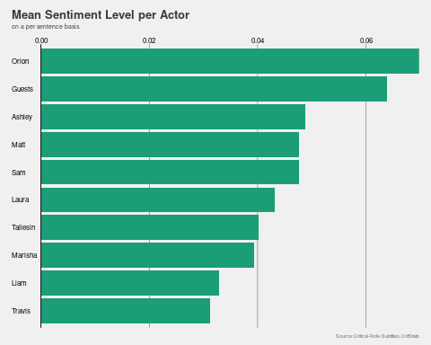

Examining the mean sentiment per episode for the different arcs we can indeed see that the first two arcs were happier compared to most other ones. After a happy start and everybody getting accustomed to streaming and watching Dungeons and Dragons on a live stream, the story takes a darker turn. The exception to this is the ‘Daring Deeds’-arc. This seems hardly surprising for viewers of the show given how the character was introduced and how the story develops during their presence.

As with most goodbyes, the last arc of the arc involves saying farewell goodbye to the characters. Unsurprisingly, this results in the same sad sentiment for the entire arc. Still, the story is also not exactly sunshine, lollipops and rainbows. Yet, in the interest of keep this text light on spoilers, let’s not drive into the story any further. Instead let’s investigate whether the difference in sentiment was driven by differences in the amount of combat. As more combat represents more chances of dying, this may be a driving force behind the differences between the arcs.

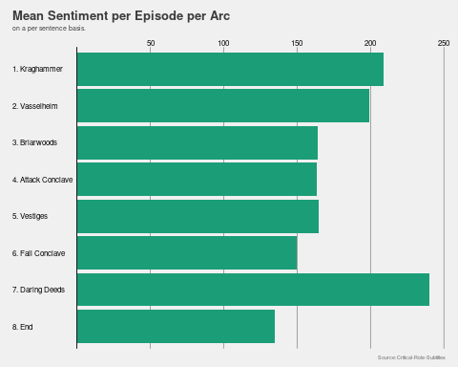

As we can see below, the earlier arcs had more time dedicated to combat. During the search for the Vestiges of Divergence, while the group has to figure out where to go first, the time spent in combat is the lowest(17percent). In the last three arc, around a quarter of the time was dedicated to combat. However, this means that combat may not be the driving factor behind sad moments in the story but can be found in role-play as well. Thus, it could be that in the beginning of the show players were less comfortable with the rules as they changed to a different rule set compared to playing off-screen.

Additionally before streaming, the group didn’t play on a set schedule. Consequently, it seems likely that the players got more used to playing their characters and the abilities they have. Thus, the time does not necessarily reflect the in-game time in combat. To investigate the issue further let’s look at the most happy and sad episodes to see whether they involve combat. As these episodes may also be the ones, which drive much of the story forward, the next paragraph contains spoilers for the uninitiated (but may also be worth rewatch).

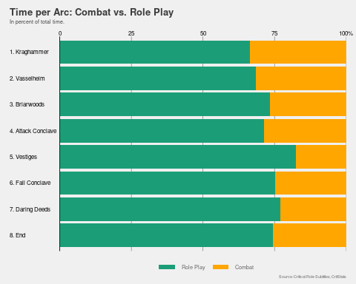

Looking at the happiest episodes a lot of the findings we have gathered so far come together. On the one hand, the top scoring episode involves the introduction of the already mentioned new character. Additionally, episode 95 involves the reunion after a one-year break in game and is more light-hearted. Yet, the other three episodes involve combat and guests. While, episode 11 involves a lot of (useless) planning while attacking a temple, episode 88 involves fighting a kraken. Moreover, episode 18 involves two guests and parts of the cast absent. This ties in nicely with the results we obtained earlier that guests genuinely happy to team up with Vox Machina.

In contrast, most of the saddest episodes involve combat. The saddest episode (51) even has a negative score. It involves planning to help the child of one character to escaping a city, while simultaneously fighting the uncle of another. Episode 68 features the fight against an antagonist and the death of one of the characters. As the other episodes on the list take place during the last arc and are preparation for the final boss fight I will not discuss them in more detail. Instead, let’s look in more detail what drives the sentiment of an episode. So far we have seen that the guests and Ashley had the happiest sentiment. We have also seen that time spent in combat and sentiment do not seem to be related when look at entire arcs. However, having obtained mixed signals, when we looked at individual episodes let’s investigate what exactly makes a happy or sad of critical role.

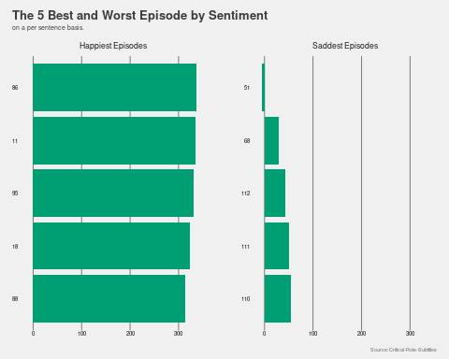

First, let’s see whether episodes starring Ashley and Guests are happier compared to episodes without. However, when we make a correlation test, we find insignificant results. This means that starring episodes Ashley or a guest, are not different than episodes without them when it comes to sentiment. In contrast, the time spent in combat does seem to negatively affect the sentiment of an episode. Using a simple OLS estimation we can estimate the effect. Doing so we estimate that one hour spend in combat is associated with a decrease 3.6 in the sentiment score of the episode. Yet, as success during combat in Dungeons and Dragons is dependent on the dice rolls made, let’s investigate the effect of those on the sentiment as well.

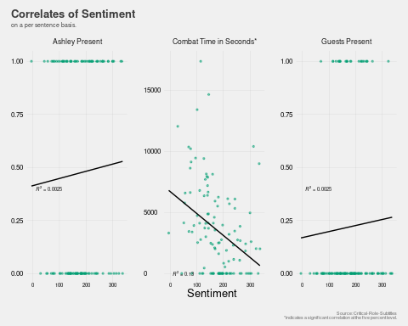

As dice rolls determine how successful an action is when playing Dungeons and Dragon, they may affect the sentiment on the table. However, when we look at all the roles made by during the game we don’t find any relationship. Yet, as always there is caveat to these numbers. I use the natural value rolled for the average of all dice rolls, as later episodes mean higher levels for the players and enemies and thus higher total values. Therefore, total value are likely to be correlated with later episodes. However, this reduces the total number of dice rolls significantly as not often we only know the total outcome (meaning including abilities modifiers). Still, we know often know when the players and the dungeon master roles a critical success (20 on 20 sided die) or a critical failure (1 out of 20).

Indeed we find associations between critical dice rolls and the sentiment of the episodes. When we run the numbers, a twenty from one of the players is associated with an decrease in the sentiment score by 5 points. As an average episode has a sentiment score of NA this is a relevant effect. This could be because combat require more dice rolls from the players. This could bias the results. Similarly, when Matt rolls a critical failure or a sucess, the episode is generally sadder (one natural one/twenty decreases sentiment by 15). [HOWEVER, the only significant effect when including all of those variable is the effect of natural twenties from Matt. The estimated effect is a decrease of 10 sentiment points!! Yet vanishes when all variables are included] Interestingly, the amount of natural ones for the players does not have a significant effect for the sentiment on the table. This could be that natural ones from a player while playing a trick on another players, often results in funny situations during role play. Another good indicator for whether an episode is happy, are the amount of face palms by Matt (one face palm increases the sentiment by 6).

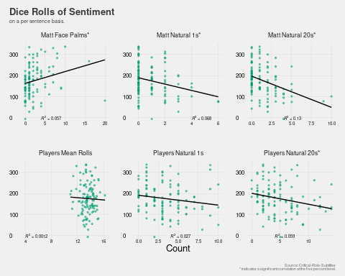

In summary, we can say that subtitles for Critical Role can be used for some funny data analyses. Taken together they can give some interesting insight into the show. So far, we only used the data for mostly descriptive analysis. However, the data can also be used from some more advanced techniques like machine learning. I will do so in a later post. In post I will try to predict the speaker of a text given the words said. Rameshkumar and Bailey (2020) construct a similar data set in their paper. However, while their data set includes some additional information, it omits the time dimension of the data. Also creating my own data set served as a good practice in data cleaning for myself. So if anybody is interested in applying some analyses to the text you may code away.

The code and the data set can be found on github.

### Acknowledgements

* [Critical Role](https://critrole.com/team/)
* [Critical Role Transcript Team](https://crtranscript.tumblr.com/about)
* [Critical Role Stats Team](https://www.critrolestats.com)

### References:

R. Rameshkumar and P. Bailey. Storytelling with Dialogue: A Critical Role Dungeons and Dragons Dataset. ACL 2020. Accessible at: [GitHub - RevanthRameshkumar/CRD3: The repo containing the Critical Role Dungeons and Dragons Dataset.](https://github.com/RevanthRameshkumar/CRD3)

### Licence:

This work is licensed under a [Creative Commons Attribution-ShareAlike 4.0 International License][cc-by-sa]