# Change request log

# Team

|  |  |  |  |
| --- | --- | --- | --- |
| **Team - 7** | | | |
| **Name** | **NetID** | **Email** | **Role** |
| Md Samiul Aftad Chowdhury | mac151830 | mac151830@utdallas.edu | Coding |
| Kenechukwu Chidozie Nwankwo | kcn062000 | kcn062000@utdallas.edu | Documentation |

# Change Request

FEMR-186:

Change the name of the “Treatment Given” field to “Procedure/Counseling”

Change the name of this field in the tab_fields table to reflect the new name.

# Concept Location

|  |  |  |
| --- | --- | --- |
| Step # | Description | Rationale |
| 1 | We ran the system |  |
| 2 | We interacted with the system: after logging in we tried to find any existing patient in the system that can be used to test other features | In order to get familiar with some of the features of the system, and identify the screens or graphical elements we had to change. |
| 3 | We searched for “Treatment Given” using the regular expression feature of the IntelliJ IDE’s search tool. | Because in the change request it only says to modify the “Treatment Given” but did not mention its location |
| 4 | Only 1 result showed that text, we clicked on the line <label for=”treatment”>Treatment Given</label>. It took use to the file treatmentTab.scala.html, the HTML file inspected using the Structure window of the IDE. | We wanted to go to the file which contains that text “Treatment Given”. |
| 5 | We inspected the HTML file treatmentTab.scala.html. | We noticed that the text “Treatment Given” was hard coded inside a label. No other variable used for that text. |
| 6 | We marked file treatmentTab.scala.html as “located”. | We confirmed this file had to be modified for the first part of change request 186 |
| 7 | Now we used MySQL workbench tool to view and modify the database table “tab_fields”. We found that “treatment” is value under the column “name” | Because in the change request it says that we have to modify the field “treatment” in the table “tab_fields” |
| 8 | We get back to IDE again to find out which of the classes and files using the filed “treatment” | We were not quite sure how that treatment filed is used in the code and for what purpose |
| 9 | We searched for the text “treatment” using the regular expression feature of the IntelliJ IDE’s search tool. |  |
| 10 | We found 15 occurrence of the text “treatment” in 9 different files. |  |
| 11 | We found that in files 2 java files and 2 html files needs to be changed | Other 11 occurrence of treatment text is for the “tabs” table not for “tab_fields” table. |
| 12 | We made a list of methods using the “treatment” tab_fields from the html template files |  |
| 13 | We have visited following classes to find out how the tab_field is being used, TabField, TabFieldItem, TabItem |  |
| 14 | From the search we have found DatabaseSeeder and PDFController this two classes using the “treatment” tab_field |  |

**Time spent (in minutes):** 25

# Impact Analysis

|  |  |  |
| --- | --- | --- |
| Step # | Description | Rationale |
| 1 | We made a list of methods using the “treatment” tab_fields | To track the classes that could be impacted by the change. |
| 2 | We inspected the class DatabaseSeeder and PDFController. Such class was marked as "to change" as well | We realized this class had to be changed because the method seedDefaultTabFields and getAssessments use the value “treatment” to get the properties of the tab_fileds. |
| 3 | We found that change the text of those fileds from treatment to procedure will not affect any other classes. |  |
| 4 | We changed treadmentTab.scala.html  <label for="treatment">Treatment Given</label>  To  <label for="procedure">Procedure/Counseling</label> | This code has no other dependency on any other classes |

**Time spent (in minutes):** 15

# Prefactoring (optional)

|  |  |  |
| --- | --- | --- |
| Step # | Description | Rationale |
| 1 | We converted the field name treadment in class DatabaseSeeder (method seedDefaultTabFields) and PDFController (method getAssessments). We manually change that text to “treatment” to procedure |  |
| 2 | After the previous change, we ran the unit tests corresponding to the classes and also we ran the system.. | We tested everything was working as before, after the refactoring. |
| 3 | We committed our changes with git. | Just in case we need to revert our changes. |

**Time spent (in minutes):** 15

# Actualization

|  |  |  |
| --- | --- | --- |
| Step # | Description | Rationale |
| 1 | We have changed classes DatabaseSeeder (method seedDefaultTabFields) and PDFController (method getAssessments). | We realized that class DatabaseSeeder and PDFController using the tab_field treatment. |

**Time spent (in minutes):** 25

# Postfactoring (optional)

|  |  |  |
| --- | --- | --- |
| Step # | Description | Rationale |
| 1 | We changed treadmentTab.scala.html  <label for="treatment">Treatment Given</label>  To  <label for="procedure">Procedure/Counseling</label> | As many methods will access the color value, it is a good idea to have a field. This would reduce the number of arguments and parameters of the methods |
| 2 | We committed and pushed our changes with git. | Just in case we need to revert our changes. |

**Time spent (in minutes):** 10

# Validation

|  |  |  |
| --- | --- | --- |
| Step # | Description | Rationale |
| 1 | Test case defined:  Inputs: Check if the text has been changed in the form  Expected output: Text has been changed to “Procedure/Counseling” under the treatment tab | This is the regular expected behavior.  The test passed. |
| 2 | Test case defined:  Inputs: Submit the “Procedure/Counseling” form  Expected output: Form successfully submitted | This is the regular expected behavior.  The test passed. The test passed. |

**Time spent (in minutes):** 25

# Timing

Summarize the time spent on each phase.

|  |  |
| --- | --- |
| Phase Name | Time (in minutes) |
| Concept location | 25 |
| Impact Analysis | 15 |
| Prefactoring | 15 |
| Actualization | 25 |
| Postfactoring | 10 |
| Verification | 25 |
| Total | 115 |

# Reverse engineering

Following classes we have visited for the second part of the change requests.

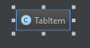

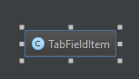

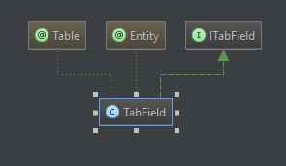

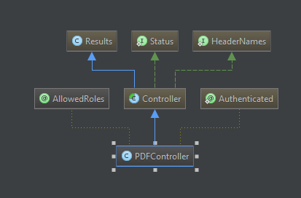

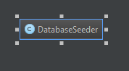

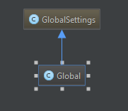

# Conclusions

For the first part of the change request straight forward change in the HTML file we did not face much challenge with that.

For the second part of the change request, it took us some time to figure out how the “treatment” field of tab_fileds is used in the HTML code also in the java code. Also we tried to change the filed name in the database manually but later found that this field is auto generated from the java code and inserted in the database in the runtime. There was a confusion that if the “treatment” field is used from the “tabs” table or the “tab_fields” table.

Classes and methods changed:

* modified: app/femr/ui/controllers/PDFController.java
  + Class PDFController
  + Method: getAssessments
  + Line: 401
* modified: app/femr/ui/views/history/indexEncounter.scala.html
  + treatmentFieldMap.get
  + Line: 183
* modified: app/femr/ui/views/partials/medical/tabs/treatmentTab.scala.html
  + <label for="procedure">Procedure/Counseling</label>
  + Line: 68 - 70
* modified: app/femr/util/startup/DatabaseSeeder.java
  + Method: seedDefaultTabFields
  + Line: 737