

<<Hotel Operation and Service Management System (HSRM) >>
Software Design Specification

– DaNang, May 2026 –

Record of changeS
Date | A*  M, D | In charge | Change Description
*A - Added M - Modified D - Deleted

Table of Contents

I. Overview 4
1. Code Packages 4
2. Database Design 5
a. Database Schema 5
b. Table Description 5
II. Code Designs 6
1. <Feature/Function Name1> 6
a. Class Diagram 6
b. Class Specifications 6
c. Sequence Diagram(s) 9
d. Database Queries 9
2. <Feature/Function Name2> 10

I. Overview

1. Code Packages
[Provide the package diagram for each sub-system. The content of this section including the overall package diagram, the explanation, package and class naming conventions in each package. Please see the sample & description table format below (please note: package names don’t follow Java package naming convention yet)]
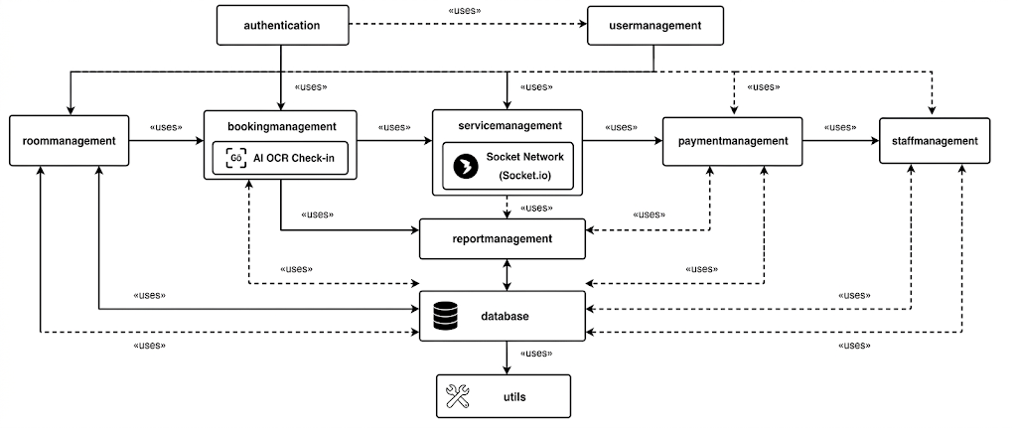
Package descriptions
No | Package | Description
01 | authentication | Handles login, logout, user authentication, and authorization functions.
02 | usermanagement | Manages customer accounts, profiles, and user information.
03 | roommanagement | Handles room information, room types, room status, and room availability management.
04 | bookingmanagement | Manages room reservations, booking schedules, check-in, and check-out operations.
05 | servicemanagement | Handles hotel services such as food service, laundry, transportation, and additional customer services.
06 | paymentmanagement | Processes invoices, payments, billing, and transaction records.
07 | staffmanagement | Manages hotel staff information, work schedules, and employee roles.
08 | reportmanagement | Generates statistical reports, revenue reports, and operational summaries.
09 | database | Handles database connections, data access, and data persistence operations.
10 | utils | Provides common utility functions, validations, formatting, and helper classes used throughout the system.

2. Database Design

a. Database Schema
[Provide the tables relationship like example below – following MySQL database naming convention]
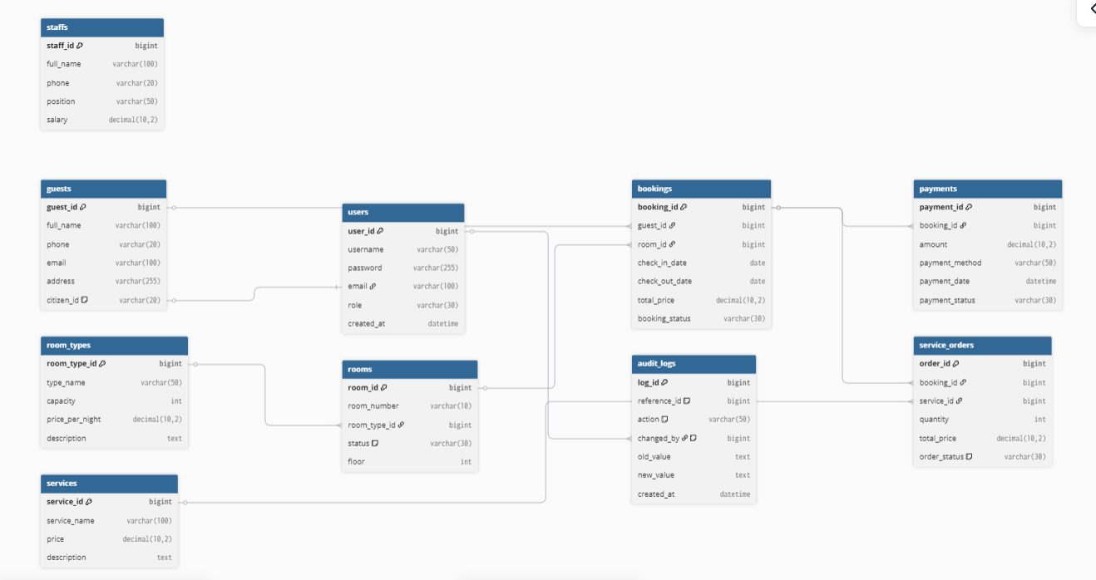

b. Table Description
No | Table | Description
01 | users | Stores system user accounts and authentication information.
02 | guests | Stores guest/customer information.
03 | room_types | Stores different room categories and pricing information.
04 | rooms | Stores hotel room information and room status.
05 | bookings | Stores room reservation and booking records.
06 | services | Stores hotel service information.
07 | service_orders | Stores service usage records for customer bookings.
08 | payments | Stores payment and billing information.
09 | staffs | Stores hotel staff information and employee details.
10 | audit_logs | Stores system operational footprints and billing mutation history to prevent fraud.

II. Code Designs

1. <Feature/Function Name1>
[Provide the detailed design for the function <Feature/Function Name1>. It include Class Diagram, Class Specifications, and Sequence Diagram(s)]

a. Class Diagram
[This part presents the class diagram for the relevant feature]
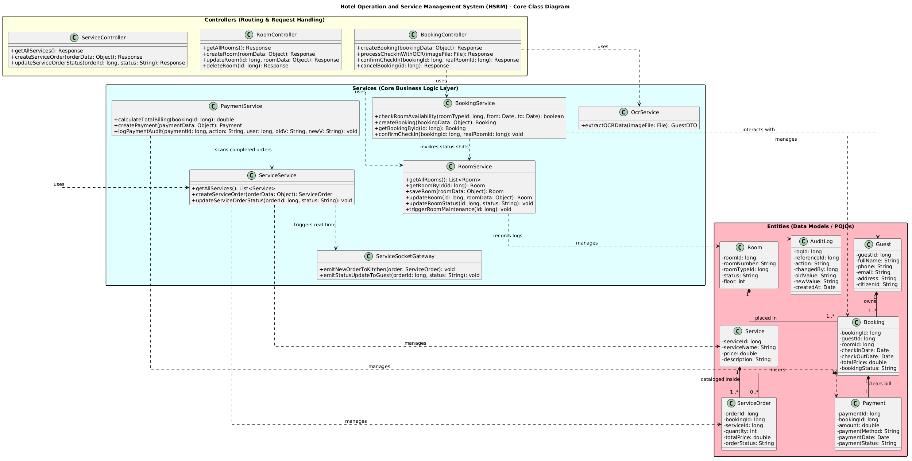

b. Class Specifications
[Provide the description for each class and the methods in each class, following the table format as below]

1. Room Management Module
Room (Entity Class): Contains the data structure and attributes of a room entity (roomId, roomNumber, roomTypeId, status, floor). It does not contain any database or business logic functions.
RoomService (Service Class): Handles business logic orchestration and database interactions for room assets.

No | Method | Description
01 | getAllRooms() | Retrieves all room records from the database to display real-time statuses on the management dashboard.
02 | getRoomById(id) | Finds and returns detailed information about a specific room based on the provided Room ID.
03 | saveRoom(roomData) | Inserts a new room record into the system database.
04 | updateRoom(id, roomData) | Updates physical details of a room (e.g., room number, floor, or type configuration).
05 | updateRoomStatus(id, status) | Fast-tracks updates to the current operational status of a room (Available, Dirty, In-use).
06 | triggerRoomMaintenance(id) | [AI & Automation Feature] Flags a room as 'Maintenance' when a technical issue is reported and automatically blocks it on the online booking portal.
07 | deleteRoom(id) | Permanently removes a room record from the system database.

2. Booking & AI OCR Check-in Module
Booking (Entity Class): Holds transaction fields for reservations (bookingId, guestId, roomId, checkInDate, checkOutDate, totalPrice, bookingStatus).
BookingService (Service Class): Executes core reservation flows, room availability algorithms, and coordinates AI OCR operations.
No | Method | Description
01 | checkRoomAvailability(roomTypeId, fromDate, toDate) | Runs an overlapping-date algorithm to verify if a room type is free within the requested period.
02 | createBooking(bookingData) | Creates a new reservation record for either online bookings or walk-in clients.
03 | getBookingById(id) | Fetches comprehensive details of a booking reservation using its unique ID.
04 | getBookingsByGuest(guestId) | Pulls the entire historical booking log associated with a specific guest account.
05 | processCheckInWithOCR(imageFile) | [AI OCR Feature] Receives the uploaded National ID/Passport image from the receptionist, forwards it to the AI pipeline to extract text fields (Name, ID number, DOB), and returns a GuestDTO to auto-fill the form.
06 | confirmCheckIn(bookingId, realRoomId) | Authorizes the guest's physical arrival, shifts the room status to 'In-use', and changes the booking state to 'Checked-In'.
07 | cancelBooking(id) | Annuls an existing reservation and sets its operational status to 'Cancelled'.

3. Guest Management Module
Guest (Entity Class): Maps the guest profile properties (guestId, fullName, phone, email, address, citizenId).
GuestService (Service Class): Oversees customer retention files and identity matching workflows.
No | Method | Description
01 | getGuestById(id) | Retrieves detailed personal demographics of a customer using their Guest ID.
02 | getGuestByCitizenId(citizenId) | [OCR Sync Mechanism] Scans the database using a National ID Number to check if the client is a returning guest before creating a duplicate record.
03 | saveGuest(guestData) | Commits a new guest profile into the database (typically populated via the AI OCR pipeline).
04 | updateGuest(id, guestData) | Modifies personal customer data fields such as contact phone numbers, emails, or home addresses.

4. Service Ordering & Real-time Synchronization Module
Service / ServiceOrder (Entity Classes): Represent structural fields for cataloged items and dynamic hospitality orders.
ServiceService (Service Class): Coordinates order placement, kitchen fulfillment workflows, and triggers instant two-sided updates via WebSockets.
No | Method | Description
01 | getAllServices() | Pulls the full list of operational amenities (Food & Beverage, laundry, spa) for guest menu layouts.
02 | getServiceById(id) | Fetches targeted item breakdowns and current unit prices for a specific service.
03 | createServiceOrder(orderData) | [Real-time Workflow] Logically initializes a service request in the DB with an 'Ordered' status and broadcasts an immediate WebSocket signal to the respective department panel (e.g., Kitchen).
04 | updateServiceOrderStatus(orderId, status) | [Socket.io Synchronize] Shifts fulfillment steps (Ordered $\rightarrow$ Processing $\rightarrow$ Completed). Upon kitchen completion, pushes a real-time event notice to the guest's client application interface.
05 | saveService(serviceData) / updateService(id, serviceData) | Allows administrators to append new items or update price details within the system's global service catalog.
06 | deleteService(id) | Deactivates or removes a service offering from the active system menu.

5. Payment & Audited Billing Module
Payment (Entity Class): Holds transactional attributes for invoicing (paymentId, bookingId, amount, paymentMethod, paymentDate, paymentStatus).
PaymentService (Service Class): Powers billing rollups and audit logging mechanisms to counter operational fraud.
No | Method | Description
01 | calculateTotalBilling(bookingId) | [Automated Billing] Dynamically calculates invoices: $\text{(Actual Days Stayed} \times \text{Room Rate)} + \text{Sum Total of all associated 'Completed' ServiceOrders}$.
02 | createPayment(paymentData) | Processes financial checkouts and seals the billing record into the database during guest departures.
03 | logPaymentAudit(paymentId, action, changedBy, oldVal, newVal) | [Audit Log Mechanism] Electronically records system mutation logs whenever a invoice is printed, modified, or discounted, capturing the responsible personnel to prevent financial leaks.
04 | getPaymentByBooking(bookingId) | Queries invoice settlements and financial clearance metrics tied to a designated booking transaction.

6. Staff Management Module

Staff (Entity Class): Maps internal employment indices (staffId, fullName, phone, position, salary).
StaffService (Service Class): Oversees core employment rosters and backend authorization levels.
No | Method | Description
01 | getAllStaffs() | Generates a list of all employed staff personnel across every operational department.
02 | getStaffById(id) | Looks up discrete HR records, active duties, and salary levels for an explicit Staff ID.
03 | saveStaff(staffData) | Onboards a new staff employee and setups structural profile fields.
04 | updateStaff(id, staffData) | Modifies personnel records (e.g., phone contact updates, structural wage advancements, or promotional role shifts).
05 | deleteStaff(id) | Terminates a staff system profile or marks their status index as inactive.

c. Sequence Diagram(s)
[Provide the sequence diagram(s) for the feature, see the sample below]
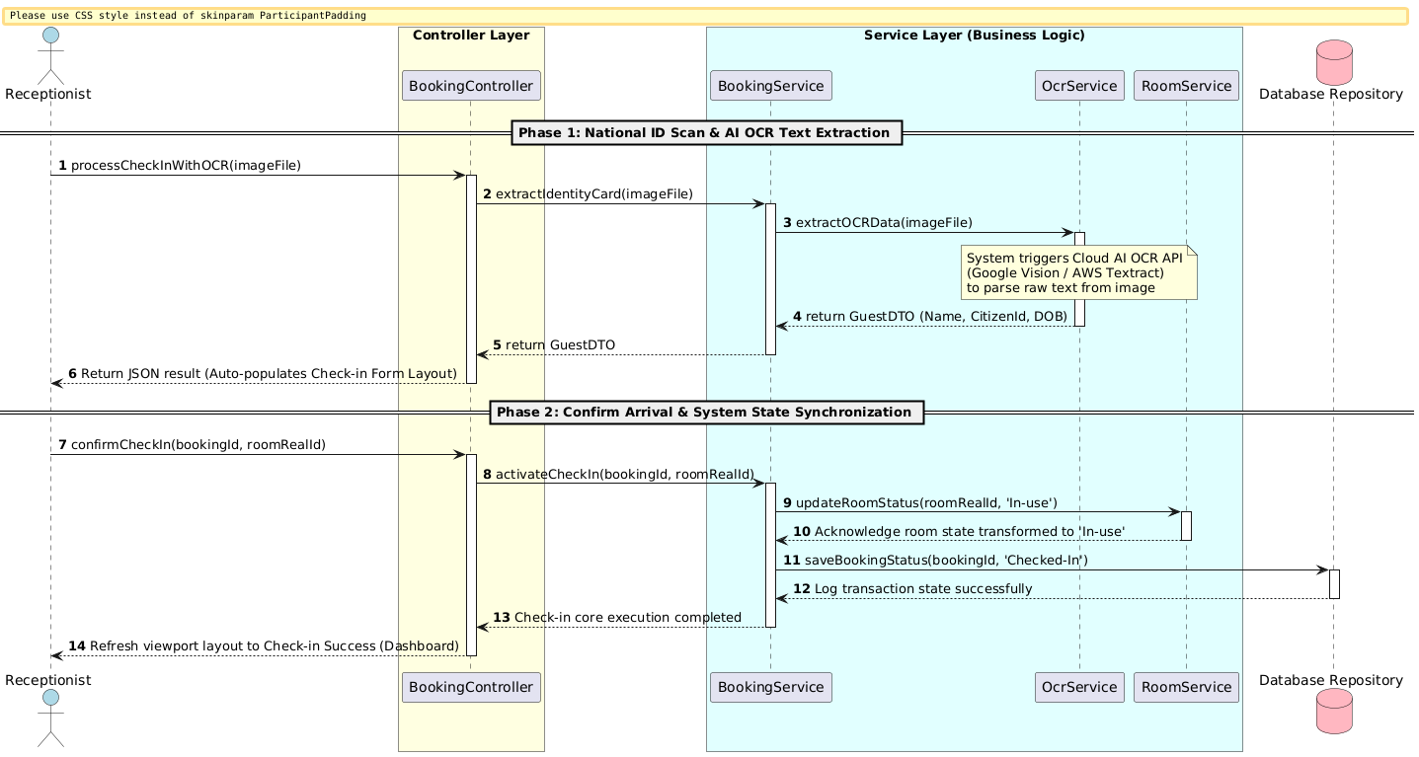

d. Database Queries
[Provide the detailed SQL (select, insert, update...) which are used in implementing the function/screen]

1. Login Function
2. Room Management Function
3. Booking Management Function
4. Payment Function
5. Service Management Function
6. Guest Management Function
7. Staff Management Function
8. Report Function

2. <Feature/Function Name2>

d. Database Queries

1. Login Function
Operation | Description | SQL Query
User Login Authentication | Validates credentials during user sign-in by checking the username and password match. | SELECT user_id, username, role, password  FROM users  WHERE username = ? AND password = ?;

2. Room Management Function
Operation | Description | SQL Query
Add New Room | Adds a newly constructed or configured room into the hotel operational system. | INSERT INTO rooms(room_number, room_type_id, status, floor)  VALUES (?, ?, ?, ?);
Get All Rooms | Fetches the complete room grid along with active housekeeping statuses for the main dashboard view. | SELECT * FROM rooms;
Update Room Status | Programmatically updates room states following housekeeping or occupant events. | UPDATE rooms  SET status = ?  WHERE room_id = ?;
Trigger Room Maintenance | [Automated Workflow] Flags a room as unavailable due to operational faults. | UPDATE rooms  SET status = 'Maintenance'  WHERE room_id = ?;
Delete Room | Purges a physical room entity from the system environment. | DELETE FROM rooms WHERE room_id = ?;

3. Booking Management Function
Operation | Description | SQL Query
Check Room Availability | Evaluates date overlap formulas to ensure no double-booking conflicts exist for the selected dates. | SELECT * FROM bookings  WHERE room_id = ?  AND booking_status != 'Cancelled'  AND ((check_in_date <= ? AND check_out_date >= ?));
Create Booking | Logs a newly reserved room contract under an initial 'Pending' state. | INSERT INTO bookings (guest_id, room_id, check_in_date, check_out_date, total_price, booking_status)  VALUES (?, ?, ?, ?, ?, 'Pending');
Get Booking Details | Pulls itemized parameters of a specific reservation alongside room details using a Booking ID. | SELECT b.*, r.room_number  FROM bookings b  JOIN rooms r ON b.room_id = r.room_id  WHERE b.booking_id = ?;
Update Booking Status | Transitions a reservation through standard lifecycle phases (e.g., Checked-In, Checked-Out, Cancelled). | UPDATE bookings  SET booking_status = ?  WHERE booking_id = ?;

4. Payment Function
Operation | Description | SQL Query
Get Active Service Orders for Billing | [Core Integration] Pulls all finalized charges (Completed service orders) incurred by a room to compound the master bill. | SELECT so.order_id, s.service_name, so.quantity, so.total_price  FROM service_orders so  JOIN services s ON so.service_id = s.service_id  WHERE so.booking_id = ? AND so.order_status = 'Completed';
Create Payment | Logs a master billing transaction entry upon successful checkout processing. | INSERT INTO payments (booking_id, amount, payment_method, payment_date, payment_status)  VALUES (?, ?, ?, NOW(), 'Paid');
Log Payment Audit | [Audit Trail Mechanism] Registers a trackable trace item inside audit tables noting billing generation and financial records. | INSERT INTO audit_logs (log_type, reference_id, action, changed_by, old_value, new_value, timestamp)  VALUES ('PAYMENT', ?, 'CREATE_BILL', ?, ?, ?, NOW());
Get Payment Information | Fetches the financial clearance metadata tied to a historical room stay. | SELECT * FROM payments WHERE booking_id = ?;

5. Service Management Function
Operation | Description | SQL Query
Add New Service | Incorporates a new structural amenity choice (e.g., a dish item or spa option) into the standard service menu. | INSERT INTO services(service_name, price, description)  VALUES (?, ?, ?);
Get All Services | Pulls the active global service registry list to populate standard consumer menus. | SELECT * FROM services;
Create Service Order | [Real-time Trigger] Writes an incoming order transaction into the database before broadcasting it via WebSockets. | INSERT INTO service_orders (booking_id, service_id, quantity, total_price, order_status)  VALUES (?, ?, ?, ?, 'Ordered');
Update Service Order Status | Steps an active service order tracking line forward through localized workflows. | UPDATE service_orders  SET order_status = ?  WHERE order_id = ?;

6. Guest Management Function
Operation | Description | SQL Query
Add New Guest via AI OCR | [AI Pipeline Sync] Fast-saves extracted metadata indices mapped from a processed National ID card scanning event. | INSERT INTO guests(full_name, phone, email, address, citizen_id)  VALUES (?, ?, ?, ?, ?);
Search Guest By Citizen ID | Queries profile databases via National ID identifiers to perform duplicate screening checks. | SELECT * FROM guests WHERE citizen_id = ?;
Search Guest By Name | Executes wildcard lookup sweeps across customer database index fields using partial names. | SELECT * FROM guests WHERE full_name LIKE ?;

7. Staff Management Function
Operation | Description | SQL Query
Add New Staff | Commits a new internal staff record listing onto the corporate personnel table. | INSERT INTO staffs(full_name, phone, position, salary)  VALUES (?, ?, ?, ?);
Update Staff Information | Updates an explicit employee profile row with fresh contact variables or salary figures. | UPDATE staffs  SET phone = ?, position = ?, salary = ?  WHERE staff_id = ?;

8. Report Function
Operation | Description | SQL Query
Calculate Total Revenue | Evaluates total financial performance yields aggregated across all 'Paid' system transactions. | SELECT SUM(amount) AS total_revenue  FROM payments  WHERE payment_status = 'Paid';
Revenue Report By Service Type | Breaks down non-room operational earnings grouped cleanly by specific menu or service classes. | SELECT s.service_name, SUM(so.total_price) AS service_revenue  FROM service_orders so  JOIN services s ON so.service_id = s.service_id  WHERE so.order_status = 'Completed'  GROUP BY s.service_name;

