Assignment 3

Team G3T2

* Vishnudatha Kanjur (3250569)
* Julian Hörz (3316908)

Solutions:

1.a) Given that,

*qr*[*X*] = 3

*qw*[*X*] = 4

Conditions for quorum are satisfied

a) write threshold + read threshold = 7 > total number of votes

b) write threshold = 4 > (total number of votes/2)

=> total number of votes = 6

The maximum of availability is for *XC* = 0.9 so *q*[*XC* ] = 3. This will also minimize the number of nodes to be locked for writing X.

A valid agreement that

* 1. minimizes the number of nodes that have to be locked for writing X
  2. maximizes the availability of *X* for writing

is as follows:

*q*[*XA*] = 1*, q*[*XB*] = 1*, q*[*XC* ] = 3, *q*[*XD*] = 1

Possible write quorums for X include {*XA, XB, XC, XD },{ XA, XC},{ XB, XC},{ XD, XC},{XA, XC, XD },{XB, XC, XD },*{*XA, XB, XC*}

Possible read quorums for X include {*XA, XB, XC, XD },{ XA, XC},{ XB, XC},{ XD, XC},{XA, XC, XD },{XB, XC, XD },*{*XA, XB, XC*},{*XA, XB, XD*}, {*XC}*

b) Given *q*[*XA*] = 1*, q*[*XB*] = 1*, q*[*XC* ] = 2*, q*[*XD*] = 3

For *qw*[*X*] = 6, there exist exactly three write quorums. And the three quorums are,

{*XA, XB, XC, XD },{XA, XC, XD },{XB, XC, XD }*

c) Given for a given node n, q[Yn]= 1.

So by majority consensus, for reading qr[Y]= for odd number of replicas=(no of nodes+1)/2 =(3+1)/2 = 2

So it can tolerate maximum one node failure. So probability can be calculated as

Probability that the logical object Y is available for reading = pr(Y)= pK* pL* pM +(1-pK)* pL* pM + pK* (1-pL)* pM + pK* pL* (1-pM )

2. a)

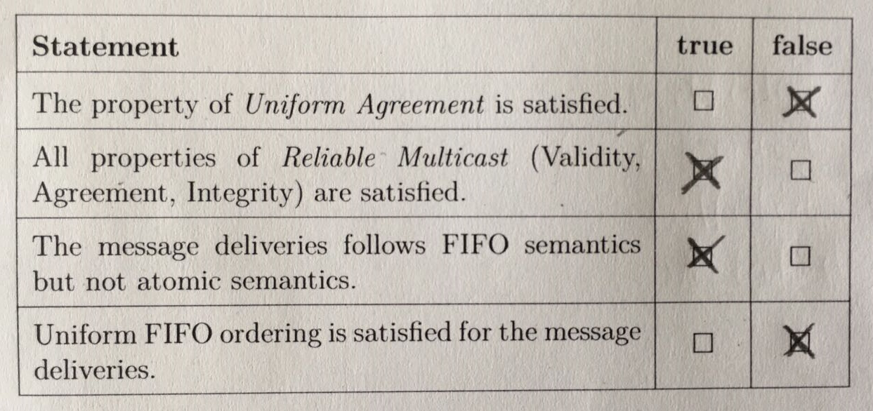

1. Uniform Agreement is not satisfied as message m3 from faulty process P2 is not delivered by P1 and P3.
2. All properties of Reliable multicast are satisfied. Agreement and Validity- Messages m1,m2 and m4 (messages from correct processes) are delivered by P1 and P3 as per the agreement and validity conditions. Integrity- Message m2 is delivered only once.
3. Message deliveries follow FIFO semantics P3 delivers m1 before m4.

Atomic ordering(total ordering) is not followed in the message deliveries. Correct process P1 delivers in the order m1, m2, m4 and correct process P3 in the order m2, m1, m4.

1. Uniform FIFO ordering is not satisfied as faulty process P2 delivers the message m3 which is not eventually delivered by other processes P1 and P3.
2. i) 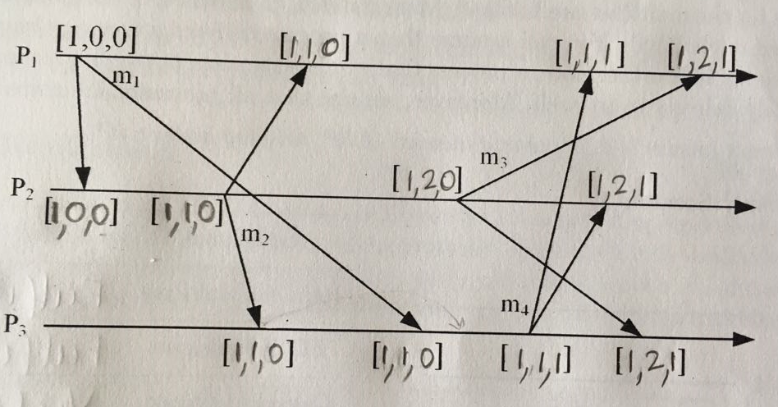

ii)

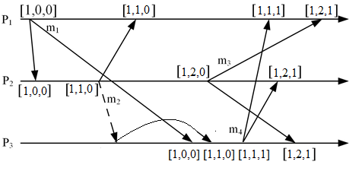

Message m3 delivered by P3 needs to be delayed till P1 m1 is delivered.

3.

a) Scenario 1:

Reliable Multicast is fulfilled as it doesn’t violate Validity, Agreement and Integrity conditions.

FIFO Multicast is fulfilled as the case doesn’t show messages from the same correct sender.

Causal Multicast is not fulfilled in the m2 is delivered by correct process C, even though, there is a causal dependency in correct process B that m2 should be delivered after m1.

Total ordering of delivering of messages is not followed in C, ie, C delivers in the sequence(m2, m1) where as A and B delivers in the sequence (m1,m2). So atomic multicast is violated.

|  |  |
| --- | --- |
| Sematics | Fulfilled/Violated |
| Reliable Multicast | Fulfilled |
| FIFO Multicast | Fulfilled |
| Causal Multicast | Violated |
| Atomic Multicast | Violated |

b) Scenario 2:

Reliable Multicast is violated as correct process C delivers message m2 two times(m2 from A and by sending m2 to B) which violates the Integrity condition.

FIFO Multicast, Causal Multicast and Atomic Multicast are Reliable Multicast, therefore, all of them are violated.

|  |  |
| --- | --- |
| Sematics | Fulfilled/Violated |
| Reliable Multicast | Violated |
| FIFO Multicast | Violated |
| Causal Multicast | Violated |
| Atomic Multicast | Violated |

c) Scenario 3:

Reliable Multicast is fulfilled as it doesn’t violate Validity, Agreement and Integrity conditions.

FIFO Multicast is fulfilled as the case doesn’t show messages from the same correct sender.

Causal Multicast is fulfilled as the case doesn’t show any causal order dependency.

Total ordering of delivering of messages is not followed in C, ie, C delivers in the sequence(m1, m2) where as A and B delivers in the sequence (m2,m1). So atomic multicast is violated.

|  |  |
| --- | --- |
| Sematics | Fulfilled/Violated |
| Reliable Multicast | Fulfilled |
| FIFO Multicast | Fulfilled |
| Causal Multicast | Fulfilled |
| Atomic Multicast | Violated |