Assignment 3

Team G3T2

* Vishnudatha Kanjur (3250569)
* Julian Hörz (3316908)

Solutions:

1. a)

i) False, synchronization depends on time t. Further that clocks has to be accurate and the clock has to be synchronized with the correct clock.

As per the lecture, synchronizing physical clocks means: Limiting the difference between the clock values (i.e., skew) to a sufficiently low amount and not to zero.

ii) Lamport’s algorithm will work only for the left process system.

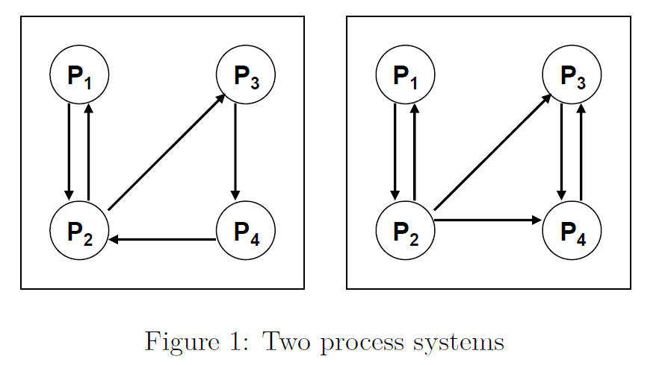

The right process system violates the assumption that there exists a directed graph of processes(Chapter 5 Slide 23). It violates it because two edges are going from P2 to P3 and P4. Therefore the graph is not directed. P3 and P4 are not connected to P1 and P2 to send messages for synchronization.

b) i)

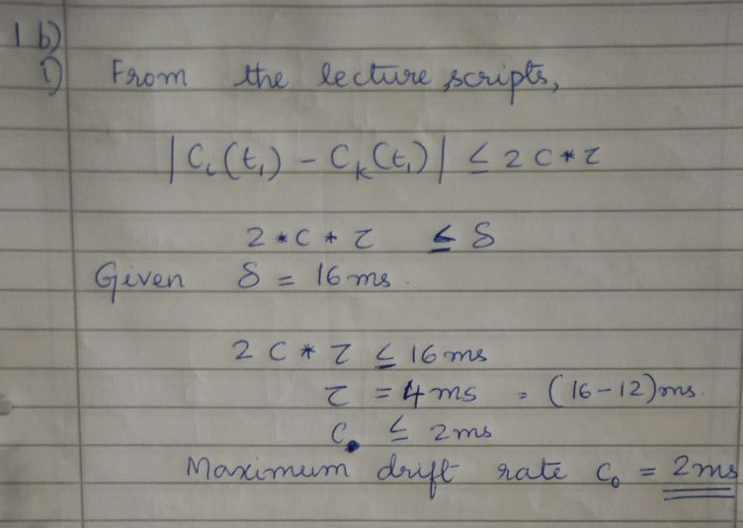

ii)

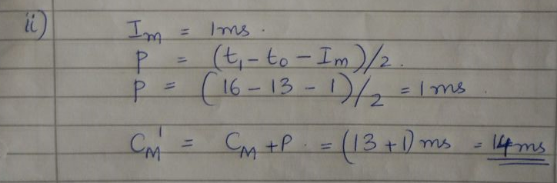

iii) The slave Cs has to slow down until the time is corrected(ie until CM has caught up) by letting some interrupts pass without incrementing the time. So t1 will be tu,

t1=16ms.

1. a) i) Concurrent relation is non transitive.

Assume P1,P2,P3 be three processes as per the below diagram and e11,e21,e31 be three states as in the below diagram. e11||e31 ,e21||e31 but e11|| e21 doesn’t hold as e11-> e21

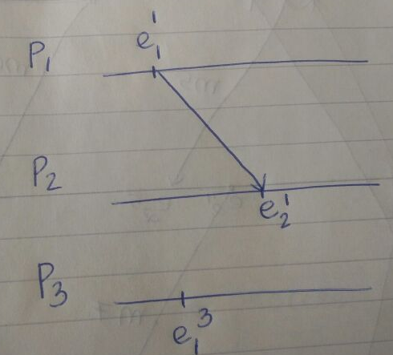

ii)

|  |  |
| --- | --- |
| **Statement true false** | **true false** |
| At least one send-event must have occurred between *t*1 and *t*2 | false |
| At least two events occurred between *t*2 and *t*3 | true |
| At least six events occurred between *t*2 and *t*3 | false |
| At least two receive-events occurred between *t*1 and *t*3 | false |
| At least one receive-event occurred between *t*2 and t3 | true |
| At least one send event occurred between *t*2 and *t*3 | false |

b) i)

|  |  |
| --- | --- |
| State eij | C(eij) |
| e11 | 1 |
| e12 | 2 |
| e13 | 3 |
| e14 | 4 |
| e21 | 4 |
| e22 | 5 |
| e23 | 6 |
| e24 | 7 |
| e31 | 1 |
| e32 | 2 |
| e33 | 3 |
| e34 | 8 |

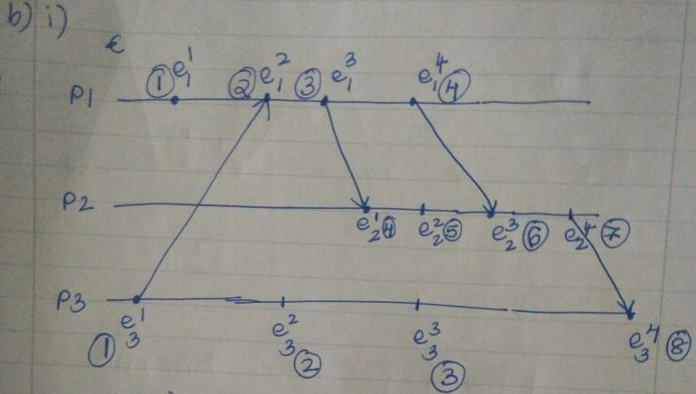

ii)

|  |  |
| --- | --- |
| State eij | VC(eij) |
| e11 | (1,0,0) |
| e12 | (2,0,1) |
| e13 | (3,0,1) |
| e14 | (4,0,1) |
| e21 | (3,1,1) |
| e22 | (3,2,1) |
| e23 | (4,3,1) |
| e24 | (4,4,1) |
| e31 | (0,0,1) |
| e32 | (0,0,2) |
| e33 | (0,0,3) |
| e34 | (4,4,4) |

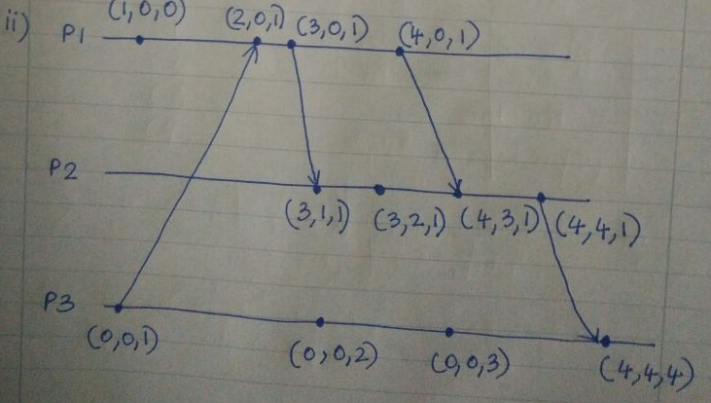

c)

i) 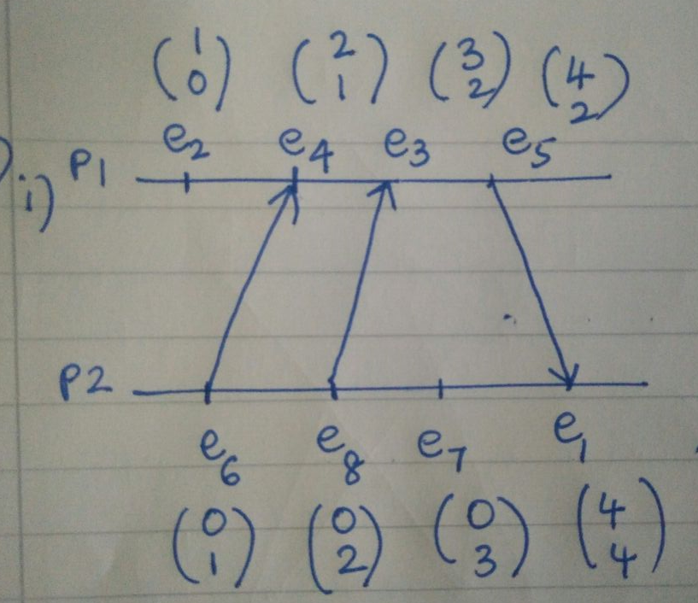

The events that belong to P1 -e2,e4,e3,e5

The events that belong to P2-e6,e8,e7,e1

ii) Local event: e2,e7

Send event: e6,e8,e5

Receive event: e4,e3,e1

3.

a) i) No. This is not a valid linearization of H as the e12 is causally dependent on e21

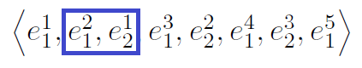

ii) No. This is not a valid linearization of H as the e22 is causally dependent on e13

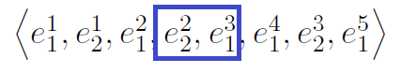

iii) Yes. This is a valid linearization of H as all the dependencies are captured accurately.

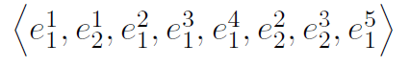

b)

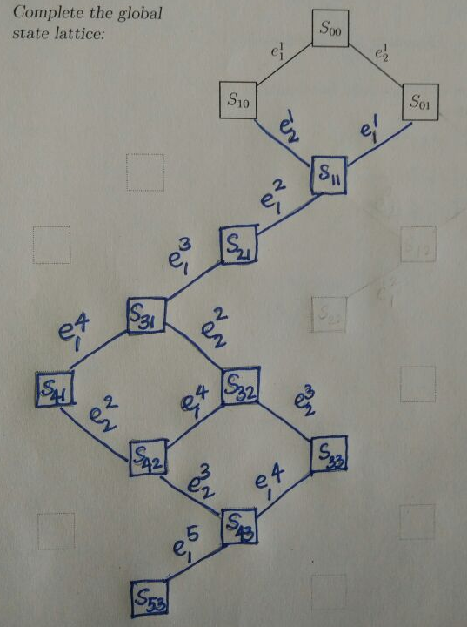

4.

Channel c2 recorded m3

P1 Recorded

a)

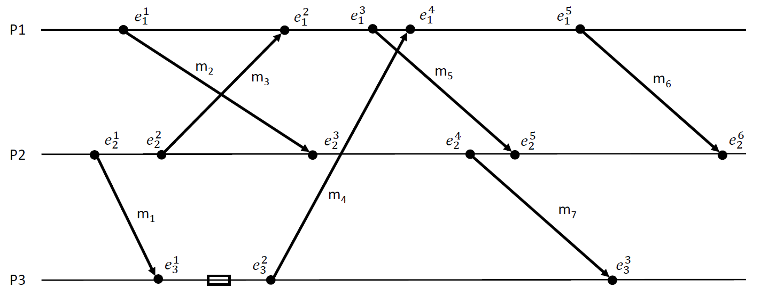

P2 recorded

C2

C1

C3

C4

Channel c3 recorded m1

P3 recorded

b)

|  |  |
| --- | --- |
| Channel | Message recorded |
| C1 | empty |
| C2 | m3 |
| C3 | m1 |
| C4 | empty |