Tooth Growth Analysis

David Thayer

Sunday, January 25, 2015

We will load the Tooth Growth data set and provide a summary and exploration of the data set.

We will then determine if given the size of the groups the differences between the means in each group atre statistically significant.

##   
## Attaching package: 'dplyr'  
##   
## The following object is masked from 'package:stats':  
##   
## filter  
##   
## The following objects are masked from 'package:base':  
##   
## intersect, setdiff, setequal, union

summary(ToothGrowth) ##summarise ToothGrowth

## len supp dose   
## Min. : 4.20 OJ:30 Min. :0.500   
## 1st Qu.:13.07 VC:30 1st Qu.:0.500   
## Median :19.25 Median :1.000   
## Mean :18.81 Mean :1.167   
## 3rd Qu.:25.27 3rd Qu.:2.000   
## Max. :33.90 Max. :2.000

The following table lists the mean tooth length for each group

ag <- aggregate(len ~ ., data = ToothGrowth, mean)  
xtabs(len ~ ., data = ag)

## dose  
## supp 0.5 1 2  
## OJ 13.23 22.70 26.06  
## VC 7.98 16.77 26.14

The following table lists the standard deviation of the tooth length for each group

ag <- aggregate(len ~ ., data = ToothGrowth, sd)  
xtabs(len ~ ., data = ag)

## dose  
## supp 0.5 1 2  
## OJ 4.459709 3.910953 2.655058  
## VC 2.746634 2.515309 4.797731

Next we display confidence intervals for our three dosage groups 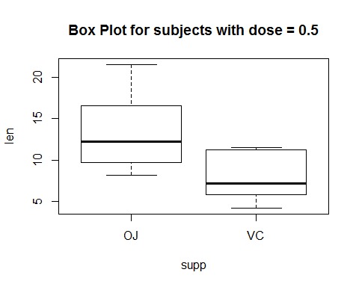 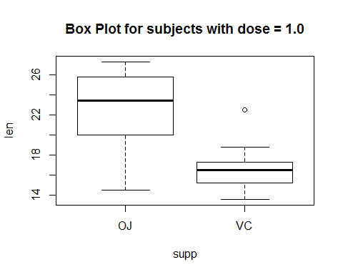 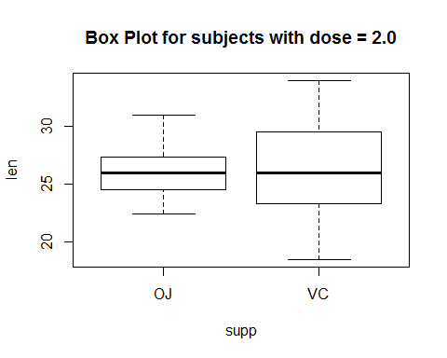

From this it is apparent thet the differences in mean between the two treatments is significant for dose levels 0.5 and 1.0 but are insignificant for dose rates 2.0.

This is assuming that all variables are distributed according to a normal distribution.