🔥

FLAMES
Ultimate Relationship Calculator
Version 3.0 - Ultimate Edition

Project Documentation

Submitted By:
SAICHARITHA DATHRIKA
June 2018

Table of Contents
1. Introduction 2
2. What is FLAMES? 2
2.1 Algorithm 2
3. Features 3
3.1 CLI Version Features 3
3.2 Web GUI Features 3
4. Screenshots 4
4.1 Input Screen 4
4.2 Result Screen 4
5. Technical Implementation 6
5.1 Technologies Used 6
6. How to Use 7
6.1 Web GUI Version 7
6.2 CLI Version 7
7. File Structure 7
8. Future Enhancements 7

1. Introduction
FLAMES is a classic relationship calculator game that has been popular among teenagers for decades. This project presents an ultimate edition of the FLAMES game with both a Command Line Interface (CLI) version written in C and a beautiful Web-based GUI version using HTML, CSS, and JavaScript.
The application allows users to enter two names and calculates the relationship between them based on the FLAMES algorithm. The result can be Friends, Love, Affection, Marriage, Enemies, or Siblings.

2. What is FLAMES?
FLAMES is an acronym where each letter represents a type of relationship:
Letter | Meaning | Description
F | Friends | Just good friends! 👫
L | Love | There's love in the air! 💕
A | Affection | Deep affection & care! 💖
M | Marriage | Wedding bells are ringing! 💒
E | Enemies | Oops! Not a good match! 😅
S | Siblings | Like brother and sister! 👨‍👩‍👧‍👦

2.1 Algorithm
The FLAMES algorithm works as follows:
- Take two names as input
- Remove spaces and convert to lowercase
- Count the frequency of each letter in both names
- Calculate the absolute difference of letter frequencies
- Sum all the differences to get the count
- Use this count to eliminate letters from 'FLAMES' one by one
- The last remaining letter determines the relationship

3. Features

3.1 CLI Version Features
- Colorful text-based user interface with ANSI colors
- ASCII art banner
- Support for names with spaces (up to 100 characters)
- History tracking (up to 50 records)
- Auto-save results to file
- Sound effects (toggleable)
- Export history to timestamped file
- Cross-platform support (Windows, Mac, Linux)

3.2 Web GUI Features
- Beautiful gradient-animated background
- Responsive design (works on mobile devices)
- Confetti animation for Love/Marriage results
- Sound effects using Web Audio API
- History stored in browser's LocalStorage
- Share results feature
- No installation required - runs in any browser

4. Screenshots

4.1 Input Screen
The main input screen allows users to enter two names. The interface features a beautiful gradient background, colorful FLAMES letter badges with tooltips, and a clean input form.
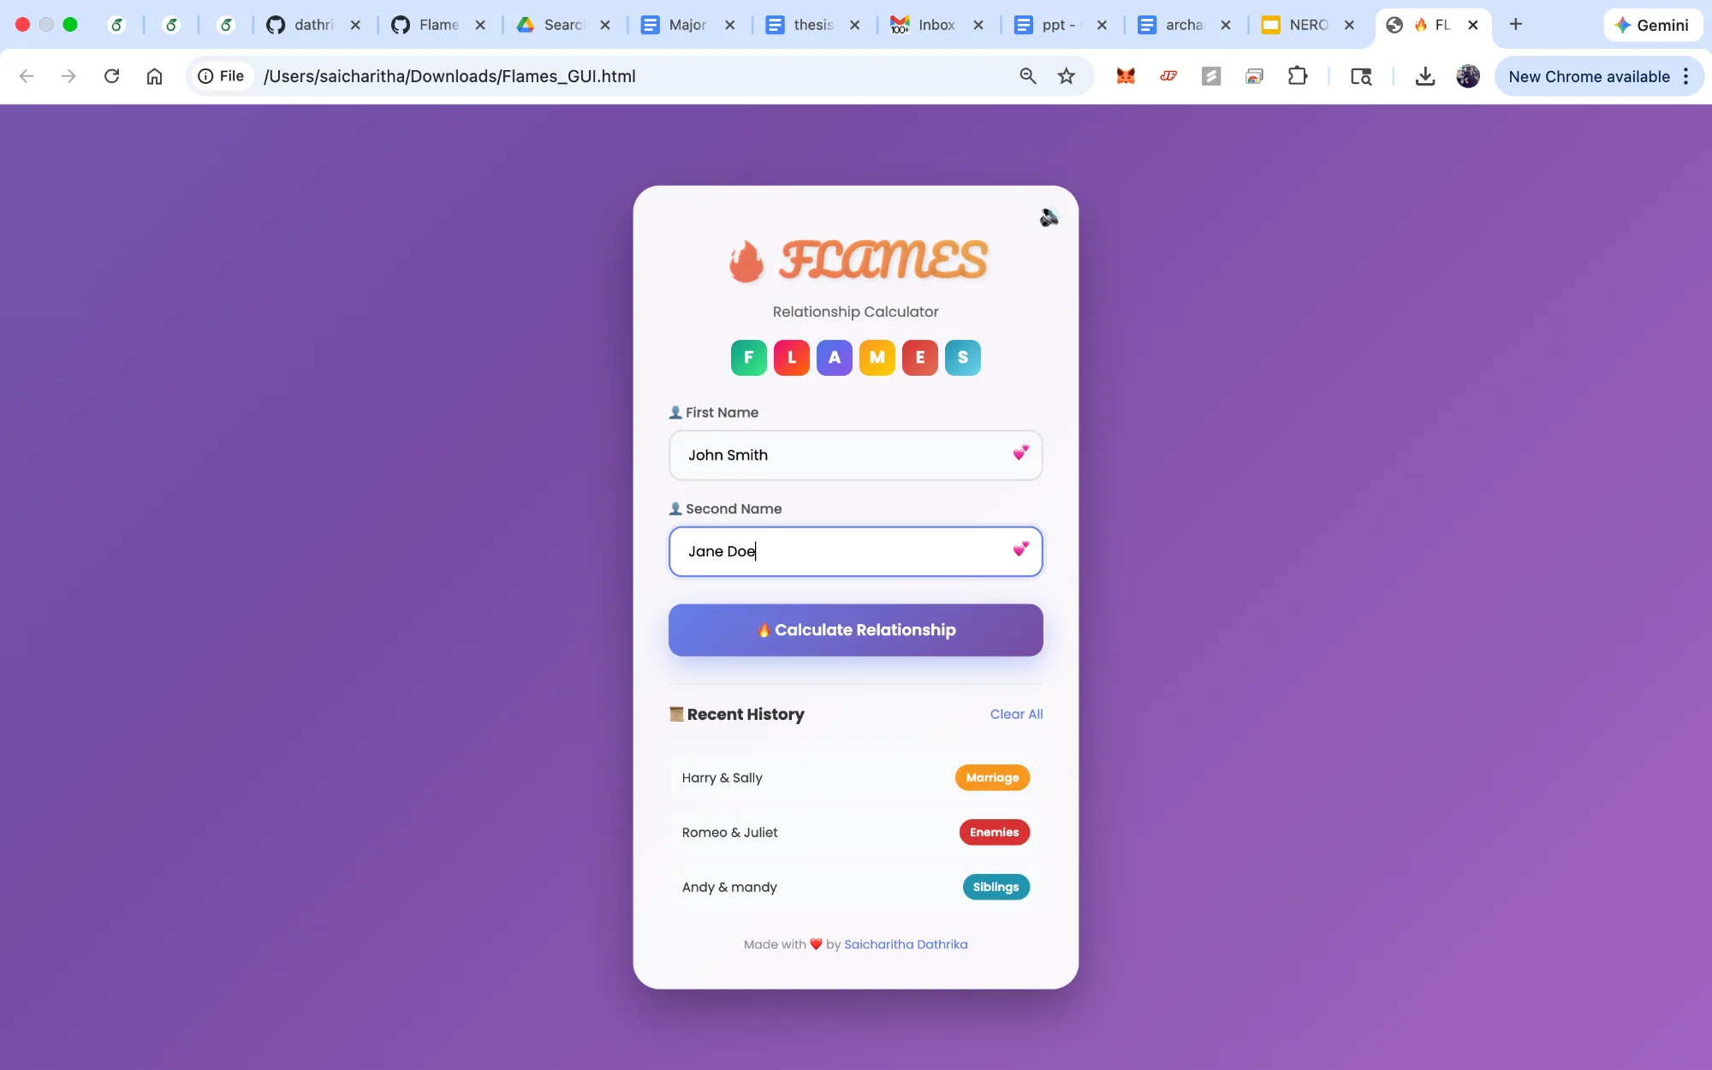
Figure 1: FLAMES Input Screen

4.2 Result Screen
After calculation, the result is displayed with a beautiful colored card, confetti animation (for Love/Marriage), and the history of previous calculations. Users can share their results or try another pair.
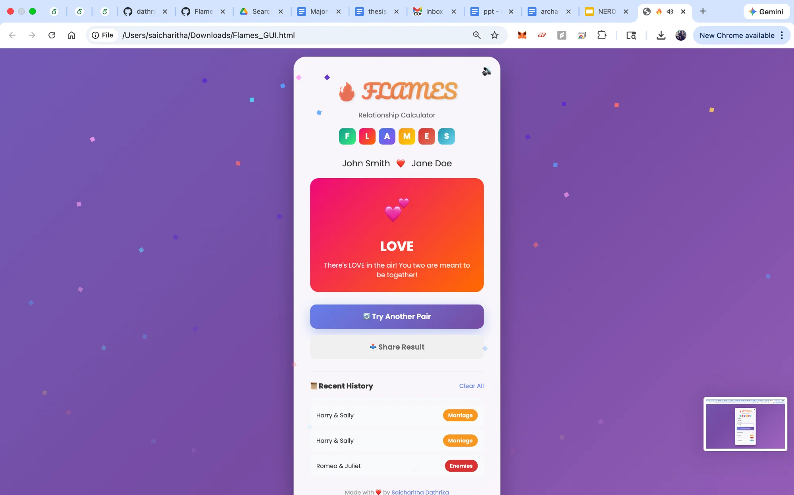
Figure 2: FLAMES Result Screen with Confetti Animation

5. Technical Implementation

5.1 Technologies Used
Component | Technology
CLI Version | C Programming Language
Web GUI | HTML5, CSS3, JavaScript (ES6+)
Styling | CSS Animations, Gradients, Flexbox
Fonts | Google Fonts (Poppins, Pacifico)
Sound | Web Audio API
Storage | LocalStorage (Web), File System (CLI)

6. How to Use

6.1 Web GUI Version
- Open Flames_GUI.html in any web browser
- Enter the first name in the 'First Name' field
- Enter the second name in the 'Second Name' field
- Click 'Calculate Relationship' button
- View your result with beautiful animations!

6.2 CLI Version
Compile and run the C program:
gcc Flames_Ultimate.c -o flames
./flames

7. File Structure
flames-ultimate/
├── Flames_Ultimate.c # CLI version (v3.0)
├── Flames_GUI.html # Web GUI version
├── Flames_UI.c # CLI version (v2.0)
├── Flames.c # Original version (v1.0)
└── README.md # Documentation

8. Future Enhancements
- Mobile app versions (Android/iOS)
- More relationship types and algorithms
- Social media integration for sharing
- User accounts to save history across devices
- Dark mode theme
- Multi-language support

Made with ❤️ by
Saicharitha Dathrika

🔥 May you find your true FLAMES result! 🔥

