

# DURABLE FURNITURES

**Supervisor:** *LÊ THANH NHÂN*

### Semester: *01*

**Batch No:** *T1. 2201.E0*

### Group No: *01*

|  |  |  |
| --- | --- | --- |
| **Order:** | **Full name** | **Roll No.** |
| *1.* | *Huỳnh Tiến Đạt* | *Student1362615* |
| *2.* | *Kiếu Tấn Phúc* | *Student1362611* |
| *3.* | *Nguyễn Hoàn Thiện* | *Student1362613* |

***Month****: 04* ***Year****: 2022*

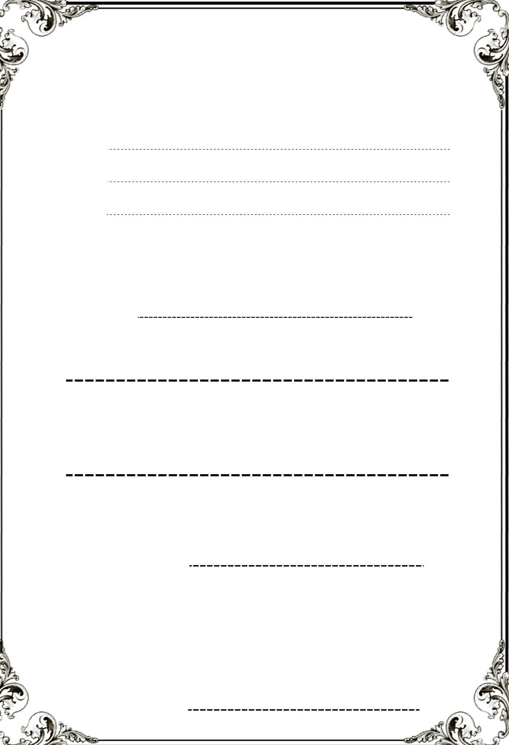

This is to certify that

**Mr. HUỲNH TIẾN ĐẠT**

**Mr. KIỀU TẤN PHÚC**

**Mr. NGUYỄN HOÀN THIỆN**

Have successfully Designed & Developed

**DURABLE FURNITURES**

Submitted by:

**Mr. LE THANH NHAN**

Date of Issue:

Authorized Signature:

**CONTENTS**

CONTENTS ACKNOWLEDGEMENT SYNOPSIS

REVIEW 1 ............................................................................................................................

1. REQUIREMENT SPECIFICATION
2. PROBLEM DEFINATION
3. CUSTOMERS REQUIREMENT SPECIFICATIONS (CRS)
4. ARCHITECTURE & DESIGN OF THE SYSTEM
5. SITEMAP
6. WEBSITE LAYOUT
   1. HOME PAGE
   2. ABOUT US PAGE
   3. PRODUCT CATEGORY PAGE
   4. PRODUCT DETAILS PAGE
   5. CONTACT PAGE
7. TASK SHEET 1

Review2 ................................................................................................................................

Review3 ................................................................................................................................

Testing Document .................................................................................................................

Final Checklist ......................................................................................................................

Task sheet .............................................................................................................................

**Acknowledge**

As we understand that the e-Project is a step-by-step learning environment that closely simulates the classroom and Lab based learning environment into actual implementation. It is a project implementation at your fingertips!! An electronic, live juncture on the machine that allows you to.

* Practice step by step i.e. laddered approach.
* Build a larger more robust application.
* Usage of certain utilities in applications designed by user.
* Single program to unified code leading to a complete application.
* Learn implementation of concepts in a phased manner.
* Enhance skills and add value.
* Work on real life projects.
* Give a real-life scenario and help to create applications more complicated and useful.
* Mentoring through email support.

We would like to send a great thank to our professor and others student for the adorable supports during the time in project.

Beside several mistakes we had made in the project, we hope to have more opportunities to widen our knowledge in web developing world.

We also thank you so much for your information and the “demo” project from India APTECH to help us get more reality experience in this project. Since we have gained more experience from this project, we will not stop learning everything as much as we can to be more successful in the future.

Your Sincerely, Team Group 01

**SYNOPSIS**

The Objective of this program we aim is to give a sample project to work on real life projects. These applications help us build a larger more robust application.

The objective is not to teach us HTML/JavaScript but to provide us with a real-life scenario and help us create basic applications using the tools.

Hence, we can revise the chapters before we start with the project.

This project is meant for students like us who have completed the module of HTML5. These programs should be done in the Lab sessions with assistance of the faculty if required.

The website (in this project) is a tool that brings everything in the world to you such as skill in technology and many things in ecommerce, ...

It is very essential for us that will have a clear understanding of the subject. We think we should go through the project and solve the assignments as per requirements given.

And get back [***eprojects@aptech.ac.in***](mailto:eprojects@aptech.ac.in) as the assigned schedule.

|  |  |  |
| --- | --- | --- |
| **Design Plan**:  **Durable Furnitures** | **Document Name**: Problem Definition | **SWD/Form** No.01/PD/Ver1.0 |
| **Effective Date**:20-04-2022 | **Version** 1.0 | **Page No**: **1** of **10** |

After reading the project specifications, the developer states the scope of the project very briefly. This is referred to as the problem definition. Queries of various staff members can be one or all of the following:

1. How many products can be displayed on Homepage at a time?
2. What information should be displayed about each product in Homepage?
3. Will users be able to contact shop when they need furniture?
4. Will the users be able to feedback their opinions?
5. Will the users be able to question about shop's product or services?

After consulting with several IT companies and considering budget constraints, Durable Furniture’s management decided to launch the Web application as a single page responsive Web application using HTML5, CSS3, JavaScript, Geolocation API, Web Storage, and Bootstrap 4, jQuery plugins, VS Code, or another HTML editor. Furthermore, the site will be tested using standard browsers as well as mobile emulation software.

|  |  |  |
| --- | --- | --- |
|  | **Prepared by (Student)** | **Approved by (Faculty)** |
|  | **Project Group No**: 01 |  |
| **Signature** |  |  |
| **Date** |  |  |

## Customer Requirements Specifications

### Client: Durable Furniture

* 1. **Objectives:**
     + Provide a website to display information about products (furniture or decors) categorizing product information according to furniture type, decorate) and Seasons.
     + The website should have soothing color with proper logo and images.
     + A main menu must have: Home, About us, Products (with Submenu), Contact, Icon Cart, Login/Register.
     + A brief summary of individual products should be displayed on the Web Page along with the product but detailed Features should be stored in Individual Word documents which can be downloaded or viewed by the User who wishes to see the same.
     + If users wish to send us an email or look for our physical location, users should be able to do so in “Contact” page.

### Inputs provided by clients:

* + - Click on clickable links from menu.
    - Click to clickable links/images in “Products" or "Categories”.
    - Click “Compare” buttons for comparison between different products.

Click “Download” buttons for downloading doc documents from website of Durable Furniture

### Outputs expected from the system:

* + - The site should display a menu which will contain the options for brief introduction about the various furniture’s available, location of the shop and any other information if required.
    - A brief summary of features of individual products should be displayed on the Web Page along with the product
    - A list of products for that brand will be displayed.
    - A document with product details being download from website of Durable Furniture.

### Processes involved in the system

* + - Link to the required webpages.
    - Link to a webpage to show the summary of features of individual products.
    - Filter of brand must be conducted.
    - Link to the document store in the website.

### Hardware Requirement:

* A minimum computer system that will help you access all the tools in the courses is a Pentium 4, 1.8 Ghz or better
* 2 Gigabytes of RAM or better

### Software Requirement:

* + - Window 7/10 OS or higher
    - HTML5/CSS/JS supporting browsers
    - Visual Studio Code.
    - Bootstrap 4
    - jQuery
    - HTML editor (VS Code, Notepad++, Sublime Text, etc.)**.**

## 4. ARCHITECTURE & DESIGN OF THE SYSTEM

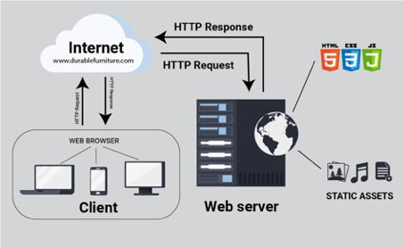

**SITEMAP**

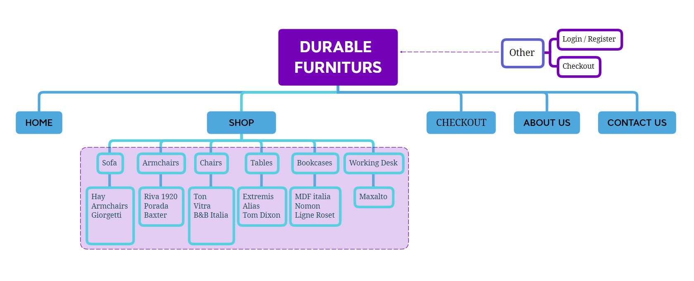

**SCREENSHOT**

* **HOMEPAGE:**

Logo Search

NavigationLogin page Cart

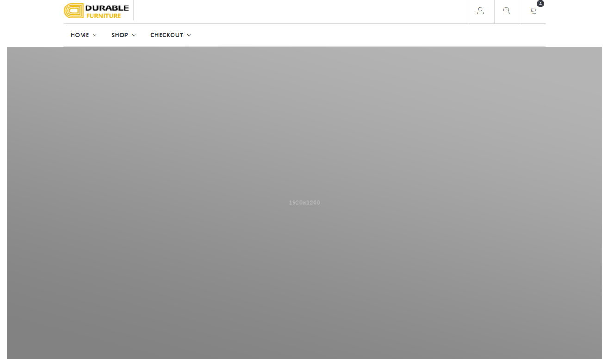

Banner

### Homepage review & code screenshot

**Description** : Homepage is the main page which showing all content about furniture, tips, product (brand, price, discount, …)

**From** : Homepage can be opened using html file, direct URL from URL bar of the browsers

**To** : In homepage, we can go to shop (general product page or detail product page if click on product or features product), login page, add to card the product & checkout page

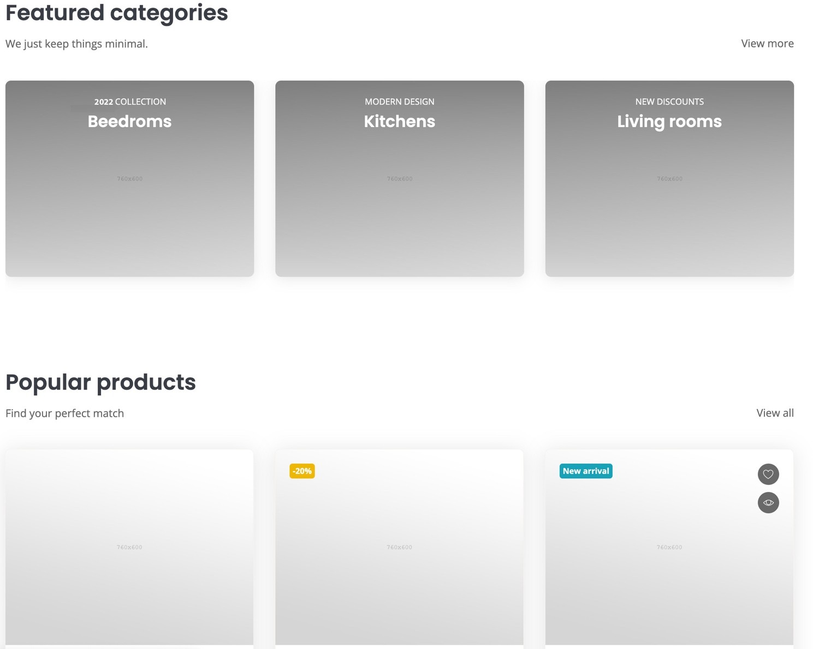

* **Login page**

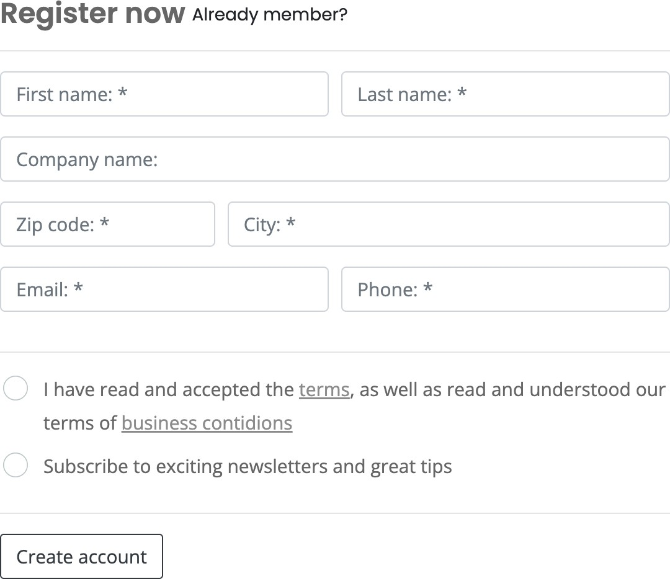

* **About us (contact us) screenshot**

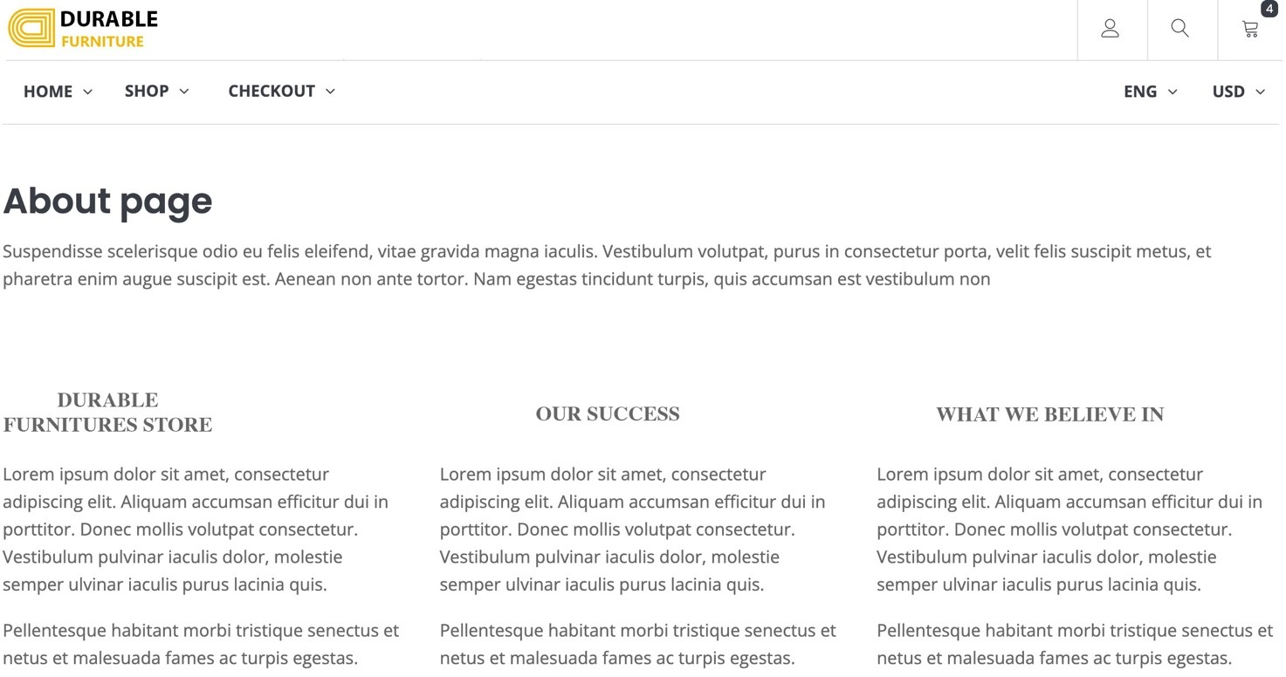

**Description:** About us page is showing information about the DURABLE FURNITURES, showing store, our success stories & our vision

**From** : About us page can be opened directly from URL or from HOMEPAGE

**To** : In about us page, we can go to shop (general product page or detail product page if click on product or features/popular product), login page, add to card the product & checkout page

## Testing documents

|  |  |  |
| --- | --- | --- |
| **Sr.No** | **Features Tested** | **Remarks** |
| 1 | Index.html | Done |
| 2 | Login.html | Done |
| 2 | About.html | Done |
| 3 | Contact.html | Done |
| 4 | Checkout.html | WIP |
| 5 | Product page | WIP |

## Final checklist

|  |  |  |
| --- | --- | --- |
| Sr.No | Aspected Tested | Suggestion/  Remarks |
| 1 | Are all the users able to view the images and links? |  |
| 2 | Have all the views, modules and controllers been properly integrated and is the site function as a single page application? |  |
| 2 | Are the GUI content devoid of spelling mistakes? |  |
| 3 | Is the application user-friendly? |  |
| 4 | Is the Website launching correctly in all popular browsers? |  |
| 5 | Are all the forms validated with proper criteria? |  |
| 6 | Do all text links lead to the appropriate website? |  |
| 7 | Do all image links lead to the appropriate website? |  |
| 8 | Are all the images and links clearly visible on the page? |  |

TASK SHEET

|  |  |  |  |  |  |  |  |
| --- | --- | --- | --- | --- | --- | --- | --- |
| **No** | **Member** | **Contents** | **Page Name** | **Activity Plan** | **Date of Preparation of Activity Plan** | | |
| **Planed Start Date** | **Actual Start Date** | **Actual Days** | **Status** |
| 1 | Huỳnh Tiến Đạt | Homepage | Homepage.html | 22/04/2022 | 06/05/2022 | 11 | OK |
| 2 | About Page | Aboutus.html | 22/04/2022 | 06/05/2022 | 11 | OK |
| 3 | Write Report Review 1 |  | 22/04/2022 | 24/04/2022 | 1 | OK |
| 4 | Wire framing general page layout and design UI. |  | 22/04/2022 | 25/04/2022 | 1 | OK |
| 5 | Brainstorming ideas for layouts, and Project Objective |  | 22/04/2022 | 25/04/2022 | 1 | OK |
|  | | | | | | | |
| 1 | Kiều Tấn Phúc | Register | Register.html | 22/04/2022 | 06/05/2022 | 11 | OK |
| 2 | Login Page | login.html | 22/04/2022 | 06/05/2022 | 11 | OK |
| 3 | Testing Responsive |  | 06/05/2022 | 08/05/2022 | 2 | OK |
| 4 | Draw site maps and architecture design |  | 22/04/2022 | 23/04/2022 | 1 | OK |
| 5 | Write Report Review 2 |  | 22/04/2022 | 08/05/2022 | 1 | OK |
|  | | | | | | | |
| 1 | Nguyễn Hoàn Thiện | Contact | Contact.html | 22/04/2022 | 06/05/2022 | 8 | OK |
| 2 | Checkout | Checkout.html | 22/04/2022 | 06/05/2022 | 8 | OK |
| 3 | Final Testing |  | 08/05/2022 | 11/05/2022 | 2 | OK |

|  |  |  |  |  |  |  |  |
| --- | --- | --- | --- | --- | --- | --- | --- |
| 4 |  | Collect static assets (pictures, mp4, documentation) |  | 22/04/2022 | 02/05/2022 | 2 | OK |
| 5 | Write Report Review 3 |  | 22/04/2022 | 06/05/2022 | 1 | OK |
|  |  |  |  |  |  |  |  |
| 1 | GROUP TEAM | Product Page | Product.html | 22/04/2022 | 06/05/2022 | 11 | OK |
| 2 | Product Detail Page | Productdetailxxx.htm l | 22/04/2022 | 06/05/2022 | 11 | OK |