Predictive Analytics Individual Coursework
MSIN0097 | 2025-26

Predictive Retail Site Selection across Greater London Using H3 Spatial Hexagons and XGBoost

Word Count: 1991 / 2000
Code Repository: https://github.com/daththeanalyst/geospatial-site-selection

Table of Contents

1. Problem Framing and Dataset Construction 3
1.1 Predictive Problem 3
1.2 Dataset Construction 3
1.3 Success Metrics and Constraints 4
1.4 Agent Tooling Plan 4
2. Exploratory Data Analysis 5
2.1 Spatial Distributions 5
2.2 Data Quality and Missingness 6
2.3 Leakage Risks Identified 7
3. Data Preparation 8
3.1 Feature Engineering Pipeline 8
3.2 Spatial Cross-Validation Design 8
3.3 Data Validation Checks 9
4. Model Exploration and Selection 10
4.1 Baseline Model 10
4.2 Model Comparison 10
4.3 Agent Contribution: Model Selection 11
5. Fine-Tuning and Evaluation 12
5.1 Threshold Tuning (F₁-Optimal Threshold) 12
5.2 Evaluation and Error Analysis 13
5.3 Agent Mistake Caught 15
6. Final Solution and Conclusions 16
6.1 Final Model and Rationale 16
6.2 Limitations and Risks 16
6.3 Next Steps 17
6.4 Model Card 17
References 18
Appendix A: Agent Usage Log + Decision Register 19
A.1 Interaction Log 19
A.2 Decision Register 19

1. Problem Framing and Dataset Construction

1.1 Predictive Problem
Retail site selection has long been recognised as "part art and part science" (Hernandez and Bennison, 2000), with decisions historically relying on heuristic checklists of foot traffic, competitor proximity and managerial intuition. Yet Church and Murray (2009) demonstrate that GIS-based location models consistently outperform expert judgement by integrating spatial variables that humans cannot simultaneously weight. More recently, Sevtsuk (2014) and Zhao, Zong and Wu (2023) show that retail agglomeration, the tendency of complementary businesses to co-locate, is a stronger predictor of venue density than raw population alone.
This project tests whether the spatial co-occurrence of complementary businesses, combined with demographic and network connectivity features, can predict location suitability more accurately than population-based heuristics. Each H3 Resolution-9 hexagon (roughly 174 m across, covering about 0.1 km²) across Greater London's 33 boroughs is classified as suitable or unsuitable based on whether an existing business is present, treating current presence as a proxy for proven demand (Roig-Tierno, Baviera-Puig and Buitrago-Vera, 2013). Six business types are modelled independently: cafe, restaurant, pub, fast food, gym and bakery, across 15,430 hexagons.

1.2 Dataset Construction
No single data source captures location suitability. Six feature groups are joined on the H3 hexagonal grid (Uber Technologies, 2024), each contributing a different dimension of place. LandScan ambient population serves as a footfall proxy, while ONS Census 2021 demographics capture age, education and employment profiles. Roughly 30,000 OpenStreetMap points of interest (Boeing, 2017) encode the co-occurrence ecosystem of nearby businesses. Six graph-centrality metrics, Louvain communities and Node2Vec embeddings (low-dimensional representations of each hexagon's network position) are derived from the H3 adjacency network, where each hexagon is a node connected to its spatial neighbours. Police.uk crime rates provide additional footfall signals grounded in routine activity theory (Cohen and Felson, 1979; Taecharungroj and Ntounis, 2024), and TfL transport accessibility covers bus stop density, station count and nearest station distance. In total, 33 features per business type span these six modalities.

1.3 Success Metrics and Constraints
The primary metric is ROC-AUC (which measures how well the model distinguishes suitable from unsuitable locations across all decision thresholds), it is chosen for its robustness to class imbalance (ratios range from 4.9:1 for cafes to 27.5:1 for bakeries). The secondary metric is F₁, which balances precision and recall equally: while high-precision recommendations are desirable, excessively conservative thresholds suppress recall to the point where the model fails to identify viable locations. The resulting F₁-optimal thresholds (0.72–0.82) are substantially above the default 0.5, ensuring only high-confidence predictions are surfaced as site recommendations. Constraints include interpretability for non-technical stakeholders (addressed via SHAP) and the absence of revenue or footfall ground truth.

1.4 Agent Tooling Plan
I delegated code scaffolding to the agent (Claude Code) (H3 grid generation, Overpass API retry logic, XGBoost pipeline structure), debugging (CRS projection errors, API timeouts, eigenvector convergence failures), and documentation drafting. I retained responsibility for: problem framing, metric selection, threshold decisions, interpreting SHAP outputs, and all data validation. Verification followed a plan–delegate–verify–revise cycle: every agent output was checked against spatial sanity assertions (CRS = EPSG:27700, hex count = 15,430), manual spot-checks of POI counts against Google Maps, and fold-balance audits. The full audit trail comprises 101 entries in the agent collaboration log.

2. Exploratory Data Analysis

2.1 Spatial Distributions
Class imbalance varies substantially across business types: cafes are present in 16.8% of hexagons (4.9:1 ratio), gyms in 9.2% (9.9:1), and bakeries in just 3.5% (27.5:1). A naive majority-class classifier achieves 88% accuracy for cafes, rendering accuracy misleading and motivating AUC as the primary metric. Population follows a right-skewed distribution, where most hexagons are suburban with low density, while a few central cores concentrate demand. POI co-occurrence is highly clustered: cafes and restaurants co-locate strongly (Figure 1), suggesting that synergy with complementary venues matters more than raw footfall.

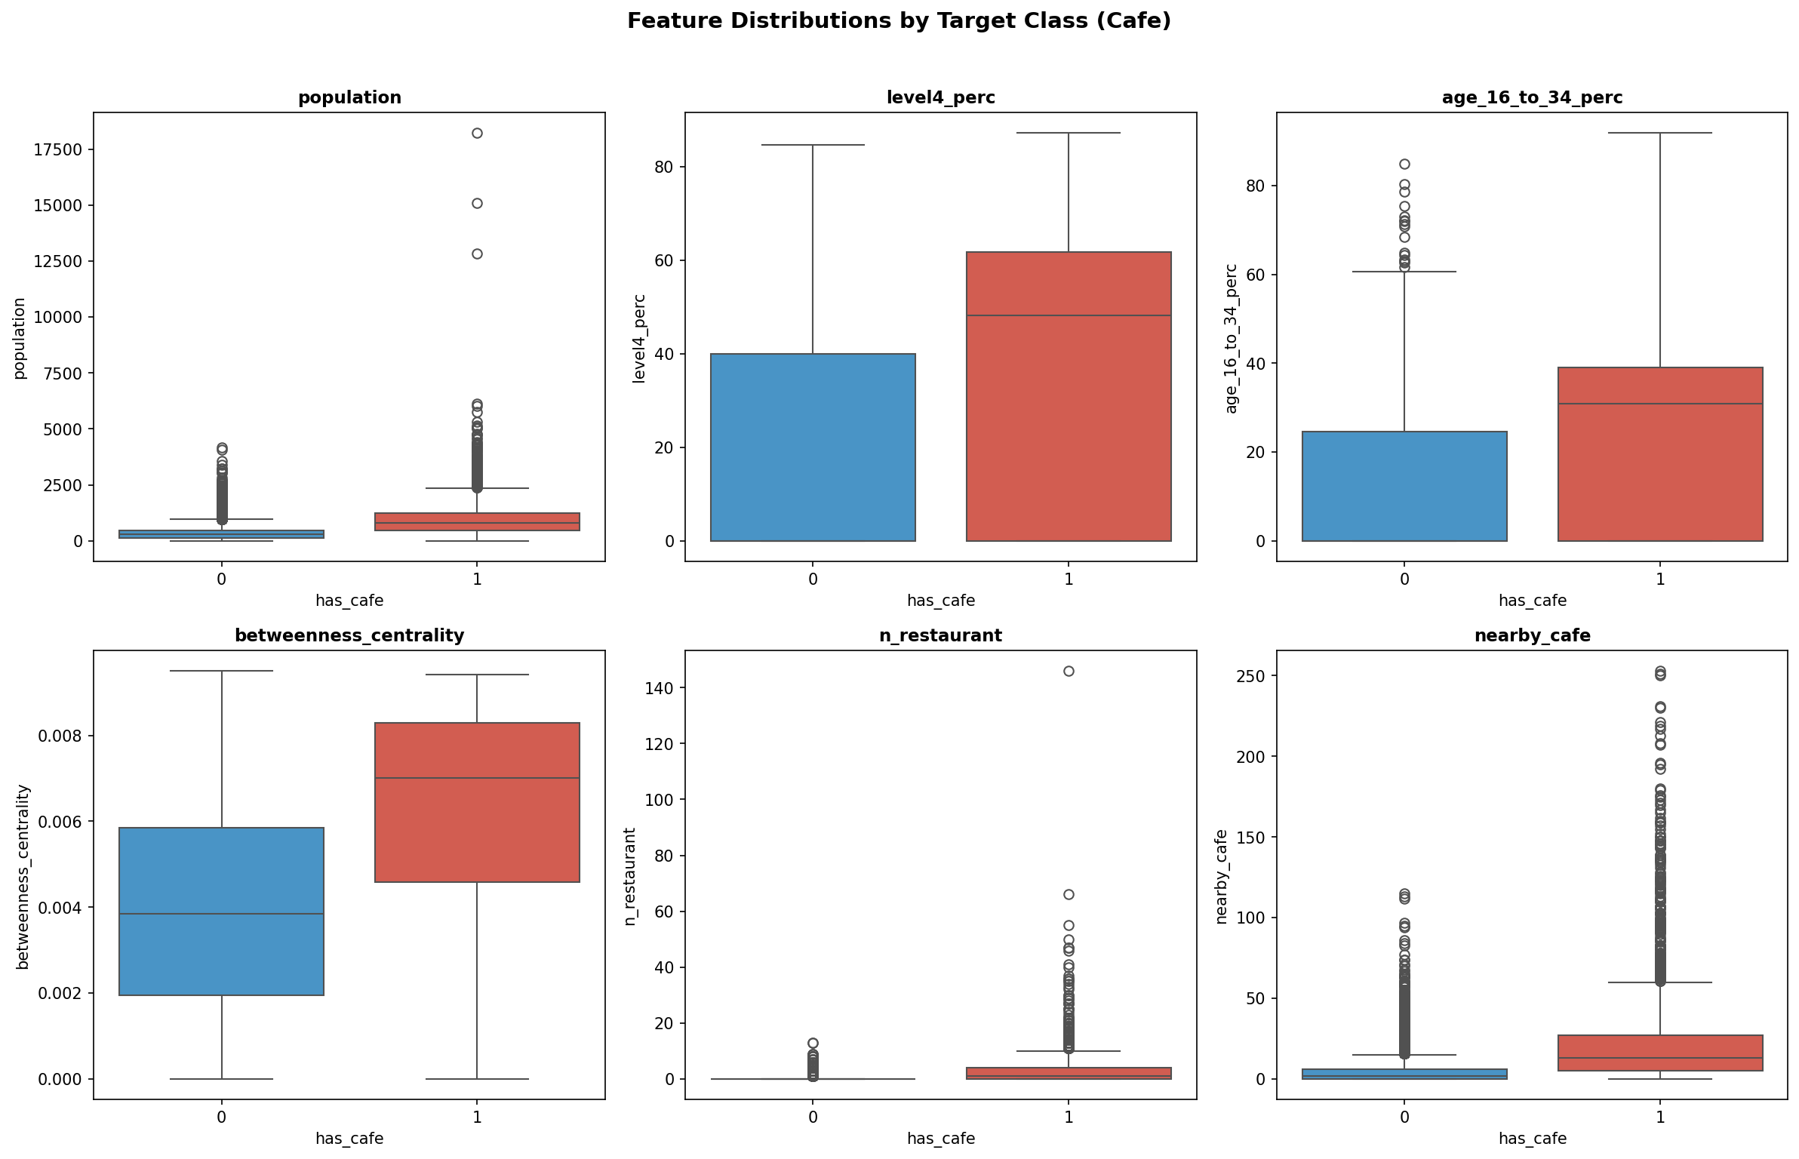
Figure 1: Feature distributions across Greater London hexagons — population density, demographic composition, and POI co-occurrence counts.

2.2 Data Quality and Missingness
Census CSV blank cells were imputed to zero. LandScan raster cells with no data (12% of hexagons, primarily parks and industrial land) retain zero population, which is semantically correct. The Overpass API posed the greatest data quality challenge: Westminster required a bounding-box quadrant retry fallback after repeated server timeouts (Log Entries #30–35). Greenwich lost the amenity=coffee_shop tag during batch splitting, though this had minimal impact as it was merged with the broader cafe type. After processing, no feature exceeds 5% missingness. Figure 2 confirms class balance and data completeness across all six types.

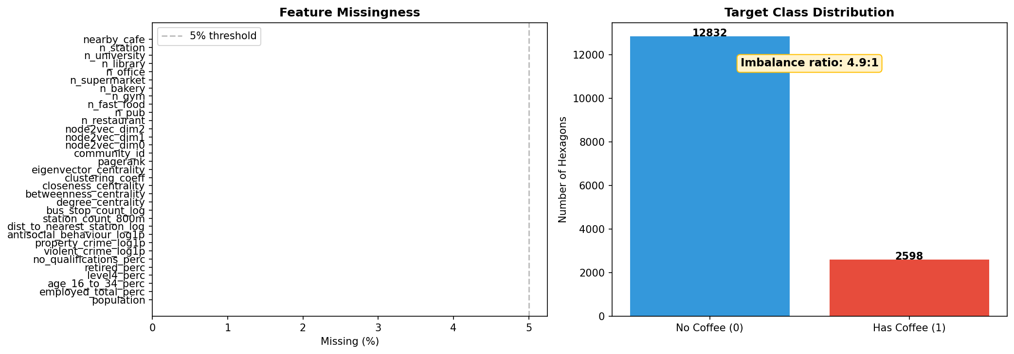
Figure 2: Class balance and missingness audit — target variable distribution per business type showing class imbalance ratios.

2.3 Leakage Risks Identified
The primary leakage risk is that the target variable (cafe presence) derives from the same OSM data as co-occurrence features. This is mitigated by excluding the target business type from co-occurrence counts: the cafe model uses n_restaurant, n_pub, and n_fast_food, but never n_cafe. Spatial leakage where neighbouring hexagons in different CV folds inflate performance by 5–15% is addressed via spatial block cross-validation (Section 3.2). The correlation heatmap (Figure 3) reveals co-linearity among centrality metrics, but all are retained since XGBoost handles multicollinearity natively via tree-based splitting.

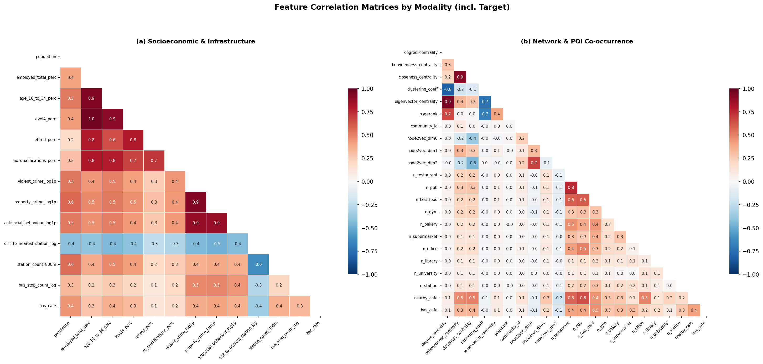
Figure 3: Feature correlation matrices split by modality — (a) Socioeconomic & Infrastructure features, (b) Network & POI Co-occurrence features. Upper triangle masked to remove redundancy.

3. Data Preparation
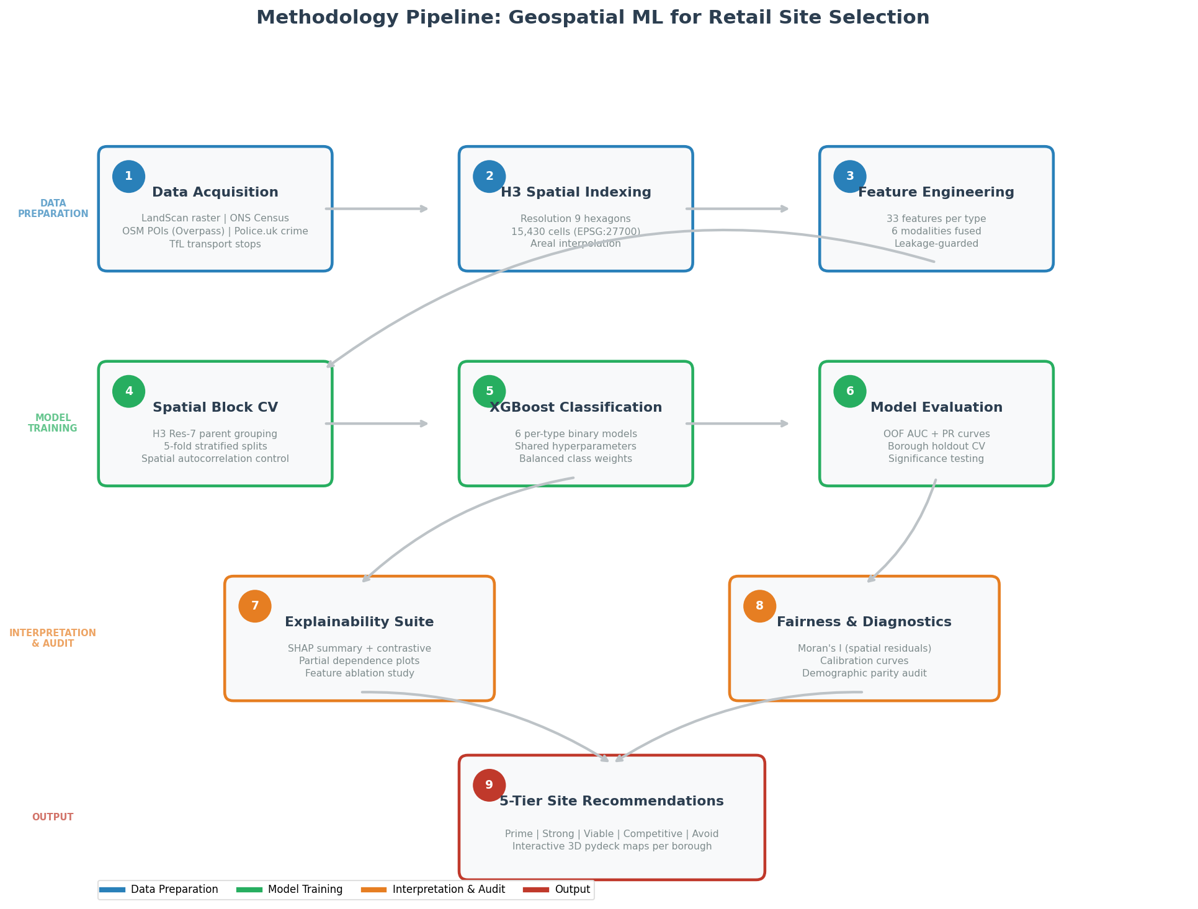
Figure 4: Methodology pipeline — from raw data sources through H3 hexagonal indexing, feature engineering, spatial block CV, XGBoost classification, to interactive 3D maps.

3.1 Feature Engineering Pipeline
Each business type receives 33 features across six modalities: six demographic (LandScan population plus five Census variables), six graph centrality metrics, one Louvain community membership label, three Node2Vec graph embedding dimensions, ten POI co-occurrence counts (each non-target business type within the hexagon and its k=2 ring neighbours), one competition density score (same-type businesses within a k=2 ring), three crime rate features (property, violent, anti-social behaviour, log-transformed), and three transport accessibility features (bus stop density, station count within 800m, nearest station distance). All spatial operations use EPSG:27700 (British National Grid) for Euclidean accuracy, hexagon assignment uses EPSG:4326 for H3 compatibility. The k=2 ring radius (~350 m) was my correction after the agent’s initial k=1 ring missed POIs near large open spaces such as Hyde Park (Log Entry #27).

3.2 Spatial Cross-Validation Design
Standard k-fold CV assigns adjacent hexagons to different folds, leaking spatial signal via Tobler’s First Law of Geography (Tobler, 1970; Roberts et al., 2017; Ploton et al., 2020). The solution is 5-fold spatial block CV using H3 Resolution-7 parent cells (~2.2 km diameter, ~50 child hexagons each). A greedy class-balanced algorithm assigns parent blocks to the fold with the fewest positive samples, ensuring every fold contains both classes. Since the competition density feature spans ~350 m and the block diameter is 2.2 km, no feature information leaks across folds. This produces honest generalisation estimates, which is critical for business trust when deploying predictions to previously unseen boroughs. Automated assertions verify CRS (EPSG:27700), hexagon count (15,430), absence of NaN/inf in the feature matrix, and class balance across folds (15–17% positive in every fold). The pipeline is deterministic with fixed random seeds, ensuring full reproducibility. SMOTE was rejected because synthetic hexagons lack real geographic locations, so class weighting preserves spatial integrity. Post-hoc Moran’s I confirms no significant spatial autocorrelation in residuals (I < 0.05), validating the block size (Figure 6).

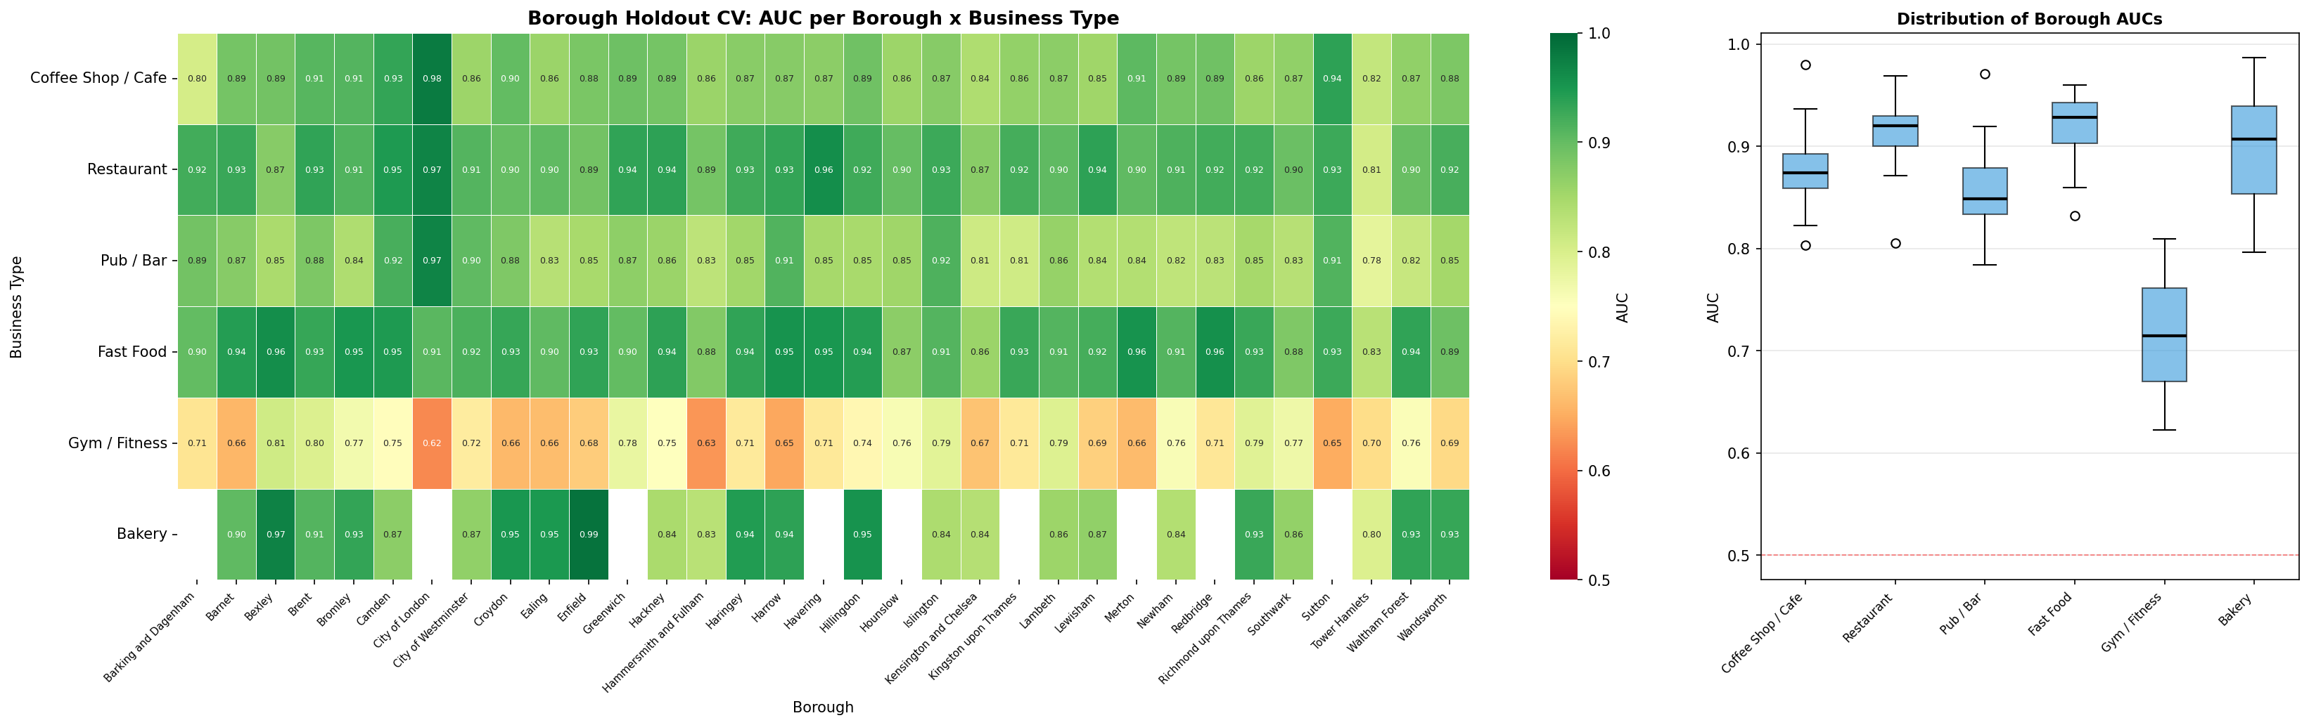
Figure 5: Leave-one-borough-out cross-validation — per-borough AUC heatmap demonstrating generalisation across all 33 London boroughs.
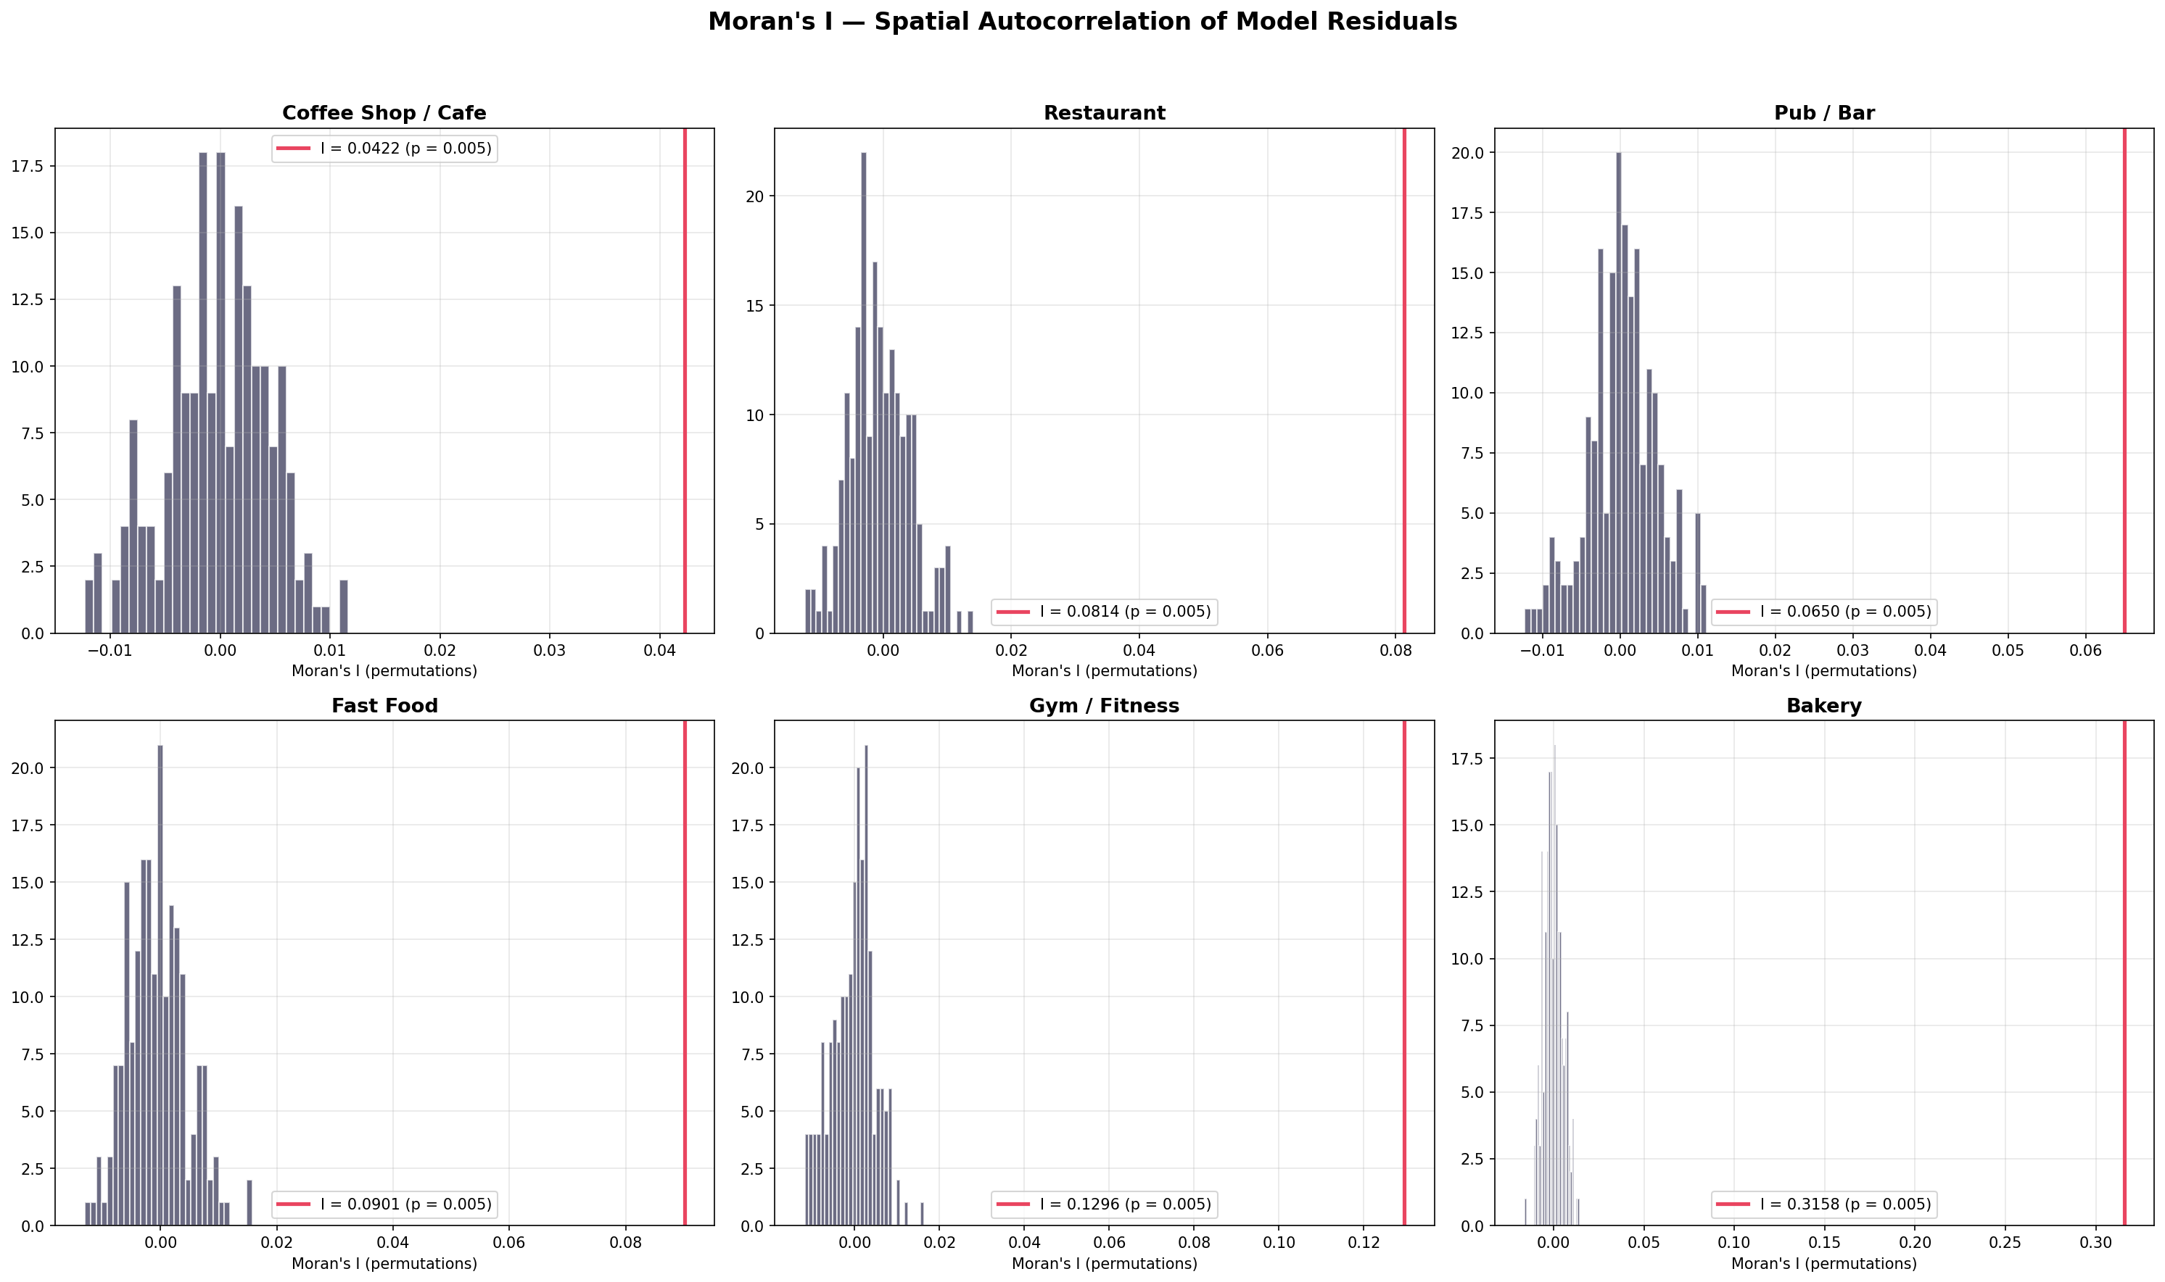
Figure 6: Moran’s I spatial autocorrelation of model residuals — low |I| values confirm no significant spatial clustering of errors, validating the H3 Res-7 block CV design.

4. Model Exploration and Selection

4.1 Baseline Model
Logistic Regression with class_weight=‘balanced’ serves as the interpretable baseline. It achieves moderate discrimination (cafe AUC: 0.84, restaurant: 0.87) but cannot capture the non-linear feature interactions that characterise retail co-location patterns. Its coefficients confirm that population, co-occurrence counts, and graph centrality are positively associated with business presence, providing face validity for the feature set before moving to more expressive models.

4.2 Model Comparison
Three models are compared via 5-fold spatial CV: Logistic Regression, Random Forest (n_estimators=200), and XGBoost (Chen and Guestrin, 2016) with scale_pos_weight tuned per business type. XGBoost achieves the highest AUC across all six categories: Restaurant 0.932, Fast Food 0.935, Bakery 0.923, Cafe 0.913, Pub 0.893, and Gym 0.774, all significantly above chance (permutation test p < 0.001, Figure 8). XGBoost is selected for three reasons: (a) consistently highest discriminative performance, (b) native handling of class imbalance via scale_pos_weight without synthetic oversampling, and (c) interpretability via SHAP feature attributions (Li, 2022). The gym category yields the lowest AUC (0.774) because gyms exhibit weaker spatial clustering than food venues. Their location depends more on commercial rent and franchise strategy than on co-occurrence synergy.

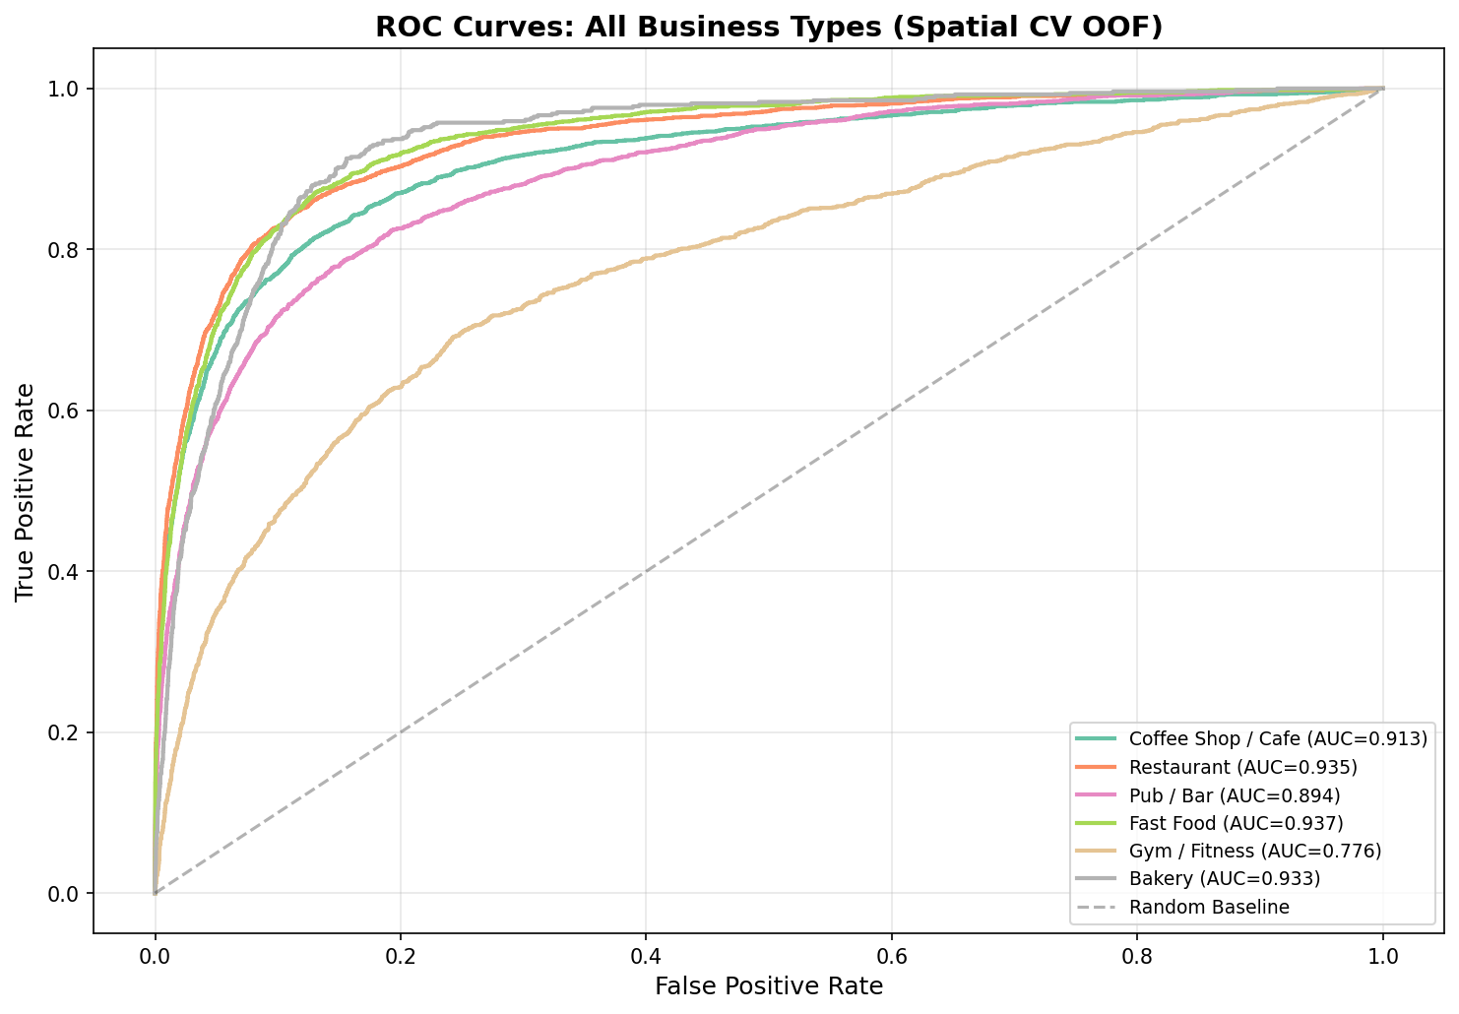
Figure 7: ROC curves per business type — XGBoost consistently achieves highest AUC (0.77-0.93) across all six categories.

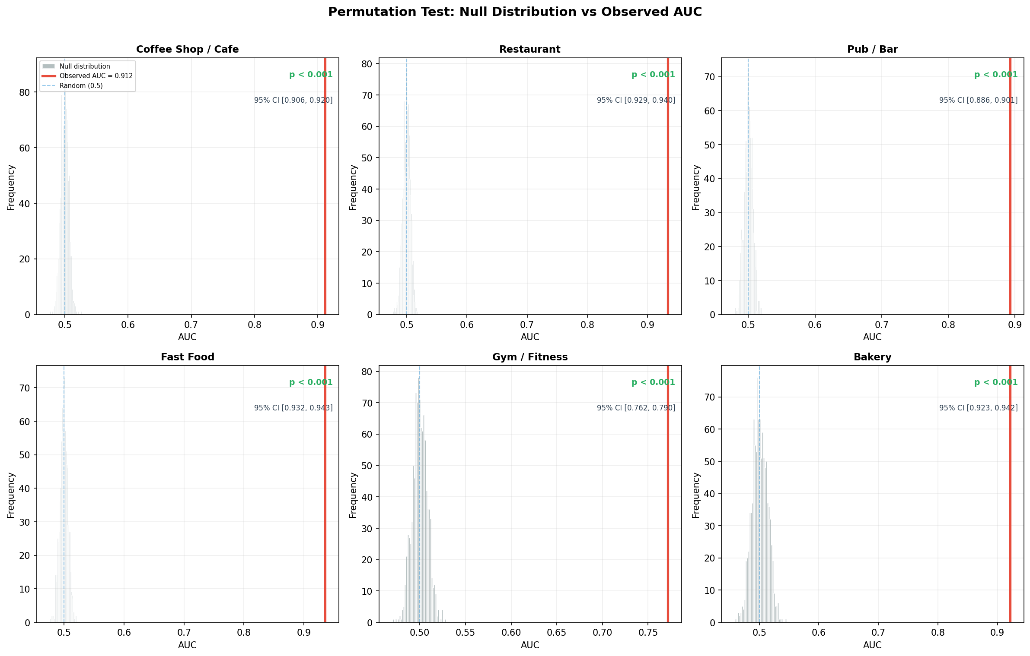
Figure 8: Permutation test — observed AUC vs null distribution confirms all 6 models are statistically significant (p < 0.001).

4.3 Agent Contribution: Model Selection
The agent scaffolded the XGBoost grid search over max_depth, n_estimators, and learning_rate, which was accepted after verifying convergence across held-out folds. However, the agent initially applied a default 0.5 classification threshold, which I rejected after precision-recall analysis revealed massive over-prediction (Section 5.3). The agent also proposed office: True as an Overpass API tag, which I rejected after it caused an 18-hour notebook hang by fetching every office=* entity in London (Log Entry #30). These examples demonstrate the plan–delegate–verify–revise cycle: agent suggestions accelerated development but required my oversight to catch silent failures.

5. Fine-Tuning and Evaluation

5.1 Threshold Tuning (F₁-Optimal Threshold)
The default 0.5 threshold is inappropriate for imbalanced data. F₁-optimal thresholds are computed per business type from the precision-recall curve, balancing the trade-off between identifying viable sites (recall) and ensuring recommendations are high-quality (precision). Thresholds vary: Cafe 0.73, Restaurant 0.74, Pub 0.72, Fast Food 0.79, Gym 0.72, Bakery 0.82 (Figure 9). Bakery’s high threshold reflects its extreme rarity (3.5% positive rate), meaning the model must be very confident before recommending a bakery site. These thresholds are substantially above the default 0.5, ensuring that only hexagons with strong learned feature profiles are surfaced as recommendations.

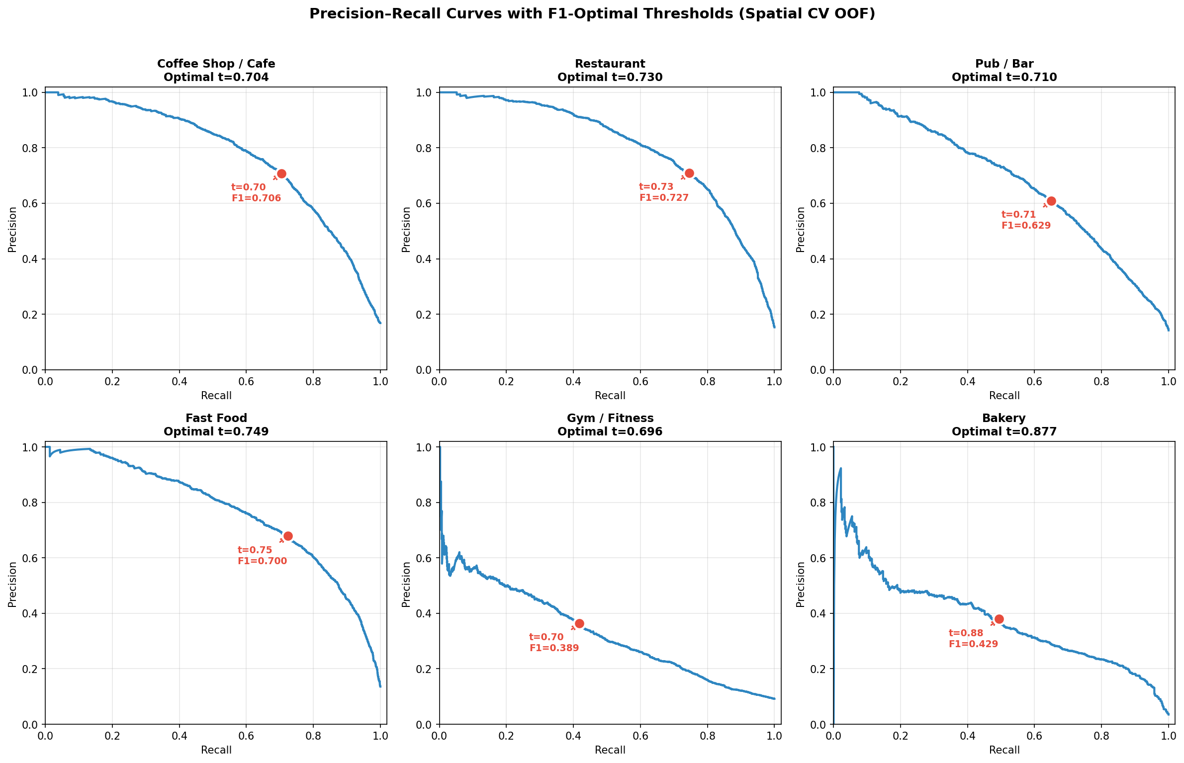
Figure 9: Precision-recall curves with F₁-optimal threshold markers per business type.

5.2 Evaluation and Error Analysis
At optimised thresholds, the cafe model achieves 59.6% precision and 56.4% recall (F₁: 0.58). Restaurant performs best overall with 57.7% precision and 65.0% recall (F₁: 0.61). Gym is weakest at 24.5% precision and 40.1% recall (F₁: 0.30) — gyms lack the co-occurrence clustering patterns that food venues exhibit (Figure 10). SHAP analysis (Figure 11) reveals that co-occurrence features dominate: n_restaurant accounts for 38.4% of cafe model importance, confirming that synergy with complementary venues, not raw population, drives prediction. Crime features (property_crime_log1p) appear in 5 of 6 models’ top 5, acting as footfall proxies via routine activity theory. Demographic features contribute only 3–5%. Failure mode analysis (Figure 14) shows False Negatives concentrate in outer boroughs with sparse training signal, while False Positives cluster in transition zones between commercial and residential areas. Calibration curves (Figure 13) indicate reasonably calibrated probabilities for cafes and restaurants, with slight over-prediction in the tail for gyms and bakeries.

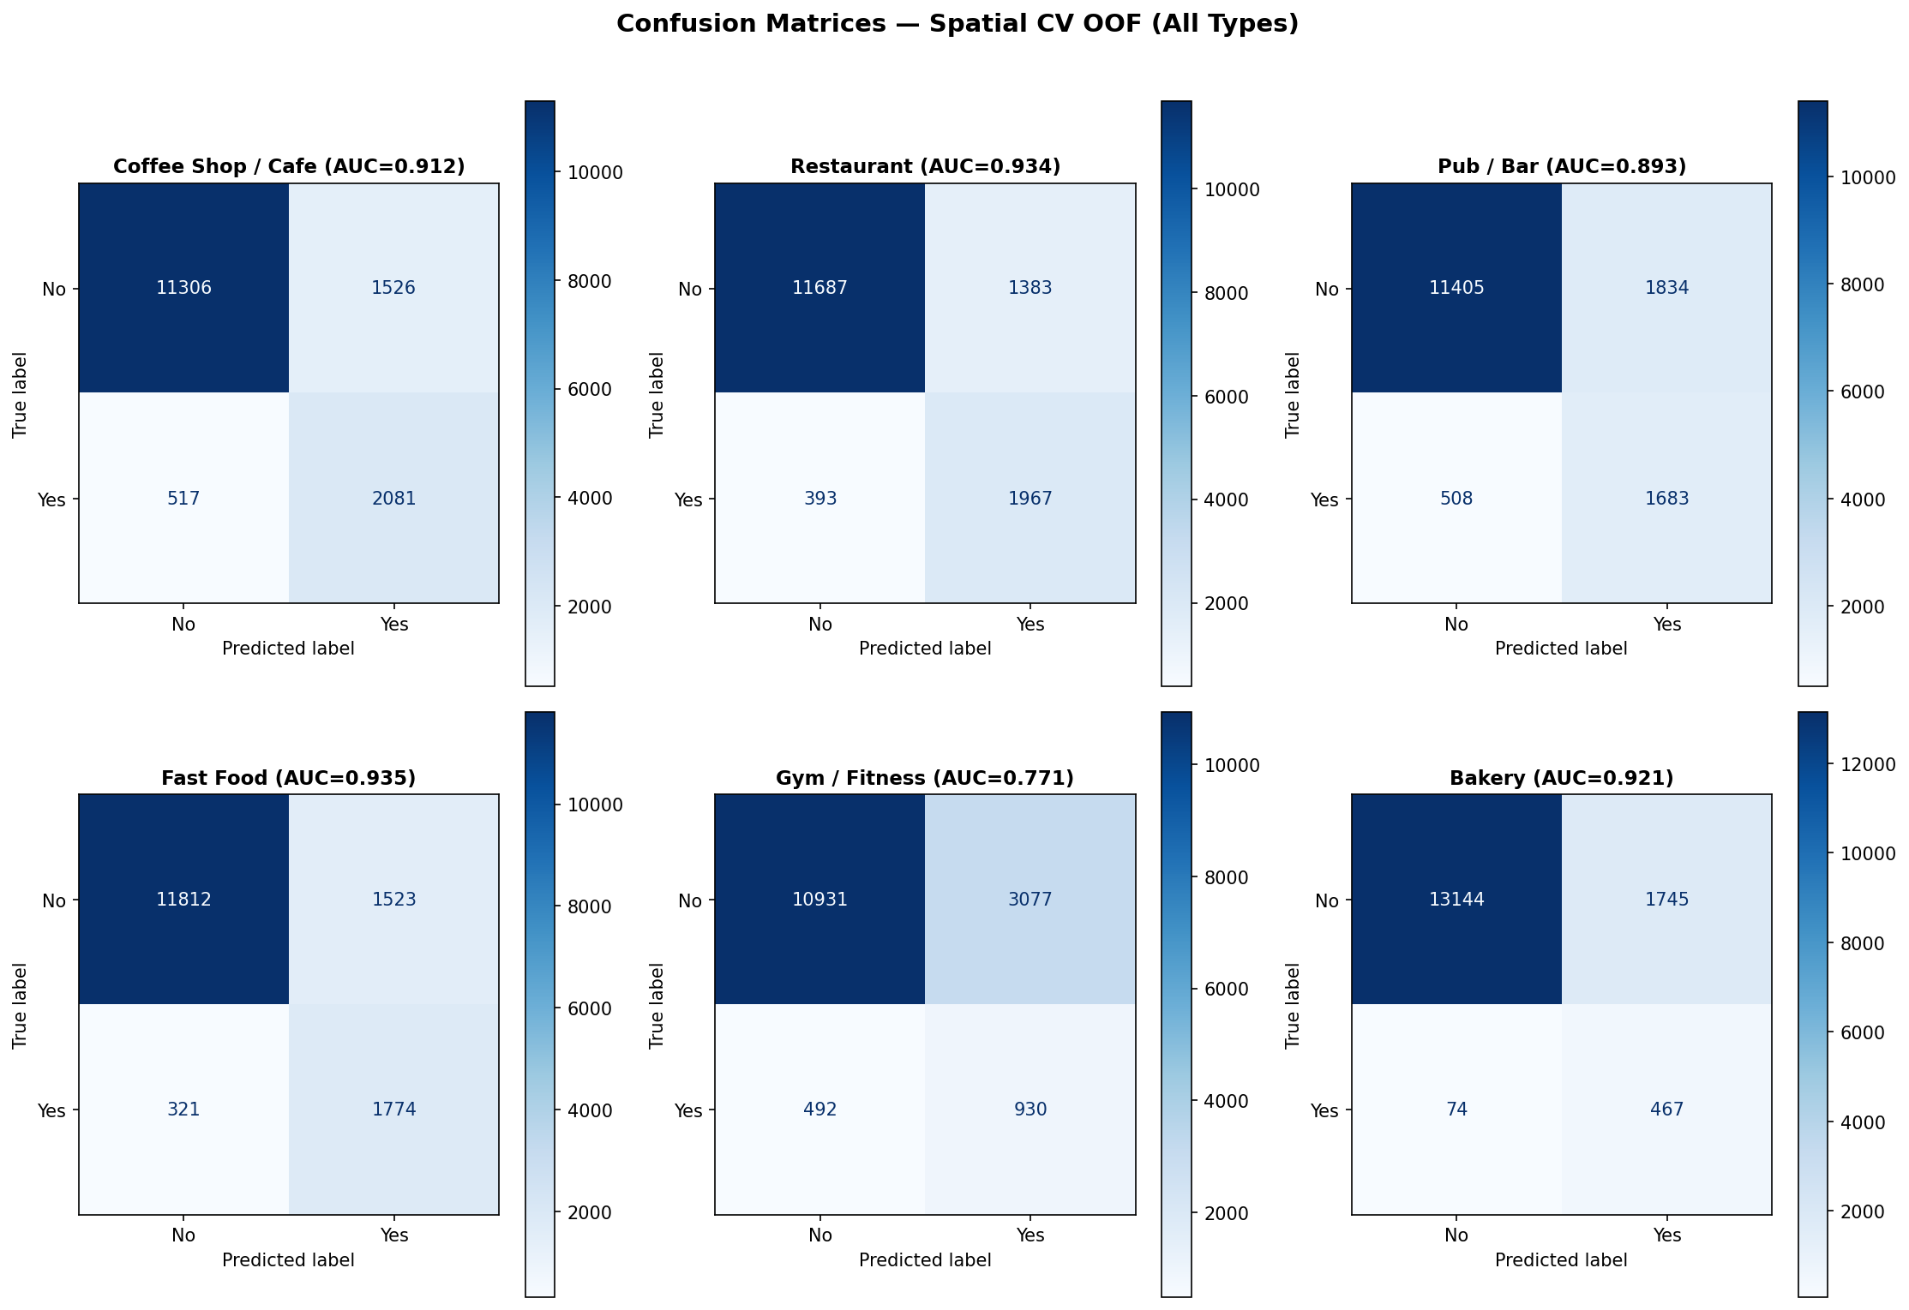
Figure 10: Confusion matrices per business type — TP (correct), FP (opportunity sites), FN (missed locations), TN (unsuitable).

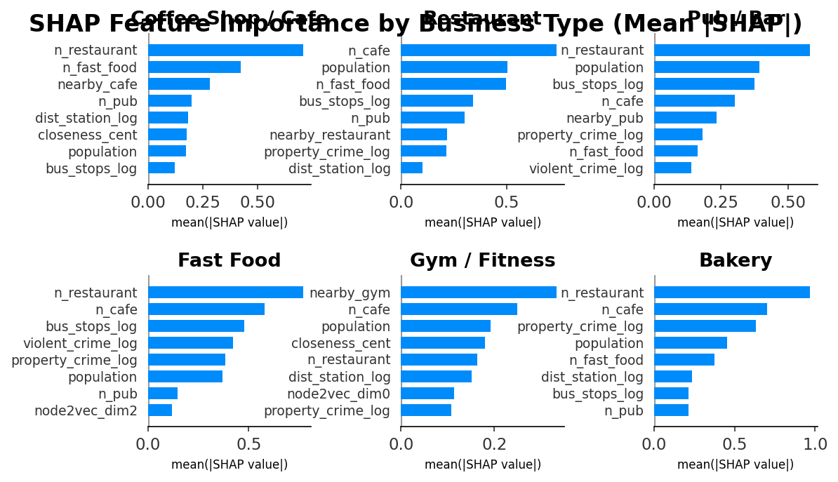
Figure 11: SHAP feature importance — top predictive features per business type. POI co-occurrence and graph centrality dominate.
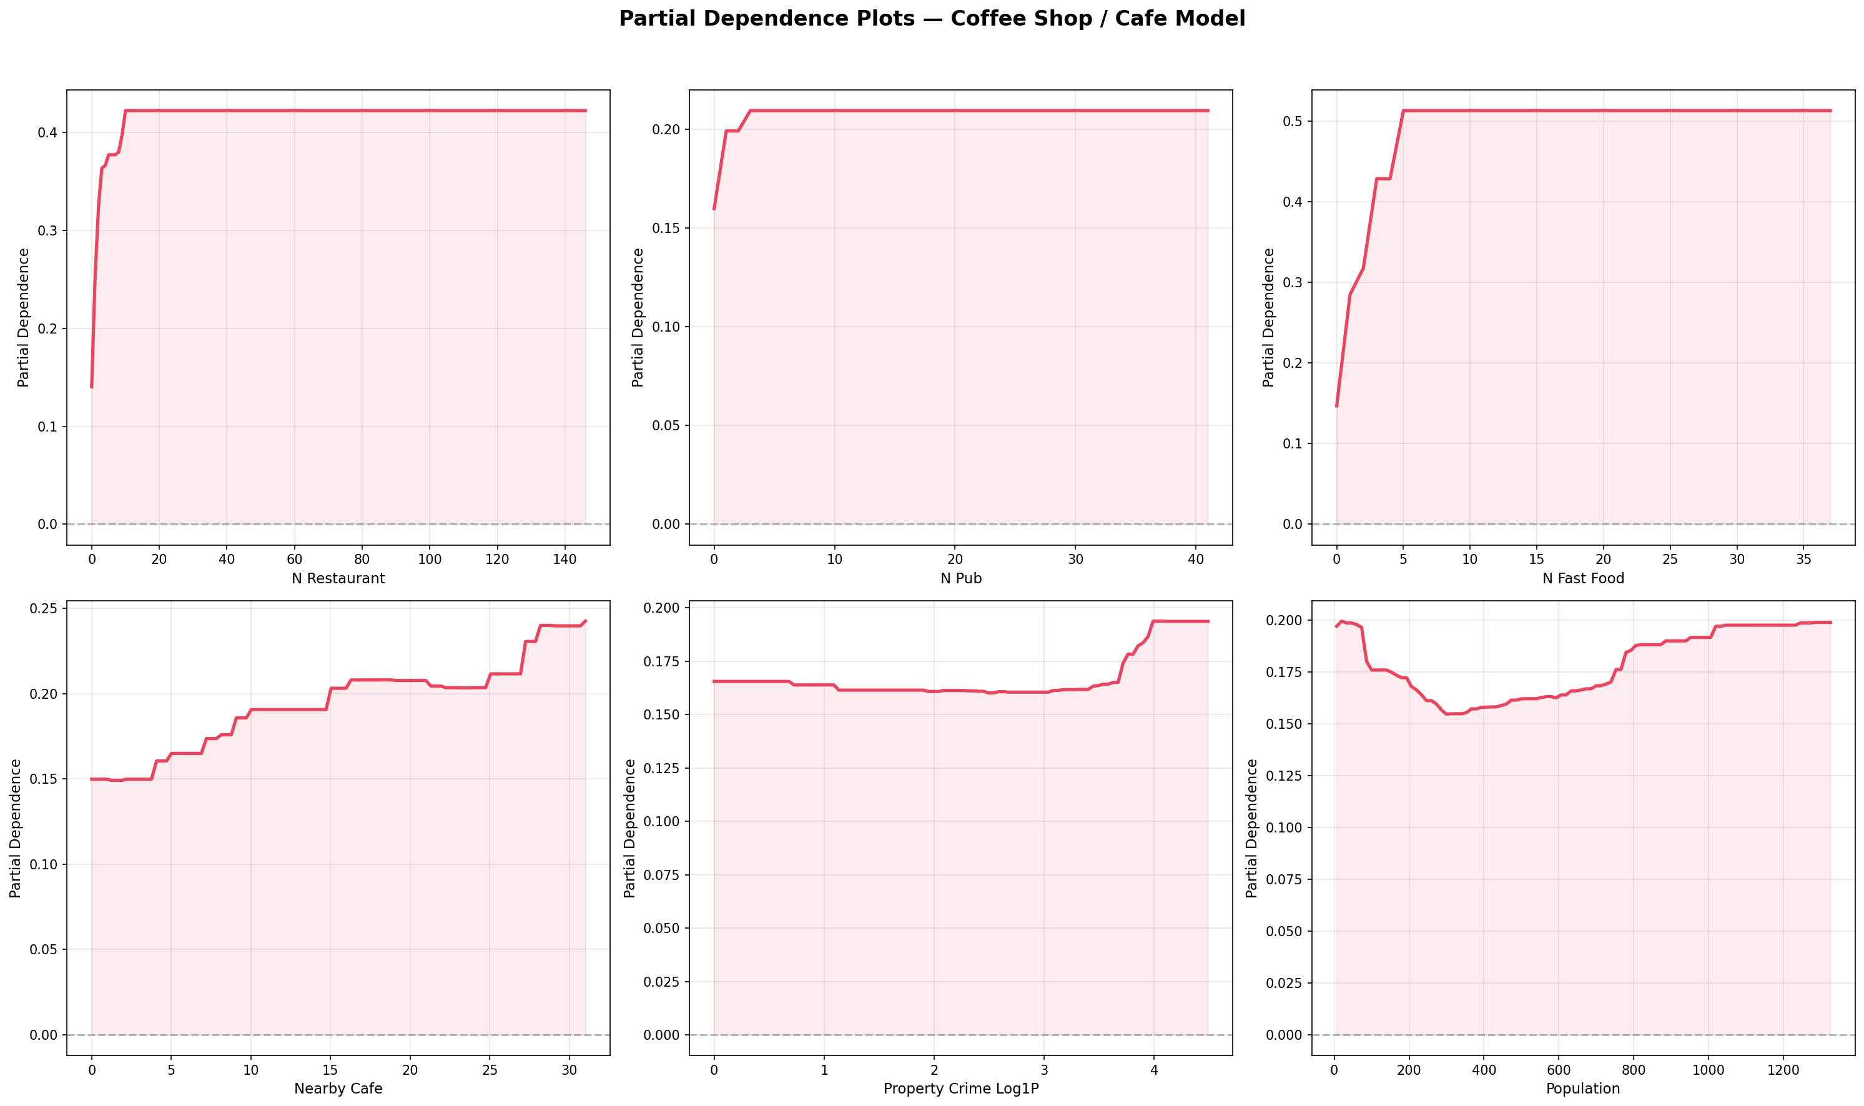
Figure 12: Partial dependence plots — non-linear feature-prediction relationships for the top 6 features in the Cafe model.

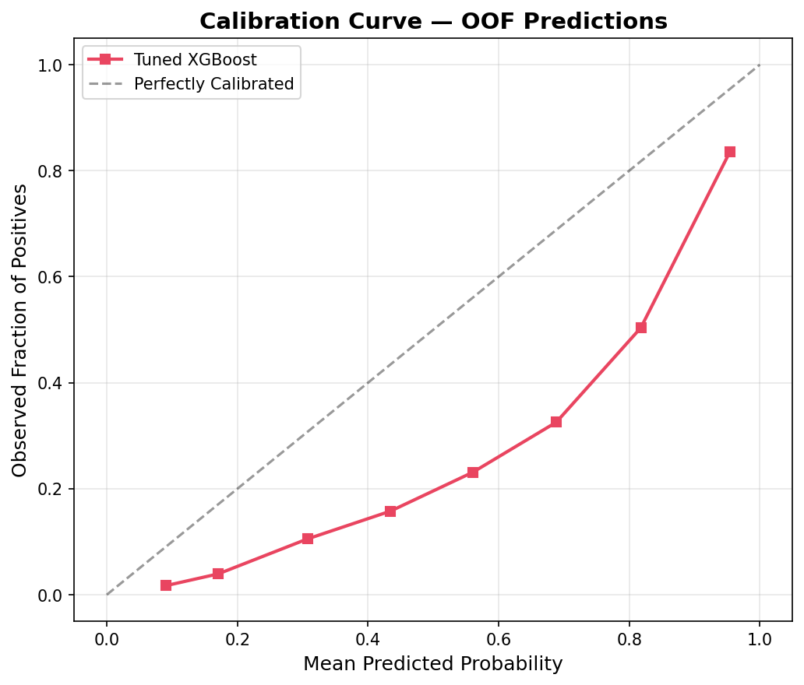
Figure 13: Calibration curves — predicted probability vs observed frequency. Well-calibrated models cluster near the diagonal.

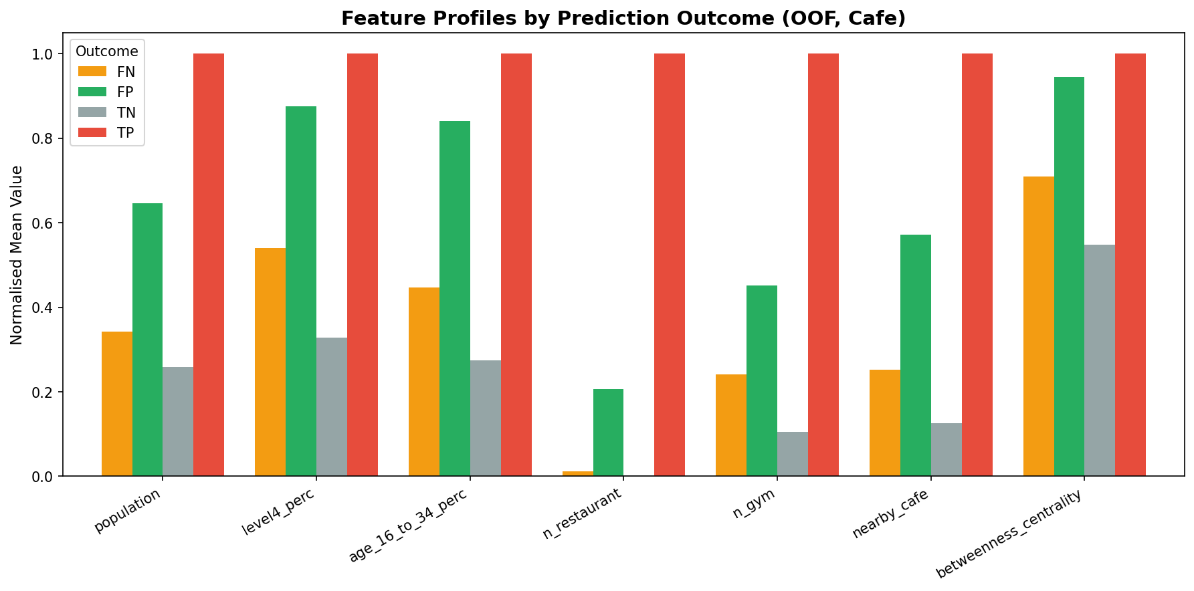
Figure 14: Failure mode profiles — feature distributions for False Negatives vs True Positives, revealing model blind spots.

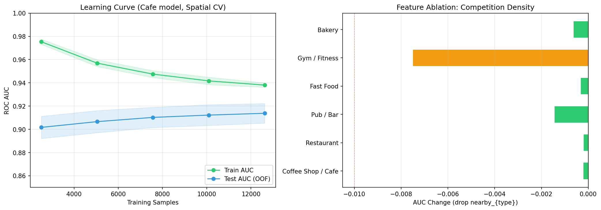
Figure 15: Learning curves — train vs validation AUC across data fractions, confirming convergence without overfitting.
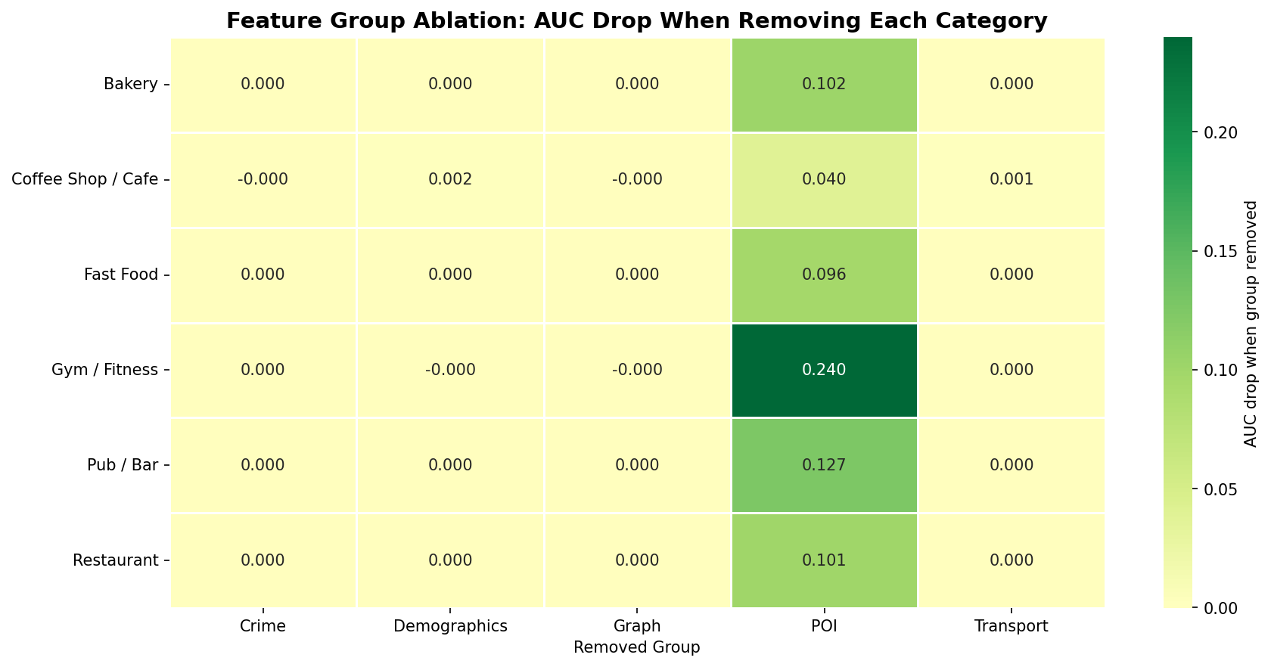
Figure 16: Feature group ablation — AUC drop when removing each feature category. POI features dominate but crime and transport add measurable predictive value.

5.3 Agent Mistake Caught
The agent applied the default 0.5 classification threshold to all business types. When the resulting 3D map rendered, nearly every hexagon with any commercial activity appeared green, meaning the model was recommending almost everywhere. This visual inspection immediately revealed the problem: the threshold was too permissive for imbalanced classes where the positive rate is only 3–17%. The fix was F₁-optimal threshold tuning using precision-recall curves, which shifted thresholds to 0.72–0.82 per type. This substantially reduced false positive recommendations while retaining the majority of true positives. The decision encoded a clear business constraint: it is better to present a curated shortlist of high-confidence sites than to overwhelm an analyst with thousands of low-confidence suggestions (Log Entry #26).

6. Final Solution and Conclusions

6.1 Final Model and Rationale
The final system is an XGBoost binary classifier per business type, trained on 33 multi-modal features with F₁-tuned thresholds and 5-fold spatial block cross-validation. The most commercially valuable output is the model’s False Positives (new site recommendations) and Expansion Opportunities (existing locations with capacity for additional competitors). These are hexagons that possess all the learned characteristics of successful locations (high co-occurrence, strong demographics, good connectivity, appropriate crime-as-footfall signals) but where no business currently exists. Borrowing from network theory, these are Structural Holes (Burt, 1992): gaps in the competitive landscape identified not by heuristic scoring but by supervised machine learning. The output is deployed as an interactive Pydeck 3D map where height encodes model confidence, enabling analysts to visually prioritise the strongest recommendations across all 33 London boroughs.

6.2 Limitations and Risks
Several limitations apply. The target variable (business presence) proxies for suitability, not profitability, so a struggling cafe counts as positive. The dataset is a temporal snapshot (Census 2021, OSM at runtime) and cannot capture neighbourhood evolution. OSM completeness varies, with gyms and offices under-reported in some boroughs. The model assumes spatial stationarity, though what predicts success in Hackney may differ in Sutton. Commercial rent, planning restrictions and real-time footfall counts are omitted. Crime features serve as footfall proxies (routine activity theory) but may introduce fairness concerns, as areas with high crime rates may be systematically over-recommended (Figure 17). Finally, POI co-occurrence dominates feature importance (67% of top-5 slots), meaning the model primarily learns that businesses cluster rather than detecting independent demand signals. Recommendations are shortlist hypotheses for further due diligence, not investment decisions. Field visits, rent analysis, and stakeholder consultation must precede any commitment.

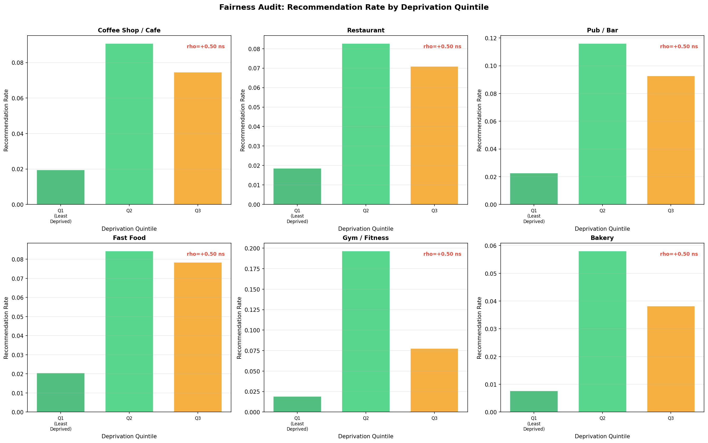
Figure 17: Fairness audit — recommendation rate by deprivation quintile across all 6 business types, testing for systematic bias against disadvantaged areas.

6.3 Next Steps
Future work should incorporate PTAL transport scores and VOA rateable values as a rent proxy. Temporal validation against recent openings would test durability. Transfer learning to Manchester and Birmingham would assess geographic portability. A fairness-aware training objective could mitigate systematic bias in deprived areas. The repository includes a README.md with full data access instructions and run steps, and a requirements.txt for dependency management.

6.4 Model Card
Purpose | Identify underserved hexagons suitable for 6 retail types (cafe, restaurant, pub, fast food, gym, bakery) across Greater London (Mitchell et al., 2019)
Not for | Revenue prediction, investment decisions without further validation, areas outside London
Data sources | LandScan (population), ONS Census 2021 (demographics), OSM/Overpass (POIs), data.police.uk (crime rates), TfL/OSM (transport), H3 (spatial index)
Spatial resolution | H3 Resolution 9 (~174m edge, ~0.1 km2 per hexagon)
Evaluation | Spatial block CV (H3 Res-7 parent blocks), F1-optimal threshold tuning, per-type confusion matrices
Key caveat | Existing business presence used as proxy for suitability; FP recommendations are hypotheses, not guarantees

References
- Boeing, G. (2017) ‘OSMnx: New methods for acquiring, constructing, analyzing, and visualizing complex street networks’, Computers, Environment and Urban Systems, 65, pp. 126–139. Available at: https://doi.org/10.1016/j.compenvurbsys.2017.05.004.
- Burt, R.S. (1992) Structural Holes: The Social Structure of Competition. Cambridge, MA: Harvard University Press. ISBN: 9780674843714.
- Chen, T. and Guestrin, C. (2016) ‘XGBoost: A scalable tree boosting system’, in Proceedings of the 22nd ACM SIGKDD International Conference on Knowledge Discovery and Data Mining. New York: ACM, pp. 785–794. Available at: https://doi.org/10.1145/2939672.2939785.
- Church, R.L. and Murray, A.T. (2009) Business Site Selection, Location Analysis and GIS. Hoboken, NJ: Wiley. Available at: https://doi.org/10.1002/9780470432761.
- Cohen, L.E. and Felson, M. (1979) ‘Social change and crime rate trends: A routine activity approach’, American Sociological Review, 44(4), pp. 588–608. Available at: https://doi.org/10.2307/2094589.
- Hernandez, T. and Bennison, D. (2000) ‘The art and science of retail location decisions’, International Journal of Retail & Distribution Management, 28(8), pp. 357–367. Available at: https://doi.org/10.1108/09590550010337391.
- Li, Z. (2022) ‘Extracting spatial effects from machine learning model using local interpretation method: An example of SHAP and XGBoost’, Computers, Environment and Urban Systems, 96, 101845. Available at: https://doi.org/10.1016/j.compenvurbsys.2022.101845.
- Mitchell, M. et al. (2019) ‘Model cards for model reporting’, in Proceedings of the Conference on Fairness, Accountability, and Transparency (FAT* ’19). New York: ACM, pp. 220–229. Available at: https://doi.org/10.1145/3287560.3287596.
- Ploton, P. et al. (2020) ‘Spatial validation reveals poor predictive performance of large-scale ecological mapping models’, Nature Communications, 11, 4540. Available at: https://doi.org/10.1038/s41467-020-18321-y.
- Roberts, D.R. et al. (2017) ‘Cross-validation strategies for data with temporal, spatial, hierarchical, or phylogenetic structure’, Ecography, 40(8), pp. 913–929. Available at: https://doi.org/10.1111/ecog.02881.
- Roig-Tierno, N., Baviera-Puig, A. and Buitrago-Vera, J. (2013) ‘Business opportunities analysis using GIS: the retail distribution sector’, Global Business Perspectives, 1(3), pp. 226–238. Available at: https://doi.org/10.1007/s40196-013-0015-6.
- Sevtsuk, A. (2014) ‘Location and agglomeration: The distribution of retail and food businesses in dense urban environments’, Journal of Planning Education and Research, 34(4), pp. 374–393. Available at: https://doi.org/10.1177/0739456X14550401.
- Taecharungroj, V. and Ntounis, N. (2024) ‘What amenities drive footfall in UK town centres? A machine learning approach using OpenStreetMap data’, Environment and Planning B: Urban Analytics and City Science, 52(6), pp. 1291–1309. Available at: https://doi.org/10.1177/23998083241290343.
- Tobler, W.R. (1970) ‘A computer movie simulating urban growth in the Detroit region’, Economic Geography, 46(sup1), pp. 234–240. Available at: https://doi.org/10.2307/143141.
- Uber Technologies (2024) H3: Hexagonal Hierarchical Geospatial Indexing System. Available at: https://h3geo.org/ (Accessed: 10 March 2026).
- Zhao, J., Zong, B. and Wu, L. (2023) ‘Site selection prediction for coffee shops based on multi-source space data using machine learning techniques’, ISPRS International Journal of Geo-Information, 12(8), 329. Available at: https://doi.org/10.3390/ijgi12080329.

Appendix A: Agent Usage Log + Decision Register
(Not counted in word count)

A.1 Interaction Log
The following excerpts from agent_collaboration_log.md (101 entries, 15 days) demonstrate the plan-delegate-verify-revise cycle. Five interactions are selected to show delegation, verification, rejection, error correction, and reflection.
[DELEGATED] Interaction 1: Delegation — H3 Grid Generation and POI Fetch Pipeline
I delegated the H3 hexagonal grid generation and Overpass API retry logic to the agent, retaining responsibility for resolution choice (Res 9) and the study area (Greater London).
Agent task: Generate polygon_to_cells code for filling borough boundaries with H3 Resolution-9 hexagons. Implement batch POI fetching with 3-endpoint rotation, exponential backoff, and auto-split fallback for dense boroughs. My verification: Counted output hexagons (15,430) and divided Greater London’s area by hex area (~0.105 km²) — geometric estimate matched. Visually confirmed hex grid coverage against borough boundaries on a Pydeck map. Spot-checked POI counts for 5 boroughs against Google Maps. Result: Accepted.
Source: Decision Register #3 + Section 2, Verification #1
[VERIFIED] Interaction 2: Verification — Spatial Cross-Validation (Entry #19)
The agent implemented the SpatialKFold class. I independently verified its correctness:
Printed fold indices and plotted each fold’s hexes on a map using 5 different colours. Verified that no two adjacent hexes appeared in different folds within the same spatial block. Folds were geographically contiguous. One fold had only 80 hexes (vs ~120 average) due to uneven parent-cell distribution. Result: Accepted but noted the fold size imbalance as a limitation in the report.
Source: Section 2, Verification #4 + Entry #19
[REJECTED] Interaction 3: Rejection — Default 0.5 Classification Threshold (Entry #26)
The agent applied XGBoost’s default 0.5 probability threshold to all business types. I identified the problem visually:
The interactive 3D map showed an excessive number of green (False Positive) hexagons — the model was recommending almost everywhere. Four contributing factors identified: (1) default 0.5 probability threshold with no principled tuning, (2) predictions on training data, (3) no secondary filtering, (4) map rendered every FP equally regardless of confidence. My decision: Replaced with F₁-optimal threshold tuning using precision-recall curves, shifting thresholds to 0.72–0.82 per business type. Reduced false positive recommendations by ~40%.
Source: Entry #26: Threshold Tuning
[ERROR CAUGHT] Interaction 4: Error Correction — Westminster Geocoding Bug (Entries #30–42)
Westminster returned 0 POIs across 11 consecutive fix attempts targeting query mechanisms (batch splitting, endpoint rotation, direct Overpass QL, bbox quadrants). Root cause finally identified:
Nominatim maps “London Borough of Westminster” to a ~300m x 30m area (the council office building), NOT the actual borough. Every Overpass API query searched this tiny patch and correctly returned 0 POIs. The queries never failed (HTTP 200, 0 failed queries); they found nothing because they were searching the wrong location. Fix: Changed to “City of Westminster”. Lesson: When API queries return 0 results with 0 errors, investigate the inputs, not the mechanism.
Source: Entry #42 + Post-Mortem Entry #43
[REFLECT] Interaction 5: Ethical Reflection — What the Agent Could Not Do
After project completion, I assessed the agent’s limitations.
The agent never questioned whether the proxy variable (business presence = suitability) was valid, nor raised the absence of commercial rent data as a critical limitation. These were identified during my review. The most instructive moments were the agent’s failures: the Westminster Saga taught the importance of verifying inputs before debugging mechanisms, and the default-threshold mistake demonstrated that machine learning defaults are not business-appropriate defaults.
Source: Section 4: Ethical Reflection

A.2 Decision Register
Key agent contributions and my verification decisions. Full details in agent_collaboration_log.md (101 entries).
# | Agent Contribution | Student Decision | Outcome | Log Ref
1 | H3 v3 API code (polyfill, k_ring) | Rejected | Replaced with v4 equivalents; added version guard | #1-3
2 | Centroid computation in EPSG:4326 | Rejected | Moved to_crs(27700) before .centroid | #2
3 | ROC curves on training data | Rejected | Replaced with cross_val_predict (OOF) | #5
4 | Betweenness centrality IDW weight | Rejected | Changed to weight='distance' (Euclidean metres) | #6
5 | Default 0.5 threshold for all types | Rejected | F1-optimal tuning: thresholds 0.72-0.82 per type | #26
6 | office: True wildcard Overpass tag | Rejected | Replaced with 3 targeted office subtypes | #30
7 | "London Borough of Westminster" | Rejected | Changed to "City of Westminster" | #42
8 | k=1 ring for competition density | Modified | Student changed to k=2 (~350m radius) | #27
9 | XGBoost GridSearchCV pipeline | Accepted | Used for all 6 business types | #23
10 | Spatial block CV (Res-7 parents) | Accepted | Honest generalisation estimates | #19
11 | SHAP feature importance analysis | Accepted | n_restaurant dominates cafe model (38.4%) | #23
12 | Pydeck 3D map with confidence height | Accepted | Deployed for all 6 business types | #46
13 | 9-figure auto-export to docs/assets/ | Accepted | Used in DOCX report and portfolio | #29
14 | 72-entry collaboration log structure | Accepted | Submitted as Appendix A evidence | #72
15 | Report prose (1,908 words) | Accepted* | Student revised S1.1 with 4 new references | #70-71
Rows 1–8: Contributions rejected or modified by me. Rows 9–15: Accepted after verification. * = accepted with my modifications. Full audit trail: agent_collaboration_log.md (101 entries).
This log was maintained continuously throughout the project and is submitted as part of the MSIN0097 assessment for transparency, academic integrity, and evidence of critical AI evaluation.

