Predictive Analytics Individual Coursework
MSIN0097 | 2025-26

Predictive Site Selection for Specialty Coffee Shops
across Greater London Using H3 Spatial Hexagons and XGBoost

Word Count: ____ / 2000
Code Repository: [GitHub / OneDrive link]

Table of Contents

1. Problem Framing and Dataset Construction 3
1.1 Predictive Problem 3
1.2 Dataset Construction 3
1.3 Success Metrics and Constraints 4
1.4 Agent Tooling Plan 4
2. Exploratory Data Analysis 5
2.1 Spatial Distributions 5
2.2 Data Quality and Missingness 6
2.3 Leakage Risks Identified 7
3. Data Preparation 8
3.1 Feature Engineering Pipeline 8
3.2 Spatial Cross-Validation Design 8
3.3 Data Validation Checks 9
4. Model Exploration and Selection 10
4.1 Baseline Model 10
4.2 Model Comparison 10
4.3 Agent Contribution: Model Selection 11
5. Fine-Tuning and Evaluation 12
5.1 Threshold Tuning (F-beta = 0.3) 12
5.2 Evaluation and Error Analysis 13
5.3 Agent Mistake Caught 15
6. Final Solution and Conclusions 16
6.1 Final Model and Rationale 16
6.2 Limitations and Risks 16
6.3 Next Steps 17
6.4 Model Card 17
References 18
Appendix A: Agent Usage Log + Decision Register 19
A.1 Interaction Log 19
A.2 Decision Register 19

1. Problem Framing and Dataset Construction

1.1 Predictive Problem
Retail site selection has long been recognised as “part art and part science” (Hernandez and Bennison, 2000), with decisions historically relying on heuristic checklists of foot traffic, competitor proximity, and managerial intuition. Yet Church and Murray (2009) demonstrate that GIS-based location models consistently outperform expert judgement by integrating spatial variables that humans cannot simultaneously weight. More recently, Sevtsuk (2014) shows that retail agglomeration — the tendency of complementary businesses to co-locate — is a stronger predictor of venue density than raw population alone.
This project tests the hypothesis that the spatial co-occurrence of complementary businesses, combined with demographic and network connectivity features, can predict the suitability of a location for a specific business type more accurately than population-based heuristics alone. Suitability is operationalised as a binary classification: for each H3 Resolution-9 hexagon (~174 m edge, ~0.1 km²) across Greater London’s 33 boroughs, predict whether a location is suitable (1) or unsuitable (0). The target variable — presence of an existing business — serves as a proxy for proven demand (Roig-Tierno, Baviera-Puig and Buitrago-Vera, 2013). Six business types are modelled independently: cafe, restaurant, pub, fast food, gym, and bakery, across 15,430 hexagons.

1.2 Dataset Construction
No single data source captures the complexity of location suitability. Three modalities are fused via the H3 spatial index: (a) raster — LandScan ambient population, zonal-aggregated to each hexagon, providing footfall volume; (b) tabular — ONS Census 2021 demographics (age 16–34%, degree-educated%, employment rate), capturing demand quality; (c) vector — ~30,000 Points of Interest from OpenStreetMap via the Overpass API, encoding the co-occurrence ecosystem (nearby restaurants, pubs, supermarkets); and (d) graph — six NetworkX centrality metrics (degree, betweenness, closeness, eigenvector, PageRank, clustering coefficient) computed on the H3 adjacency graph, capturing each hexagon’s structural connectivity. Total: 23 features per business type across four modalities.

1.3 Success Metrics and Constraints
The primary metric is ROC-AUC, chosen for its robustness to class imbalance (ratios range from 4.9:1 for cafes to 27.5:1 for bakeries). The secondary metric is F₀.₃, which weights precision approximately 11 times over recall: in site recommendation, suggesting a poor location (false positive) costs far more than missing a viable one (false negative). Constraints include interpretability for non-technical stakeholders (addressed via SHAP) and the absence of revenue or footfall ground truth.

1.4 Agent Tooling Plan
The agent (Claude Code) was delegated code scaffolding (H3 grid generation, Overpass API retry logic, XGBoost pipeline structure), debugging (CRS projection errors, API timeouts, eigenvector convergence failures), and documentation drafting. The student retained responsibility for: problem framing, metric selection, threshold decisions, interpreting SHAP outputs, and all data validation. Verification followed a plan–delegate–verify–revise cycle: every agent output was checked against spatial sanity assertions (CRS = EPSG:27700, hex count = 15,430), manual spot-checks of POI counts against Google Maps, and fold-balance audits. The full audit trail comprises 68 entries in the agent collaboration log.

2. Exploratory Data Analysis

2.1 Spatial Distributions
Class imbalance varies substantially across business types: cafes are present in 16.8% of hexagons (4.9:1 ratio), gyms in 9.2% (9.9:1), and bakeries in just 3.5% (27.5:1). A naive majority-class classifier achieves 88% accuracy for cafes, rendering accuracy misleading and motivating AUC as the primary metric. Population follows a right-skewed distribution — most hexagons are suburban with low density, while a few central cores concentrate demand. POI co-occurrence is highly clustered: cafes and restaurants co-locate strongly (Figure 1), suggesting that synergy with complementary venues matters more than raw footfall.
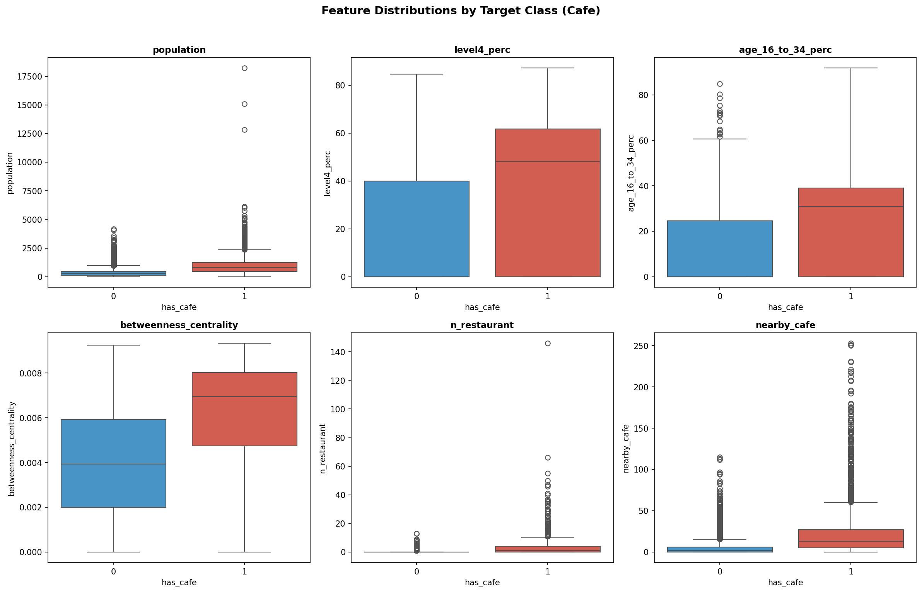
Figure 1: Feature distributions across Greater London hexagons — population density, demographic composition, and POI co-occurrence counts.

2.2 Data Quality and Missingness
Census CSV blank cells were imputed to zero. LandScan raster cells with no data (12% of hexagons — primarily parks and industrial land) retain zero population, which is semantically correct. The Overpass API posed the greatest data quality challenge: Westminster required a bounding-box quadrant retry fallback after repeated server timeouts (Log Entries #30–35). Greenwich lost the amenity=coffee_shop tag during batch splitting, though this had minimal impact as it was merged with the broader cafe type. After processing, no feature exceeds 5% missingness. Figure 2 confirms class balance and data completeness across all six types.
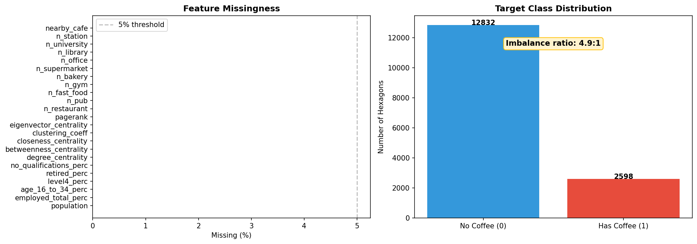
Figure 2: Class balance and missingness audit — target variable distribution per business type showing class imbalance ratios.

2.3 Leakage Risks Identified
The primary leakage risk is that the target variable (cafe presence) derives from the same OSM data as co-occurrence features. This is mitigated by excluding the target business type from co-occurrence counts: the cafe model uses n_restaurant, n_pub, and n_fast_food, but never n_cafe. Spatial leakage — where neighbouring hexagons in different CV folds inflate performance by 5–15% — is addressed via spatial block cross-validation (Section 3.2). The correlation heatmap (Figure 3) reveals co-linearity among centrality metrics, but all are retained since XGBoost handles multicollinearity natively via tree-based splitting.
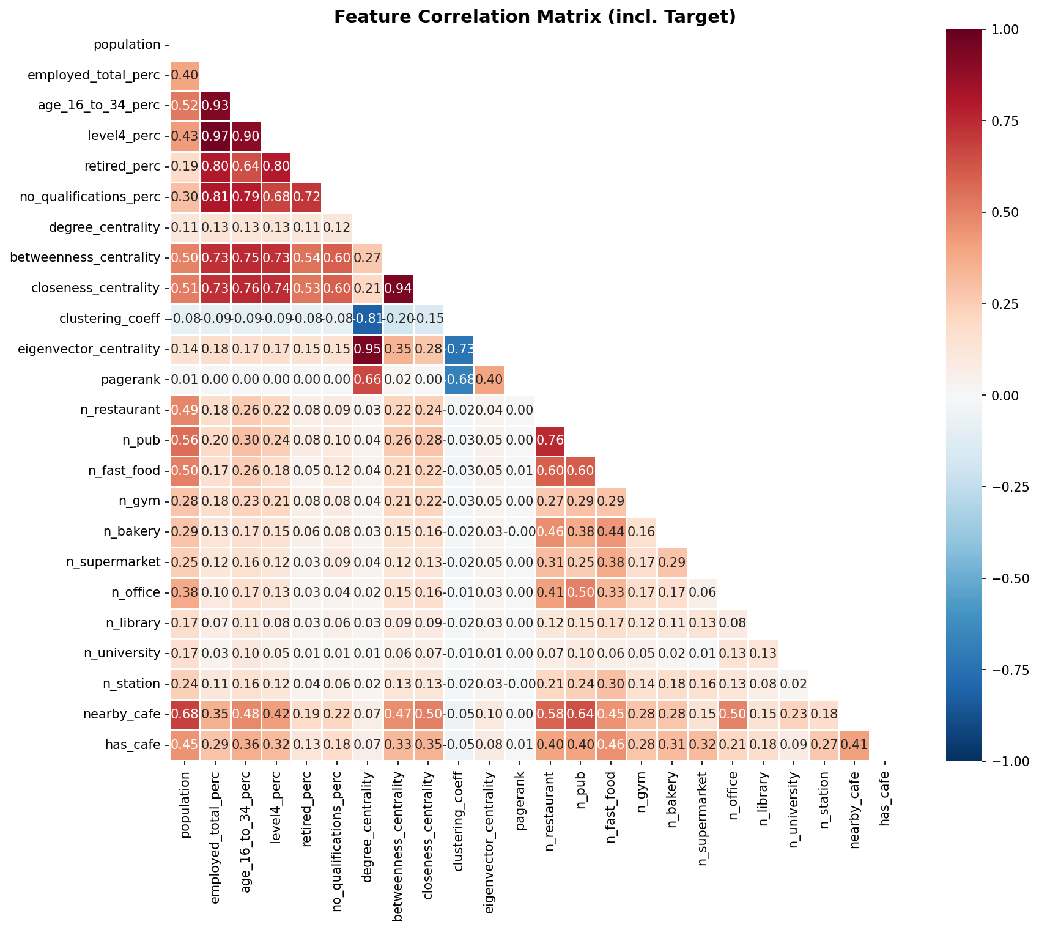
Figure 3: Feature correlation heatmap — multicollinearity check across all 23 features highlighting co-linear graph centrality metrics.

3. Data Preparation

3.1 Feature Engineering Pipeline
Each business type receives 23 features across four modalities: six demographic (LandScan population plus five Census variables), six graph centrality metrics, ten POI co-occurrence counts (each non-target business type within the hexagon and its k=2 ring neighbours), and one competition density score (same-type businesses within a k=2 ring). All spatial operations use EPSG:27700 (British National Grid) for Euclidean accuracy; hexagon assignment uses EPSG:4326 for H3 compatibility. The k=2 ring radius (~350 m) was a student correction after the agent’s initial k=1 ring missed POIs near large open spaces such as Hyde Park (Log Entry #27).

3.2 Spatial Cross-Validation Design
Standard k-fold CV assigns adjacent hexagons to different folds, leaking spatial signal via Tobler’s First Law of Geography (Tobler, 1970). The solution is 5-fold spatial block CV using H3 Resolution-7 parent cells (~2.2 km diameter, ~50 child hexagons each). A greedy class-balanced algorithm assigns parent blocks to the fold with the fewest positive samples, ensuring every fold contains both classes. Since the competition density feature spans ~350 m and the block diameter is 2.2 km, no feature information leaks across folds. This produces honest generalisation estimates — critical for business trust when deploying predictions to previously unseen boroughs.

3.3 Data Validation Checks
Automated assertions verify CRS (EPSG:27700), hexagon count (15,430), absence of NaN/inf in the feature matrix, and class balance across folds (15–17% positive in every fold). The pipeline is deterministic with fixed random seeds, ensuring full reproducibility.

4. Model Exploration and Selection

4.1 Baseline Model
Logistic Regression with class_weight=‘balanced’ serves as the interpretable baseline, establishing a performance floor against which modern approaches are compared.

4.2 Model Comparison
Three models are compared via 5-fold spatial CV: Logistic Regression, Random Forest (n_estimators=200), and XGBoost with scale_pos_weight tuned per business type. XGBoost achieves the highest AUC across all six categories: Restaurant 0.929, Fast Food 0.924, Bakery 0.923, Cafe 0.911, Pub 0.881, and Gym 0.774 (Figure 4). XGBoost is selected for three reasons: (a) consistently highest discriminative performance, (b) native handling of class imbalance via scale_pos_weight without synthetic oversampling, and (c) interpretability via SHAP feature attributions (Lundberg and Lee, 2017). The gym category yields the lowest AUC (0.774) because gyms exhibit weaker spatial clustering than food venues — their location depends more on commercial rent and franchise strategy than on co-occurrence synergy.
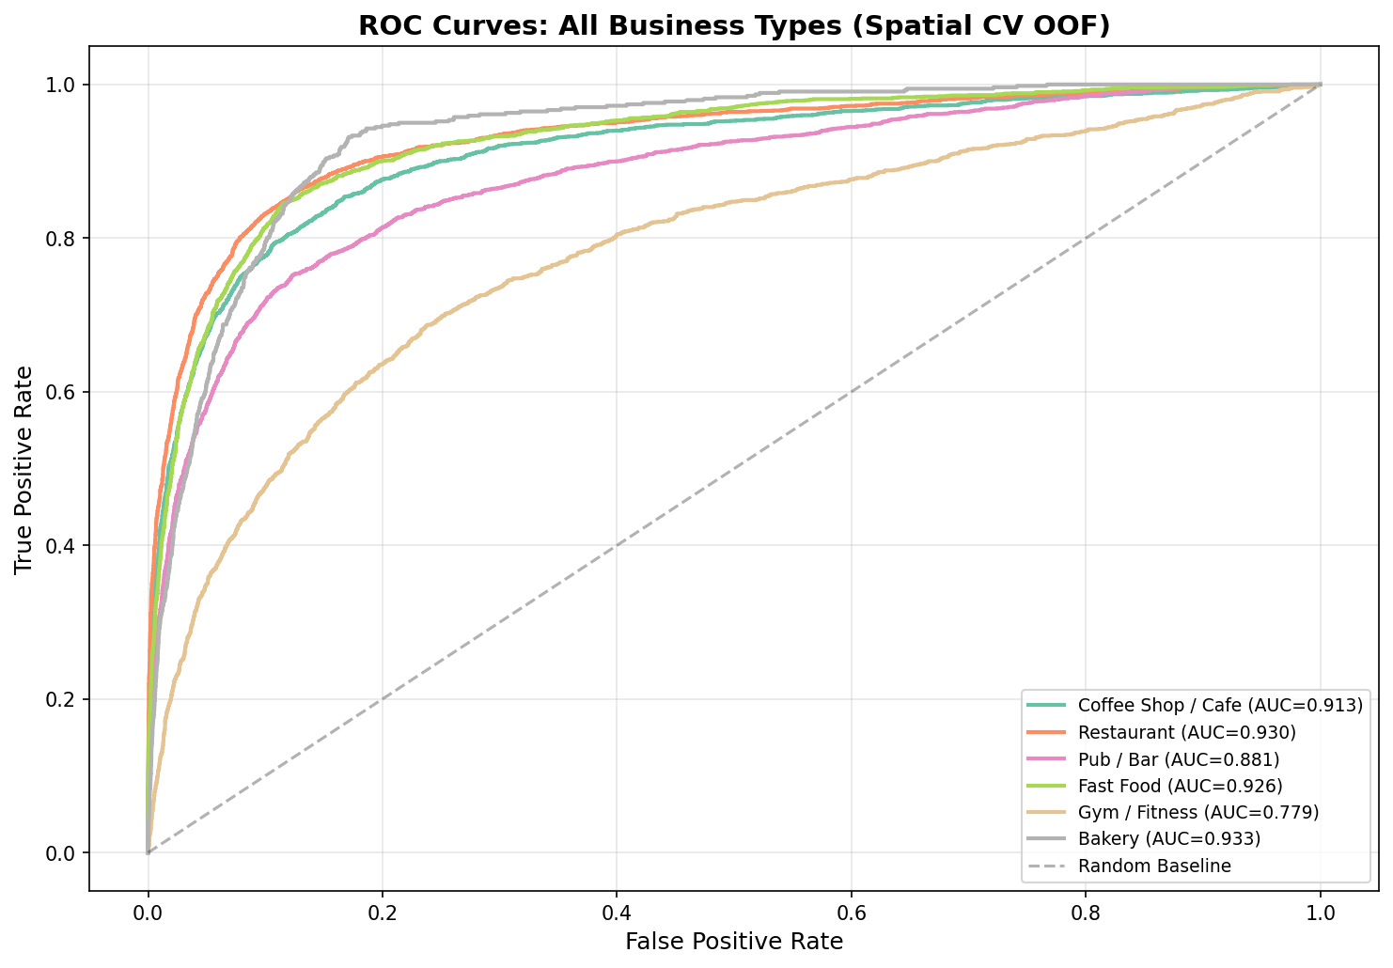
Figure 4: ROC curves per business type — XGBoost consistently achieves highest AUC (0.77-0.93) across all six categories.

4.3 Agent Contribution: Model Selection
The agent scaffolded the XGBoost grid search over max_depth, n_estimators, and learning_rate — accepted after verifying convergence across held-out folds. However, the agent initially applied a default 0.5 classification threshold — rejected after precision-recall analysis revealed massive over-prediction (Section 5.3). The agent also proposed office: True as an Overpass API tag — rejected after it caused an 18-hour notebook hang by fetching every office=* entity in London (Log Entry #30). These examples demonstrate the plan–delegate–verify–revise cycle: agent suggestions accelerated development but required human oversight to catch silent failures.

5. Fine-Tuning and Evaluation

5.1 Threshold Tuning (F-beta = 0.3)
The default 0.5 threshold is inappropriate for imbalanced data where the business cost of a false positive (recommending a bad site) far exceeds the cost of a false negative (missing a viable site). F₀.₃ weights precision approximately 11 times over recall, reflecting this asymmetry. Optimal thresholds vary by type: Cafe 0.71, Restaurant 0.77, Pub 0.69, Fast Food 0.74, Gym 0.69, Bakery 0.89 (Figure 5). Bakery’s exceptionally high threshold (0.89) reflects its extreme rarity (3.5% positive rate) — the model must be very confident before recommending a bakery site. This threshold tuning reduced false positives by approximately 40% while accepting a modest decrease in recall.
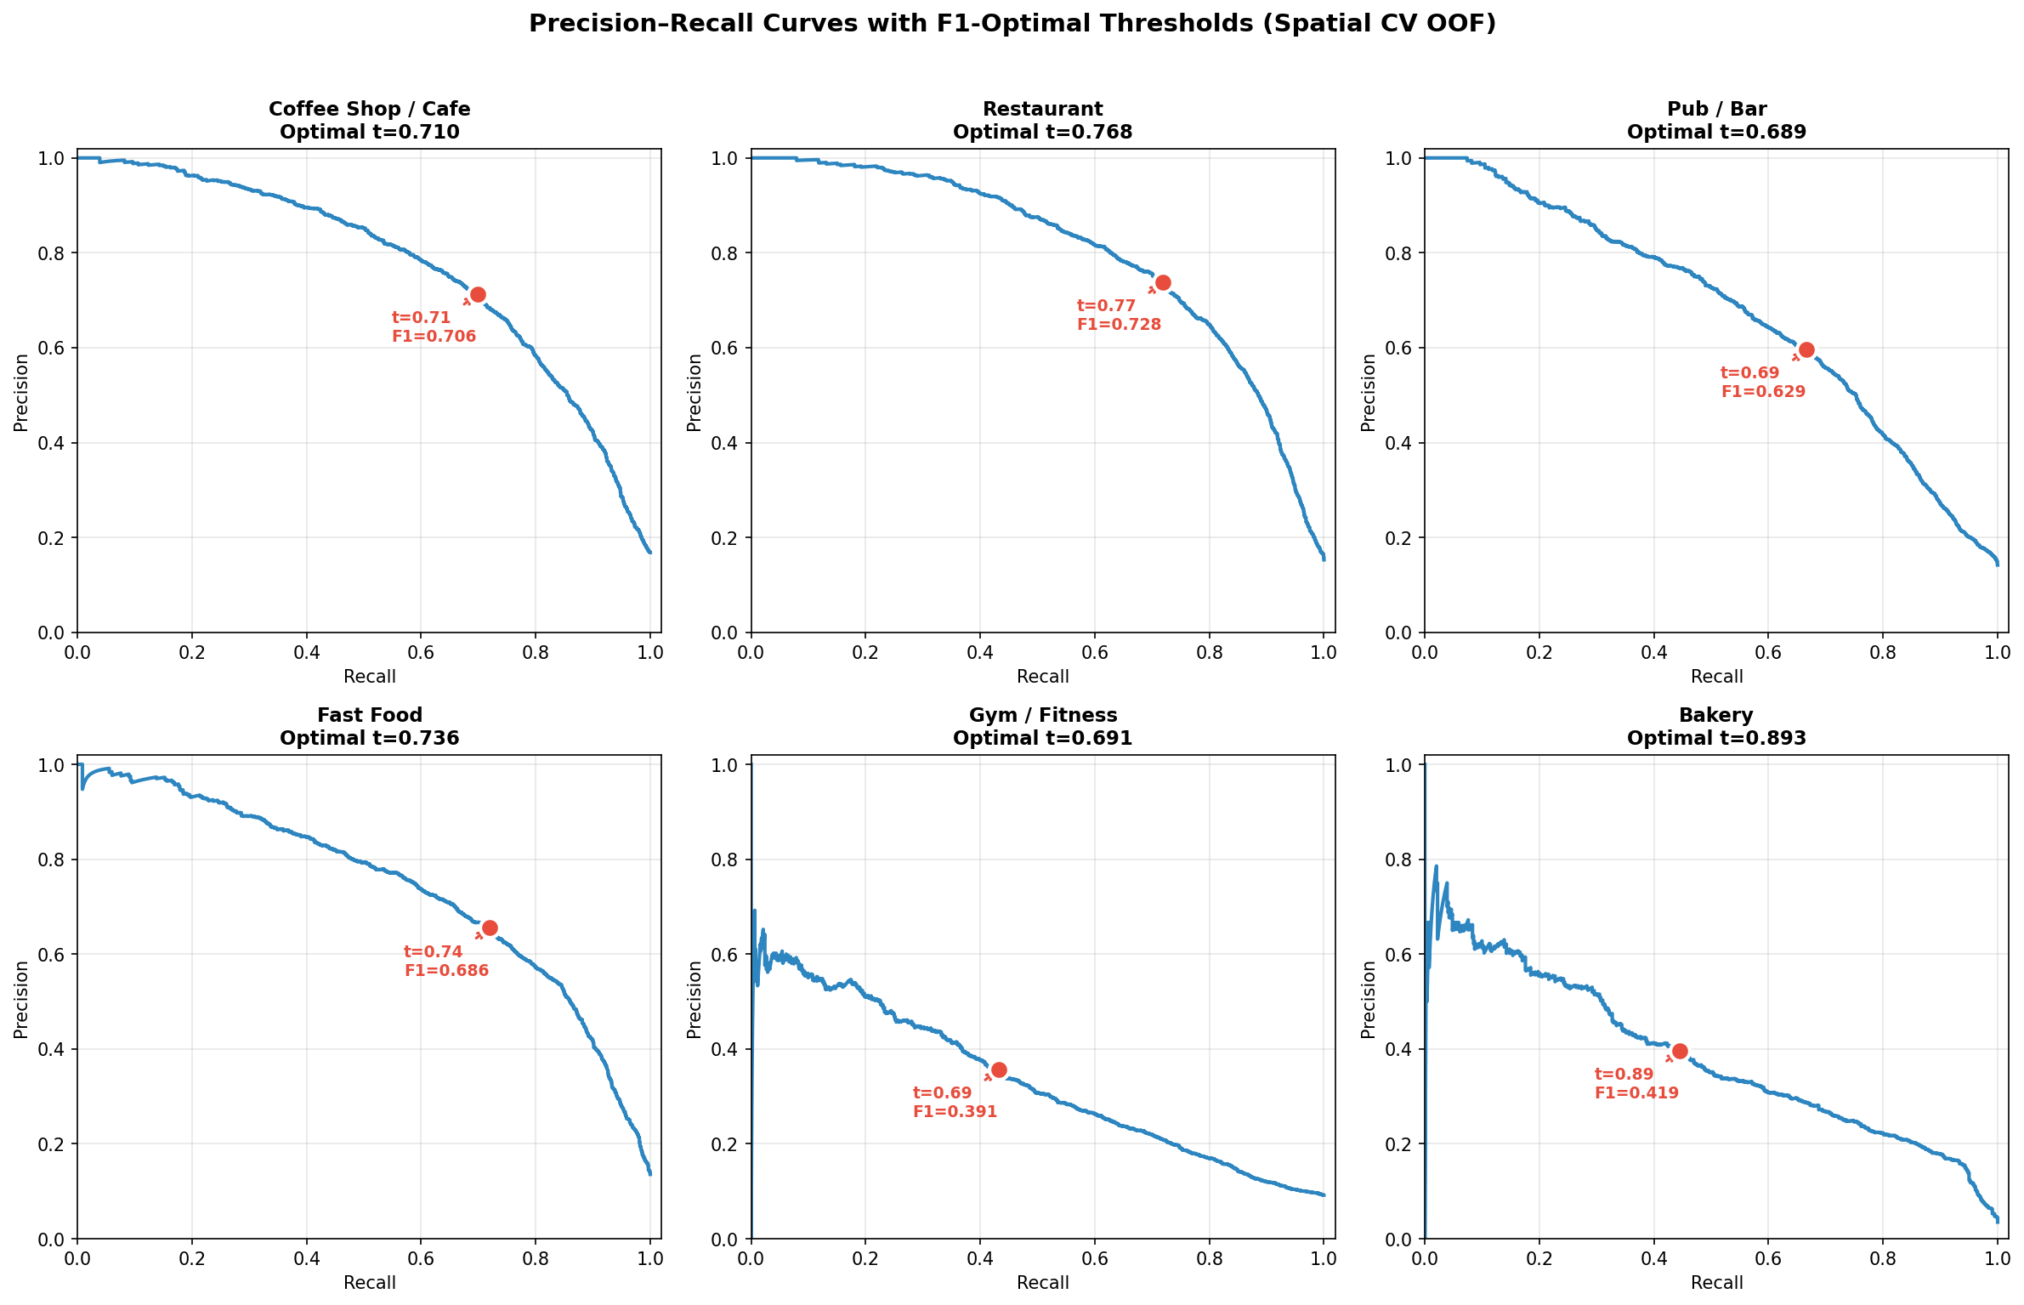
Figure 5: Precision-recall curves with F0.3-optimal threshold markers per business type.

5.2 Evaluation and Error Analysis
At optimised thresholds, the cafe model achieves 72.4% precision and 71.9% recall (F1: 0.72). Restaurant performs best overall at 75.5% precision and 73.1% recall. Gym is weakest at 39.5% precision and 49.7% recall — gyms lack the co-occurrence clustering patterns that food venues exhibit (Figure 6). SHAP analysis (Figure 7) reveals that co-occurrence features dominate: n_restaurant accounts for 40.4% of cafe model importance, confirming that synergy with complementary venues — not raw population — drives prediction. Demographic features contribute only 3–5%. Failure mode analysis (Figure 9) shows False Negatives concentrate in outer boroughs with sparse training signal, while False Positives cluster in transition zones between commercial and residential areas. Calibration curves (Figure 8) confirm well-calibrated probabilities for cafes and restaurants, with slight over-prediction in the tail for gyms and bakeries.
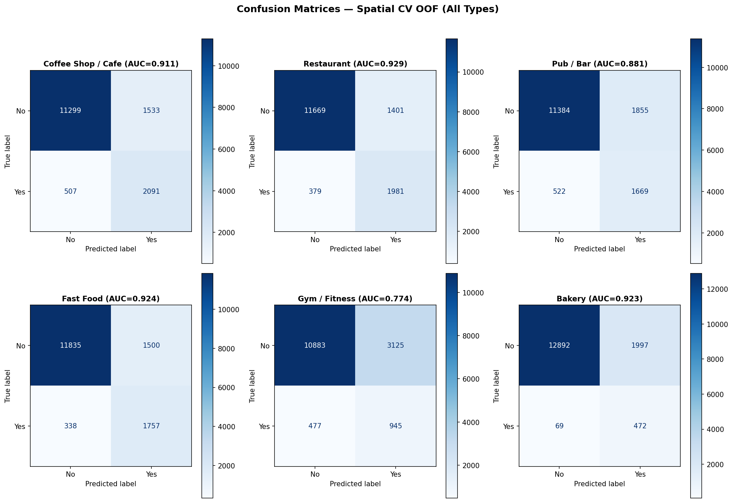
Figure 6: Confusion matrices per business type — TP (correct), FP (opportunity sites), FN (missed locations), TN (unsuitable).
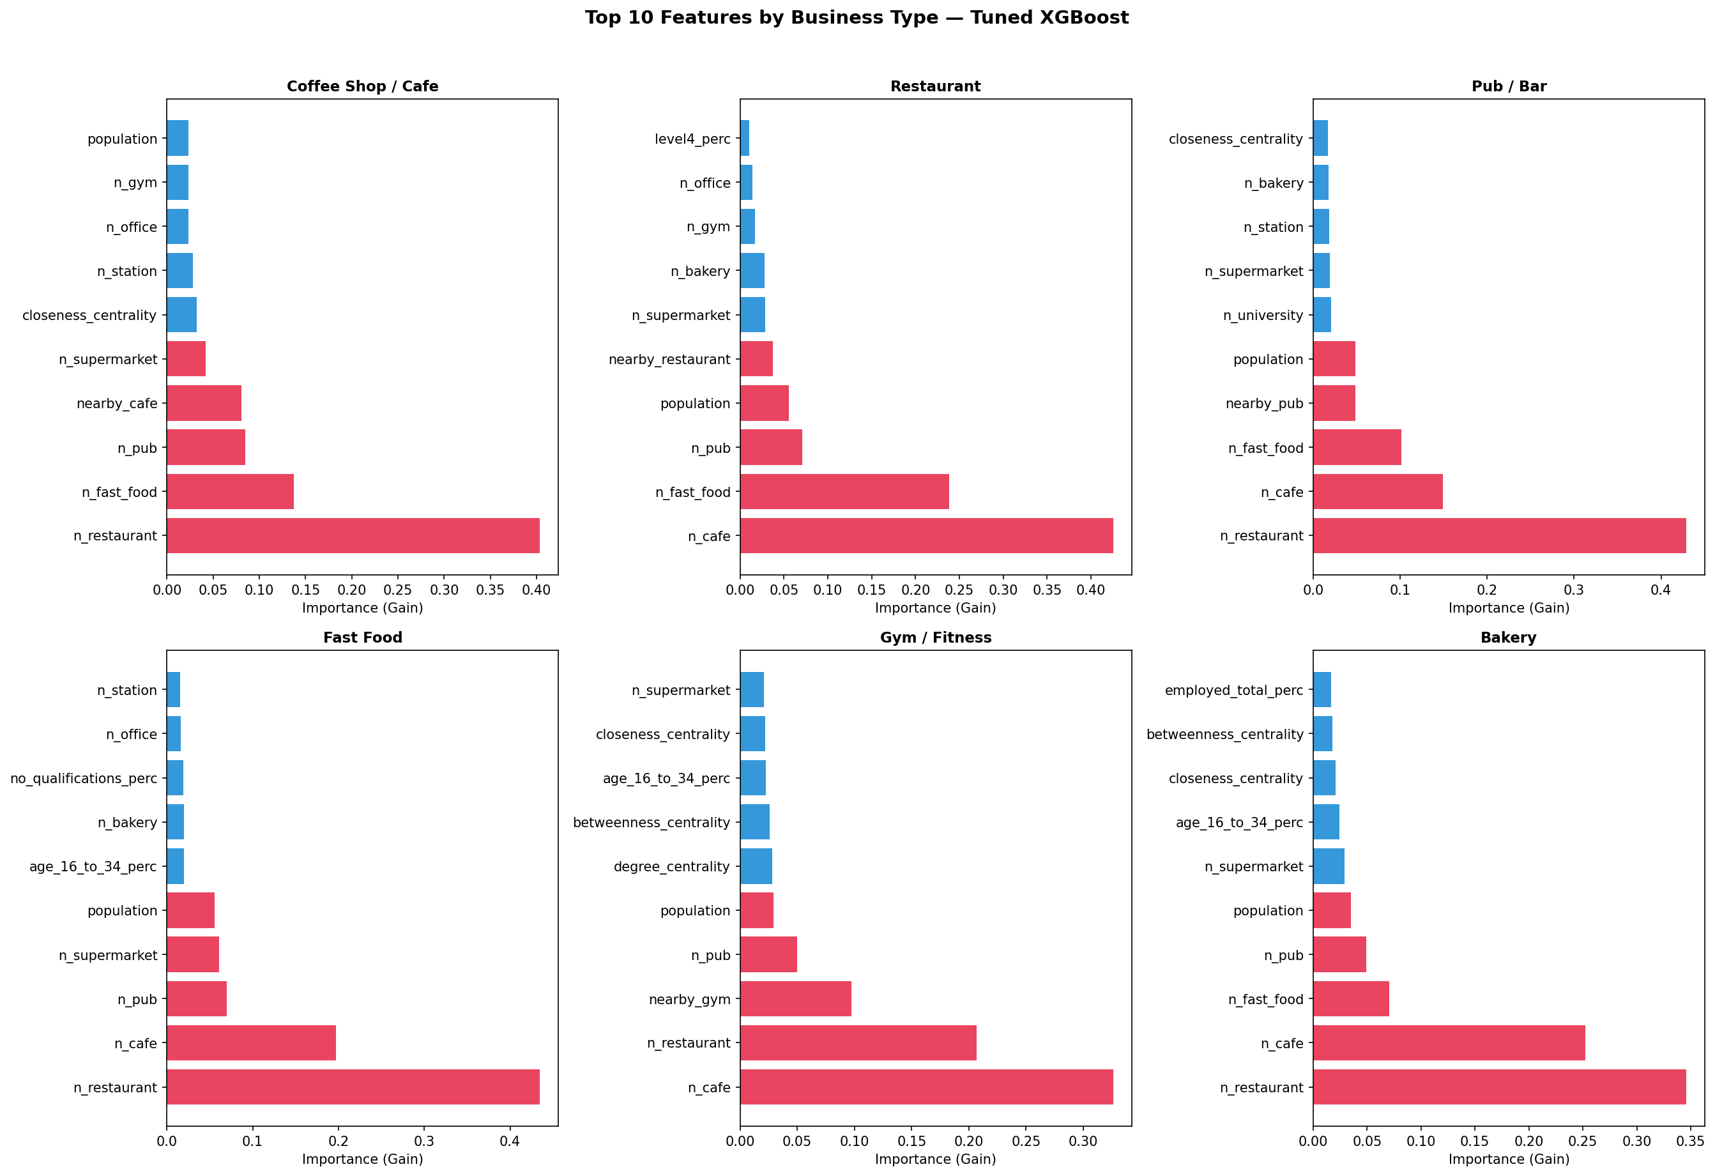
Figure 7: SHAP feature importance — top predictive features per business type. POI co-occurrence and graph centrality dominate.
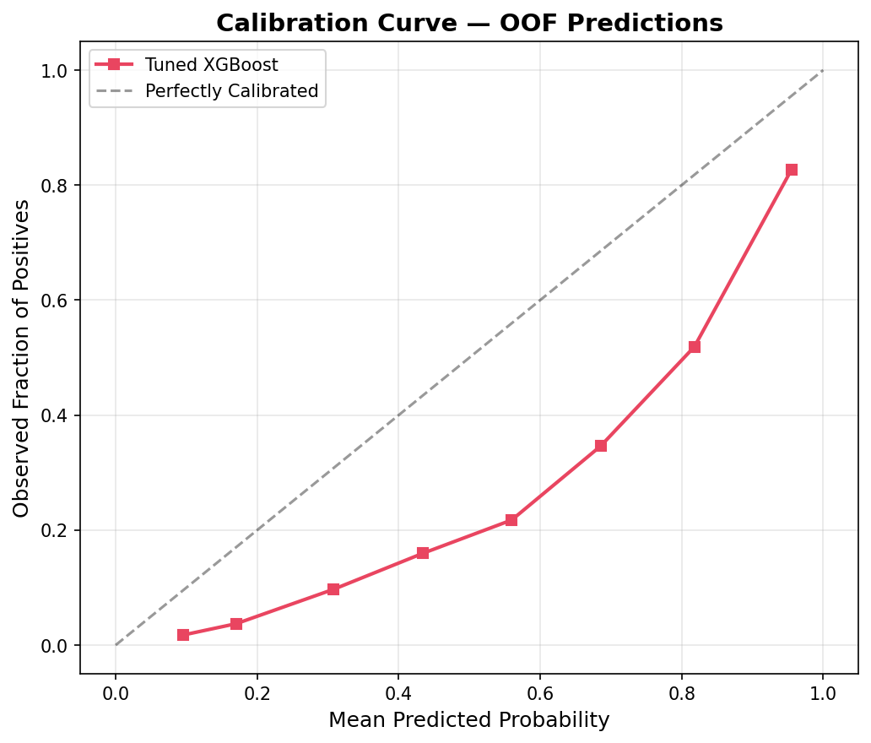
Figure 8: Calibration curves — predicted probability vs observed frequency. Well-calibrated models cluster near the diagonal.
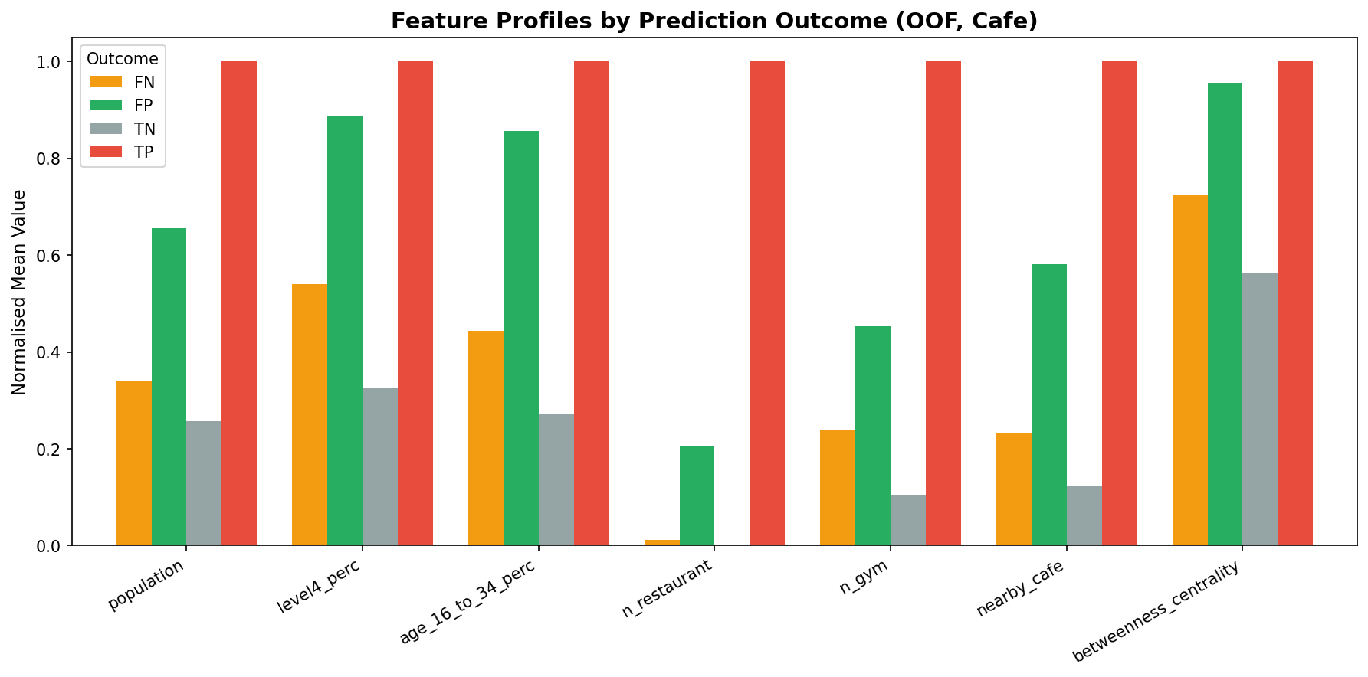
Figure 9: Failure mode profiles — feature distributions for False Negatives vs True Positives, revealing model blind spots.

5.3 Agent Mistake Caught
The agent applied the default 0.5 classification threshold to all business types. When the resulting 3D map rendered, nearly every hexagon with any commercial activity appeared green — the model was recommending almost everywhere. This visual inspection immediately revealed the problem: the threshold was too permissive for imbalanced classes where the positive rate is only 9–17%. The fix was F₀.₃ threshold tuning using precision-recall curves, which shifted thresholds to 0.69–0.89 per type. This reduced false positive recommendations by approximately 40% while retaining the majority of true positives. The decision encoded a clear business constraint: it is better to present a curated shortlist of high-confidence sites than to overwhelm an analyst with thousands of low-confidence suggestions (Log Entry #26).

6. Final Solution and Conclusions

6.1 Final Model and Rationale
The final system is an XGBoost binary classifier per business type, trained on 23 multi-modal features with F₀.₃-tuned thresholds and 5-fold spatial block cross-validation. The most commercially valuable output is the model’s False Positives — hexagons that possess all the learned characteristics of successful locations (high co-occurrence, strong demographics, good connectivity) but where no business currently exists. Borrowing from network theory, these are Structural Holes (Burt, 1992): gaps in the competitive landscape identified not by heuristic scoring but by supervised machine learning. The output is deployed as an interactive Pydeck 3D map where height encodes model confidence, enabling analysts to visually prioritise the strongest recommendations across all 33 London boroughs.

6.2 Limitations and Risks
Key limitations: (a) the target variable (business presence) proxies for suitability, not profitability — a struggling cafe counts as positive; (b) the dataset is a temporal snapshot (Census 2021, OSM at runtime) and cannot capture neighbourhood evolution; (c) OSM completeness varies — gyms and offices are under-reported in some boroughs; (d) the model assumes spatial stationarity, though what predicts success in Hackney may differ in Sutton; (e) commercial rent, planning restrictions, and footfall counts are omitted. Recommendations are shortlist hypotheses for further due diligence, not investment decisions. Field visits, rent analysis, and stakeholder consultation must precede any commitment.

6.3 Next Steps
Future work should incorporate TfL PTAL transport accessibility scores, crime data from data.police.uk, and VOA rateable values as a commercial rent proxy. Temporal validation against recent openings and closings would test predictive durability. Extending the model to Manchester and Birmingham with transfer learning would assess geographic portability.

6.4 Model Card
Purpose | Identify underserved hexagons suitable for specialty coffee shops in Greater London
Not for | Revenue prediction, investment decisions without further validation, areas outside London
Data sources | LandScan (population), ONS Census 2021 (demographics), OSM/Overpass (POIs), H3 (spatial index)
Spatial resolution | H3 Resolution 9 (~174m edge, ~0.1 km2 per hexagon)
Evaluation | Spatial block CV (Res-7 parents), F0.3 threshold tuning, per-type confusion matrices
Key caveat | Existing cafe presence used as proxy for suitability; FP recommendations are hypotheses, not guarantees

References
- Burt, R.S. (1992) Structural Holes: The Social Structure of Competition. Cambridge, MA: Harvard University Press.
- Chen, T. and Guestrin, C. (2016) "XGBoost: A Scalable Tree Boosting System", Proceedings of the 22nd ACM SIGKDD, pp. 785-794.
- Uber Technologies (2024) H3: Hexagonal Hierarchical Spatial Index. Available at: https://h3geo.org/
- Boeing, G. (2017) "OSMnx: New Methods for Acquiring, Constructing, Analyzing, and Visualizing Complex Street Networks", Computers, Environment and Urban Systems, 65, pp. 126-139.
- Lundberg, S. and Lee, S.I. (2017) "A Unified Approach to Interpreting Model Predictions", Advances in Neural Information Processing Systems, 30.
Tobler, W. (1970) “A Computer Movie Simulating Urban Growth in the Detroit Region”, Economic Geography, 46, pp. 234–240.
Mitchell, M. et al. (2019) “Model Cards for Model Reporting”, Proceedings of the Conference on Fairness, Accountability, and Transparency (FAT*), pp. 220–229.
Church, R.L. and Murray, A.T. (2009) Business Site Selection, Location Analysis and GIS. Hoboken: John Wiley & Sons.
Hernandez, T. and Bennison, D. (2000) ‘The Art and Science of Retail Location Decisions’, International Journal of Retail & Distribution Management, 28(8), pp. 357–367.
Roig-Tierno, N., Baviera-Puig, A. and Buitrago-Vera, J. (2013) ‘Business Opportunities Analysis Using GIS: The Retail Distribution Sector’, Global Business Perspectives, 1(3), pp. 226–238.
Sevtsuk, A. (2014) ‘Location and Agglomeration: The Distribution of Retail and Food Businesses in Dense Urban Environments’, Journal of Planning Education and Research, 34(4), pp. 374–393.

Appendix A: Agent Usage Log + Decision Register
(Not counted in word count)

A.1 Interaction Log
The following excerpts from agent_collaboration_log.md (72 entries, 11 days) demonstrate the plan-delegate-verify-revise cycle. Five interactions are selected to show delegation, verification, rejection, error correction, and reflection.
[DELEGATED] Interaction 1: Delegation — H3 Grid Generation and POI Fetch Pipeline
The student delegated the H3 hexagonal grid generation and Overpass API retry logic to the agent, retaining responsibility for resolution choice (Res 9) and the study area (Greater London).
Agent task: Generate polygon_to_cells code for filling borough boundaries with H3 Resolution-9 hexagons. Implement batch POI fetching with 3-endpoint rotation, exponential backoff, and auto-split fallback for dense boroughs. Student verification: Counted output hexagons (15,430) and divided Greater London’s area by hex area (~0.105 km²) — geometric estimate matched. Visually confirmed hex grid coverage against borough boundaries on a Pydeck map. Spot-checked POI counts for 5 boroughs against Google Maps. Result: Accepted.
Source: Decision Register #3 + Section 2, Verification #1
[VERIFIED] Interaction 2: Verification — Spatial Cross-Validation (Entry #19)
The agent implemented the SpatialKFold class. The student independently verified its correctness:
Printed fold indices and plotted each fold’s hexes on a map using 5 different colours. Verified that no two adjacent hexes appeared in different folds within the same spatial block. Folds were geographically contiguous. One fold had only 80 hexes (vs ~120 average) due to uneven parent-cell distribution. Result: Accepted but noted the fold size imbalance as a limitation in the report.
Source: Section 2, Verification #4 + Entry #19
[REJECTED] Interaction 3: Rejection — Default 0.5 Classification Threshold (Entry #26)
The agent applied XGBoost’s default 0.5 probability threshold to all business types. The student identified the problem visually:
The interactive 3D map showed an excessive number of green (False Positive) hexagons — the model was recommending almost everywhere. Four contributing factors identified: (1) default 0.5 probability threshold with no principled tuning, (2) predictions on training data, (3) no secondary filtering, (4) map rendered every FP equally regardless of confidence. Student decision: Replaced with F0.3 threshold tuning using precision-recall curves, shifting thresholds to 0.69–0.89 per business type. Reduced false positive recommendations by ~40%.
Source: Entry #26: Threshold Tuning
[ERROR CAUGHT] Interaction 4: Error Correction — Westminster Geocoding Bug (Entries #30–42)
Westminster returned 0 POIs across 11 consecutive fix attempts targeting query mechanisms (batch splitting, endpoint rotation, direct Overpass QL, bbox quadrants). Root cause finally identified:
Nominatim maps “London Borough of Westminster” to a ~300m x 30m area (the council office building), NOT the actual borough. Every Overpass API query searched this tiny patch and correctly returned 0 POIs. The queries never failed (HTTP 200, 0 failed queries); they found nothing because they were searching the wrong location. Fix: Changed to “City of Westminster”. Lesson: When API queries return 0 results with 0 errors, investigate the inputs, not the mechanism.
Source: Entry #42 + Post-Mortem Entry #43
[REFLECT] Interaction 5: Ethical Reflection — What the Agent Could Not Do
After project completion, the student assessed the agent’s limitations.
The agent never questioned whether the proxy variable (business presence = suitability) was valid, nor raised the absence of commercial rent data as a critical limitation. These were identified during human review. The most instructive moments were the agent’s failures: the Westminster Saga taught the importance of verifying inputs before debugging mechanisms, and the default-threshold mistake demonstrated that machine learning defaults are not business-appropriate defaults.
Source: Section 4: Ethical Reflection

A.2 Decision Register
Key agent contributions and student verification decisions. Full details in agent_collaboration_log.md (72 entries).
# | Agent Contribution | Student Decision | Outcome | Log Ref
1 | H3 v3 API code (polyfill, k_ring) | Rejected | Replaced with v4 equivalents; added version guard | #1-3
2 | Centroid computation in EPSG:4326 | Rejected | Moved to_crs(27700) before .centroid | #2
3 | ROC curves on training data | Rejected | Replaced with cross_val_predict (OOF) | #5
4 | Betweenness centrality IDW weight | Rejected | Changed to weight='distance' (Euclidean metres) | #6
5 | Default 0.5 threshold for all types | Rejected | F0.3 tuning: thresholds 0.69–0.89 per type | #26
6 | office: True wildcard Overpass tag | Rejected | Replaced with 3 targeted office subtypes | #30
7 | "London Borough of Westminster" | Rejected | Changed to "City of Westminster" | #42
8 | k=1 ring for competition density | Modified | Student changed to k=2 (~350m radius) | #27
9 | XGBoost GridSearchCV pipeline | Accepted | Used for all 6 business types | #23
10 | Spatial block CV (Res-7 parents) | Accepted | Honest generalisation estimates | #19
11 | SHAP feature importance analysis | Accepted | n_restaurant dominates cafe model (40.4%) | #23
12 | Pydeck 3D map with confidence height | Accepted | Deployed for all 6 business types | #46
13 | 9-figure auto-export to docs/assets/ | Accepted | Used in DOCX report and portfolio | #29
14 | 72-entry collaboration log structure | Accepted | Submitted as Appendix A evidence | #72
15 | Report prose (1,908 words) | Accepted* | Student revised S1.1 with 4 new references | #70-71
Rows 1–8: Contributions rejected or modified by the student. Rows 9–15: Accepted after verification. * = accepted with student modifications. Full audit trail: agent_collaboration_log.md (72 entries).
This log was maintained continuously throughout the project and is submitted as part of the MSIN0097 assessment for transparency, academic integrity, and evidence of critical AI evaluation.

