Case Report: Personal Training at the New York Health Club

Fill in your names, team number, and section number in the header. Below, write your answers to Questions 1-4. If you need to make additional assumptions to answer a question, clearly state them, logically defend them, and then proceed to answer the question accordingly.
Please format your report in the following way:
- Limit your answers to 5 pages. Use 11 pt font or larger and 1.5 line spacing. The idea is to answer the questions concisely.
- Draw diagrams in black or gray lines on white background, because your report will be printed in black and white for grading.
- Submit one file per group. Attach all necessary diagrams and calculations to your report, and keep this file letter-sized (8.5x11), otherwise your report will not be printed correctly.
The case is due 16 March, 10:00am. We will discuss the answers on Tuesday. Please print out your answers for your own reference during the class discussion.

Please leave rest of this page blank. No answer should appear on this cover page.

Case Report: Personal Training at New York Health Club

- Question 1: Flat Rate Pricing Strategy

Recommendation: Charge a flat rate of $75 per session.

Methodology:
Using the survey data from 113 respondents, we computed each customer’s maximum willingness-to-pay (WTP) across all six time periods (Column H = MAX of 6am–9am through 9pm–close). We evaluated six candidate price points ($25 to $150 in $25 increments) by counting respondents whose maximum WTP meets or exceeds each price. This proportion was applied to the full population of 10,000 members to estimate demand, and multiplied by the price to calculate total revenue.

Results:
Price | Respondents  (WTP ≥ Price) | % of  Members | Total  Demand | Total  Revenue
$150 | 1 | 0.88% | 88 | $13,274
$125 | 10 | 8.85% | 885 | $110,619
$100 | 32 | 28.32% | 2,832 | $283,186
$75 | 72 | 63.72% | 6,372 | $477,876
$50 | 97 | 85.84% | 8,584 | $429,204
$25 | 113 | 100.00% | 10,000 | $250,000
Optimal price: $75 → Maximum revenue: $477,876
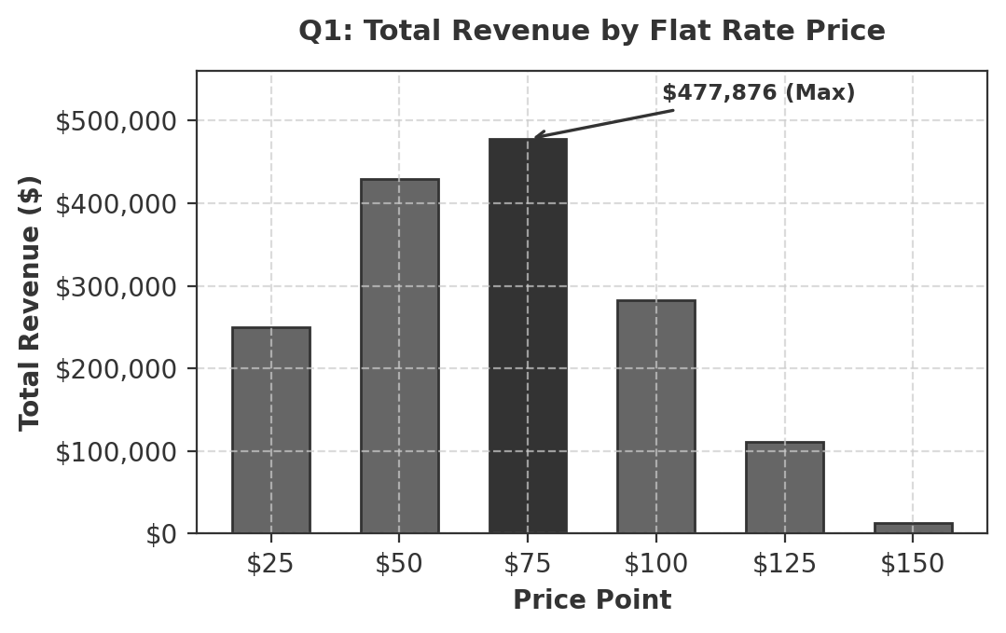

Analysis:
At $75, 63.72% of members (6,372 out of 10,000) would purchase personal training, generating $477,876 in total revenue. This represents the optimal trade-off between price and demand volume. Lowering the price to $50 captures more customers (8,584) but sacrifices too much per-session revenue. Raising it to $100 prices out too many members, reducing demand to just 2,832. Notably, the $75 flat rate exceeds NYHC’s current average revenue per session of $68.10, while also eliminating the inconsistent negotiation-based pricing that creates fraud risk and discourages new members.

- Question 2: Variable Pricing Strategy (Peak vs Non-Peak)

Recommendation: Charge $75 for peak hours (5–9pm), with non-peak fixed at $50.

Methodology:
To increase revenue NYHC aims to evaluate the introduction of premium pricing for popular hours (5-9pm). To determine the optimal peak price, customer decision-making was modelled across three scenarios: purchasing during non-peak hours, purchasing during peak hours or not purchasing at all. For each respondent the following were computed:
- non-peak willingness to pay (WTP): the highest WTP across all time slots (excluding 5-9pm).
- peak WTP: the WTP specifically during the 5-9pm slot.
- Net utility: computed as WTP – price charged for the respective time slot.

Net utility = WTP – price, pick the max.

Results:
Peak  Price | Non-Peak  Demand | Peak  Demand | Non-Peak  Revenue | Peak  Revenue | Total  Revenue
$50 | 973 | 7,611 | $48,673 | $380,531 | $429,204
$75 | 7,611 | 708 | $380,531 | $53,097 | $433,628
$100 | 8,142 | 88 | $407,080 | $8,850 | $415,929
$125 | 8,142 | 0 | $407,080 | $0 | $407,080
$150 | 8,142 | 0 | $407,080 | $0 | $407,080
Optimal peak price: $75 → Maximum total revenue: $433,628

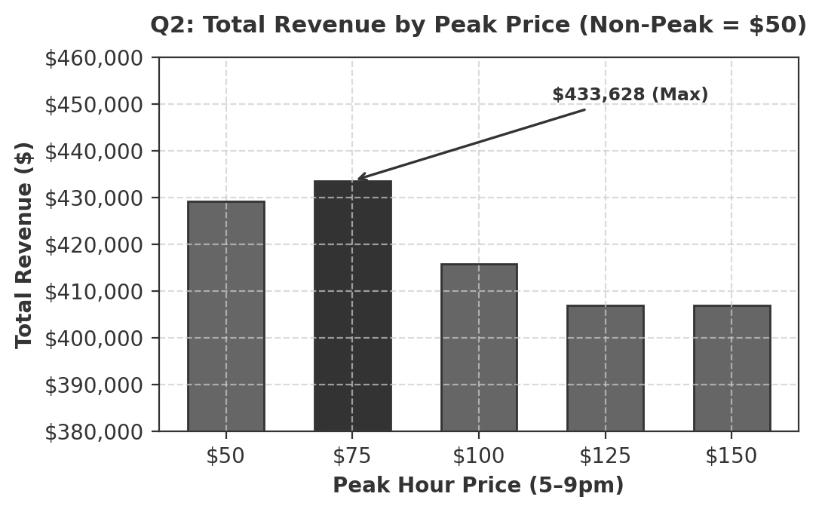

Analysis:
The analysis assumes that revenue maximization is equivalent to profit maximisation as no cost variable is provided, therefore assuming the variable is constant across peak and non-peak hours.

The optimal peak price is $75 with a total revenue of $433,628. To understand this result it is relevant to analyse demand change as the peak price increases. When peak and non-peak prices are set at $50, customers have no motive to avoid peak hours, as a result members will concentrate between 5-9pm slot (7,611 members). Although members flow is high, overall revenue remails low as customers pay the lower price across all times.
Increasing the peak price to $75 provides a premium price band to encourage customers to non-peak hours. 708 members are willing to pay the peak hours price, which generates the highest revenue by combining large off-peak demand ($380,531) with a smaller peak demand ($53,097).

When peak price exceeds $100 demand decreases significantly, as nearly no customers are willing to pay the price, with revenue plateauing at $407,080. This strategy performs worse than the standard pricing strategy (Q1) by $44,248 as it assumes a $50 charge for non-peak hours, reducing the average price compared to the standard $75 pricing model. This discounts customers who would have been willing to pay more.

- Question 3: Segment-Based Pricing (Students vs Non-Students)

REVENUE MAXIMISATION

Step 1 — Optimal Student Price:
Using the same methodology as Q1, we analysed the 33 student respondents separately. Student population: 2,920 (33/113 × 10,000).
Price | Students  (WTP ≥ Price) | Total  Demand | Total  Revenue
$150 | 0 (0.00%) | 0 | $0
$125 | 1 (3.03%) | 88 | $11,062
$100 | 2 (6.06%) | 177 | $17,699
$75 | 15 (45.45%) | 1,327 | $99,558
$50 | 25 (75.76%) | 2,212 | $110,619
$25 | 33 (100%) | 2,920 | $73,009
Optimal student price: $50 → Revenue: $110,619

The revenue-maximising student price is $50. Students are more price-sensitive, with WTP concentrated at $25–$50. At the Q1 flat rate of $75, student revenue would only be $99,558; at $50, it rises to $110,619 (+$11,062).

Step 2 — Optimal Non-Student Price:
We analysed the 80 non-student respondents separately. Non-student population: 7,080 (80/113 × 10,000).
Price | Non-Students  (WTP ≥ Price) | Total  Demand | Total  Revenue
$150 | 1 (1.25%) | 88 | $13,274
$125 | 9 (11.25%) | 796 | $99,558
$100 | 30 (37.50%) | 2,655 | $265,487
$75 | 57 (71.25%) | 5,044 | $378,319
$50 | 72 (90.00%) | 6,372 | $318,584
$25 | 80 (100%) | 7,080 | $176,991
Optimal non-student price: $75 → Revenue: $378,319

The optimal non-student price is $75—the same as Q1. Non-students have higher WTP.

Revenue Comparison:
Two-tier total: $110,619 (students) + $378,319 (non-students) = $488,938
Q1 flat rate: $477,876
Improvement: +$11,062 (+2.3%). The gain comes entirely from capturing more price-sensitive students.

CONGESTION CONCERNS

Step 3 — Demand Distribution Analysis:
Under two-tier pricing, each customer faces a flat price for all slots within their segment. When multiple slots yield the same maximum net utility, the customer is equally likely to choose any of them. We compared demand across all six time periods:
Time Period | Two-Tier  Demand | Flat Rate  Demand | Change
6am–9am | 1,456 | 1,294 | +162
9am–noon | 563 | 468 | +96
Noon–2pm | 895 | 799 | +96
2pm–5pm | 681 | 541 | +140
5pm–9pm | 2,415 | 2,142 | +273
9pm–close | 1,246 | 1,128 | +118
TOTAL | 7,257 | 6,372 | +885
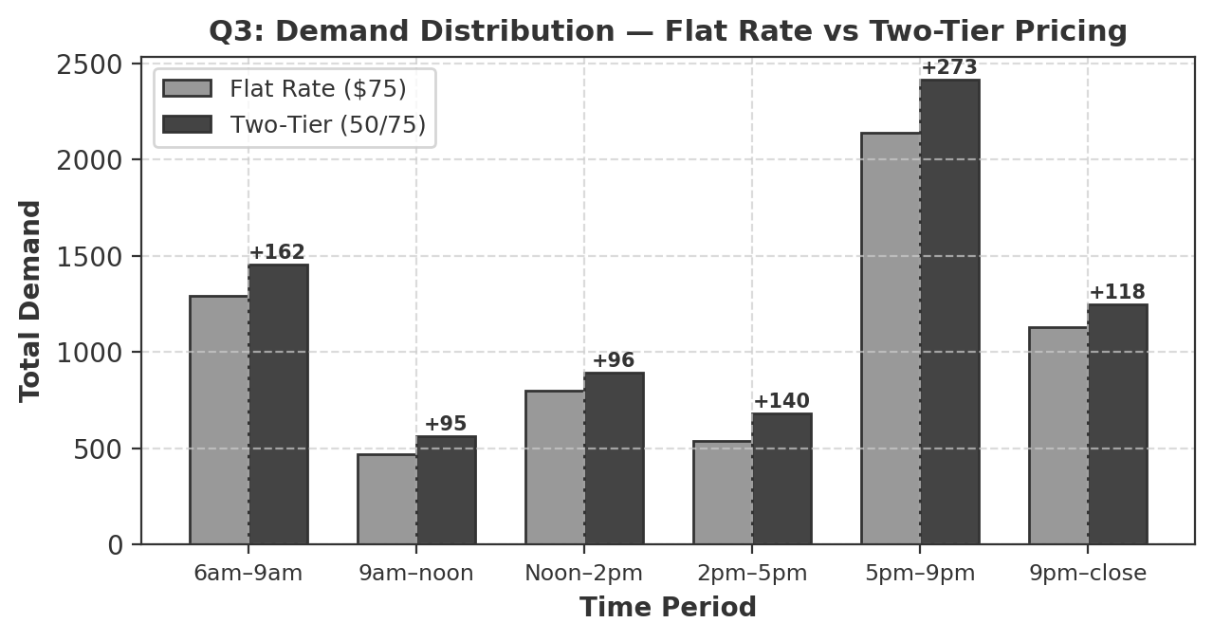
Demand increases across every time period. The largest increase occurs during 5–9pm peak (+273), which is already the most congested slot. The total additional demand is 885 sessions (+13.9%), driven entirely by 10 additional student buyers entering the system.

Step 4 — Congestion Risks and Proposed Solutions:
The two-tier strategy, while generating +$11,062 in revenue, raises significant congestion concerns. The 5–9pm slot already has the highest demand (2,142 under flat rate), and adding 273 more sessions intensifies peak crowding, potentially degrading member experience and causing churn that offsets revenue gains.

Proposed solutions:
1. Combine time-based and segment pricing: Offer students the $50 rate only during non-peak hours, while charging students a higher rate during peak hours. This steers price-sensitive students toward underutilised slots.
2. Capacity management: Implement a booking system that caps personal training sessions per hour, directing members to available alternatives when a slot is full.
3. Dynamic incentives: Offer additional perks for students who book non-peak sessions, further incentivising off-peak usage.
4. Pilot and monitor: Implement two-tier pricing as a trial, tracking hourly utilisation. Adjust student peak pricing upward if congestion exceeds thresholds.

- Question 4: Assessment of NYHC’s Survey and WTP Data

Strengths:
The survey captures individual-level willingness-to-pay across all six time slots, enabling granular analysis by time period and customer segment. The inclusion of a student identifier allows for segment-specific pricing. The design is straightforward: respondents state maximum WTP for each period, making data easy to interpret and model.

Limitations:
1. Hypothetical bias: Stated WTP typically overstates actual purchasing behaviour. Respondents report higher values than they would commit to in practice, meaning our revenue projections may be optimistic.

2. Non-response and selection bias: Only 1,000 of 10,000 members responded (10% rate), and our analysis uses a subsample of 113. Respondents may differ systematically from non-respondents—those more interested in personal training may be overrepresented, inflating apparent demand.

3. Discrete price intervals: WTP values are restricted to $25 increments ($25–$150). This coarse granularity means the true optimal price may fall between tested intervals (e.g., $65 or $80 rather than exactly $75).

4. Static and context-free: The survey captures preferences at a single point in time, without accounting for seasonal variation, competitive alternatives, or how preferences might change once new pricing is implemented.

5. Strategic response: Members may strategically understate WTP if they believe the survey will influence future prices.

Recommended Validation Methods:
• A/B price testing: Run controlled experiments at varying price points to observe actual purchase behaviour rather than stated intent.
• Conjoint analysis: Present members with realistic trade-off scenarios (varying price, time, trainer quality) to elicit more reliable preference data.
• Historical transaction analysis: Examine existing purchase records by time, price level, and demographics to calibrate survey findings against revealed preferences.
• Pilot programmes: Implement pricing changes on a trial basis and measure real demand response before committing permanently.

In summary, while the survey data is sufficient for directional guidance and comparing pricing strategies, NYHC should validate key findings with behavioural data before making permanent pricing decisions.

