**Computer Networks**

* A computer network is a set of connected computers.
* Computers on a network are called nodes.
* The connection between computers can be done via cabling, most commonly the Ethernet cable, or wirelessly through radio waves.
* Connected computers can share resources, like access to the Internet, printers, file servers, and others.
* A network is a multipurpose connection, which allows a single computer to do more.

**A typical university network scenario**

* Consider a university consisting of few institutions. Each institution will have few departments. The university would **like to upgrade** the network technology to provide better e-learning, web Services, email services, corporate information systems, voice, video communication, multimedia and other developments.
* The university campus has three buildings: Building A, B and C. The university server room, IT staff and university support staff offices are in Building B. The laboratories are in Building A and C.
* Assume that the **current network technology** is based on **10BaseT cabling** and **10Base-T Hubs**. Remote access into the university network is provided through an ADSL Internet link terminating in a building B.
* The university has about 20,000 students in **three facilities distributed over the campuses**; these are the faculties of Engineering/Computing, Health Sciences, Business, and Art/Design. Every member of staff in the University has a PC and a Laptop.
* **Requirements of new network technology:**
  1. Each student will be offered 2GB of storage. Total storage space required for 20,000 students is 40.96 TB
  2. Each staff member will be offered 5GB of storage. Total storage space required for 450 staff members is 2.304 TB.
  3. Wireless LAN access within all buildings.
  4. IP based video and voice communication.
  5. Remote access to university network.
  6. Provisions for backups, disaster recovery and redundancy.
* **Facility Requirements in Each Building:**
  + **Building A:**
    - Total number of workstations are 700.
    - 500 workstations in 6 separate laboratories with 84 workstations in each lab.
    - 200 workstations in the library.
    - Network Diagram in Building A

**Network Diagram of Building A**

* + **Building B:**
    - Total number of workstations are 600.
    - 500 workstations in 3 labs. 167 workstations in each lab.
    - 50 workstations for IT staff machines.
    - 50 workstations for university support services staff.
    - Servers: DNS Server, HTTP server, SMTP server, FTP server, TFTP Server
    - Network Diagram in Building B

**Network Diagram of Building B**

* + **Building C:**
    - Total number of workstations are 750
    - 750 workstations in 10 labs.

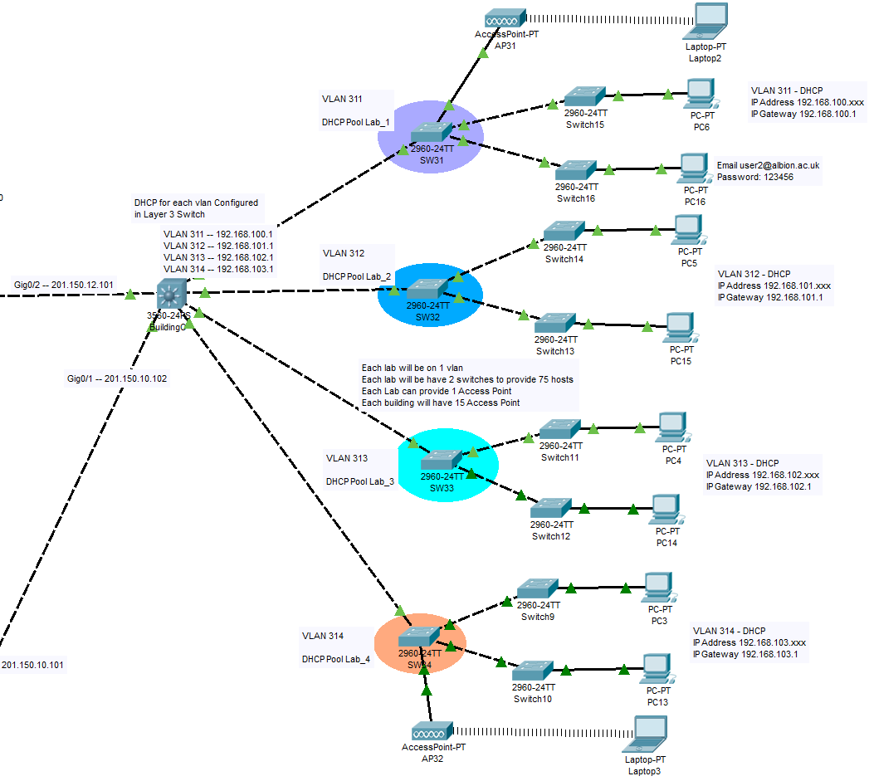

**Network Diagram of Building C**

**Network Topology between buildings**

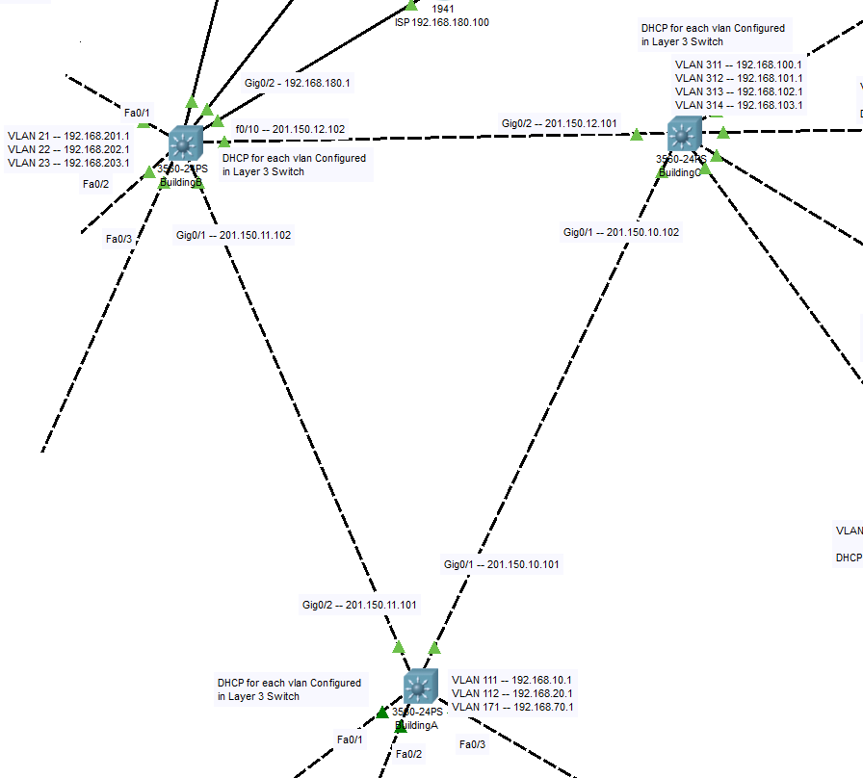

**Reference:**

* + **SEKTI WICAKSONO**, MSC COMPUTER SCIENCE, COCS71175 - IT INFRASTRUCTURE, Staffordshire University
  + **GitHub:** <https://github.com/sekti92/it_infrastructure>