**Scenario 11: Creation and usage of webservice services**

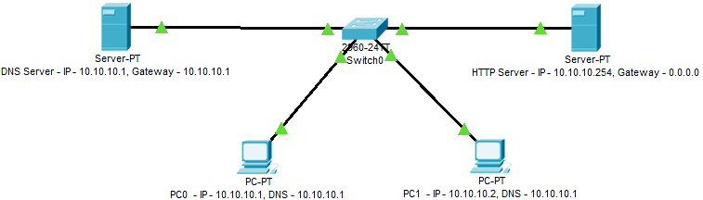

* Create the topology, assign the IP, subnet and gateway to devices as show in the figure above.
* On HTTP server go to services tab 🡪 select HTTP service 🡪 enable HTTP protocol
* Click on new file and copy the HTML code below:

<div class="bgimg">

<div class="topleft">

<p>MAHE, Manipal</p>

</div>

<div class="middle">

<h1>Welcome to Networking Workshop</h1>

<hr>

<p>09 December 2019</p>

</div>

<div class="bottomleft">

<p>Greetings From MSOIS</p>

</div>

</div>

* save it as “***index.html***”
* On DNS server go to services tab 🡪 select DNS service 🡪 enable DNS service
* Name = msois.com, address = 10.10.10.254 and click save.
* From PC0 or 1 🡪 Desktop 🡪 web browser 🡪 access website by entering url as ***msois.com*** 🡪 you will be presented with a web page.