**Scenario 13: Configuring Organisational Hardware Firewall**

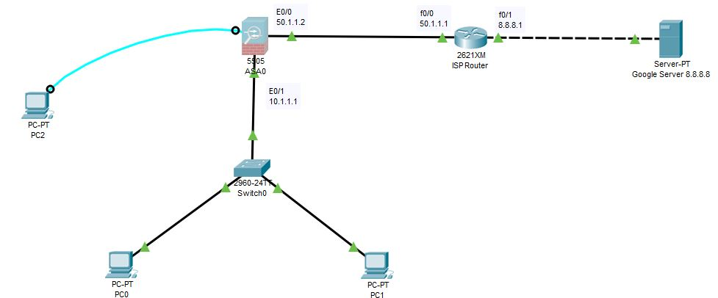

**ASA Firewall Configurations:**

* Go to the console of PC2 to access ASA Server using Terminal application.

**en**

**show running-config**

* By default DHCP is enabled we need to remove it

**conf t**

**no dhcpd address 192.168.1.5-192.168.1.36 inside**

**exit**

**show running-config** (Now there is no dhcp configuration).

* Now we need to remove default VLAN IP address and set it to our environment

**conf t**

**int vlan 1**

**ip add 10.1.1.1 255.0.0.0**

**no shut**

**nameif inside**

**security-level 100** (inside)

**exit**

**int e0/1**

**switchport access vlan 1**

**no shut**

**exit**

**int vlan 2**

**ip add 50.1.1.2 255.0.0.0**

**no shut**

**nameif outside**

**security-level 0** (outside)

**exit**

**int e0/0**

**switchport access vlan 2**

**exit**

* Configuring DHCP and DNS ASA Server so that PC inside network go IP Adddress dynamically:
* Go to the console of PC2 to access ASA Server terminal using Terminal.

**conf t**

**dhcpd address 10.1.1.10-10.1.1.30 inside**

**dhcpd dns 8.8.8.8 interface inside**

* Configuring Default Route on ASA:

**route outside 0.0.0.0 0.0.0.0 50.1.1.1**

**Router Configurations**:

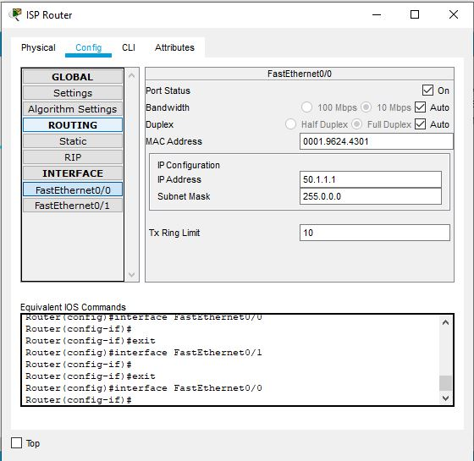

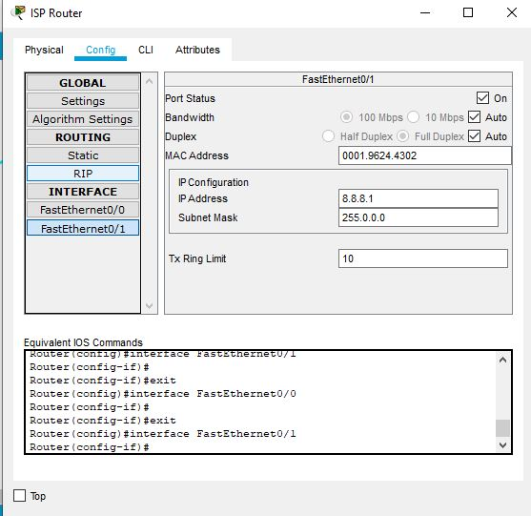

* Configuring OSPF Routeing Protocol:
* Go to CLI of router:

**Conf t**

**router ospf 1**

**net 50.0.0.0 0.255.255.255 area 0**

**net 8.0.0.0 0.255.255.255 area 0**

**Google Server Configurations:**

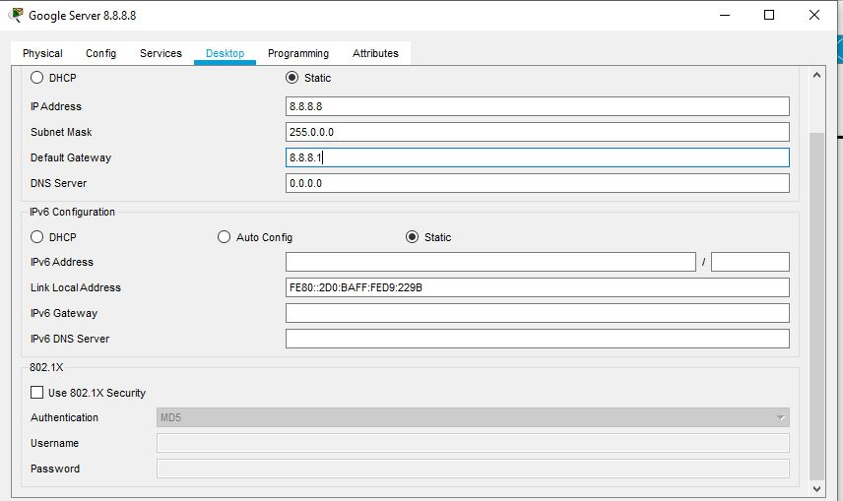

**Assigning IP address to PC0 and PC1:**

* Enable DHCP on PC1 and PC2

**Create object Network & Enable NAT on ASA:**

* Before do this pass a packet from PC0 to Google Server it should fail
* Go to the console of PC2 to access ASA Server using Terminal application.

**object network ?**

**object network LAN (any Name)**

**subnet 10.0.0.0 255.0.0.0**

**nat ?**

**nat (inside, outside) dynamic interface**

* Now pass a packet from PC0 to Google Server it should fail
* Open CLI of BOTh PCS and ping -t 8.8.8.8 it should fail and minimize

**Create ACL on ASA:**

* Go to the console of PC2 to access ASA Server using Terminal application.

**Conf t**

**access-list maherules (general name) ?**

**access-list maherules (general name) extended permit tcp any any**

**access-list maherules (general name) extended permit icmp any any**

**access-group maherules ?**

**access-group maherules in interface outside**

* (now check the CLI of both PCs we will see ping responses)

**On ASA terminal:**

**show nat**

**show xlate**

* You should be able to see the NAP/PAT translations