**Scenario 3: Understanding the Configuration and Working of Bridge/Link Layer Switch connecting multiple Network (Across many LAB)**

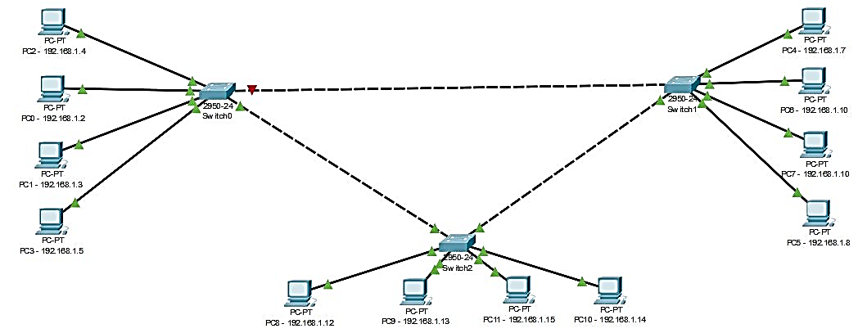

* Assign IP Address and Subnet Mask as shown in the figure.
* Send Simple PDU within the Network and Across the Network.