**Lab 1: 2D Unity Game – Space Explorer**

**Unity version: 6000.0.32f1**

**A. Game Concept**

Space Explorer is a 2D space-themed game where the player controls a spaceship, navigating through space while avoiding asteroids and collecting stars to enhance their shooting ability.

**B. Game Elements**

**1. Spaceship (Player)**

1.1 Description: A 2D spaceship that the player controls.

1.2 Functionality:

Change the spaceship type using the right mouse button.

Move in all directions using the arrow keys.

Shoot **fireballs** to destroy obstacles using the left mouse button.

* Form 1: Shoot red fireballs
* Form 2: Shoot blue fire balls

Collect **Balls** to upgrade **fireballs**.

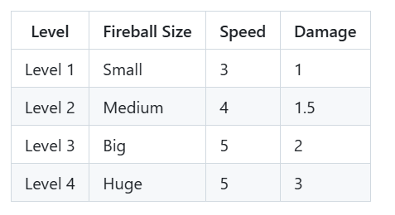

**2. Asteroids**

2.1 Description:

* Floating 2D asteroids appearing randomly in space.
* Asteroid have 5 types with different HP:
* Type 1 - Type 4: random HP from 3 - 6
* Type 5: have 7 HP
* Asteroid after destroyed by bullet will have explosion effect

2.2 Functionality:

* Creating challenges for player
* If an asteroid collides with the spaceship, the game will end.
* Move unpredictably within the scene.
* If the spaceship collides with an asteroid, the game ends.

**3. Balls (Item Drop)**

3.1 Description: Collectible 2D balls scattered throughout space. Spawn every 30s. Comes in 2 forms, blue and red.

3.2 Functionality:

* Increase the player's shooting power when collected.
* Enhance the gameplay experience by rewarding exploration.

**C. Game Flow**

**1. Main Menu Scene**

* Play Button: Starts the game and transitions to the Gameplay Scene.
* Exit Button: Closes the game.

**2. Gameplay Scene**

2.1 Game Elements

* Spaceship (player).
* Asteroids (obstacles).
* Balls (collectibles).

2.2 Objective

* Navigate the spaceship while avoiding asteroids.
* Collect balls to improve shooting abilities.
* The game ends when the spaceship collides with an asteroid.

2.3 UI Elements

* Score display to track the player's progress.

**3. End Game Scene**

* Displays the player's final score.
* Provides options to:
* Return to Main Menu: Restart the game.
* Quit the Game: Exit the application.