**Lab 1: 2D Unity Game – Space Explorer**

**Unity version: 6000.0.32f1**

**A. Game Concept**

Space Explorer is a 2D space-themed game where the player controls a spaceship, navigating through space while avoiding asteroids and collecting stars to enhance their shooting ability.

**B. Game Elements**

**1. Spaceship (Player)**

1.1 Description: A 2D spaceship that the player controls.

1.2 Functionality:

1. Change the spaceship type using the right mouse button.
2. Move in all directions using the arrow keys.
3. Shoot **fireballs** to destroy obstacles using the left mouse button.

* Form 1: Shoot red fireballs
* Form 2: Shoot blue fire balls

1. Collect **Balls** to upgrade **fireballs**.

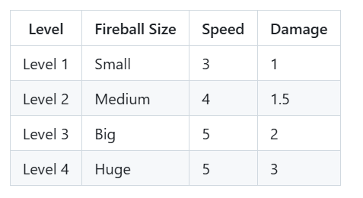

**2. Asteroids**

2.1 Description:

* Floating 2D asteroids appearing randomly in space.
* Asteroid have 4 types with random HP between 3 and 6:
* One of the asteroids is larger, rewarding 2 points when destroyed.
* The remaining asteroids each grant 1 point upon destruction.
* When an asteroid is destroyed by a bullet, it triggers an explosion effect.

2.2 Functionality:

* Creating challenges for player
* If an asteroid collides with the spaceship, the game will end.
* Some asteroids appear unpredictably within the scene, some of them even move to follow the plane to make the game more challenging.
* If the spaceship collides with an asteroid, the game ends.

2.3 Level Progression:

* Asteroid speed increases over time, making them harder to avoid.
* The spawn rate of asteroids increases, reducing reaction time for players.
* Larger asteroids may appear more frequently at higher levels.
* Players must adapt to faster-moving threats and react quickly to survive longer.

**3. Balls (Item Drop)**

3.1 Description: Collectible 2D balls scattered throughout space. Spawn every 30s. Comes in 2 forms, blue and red.

3.2 Functionality:

* Increase the player's shooting power when collected.
* Enhance the gameplay experience by rewarding exploration.

**4. Stars (Item Drop)**

4.1 Description: Collectible 2D stars scattered throughout space. Spawn every 10s.

4.2 Functionality: Increase the player's point power when collected (10 points).

**C. Game Flow**

**1. Main Menu Scene**

* Play Button: Starts the game and transitions to the Gameplay Scene.
* Help Button: Guid for player.
* Exit Button: Closes the game.

**2. Gameplay Scene**

2.1 Game Elements

* Spaceship (player).
* Asteroids (obstacles).
* Balls (collectibles).
* Stars (collectibles)

2.2 Objective

* Navigate the spaceship while avoiding asteroids.
* Collect balls to improve shooting abilities.
* Collect stars to get scores
* The game ends when the spaceship collides with an asteroid.

2.3 UI Elements

* Score display to track the player's progress.

**3. End Game Scene**

* Displays the player's final score.
* Provides options to:
* Return to Main Menu: Restart the game.
* Quit the Game: Exit the application.