Calibrated Refusal for Enterprise Retrieval-Augmented Generation over Conflicting Procedures
Anonymous Author(s)
Affiliation and e-mail omitted for double-blind review
Keywords: Retrieval-Augmented Generation, Refusal, Enterprise Search, Document Conflict, BM25.
Abstract: Workplace retrieval-augmented generation systems answer operational questions from an intranet of procedures. When that intranet contains a current rule, a superseded copy, and marketing text that disagrees with both, a ranker that returns a lexically relevant document is not yet a safe answerer. This paper treats refusal as a first-class system action. We specify three inspectable policies on top of a BM25 retriever: always answer from the rank-1 record, refuse when extracted slot values in the top-3 disagree, and prefer a record marked current when one is retrieved. The policies are tested on an 18-document constructed retailer corpus and six desk queries covering factoid lookup, conflict, staleness, missing scope, customer wording, and repair. No language model wording is sampled and no user study is invented. Always answering from rank-1 is wrong on 4 of 6 tasks, including a 30-day refund window and a 15% restocking fee that are no longer in force. Conflict-based refusal produces 0 wrong answers but over-refuses when a governing value is recoverable. Preferring the current record recovers the 14-day window and the 8% fee and still refuses an international warranty that the corpus does not license. The result is a small, reproducible refusal gate for enterprise RAG, not a new neural architecture.

1 INTRODUCTION
Enterprise assistants that retrieve internal procedures and then generate an answer are now a standard applied-IT pattern [1]. The usual evaluation asks whether the generated sentence is faithful to the retrieved text. That test is incomplete when the retrieved set itself disagrees. A superseded standard operating procedure can outrank the current one because the two files repeat the same terms. Marketing copy can outrank a governing rule because it mentions the customer and the refund. In those cases a fluent answer is a wrong business action.
This paper asks a narrower systems question than answer quality. When should a workplace RAG stack refuse to state a number? We keep the generator out of the loop on purpose. The object of study is the gate that sits on retrieved things: extract a slot, test for conflict, and either emit a value or refuse. Three policies are compared on the same ranking. The contribution is an inspectable refusal design and a corpus-level measurement, not a claim about employee trust or about large-language-model wording.
A running example makes the failure concrete. The current refund procedure says 14 calendar days. A superseded copy still says 30. The public website still says 30. A worker types what is the refund window for an unopened item. BM25 returns the superseded file first because unopened, refund, and days occur in both texts. A stack that speaks rank-1 tells the worker 30 days. That sentence is lexically grounded and operationally false. Refusal is the action that stops that sentence before a customer hears it.
The rest of the paper is organized as follows. Section 2 reviews retrieval-augmented generation and abstention. Section 3 describes the corpus, the slot extractor, and the three policies. Section 4 reports retrieval and refusal outcomes. Section 5 discusses implications and limits. Section 6 concludes.

2 RELATED WORK
This section separates two lines of work that are often collapsed in enterprise demos: retrieving passages for generation, and deciding not to answer.

2.1 Retrieval-Augmented Generation
Lewis et al. introduced retrieval-augmented generation as a way to condition a parametric model on non-parametric memory [1]. Dense retrievers such as DPR [5] and fusion-in-decoder architectures [6] improved open-domain question answering on Wikipedia-scale collections. Later surveys document the spread of RAG into assistants that cite internal files [8]. Retrieval also reduces some classes of conversational hallucination [4]. Those results assume that a relevant passage is close to a correct passage. Workplace intranets violate that assumption: relevance and currency are different properties.
BM25 remains a strong and inspectable lexical baseline [2]. We use it so that a reviewer can see why a superseded file wins: it repeats the query terms. Nothing in the refusal policies requires BM25. A dense index can be swapped without changing the slot tests.

2.2 Refusal and Abstention
Self-RAG trains a model to retrieve on demand and to critique its own generations with reflection tokens [3]. Language models can also report uncertainty about their own answers [7]. Those methods operate on generated text. They do not, by themselves, encode the institutional fact that two retrieved procedures disagree on a refund window. Corrective and iterative RAG rewrite the query when the first set looks weak [9], [10]. Black-box retrieval wrappers and hallucination corpora make the same point from the generator side [11], [12]. That is useful when the right document is missing from the top-k. It is the wrong move when the right document and the wrong document are both present and the wrong one is ranked first.
The gap we address is therefore small and applied. Enterprise RAG needs a gate that can refuse a number because the retrieved things conflict, not only because the generator is unsure. The gate should be readable by an auditor.

3 METHOD
The method has four parts: a constructed intranet, six desk queries, a lexical retriever with a slot extractor, and three refusal policies. Figure 1 shows the pipeline. The generator is omitted so that wording effects do not hide ranking and conflict.
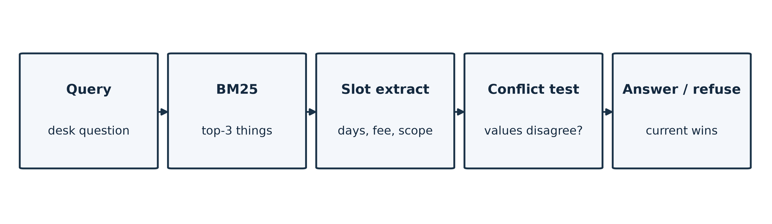
Figure 1: Refusal gate on top of BM25 retrieval and slot extraction.

3.1 Corpus and Tasks
A live company corpus cannot be published and would mix unknown missing files into the measurement. The evaluation fixture is an 18-record English intranet for a fictional retailer, Northline Parcels. The set is written so that four situations exist as files, not only as story: a current 14-day refund rule, a superseded 30-day rule, public marketing copy that still promises 30 days, and a domestic warranty that forbids quoting an international period. Table 1 lists the records that instantiate those situations.
Table 1: Records that instantiate conflict, staleness, and missing scope.
Record | Status | Slot
SOP-REFUND- UNOPENED-v3 | Current, 1 Mar 2026 | 14 days
SOP-REFUND- UNOPENED-v2 | Superseded, 1 Jun 2024 | 30 days
POLICY-WEB-RETURNS | Marketing, 12 Nov 2025 | 30 days
PRICE-LIST-2026 / 2024 | Current 8% / old 15% | Restock fee
SOP-WARRANTY-DOMESTIC | Domestic only | No intl. number
CHANGELOG-REFUNDS | 1 Mar 2026 | 30 days withdrawn

Six queries force six actions a desk system must get right. T1 asks for the unopened refund window. T2 asks whether a day-20 return is allowed. T3 asks for the restocking fee on an opened unused return. T4 asks for an international warranty period. T5 asks for one customer-facing sentence about the day-20 case. T6 asks whether a 30-day answer is still correct. Gold values are taken from the current governing record: 14 days, 14 days, 8%, refuse, 14 days, and 14 days.

3.2 Retriever and Slot Extraction
Ranking uses BM25 with k1 = 1.5 and b = 0.75 [2]. For each query the top-3 records are kept. A regular-expression extractor then reads days, restocking percentages, a superseded flag, a current flag, and an explicit ban on quoting an international warranty. Mentions that sit next to previous, from, or withdrawn are ignored so that a current file that names the old 30-day window is not read as a 30-day rule. The extractor is deterministic. The same rules are published with the corpus.

3.3 Refusal Policies
Three policies consume the same top-3 extract. Always rank-1 emits the slot value of the first record, or 12 months when the first record is the domestic warranty. Conflict refuse emits REFUSE when the distinct extracted values for the asked slot in the top-3 are more than one, or when the query asks for an international warranty. Current override first looks for a record marked current in that top-3 and emits its value; if none is found it falls back to conflict refuse. No policy averages 14 and 30.

3.4 Evaluation Metrics
We score four outcomes. A correct answer is a predicted number that equals the gold slot. A wrong answer is a predicted number that does not. A correct refuse is REFUSE on T4. A false refuse is REFUSE on a task whose gold is a number. Safe means not wrong: a correct answer, a correct refuse, or a false refuse. False refuse is safe for a desk because it sends the worker to a human instead of a withdrawn number. It is still a cost, which is why we report it separately.

4 RESULTS
Results are reported in two layers. The first layer is what BM25 actually returns. The second layer is what each policy does with that set. Table 2 summarizes both.
Table 2: Policy outcomes on six desk queries. Gold is the current governing value or REFUSE.
Task | Gold | Rank-1 | Conflict refuse | Current override
T1 Factoid | 14 | 30 wrong | REFUSE | 14 correct
T2 Conflict | 14 | 30 wrong | REFUSE | 14 correct
T3 Stale fee | 8 | 15 wrong | REFUSE | 8 correct
T4 Missing | REFUSE | 12 wrong | REFUSE correct | REFUSE correct
T5 Inform | 14 | 14 correct | 14 correct | 14 correct
T6 Repair | 14 | 14 correct | REFUSE | 14 correct

4.1 Retrieval Evidence
On T1 the superseded 30-day procedure is ranked first and the current 14-day procedure is second. On T2 the marketing page that promises 30 days is ranked first and the governing procedure is third. On T3 the 2024 price list that charges 15% is ranked first and the 2026 list that charges 8% is second. Figure 2 plots those extracted numbers against the governing value. Rank-1 is not a rare error on this corpus. It is the default lexical winner when the old file is a close paraphrase of the new file.
T4 is different. The only warranty record is domestic and tells staff not to quote a period for a foreign address. It is ranked first. Absence here is a retrieved refusal instruction, not an empty index. T5 and T6 show that query wording can already surface the current procedure or the changelog. That is why a rank-1 baseline is not wrong on every task. It is wrong on the ordinary ones.
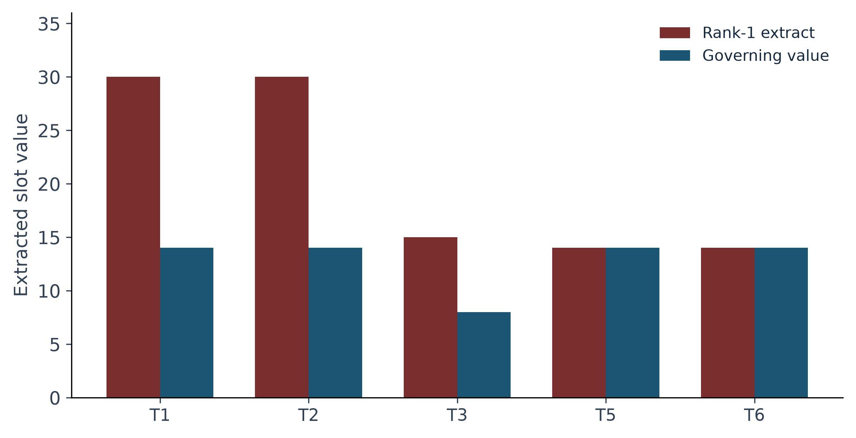
Figure 2: Rank-1 extracted slot versus the governing value. T4 is omitted because gold is REFUSE.

4.2 Refusal Outcomes
Always answering from rank-1 is wrong on 4 of 6 tasks. The wrong numbers are exactly the ones a desk must not say: 30 days, 30 days again, 15%, and a 12-month international warranty. Conflict refuse produces 0 wrong answers. It refuses T1, T2, T3, and T6 because 14 and 30, or 8 and 15, both appear in the top-3, and it correctly refuses T4. The cost is over-refusal: T1, T3, and T6 have a recoverable governing value. Current override recovers those values and still refuses T4. Figure 3 compares the wrong-answer counts.
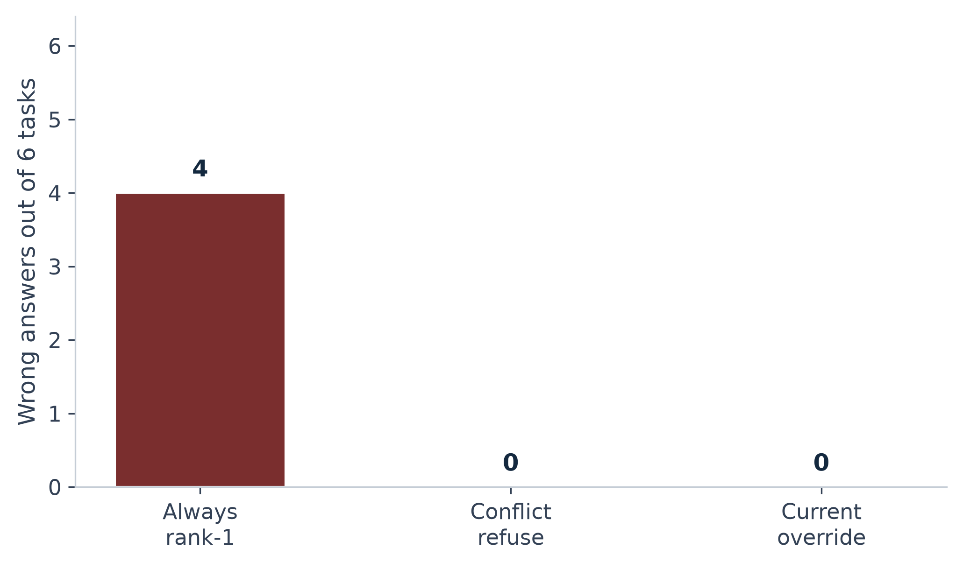
Figure 3: Wrong answers out of six tasks for the three policies.
Counted that way, always rank-1 is safe on 2 of 6 tasks and wrong on 4. Conflict refuse is safe on all 6 and wrong on 0, with 4 false refuses. Current override is safe on all 6, wrong on 0, and false-refuses only T4, which is the intended refuse. The interesting comparison is therefore not accuracy against a generator. It is wrong-answer rate against an inspectable gate.
Task by task, the mechanism is visible. T1 is a near-paraphrase fight: v2 and v3 share the same lexical frame, so BM25 cannot see effective date. Conflict refuse sees 30 and 14 and stops. Current override reads the replaces line on v3 and emits 14. T2 is institutional rather than temporal: marketing copy is supposed to be friendlier than the desk rule. Rank-1 follows the public page. Current override ignores that page because it is not marked current. T3 repeats T1 for a percentage. T4 is the only task whose gold is REFUSE; both refusal policies get it and the rank-1 baseline does not. T5 already retrieves v3 first, so all three policies emit 14. T6 retrieves the changelog first; a last-number read of that file already yields 14, which is why rank-1 is correct there, but the same changelog still contains 30, so conflict refuse over-fires until the current file is preferred.
The current-override policy is not magic. It works because the corpus marks currency in the file: a replaces line, a 2026 price-list name, or an explicit SUPERSEDED stamp. A company that never marks those fields cannot run this gate. That is an information-organization requirement, not a model requirement.

5 DISCUSSION
The measurement supports a practical design rule. Do not emit a slot from rank-1 when the top-k contains more than one value for that slot, unless a record in that set is marked current. The rule is cheap, auditable, and independent of the generator. It also shows why accuracy-only RAG scores mislead: a system that always talks can look useful while stating a withdrawn 30-day window.

5.1 Implications
Three implementation implications follow. First, dates and version status must be first-class fields in the snippet, not characters buried in a filename. Second, when two retrieved things disagree on days or percent, the interface should refuse or show both; it should not average them. Third, changelogs should stay retrievable, because they are the repair cue on T6. None of these is a new neural architecture.

5.2 Limitations
The policies are also a specification for a later language-model stage. A generator can be added on top of current override without changing the gold labels. The generator would then be allowed to write a sentence only when the gate emits a number, and would be required to produce a refusal plus the conflicting snippets when the gate emits REFUSE. That experiment is future work. It is not reported here because an extra sampler would add an uncontrolled source of wording to a paper whose claim is about the gate.
The corpus is fictional and English-only. Eighteen documents are enough to instantiate the conflicts and small enough to audit by hand; they are not a company. BM25 is one retriever. A dense or hybrid ranker might promote the current file more often; that is an open measurement. No language-model wording is reported, so fluency effects are out of scope. No employees were observed. Anyone citing this paper as a user study would be mis-citing it. The work is also distinct from an information-behavior analysis of the same fixture: here the unit of evaluation is the system action, not the worker's knowledge state. Reuse of the constructed files does not make the two papers the same claim.

5.3 Threats to Validity
Construct validity depends on the slot extractor. A missed 30-day hyphen or a withdrawn window read as current would change Table 2. We publish the extractor with the corpus so that threat can be audited. Internal validity is limited by the designed conflicts: we planted a 14-versus-30 pair and then measured whether the policies see it. External validity is limited to English SOP-like prose. The paper does not claim that every intranet will rank a superseded file first. It claims that when that ranking happens, a current-override gate is a cheap and testable response.

6 CONCLUSION
Enterprise RAG fails in a boring way: the first retrieved thing is often the old thing. A gate that always speaks that thing is wrong on the ordinary refund and fee questions in this fixture. A gate that refuses when extracted slots disagree stops the wrong numbers and then over-refuses. Preferring a record marked current recovers the governing 14-day window and the 8% fee and still refuses an unlicensed international warranty. The next useful measurement is the same gate on a dense index and, separately, on recorded desk sessions. This paper stops at the inspectable policies and the corpus walkthrough.

References
- [1] P. Lewis, E. Perez, A. Piktus, F. Petroni, V. Karpukhin, N. Goyal, H. Küttler, M. Lewis, W. Yih, T. Rocktäschel, S. Riedel, and D. Kiela, “Retrieval-augmented generation for knowledge-intensive NLP tasks,” in Advances in Neural Information Processing Systems, vol. 33, 2020, pp. 9459–9474.
- [2] S. Robertson and H. Zaragoza, “The probabilistic relevance framework: BM25 and beyond,” Foundations and Trends in Information Retrieval, vol. 3, no. 4, pp. 333–389, 2009, doi: 10.1561/1500000019.
- [3] A. Asai, Z. Wu, Y. Wang, A. Sil, and H. Hajishirzi, “Self-RAG: Learning to retrieve, generate, and critique through self-reflection,” in Proc. International Conference on Learning Representations, 2024, doi: 10.48550/arXiv.2310.11511.
- [4] K. Shuster, S. Poff, M. Chen, D. Kiela, and J. Weston, “Retrieval augmentation reduces hallucination in conversation,” in Findings of the Association for Computational Linguistics: EMNLP 2021, 2021, pp. 3784–3803, doi: 10.18653/v1/2021.findings-emnlp.320.
- [5] V. Karpukhin, B. Oğuz, S. Min, P. Lewis, L. Wu, S. Edunov, D. Chen, and W. Yih, “Dense passage retrieval for open-domain question answering,” in Proc. Conference on Empirical Methods in Natural Language Processing, 2020, pp. 6769–6781, doi: 10.18653/v1/2020.emnlp-main.550.
- [6] G. Izacard and E. Grave, “Leveraging passage retrieval with generative models for open domain question answering,” in Proc. Conference of the European Chapter of the Association for Computational Linguistics, 2021, pp. 874–880, doi: 10.18653/v1/2021.eacl-main.74.
- [7] S. Kadavath et al., “Language models (mostly) know what they know,” arXiv preprint, 2022, doi: 10.48550/arXiv.2207.05221.
- [8] Y. Gao, Y. Xiong, X. Gao, K. Jia, J. Pan, Y. Bi, Y. Dai, J. Sun, M. Wang, and H. Wang, “Retrieval-augmented generation for large language models: A survey,” arXiv preprint, 2023, doi: 10.48550/arXiv.2312.10997.
- [9] Z. Jiang, F. F. Xu, L. Gao, Z. Sun, Q. Liu, J. Dwivedi-Yu, Y. Yang, J. Callan, and G. Neubig, “Active retrieval augmented generation,” in Proc. Conference on Empirical Methods in Natural Language Processing, 2023, pp. 7969–7992, doi: 10.18653/v1/2023.emnlp-main.495.
- [10] S.-Q. Yan, J.-C. Gu, Y. Zhu, and Z.-H. Ling, “Corrective retrieval augmented generation,” arXiv preprint, 2024, doi: 10.48550/arXiv.2401.15884.
- [11] W. Shi, S. Min, M. Yasunaga, M. Seo, R. James, M. Lewis, L. Zettlemoyer, and W. Yih, “REPLUG: Retrieval-augmented black-box language models,” in Proc. Conference of the North American Chapter of the Association for Computational Linguistics, 2024, pp. 8371–8384, doi: 10.18653/v1/2024.naacl-long.463.
- [12] C. Niu, Y. Wu, J. Zhu, S. Xu, K. Shum, R. Zhong, J. Song, and T. Zhang, “RAGTruth: A hallucination corpus for developing trustworthy retrieval-augmented language models,” in Proc. Annual Meeting of the Association for Computational Linguistics, 2024, pp. 10862–10878, doi: 10.18653/v1/2024.acl-long.585.

