1. Given the provided data, what are three conclusions we can draw about Kickstarter campaigns?
   * Plays have a highest number of projects submitted and also have the highest number of projects successful in raising fund at successful rate 65% vs average successful rate 53%. However, some sub-categories have successful rate 100% such as film/documentary, music/rock, technology/hardware…)

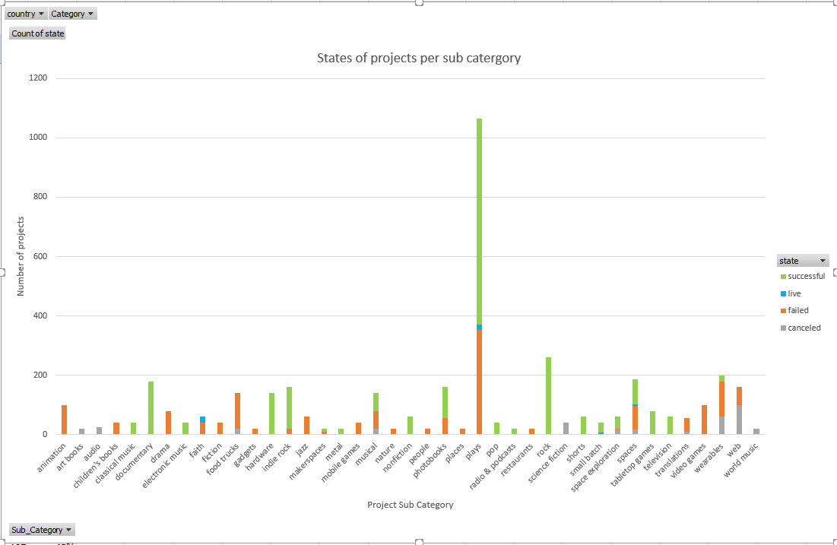

* + Successful projects in Hardware get the highest fund and highest number of backers in US

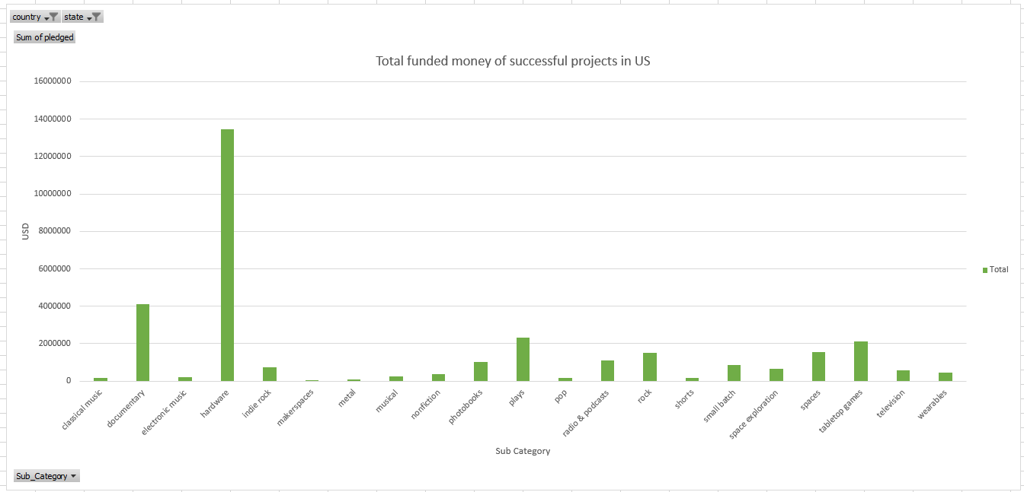

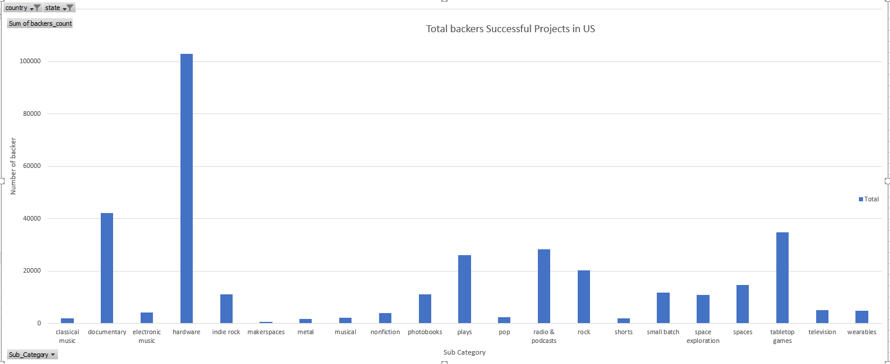

* + “Staff pick” projects has higher chance to succeed (87%) than none Staff pick projects (48%)

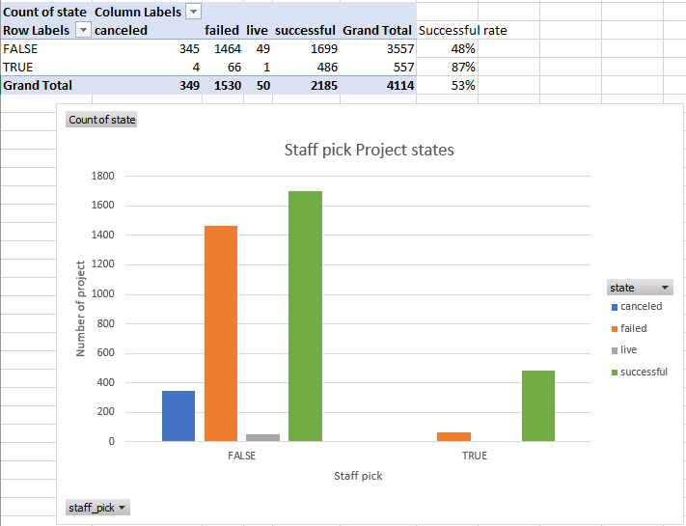

1. What are some limitations of this dataset?
   * Because of different currency, we can’t aggregate the goal/pledged value directly from this dataset across the countries. We need to create an additional conversion column to a single currency if we wish to do so.
   * We don’t know the reason why the project successful or failed even though they are the same category/sub-category.
   * Data for 2009 and 2017 were not full year. 2009 data started from May, and 2017 data ended in March.
2. What are some other possible tables and/or graphs that we could create?
   * Create the graph country vs state and see most of the projects is from US

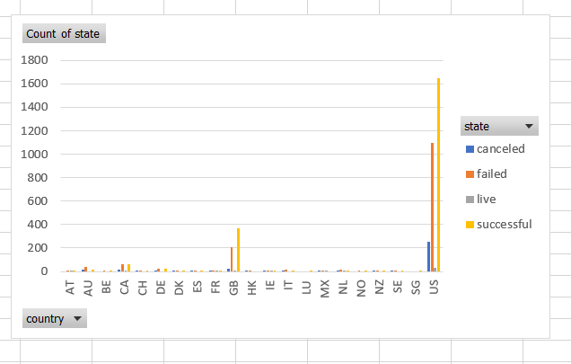

* + Create the graph category/sub category vs pledged to see which area got most of the fund filter by country. (technology got highest of the fund in US)

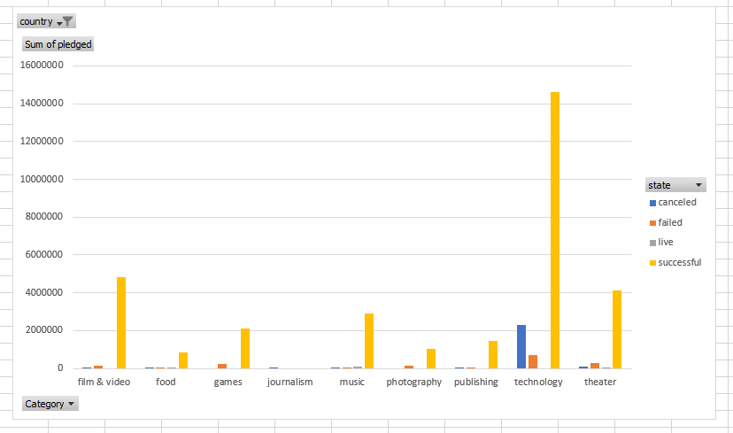

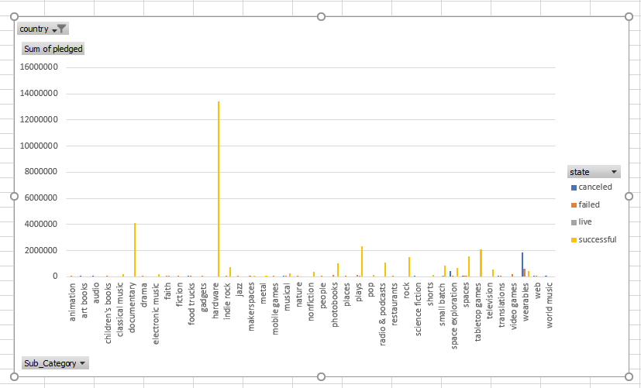

* + Create a chart showing number of projects over years to see the trend of using Kickstarter (2015 has highest number of projects submitted)

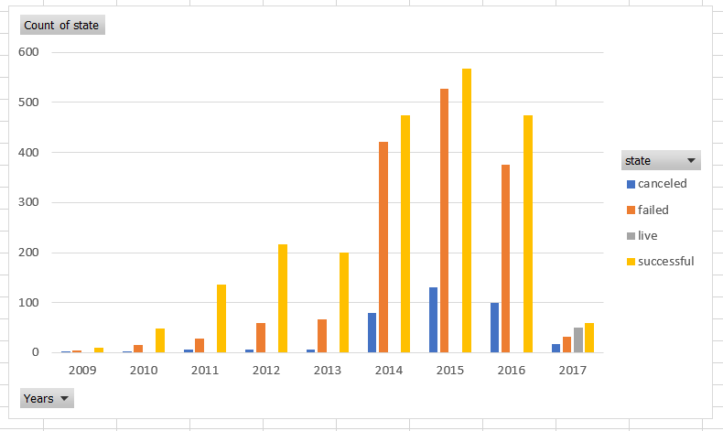

* + Average donation for a successful project in US over years (80-100 USD)

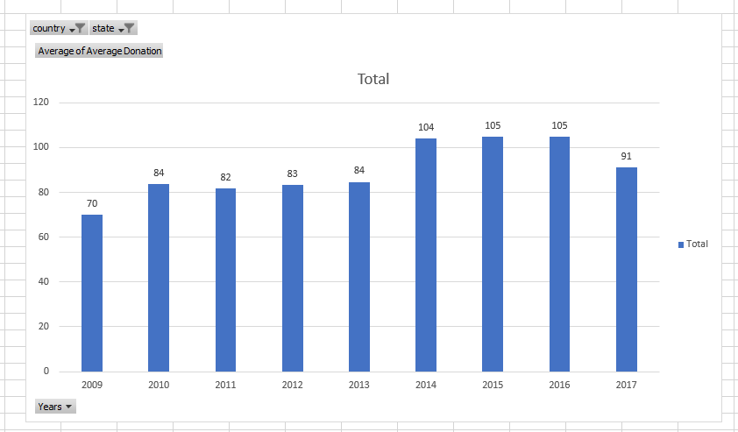

* + Average donation for a successful project per category (technology has highest average donation ~164 USD)

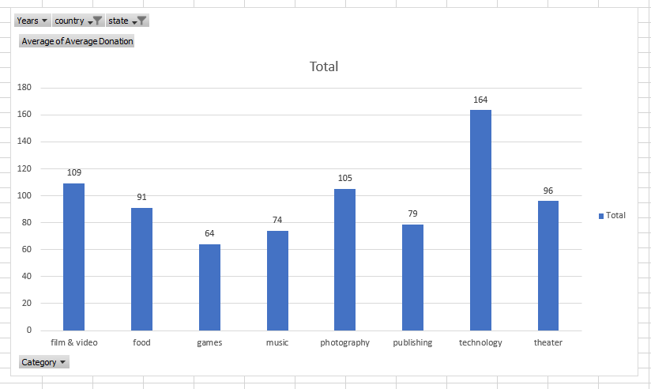

* + Number of backers per category (Technology get most of the attention as it has highest number backer)

