##### <Manager>Create Project

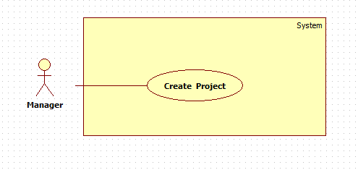

Figure : <Manager>Create **Project**

|  |  |  |  |
| --- | --- | --- | --- |
| **USE CASE – UC002** | | | |
| **Use Case No.** | UC001 | **Use Case Version** | 1.0 |
| **Use Case Name** | Create Project | | |
| **Author** | Trần Thị Kim Anh | | |
| **Date** | 20-05-2015 | **Priority** | Normal |
| **Actor:**   * Manager   **Summary:**   * This use case is about notify manager of create new project for member..   **Goal:**   * New Project is created.   **Triggers:**  Manager chooses “Project” on Menu bar, then choose “Create”.  **Preconditions**:   * Log into the system with Manager role.   **Post Conditions:**   * **Success**: New content of new project are created. * **Fail**: System shows error message.   **Main Success Scenario:**   |  |  |  | | --- | --- | --- | | Step | Actor Action | System Response | | 1 | Manager chooses “Project” on Menu bar, then chooses “Create” | System shows new window contains:   * “Project Name”: textbox * “Project Description”: textbox * “Start date”: date picker, require * “End date”: date picker, require * “Assignee”: textbox * “Create”: button * “Cancel”: button | | 2 | Manager inputs requested data |  | | 3 | Manager clicks “Create” button | System closes current window and shows new window contains:   * Information of new project (name, description, time…) * “Create”: button * “Cancel”: button   [Exception 1, 2, 3] |   **Alternative Scenario:**   |  |  |  | | --- | --- | --- | | No | Actor Action | System Response | | 1 | Manager clicks “Cancel” button. | System auto come-back Home page. |   **Exceptions:**   |  |  |  | | --- | --- | --- | | No | Actor Action | System Response | | 1 | Project name is exist. | System shows message “This project name is exist.” | | 2 | Assignee A is busy | System shows message “A is joining another project.” | | 3 | Don’t fill information but click “Create” button. | System shows message “Please fill all Information.” |   **Relationships**: N/A  **Business Rules:** | | | |

Table : <Manager>Create Project

##### <Manager>Assign Project

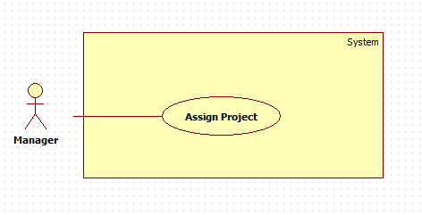

Figure : <Manager>Assign **Project**

|  |  |  |  |
| --- | --- | --- | --- |
| **USE CASE – UC002** | | | |
| **Use Case No.** | UC002 | **Use Case Version** | 1.0 |
| **Use Case Name** | Assign Project | | |
| **Author** | Trần Thị Kim Anh | | |
| **Date** | 20-05-2015 | **Priority** | Normal |
| **Actor:**   * Manager   **Summary:**   * This use case is about notify manager of assign project for member..   **Goal:**   * Assign member for project is successful.   **Triggers:**  Manager chooses “Project” on Menu bar, then choose “View”.  **Preconditions**:   * Log into the system with Manager role. * Project are not assigned for ay member.   **Post Conditions:**   * **Success**: Project has manager of project. * **Fail**: System shows error message.   **Main Success Scenario:**   |  |  |  | | --- | --- | --- | | Step | Actor Action | System Response | | 1 | Manager chooses “Project” on Menu bar, then choose “View” | System shows new window contains:   * Information of project (name, description, date. Status) * Assignee: textbox * “Update”: button * “Cancel”: button | | 2 | Manager inputs content in “assignee” part. |  | | 3 | Manager clicks “Update” button | System closes current window and shows new window contains:   * Information of new project (name, description, time…) * “Cancel”: button   [Exception 1, 2, 3] |   **Alternative Scenario:**   |  |  |  | | --- | --- | --- | | No | Actor Action | System Response | | 1 | Manager clicks “Cancel” button. | System auto come-back Home page. |   **Exceptions:**   |  |  |  | | --- | --- | --- | | No | Actor Action | System Response | | 1 | Assignee A is busy | System shows message “A is joining another project. Please input another name.” | | 2 |  |  | | 3 |  |  |   **Relationships**: N/A  **Business Rules:** | | | |

Table : <Manager>Assign Project