Table of Contents
1. Postgresql 2
1.1 Database 2
1.2 Entity relationship diagram 2
2. Communicate with order system 2
2.1 HTTP POST 3
2.1.1 Create new user 3
2.1.2 Create new product 3
2.1.3 Create new order 4
2.2 HTTP GET 5
2.2.1 Login 5
2.2.2 Get list of products: 6
2.2.3 Get list of order 7
2.3 HTTP PUT 7
2.3.1 Update products 8
2.3.2 Remove product 8
2.3.3 Update order 8

1. Postgresql

1.1 Database
We created dordersystem database on Postgresql by manually or script, refer to README.md.
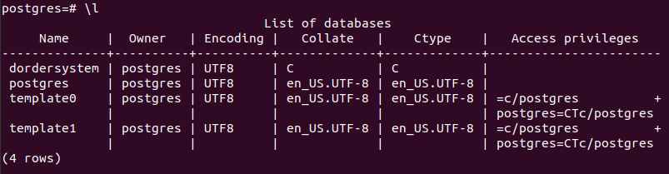

1.2 Entity relationship diagram
In dordersystem database, we have four tables: users, products, orders, orderproducts.
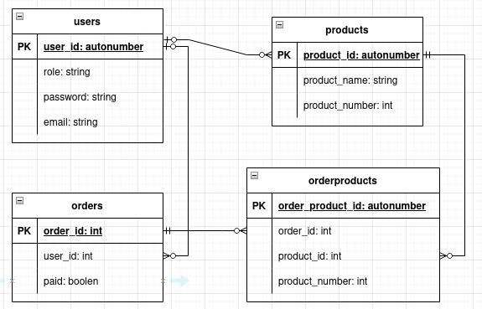
- users: to save account information. Except creating account, every other operations must require login successful. Role can be either “vendor” or “customer”.
- products: to consist of product’s inventory. Only vendor account can create new product, update product_name or product_number, delete product base on product_id.
- orders: to save overall order. Whenever a user creates an order, new order information will be save to orders table. order_id is time under Unixnano format, user_id is user creating order.
- orderproducts: to include detail product in each order. order_id is the order identification that ordered product belongs to.

2. Communicate with order system
The endpoints can be invoked using any REST client such as POSTMAN, etc. Order system supports HTTP GET/POST/PUT method.
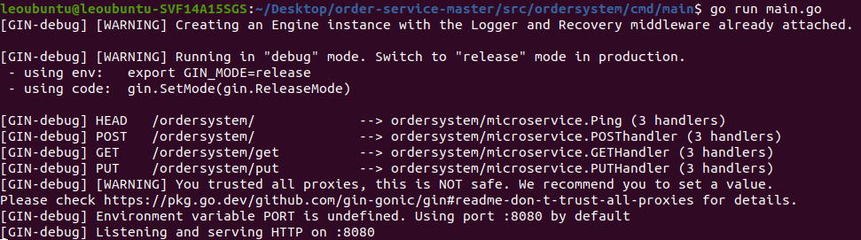

2.1 HTTP POST
We can use HTTP POST to create new user or new product.

2.1.1 Create new user
To create new user:
- url is http://localhost:8080/ordersystem/
- cmd is “new_user”
- other field like email, password, role. Role is either “vendor” or “customer”
We can not create new user if missing/invalid one of those field or email is already exist.
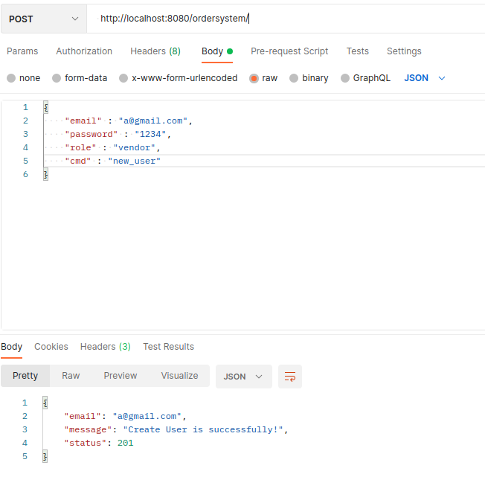
If creating new user is successful, we will get status 201 feedback. We can check it manually by show table users in Postgresql or by login using HTTP GET.
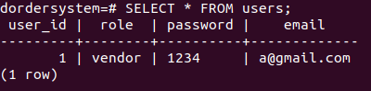

2.1.2 Create new product
To create new product:
- url is http://localhost:8080/ordersystem/
- email and password belong to vendor account. Only vendor account can create new products.
- cmd is “new_product”
- product_name and product_number
Vendor account can’t create new product if missing/invalid one of those field.
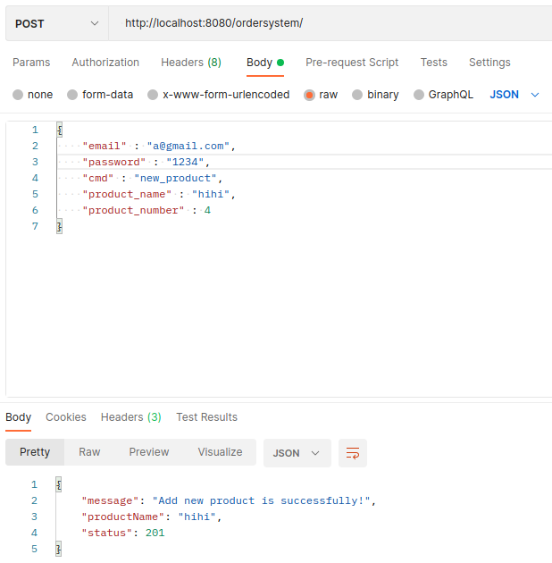
If we create new product successfully, we will get status 201 back. We can check in Postgresql by manually or HTTP GET get_product.

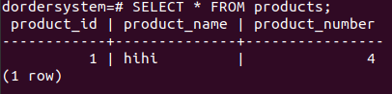
2.1.3 Create new order
To create new order, using:
- url: http://localhost:8080/ordersystem/
- valid email and password. Both vendor and customer can create order
- cmd: “new_order”
- products: list of products, includes product_id and product_number
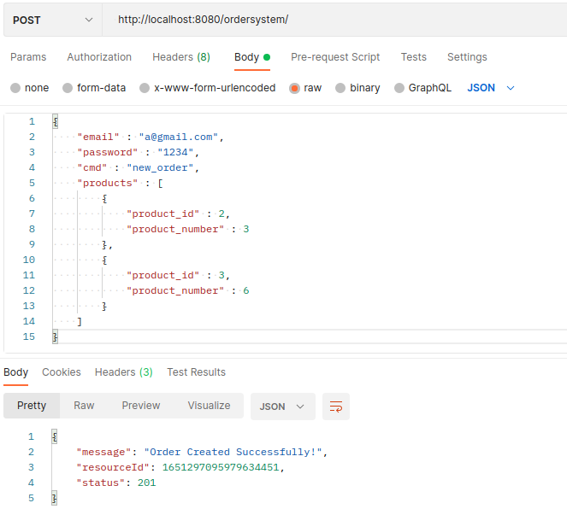
If we create new order successfully, order system will assign order_id bases on time under Unix nano format.
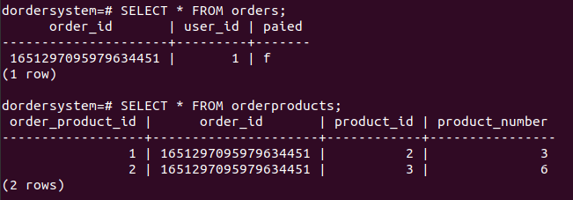

2.2 HTTP GET

2.2.1 Login
We can use HTTP GET to check if login is valid or not.
I just realize I should use POST to check login state instead of GET. But don’t worry, It’s just demonstration and I can update it later :(
To check account login, we use:
- url: http://localhost:8080/ordersystem/get?email=a@gmail.com&password=1234&cmd=login
- If we login successfully, we will get status 200 and all information about that account
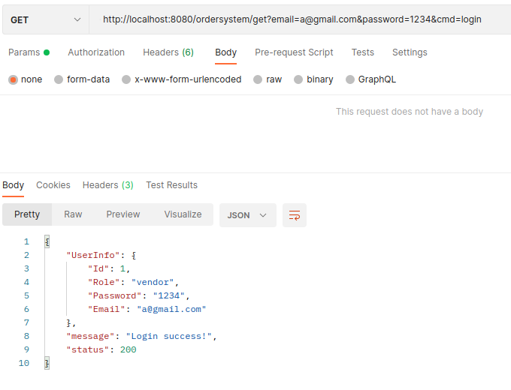
- If we login failed, we will get status 401 with the error (invalid email, password).

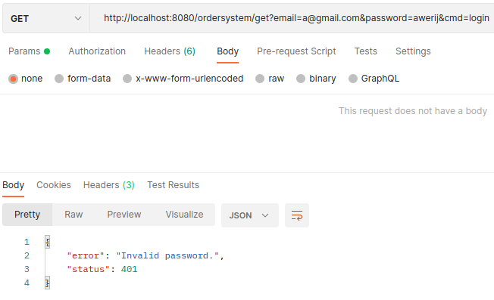
2.2.2 Get list of products:
We can get list of products by request to
- url: http://localhost:8080/ordersystem/get?email=a@gmail.com&password=1234&cmd=get_product
- cmd is “get_product”
If we use invalid account or invalid cmd, we won’t get list of products. Both vendor and customer can view it.

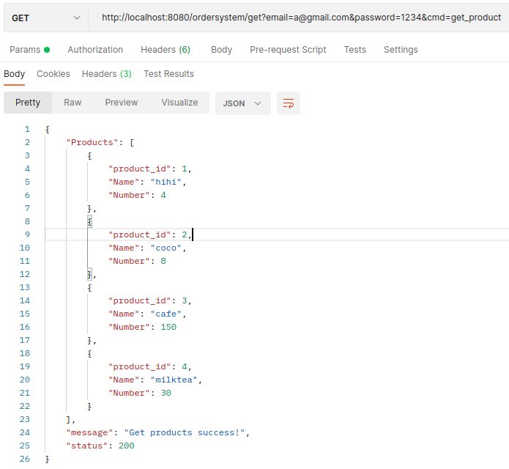
2.2.3 Get list of order
To get list of order, we first login by using our own account. Order system will return order of us.
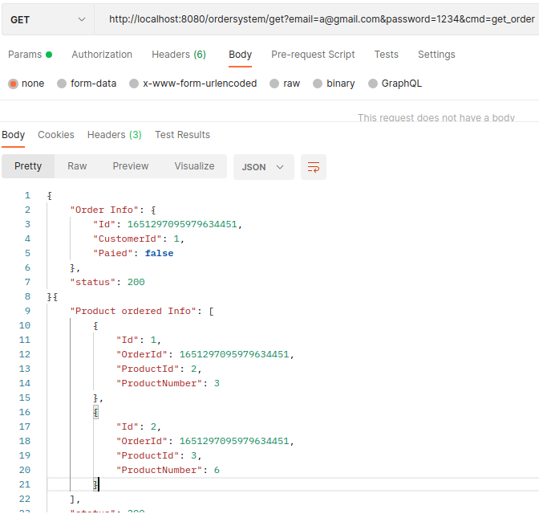

2.3 HTTP PUT
We use HTTP PUT to update/remove products or update the order.

2.3.1 Update products
Only vendor account can update products.
- url: http://localhost:8080/ordersystem/put?email=a@gmail.com&password=1234&cmd=update_product
- product_id: must have. Order system will base on product_id to update product_name or product_number.
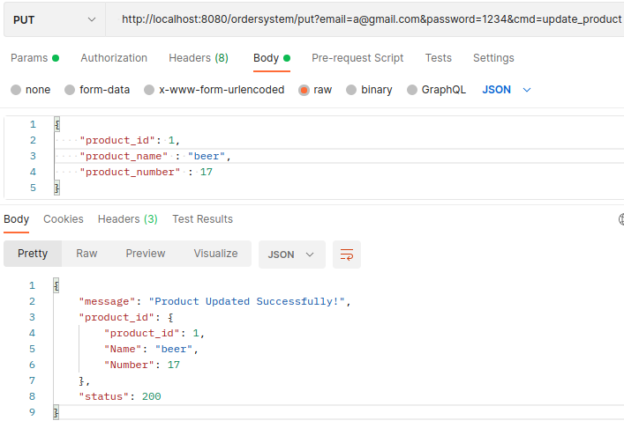
As we can see, product_id number 1 has product_name “hihi” and product_number “4”. After PUT operator, it changes.

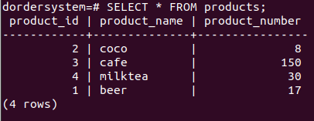
2.3.2 Remove product
The same as Update product, but we replace cmd to “remove_product”

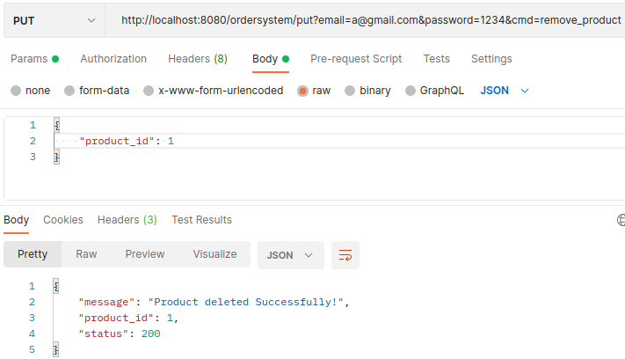
2.3.3 Update order
We have to mention order_id to update order
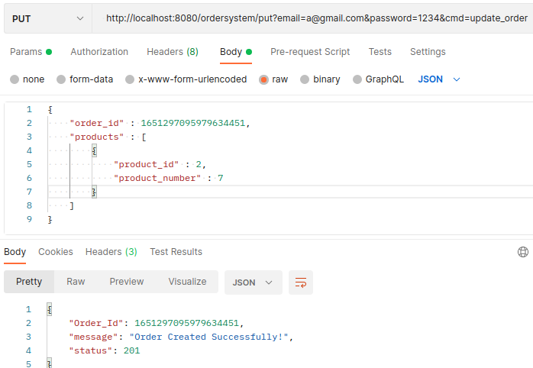
Here is updated order
