BÁO CÁO THỰC HÀNH LAB 1  
LẬP TRÌNH HƯỚNG ĐỐI TƯỢNG

# The Very First Java Programs

## *2.2.1* Write, compile the first Java application:

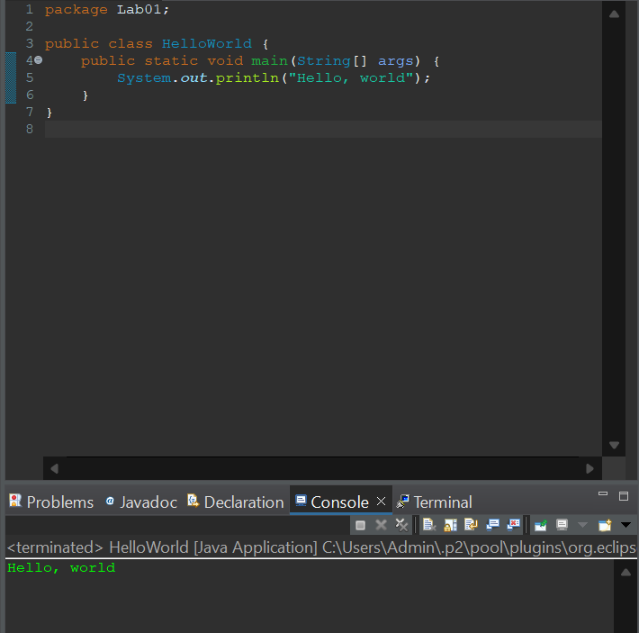

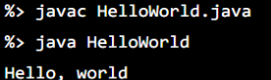

*Kết quả*

## *2.2.1* Write, compile the first Java application:

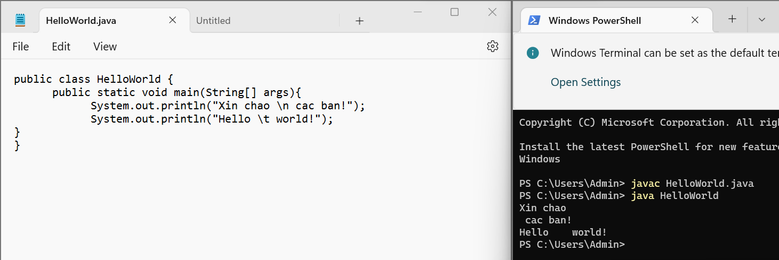

## 2.2.2 Write, compile the first dialog Java program

### 

## 2.2.3 Write, compile the first input dialog Java application

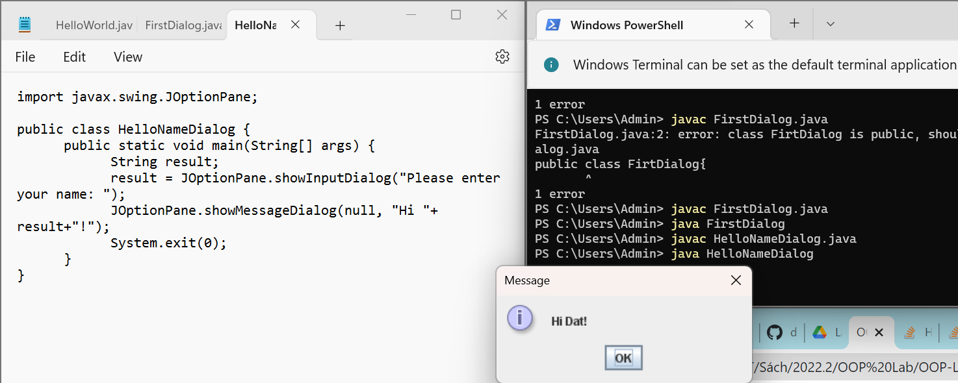

## 2.2.4 Write, compile, and run the following example:

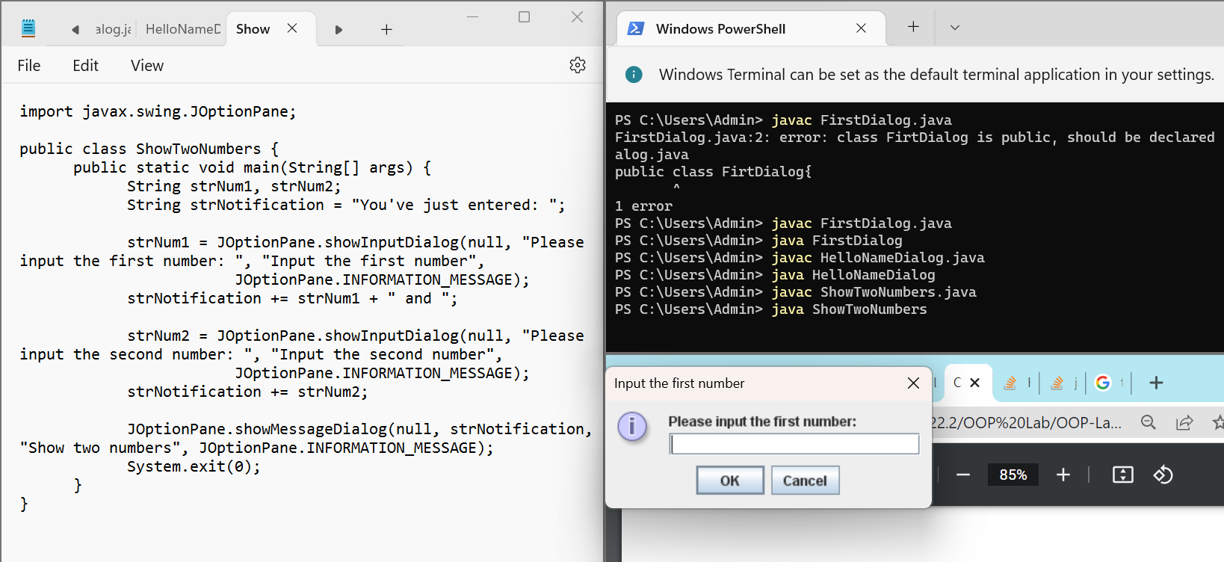

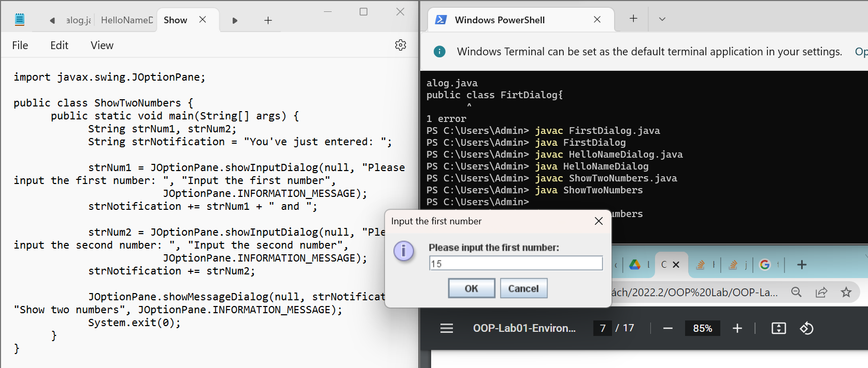

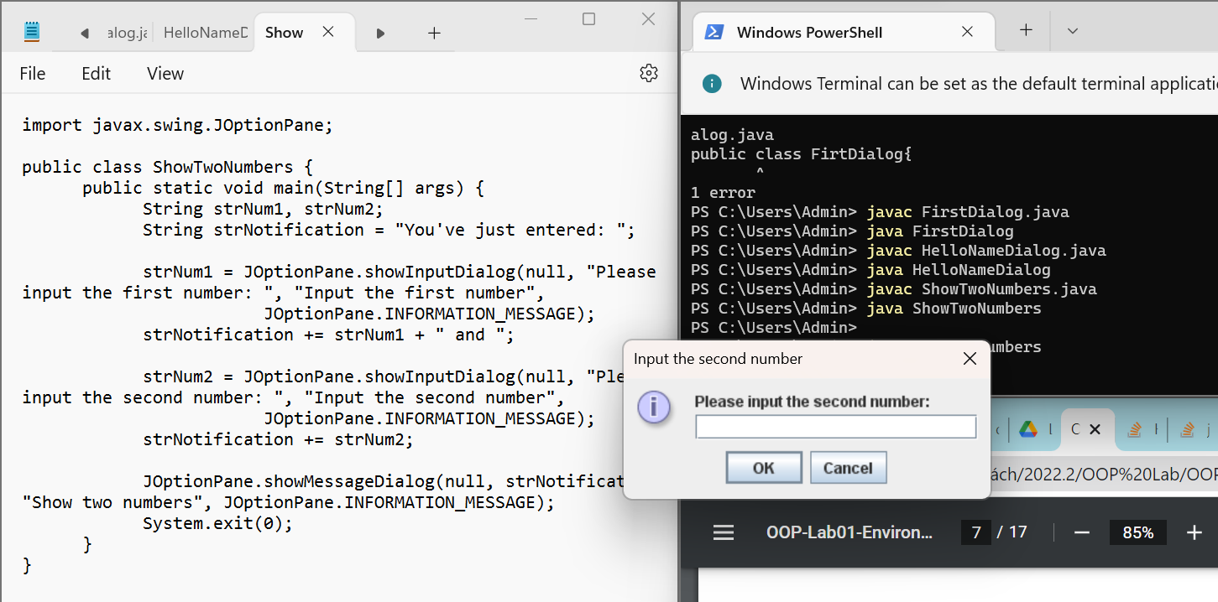

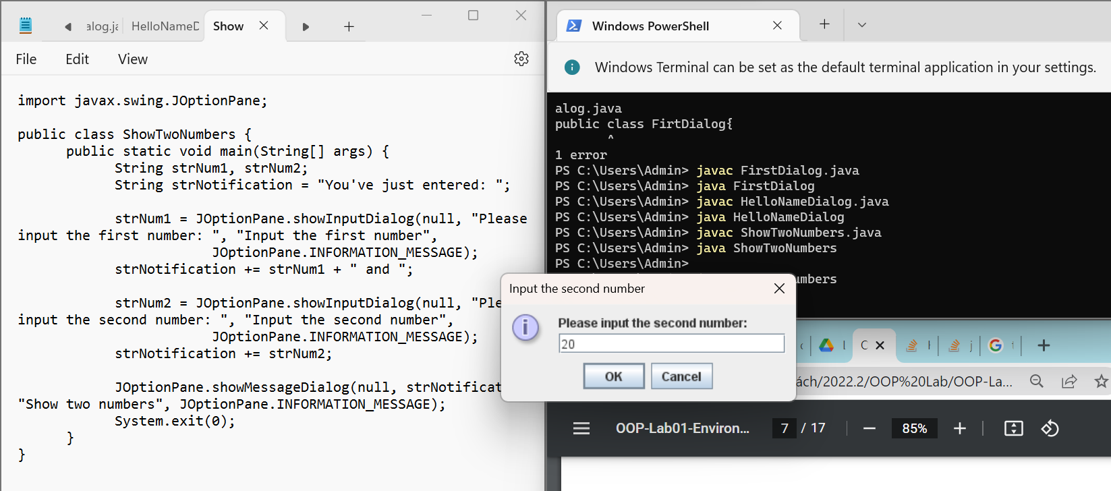

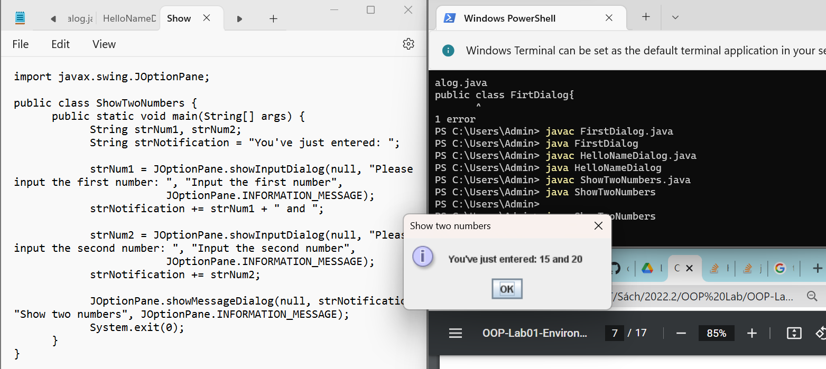

## 2.2.5 Write a program to calculate sum, difference, product, and quotient of 2 double numbers which are entered by users.

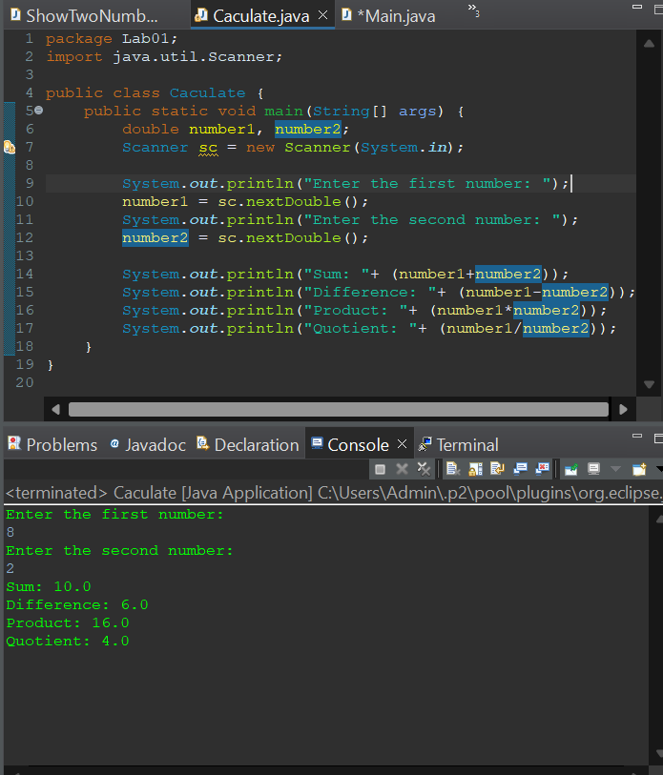

## 2.2.6 Write a program to solve

A,

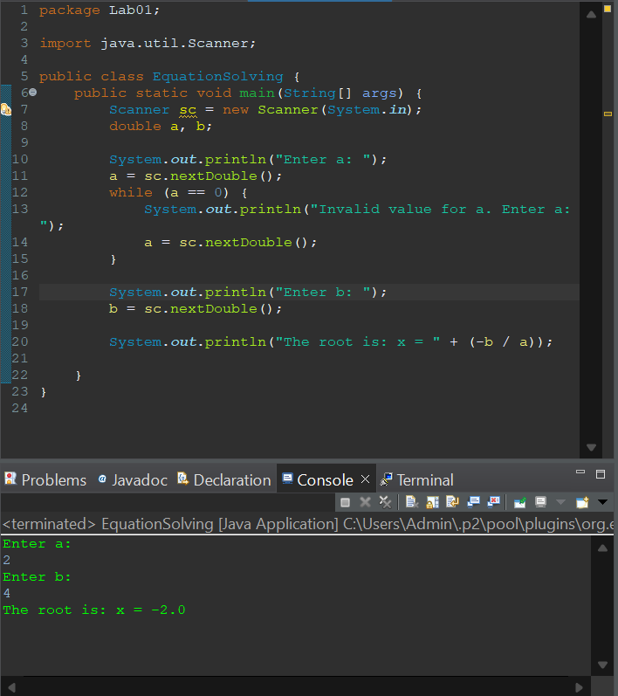

B,

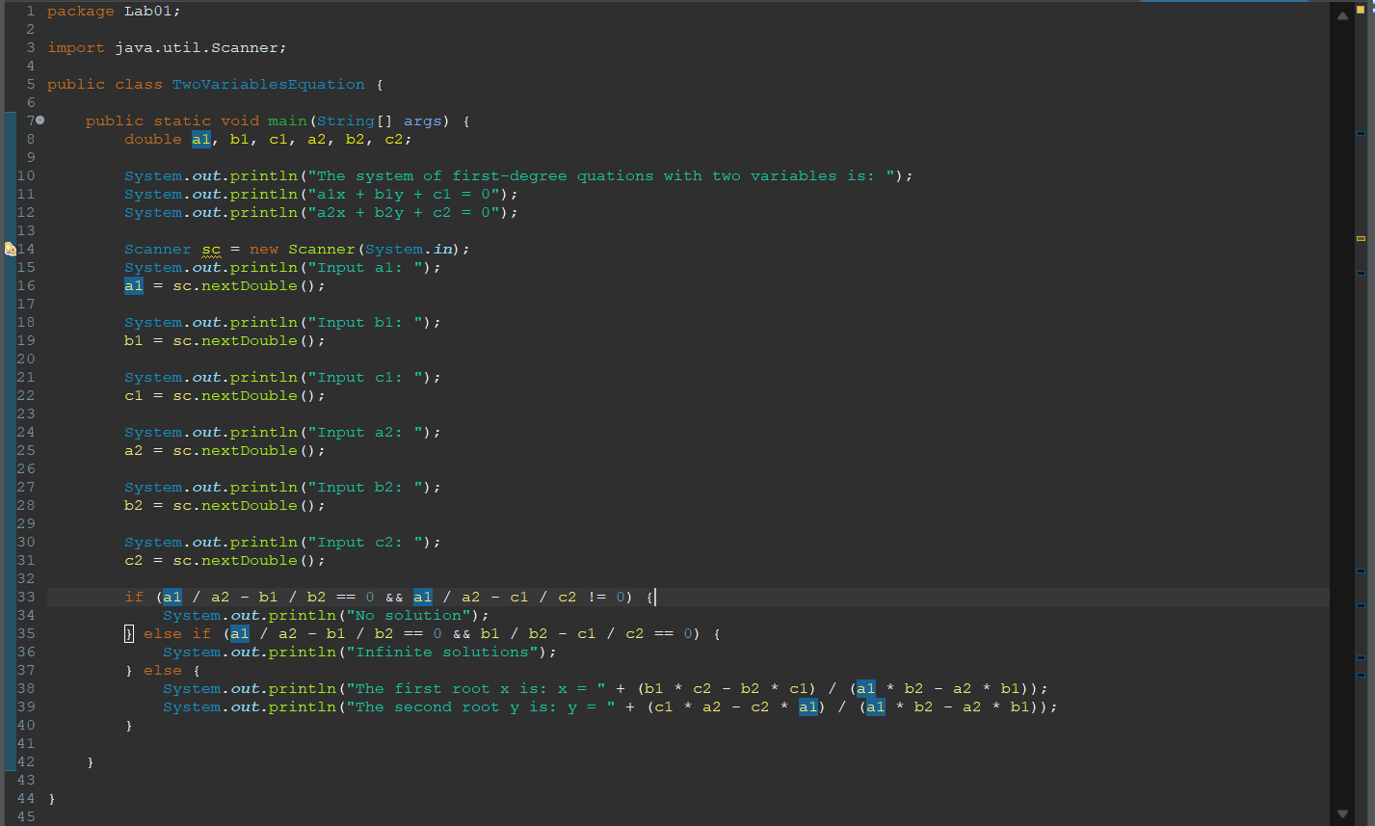

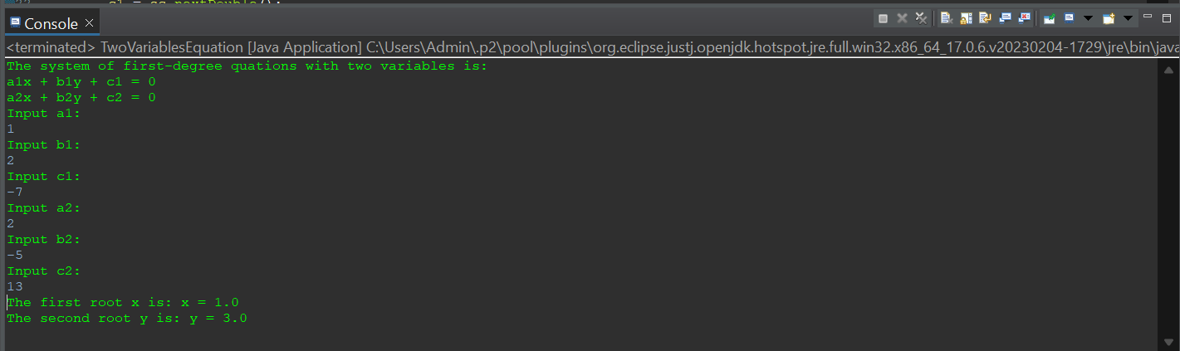

C,

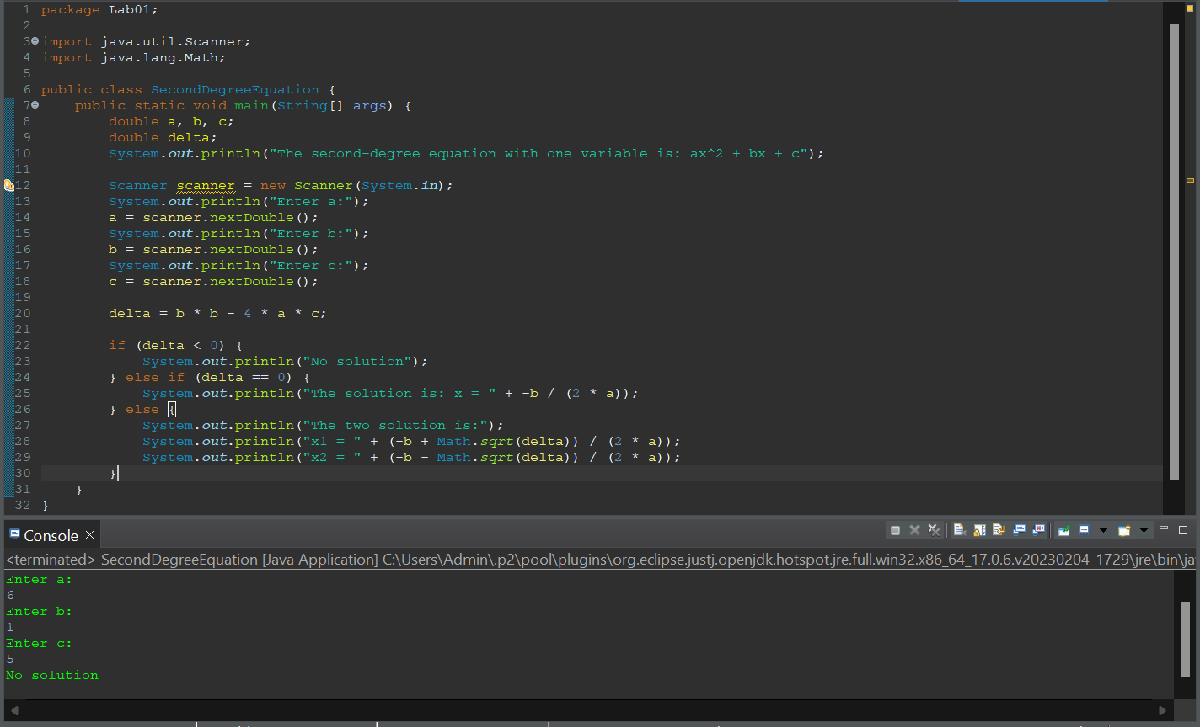

6. Exercise

6.1 Write, compile and run the ChoosingOption program:

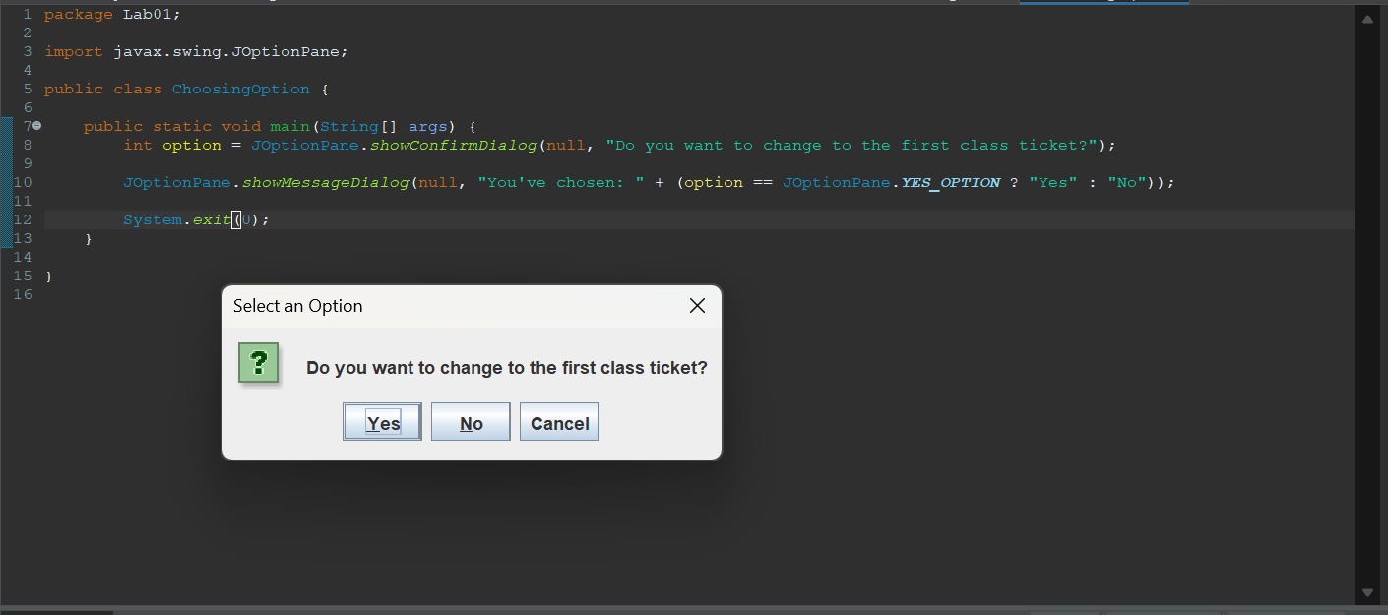

6.2 Write a program for input/output from keyboard

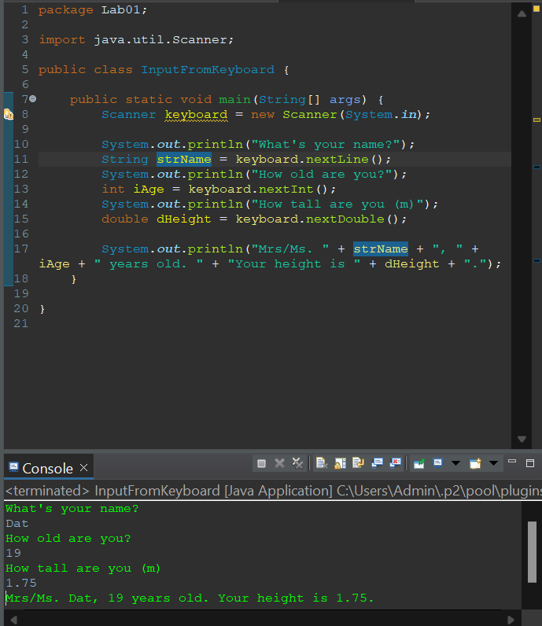

6.3 Write a program to display a triangle with a height of n stars (*), n is entered by users.

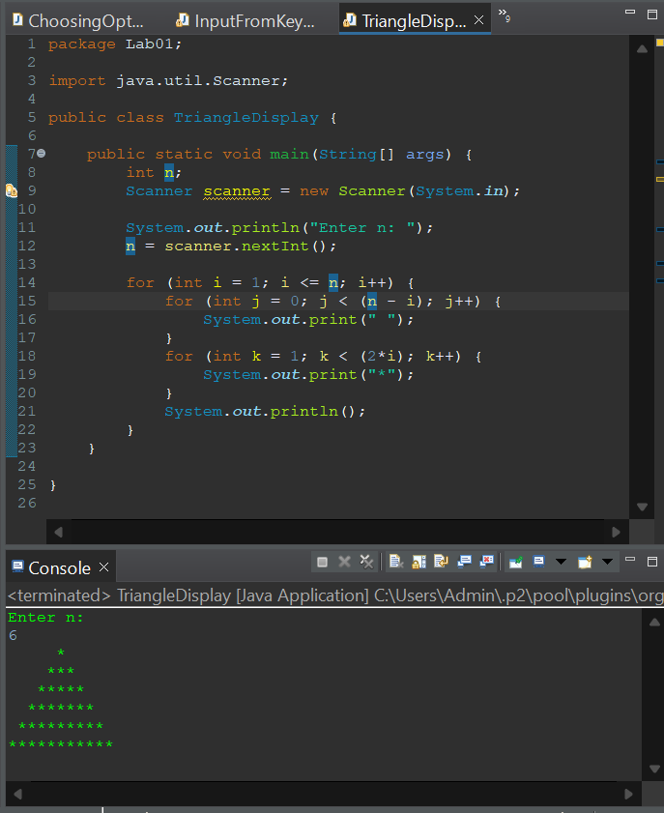

6.4 Write a program to display the number of days of a month, which is entered by users (both month and year). If it is an invalid month/year, ask the user to enter again.

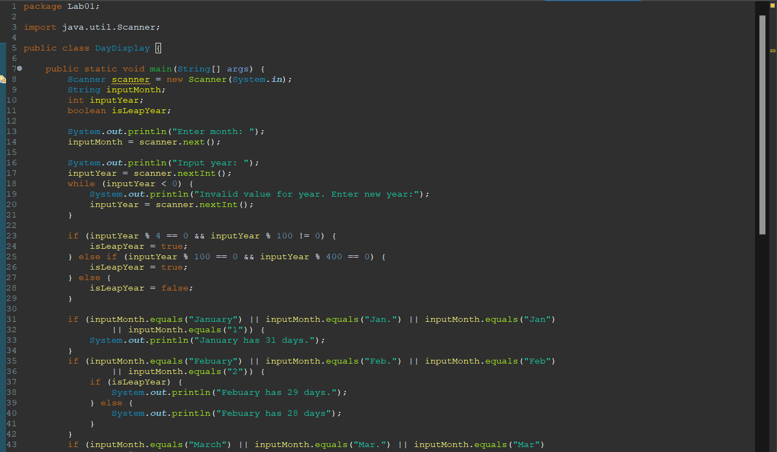

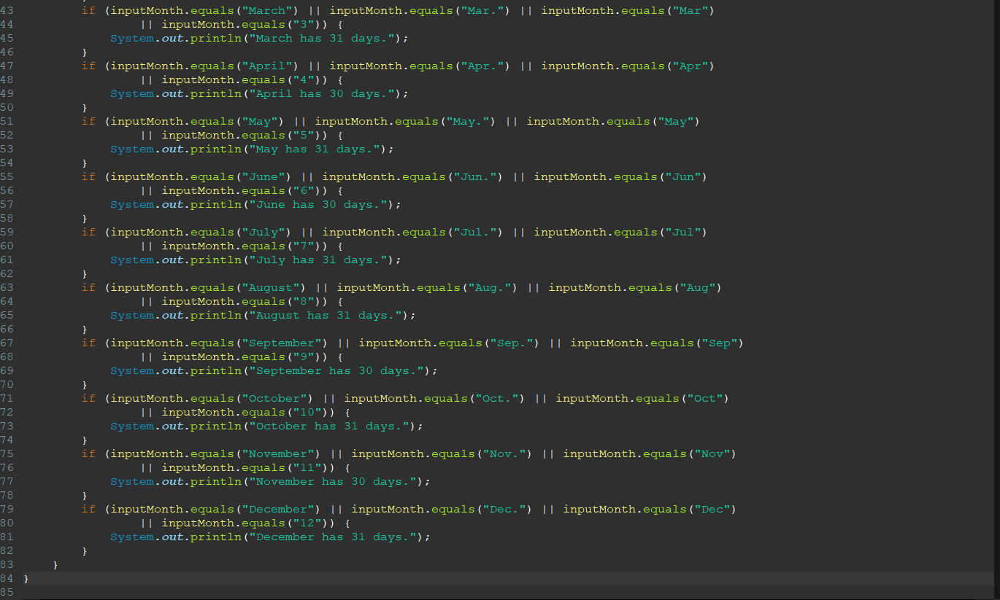

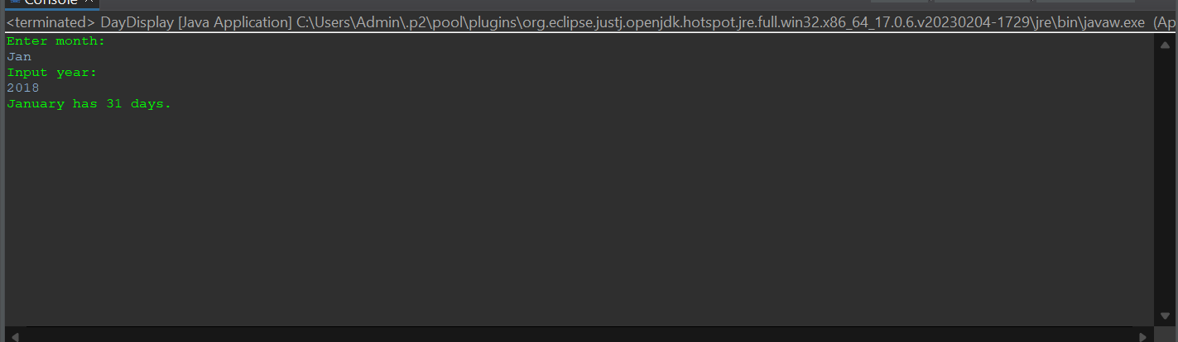

6.5 Write a Java program to sort a numeric array, and calculate the sum and average value of array elements.

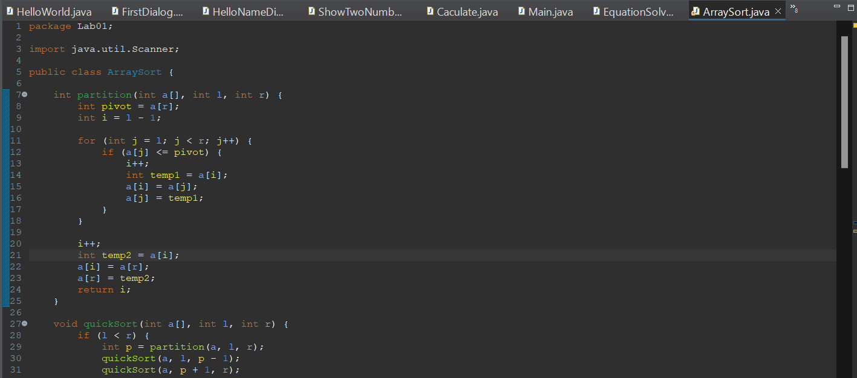

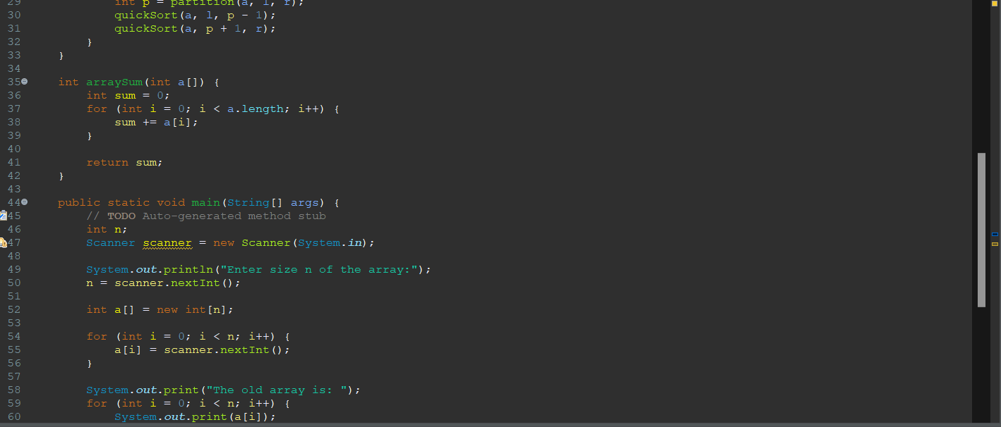

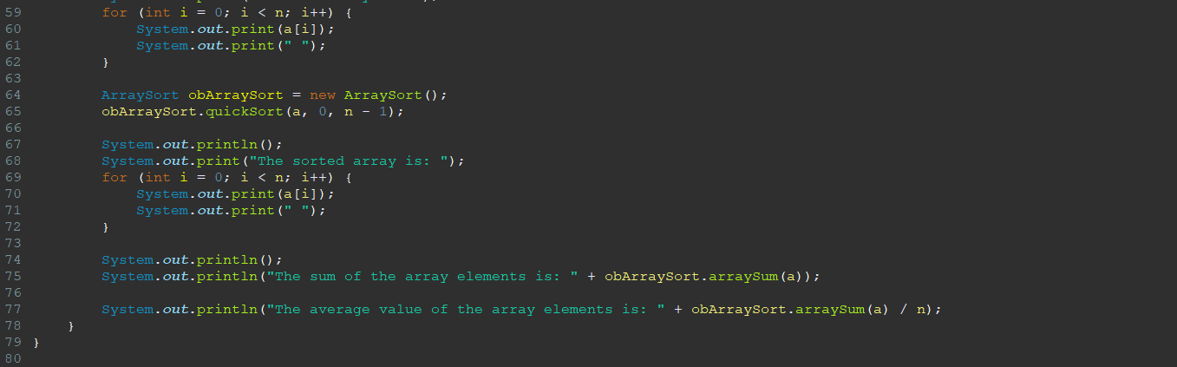

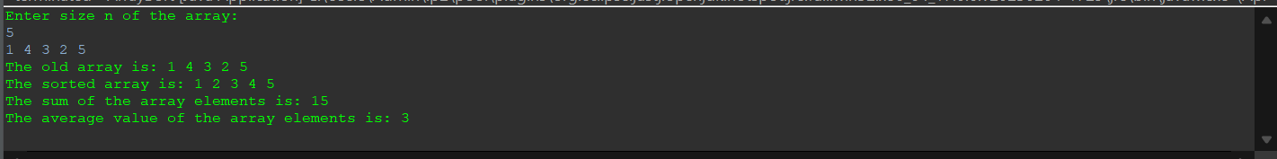

6.6 Write a Java program to add two matrices of the same size

