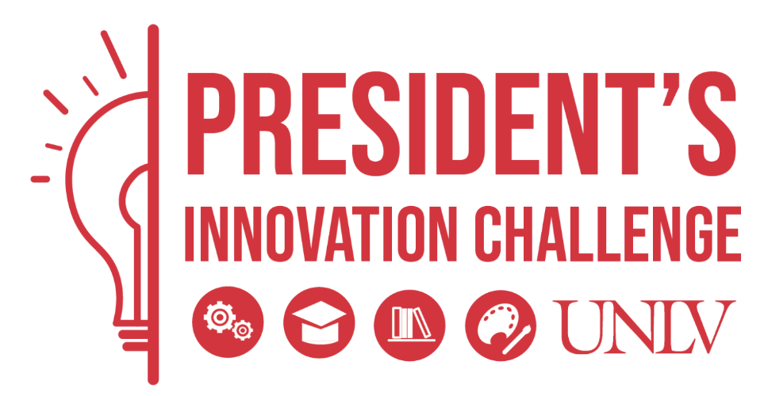

**President’s Innovation Challenge**

**Full Submission**

**April 17, 2023**

**Team Name: EMMA**

**Team Members: Alex Akoopie, Ronday Banks, Tan Nguyen, Amber To**

**Mentor(s): N/A**



**Full Submission Flow**

* Please use the outline below as your guide/submission flow
  + This document will be shared with the judges on Monday, April 17 so that they may have enough time to review it prior to your presentation on May 1.
  + Use this document to include details about your idea that you would not show to the general public or in your PowerPoint presentation. The flow/outline is the same as your slide deck, just more detailed
  + The judges that are reviewing your submission may or may not have expertise in your field, so we suggest you include drawings, artwork, photographs and detail that will allow them to get an understanding of your solution
* **1,500-word document is suggested, but a 2,000-word document is the maximum**
* Use Roboto, 12-point font

**Purpose/mantra**

**Team – leave for meeting**

* What are the strengths of your team?
* Why are you the team to solve this problem? – it has the potential to make impact to all UNLV or college students at large.

**Problem**

* Is the problem: big, urgent, frequent, costly to solve?
  + Big?: Whats the saving costs or monetary improvement?
  + Urgent?: how much UNLV care?
  + Frequent: peak hour twice or thrice a year
  + Costly?: How much time and money does it cost to implement?
    - Hardware:
      * Option 1 (on-site): nVIDIA A100 GPUs $10k/each
      * Option 2 (web service – not sure how to run): Google Colab ($50/mo), AWS SageMaker (~$80/mo). Both offer flexible pricing for scale deployment.
      * Option 3 (pretrained): Use a pretrained model and optimize its parameters for the domain-specific task at hand (enrollment).
    - Software development & maintenance:
      * 3 CS students?

**Solution**

* How does this relate to the sustainability problem statement?
  + Implementing a large language model (LLM) for an enrollment application has economic sustainability concerns. High resource usage often involves significant computational power, electricity, and storage space.
* How does your innovation solve the problem above & state your Value Proposition.
  + Value proposition connects your solution to your potential customers
    - Innovation can focus on optimizing the training process to reduce resource consumption which could involve iumprovements in algorithm efficiency. On the otherhand, we use a pretrained LLM to only fine-tune the outputs. This would be less accurate but it would address the sustainability concern.
* Have you researched alternative solutions in the market, why is your solution better?
  + Our solution ideally would be more cost-effective than alternative solutions on the market. All other solutions are geared towards more general-purpose LLMs rather than specifically targeting enrollment module management.
* Are there regulatory or legal obstacles with your strategy?
  + Data privacy and protection regulations, especially in educational settings, must be adhered to. There must be user consent to collect sensitive information such as grades, it must comply with privacy laws such as the Family Educational Rights and Privacy Act (FERPA), there must be data security, transparency, and accountability. Furthermore, it is of best interest to anonymize the process and aggregate the data to prevent privacy breach. It will most-likely be the case that user data will not be collected, but used to calculate an output.

**Describe your Proof of Concept or Prototype**

* How will you prove this works?
  + Design
    - Take conclusions from academic papers citing how successful students pass courses. Clearly outline features related to legal compliance and student needs.
  + Criteria
    - Arrange the points in the conclusions and use them as criteria for recommendation algorithm.
  + Measurement
    - Surveys, user feedback, or comparing results with a superior LLM (ChatGPT-4).
  + Results
    - An academic advisor for the department can confirm whether or not the results are an adequate match to what they would recommend. Then the student can follow the recommendation and enroll in their classes.
  + Analysis and Discussion
    - If the enrollment module manager is promising enough, it can automatically enroll students who are too shy to put the effort into enrolling for classes. This automation will increase funding for the college by making sure students always pay their tuition and enroll efficiently into the best courses possible for their major.

**Scaling**

* + How will you go-to market? And how will you scale after that market entry?
    - If EMMA is successful for UNLV engineering department, then it can be scaled to other departments and other universities as a whole. At most, EMMA can be scaled to all academic institutions. Perhaps K-12 will have a slightly alternative model to account for the fact that a full spectrum of students are forced to attend those institutions (account for slow learner, etc). Going to market will be difficult if we have to get consent from every institution. It would be easier to build a web application that anyone can use anywhere, similar to rate my professor.

**Commitment**

* Are you ready and willing to take this to the next step?

**References**

**Appendix**