JNDI (Java Naming Directory Interface)

connection pool　là gì

clean install ->để build

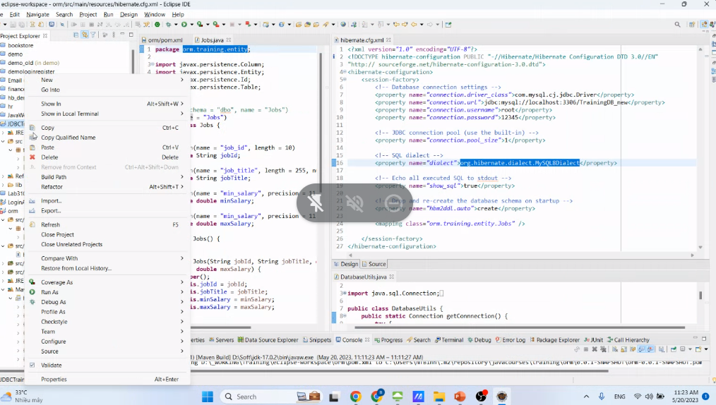

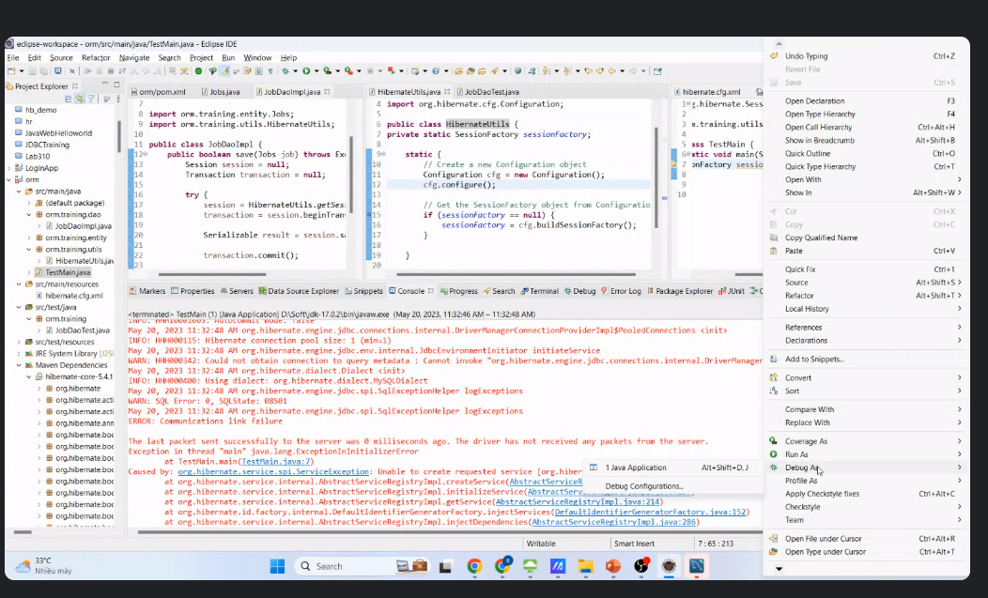

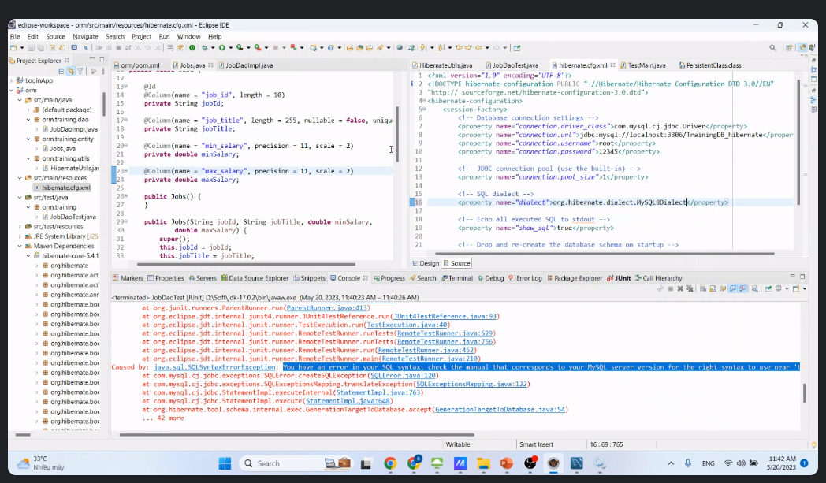

org.hibernate.dialect.MySQL8Dialect

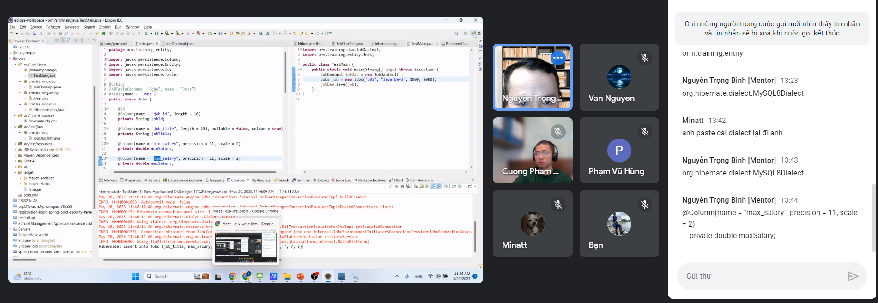

public class TestMain {

public static void main(String[] args) throws Exception {

JobDaoImpl jobDao = new JobDaoImpl();

Jobs job = new Jobs("J03", "Java Dev3", 1000, 2000);

jobDao.save(job);

}

}