**<<BMOS>>**

**Bird Meal Order System**

– HoChiMinh, May 2023 –

**Group 5 – Bird meal order system**

* Phạm Võ Minh Tâm
* Nguyễn Tấn Đạt
* Lê Chí Phát
* Phan Văn Cường
* Nguyễn Đoàn Anh Duy

# **I. Overview**

## **1. Code Packages**

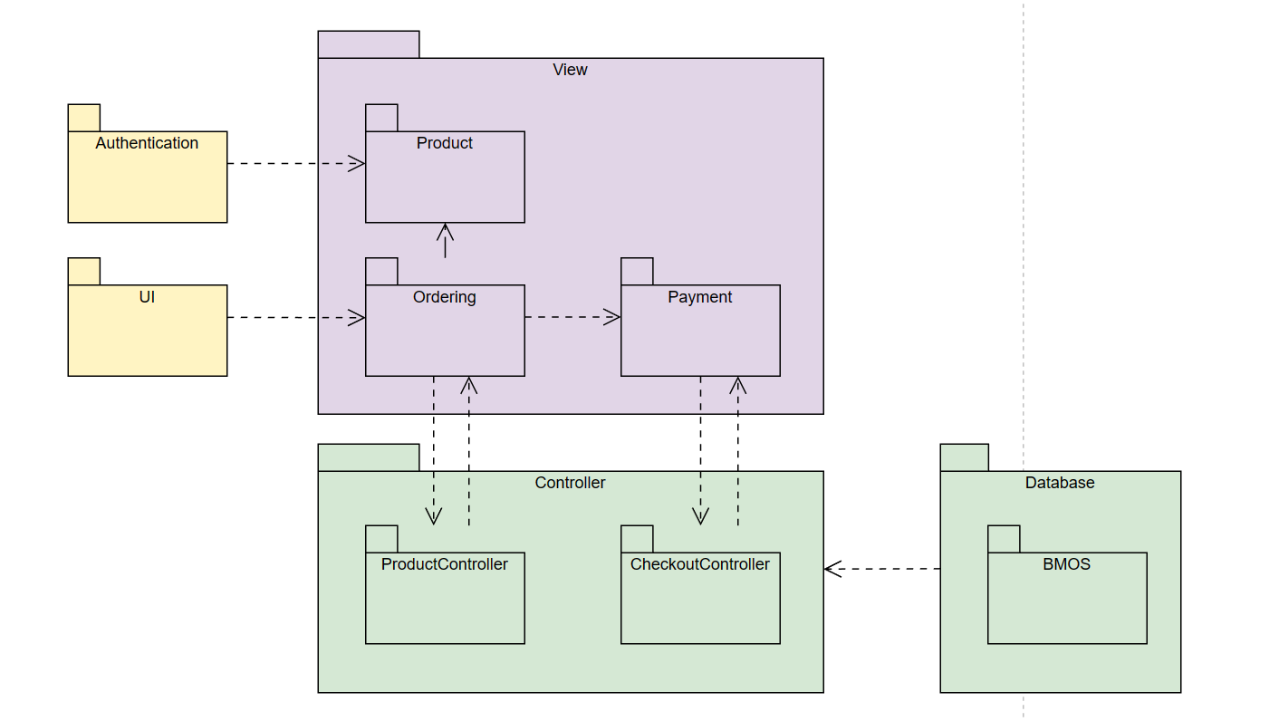

***Package descriptions***

|  |  |  |
| --- | --- | --- |
| **No** | **Package** | **Description** |
| *01* | *Authentication* | *<Login & Logout>* |
| *02* | *UI* | *<Layout website>* |
| *03* | *Product* | *<Display listproduct to buy>* |
| *04* | *Order* | *<Display orderbiew contain controller and view to handle order task>* |
| *05* | *Payment* | *<this package contain controller and view to handle payment task>* |
| *06* | *ProductController* | *<this package contain method to handle action to product item>* |
| *07* | *CheckoutController* | *<this package contain method to handle checkout action>* |
| *08* | *BMOS* | *<This package contain database to store data in the system.>* |

## **2. Database Design**

### **a. Database Schema**

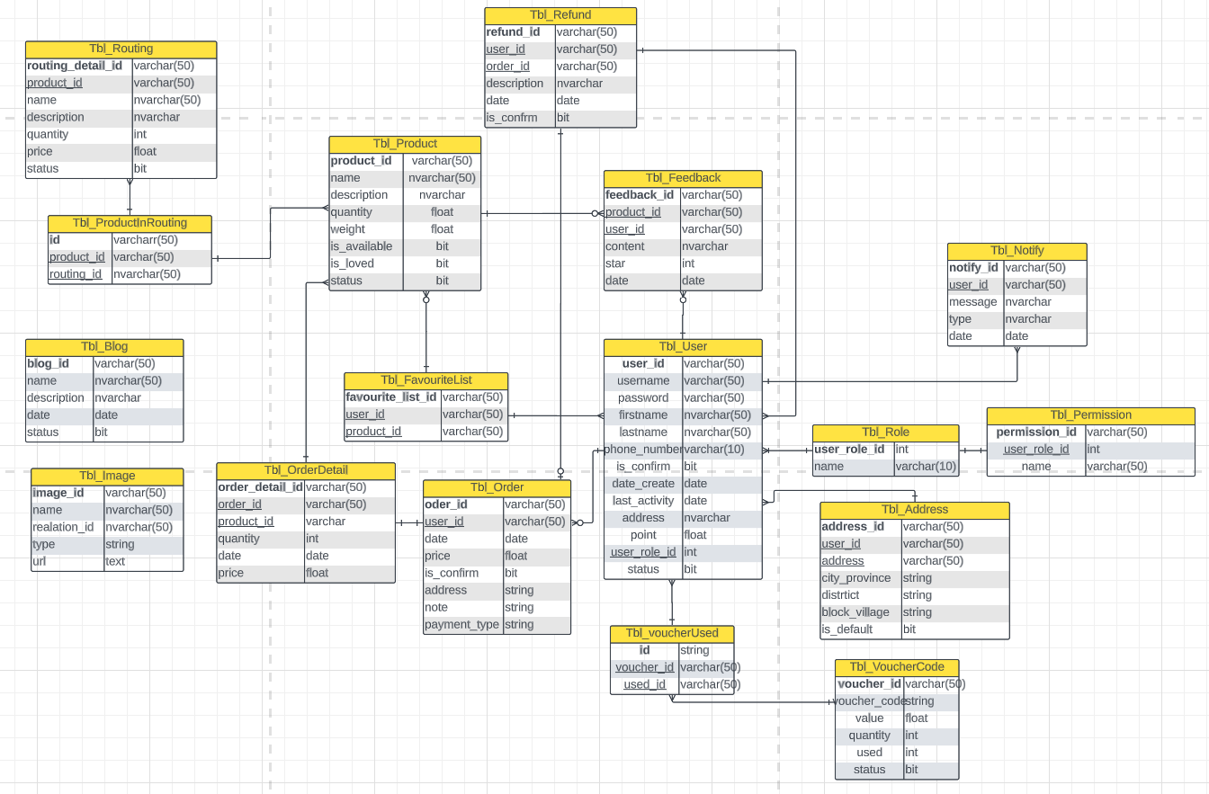

*[***b. Table Description**

|  |  |  |
| --- | --- | --- |
| **No** | **Table** | **Description** |
| *01* | *<Tbl_User>* | *This table contain user data to handle with the system* |
| *02* | *<Tbl_role>* | *this table use to authentication* |
| *03* | *<Tbl Permission>* | *this table use to authorization* |
| *04* | *<Tbl_Notify>* | *this table use to store notification to user* |
| *05* | *<Tbl_Feedback>* | *this table use to store feedback in product* |
| *06* | *<Tbl_Refund>* | *this table use to store refund offer* |
| *07* | *<Tbl_Order>* | *this table use to store order in the system* |
| *08* | *<Tbl_Order_Detail>* | *this table use to store order detail* |
| *09* | *<Tbl_Product>* | *this table use to store product information in the system* |
| *10* | *<Tbl_Routing>* | *this table use to store routing information* |
| *11* | *<Tbl_ProductInRouting>* | *This table is link between tblProduct and tblRouting.* |
| *12* | *<Tbl_Image>* | *this table use to store image url link store in firebase storage* |
| *13* | *<Tbl_Blog>* | *this table use to store blog in the system.* |
| *14* | *<Tbl_Favourite_List>* | *this table use to store favorite product which user add to their favorite list* |
| *15* | *<Tbl_Address>* | *This table to store address data for use have multil choice which location they will recive their order* |
| *16* | *<Tbl_VoucherCode>* | *This table to store code voucher in the system* |
| *17* | *<Tbl_VoucherUsed>* | *This table to check which code are used by which user* |
|  |  |  |

# **II. Code Designs**

## **1. <Search>**

### **b. Class Diagram**

*[Provide the description for each class and the methods in each class, following the table format as below]*

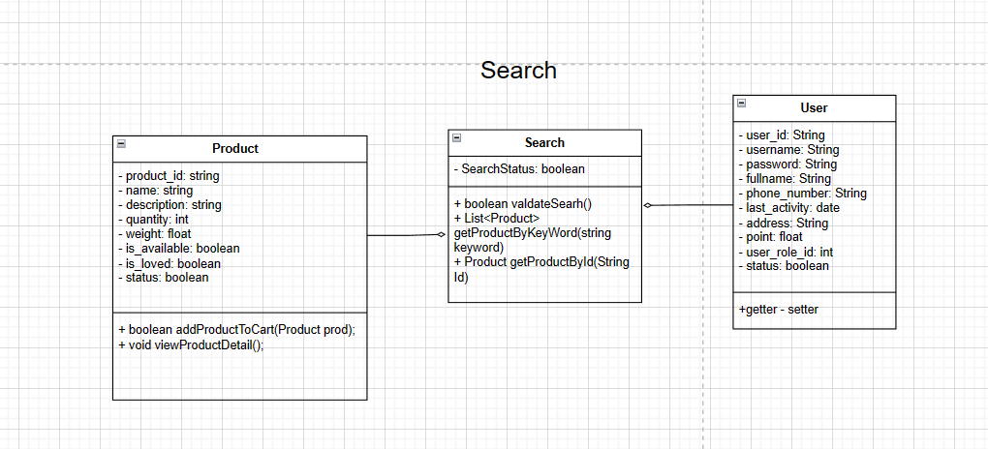

## **2. <Checkout>**

### **b. Class Diagram**

*[Provide the description for each class and the methods in each class, following the table format as below]*

# 

## **2. <Forgot password>**

### **b. Class Diagram**

## **2. <Refund>**

## 

**Use Case List**

|  |  |
| --- | --- |
| ***Primary Actor*** | ***Use Cases*** |
| Admin | 1. View Dashboard 2. Manage Account |
| Staff | 1. Manage Product 2. Manage Order 3. Manage Feedback 4. Manage Blog 5. Manage Refund |
| Customer | 1. Make Order 2. Edit Order 3. Cancel Order 4. Search Product 5. Add Favorite Product 6. View Product List/ Routing 7. View Feedback 8. Contact 9. Get bonus point 10. Checkout 11. Feedback 12. Refund Product |
| Guest | 1. Register Account 2. Make Order 3. Edit Order 4. Cancel Order 5. Search And Filter Product 6. View Product List/ Routing 7. Refund Product |

**Use Case Diagram**

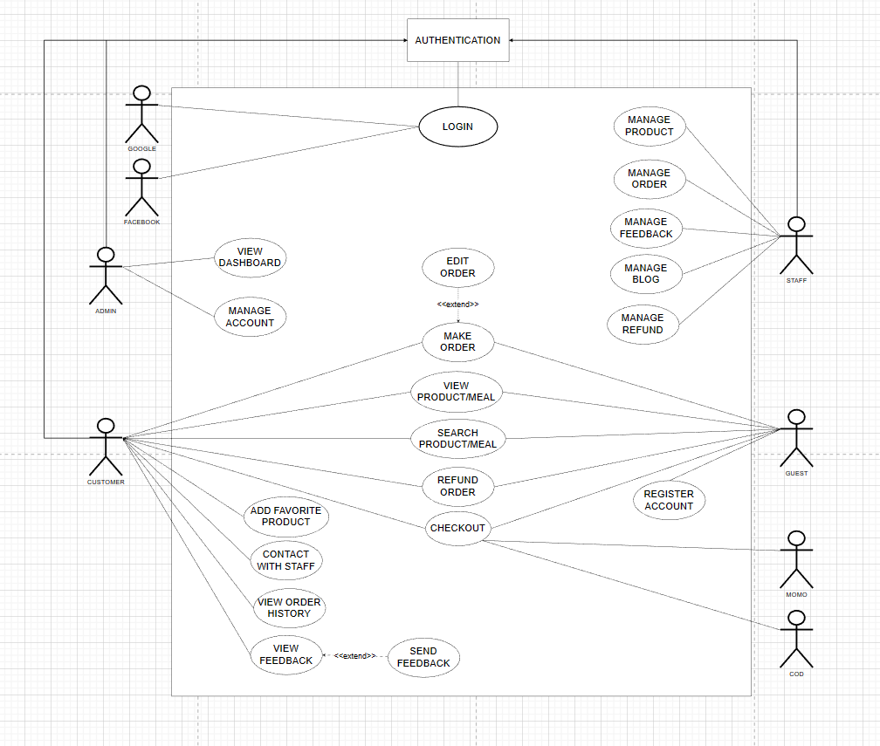

**Use Case Template**

|  |  |  |  |
| --- | --- | --- | --- |
| UC ID and Name: | **UC-1 View Dashboard** | | |
| Created By: |  | Date Created: | 5/24/23 |
| Primary Actor: | Admin | Secondary Actors: | Bird Meal Order System |
| Trigger: | The Admin indicates that he wants to see the system's dashboard. | | |
| Description: | Admin access system to view the store's sales details for the month, quarter or year, the report of the products sold including the total number of orders, the number of product views, the amount of the product being refunded and top best selling products. | | |
| Preconditions: | PRE-1. Admin is logged into BMOS | | |
| Postcondition: | POST-1. Print a paper sales statement.  POST-2. Plan and develop a strategy for product sales.  POST-3. Track, measure and analyze business-related data. | | |
| Normal Flow: | **1.0 View current month's revenue**  1. Admin asks to view Dashboard to check sales revenue.  2. BMOS displays the store's sales table. | | |
| Alternative Flows: | **1.1 View the store's other months' sales**  1. Admin asked to view the revenue of other months. (see 1.1.E1)  2. Return to step 2 of normal flow. | | |
| Exceptions: | **1.1 E1 Inquiry months see sales as months with no data**  1. BMOS will show an empty revenue table.  2. Admin will ask to see another month's revenue. | | |
| Priority: | Medium | | |
| Frequency of Use: | The function only applies to one Admin to use, on average, once a month. | | |
| Business Rules: | - For users with Admin rights, the system allows users to access the system using an account provided by the system administrator.  - Graph of Revenue Statistics over time is shown as a column chart  - Block displays trending sales information:  + List the top 10 products with the highest purchases in the month.  + Information displayed includes: product name, product price and number of orders sold.  - Block shows the number of website visitors, the total number of orders for the month, the total revenue of the month, the total number of refund orders.  - Admin searches for revenue by time selection. | | |
| Other Information: | 1, Admin can see all store sales within 1 year.  2. The default month showing revenue is the current month. To be able to see the revenue of other months, Admin can enter the date in the textbox. | | |
| Assumptions: | None | | |

|  |  |  |  |
| --- | --- | --- | --- |
| UC ID and Name: | **UC-2 Manage Account** | | |
| Created By: |  | Date Created: | 5/24/23 |
| Primary Actor: | Admin | Secondary Actors: | Bird Meal Order System |
| Trigger: | The Admin indicates that he wants account management in the system. | | |
| Description: | Displays a list of accounts in the system with full information. Admin has the right to add new accounts or delete accounts below level. | | |
| Preconditions: | PRE-1. Admin is logged into BMOS | | |
| Postconditions: | POST-1. The data on the database will be updated again.  POST-2. Account is added, depending on the role of the account that can perform certain functions on the system.  POST-3. Deleted accounts will lose access from the system. | | |
| Normal Flow: | **1.0 Add new account**  1. Admin requires adding a new account to the system.  2. The system will appear as a form for Admin to enter the account information to create.  3. Admin clicks the "Add" button to add a new account into the system..  **2.0 Delete account in the list**  1. Admin requests to delete an account on the system.  2. Select the account you want to delete and click "Delete".  **3.0 View detail account in the list**  1. Admin asks to see account details.  2. Admin click the "Detail" button to view account information. | | |
| Alternative Flows: | **2.1 Search account to delete**  1. Admin enter the account name in the search bar.  2. The searched account will show up on the list.  3. Select the account you want to delete and click "Delete".  **3.1 Search account to view detail**  1. Admin enter the account name in the search bar.  2. The searched account will show up on the list.  3. Select the account you want to view and click "Detail". | | |
| Exceptions: | **1.0 E1 Duplicate account name**  1. The added account name already exists on the system.  2. The system will display the message "Duplicate username".  3. Admin will enter a new username. | | |
| Priority: | Medium | | |
| Frequency of Use: | Sometimes the Admin wants to add or remove accounts. | | |
| Business Rules: | - For users with Admin rights, the system allows users to access the system using an account provided by the system administrator.  - Admin is granted permission to block user accounts.  - Account information is presented in tabular form, including columns ID, Name, Email, Role, Status, Detail:  + Details of an account are shown by a push up including phone number, email, id, address when admin presses the details button.  - Textbox Search: Admin can search user accounts by ID, Name, Email.  - Their ID number was only one.  - Sort box: admin can sort the name of the account by A-Z, Z-A. | | |
| Other Information: | None | | |
| Assumptions: | None | | |

|  |  |  |  |
| --- | --- | --- | --- |
| UC ID and Name: | **UC-3 Manage Product** | | |
| Created By: |  | Date Created: |  |
| Primary Actor: | Staff | Secondary Actors: | Bird Meal Order System |
| Trigger: | Staff click on Manage Product in sidebar of management page | | |
| Description: | Render a list of products in the system into a table. Have id product, quantity, price column and action column for staff can edit product detail and can add new product by clicking on add product button. | | |
| Preconditions: | PRE-1. Staff need to login with a staff account. | | |
| Postconditions: | POST-1. Add a new product.  POST-2. View product detail  POST-3. Edit product detail  POST-4. Remove product  POST-5. Search product by product ID | | |
| Normal Flow: | 1.0. **Add a Product**   1. Login with staff account. 2. Click on “Add Product” Manage Product Page. 3. System pops up a form with input text for customers to fill in product details. 4. Click on the Add button to complete the Add process.   2.0. **Remove Product**   1. Login with staff account. 2. Click on “Remove Button”Manage Product Page. 3. System pops up a message to confirm to remove that product.   3.0. **Update Product**   1. Login with staff account. 2. Click on “Update Product” Manage Product Page. 3. System pops up a form with input text for staff to edit in product details. 4. Click on the Update button to complete the update process.   4.0 **Search Product by product name:**   1. Login with staff account 2. Type in search button 3. The information need to valid 4. Click on the search button. 5. Display a list of products familiar with keywords. | | |
| Alternative Flows: | 1. Staff want to see all products in the website 2. Staff asked to view and edit product detail 3. Staff asked to don’t sell a new product 4. Staff wanted to notify us that the product was sold out. 5. Staff want to add a new product in the product list page. | | |
| Exceptions: | 1. Database crashed 2. Cannot connect database 3. System render manages the product page with no data. 4. Can not search product by product name. 5. Search returns the wrong product. | | |
| Priority: | Medium | | |
| Frequency of Use: | Sometimes, when staff want to see, add or remove a product and edit product detail. | | |
| Business Rules: | - For users with Staff rights, the system allows users to access the system using an account provided by the system administrator.  - Account information is presented in tabular form, including columns ID,Quantity, Price.  - Can search products by ID, name.  - Staff can add products.  - Staff can delete products.  - Their ID number was only one. | | |
| Other Information: | Staff can notify the supplier when the product is out of stock. | | |
| Assumptions: | This feature will help staff to manage all products in the system. Avoid mistakes in the management process. | | |

|  |  |  |  |
| --- | --- | --- | --- |
| UC ID and Name: | **UC-4 Manage Order** | | |
| Created By: |  | Date Created: |  |
| Primary Actor: | Staff | Secondary Actors: | Bird Meal Order System |
| Trigger: | Staff click on Manage Product in sidebar of management page | | |
| Description: | Render a list of Order in the system into a table. Have user id, order id, total price date column and action column for staff can view order detail buy click on “detail” button | | |
| Preconditions: | PRE-1. Staff need to login with a staff account. | | |
| Postconditions: | POST-1. View order detail  POST-2. Search order by user id. | | |
| Normal Flow: | 1.0. **View Order Detail**  1. Login with staff account.  2. Click on the “Detail button” Manage Order Page.  3. System pops up a form with text for staff to see order details.  2.0 **Search Order by user name:**   1. Login with staff account 2. Type in search button 3. The information need to valid 4. Click on the search button. 5. Display a list of Order familiar with keywords. | | |
| Alternative Flows: | 1. Staff want to see all order in website 2. Staff asked to search an order by their id. | | |
| Exceptions: | 1. System can not record order in system into database 2. Database crashed 3. Cannot connect database 4. Can not search order by user id 5. Manage Order page have no data | | |
| Priority: | Medium | | |
| Frequency of Use: | Sometimes, when staff want to manage the Order of the website, and want to search order by order id. Moreover, staff can know which user is the owner of each order. | | |
| Business Rules: | - For users with Staff rights, the system allows users to access the system using an account provided by the system administrator.  - Order information is presented in tabular form, including columns userID, orderID, quantity, date, total.  - Details of order are shown by a push up including date,username,total,quantity.  - Can search order by account name and user id.  - Their ID number was only one.  -This order list is the list that represents all successful orders. | | |
| Other Information: | Staff can trackinging which orders users have purchased | | |
| Assumptions: | This feature will help staff to manage all orders in the system. Therefore, staff can report which user is buying the most products on our website. | | |

|  |  |  |  |
| --- | --- | --- | --- |
| UC ID and Name: | **UC-5 Manage Feedback** | | |
| Created By: |  | Date Created: |  |
| Primary Actor: | Staff | Secondary Actors: | Bird Meal Order System |
| Trigger: | Staff click on Manage feedback in sidebar of management page | | |
| Description: | Render a list of feedback in the system into a table. Have user id, product id, feedback, star star and date column. Also, having an action column for staff can view feedback in detail by clicking on the “detail” button. | | |
| Preconditions: | PRE-1. Staff need to login with a staff account. | | |
| Postconditions: | 1. View feedback detail 2. Search feedback by user id. | | |
| Normal Flow: | 1. Login with staff account. 2. Click on “Manage feedback” in sidebar | | |
| Alternative Flows: | 1.0. **View Feedback Detail**  1. Login with staff account.  2. Click on the “Detail button” Manage Feedback Page.  3. System pops up a form with text for staff to see feedback details.  2.0 **Search feedback by user name:**   1. Login with staff account 2. Type in search button 3. The information need to valid 4. Click on the search button. 5. Display a list of feedback familiar with keywords. | | |
| Exceptions: | 1. System can not record feedback in system into database 2. Database crashed 3. Cannot connect database 4. Can not search feedback by user id 5. Manage feedback page have no data | | |
| Priority: | Medium | | |
| Frequency of Use: | Sometimes, when staff want to manage the Feedback of the website, and want to search feedback by user id. Moreover, staff can know which product has good feedback. and which product has bad feedback to manage that product or check it again. | | |
| Business Rules: | - For users with Staff permission, the system allows users to access the system using an account provided by the system administrator.  - Feedback is presented in tabular form, including columns userID,productID, rating star.  - Staff can delete feedback.  - Staff can allow customer feedback to appear in product details.  - Their ID number was only one. | | |
| Other Information: | Staff can trackinging which product is suitable with users. | | |
| Assumptions: | This feature will help staff to manage all feedback in the system. Therefore, staff can report which product has a bad feedback for refund or remove that product from the website. | | |

|  |  |  |  |
| --- | --- | --- | --- |
| UC ID and Name: | **UC-6 Manage Blog** | | |
| Created By: |  | Date Created: |  |
| Primary Actor: | Staff | Secondary Actors: | Bird Meal Order System |
| Trigger: | Staff click on Manage Blog in sidebar of management page | | |
| Description: | Render a list Blog of the system into a table. Have user id,blog id, blog content, date column. Also, having an action column for staff can view Blog in detail by clicking on the “detail” button. And staff can create a new Blog by clicking on the add blog button. The system will pop up a form for staff to type a blog detail. | | |
| Preconditions: | PRE-1. Staff need to login with a staff account. | | |
| Postconditions: | 1. View Blog detail 2. Search blog by blog id. 3. Create a new blog 4. Edit and remove a blog. | | |
| Normal Flow: | 1.0. **Add a Blog**  1. Login with staff account.  2. Click on “Add Blog Product” Manage Blog Page.  3. System pops up a form with input text for customers to fill in blog details.  4. Click on the Add button to complete the Add blog process.  2.0. **Remove Blog**   1. Login with staff account. 2. Click on “Remove Blog”Manage Blog Page. 3. System pops up a message to confirm to remove that Blog.   3.0. **Update Blog**   1. Login with staff account. 2. Click on “Update Blog” Manage Product Page. 3. System pops up a form with input text for staff to edit in blog details. 4. Click on the Update button to complete the update process.   4.0 **Search Blog by blog name:**   1. Login with staff account 2. Type in search button 3. The information need to valid 4. Click on the search button. 5. Display a list of products familiar with keywords. | | |
| Alternative Flows: | 1. Staff asked to view all blogs on the website. 2. Staff want to view blog details. 3. Staff want to edit or remove a blog. 4. Staff asked to create a new blog. | | |
| Exceptions: | 1. System can not record when staff create a new blog in system into database 2. Database crashed 3. Cannot connect database 4. Can not search blog by blog name 5. Manage feedback page have no data | | |
| Priority: | Medium | | |
| Frequency of Use: | Sometimes, when staff want to manage the blog of the website, and want to search the blog by user id. | | |
| Business Rules: | - For users with Staff rights, the system allows users to access the system using an account provided by the system administrator.  - Blog information is presented in tabular form, including columns id,blog title,date.  - Staff can add and edit blog  - Staff can delete blog  - Their ID number was only one. | | |
| Other Information: | Staff can trackinging which staff posts that blog. | | |
| Assumptions: | This feature will help staff to manage all blogs in the system. Therefore, staff can update hot information or news about the bird world into the website. | | |

|  |  |  |  |
| --- | --- | --- | --- |
| UC ID and Name: | **UC-7 Manage Refund** | | |
| Created By: |  | Date Created: |  |
| Primary Actor: | Staff | Secondary Actors: | Bird Meal Order System |
| Trigger: | Staff click on Manage Refund in sidebar of management page | | |
| Description: | Render a list refund of the users that were sent to our system into a table. Have user id, order id, product image, reason to refund column. Also, having an action column for staff can confirm | | |
| Preconditions: | PRE-1. Staff need to login with a staff account. | | |
| Postconditions: | POS-1. View rendfund detail  POS-2. Search refund by orderID. | | |
| Normal Flow: | 1.0. **View Refund Detail**  1. Login with staff account.  2. Click on the “Detail button” Manage Refund Page.  3. System pops up a form with text for staff to see feedback details.  2.0 **Search refund by orderid:**   1. Login with staff account 2. Type in search button 3. The information need to valid 4. Click on the search button. 5. Display a list of feedback familiar with keywords.   3.0 **Confirm Refund Offer**   1. Login with staff account 2. Click “Confirm button” in the Action Column.   4.0 **Denied Refund Offer**   1. Login with staff account 2. Click “Detail” in the Action Column. 3. System pops up a form so staff can see a refund order details. 4. Click on “Denied button” in form. | | |
| Alternative Flows: | 1. Staff asked to view all refund offers on the website. 2. Staff want to view refund details. 3. Staff want to edit or remove a blog. 4. Staff asked to create a new blog. | | |
| Exceptions: | 1. System can not record when customer send a refund offer in system into database 2. Database crashed 3. Cannot connect database 4. Can not search blog by order id name 5. Manage feedback page have no data | | |
| Priority: | Medium | | |
| Frequency of Use: |  | | |
| Business Rules: | - For users with Staff rights, the system allows users to access the system using an account provided by the system administrator.  -Refund information is presented in tabular form, including columns order id, user id, reason, date.  -Details of request refund are shown by a push up including date, ID, -UserID,Reason, Email, Phone, Photo product.  -Staff can accept refund  -Staff can denied refund | | |
| Other Information: |  | | |
| Assumptions: |  | | |

|  |  |  |  |
| --- | --- | --- | --- |
| UC ID and Name: | **UC-8 Make Order** | | |
| Created By: |  | Date Created: |  |
| Primary Actor: | Customer, Guest | Secondary Actors: | Bird Meal Order System |
| Trigger: | User indicates that he wants to order a product. | | |
| Description: | This Use Case describes the process of a customer making an order for a product on the website. | | |
| Preconditions: | PRE-1. The customer must have selected the product(s) they wish to order. | | |
| Postconditions: | POST-1. The customer's order is recorded in the system.  POST-2. The inventory is updated to reflect the order. | | |
| Normal Flow: | **1.0 Order a single product**  1. Customers or guests ask to order a specific product on the website.  2. BMOS system displays a list of available products in the system.  3. Customers or guests select one or more food items from the website.  4. Customers or guests click on the “add food item” button to add them into their cart.  5. BMOS stores that food item in the system and notices the message that food was added into their cart. | | |
| Alternative Flows: | **1.1 Order multi products.**  1. Users can add another product after they add the product to cart.  2. Return to step 1 in normal flow. | | |
| Exceptions: | **1.0 E1 Order quantity is larger than stock quantity**  1. The customer adds a product quantity larger than the inventory quantity  2. The system will display the message “The number of products is not enough”.  3.1 The customers can choose to buy similar products.  3.2 The customers will close this user case. | | |
| Priority: | Medium | | |
| Frequency of Use: | Sometimes, for each user who visits our website and wishes to order one product from the product list displayed on the homepage or they can search for the product by name. | | |
| Business Rules: | Orders can only be completed when confirmed by the customer via Gmail  The selected products must be in stock.  The customer's billing and shipping information must be valid and complete.  The customer must accept the terms and conditions before placing the order.  This order list is the list that represents all successful orders. | | |
| Other Information: |  | | |
| Assumptions: |  | | |

|  |  |  |  |
| --- | --- | --- | --- |
| UC ID and Name: | **UC-9 Edit Order** | | |
| Created By: |  | Date Created: |  |
| Primary Actor: | Customer | Secondary Actors: | Bird Meal Order System |
| Trigger: | When user interact with button to edit their cart such as add or subtract the quantity, or they can click on remove product or remove all product button in their cart detail | | |
| Description: | This Use Case describes the process of a customer editing an order for a product or products on a company's website | | |
| Preconditions: | The customer must have an existing order that they wish to edit. | | |
| Postconditions: | The customer's updated order is recorded in the system.  The inventory is updated to reflect the changes in the order. | | |
| Normal Flow: | **1.0 Editing a product**  1. Customers navigate to their shopping cart.  2. Customer makes desired changes to the order such as subtract adding product quantity, reducing product quantity by clicking on add button and button  3. The system updates order details. | | |
| Alternative Flows: | **1.1 Delete a product**  1. Customers navigate to their shopping cart.  2. The customer deletes the product for the order by clicking the remove button.  3. The system updates order details. | | |
| Exceptions: | **1.0 E1 There are no products in the cart**  1. Customer has not added any products to the cart  2. Customer clicks on the cart to edit the product  3. The system will display the message “There are no products in the cart”.  4.1 The customer will exit the shopping cart and purchase a new product.  4.2 The customer will close this use case. | | |
| Priority: | Medium | | |
| Frequency of Use: |  | | |
| Business Rules: | The Edit Order operation is only performed when the customer already has the product in the cart  The order must not have been paid yet.  The customer can only add or remove products to/from the order if they are in stock. | | |
| Other Information: |  | | |
| Assumptions: |  | | |

|  |  |  |  |
| --- | --- | --- | --- |
| UC ID and Name: | **UC-10 Cancel Order** | | |
| Created By: |  | Date Created: |  |
| Primary Actor: | Customer | Secondary Actors: | Bird Meal Order System |
| Trigger: | The Admin indicates that he wants to see the system's dashboard. | | |
| Description: | This Use Case describes the process of a customer canceling an order for a product or products on a company's website. | | |
| Preconditions: | The customer must have an existing order that they wish to cancel. | | |
| Postconditions: | The customer's order is canceled in the system.  The inventory is updated to reflect the cancellation of the order. | | |
| Normal Flow: | **1.1 Cancel Order**  1. Customers navigate to their shopping cart.  2. The customer executes the order by clicking the "remove all" button.  3. The system updates order details. | | |
| Alternative Flows: |  | | |
| Exceptions: | **1.0 E1 There are no products in the cart**  1. Customer has not added any products to the cart  2. Customer clicks on the cart to edit the product  3. The system will display the message “There are no products in the cart”.  4.1 The customer will exit the shopping cart and purchase a new product.  4.2 The customer will close this use case. | | |
| Priority: | Medium | | |
| Frequency of Use: |  | | |
| Business Rules: | The Edit Order operation is only performed when the customer already has the product in the cart  The order must not have been payment yet. | | |
| Other Information: |  | | |
| Assumptions: |  | | |

|  |  |  |  |
| --- | --- | --- | --- |
| UC ID and Name: | **UC-11 Search And Filter Product** | | |
| Created By: |  | Date Created: |  |
| Primary Actor: | Customer | Secondary Actors: | Bird Meal Order System |
| Trigger: | When the user clicks on the search button in search input. | | |
| Description: | This Use Case describes the process of a customer searching and filtering products on a company's website. | | |
| Preconditions: | The customer must be on the company's website and have access to the search and filter functionality. | | |
| Postconditions: | The customer is presented with a list of products that match their search and filter criteria. | | |
| Normal Flow: | **1.0 Search products**  1. Customers enter keywords in the search bar and press the search button.  2. The system displays a list of products matching the keyword. | | |
| Alternative Flows: | **1.1 Filter products**  3. Customers apply filters to search results, such as price range, category, brand, etc.  4. The system updates the search results based on the filters applied. | | |
| Exceptions: | **1.0 E1 Customer does not enter a keyword when click "search" button.**  1. Customers click the search button when there are no keywords in the search bar.  2. The system will display the message “Please fill out this field”.  3.1 Customers will enter keywords in the search bar and click the search button.  3.2 The customer will close this use case. | | |
| Priority: | Medium | | |
| Frequency of Use: | Sometimes, when user asked to search product in system | | |
| Business Rules: | Customers can only search for products when they enter "key word" in the search bar  The search results must only include products that are currently in stock.  The filter criteria must be valid and applicable to the search results. | | |
| Other Information: | The search and filter functionality may be integrated with the website's navigation and category pages, allowing customers to browse and filter products by category as well as search query. | | |
| Assumptions: |  | | |

|  |  |  |  |
| --- | --- | --- | --- |
| UC ID and Name: | **UC-12 Add Favorite Product** | | |
| Created By: |  | Date Created: |  |
| Primary Actor: | Customer | Secondary Actors: | Bird Meal Order System |
| Trigger: | When ussr click on heart icon in product detail or meal detail | | |
| Description: | This Use Case describes the process of a customer adding a product to their list of favorite products on a company's website. | | |
| Preconditions: | The customer must be logged in to their account on the company website. | | |
| Postconditions: | The customer's selected product is added to their list of favorite products in the system. | | |
| Normal Flow: | **1.0** **Add Favorite Product**  1. The customer navigates to the product page of the product they wish to add to their favorites.  2. The customer clicks on the "Add to Favorites" button or icon on the product page.  3. The system adds the selected product to the customer's list of favorite products in their account. | | |
| Alternative Flows: | None | | |
| Exceptions: | **1.0 E1 Customer is not logged in**  1. Customer is not logged in  2. Customers visit the product detail page  3. Customers click "add favorite" button  4. The system will display the message “Do you like this product? Please log in”.  5.1 Customers will login and return to like the product.  5.2 Customers will close this use case. | | |
| Priority: | Medium | | |
| Frequency of Use: |  | | |
| Business Rules: | To add favorite products, customers must have an account and have successfully logged in  The customer can only add products to their list of favorites if they are currently in stock.  The customer can only add products to their list of favorites once. | | |
| Other Information: |  | | |
| Assumptions: | The favorite products functionality may be integrated with the website's recommendation engine, allowing customers to receive personalized recommendations based on their favorite products and browsing history. | | |

|  |  |  |  |
| --- | --- | --- | --- |
| UC ID and Name: | **UC-15 Contact** | | |
| Created By: | AnhDuy | Date Created: | 5/24/23 |
| Primary Actor: | Customer | Secondary Actors: Guest | Bird Meal Order System |
| Trigger: | When they want to have conversations with staff. | | |
| Description: | Allow customers and guests to have conversations with staff about products or something. | | |
| Preconditions: | None | | |
| Postconditions: | POST-1. | | |
| Normal Flow: | 1. Visit BMOS websites. 2. Click on the “contact” button. | | |
| Alternative Flows: | None | | |
| Exceptions: | 1. Cannot connect to staff. 2. Cannot type letter. | | |
| Priority: | Medium | | |
| Frequency of Use: | Sometimes, when customers or guests want to have conversations with staff. | | |
| Business Rules: | Conversation just starts when a customer or guest clicks on the “contact” button. | | |
| Other Information: | None | | |
| Assumptions: | Customers and guests can know more about products by getting information and advice from staff. | | |

|  |  |  |  |
| --- | --- | --- | --- |
| UC ID and Name: | **UC-16 Earn bonus point** | | |
| Created By: | AnhDuy | Date Created: | 5/24/23 |
| Primary Actor: | Customer | Secondary Actors: | Bird Meal Order System |
| Trigger: | When a customer buys a product successfully. | | |
| Description: | After a customer buys a product, they will receive a bonus point, which can be used to decrease the price of other products when the customer wants. | | |
| Preconditions: | PRE-1. Customer login to BMOS | | |
| Postconditions: | POST-1. Collect bonus points.  POST-2. Buy other products.  POST-3. Use bonus points for that product. | | |
| Normal Flow: | 1. Login with customer account. 2. Buy a product. 3. Earn bonus points. | | |
| Alternative Flows: | 1. Customers want to earn more bonus points. 2. Buy other products. | | |
| Exceptions: | 1. System can not record bonus points in system into database 2. Database crashed 3. Cannot connect database | | |
| Priority: | Medium | | |
| Frequency of Use: | Usually, when customers buy a product. | | |
| Business Rules: | Bonus points will just add when customers or guests buy a product. | | |
| Other Information: | Customers can collect bonus points to stack it and use it whenever they want. | | |
| Assumptions: | None | | |

|  |  |  |  |
| --- | --- | --- | --- |
| UC ID and Name: | **UC-17 Checkout** | | |
| Created By: | AnhDuy | Date Created: | 5/24/23 |
| Primary Actor: | Customer | Secondary Actors: Guest | Bird Meal Order System |
| Trigger: | When click button “buy” or “purchase” | | |
| Description: | Customers and guests can choose payment and add bonus points to decrease price and purchase products on cart. | | |
| Preconditions: | PRE-1. Need to have a product on cart. | | |
| Postconditions: | POST-1. Get bonus points.  POST-2. Give feedback.  POST-3. Buy other products. | | |
| Normal Flow: | 1. Login 2. Search product. 3. Select product to cart. 4. Checkout. | | |
| Alternative Flows: | None | | |
| Exceptions: | 1. System can not record bonus points in system into database 2. Database crashed 3. Cannot connect database | | |
| Priority: | High | | |
| Frequency of Use: | Usually, when customers buy a product. | | |
| Business Rules: | Checkout is just done when customers or guests choose 1 of the payment and purchase it for a product. | | |
| Other Information: | None | | |
| Assumptions: | Customers and guests can choose what payment and add bonus points to decrease price. | | |

|  |  |  |  |
| --- | --- | --- | --- |
| UC ID and Name: | **UC-18 Feedback** | | |
| Created By: | AnhDuy | Date Created: | 5/24/23 |
| Primary Actor: | Customer | Secondary Actors: | Bird Meal Order System |
| Trigger: | Customer click on “feedback” button | | |
| Description: | Allow customers to give their opinion about their product they pay for. | | |
| Preconditions: | PRE-1. Need to login with a customer account and buy a product to give feedback to that product. | | |
| Postconditions: | POST-1. System update that feedback.  POST-2. Other customers can see feedback about the product.  POST-3. Buy another product. | | |
| Normal Flow: | 1. Login to Customer accounts. 2. Buy a product. 3. Give feedback. | | |
| Alternative Flows: | 1. Customers want to give other feedback. 2. Click on the “feedback” button and edit. | | |
| Exceptions: | 1. System can not record feedback in system into database 2. Database crashed 3. Cannot connect database | | |
| Priority: | Medium | | |
| Frequency of Use: | Sometimes, when customers want to comment about a product they buy. | | |
| Business Rules: | Feedback will just send when customers type characters in that textbox. | | |
| Other Information: | Customer can comment that the product is good or not | | |
| Assumptions: | Let other customers see that the product is good or not, decide to buy or not. | | |

|  |  |  |  |
| --- | --- | --- | --- |
| UC ID and Name: | **UC-19 Refund product** | | |
| Created By: | AnhDuy | Date Created: | 5/24/23 |
| Primary Actor: | Customer | Secondary Actors: Guest | Bird Meal Order System |
| Trigger: | Click on Refund button | | |
| Description: | Allow customers and guests to refund their product after buying when that product has a problem. | | |
| Preconditions: | PRE-1. Need to buy product and staff allow that refund request. | | |
| Postconditions: | POST-1. Get money back.  POST-2. Search for another product  POST-3. Buy a new product. | | |
| Normal Flow: | 1. Purchase products 2. Fill form refund products 3. Staff check form refund 4. Staff contract and take product 5. Return the product | | |
| Alternative Flows: | Customers want to refund products when there are product errors. | | |
| Exceptions: | 1. System can not record feedback in system into database 2. Database crashed 3. Cannot connect database | | |
| Priority: | Medium | | |
| Frequency of Use: | Sometimes, customers want to exchange for other products when products have problems. | | |
| Business Rules: | Customers need staff to allow refund requests to exchange products. | | |
| Other Information: | None | | |
| Assumptions: | Allow customers to exchange to other products when there is a problem. | | |

|  |  |  |  |
| --- | --- | --- | --- |
| UC ID and Name: | **UC-20** Register Account | | |
| Created By: |  | Date Created: |  |
| Primary Actor: | Guest, Customer | Secondary Actors: | Bird Meal Order System |
| Trigger: | When a user Registers without an account. Registration will happen for the user to fill in the information needed to create a new account. | | |
| Description: | When users need to create an account for shopping and gain discount points for next time. After registration, the account will be updated to the database, provide security, notification, authentication... | | |
| Preconditions: | Guest, Customer must join Home Page BMOS | | |
| Postconditions: | Create new account | | |
| Normal Flow: | 1. Customer join login page  2.Click on “Register” in Login page | | |
| Alternative Flows: | When a customer wants to create a new account. | | |
| Exceptions: | 1.Duplicate account username  2.Password between 6 and 30 characters | | |
| Priority: | Medium | | |
| Frequency of Use: | The function only applies to guest,customer to use, once for one account | | |
| Business Rules: | A new account will be created if the user fills in the correct registration information and presses register. | | |
| Other Information: | Customers cannot create an account if they have the same username | | |
| Assumptions: | This feature helps customers who buy a lot to save information and earn points for themselves | | |

|  |  |  |  |
| --- | --- | --- | --- |
| UC ID and Name: | **UC-24 Search And Filter Product** | | |
| Created By: |  | Date Created: |  |
| Primary Actor: | Guest, Customer | Secondary Actors: | Bird Meal Order System |
| Trigger: | Customers will choose their target to search for a product in the form filter. | | |
| Description: | This function helps users to easily find products quickly based on available requirements. | | |
| Preconditions: | Guest, Customer must join Home Page BMOS | | |
| Postconditions: | 1.Search with filter 2.Search with no filter | | |
| Normal Flow: | 1.Customer join home page  2.Click icon “Search” in sidebar  3.Fill products and filters customers want to find. | | |
| Alternative Flows: | Customers want to find the products they want easily. | | |
| Exceptions: | 1.Can't find the product customer just searched | | |
| Priority: | High | | |
| Frequency of Use: | Can be used many times depending on the number of times the customer uses it | | |
| Business Rules: | Search will work after the user enters the keyword they want to find in the search in the sidebar. | | |
| Other Information: | 1.Customers can search with multiple filters  2.Customers can search for products anywhere except the checkout page and the login page | | |
| Assumptions: | This feature helps customers find the products they want faster. | | |

|  |  |  |  |
| --- | --- | --- | --- |
| UC ID and Name: | **UC-25 View Product List/ Routing** | | |
| Created By: | Guest, Customer | Date Created: |  |
| Primary Actor: | Admin | Secondary Actors: | Bird Meal Order System |
| Trigger: | When a user visits the Home page. | | |
| Description: | Render product list and meal routing in system. | | |
| Preconditions: | Guest, Customer must join Home Page BMOS or search product. | | |
| Postconditions: | 1.Show all list products.  2.Show all lít routing | | |
| Normal Flow: | 1.Customer join home page  2.Click icon “Search” in sidebar  3.Fill products and filters customers want to find. 4.Show list product/routing | | |
| Alternative Flows: | 1.Customers want to find and choose the products they want to buy. | | |
| Exceptions: | Show empty product list. | | |
| Priority: | High | | |
| Frequency of Use: | Can be used many times depending on the number of times the customer uses it | | |
| Business Rules: | Product list or meal routing will be displayed if the search is successful. | | |
| Other Information: | 1.One screen will display 10 products  2.The first page will be the 1st page and if more than 10 products will push past the next pages | | |
| Assumptions: | This feature helps customers choose the products they want easily. | | |

|  |  |  |  |
| --- | --- | --- | --- |
| UC ID and Name: | **UC-26 Refund Product** | | |
| Created By: |  | Date Created: |  |
| Primary Actor: | Guest,Customer | Secondary Actors: | Bird Meal Order System |
| Trigger: | When the customer fills in the return form | | |
| Description: | When customers find that the product is not as required or damaged, they can return the product to BMOS and BMOS will resend the new product. | | |
| Preconditions: | Guest, Customer must buy products | | |
| Postconditions: | Refund products | | |
| Normal Flow: | 1.Purchase products  2.Fill form refund products  3.Staff check form refund  4.Staff contract and take product  5.Return the product | | |
| Alternative Flows: | Customers want to refund products when there are product errors. | | |
| Exceptions: | Staff take form refund products with info that does not exist. | | |
| Priority: | Low | | |
| Frequency of Use: | Used one times for each product you want to refund | | |
| Business Rules: | Customers need staff to allow refund requests to exchange products. | | |
| Other Information: | There will be an order id for the staff to distinguish the orders. | | |
| Assumptions: | This feature helps customers refund the product's error. | | |