

**<<BMOS>>**

**Bird Meal Order System**

– Hanoi, August 2022 –

**record of changes**

|  |  |  |  |
| --- | --- | --- | --- |
| **Date** | **A* M, D** | **In charge** | **Change Description** |
| 13/Apr | A | KienNT | Thêm mô tả chức năng Setting Details (II.1.a) |
|  |  |  |  |
|  |  |  |  |
|  |  |  |  |
|  |  |  |  |
|  |  |  |  |
|  |  |  |  |
|  |  |  |  |
|  |  |  |  |
|  |  |  |  |
|  |  |  |  |
|  |  |  |  |

*A - Added M - Modified D - Deleted

**PROCESS FEATURE:**[**Process Feature - BMOS - Google Trang tính**](https://docs.google.com/spreadsheets/d/1DTs_g6HtSjsNskK-KXeCrVk-5Jq9lABQUq1GII-uTXw/edit?hl=vi#gid=0)

**Table of Contents**

**I. Overview 4**

1. Introduction 4

2. System Functions 5

a. Screen Flow 5

b. Screen Details 5

c. User Authorization 6

d. Non-Screen Functions 7

3. Entity Relationship Diagram 7

**II. Functional Requirements 9**

Public feature: 9

1.Feature: Search Product 9

a. Search with filter 9

b. Search with no filter 9

2.Feature: Update 9

a. Change Password 10

b. Edit Profile 10

3. Feature: Cart 11

a. Add product to cart 11

b. Edit product in cart 12

4. Feature: Authentication 12

a. Login 12

b. Logout 13

c. Register 14

d. Reset Password 15

5. Feature: View 17

a. View product/meal routing list 17

6. Feature: Feedback 17

a. Rating 17

b. View feedback 18

c. Send feedback 19

7. Feature: Checkout 19

8. Feature: Contact 20

Manager Feature 21

1. View Dashboard 21

2. Account management by Admin 21

3. Search account 22

4. View profile account detail 23

5. Product Management 23

6. Feedback management 24

7. Contact management 24

# I. Overview

## 1. Introduction

Our product is an online shopping platform on the website designed to give customers a shopping experience for their pet bird food. It will allow customers to find and choose the right food for each type of bird, with a certain origin, and we provide a variety of feeding routes for a variety of improvement purposes. Thereby helping bird owners to care about the quality of meals for their pets.

The platform will be used in a consumer setting, accessed through a web browser. Customers will require an internet connection to use the platform. The platform will depend on third-party services, such as Momo payment gateways and shipping providers, to function properly.

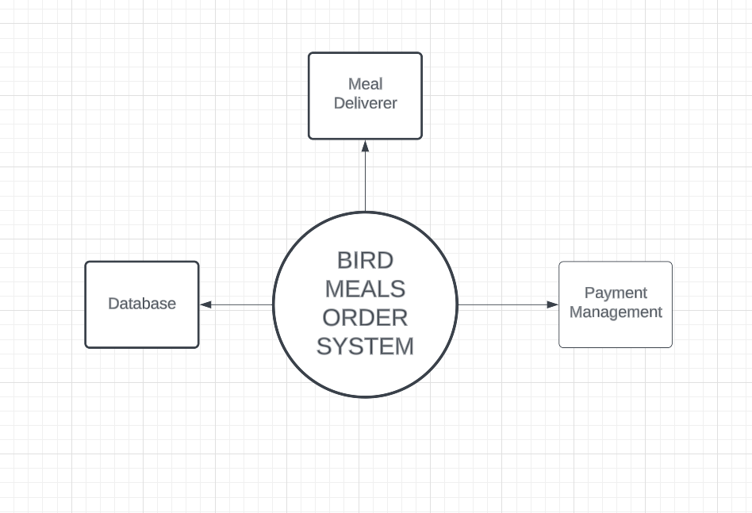>>

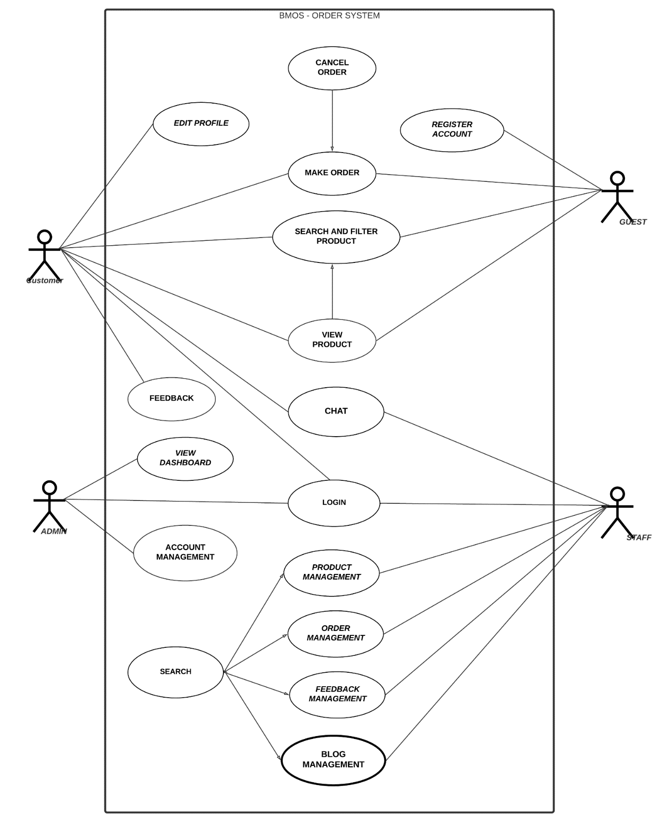

## 2. System Functions

### a. Screen Flow

*[This part shows the system screens and the relationship among screens. You can draw the Screens Flow for the system in the form of diagram as below]*

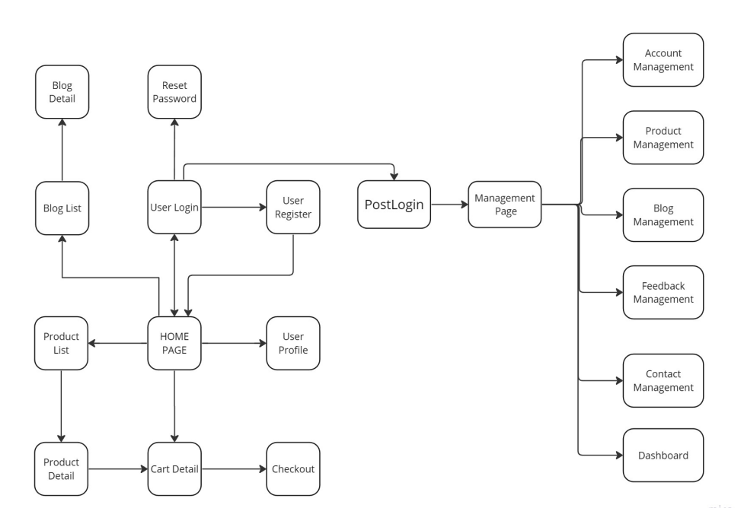

### b. Screen Details

*[Provide the descriptions for the screens in the Screens Flow above]*

|  |  |  |  |
| --- | --- | --- | --- |
| **Code** | **Feature function** | **Screen** | **Description** |
| B001 | Login | User Login | Has a form field username and password to login or you can login with Gmail. |
| B002 | Reset password | If you forgot the password please choose the reset button. |
| B003 | Register | Register User | Have a form for new users to fill in username and password. |
| B004 | Logout | Homepage | Has a logout button to log out current users. |
| B005 | Change password | User profile | Has a change password option so users can change their password. |
| B006 | Edit profile | Render a form with info user files such as: input user name, user email…. for user can fill in. |
| B007 | Search with filter | Homepage | Has a form, or radius form for customers to type what they want to filter in search to buy in the product list. |
| B008 | Search with filter | Product list | The same feature but in another screen. |
| B009 | Search no filter | Homepage | Customers can search all product lists in search type input. |
| B010 | Search no filter | Product List | The same feature but in another screen. |
| B011 | View product list/meal routing | Homepage | The system will render the product and meal routing list when they visit the homepage.. |
| B012 | Rating | Product detail | Display one to five stars for customers to choose which start they want to rate. |
| B013 | View feedback | Display product feedback of other customers when staff commit. |
| B014 | Send feedback | Have a textbox under product detail for customers to type their feedback. |
| B015 | Add product to cart | Have a button to add product in cart and notify for customer quantity of product in cart. |
| B016 | Edit products to cart | Cart detail | In this page, user can edit increase or decrease the number of products added to cart |
| B017 | View total price | User can view total price of products added to cart |
| B018 | Check out | Checkout | This page shown consignee information and payment methods can be used for payment |
| B019 | Contact | All screen | User can contact with staff |
| B020 | Edit Product | Home Page | Edit product detail or remove product |
| B021 | Dashboard | Management Page | View report revenue of shop |
| B022 | View Account List | Show list account of system include staff and customer account |
| B023 | View Account Profile | View account profile |
| B024 | Edit Account Profile | Can change profile information and disable accounts. |
| B025 | Filter Account | Can filter customer account and customer account |
| B027 | Add Product | Create new product in system |
| B028 | Add Meal Routing | Create new meal routing in system |
| B030 | Edit Meal Routing | Edit meal routing detail or remove them |
| B031 | Edit Blog | Edit blog detail or remove them |
| B032 | Create Blog | Post a blog on a blog page. |
| B033 | Confirm feedback | Show feedback product list and can accept them show in product detail |

### c. User Authorization

*[Provide the system roles authorization to the system features (down to screens, and event to the screen activities if applicable) in the table form as below – replace Role1, Role2,… with the specific system user role names]*

|  |  |  |  |  |
| --- | --- | --- | --- | --- |
| **Screen** | **Admin** | **Staff** | **Customer** | **Guest** |
| Home Page | X | X | X | X |
| Login Page | X | X | X |  |
| Register Page |  |  | X |  |
| Products List Page | X | X | X | X |
| Products Detail Page | X | X | X | X |
| User Profile Page |  | X | X |  |
| Cart Detail Page |  |  | X | X |
| Checkout Page |  |  | X | X |
| Management Page | X | X |  |  |
| Dashboard Page | X |  |  |  |
| Account Management Page | X |  |  |  |
| Product Management Page |  | X |  |  |
| Feedback Management Page |  | X |  |  |
| Contact Management Page |  | X |  |  |

In which:

* Role1: <<role1 description>>
* Role2: <<role2 description>>
* …

### d. Non-Screen Functions

*[Provide the descriptions for the non-screen system functions, i.e batch/cron job, service, API, etc.]*

|  |  |  |  |
| --- | --- | --- | --- |
| **#** | **Feature** | **System Function** | **Description** |
| 1 | <<Feature Name>> | <<Function Name1>> | <<Function Name1 Description>> |
| 2 | … |  |  |

## 3. Entity Relationship Diagram

*[Provide the entity relationship diagram and the entity descriptions in the table format as below]*

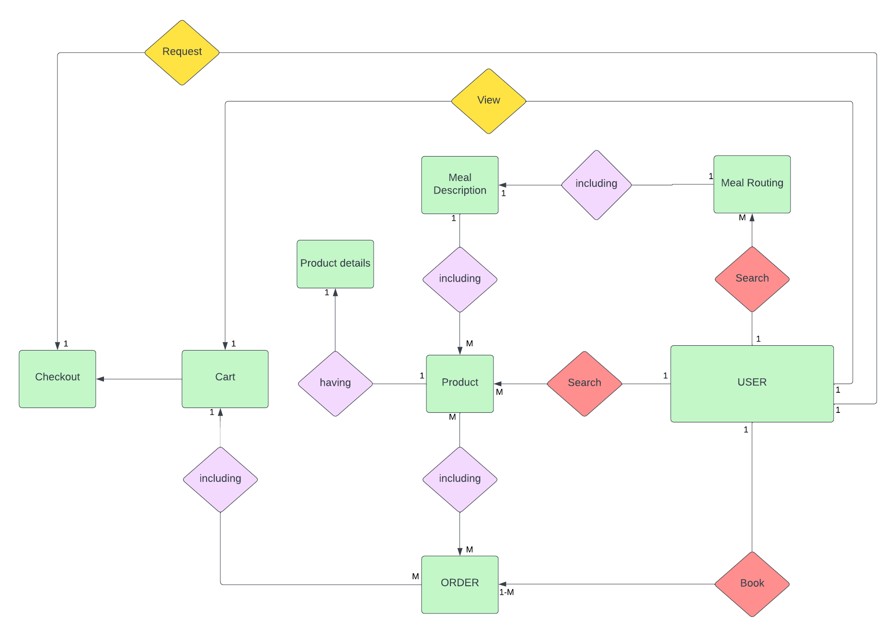

**Entities Description**

|  |  |  |
| --- | --- | --- |
| **#** | **Entity** | **Description** |
| 1 | User |  |
| 2 | Meal |  |
| 3 | Meal Subscription |  |
| 4 | … |  |

# II. Functional Requirements

## Public feature:

### 1.Feature: Search Product

- Screen layout:

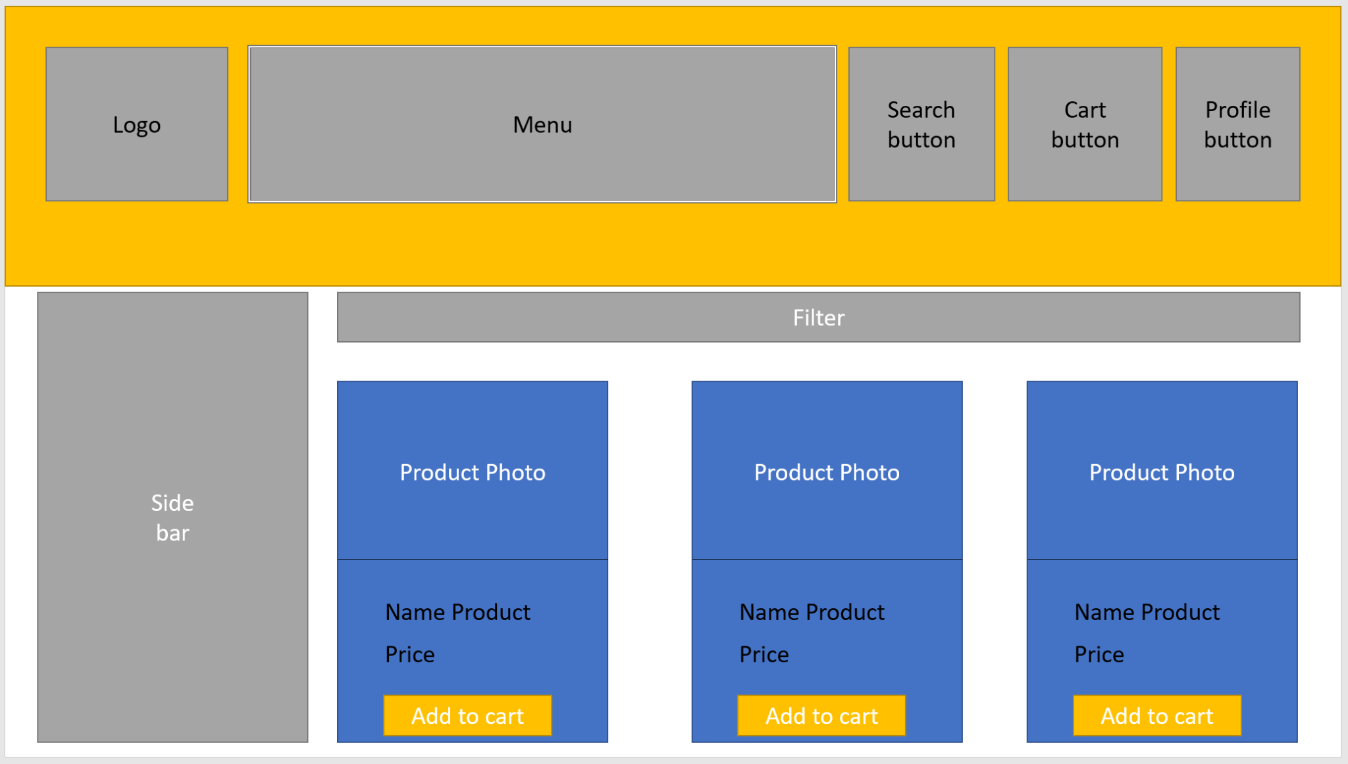

#### a. Search with filter

- Function trigger: Customers will choose their target to search for a product in the form filter.

- Function description: This function helps users to easily find products quickly based on available requirements.

- Function details: In the main screen, the user clicks on the "Filter" icon. Here, a menu will appear with checkboxes named available search requirements. Users need to select the appropriate search requirements, then tick the checkbox and then click the "Search" button. The system will display the search results on the screen.

#### b. Search with no filter

- Function trigger: When User clicks the button with name "Search".

- Function description: This function helps users to search related products based on the keywords entered by the user in the search bar.

- Function details: Users click on the search bar on the screen and type keywords related to the product to be searched. Then, click on the "Search" button, a list of products related to the keyword that the user entered will be rendered on the screen. If the searched product is not suitable, the user can repeat the operation to search for the product.

### 2.Feature: Update

#### a. Change Password

- Function trigger: Customer clicks on “Change password” in the User Profile page.

- Function description: User can change set password to new password.

- Function details: In the User Profile page, the user clicks on "Change password", the system will appear a form asking the user to enter a new password, then the system will send an authentication form asking the user to enter the username and the password you are using to confirm. If the authentication is successful, the new password will be changed. If the authentication fails or the user closes the authentication form, the current password will be preserved and will not be changed..

- Screen layout: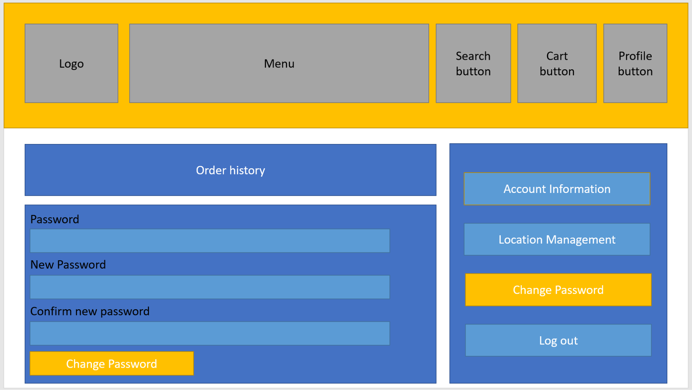

#### b. Edit Profile

- Function trigger: This function triggers when a customer clicks the "Edit" button in the "Location Management" section of the User Profile page.

- Function description: User can edit his/her registered information.

- Function details: display a below screen, similar user profile page but with editable data.

- Screen layout: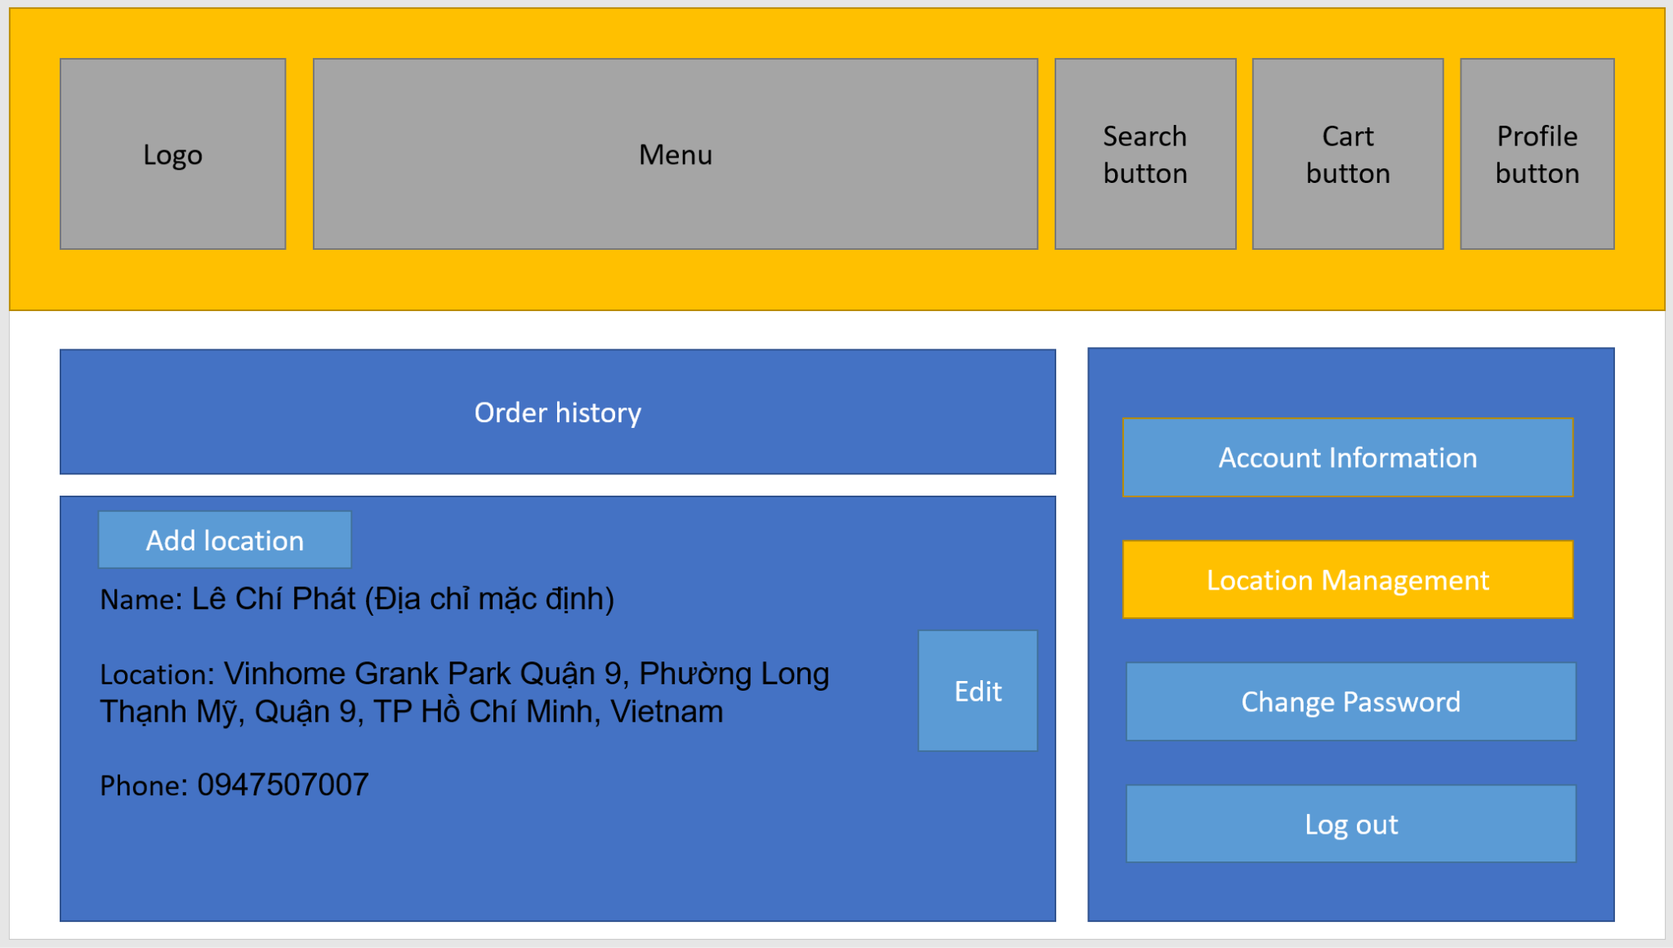

### 3. Feature: Cart

#### a. Add product to cart

- Function trigger: When a customer clicks “Add to cart” in product detail.

- Function description: This function allows users to add the products they want to buy to the cart so they can proceed to checkout later.

- Function details: When the user clicks on the “Add to cart” button, the product will be added to the cart and the product's information will be stored in the user's cart. Users can continue to add other products or view their shopping cart to check and edit before checkout.

- Screen layout: 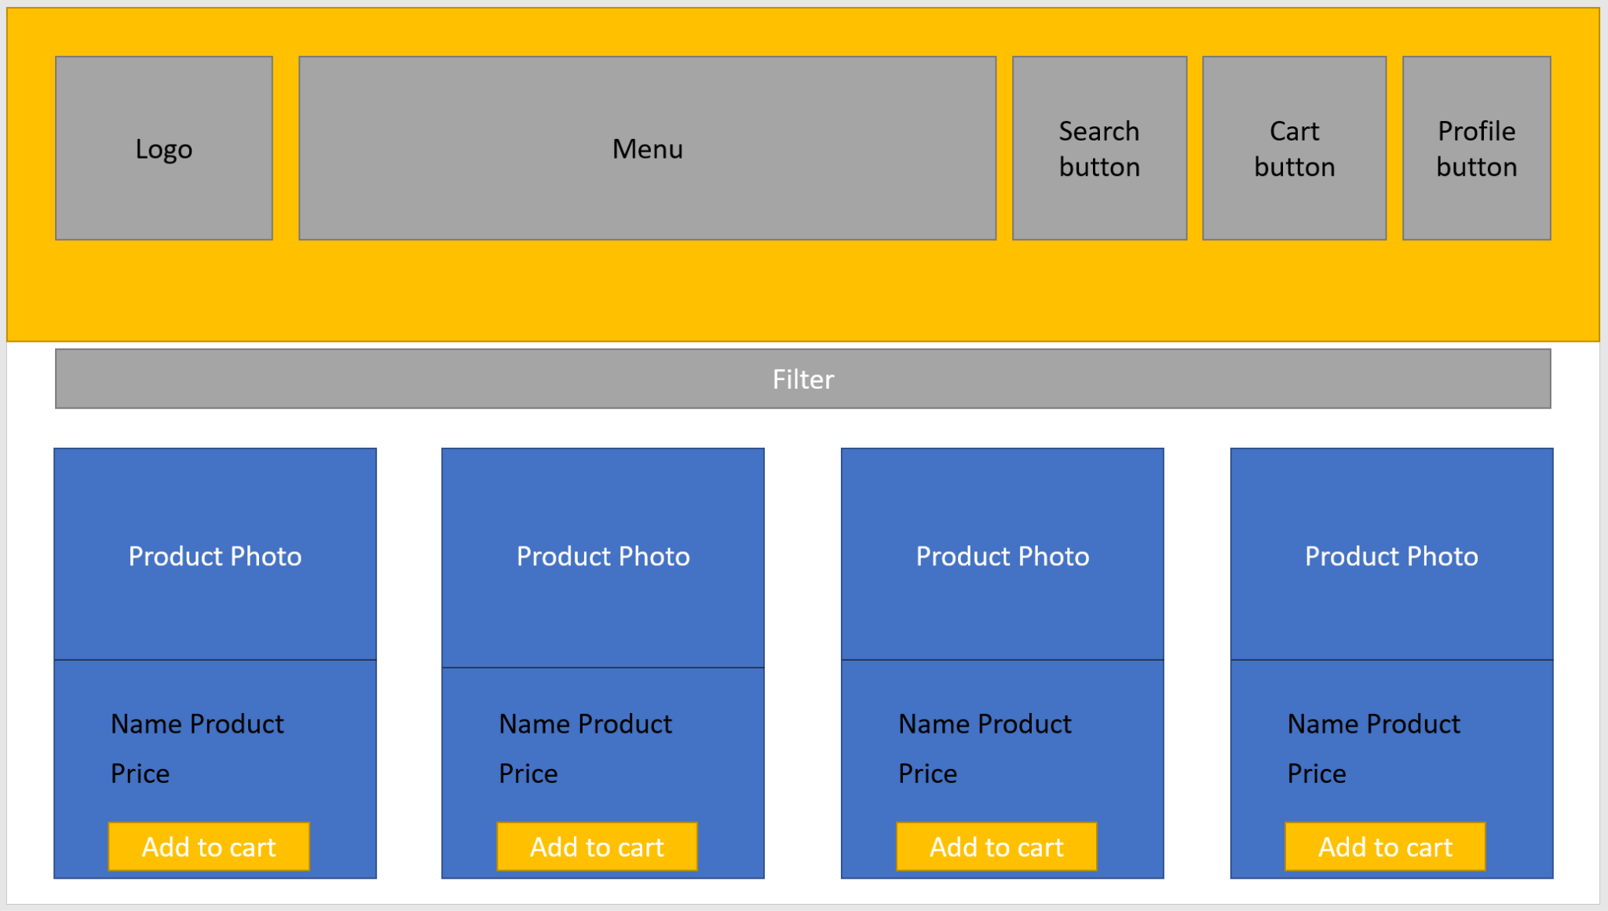

#### b. Edit product in cart

- function trigger: User click on “icon cart” in the header and sendirect to cart detail.

- Function description: Users can edit the quantity of product or remove them out of cart.

- Function details: To be able to edit the products added to the cart, the user can click on the cart icon on the header, the "Product detail" page will appear on the screen. At this page, users can increase or decrease the quantity of previously added products or users can click the "Remove to cart" button to remove the products added to the cart.

- screen layout: 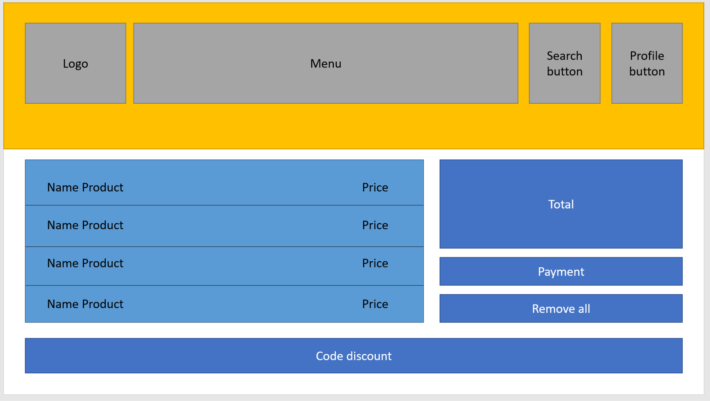

### 4. Feature: Authentication

#### a. Login

- Function trigger: User click the button with name “Login” in screen

- Function description: This function allows users with an activated account or an administrator to log in to the system. When filling in the login information completely and correctly, the system will verify and redirect the page to the homepage if it is a customer account or to the admin page if it is an admin account.

- Function details: The login function starts when the user has an account but has not logged into the system. Here users can login using the login form by filling in the username and password information on the displayed form, then pressing the login button. The system will check the login information, if it is wrong, the system will display the login page and error message again, if successful, the system will save the login data to the session and redirect to the homepage if logged in with the user account or admin page if the user fills in the login information as an admin account.

Users can also choose to log in with a social network account like Google if they click on the login icon with a social network account. The system will then redirect to the authentication page corresponding to that social network. If the authentication is successful, the system will get user information to compare with the database, if the user has not registered with that account, the system will automatically register, save data to the database and session, then transfer Navigate to the homepage and end the login function.

-screen layout: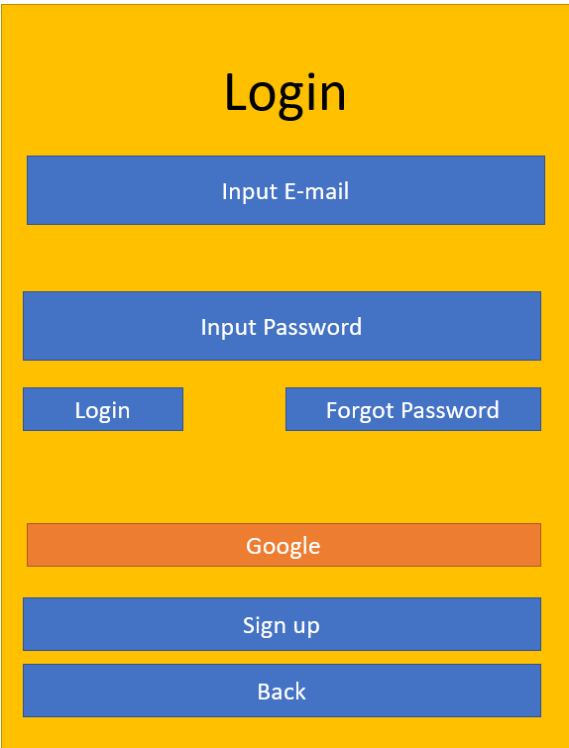

#### b. Logout

- Function trigger: When the user clicks the button with name “Log out” on screen.

- Function description: The function allows users to log out of the system and return to the home page.

- Function details: The logout function starts when the user is logged in in the system and wants to log out the account from the system. On the homepage the user will press the logout button, the system will display the user message "Do you want to exit?" with "Yes" and "No" buttons. Here if the user selects "Yes", the system will cancel the session, exit the login screen and reload the homepage. If the user selects "No", the system will not perform the logout and return to the current screen.

#### c. Register

- Function trigger: When the user clicks on the “Sign up” button. The registration form will occur for users to fill out required information.

- Function description: When users need to create an account for shopping and gain discount points for next time. After registration, the account will be updated to the database, provide security, notification, authentication...

- Function details: The function will receive the information of the user, such as their username, email address, password and some personal information by input. System shall validate the user's input on the registration form to ensure all required fields are filled out and that the email address is in a valid format. The system shall require users to authenticate themselves with their email address and password when logging into their account. The system shall ensure that user passwords are stored securely using encryption or other industry-standard security measures. The system shall create a user profile for the user upon successful account creation, which may include personal information, preferences, or other optional details. The system shall ensure that the registration form and login functionality are accessible to users with disabilities and comply with relevant accessibility standards.

- Screen layout: 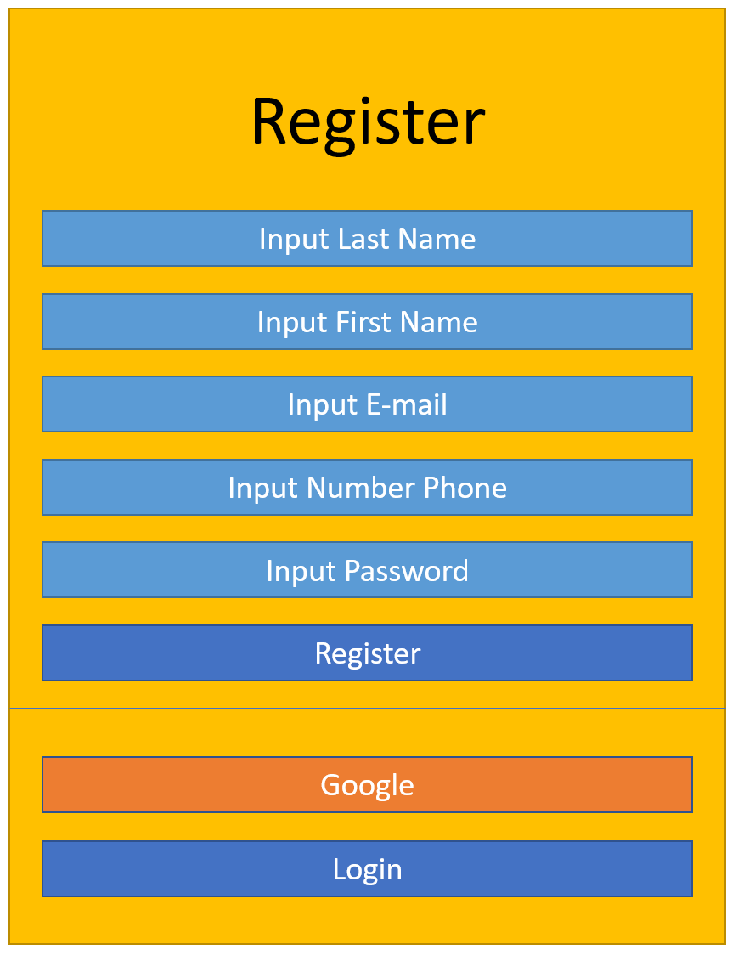

#### d. Reset Password

- Function trigger: When the user clicks "Reset Password" in the User Login page.

- Function description: This function makes it possible for the user to create a new password when the user forgets the current password.

- Function details: When the user clicks "Log In" in the header to log into the system. The User Login page will appear, in this page the words "Forgot Password" will appear. After clicking, here will appear a form for users to enter the email registered on the system. The system will check the email entered by the user. If email is already registered on the system. The system will send the current password to the user email. If the entered email does not exist on the system, the system will reload the form and the message "The email entered is not registered on the system".

- Screen layout:

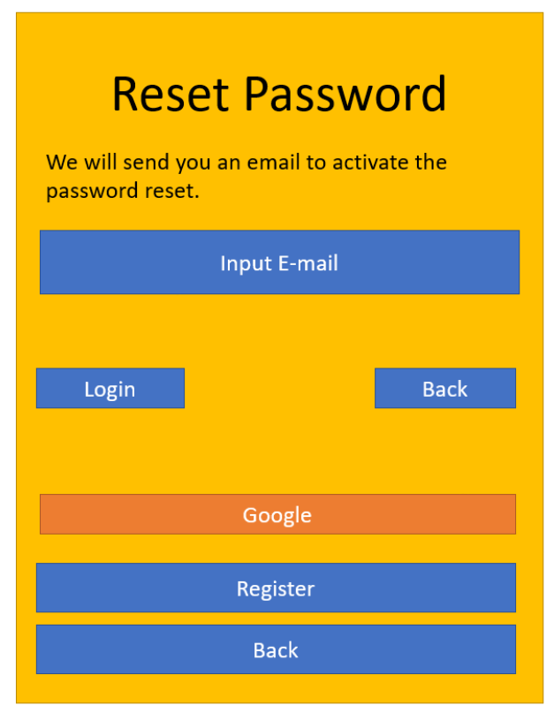

### 5. Feature: View

- Screen layout:

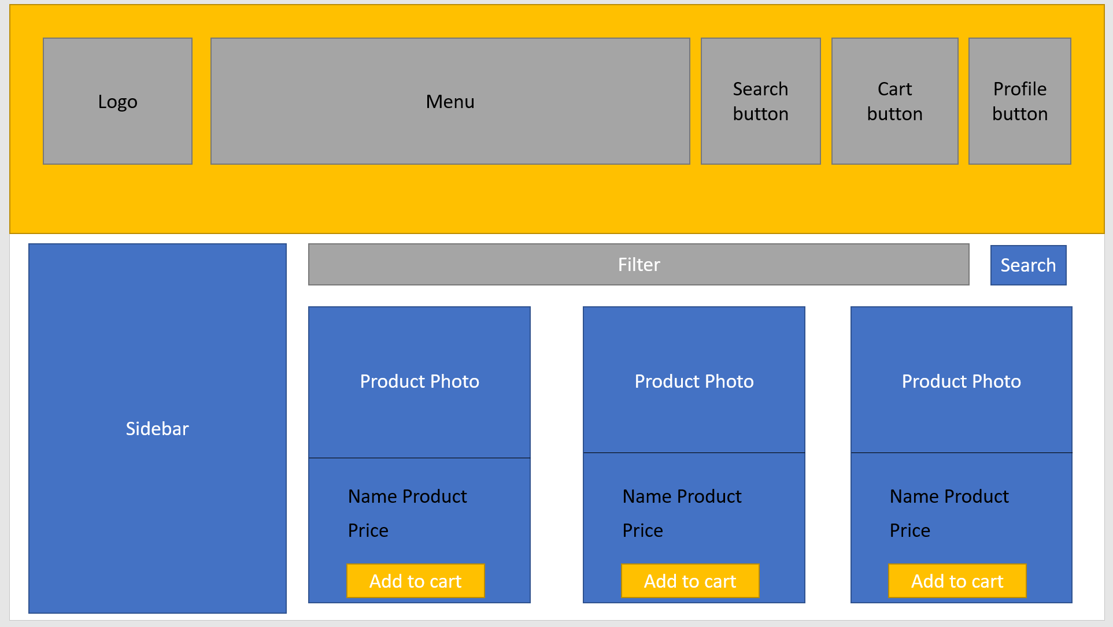

#### a. View product/meal routing list

- Function trigger: When a user visits the Home page.

- Function description: Render product list and meal routing in system.

- Function details: Render a screen below, for customers to choose the product and meal which they are looking for.

### 6. Feature: Feedback

#### a. Rating

- Function trigger: when user clicks on start in product item or in product detail.

- Function description: Users can rate 1 to 5 stars in a product, to show how satisfied their requirement.

- Function details: render a screen below, for users to rate our product.

-screen layout: 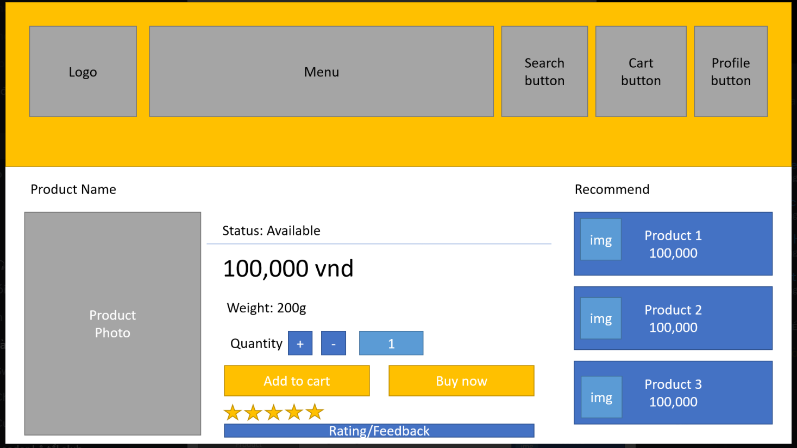

#### b. View feedback

- Function trigger: When a user clicks on a product item to see product detail.

- Function description: Feedback of other users will render in the feedback content.

- Function details: Render a screen below, where to show feedback of this product.

- Screen layout:

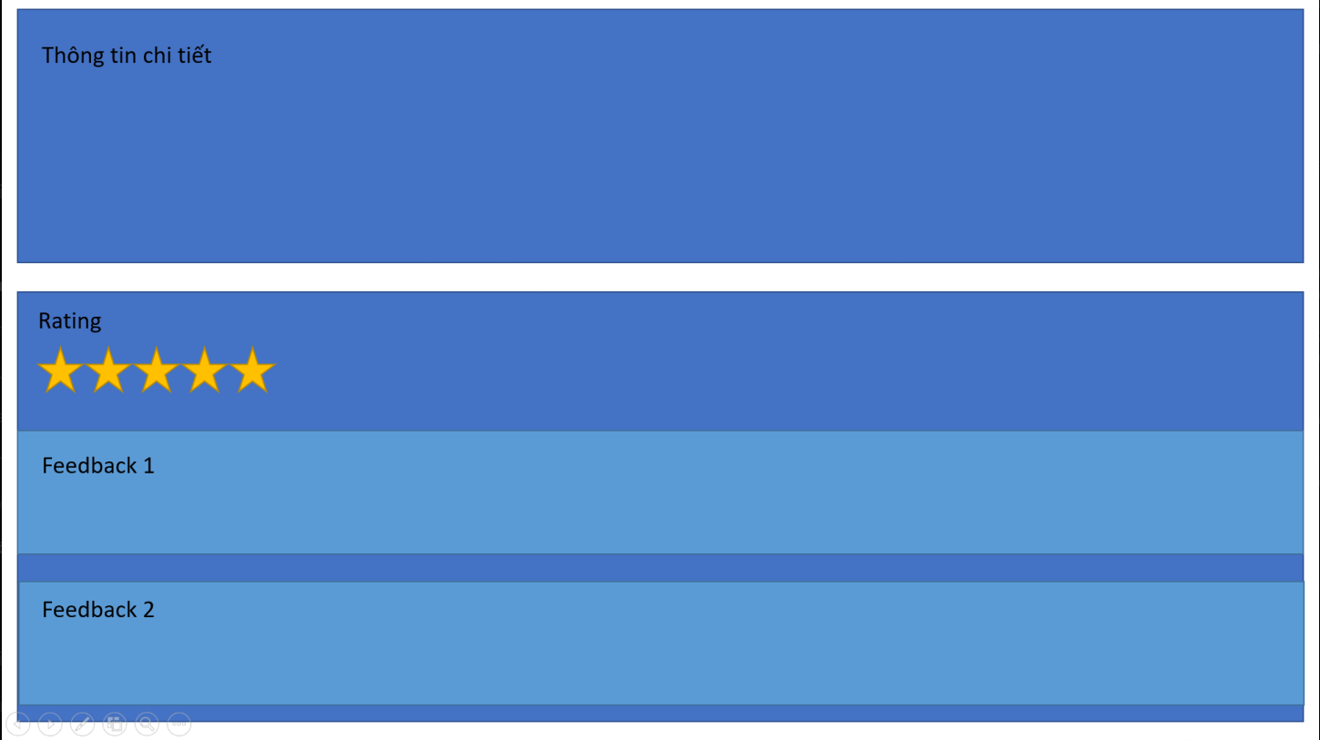

#### c. Send feedback

- Function trigger: In product detail users can type their feedback on this product.

- Function description: have an input text in the below of product detail for users to type their feedback.

- Function details: Render a screen below, for users to type their feedback.

- screen feedback: 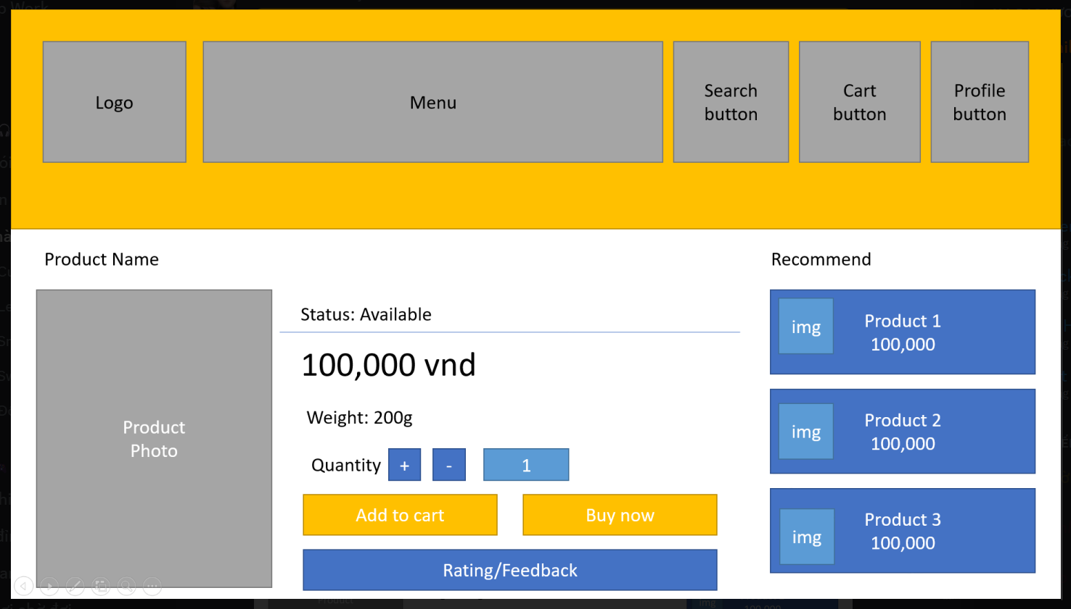

### 7. Feature: Checkout

- Function trigger: When the user clicks on “checkout button” in cart detail.

- Function description: Sendirect them to the check out page.

- Function details: Display a screen below, for customers to fill in the info such as their phone and their location to receive the product.

- Screen layout: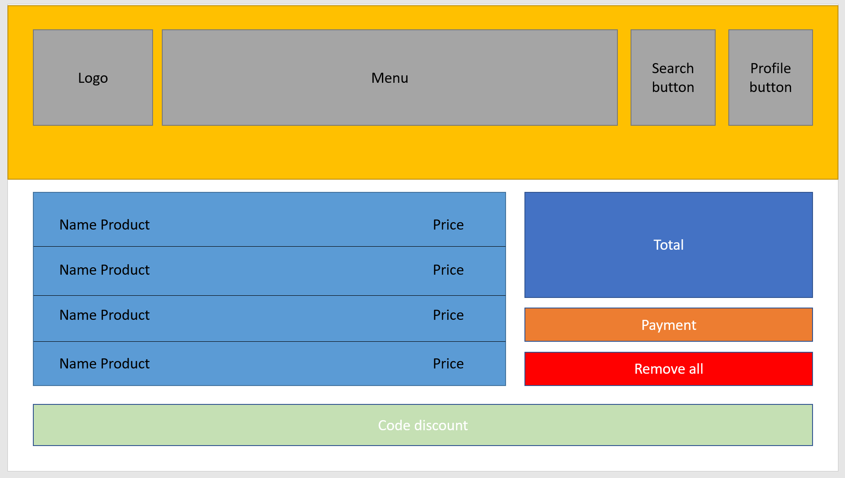

### 8. Feature: Contact

- Function trigger: when user clicks on contact icon in the bellow of screen.

- Function description: Users can contact staff on the contact page.

- Function details: Render a screen below, for type their message and send it to Contact Management.

- Screen layout:

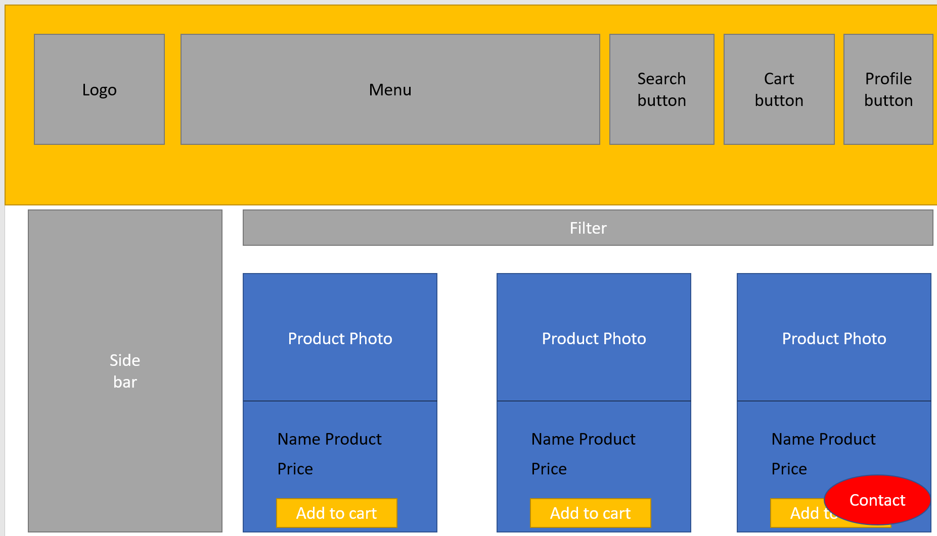

## Manager Feature

### 1. View Dashboard

- Function trigger: When login with an Admin account and choose “View Dashboard” in the sidebar.

- Function description: This function helps admin to see details of revenue and reports of products that were sold.

- Function details: Render a screen below to show the report and revenue of the system.

- Screen layout: 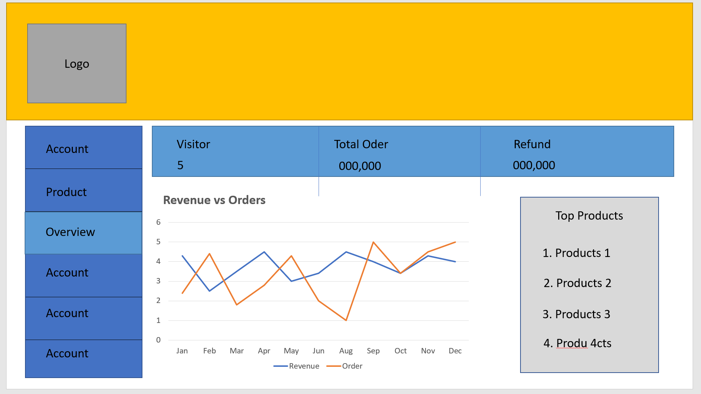

### 2. Account management by Admin

- Function trigger: When admin clicks on “Account management” in the sidebar of the management page.

- Function description: Show the list of accounts in the system so the admin can manage them.

- Function details: Admin can view account profile details and disable them.

- Screen layout: 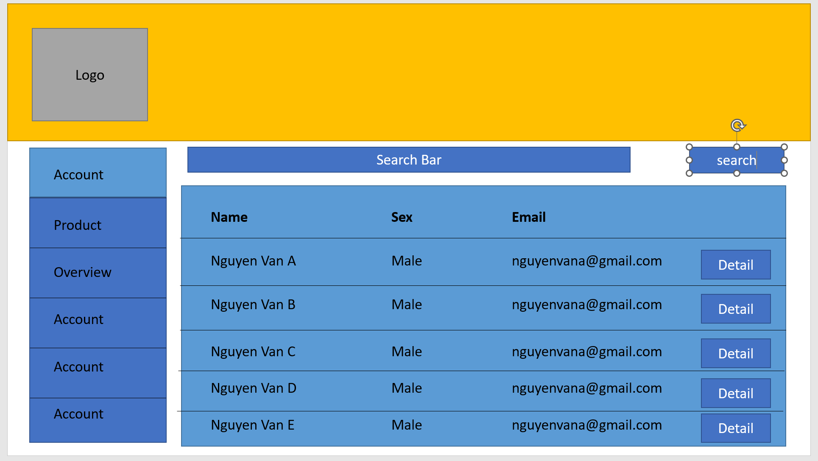

### 3. Search account

- Function trigger: Admin click search button in account management page.

- Function description: Will return the account with information mapping with the keyword in search input.

- Function details: When an admin types their account name in search input and clicks the “Search” button the function will render the list of accounts suitable with this keyword.

- Screen layout: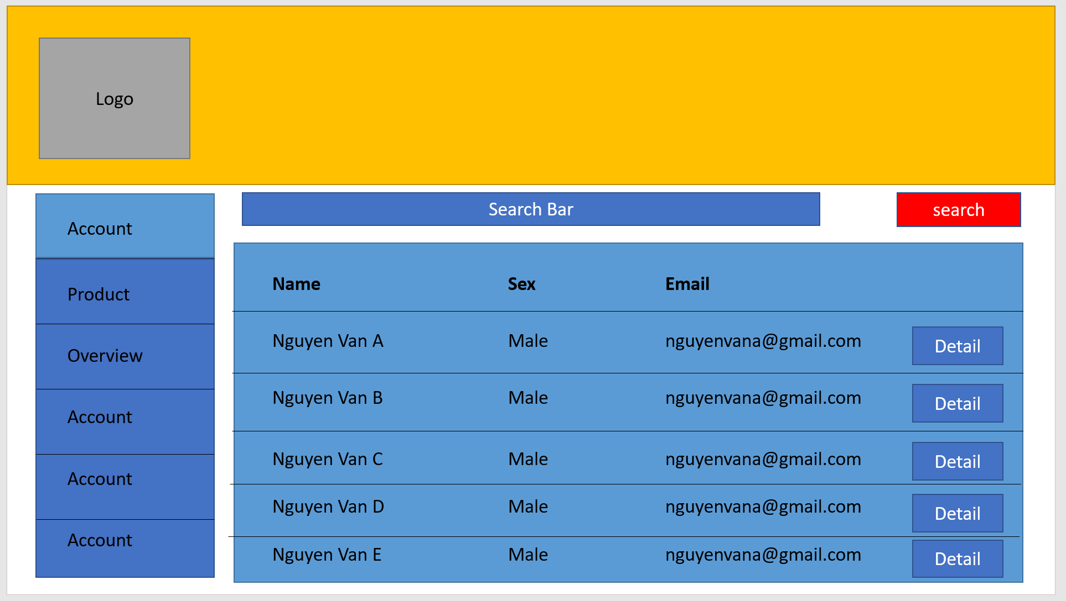

### 4. View profile account detail

- Function trigger: Admin click on “Detail” of account in account management page.

- Function description: Pop up a screen profile detail of which account admin wants to see.

- Function details: Render screen profile detail to show name, password, and have important option is “disable” account for which account admin have reason to avoid them in our system/.

- Screen layout: x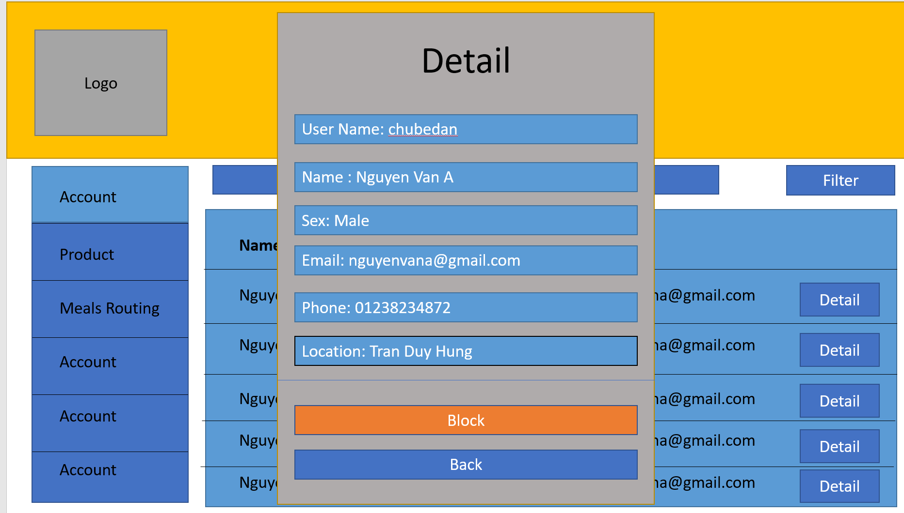

### 5. Product Management

- Function trigger: When staff click on “Product Management” in sidebar of Management Page.

- Function description: Staff can manage the product system through a list of products in the product management screen.

- Function details: Render a screen below, allow staff to edit product lists and update them or add a new product by clicking on the add button.

-screen layout: 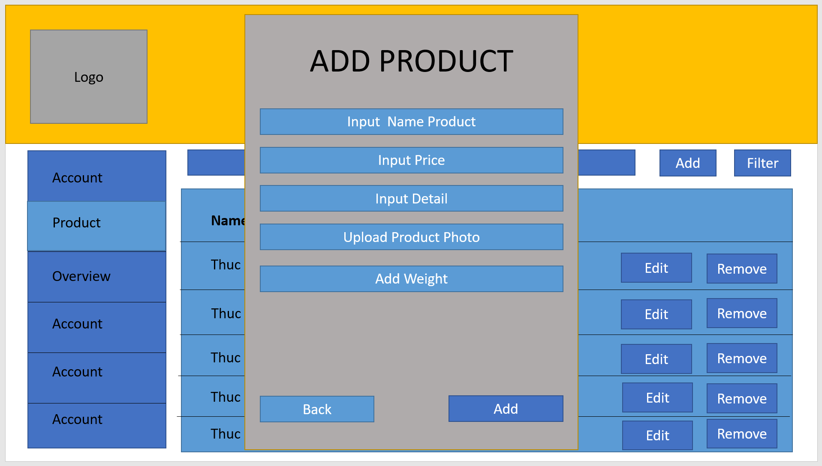

### 6. Feedback management

- Function trigger: When staff click in “Feedback Management” in sidebar of Management Page.

- Function description: Show the list of feedback of each product.

- Function details: Render the screen below, have name product, start, and feedback content for staff can accept them push in product details to avoid feedback unstable such as spam or danger url.

- screen layout: 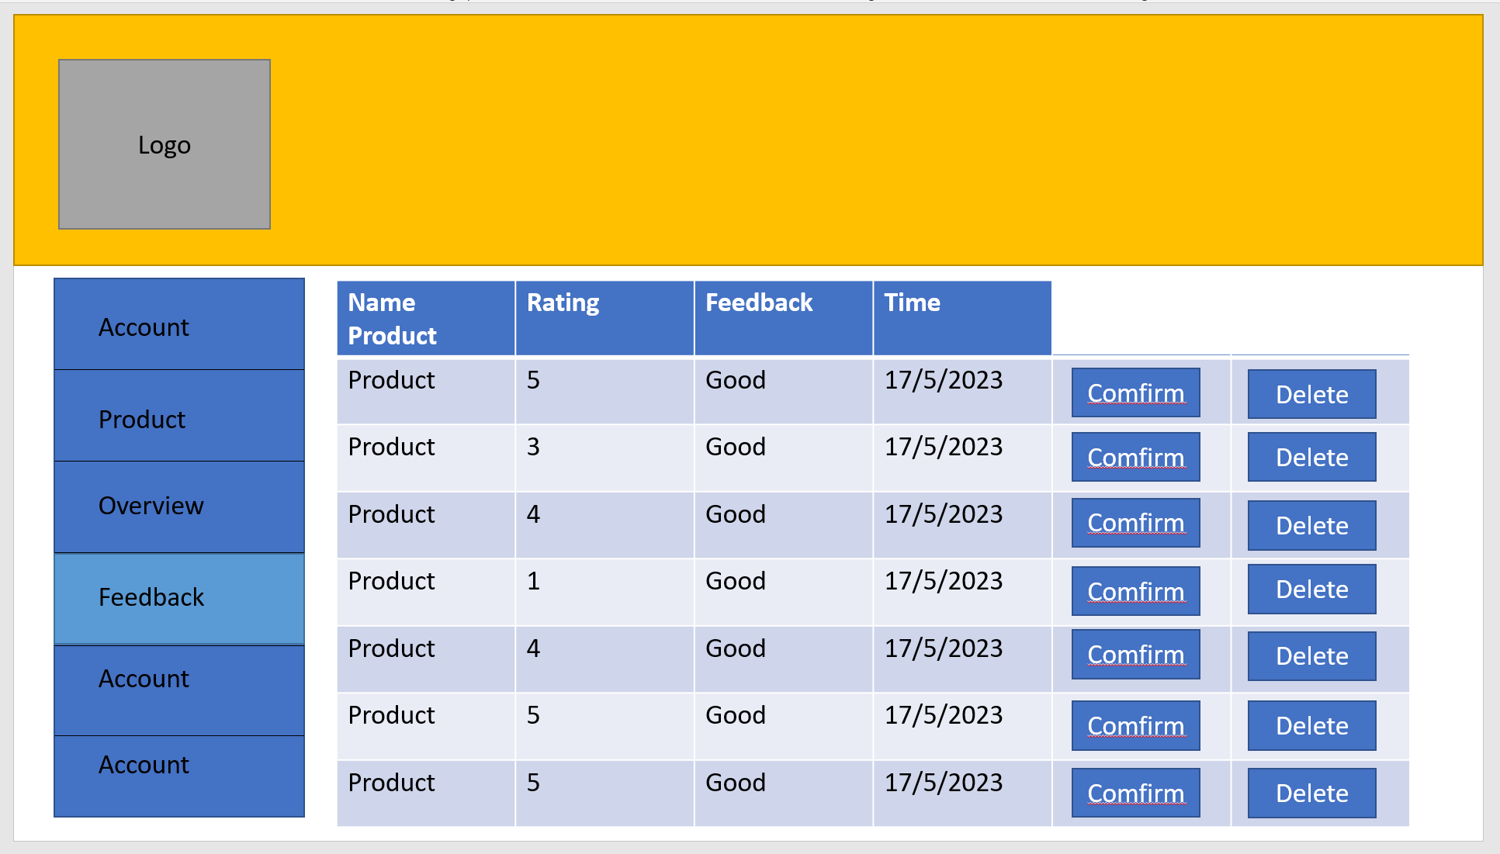

### 7. Contact management

- Function trigger: When staff click on “Contact Management” in the sidebar of the Management Page.

- Function description: Show the list of contacts of each customer.

- Function details: Render the screen below, have the name customer for staff and chat with them. this function will render the screen familiar with the message desktop.

- screen layout: 