SWD392 – SOFTWARE ARCHITECTURE AND DESIGN
PROJECT ASSIGNMENT / LAB
WORKER MANAGEMENT SYSTEM
Worker Information Management – LAB211 J1.S.P0056
Assignment 01 – Use Case Model
User Requirement Document (URD)
Student: Nguyễn Xuân Đạt
Roll Number: HE181308
Class: SWD392_SE1931-NET
Lecturer: ANNV22
— Hanoi, July 2026 —

Table of Contents

I. Record of Changes
Date | A* / M, D | In charge | Change Description
16/07/2026 | A | Nguyễn Xuân Đạt | Initial version – Use Case Model for the Worker Management System (J1.S.P0056).
*A - Added M - Modified D - Deleted

II. Software Requirement Specification

1. Context Diagram
The Worker Management System is a console application built for the LAB211 assignment J1.S.P0056. Its purpose is to let an HR staff member manage worker information: add new workers, increase or decrease a worker’s salary, and review the history of all salary adjustments. The system interacts with a single human actor (the User) and two internal data stores: the worker store (an in-memory map keyed by worker code) and the salary history store (an in-memory list of adjustment records).
The context diagram below shows the external entity and the main data exchanged with the system for release 1.0.
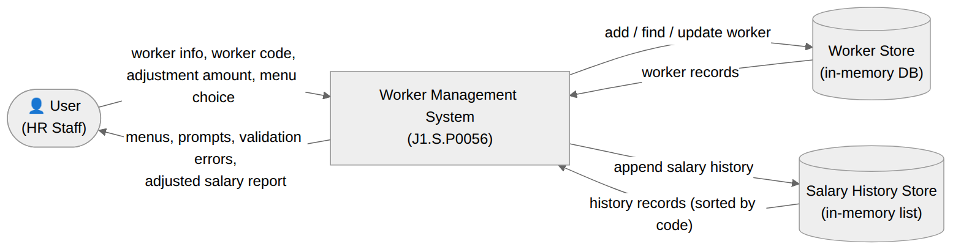
Figure 1. Context Diagram – Worker Management System

2. Use Case Modelling

2.1 Actors
An actor represents the role played by all users of the same type when interacting with the system. The Worker Management System has one human actor.
# | Actor | Description
1 | User (HR Staff) | The end user who operates the console program: adds workers, increases/decreases salaries, and views the adjusted salary report.

2.2 UC Diagrams

2.2.1 UCs for User
The User can add a worker, increase a salary, decrease a salary, show the adjusted salary report, or quit. Adding a worker always includes validating the worker data (code, age, salary). Increasing and decreasing a salary always include checking that the worker code exists, checking that the amount is positive, and saving the salary history.
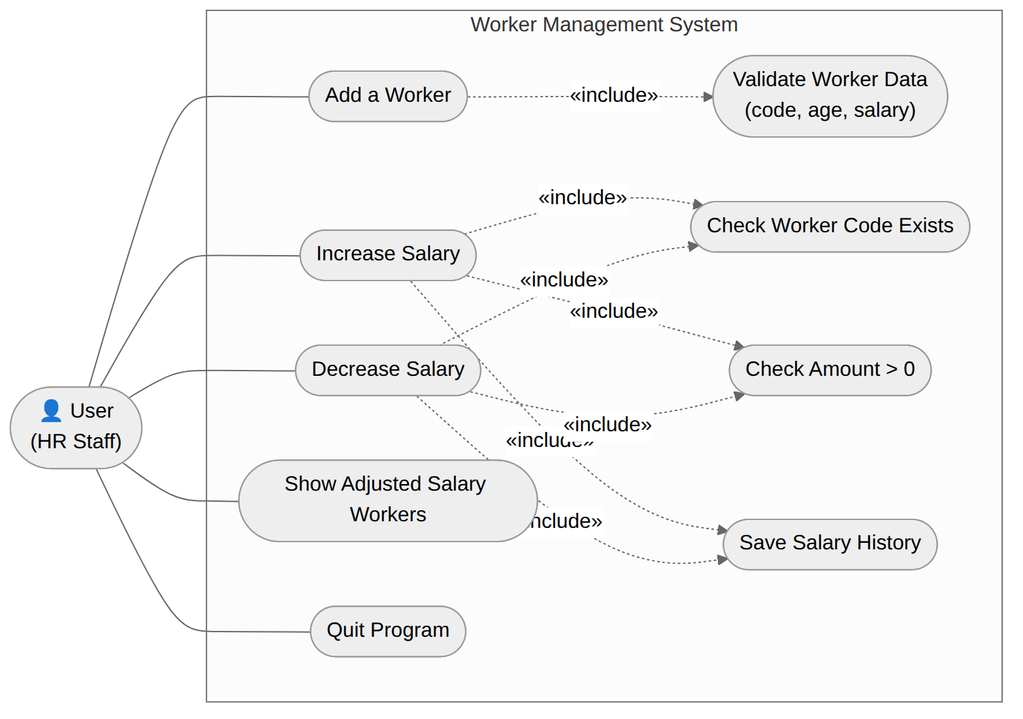
Figure 2. Use Case Diagram – User

2.3 Activity Diagrams

2.3.1 Add a Worker
- Summary: the User enters a new worker’s information; the system validates the code, age and salary, stores the worker in the DB, and reports the result.
- Dependency: includes Validate Worker Data (code not null/duplicated, age 18–50, salary > 0).
- Actors: User (HR Staff).
- Preconditions: the application is running and the main menu is displayed.
Activity Diagram:
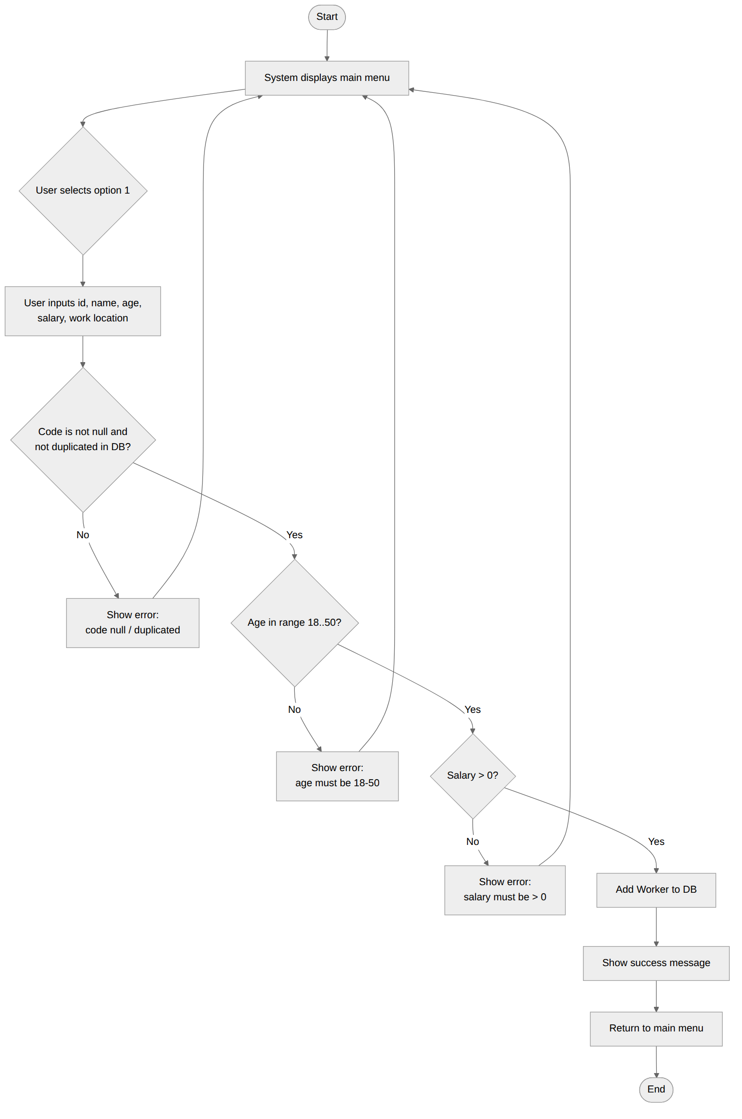
Figure 3. Activity Diagram – Add a Worker

2.3.2 Adjust Salary (Increase / Decrease)
- Summary: the User enters a worker code and an amount; the system verifies the code exists and the amount is positive, updates the salary, saves a history record and reports the result.
- Dependency: includes Check Worker Code Exists, Check Amount > 0 and Save Salary History.
- Actors: User (HR Staff).
- Preconditions: the application is running; the worker to be adjusted should exist in the DB.
Activity Diagram:
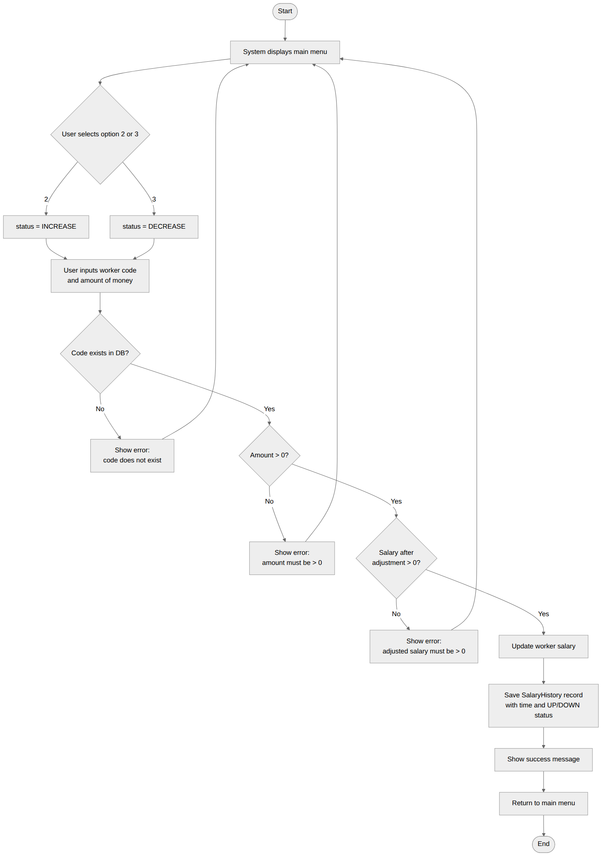
Figure 4. Activity Diagram – Adjust Salary

2.3.3 Show Adjusted Salary Workers
- Summary: the User asks for the adjusted salary report; the system sorts all salary history records by worker code and displays them as a table.
- Actors: User (HR Staff).
- Preconditions: the application is running.
Activity Diagram:
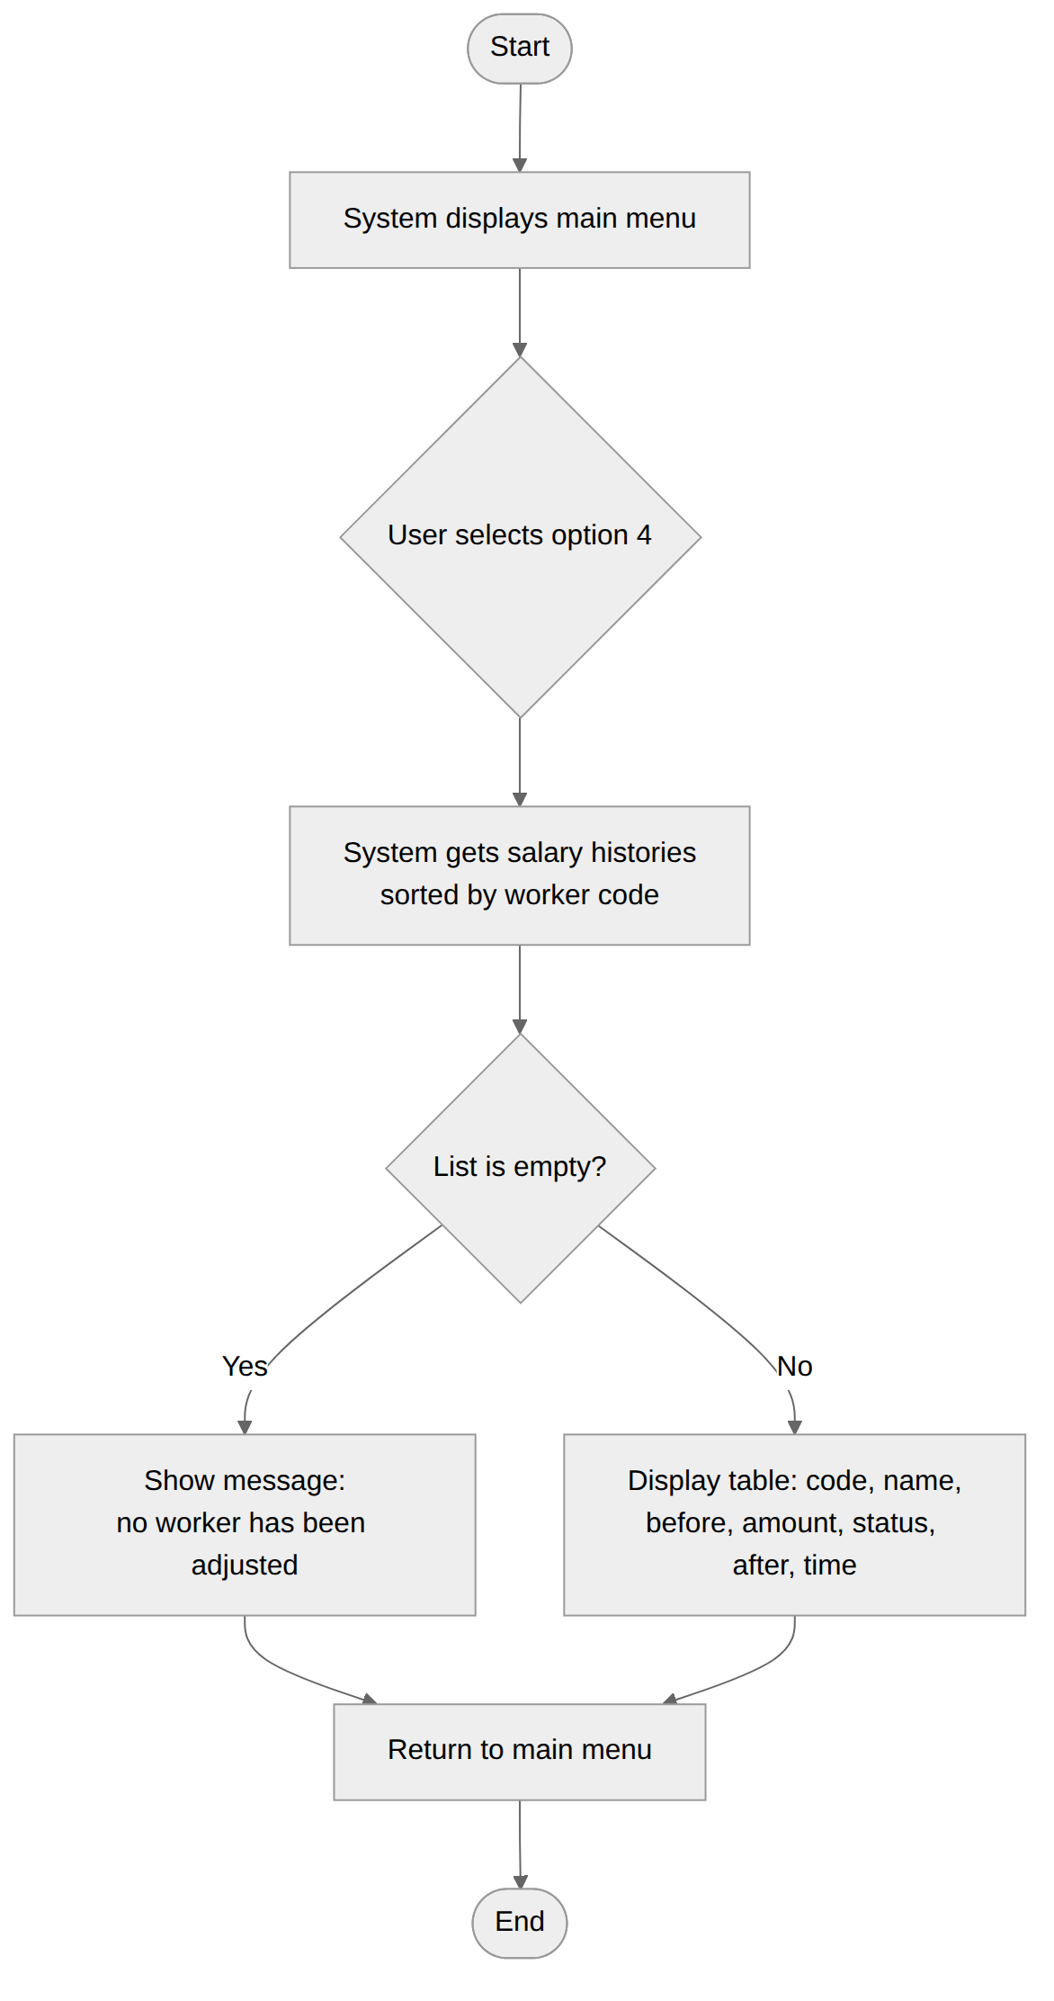
Figure 5. Activity Diagram – Show Adjusted Salary Workers

3. Use Case Specifications

3.1 Worker Management

3.1.1 Add a Worker
Primary Actors | User (HR Staff) | Secondary Actors | None
Trigger | The User selects option 1 (Add a worker) from the main menu.
Description | As an HR staff member, I want to add a new worker with a unique code, name, age, salary and work location, so that the worker is stored in the system and can later receive salary adjustments.
Preconditions | The application is running and the main menu is displayed.
Postconditions | On success the Worker is stored in the in-memory DB and a success message is shown. On failure a descriptive error message is shown and nothing is stored. The system returns to the main menu.
Main Sequence | 1. The User selects option 1 from the main menu.  2. The system prompts for the worker code (id), name, age, salary and work location.  3. The User enters the worker information.  4. The system validates that the code is not null/empty and not duplicated in the DB. [Alt A1]  5. The system validates that the age is in the range 18 to 50. [Alt A2]  6. The system validates that the salary is greater than 0. [Alt A3]  7. The system adds the Worker to the DB (keyed by code).  8. The system displays "Add worker successfully!" and returns to the main menu.
Alternative Sequences | A1 (step 4) – Code is null/empty or duplicated: the system shows the corresponding error message and returns to the main menu.  A2 (step 5) – Age out of range: the system shows "Age must be in range 18 to 50." and returns to the main menu.  A3 (step 6) – Salary invalid: the system shows "Salary must be greater than 0." and returns to the main menu.

3.1.2 Increase Salary
Primary Actors | User (HR Staff) | Secondary Actors | None
Trigger | The User selects option 2 (Increase salary) from the main menu.
Description | As an HR staff member, I want to increase the salary of an existing worker by a positive amount, so that the raise takes effect and is recorded in the salary history.
Preconditions | The application is running; at least one worker should exist in the DB for the operation to succeed.
Postconditions | On success the worker’s salary is increased, a SalaryHistory record with status UP is saved, and a success message is shown. On failure an error is shown and nothing changes.
Main Sequence | 1. The User selects option 2 from the main menu.  2. The system prompts for the worker code (id).  3. The User enters the code.  4. The system prompts for the amount of money to raise.  5. The User enters the amount.  6. The system checks that the code exists in the DB. [Alt A1]  7. The system checks that the amount is greater than 0. [Alt A2]  8. The system adds the amount to the worker’s salary and saves a SalaryHistory record (before, amount, UP, after, time).  9. The system displays "Salary adjusted successfully!" and returns to the main menu.
Alternative Sequences | A1 (step 6) – Code does not exist in the DB: the system shows an error and returns to the main menu.  A2 (step 7) – Amount is not greater than 0: the system shows "Amount of money must be greater than 0." and returns to the main menu.

3.1.3 Decrease Salary
Primary Actors | User (HR Staff) | Secondary Actors | None
Trigger | The User selects option 3 (Decrease salary) from the main menu.
Description | As an HR staff member, I want to decrease the salary of an existing worker by a positive amount, so that the cut takes effect and is recorded in the salary history.
Preconditions | The application is running; at least one worker should exist in the DB for the operation to succeed.
Postconditions | On success the worker’s salary is decreased, a SalaryHistory record with status DOWN is saved, and a success message is shown. On failure an error is shown and nothing changes.
Main Sequence | 1. The User selects option 3 from the main menu.  2. The system prompts for the worker code (id).  3. The User enters the code.  4. The system prompts for the amount of money to cut.  5. The User enters the amount.  6. The system checks that the code exists in the DB. [Alt A1]  7. The system checks that the amount is greater than 0. [Alt A2]  8. The system checks that the salary after the cut is still greater than 0. [Alt A3]  9. The system subtracts the amount from the worker’s salary and saves a SalaryHistory record (before, amount, DOWN, after, time).  10. The system displays "Salary adjusted successfully!" and returns to the main menu.
Alternative Sequences | A1 (step 6) – Code does not exist in the DB: the system shows an error and returns to the main menu.  A2 (step 7) – Amount is not greater than 0: the system shows an error and returns to the main menu.  A3 (step 8) – Salary after adjustment would be ≤ 0: the system shows "Salary after adjustment must be greater than 0." and returns to the main menu.

3.1.4 Show Adjusted Salary Workers
Primary Actors | User (HR Staff) | Secondary Actors | None
Trigger | The User selects option 4 (Show adjusted salary worker information) from the main menu.
Description | As an HR staff member, I want to see the list of all salary adjustments sorted by worker code, so that I can review who has been adjusted, by how much, and when.
Preconditions | The application is running.
Postconditions | The list of SalaryHistory records, sorted by worker code, is displayed. The stored data is not modified.
Main Sequence | 1. The User selects option 4 from the main menu.  2. The system retrieves all SalaryHistory records and sorts them by worker code (id).  3. The system displays the records as a table: code, name, salary before, amount, status (UP/DOWN), salary after, time.  4. The system returns to the main menu.
Alternative Sequences | Step 3 – No adjustment has been made yet: the system shows "No worker has been adjusted salary." and returns to the main menu.

4. Non-Functional Requirements

4.1 External Interfaces
- User Interface: text-based console; keyboard input and standard output. Menus, prompts and error messages are plain English text.
- Hardware Interfaces: none specific; any machine able to run a Java Runtime Environment.
- Software Interfaces: Java SE 11 or later. All data is kept in memory for the lifetime of the program; no external files or database are required.
- Communication Interfaces: none; the application is a standalone console program with no network connection.

4.2 Quality Attributes

4.2.1 Usability
- The menu is always re-displayed after each operation, so the user never gets lost.
- Invalid input produces a clear, specific error message and returns the user safely to the menu without crashing.
- A first-time user can add a worker and adjust a salary within about one minute.

4.2.2 Performance
- Adding a worker and adjusting a salary are O(1) map operations; each completes in well under one second.
- The adjusted salary report is sorted by worker code in O(n log n) over the history records.

4.2.3 Data Integrity
- Worker codes are unique; a duplicated or empty code is rejected before anything is stored.
- Age (18–50), salary (> 0) and adjustment amount (> 0) rules are enforced by the Model before any state change.
- A salary can never become zero or negative: a decrease that would do so is rejected.
- Every successful adjustment is recorded in the salary history with a timestamp and UP/DOWN status.

4.2.4 Reliability
- Non-numeric input for numeric fields (age, salary, amount, menu choice) is caught and re-prompted instead of terminating the program.
- Business rule violations are reported through exceptions that are caught by the Controller; the program always returns to the main menu.

