SWD392 – SOFTWARE ARCHITECTURE AND DESIGN
PROJECT ASSIGNMENT / LAB
WORKER MANAGEMENT SYSTEM
Worker Information Management – LAB211 J1.S.P0056
Assignment 02 – Analysis Model
Static & Dynamic Modeling
Student: Nguyễn Xuân Đạt
Roll Number: HE181308
Class: SWD392_SE1931-NET
Lecturer: ANNV22
— Hanoi, July 2026 —

Table of Contents

I. Record of Changes
Date | A* / M, D | In charge | Change Description
16/07/2026 | A | Nguyễn Xuân Đạt | Initial version – Analysis Model for the Worker Management System (J1.S.P0056).
*A - Added M - Modified D - Deleted

II. Static Modeling

1. Context Modeling
Static modeling defines the boundary of the system and the external entities with which it exchanges data. The Worker Management System interacts with one human actor (the User) and two internal data stores: the worker store (an in-memory Map keyed by worker code) and the salary history store (an in-memory List of adjustment records). The context model below summarizes these boundaries.
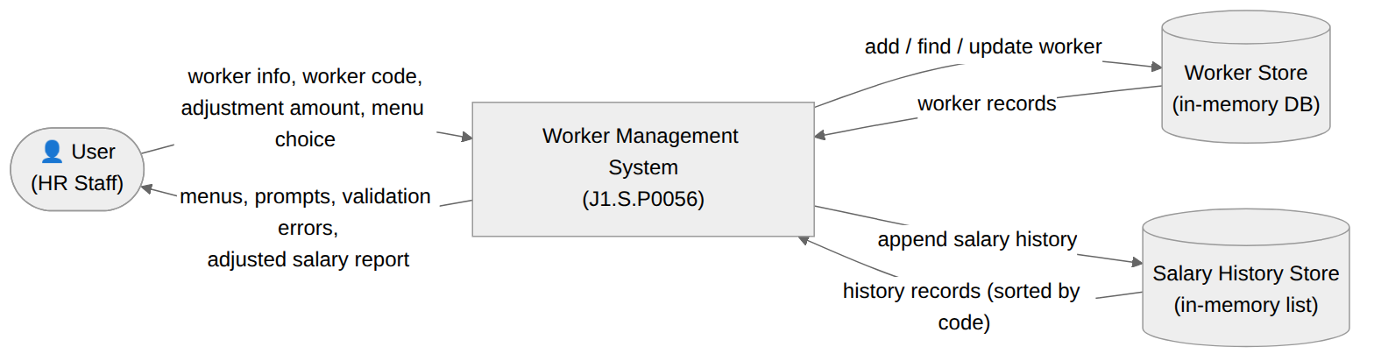
Figure 1. Context Model – Worker Management System

2. Entity Classes
The analysis identifies two persistent business entities. Worker is the master record managed by the system; SalaryHistory is the adjustment record created every time a salary is changed. The SalaryStatus enumeration qualifies each adjustment as an increase (UP) or a decrease (DOWN).
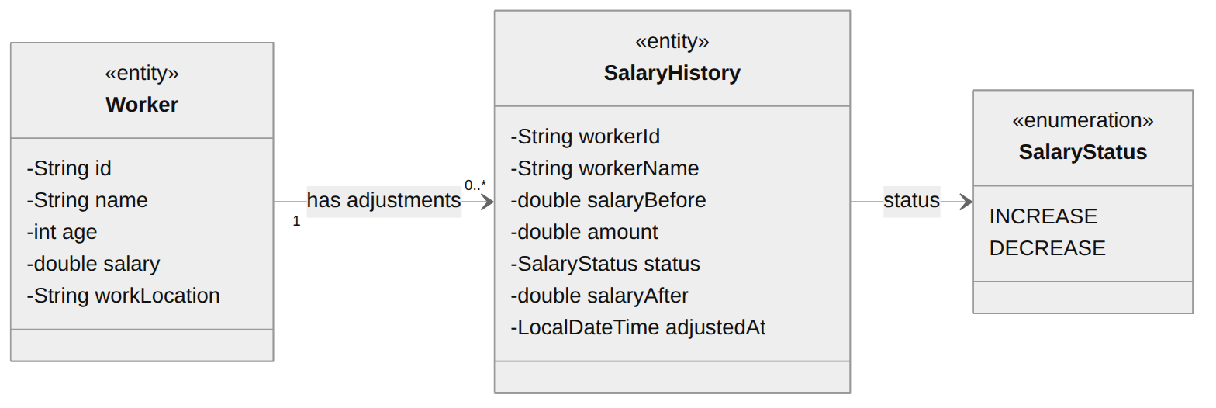
Figure 2. Entity Classes – Worker & SalaryHistory
Worker
Attribute | Type | Description
id | String | Unique worker code; acts as the key of the in-memory DB. Cannot be null or duplicated.
name | String | Full name of the worker.
age | int | Worker age; must be in the range 18 to 50.
salary | double | Current salary; must be greater than 0.
workLocation | String | The location where the worker works.

SalaryHistory
Attribute | Type | Description
workerId | String | Code of the adjusted worker (references Worker.id).
workerName | String | Name of the worker at adjustment time.
salaryBefore | double | Salary before the adjustment.
amount | double | Adjustment amount; always greater than 0.
status | SalaryStatus | INCREASE (shown as UP) or DECREASE (shown as DOWN).
salaryAfter | double | Salary after the adjustment; greater than 0.
adjustedAt | LocalDateTime | Timestamp of the adjustment.

III. Object & Class Structuring

1. Add a Worker

a. Class Diagram
The robustness (View of Participating Classes) diagram below shows the boundary, control and entity objects that collaborate to realize the Add a Worker use case.
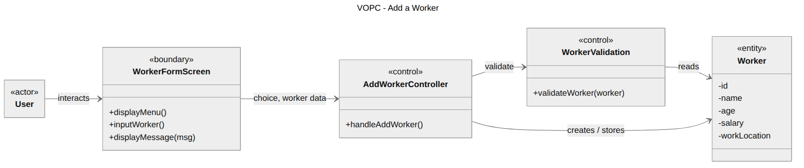
Figure 3. VOPC – Add a Worker

b. Class Description
Analysis Class | Stereotype | Responsibility | Realized by
WorkerFormScreen | «boundary» | Handles all console interaction for adding a worker: shows the menu and prompts, reads id, name, age, salary and work location, and displays results. | WorkerView
AddWorkerController | «control» | Orchestrates the Add a Worker use case: passes the entered data to the model and routes the success/error message back to the screen. | WorkerController
WorkerValidation | «control» | Validates the business rules: code not null/duplicated, age 18–50, salary > 0. | Management (validateWorker)
Worker | «entity» | Represents a worker (id, name, age, salary, work location); stored in the in-memory DB keyed by code. | Worker

2. Adjust Salary (Increase / Decrease)

a. Class Diagram
Adjusting a salary involves a boundary object (the salary screen), a control object that coordinates the use case, a rules object that validates the request, and the two entities that are read and written.
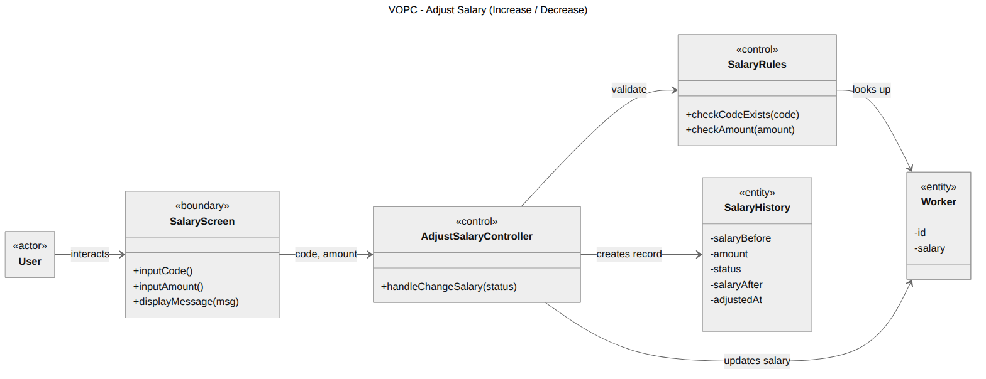
Figure 4. VOPC – Adjust Salary

b. Class Description
Analysis Class | Stereotype | Responsibility | Realized by
SalaryScreen | «boundary» | Prompts for the worker code and the amount of money; displays the outcome. | WorkerView
AdjustSalaryController | «control» | Coordinates the adjustment: forwards status (INCREASE/DECREASE), code and amount to the model. | WorkerController
SalaryRules | «control» | Checks the code exists in the DB, the amount is > 0, and the resulting salary stays > 0. | Management (changeSalary)
Worker | «entity» | The worker whose salary is updated. | Worker
SalaryHistory | «entity» | The adjustment record (before, amount, UP/DOWN, after, time) appended to the history store. | SalaryHistory

IV. Dynamic Interaction Modeling

1. Add a Worker

a. Communication Diagram
The communication diagram below shows the numbered message exchange between the participating objects when a worker is added.
Figure 5. Communication Diagram – Add a Worker

b. Sequence Diagram
The analysis-level sequence diagram shows the same collaboration ordered over time.
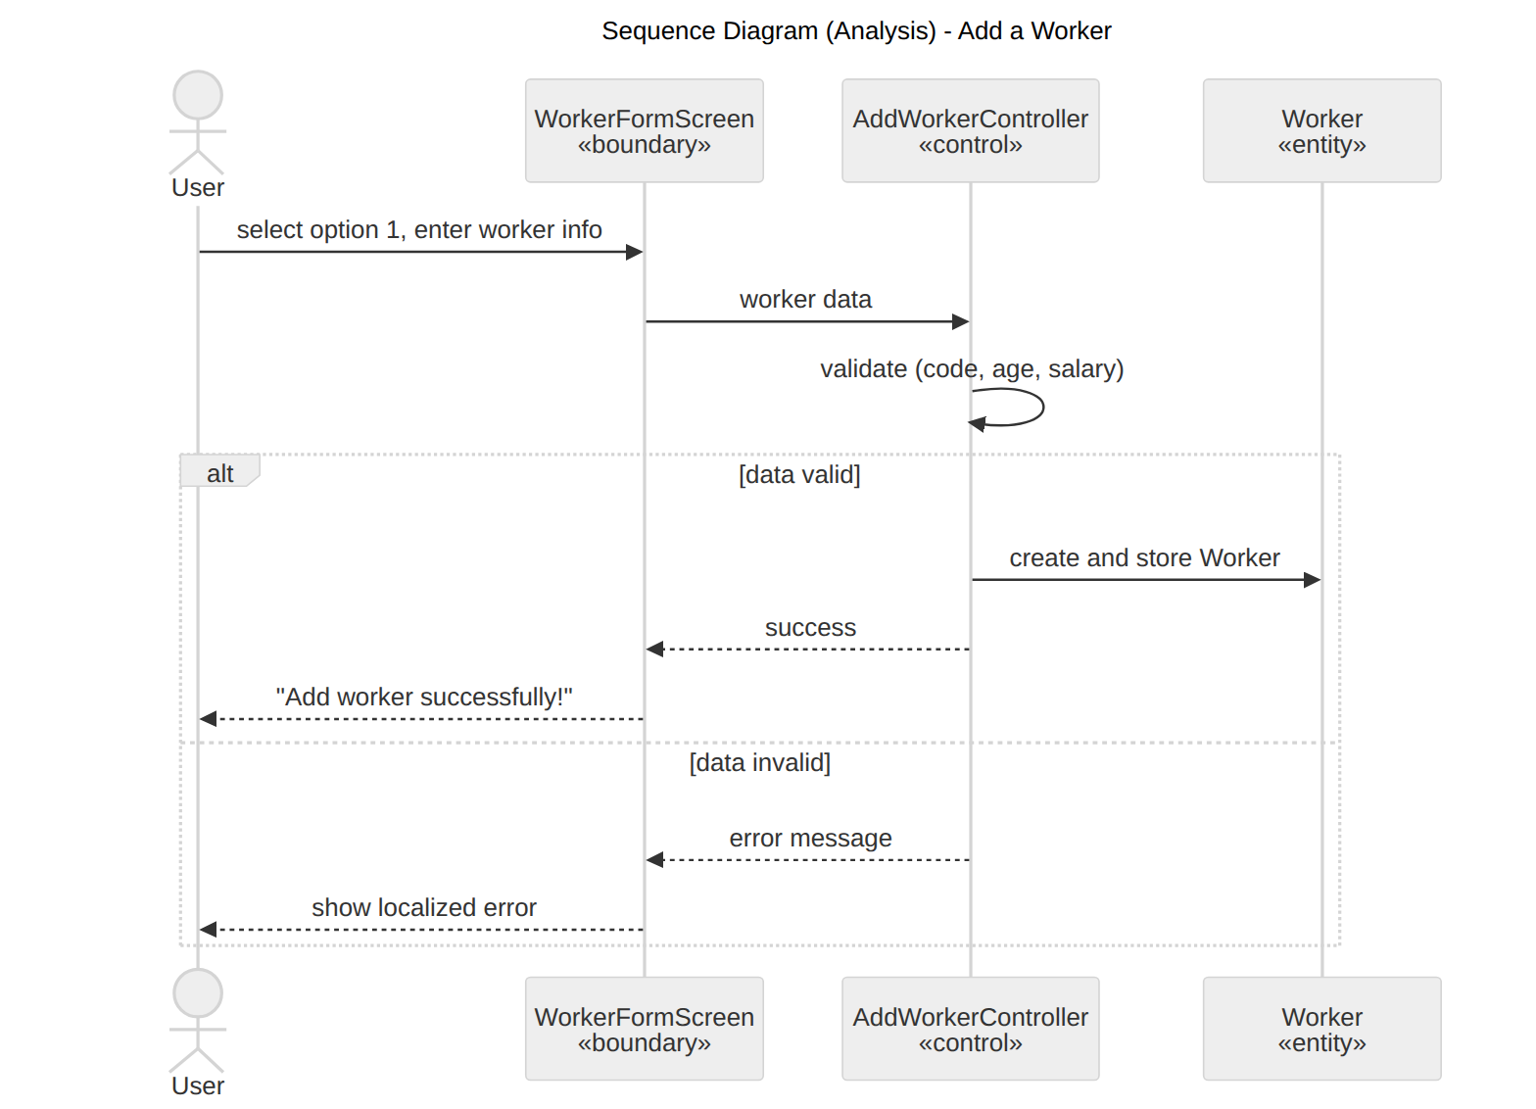
Figure 6. Sequence Diagram (Analysis) – Add a Worker

2. Adjust Salary (Increase / Decrease)

a. Communication Diagram
Adjusting a salary is a slightly longer interaction: the controller collects the code and the amount, the model validates both, updates the worker and appends a history record.
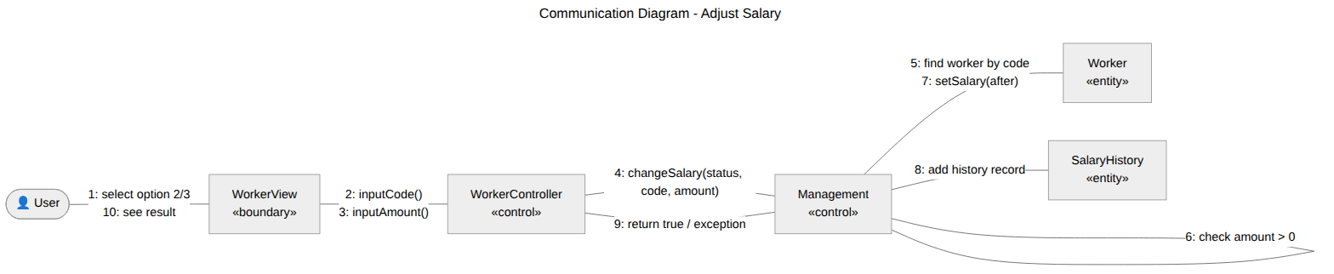
Figure 7. Communication Diagram – Adjust Salary

b. Sequence Diagram
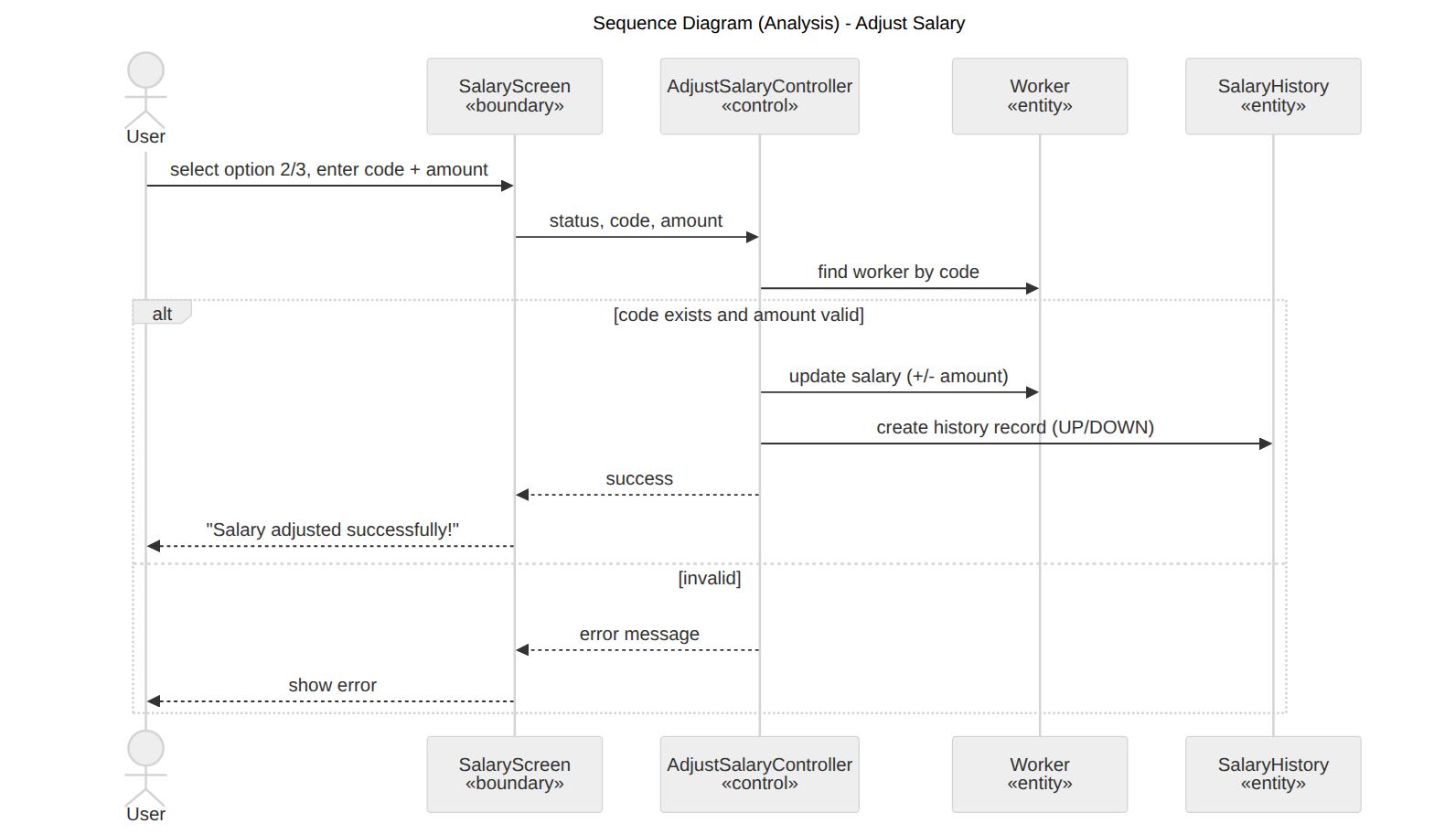
Figure 8. Sequence Diagram (Analysis) – Adjust Salary

V. Finite State Machine

1. Salary Adjustment Session
A salary adjustment session progresses through entering the worker code, entering the amount and validating the request, and ends in either Succeeded (salary updated, history saved) or Failed (a rule was violated). In both cases the system returns to the main menu.
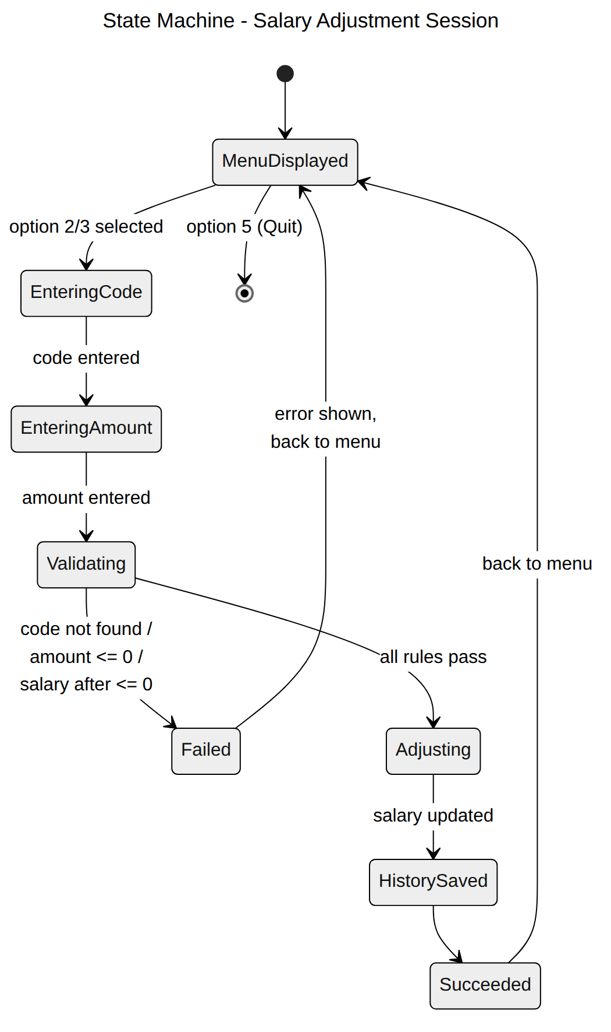
Figure 9. State Machine – Salary Adjustment Session

2. Worker Record
Each worker record starts outside the system, becomes Registered when it passes validation and is stored in the DB, and moves to Adjusted after its first successful salary adjustment. Every further adjustment keeps the record in the Adjusted state and appends one more history row.
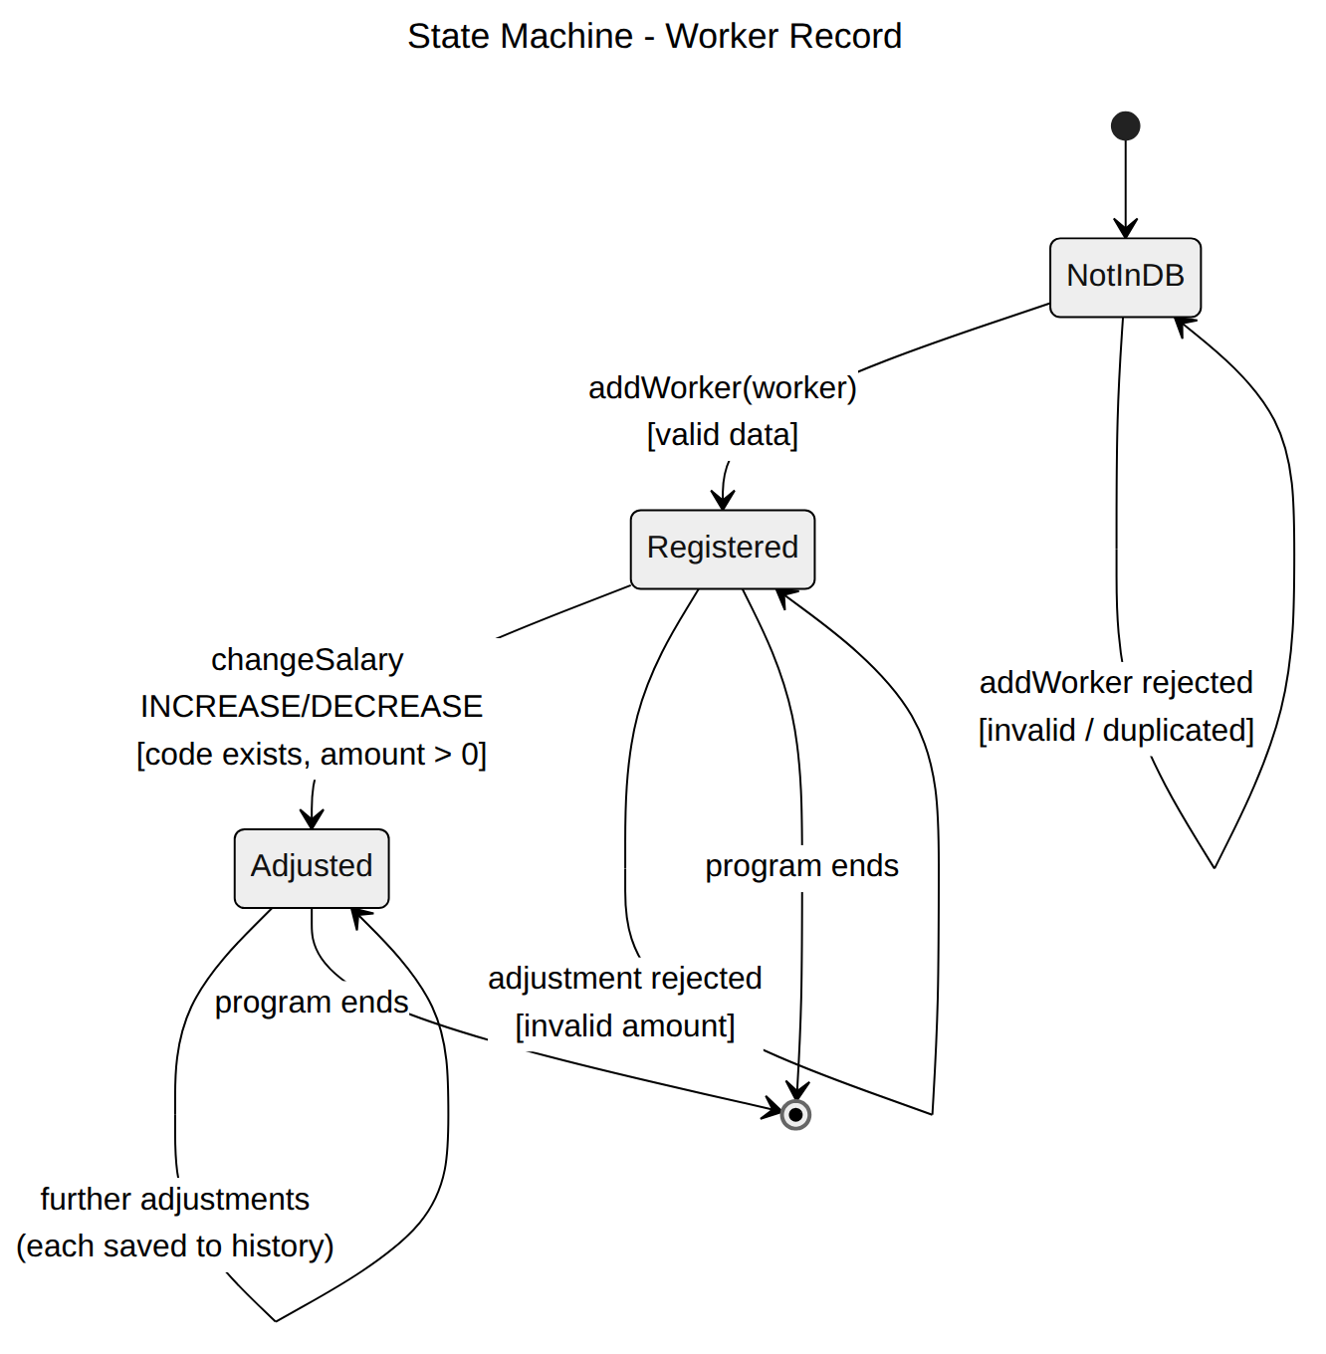
Figure 10. State Machine – Worker Record

