SWD392 – SOFTWARE ARCHITECTURE AND DESIGN
PROJECT ASSIGNMENT / LAB
WORKER MANAGEMENT SYSTEM
Worker Information Management – LAB211 J1.S.P0056
Assignment 03 – Design Model
User Interface, Architecture & Detailed Design
Student: Nguyễn Xuân Đạt
Roll Number: HE181308
Class: SWD392_SE1931-NET
Lecturer: ANNV22
— Hanoi, July 2026 —

Table of Contents

I. Record of Changes
Date | A* / M, D | In charge | Change Description
16/07/2026 | A | Nguyễn Xuân Đạt | Initial version – Design Model for the Worker Management System (J1.S.P0056).
*A - Added M - Modified D - Deleted

II. User Interface Design
The application is a console program, so each "screen" is a block of text printed to standard output. All interaction follows the same cycle: the main menu is displayed, the user selects an option, the system prompts for the data it needs, shows the result, and returns to the menu.

1. Worker Management

1.1 Main Menu Screen
The first screen lists the five options of the program. It is re-displayed after every completed or failed operation.
===== WORKER MANAGEMENT =====
1. Add a worker
2. Increase salary
3. Decrease salary
4. Show adjusted salary worker information
5. Quit
Please select an option (1-5): _
Screen 1. Main menu

1.2 Add Worker Screen
Option 1 prompts for the five fields of a worker, then reports the result of the validation.
Enter worker code (id): W01
Enter worker name: Tran Thi A
Enter worker age: 30
Enter worker salary: 8000
Enter work location: Da Nang
Add worker successfully!
Screen 2. Add a worker (successful case)

1.3 Adjust Salary Screen
Options 2 and 3 share the same dialog: the user provides the worker code and the amount of money.
Enter worker code (id): W01
Enter amount of money: 2000
Salary adjusted successfully!
Screen 3. Increase / decrease salary

1.4 Adjusted Salary Report Screen
Option 4 prints the salary history sorted by worker code as a fixed-width table.
----- ADJUSTED SALARY WORKERS -----
Code | Name | Before | Amount | Status | After | Time
W01 | Tran Thi A | 8000.00 | 2000.00 | UP | 10000.00| 16/07/2026 13:42:20
W02 | Nguyen Van B | 5000.00 | 1500.00 | DOWN | 3500.00| 16/07/2026 13:42:20
Screen 4. Adjusted salary workers

1.5 Error Messages
Every violated business rule produces a specific message prefixed with "ERROR:", after which the main menu is shown again.
ERROR: Worker code [W99] does not exist in DB.
-- or --
ERROR: Age must be in range 18 to 50.
Screen 5. Error examples

III. High-Level Design

1. Software Architecture
The system follows the MVC (Model–View–Controller) architectural pattern. The View owns all console input/output; the Controller receives the user’s choices and coordinates the use cases; the Model holds the business rules, the entities and the in-memory data stores. The Controller depends on the Model only through the IWorkerManagement interface (Dependency Inversion), so the business logic can be replaced or extended without touching the Controller.
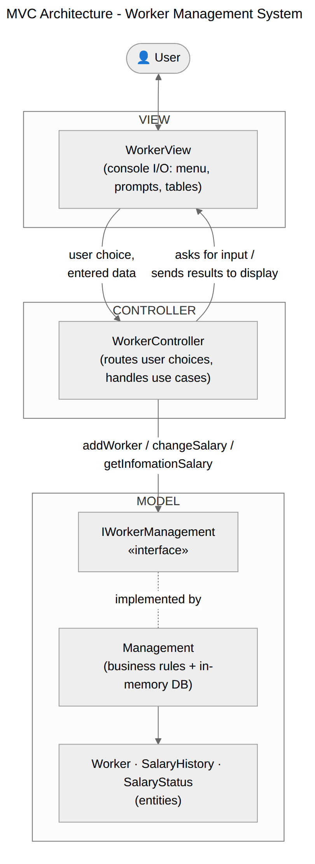
Figure 1. MVC Architecture

1.1 Sub-Systems / Components

1.1.1 View
- WorkerView – displays the menu, reads and validates the format of keyboard input (numeric re-prompt loops), prints result messages and the adjusted salary table.

1.1.2 Controller
- WorkerController – main loop of the program; routes option 1 to handleAddWorker(), options 2/3 to handleChangeSalary(INCREASE/DECREASE), option 4 to handleShowSalaryInfo() and option 5 to quit.
- Main – entry point; wires Management and WorkerView into WorkerController and starts run().

1.1.3 Model
- IWorkerManagement – abstraction of the business logic: addWorker, changeSalary, getInfomationSalary.
- Management – implements the three operations, enforces all business rules, and owns the in-memory worker store and salary history store.
- Worker, SalaryHistory, SalaryStatus – entities and enumeration carried between the layers.
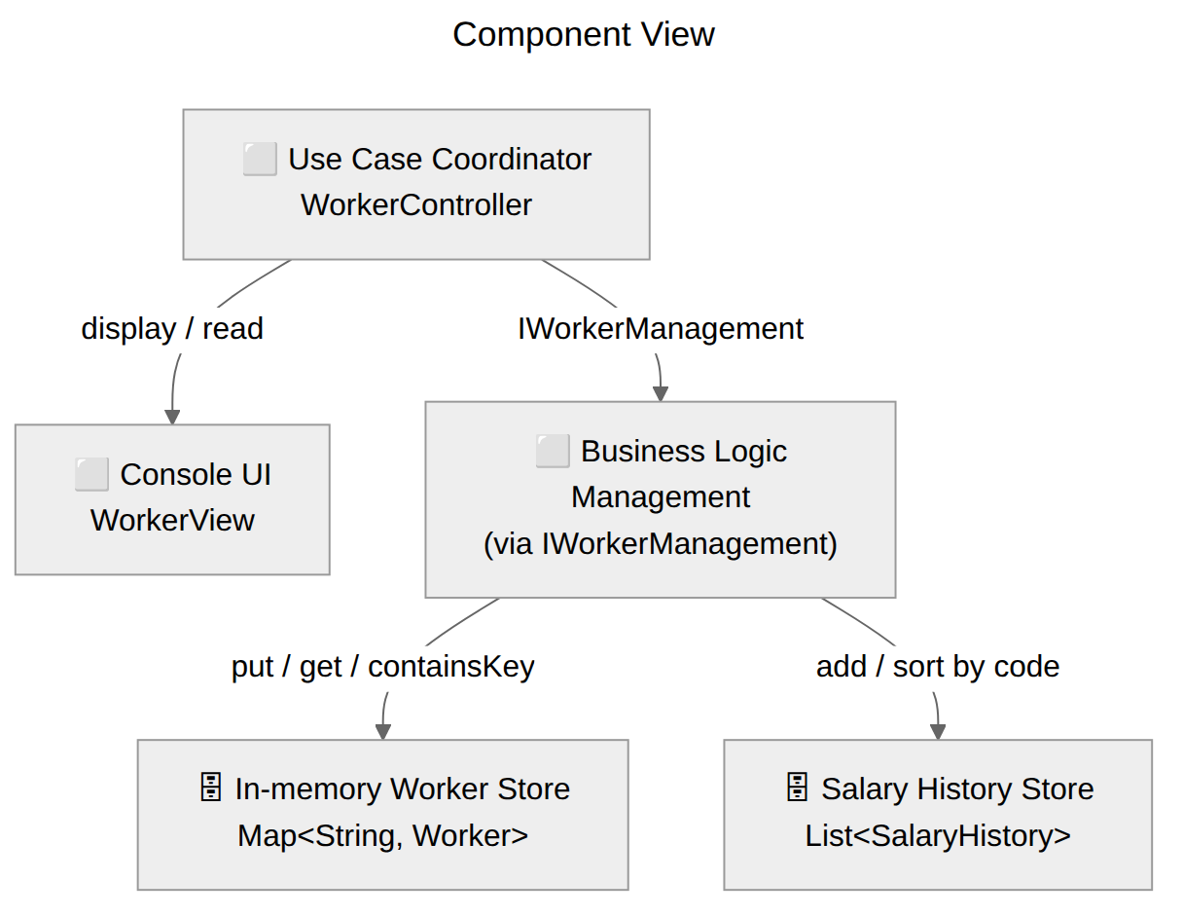
Figure 2. Component view

1.2 External Interfaces
- Standard input / standard output – the only external interface of release 1.0.
- Worker store and salary history store are in-memory structures owned by the Model; no files or database are used.

2. Package Diagram
The source code is organized into three packages that mirror the three MVC roles, plus the Main entry point in the default package.
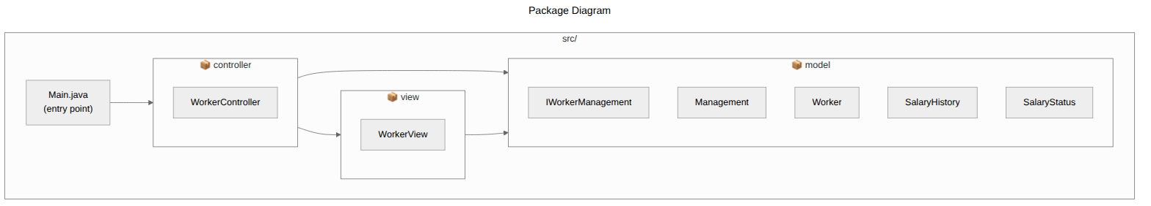
Figure 3. Package Diagram

3. Data Design
The system uses lightweight in-memory data structures instead of a database. The worker "table" is a Map keyed by worker code; the salary history is an append-only List. The logical data model and the constraints are shown below.
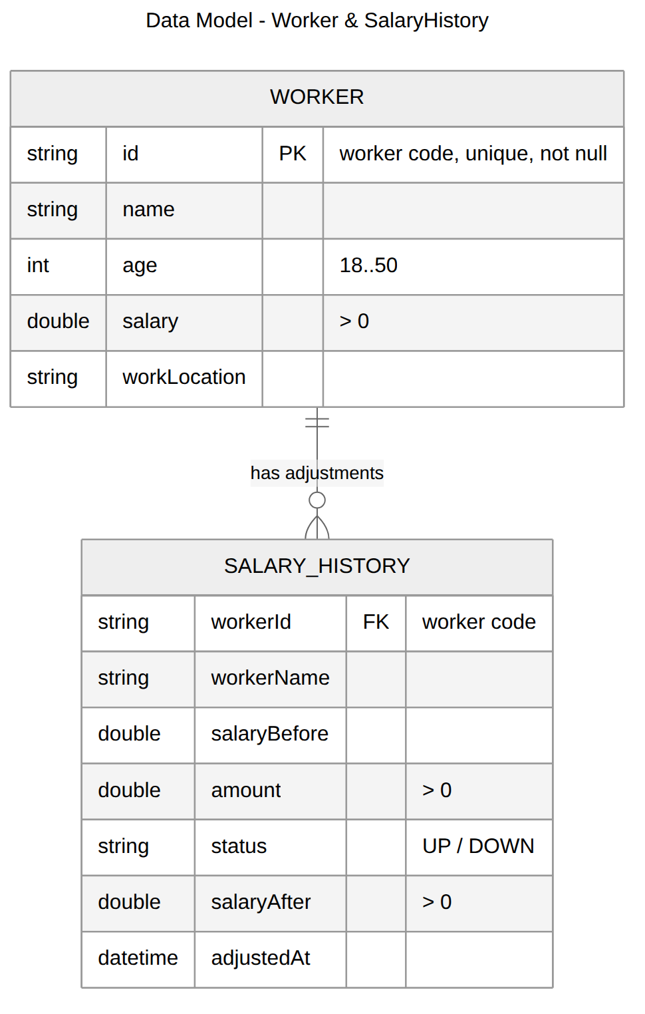
Figure 4. Data Model – Worker & SalaryHistory

3.1 Worker store (Map<String, Worker>)
Field | Type | Key | Description
id | String | PK | Unique worker code; the map key. Not null, not duplicated.
name | String |  | Full name of the worker.
age | int |  | Must be in range 18 to 50.
salary | double |  | Must be greater than 0 at all times.
workLocation | String |  | Work location.

3.2 Salary history store (List<SalaryHistory>)
Field | Type | Key | Description
workerId | String | FK | Code of the adjusted worker (references Worker.id).
workerName | String |  | Worker name at adjustment time.
salaryBefore | double |  | Salary before the adjustment.
amount | double |  | Adjustment amount (> 0).
status | enum |  | INCREASE (UP) or DECREASE (DOWN).
salaryAfter | double |  | Salary after the adjustment (> 0).
adjustedAt | LocalDateTime |  | Timestamp of the adjustment.

IV. Detailed Design

1. Class Diagram
The design class diagram below shows the attributes, operations and relationships of all classes that implement the system, grouped by MVC role.
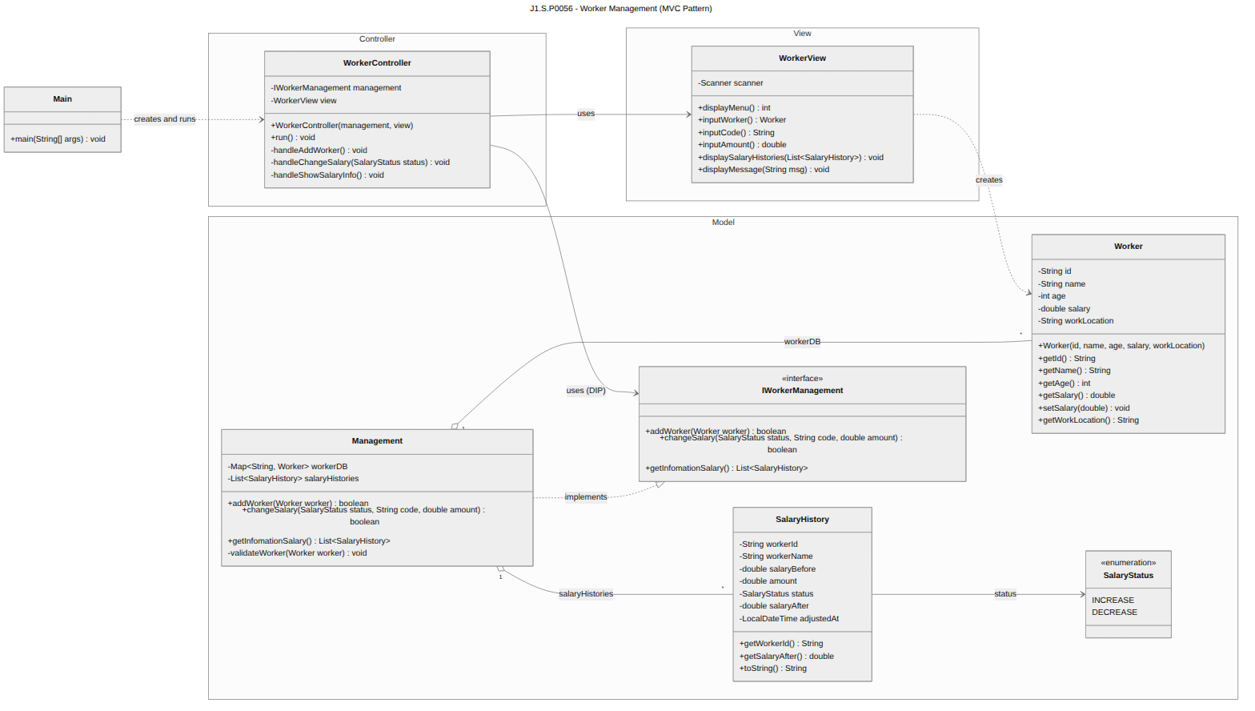
Figure 5. Design Class Diagram – Worker Management (MVC)

2. Sequence Diagram – Add a Worker
The sequence diagram shows the runtime collaboration for adding a worker, including all three validation branches and the successful path.
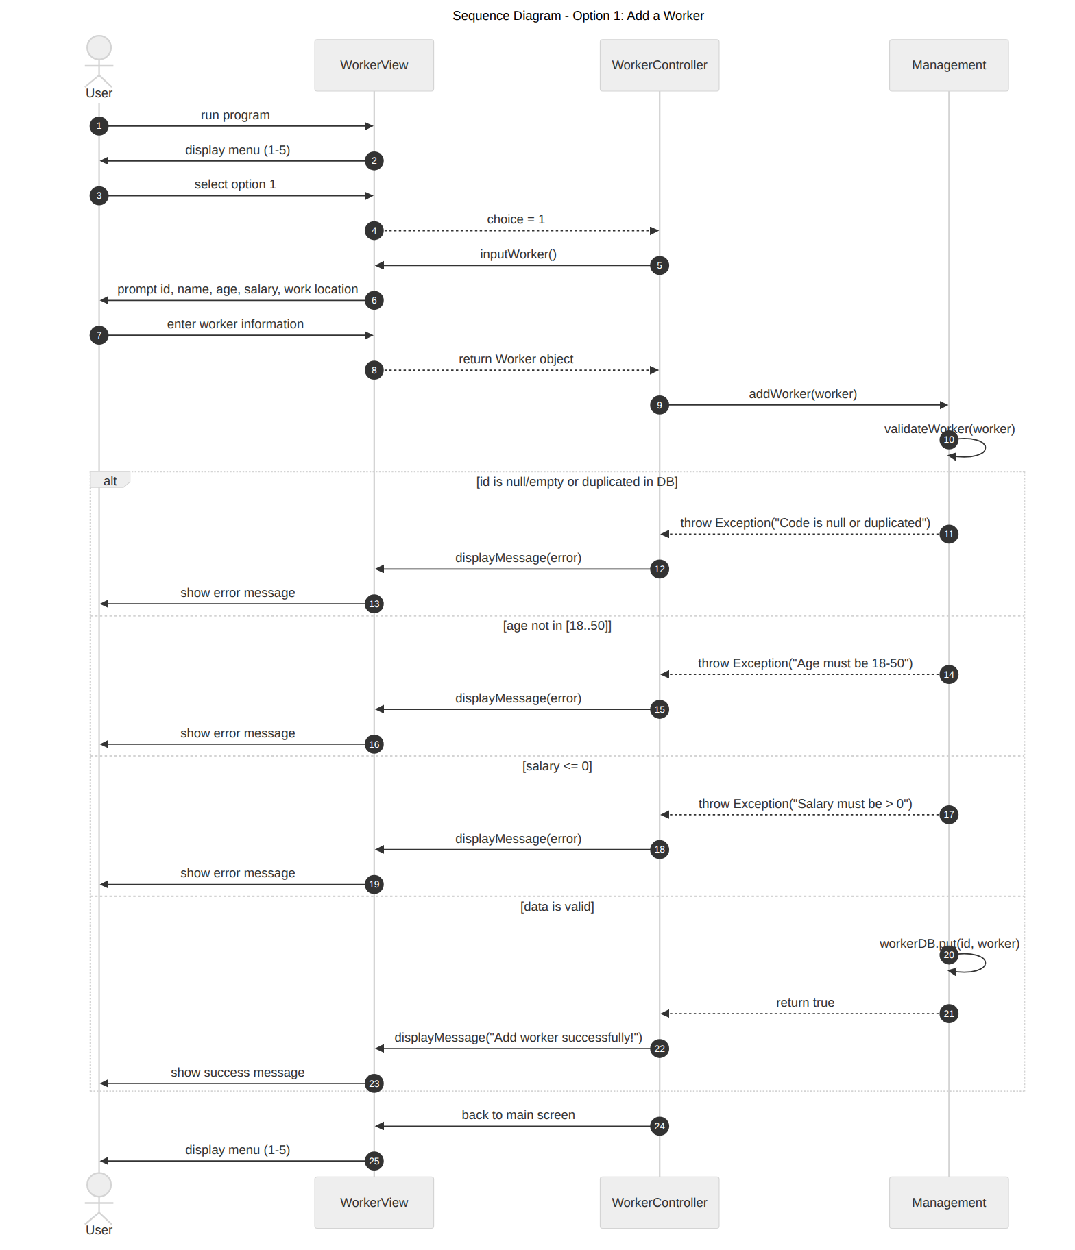
Figure 6. Sequence Diagram (Design) – Add a Worker

3. Sequence Diagram – Adjust Salary
Options 2 and 3 share one flow: the status (INCREASE or DECREASE) selects the arithmetic, all other steps are identical, including saving the SalaryHistory record.
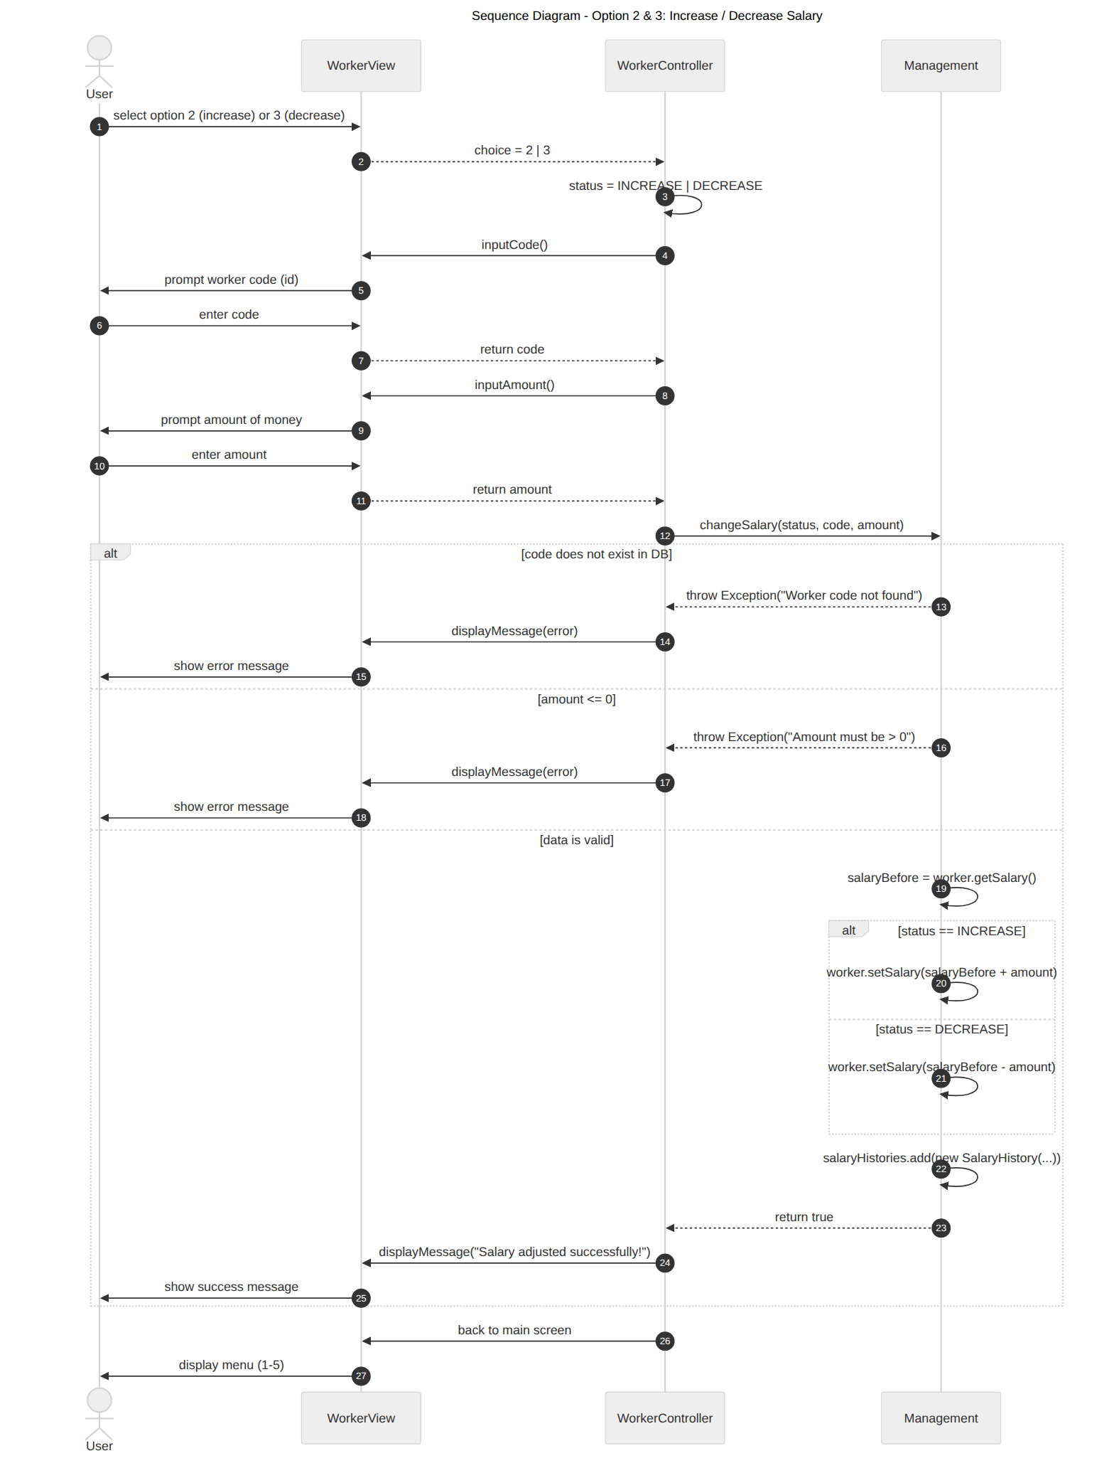
Figure 7. Sequence Diagram (Design) – Increase / Decrease Salary

4. Sequence Diagram – Show Adjusted Salary Workers
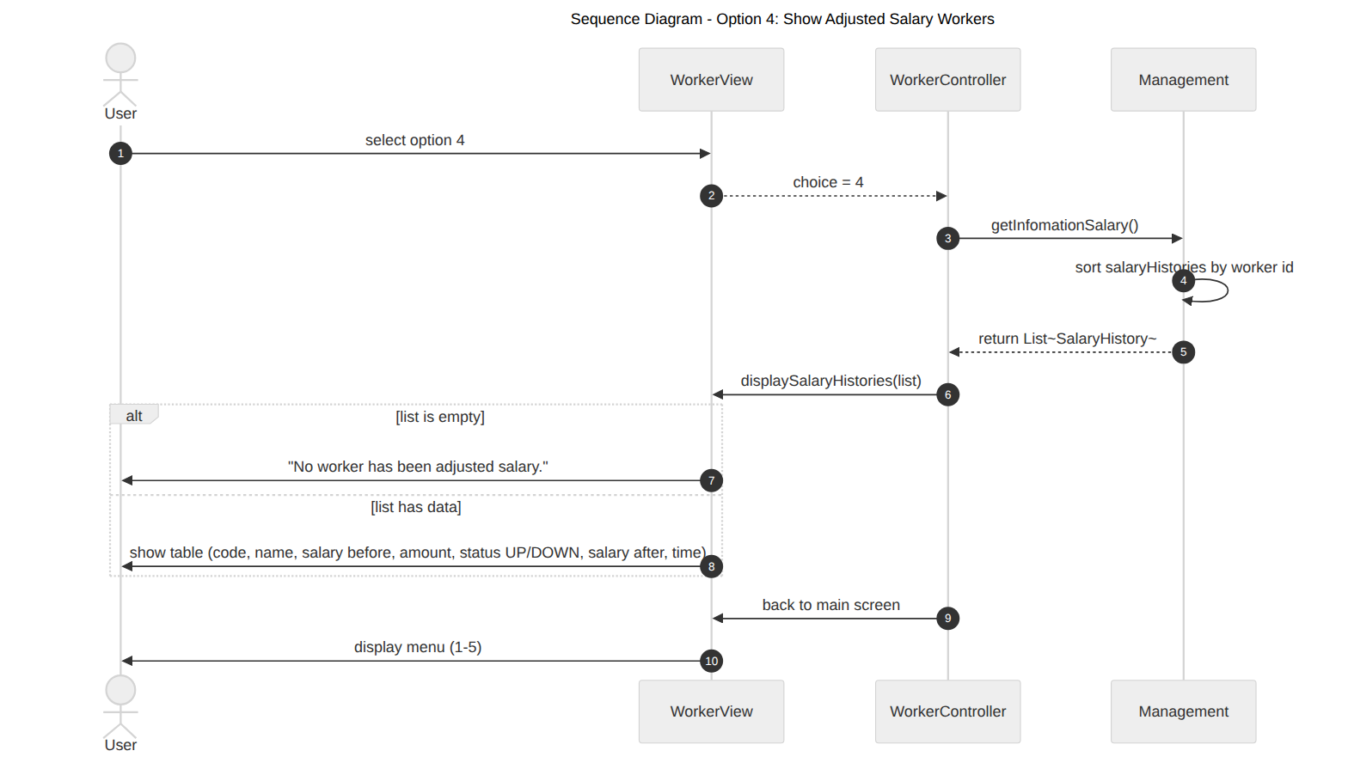
Figure 8. Sequence Diagram (Design) – Show Adjusted Salary Workers

